SLA Activity 3 on
Movie Review Analysis
Natural Language Processing (NLP)
Submitted by
Name PRN NO Roll No
Aaryan Gajra 124BTCM1014 26
Nihaar Kotak 124BTCM1220 35
Class: TYCM3 Semester: V
Under the guidance of
Shreyasee Patra
Department of Computer Engineering
Shah & Anchor Kutchhi Engineering College
Academic Year: 2026 – 2027

1. Introduction
Online reviews influence how audiences choose films and how platforms understand viewer response. A large collection of reviews is difficult to read manually, and individual words can change meaning when used in phrases, negation or informal expressions. An automated sentiment analyzer can help summarize review text by assigning a positive or negative label.
This SLA 3 report presents the implementation and evaluation of the Movie Review Analysis system. The application accepts a single review or a batch file, processes review text with a saved TF-IDF and Logistic Regression model, and displays a sentiment prediction, confidence value and keyword-based aspect tags. The report describes the supplied code and model artifacts; reported scores are limited to the included IMDb test split.

2. Problem Statement
Movie review analysis presents several challenges for automated text processing:
- Sentiment complexity: opinions may contain praise, criticism, negation, mixed views, sarcasm or irony.
- Large review volumes: manually reading and labeling thousands of reviews is slow and inconsistent.
- Domain variation: reviews differ by platform, genre, length, vocabulary and writing style.
- Aspect interpretation: reviewers may discuss acting, story, direction, music or visuals, and a whole-review label does not show which aspect shaped the opinion.
- Reliable evaluation: a test score from one dataset cannot establish performance on every new review source.
The project addresses the basic binary sentiment task by using supervised learning on labeled IMDb reviews and connecting the model to a browser-based application.

3. Objectives
The objectives of this activity are:
- Implement a working NLP system that classifies movie reviews as Positive or Negative.
- Train and save a text classification pipeline using the included IMDb dataset.
- Connect the model to a FastAPI backend and a browser interface.
- Support both individual review analysis and CSV, TXT and JSON batch files.
- Measure classifier performance on a held-out test split and document observed limitations.
- Identify practical improvements for contextual sentiment and aspect-level analysis.

4. Choice of Sentiment Analysis Approach
Three broad approaches can be used for review sentiment. This project selects a classical supervised baseline because it is efficient for sparse text and can be trained using the labeled dataset available in the project.
Table 1: Comparative analysis of sentiment approaches
Feature | Lexicon / Rule Based | TF-IDF + Logistic Regression | Transformer Model
Methodology | Word lists and hand-written rules | Weighted word and phrase features with a trained linear classifier | Contextual token representations and neural classification
Computational overhead | Very low | Low; practical on CPU | Higher; model size and inference cost depend on deployment
Strength | Simple and transparent | Strong baseline; fast training and inference | Can capture more context and phrase interactions
Limitation | Negation, slang and context are difficult | Limited context; depends on training vocabulary | Requires more resources and careful evaluation
Role in this project | Not used as main sentiment model | Implemented method | Possible future comparison

Aspect detection in the current application is a separate keyword-based component. It identifies the presence of selected movie topics, but does not assign positive or negative sentiment to each topic.

5. Technical Architecture and Technology Stack
The project is a local web application in which a browser page communicates with a Python API. The trained model is loaded from a local Joblib file when the backend starts. No external sentiment service or movie metadata API is required for prediction.
Table 2: Components and design decisions
Component | Approach used | Reason / role
Preprocessing | HTML tag removal and whitespace normalization | Same cleaning step is used for training and inference.
Sentiment model | TF-IDF unigrams and bigrams with Logistic Regression | Classical, compact model for labeled text classification.
Aspect tags | Keyword groups for five movie aspects | Lightweight topic tags returned with the sentiment prediction.
Backend | FastAPI and Uvicorn | Exposes model inference and batch routes as JSON endpoints.
Frontend | HTML5, CSS and vanilla JavaScript | Provides review entry, upload and result display.
Model storage | Joblib serialized pipeline | Loads fitted vectorizer and classifier locally.
Dataset | IMDb Dataset.csv, 50,000 labeled reviews | Provides balanced positive and negative examples.

Table 3: Technology stack as implemented
Layer | Technology | Role in the project
Language | Python | Training script and FastAPI backend.
Web framework | FastAPI | Health, prediction and file upload routes.
ML / NLP | scikit-learn | TF-IDF feature extraction and Logistic Regression.
Model storage | Joblib | Serializes and loads the fitted pipeline.
Frontend | HTML, CSS, JavaScript | Responsive review analysis page.
Server | Uvicorn | Runs the local API service.
Data processing | Pandas | Loads and processes the IMDb CSV during training.

6. System Architecture
The application follows a client-server architecture (Fig. 1). The browser sends review text or an uploaded file to FastAPI. The service cleans the text, invokes the saved model and returns JSON for display.
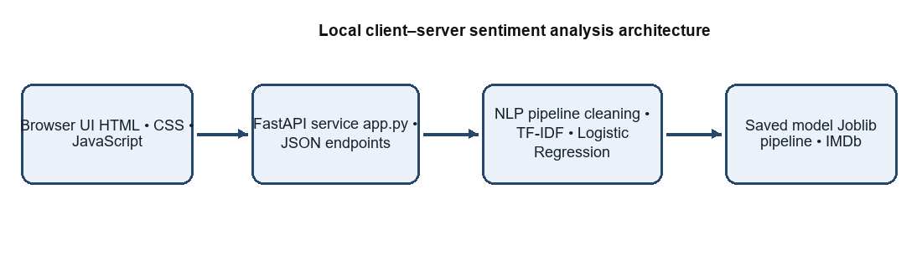
Fig. 1: System architecture of the Movie Review Analysis application
- Presentation layer: the browser accepts review text and displays sentiment, confidence, aspect tags and batch rows.
- Application layer: FastAPI validates requests, parses supported files and returns prediction results.
- NLP layer: preprocessing and keyword-based aspect detection operate alongside the saved classifier.
- Model layer: the Joblib pipeline applies TF-IDF transformation and Logistic Regression.

7. API Used

7.1 Internal Application API
The project uses its own local REST API. The backend loads the trained model from model/imdb_sentiment_model.joblib. Requests are sent to the local server, and the prediction response contains the sentiment, confidence, aspects and original review text.
Table 4: Internal REST endpoints
Route | Method | Input | Purpose / output
/health | GET | None | Reports service status and model-loaded state.
/predict | POST | JSON containing review | Returns sentiment, confidence, aspects and the review.
/batch-predict | POST | CSV, TXT or JSON upload | Returns predictions for up to 1,000 parsed reviews.
/docs | GET | None | FastAPI interactive API documentation.

7.2 External API Requirements
No third-party sentiment API, API key, or live movie-data service is used by the supplied implementation. The browser communicates with the local FastAPI service at http://127.0.0.1:8000. The API server must therefore be running while the website is used.

8. How the API Is Used
The frontend-to-backend request flow is shown in Fig. 2. For a single review, the browser submits JSON to /predict. For batch analysis, it sends the selected file as multipart form data to /batch-predict.
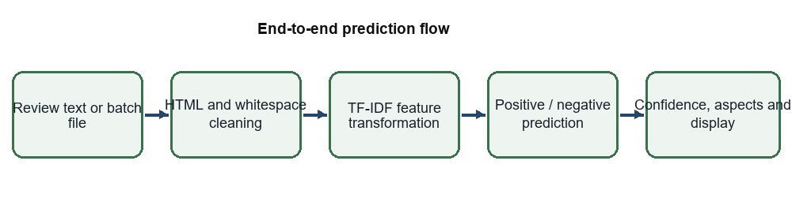
Fig. 2: Review input and prediction flow

Step 1: Review input
The user types or pastes a review in the browser, or selects a CSV, TXT or JSON file for batch analysis.

Step 2: Request construction
For a single review, JavaScript sends a JSON object containing the review string. For a batch, the file is attached to a multipart request.

Step 3: Input cleaning
The backend removes HTML break tags and other HTML-like tags, normalizes whitespace and trims the text. Empty review input is rejected.

Step 4: Model inference
The saved scikit-learn pipeline transforms text with its fitted TF-IDF vectorizer and predicts a binary sentiment label and class probabilities.

Step 5: Aspect tags and confidence
The backend selects the higher class probability as confidence and searches for keyword groups associated with Acting, Story, Direction, Music and Visuals.

Step 6: Result display
The API returns JSON. The browser updates the prediction card and confidence bar or fills a table with batch results.
Table 5: API validation and response behavior
Condition | Implementation behavior
Empty single review | Backend returns HTTP 400; the browser also prompts when its text area is empty.
Supported batch file | CSV, TXT and JSON are parsed; processing is limited to 1,000 reviews per request.
Invalid JSON | Backend returns an invalid JSON error.
Unsupported file extension | Backend asks for CSV, TXT or JSON input.
API unavailable | Frontend displays an API-not-connected message.

9. Dataset
The supplied training script uses the IMDb Dataset.csv file, described in the project README and metrics file as 50,000 movie reviews. The dataset contains 25,000 positive and 25,000 negative labels. A stratified 80/20 split preserves class balance in training and test partitions.
Table 6: Dataset summary
Property | Value
Dataset | IMDb Dataset.csv
Total reviews | 50,000
Positive / negative reviews | 25,000 / 25,000
Training / test reviews | 40,000 / 10,000
Input / target fields | review / sentiment
Label encoding | negative = 0; positive = 1
Split | 80/20 stratified; random_state = 42

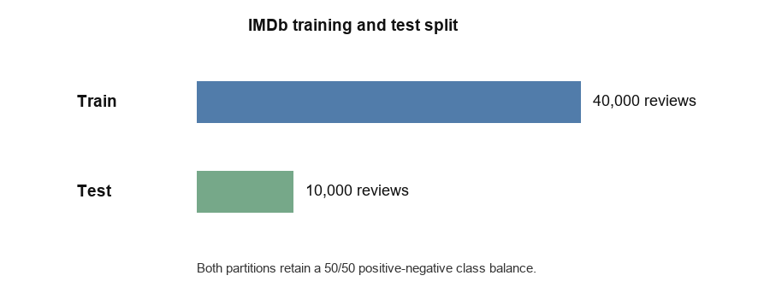
Fig. 3: Training and held-out split sizes; each preserves balanced sentiment classes
The held-out test set contains 5,000 negative and 5,000 positive reviews. The metrics file records performance for this split. Generalization to a different review source has not been measured in the supplied artifacts.

10. Algorithm
Each review passes through text cleaning, TF-IDF vectorization and binary Logistic Regression. The pipeline is trained once using the labeled dataset and saved to disk for later inference.

10.1 Text preprocessing
- Replace HTML break tags and other HTML-like tags with whitespace.
- Collapse repeated whitespace and trim the cleaned review.
- The vectorizer lowercases text and strips accents during feature extraction.
- Keep the same cleaning function in training and API inference.

10.2 TF-IDF feature extraction
Term Frequency–Inverse Document Frequency (TF-IDF) assigns weights to terms based on their presence in a review and their rarity across the training collection. The vectorizer uses unigrams and bigrams so that both individual words and adjacent two-word phrases can contribute to the prediction.
TF-IDF(t,d) = TF(t,d) × IDF(t), IDF(t) = log[(1 + N) / (1 + df(t))] + 1
The training configuration sets ngram_range=(1, 2), min_df=2, max_df=0.95, max_features=120000 and sublinear_tf=True.

10.3 Logistic Regression classification
Logistic Regression estimates class probabilities from the TF-IDF feature vector. For the binary classes, the probability of the positive class can be expressed as p(y=1|x) = 1 / (1 + exp(−(w·x + b))). The class with the larger predicted probability is returned. The implementation uses the liblinear solver and a maximum of 1,000 iterations.
Table 7: Model training configuration
Parameter | Value
Vectorizer | TfidfVectorizer
N-gram range | (1, 2)
min_df / max_df | 2 / 0.95
Maximum feature count | 120,000
Sublinear term frequency | True
Classifier | LogisticRegression, solver=liblinear
Maximum iterations | 1,000
Train/test split | 80/20, stratified; random_state=42

10.4 Confidence and aspect tags
The response confidence is the maximum of the two predicted class probabilities multiplied by 100. Aspect detection checks for predefined keywords. This component detects aspect presence only; it is not an aspect-level sentiment classifier.

11. How It Works
Figure 2 shows the end-to-end processing path. For a batch request, CSV column names such as review, reviews, text or comment are recognized; TXT files are interpreted as non-empty lines; JSON must contain an array of review strings or supported review fields.
Table 8: Worked example predictions recorded with the project
Review example | Prediction | Confidence
The movie was excellent, the acting was brilliant and I really enjoyed it. | Positive | 97.41%
The story was boring and disappointing. I would not recommend this movie. | Negative | 97.38%

These illustrative outputs are recorded in model/prediction_demo.json and in the supplied SLA 2 report. They demonstrate example behavior and are distinct from the aggregate held-out evaluation.

12. Algorithm Results

12.1 Held-out sentiment evaluation
The results below are reported in model/metrics.json for 10,000 test reviews. Accuracy is the fraction of predictions that match the labeled test data. Precision, recall and F1-score are class-specific; the overall averages are weighted by support.
Table 9: Sentiment model performance
Metric | Negative | Positive | Macro / weighted
Precision | 91.53% | 90.48% | 91.01%
Recall | 90.36% | 91.64% | 91.00%
F1-score | 90.94% | 91.06% | 91.00%
Support | 5,000 | 5,000 | 10,000
Accuracy | — | — | 91.00%

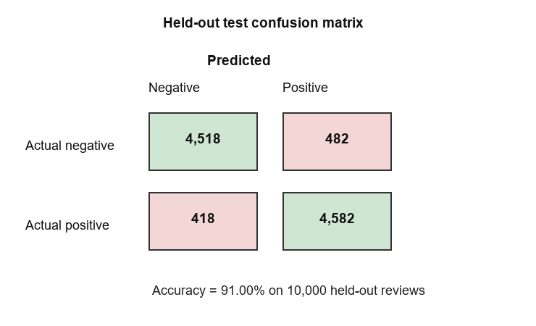
Fig. 4: Confusion matrix for the 10,000-review held-out test set
The model correctly classified 4,518 negative and 4,582 positive reviews. It incorrectly classified 482 negative reviews as positive and 418 positive reviews as negative. The class-level results are close on this balanced split; external-domain performance remains unknown.

12.2 Interpretation and error considerations
TF-IDF represents weighted words and adjacent phrases, but it does not encode full sentence context. Sarcasm, irony, subtle negation, mixed opinions, domain-specific vocabulary and unfamiliar writing styles can therefore contribute to errors. The supplied metrics file contains aggregate results and does not include individual misclassified examples, so specific error causes are not claimed as measured findings.

13. Final Results
The delivered project connects a trained model to a working single-page interface and FastAPI backend. Based on the included artifacts, the core modules have the following status:
Table 10: Module status of the submitted system
Module | Status | Evidence in project
IMDb sentiment model | Implemented | Saved Joblib pipeline and training script.
Single-review API | Implemented | POST /predict in app.py.
Batch prediction | Implemented | CSV, TXT and JSON support in /batch-predict.
Aspect keyword tags | Implemented | Five keyword groups in find_aspects().
Browser interface | Implemented | frontend/index.html with single-review and batch views.
External movie API integration | Not part of current scope | No external movie data service is required by the supplied code.
Neutral sentiment class | Not implemented | Training labels and response use positive / negative only.

The reported 91.00% accuracy is obtained from the included 50,000-review IMDb experiment with a 10,000-review test set. It should not be interpreted as a guarantee for future reviews or as a measure of aspect-tag accuracy.

14. Functional Features of the System
Table 11: Functional features and implementation status
Feature | Status / description
Single review analysis | Implemented: accepts review text and returns a binary sentiment label and confidence.
Batch file input | Implemented: CSV, TXT and JSON uploads; up to 1,000 reviews per request.
Confidence visualization | Implemented: percentage value and progress bar.
Aspect display | Implemented as keyword topic tags; no aspect polarity is predicted.
API health route | Implemented: reports service health and model load status.
External live movie search | Not implemented in the supplied project.
Neutral or mixed class | Not implemented; every prediction is positive or negative.
Browser/server requirement | Local FastAPI service must be running for the frontend to analyze reviews.

Potential real-world uses
- Summarizing large sets of movie reviews for a research or classroom demonstration.
- Providing a first-pass sentiment estimate for a review collection.
- Exploring sentiment distributions in batch data before more detailed qualitative analysis.
Predictions are automated estimates and should be reviewed before being used to make consequential decisions about reviewers or published content.

15. Observations and Future Scope

Advantages observed
- The saved classifier is integrated into a practical browser and API workflow.
- The IMDb training and test sets are balanced, and the held-out results are available in the project metrics file.
- The same text cleaning function is used by the training script and backend.
- Batch prediction supports common text review file formats without an external sentiment API.

Limitations found
- Only positive and negative sentiment classes are supported.
- Keyword-based aspect tags do not identify whether an aspect is praised or criticized.
- Sarcasm, irony, contextual negation and mixed reviews remain difficult for a TF-IDF baseline.
- The reported accuracy is limited to the IMDb held-out split; evaluation on another domain is absent.
- The confidence value is the largest predicted class probability and has not been independently calibrated.
- The browser depends on a locally running API address.

Future scope
- Add a neutral or mixed sentiment class and evaluate it with balanced test data.
- Compare the current baseline with contextual models such as BERT or RoBERTa.
- Implement aspect-based sentiment analysis for acting, story, direction, music and visuals.
- Evaluate on a separate, documented dataset of reviews from another platform or genre.
- Add probability calibration and report confidence intervals and error examples.
- Improve deployment, monitoring, input validation and API security for a hosted version.

16. Conclusion
The Movie Review Analysis project implements an end-to-end NLP application that classifies movie reviews as positive or negative. The browser interface communicates with a FastAPI backend, which cleans the text and applies the saved TF-IDF and Logistic Regression pipeline. The application also supports batch files and displays confidence and keyword-based aspect tags.
The supplied evaluation reports 91.00% accuracy on a balanced 10,000-review IMDb test split, with similar precision, recall and F1-score for both classes. These results demonstrate a useful baseline on the dataset used for training and testing. Contextual language, domain shifts and aspect polarity remain open problems, and the next evaluation should include an independent review dataset.

References
[1] IMDb Dataset.csv, dataset supplied with the Movie Review Analysis project; split and performance results recorded in model/metrics.json.
[2] Aaryan Gajra and Nihaar Kotak, “SLA Report 2 on Movie Review Analysis in NLP,” supplied project report, Academic Year 2026–2027.
[3] Project source: app.py, model/train_model.py, frontend/index.html, README.txt, requirements.txt, model/metrics.json and model/prediction_demo.json.
[4] Scikit-learn, “TfidfVectorizer,” https://scikit-learn.org/stable/modules/generated/sklearn.feature_extraction.text.TfidfVectorizer.html.
[5] Scikit-learn, “LogisticRegression,” https://scikit-learn.org/stable/modules/generated/sklearn.linear_model.LogisticRegression.html.
[6] FastAPI, “First Steps,” https://fastapi.tiangolo.com/tutorial/first-steps/.
[7] FastAPI, “Request Files,” https://fastapi.tiangolo.com/tutorial/request-files/.

