Game Design Document

Fill up the following document

1. Write the title of your project.

Airborne Racing : Racing Without Limits

1. What is the goal of the game?

The Goal Of The Game Is To Make To Make A Car Racing Game With Ranks and Medals and added features.

1. Write a brief story of your game.

The Game is about the story of a young racer who is racing to win and earn medals, help him by playing for him and making him win by competing against other racers and winning from them.

1. Which are the playing characters of this game?

* Playing characters are the ones who respond to the user based on the input from the user.
* Cars, monkeys, dinos, wizards, etc., are the playing characters in the game.

|  |  |  |
| --- | --- | --- |
| Number | Character Name | What can this character do? |
| 1 | Player 1 | Move according to the user |
| 2 | Player 2 | Move according to the user |
| 3 | Player 3 | Move according to the user |
| 4 | Player 4 | Move according to the user |
| 5 |  |  |
| 6 |  |  |
| 7 |  |  |
| 8 |  |  |

1. Which are the Non-Playing Characters of this game?

* Non-Playing characters are the ones that don't have an action or behavior when the user interacts with the game.
* Hurdles, stones, bananas, coins, etc., are non-playing characters in the game.

|  |  |  |
| --- | --- | --- |
| Number | Character Name | What can this character do? |
| 1 | Track | Let cars go on it. |
| 2 |  |  |
| 3 |  |  |
| 4 |  |  |
| 5 |  |  |
| 6 |  |  |
| 7 |  |  |
| 8 |  |  |

Draw your imagination of this game. What does this game look like?

* Draw the game either on your computer or on paper.
* Add images of the game scenes to show each of the playing and non-playing characters at least once.

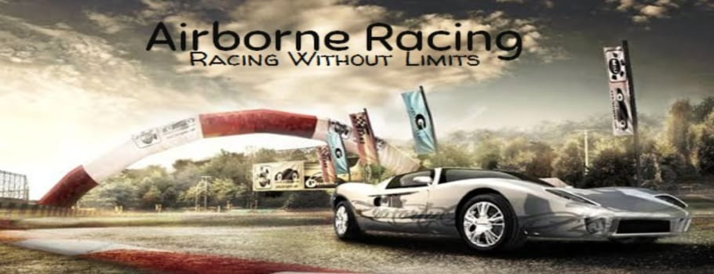

How do you plan to make your game engaging?

I plan to make it engaging by adding medals ,ranks and more of highlights than the original game. Hope people like it