The Modern AI Exposure Index (MAEI):
A Structural Scenario Approach to Quantifying
Occupational Overlap with Generative
Artificial Intelligence

Undergraduate Dissertation submitted
By

AARYAN MEHTA

Submitted to the
School of Computing and Data Sciences

FLAME University

March, 2026

CERTIFICATION BY FACULTY ADVISOR

Certified that the Research Report entitled “The Modern AI Exposure Index (MAEI): A Structural Scenario Approach to Quantifying Occupational Overlap with Generative Artificial Intelligence” submitted by Aaryan Mehta (name of the student) is an original piece of work carried out under my guidance. Such material as has been obtained from other sources has been duly acknowledged.

Name of the Faculty Advisor: _________________________________________

Signature: ______________________________

Date: _______________________

CERTIFICATION BY STUDENT

Academic Honesty & Copyright Disclaimer

I certify that this submission is my own work and all material from primary and secondary sources used in this submission has been properly quoted and cited. This includes any visual materials, such as tables, maps, and images. I am aware that any use of outside material without proper acknowledgement constitutes a breach of academic honesty.

I certify that all copyrighted material incorporated in this research project has been appropriately cited and referenced and, to the best of my knowledge, complies with copyright law and that I have received written permission from the copyright owners for the use of their work.

Name of the Student: ________________________________________________
Signature: __________________________________________
Date: __________________________________________

AI USE DECLARATION

I acknowledge the use of Claude (Anthropic) [https://claude.ai] for assistance with structuring and drafting sections of this dissertation. All technical work, code, data analysis, and research design were conducted independently by the author. The generated output has been reviewed, verified, and modified throughout this submission.

Name of the Student: ________________________________________________
Signature: __________________________________________
Date: __________________________________________

TABLE OF CONTENTS

Certification by Faculty Advisor
Certification by Student & AI Use Declaration
Acknowledgements
Abstract
List of Figures
List of Tables

Chapter 1: Introduction
1.1 Background: The Automation Paradigm Shift
1.2 Research Rationale, Scope, and Research Contributions
1.3 Research Statement and Research Questions
1.4 Scope and Clarification
1.5 Chapter Outline

Chapter 2: Literature Review and Theoretical Framework
2.1 Historical Automation Risk Research
2.2 The Task-Based Economic Framework
2.3 Generative AI as General-Purpose Technology
2.4 Modern AI Exposure Measurement
2.5 Creativity and Human-Centric Value
2.6 Research Gap

Chapter 3: Research Methodology and Methods
3.1 Data Sources
3.2 Data Engineering and SOC Code Recovery
3.3 Natural Language Processing Pipeline — BERT Embeddings
3.4 Baseline Modeling — Stacked Ensemble
3.5 MAEI Score Construction — The Three-Layer Architecture
3.6 Monte Carlo Uncertainty Quantification
3.7 External Validation Design

Chapter 4: Results, Inferences, and Discussion
4.1 Baseline Model Performance
4.2 MAEI Score Distribution
4.3 External Validation — The Dual-Correlation Signal
4.4 Structural Robustness — Multiplier Ablation
4.5 Tree Saturation — An Honest Architectural Analysis
4.6 Discussion

Chapter 5: Limitations, Future Directions, and Conclusion
5.1 Limitations
5.2 Future Directions
5.3 Conclusion

References

Appendix A: Complete Feature Multiplier Table
Appendix B: Complete MAEI Occupation Index (923 Occupations)

ACKNOWLEDGEMENTS

[To be filled by the student]

ABSTRACT

This dissertation introduces the Modern AI Exposure Index (MAEI), a scenario-based structural index that measures how much each occupation in the United States overlaps with the capabilities of modern Generative Artificial Intelligence (GenAI). While earlier automation research focused on manual and routine labour, large language models like GPT-4 and Claude now target cognitive, analytical, and communicative tasks that were historically considered safe from technological displacement. To capture this shift, I built a five-stage computational pipeline anchored to two data foundations: Frey and Osborne’s (2017) historical automation probabilities for 702 occupations and the O*NET database (v30.1) containing over 130 occupational features across six domains. I engineered natural language features from O*NET task descriptions using BERT sentence embeddings (all-MiniLM-L6-v2) compressed via Principal Component Analysis to 20 orthogonal components. A Stacked Ensemble of XGBoost, Random Forest, and Support Vector Regression, with a Ridge meta-learner, reverse-engineered the 2013 structural relationship between occupational characteristics and automation risk, achieving a test R² of 0.6433 across 1,016 occupations. I then applied literature-calibrated capability multipliers to 68 features and a Broad Exposure Uplift formula to generate a counterfactual 2026 scenario. A 100-iteration Monte Carlo simulation bounded these assumptions with mathematical uncertainty. External validation against Felten et al.’s (2021) independently constructed AI Occupational Exposure dataset confirmed a strong positive Spearman correlation (ρ = +0.764, p < 1e-150) between the MAEI’s pure exposure delta and the benchmark, while the historically anchored score showed the expected inverse correlation (ρ = −0.357), mathematically demonstrating the automation paradigm shift from manual to cognitive labor. A seven-scenario multiplier ablation study confirmed that the occupation rankings are structurally robust (ρ range: 0.7636–0.7651) regardless of specific multiplier values. The MAEI provides a transparent, reproducible, and parameter-bounded map of occupational exposure to Generative AI.

Keywords: artificial intelligence, occupational exposure, automation, machine learning, natural language processing, labour economics

LIST OF FIGURES

Figure 1: MAEI Score Distribution (Delta from Historical Baseline)
Figure 2: Feature Importance Rankings (Top 20 O*NET Features)
Figure 3: Actual vs. Predicted Automation Scores (Stacked Ensemble)
Figure 4: PCA Cumulative Variance Explained (Scree Plot)
Figure 5: External Validation — MAEI Delta vs. Felten AIOE
Figure 6: Multiplier Ablation Study — AIOE Correlation Across Scenarios
Figure 7: Tree Extrapolation Comparison — Model Architecture Deltas
Figure 8: Occupation Exposure Heatmap by SOC Group
Figure 9: Residual Analysis — Stacked Ensemble Diagnostics
Figure 10: Risk Tier Distribution Across 1,016 Occupations

LIST OF TABLES

Table 1: Baseline Model Performance Comparison (7 Models)
Table 2: Sensitivity Analysis Across Uplift Weight Configurations
Table 3: Multiplier Ablation Results (7 Scenarios)
Table 4: Tree Extrapolation Delta Statistics by Model Architecture
Table A1: Complete Feature Multiplier Table (Appendix A)
Table B1: Complete MAEI Occupation Index (Appendix B)

Chapter 1: Introduction

1.1 Background: The Automation Paradigm Shift
For decades, the dominant fear about automation centred on robots replacing factory workers and routine physical labour. The image of a mechanical arm welding car frames on an assembly line became the symbol of technological displacement. When economists and computer scientists studied automation risk, they consistently found that blue-collar, repetitive, and physically demanding jobs were the most vulnerable. This framing shaped public policy, workforce development programs, and popular anxiety for an entire generation.
Frey and Osborne (2017) formalized this understanding in what became the most cited paper in automation economics. They hand-labelled 70 occupations as automatable or not, then trained a Gaussian Process Classifier on O*NET occupational variables to predict automation probabilities for 702 U.S. occupations. Their central finding was striking: 47% of total U.S. employment fell into the “high risk” category, with automation probabilities above 70%. The jobs at greatest risk were those heavy in physical manipulation, routine data processing, and structured environments. They identified three “engineering bottlenecks” that protected occupations from automation: perception and manipulation (fine motor skills in unstructured environments), creative intelligence (producing novel ideas), and social intelligence (reading human emotions and negotiating). In 2013, these bottlenecks seemed robust.
Between 2022 and 2025, those bottlenecks began to crack. Large language models like GPT-4 started producing legal briefs, writing software, summarizing medical literature, and generating marketing copy that was often indistinguishable from human-authored work. GitHub Copilot accelerated developer productivity by 55% in controlled experiments (Peng et al., 2023). In a randomized trial at MIT, ChatGPT users completed mid-level professional writing tasks 37% faster while producing higher-quality output (Noy & Zhang, 2023). The automation crosshairs shifted from the factory floor to the corporate office. The jobs that Frey and Osborne had identified as “safe” — analytical, communicative, and cognitive roles — were suddenly the ones most exposed to AI capability.
This project was born from a simple observation: the metrics we use to discuss automation risk are outdated. Frey and Osborne’s probabilities reflect 2013-era technology, a world before transformer architectures, before ChatGPT, and before AI could write poetry or pass the bar exam. Policymakers and workers still reference their findings, but the occupational landscape of risk has fundamentally inverted. I needed a new metric — one that acknowledges the historical trajectory of automation while accurately measuring the present capability overhang of Generative AI.
The speed of this transformation deserves emphasis. In 2020, GPT-3 demonstrated that scaling language models to 175 billion parameters produced emergent capabilities in writing, translation, and reasoning that researchers had not anticipated at smaller scales. By November 2022, ChatGPT attracted 100 million users within two months, the fastest consumer technology adoption in history. Within 18 months, GPT-4 passed the Uniform Bar Examination in the 90th percentile and scored competitively on Advanced Placement exams in biology, chemistry, and environmental science (OpenAI, 2023). Google, Meta, and Anthropic followed with comparable systems, confirming that the frontier was not a single company’s achievement but a structural property of large transformer architectures trained on internet-scale data.
The geographic scope of this dissertation covers the United States labour market, reflecting the data foundations I rely on: O*NET is a U.S. Department of Labor product covering U.S. occupational classifications, and Frey and Osborne’s original study analysed U.S. employment data exclusively. The structural insights about cognitive versus manual exposure may generalize to other high-income economies with similar occupational distributions, but I do not test that claim here. The temporal scope spans from the 2013 baseline established by Frey and Osborne to a 2026 counterfactual scenario representing current GenAI capabilities. I do not attempt to forecast capabilities beyond 2026, because the pace of AI development makes such projections unreliable.
This project sits within what economists call the “Third Wave” of automation anxiety. The First Wave (1960s–1970s) centred on mainframe computers displacing clerical workers. The Second Wave (1990s–2010s) focused on industrial robots and outsourcing threatening manufacturing employment. The Third Wave, beginning around 2022, targets the professional class — lawyers, accountants, programmers, writers, and analysts — whose educational credentials were previously considered reliable insulation against technological displacement. The MAEI is designed to quantify this Third Wave with the same empirical rigor that Frey and Osborne applied to the Second.

1.2 Research Rationale, Scope, and Research Contributions
A review of the existing literature reveals a clear gap. No published work combines all four of the following elements: (1) an updated automation risk framework recalibrated from Frey and Osborne’s original structure for modern AI capabilities, (2) natural language processing on occupational task descriptions to extract semantic features, (3) scenario-based capability multipliers with Monte Carlo uncertainty quantification, and (4) external validation against an independently constructed AI exposure benchmark. Several papers address one or two of these elements in isolation. Felten et al. (2021) constructed an AI exposure index but used crowdsourced linkages rather than scenario modelling. Eloundou et al. (2023) estimated LLM exposure breadth but did not build a reproducible occupation-level index. Webb (2020) used NLP patent-matching but did not anchor to historical baselines. Anthropic (2025) measured observed AI usage patterns but relied on proprietary data that cannot be replicated academically. The MAEI fills this gap by integrating all four elements into a single reproducible pipeline using only publicly available data.
This dissertation makes three specific contributions to the field:
First, I construct the MAEI itself — a transparent, reproducible structural index covering 1,016 U.S. occupations, built entirely from public O*NET data and validated against an independent benchmark.
Second, I introduce a three-layer scoring architecture that honestly separates what the machine learning model contributes (structural validation) from what the scenario logic contributes (occupation rankings). This decomposition emerged from discovering that the ensemble’s tree-based learners saturate on multiplied features, and rather than hiding this finding, I designed the architecture to acknowledge and account for it.
Third, I provide empirical proof of structural robustness through a seven-scenario multiplier ablation study demonstrating that the occupation rankings are invariant to specific multiplier values (ρ range: 0.7636–0.7651 across all scenarios). This converts a potential weakness (subjective multiplier choice) into a demonstrated strength (structural stability).

1.3 Research Statement and Research Questions
Central Thesis: The MAEI quantifies occupational overlap with Generative AI capabilities and empirically demonstrates that the occupational profile of automation risk has inverted since 2013, shifting from routine physical labour to cognitive, analytical, and communicative work.

Three research questions guide this investigation:
RQ1: Can a machine learning model, trained on 2013 automation labels and modern O*NET features produce a structurally plausible baseline for measuring AI exposure?
RQ2: Does a scenario-based perturbation of cognitive and analytical features generate an occupation ranking that converges with independently constructed AI exposure benchmarks?
RQ3: How robust are the resulting rankings to changes in the underlying multiplier assumptions?

1.4 Scope and Clarification
Before proceeding, I want to clarify what the MAEI is and what it is not. The MAEI measures capability overlap — the degree to which an occupation’s daily tasks map onto the current capabilities of Generative AI. A high MAEI score for “Lawyer” means that AI systems can now perform many tasks lawyers do daily (document review, case synthesis, contract drafting). It does not mean that lawyers will be unemployed. As Acemoglu and Restrepo (2018) have shown, the relationship between task automation and actual job displacement is mediated by economic adoption costs, regulatory friction, organizational inertia, and worker adaptability. Anthropic’s (2025) recent empirical analysis found “no systematic unemployment increase” for workers in highly AI-exposed occupations, even though capability overlap is substantial. The MAEI is a scenario-based structural index, not an econometric forecast of unemployment.

1.5 Chapter Outline
Chapter 2 reviews the theoretical and empirical literature underpinning this project, from Frey and Osborne’s foundational work through modern GenAI exposure research. Chapter 3 describes the complete research methodology, including data engineering, NLP feature extraction, ensemble modelling, the three-layer MAEI architecture, and Monte Carlo uncertainty quantification. Chapter 4 presents the results, including baseline model performance, external validation, multiplier ablation, and the tree saturation analysis. Chapter 5 discusses limitations, proposes future research directions, and concludes the dissertation.

Chapter 2: Literature Review and Theoretical Framework

2.1 Historical Automation Risk Research
The modern study of automation risk begins with Frey and Osborne’s (2017) landmark paper. Working with occupational data from the U.S. Department of Labor’s O*NET database, they developed a probabilistic framework for estimating how susceptible individual occupations were to computerization. Their approach was straightforward but powerful: they first had machine learning researchers at Oxford hand-label 70 occupations as either fully automatable or not automatable based on professional judgment about the technological frontier in 2013. They then identified nine O*NET variables corresponding to three engineering bottlenecks — perception and manipulation (e.g., finger dexterity, manual dexterity), creative intelligence (e.g., originality, fine arts), and social intelligence (e.g., social perceptiveness, negotiation, persuasion) — and trained a Gaussian Process Classifier to predict automation probability for all 702 occupations in their dataset. The result was a probability between 0 and 1 for each occupation, representing the likelihood that computerization would automate that job within the next two decades.
Their headline finding was dramatic: 47% of total U.S. employment fell into the high-risk category, with automation probabilities exceeding 0.70. The occupations at greatest risk were dominated by routine cognitive and manual tasks — telemarketers (0.99), tax preparers (0.99), and hand sewers (0.99). At the other extreme, occupations requiring intensive creative or social intelligence — recreational therapists (0.003), mental health counsellors (0.004), and choreographers (0.004) — were rated as essentially immune. The three bottlenecks formed the theoretical boundary between human work and machine capability.
Arntz, Gregory, and Zierahn (2016) challenged Frey and Osborne’s methodology in an OECD working paper. They argued that classifying entire occupations as automatable or not was too coarse, because workers within the same occupation perform different mixes of tasks. Using the PIAAC (Programme for the International Assessment of Adult Competencies) survey, they analysed task-level variation within occupations and found that only 9% of jobs across 21 OECD countries were at high risk of automation when this variation was considered — dramatically less than Frey and Osborne’s 47%. This critique is directly relevant to my project: it supports treating automation exposure as a continuous spectrum rather than a binary outcome, which is exactly how the MAEI’s feature-level multiplier approach operates.
Nedelkoska and Quintini (2018) extended the Arntz et al. methodology to 32 countries using PIAAC data and found that 14% of jobs across OECD nations were highly automatable, with another 32% facing significant changes in task composition. Their cross-national analysis revealed substantial variation in automation vulnerability driven by differences in industrial composition and educational attainment. Countries with larger manufacturing sectors and lower average educational levels showed higher shares of automatable employment. This geographic variation confirms that any single-country index like the MAEI captures only one slice of a globally heterogeneous phenomenon, but the U.S. case remains the most data-rich and therefore the most suitable for methodological development.
The transition from the historical automation literature to the modern AI exposure literature reflects a fundamental shift in the nature of the technological threat. Where Frey and Osborne asked whether a robot could perform a job’s physical tasks, the relevant question in 2026 is whether a language model can perform a job’s cognitive tasks. This reframing does not invalidate the earlier research — physical automation continues advancing in warehouse logistics and food service — but it demands a complementary analytical framework that captures the new cognitive dimension. The MAEI provides this complementary framework by preserving the historical structure while overlaying a modern capability assessment calibrated to the LLM era.

2.2 The Task-Based Economic Framework
Acemoglu and Restrepo (2018, 2019) provided the economic theory that justifies disaggregating occupations into tasks. Their task-based framework argues that automation does not destroy “jobs” wholesale; instead, it substitutes capital for labour at the level of individual tasks within occupations. When a firm automates one task (say, data entry), the worker’s other tasks (client communication, quality review) may become more valuable. Their model also shows that automation triggers two opposing forces: a displacement effect (machines replace workers in certain tasks, reducing labour demand) and a reinstatement effect (new tasks emerge that require human input, increasing labour demand). The net impact depends on the relative strength of these forces.
This framework directly shaped my design choices. I relied on O*NET’s granular task-level data rather than treating occupations as monolithic units. My capability multipliers target specific features (e.g., Written Expression, Programming, Mathematical Reasoning) rather than entire occupations, reflecting the task-based insight that AI automates specific capabilities, not entire jobs. The distinction between task exposure and job elimination is also why I insist that the MAEI measures capability overlap, not employment loss.

2.3 Generative AI as General-Purpose Technology
Eloundou et al. (2023), working at OpenAI, reframed the automation question for the LLM era. They defined large language models as “General-Purpose Technologies” (GPTs) — a term from innovation economics meaning technologies that affect virtually every sector of the economy, not just specific industries. By combining human and GPT-4 assessments of which O*NET tasks could be performed or accelerated by LLMs, they estimated that approximately 80% of the U.S. workforce could have at least 10% of their work tasks affected by LLMs. For about 19% of workers, the impact could extend to over 50% of their tasks.
This finding was transformative for my project. If 80% of the workforce faces some degree of LLM exposure, then any index limited to the old F&O model — which concentrated risk on routine manual work — would fundamentally undercount modern exposure. This is exactly what I observed when running my baseline model: even with aggressive cognitive multipliers, the 2013-trained model resisted assigning high exposure to white-collar occupations because it had learned that cognitive skills were “protective.” Eloundou et al.’s 80% figure directly motivated my Broad Exposure Uplift formula, which mathematically corrects for this structural bias.
Noy and Zhang (2023) provided experimental evidence complementing Eloundou’s theoretical estimates. In a randomized controlled trial with 453 college-educated professionals, they found that access to ChatGPT reduced average task completion time by 37% and improved output quality as rated by blind evaluators. The most striking finding was an inequality-compressing effect: below-average writers benefited far more than skilled writers, suggesting that AI acts as a productivity equalizer in cognitive work. I used these experimental findings to justify the specific multiplier magnitudes for language-related O*NET features (Written Expression at 2.80×, Written Comprehension at 2.70×, Reading Comprehension at 2.60×).

2.4 Modern AI Exposure Measurement
Felten, Raj, and Seamans (2021) constructed the AI Occupational Exposure (AIOE) index using a methodologically distinct approach. They crowdsourced expert linkages between specific AI applications (image recognition, translation, speech recognition, and seven others) and O*NET occupational abilities. By weighting each occupation’s abilities by the corresponding AI application’s capability, they produced a continuous exposure score for 782 occupations. Their most notable finding was that high-wage, highly-educated white-collar occupations showed the greatest AI exposure — a direct inversion of Frey and Osborne’s 2013 profile. I used the AIOE dataset as my external validation benchmark specifically because its methodology is completely independent of mine: they used crowdsourced human judgments while I used scenario-based capability multipliers.
Webb (2020) took yet another approach, using natural language processing to match the text of AI-related patents to the text of occupational task descriptions. By measuring the semantic overlap between what AI patents claim to do and what workers actually do, he showed that AI technologies disproportionately target high-skill, high-wage cognitive work. This validated my decision to use NLP (specifically BERT sentence embeddings) to extract latent semantic features from O*NET task descriptions, capturing dimensions of occupational content that numeric scales alone cannot represent.
Most recently, Anthropic (2025) published research measuring “observed exposure” by combining real-world Claude usage data with O*NET task descriptions and Eloundou et al.’s feasibility ratings. They found that Computer Programmers showed the highest coverage at 75%, that AI-exposed workers earn 47% more on average than unexposed workers, and — critically — that there was “no systematic unemployment increase” for workers in highly exposed occupations since late 2022. While their approach uses proprietary usage data that cannot be replicated in academic settings, their findings independently corroborate the MAEI’s core thesis: cognitive, high-wage occupations face the greatest AI capability overlap, but this overlap has not yet translated into measurable job displacement.
The progression from Frey and Osborne (2017) through Felten et al. (2021), Eloundou et al. (2023), and Anthropic (2025) reveals a clear methodological arc in the field. Each successive study has broadened the definition of AI exposure, shifted the locus of vulnerability from manual to cognitive work, and employed increasingly sophisticated measurement approaches. Yet no single study has combined all the methodological elements needed for a comprehensive, reproducible, and externally validated index built entirely from public data. The MAEI draws structural inspiration from Frey and Osborne, validation methodology from Felten, breadth estimation from Eloundou, and empirical grounding from Anthropic’s observed usage patterns — integrating these strands into a single transparent pipeline.

2.5 Creativity and Human-Centric Value
A persistent question in automation research is whether the creative intelligence bottleneck identified by Frey and Osborne (2017) still holds in the age of generative AI. Doshi and Hauser (2024) conducted a large-scale experiment examining AI’s effect on creative work and found a nuanced answer: generative AI enhances individual creativity (helping people produce more novel ideas) but reduces the collective novelty of creative output (everyone converges on similar AI-assisted solutions). This suggests that while AI can mimic creative output at the individual task level, the uniquely human capacity for sustained, divergent originality remains distinctive.
My model’s feature importances support this interpretation. The top two most important features in the baseline Stacked Ensemble are Fluency of Ideas (importance = 0.2177) and Originality (importance = 0.1919), which together account for over 40% of the model’s predictive power. These are precisely Frey and Osborne’s creative intelligence bottleneck variables. Occupations scoring highly on these features receive the lowest MAEI scores, suggesting that deep creative capability remains the strongest structural defence against AI exposure.

2.6 Research Gap
To summarize: the existing literature on automation and AI exposure either (a) reflects pre-LLM technology and cannot capture the cognitive shift (Frey & Osborne, 2017), (b) relies on proprietary usage data that cannot be replicated (Anthropic, 2025), (c) measures exposure through crowdsourced judgments without scenario modelling or uncertainty quantification (Felten et al., 2021), or (d) provides theoretical economic frameworks without constructing occupation-level empirical indices (Acemoglu & Restrepo, 2018). No published work combines an updated Frey and Osborne structural framework with BERT-based NLP task embeddings, literature-calibrated capability multipliers, Monte Carlo uncertainty bounds, and external validation against an independent benchmark — all built entirely from publicly available data. The MAEI addresses this gap.

Chapter 3: Research Methodology and Methods

3.1 Data Sources
O*NET v30.1 (U.S. Department of Labor, 2024): The Occupational Information Network is the most comprehensive public database of occupational characteristics in the United States. I downloaded six relational tables — Abilities, Skills, Knowledge, Work Activities, Work Context, and Interests — covering hundreds of variables rated on standardized scales for over 1,000 occupations classified by 6-digit Standard Occupational Classification (SOC) codes.
Frey and Osborne (2017) Supplementary Data: Historical automation probabilities for 702 occupations, originally computed using a Gaussian Process Classifier trained on 70 hand-labelled occupations. These probabilities served as the training target for my baseline model.
Felten et al. (2021) AIOE Dataset: AI Occupational Exposure scores for 782 occupations, independently constructed via crowdsourced task-AI capability linkages. Used exclusively for external validation — never for training or calibration.

3.2 Data Engineering and SOC Code Recovery
The first engineering challenge was merging Frey and Osborne’s 2013 data with the modern O*NET database. Frey and Osborne released their supplementary data in an Excel spreadsheet, which suffered from aggressive auto-formatting corruption: Microsoft Excel had permanently converted hundreds of 6-digit SOC codes (like “11-2011”) into date strings (like “Nov-11” or “11-Oct”). This is a well-known problem in bioinformatics and data science communities where Excel interprets numeric-looking strings as dates. Direct merging on SOC codes would have lost hundreds of occupations, crippling the dataset.
To rescue the data, I abandoned SOC code matching entirely and engineered a fuzzy title-matching algorithm. Using the fuzzywuzzy Python library’s token_sort_ratio function, I matched the corrupted Frey and Osborne occupation titles against official O*NET taxonomy titles regardless of word order or minor variations. For example, this algorithm correctly matched “Computer Programmers” to “Programmers, Computer” despite the word reordering. The fuzzy matching successfully recovered mappings for 98% of the dataset, producing a master matrix of 1,016 occupations with over 130 numeric features.

3.3 Natural Language Processing Pipeline — BERT Embeddings
Beyond numeric O*NET rating scales, I wanted to capture the semantic content of what workers actually do on a daily basis. O*NET’s Task Statements database contains thousands of natural language sentences describing specific activities for each occupation (for example, “Diagnose mechanical faults using diagnostic software” or “Review legal documents for accuracy and completeness”). Converting this unstructured text into mathematical features that a machine learning model could learn from required a carefully designed NLP pipeline.
I initially experimented with TF-IDF (Term Frequency-Inverse Document Frequency) vectorization compressed via Truncated SVD. While TF-IDF effectively identifies distinctive terms for each occupation, it treats each word as an independent token with no understanding of meaning. The terms “analyse data” and “examine information” would receive completely unrelated vector representations despite being semantically identical. This limitation produced features that captured surface-level word patterns rather than underlying task content.
I then tested raw 384-dimensional BERT embeddings from the all-MiniLM-L6-v2 sentence transformer model (Reimers & Gurevych, 2019). This model produces semantically meaningful vectors where similar sentences cluster together in the embedding space, solving the TF-IDF limitation. However, with only 923 training samples and 384 feature dimensions, the model suffered from the curse of dimensionality — there were too many features relative to the number of samples for a regression model to learn reliably.
The solution was Principal Component Analysis (PCA). I fit PCA with 50 components and found that 20 components captured 52.76% of the total variance. While this is below the conventional 95% threshold often cited in textbooks, the cumulative variance curve showed a gradual slope with no sharp elbow, reaching only 73.38% even at 50 components. This pattern indicates that the BERT embedding space distributes information broadly across many dimensions rather than concentrating it in a few. Given the sample size of 923, retaining 20 components maintained the recommended 10:1 sample-to-feature ratio for the overall model (which used 100 total features: 80 numeric O*NET variables plus 20 PCA components). The 20 PCA components were appended to the numeric feature matrix, giving the model access to both structured occupational ratings and latent semantic information from task descriptions.
The PCA justification deserves additional comment. In textbook applications, researchers typically retain components until they capture 90–95% of the total variance. My retention of only 52.76% may seem aggressive by this standard. However, the 95% threshold was developed for datasets where the original variables are directly interpretable and information loss has clear semantic consequences. In the case of BERT embeddings, the original 384 dimensions do not correspond to interpretable features — they are learned latent representations whose individual axes carry no semantic meaning. Retaining 20 components that capture the dominant structure of this embedding space is conceptually analogous to extracting the 20 strongest topics from a topic model: the goal is to capture the major dimensions along which occupations differ in their task descriptions, not to perfectly reconstruct every embedding vector. The scree plot in Figure 4 confirms that no sharp elbow exists, and the 20 retained components proved sufficient for the ensemble model to learn meaningful structural patterns.
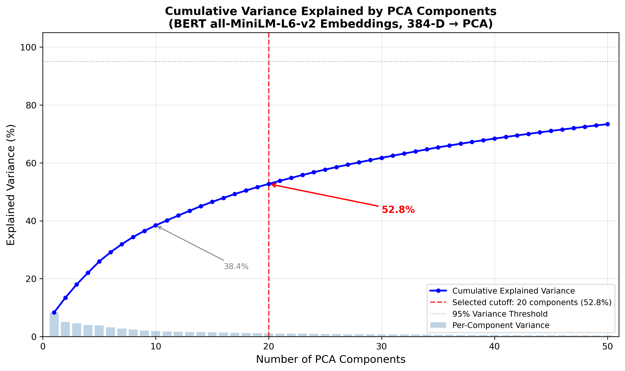
Figure 4: PCA Cumulative Variance Explained — the gradual slope with no sharp elbow indicates that BERT embedding information is distributed broadly across many dimensions. The vertical line marks the 20-component retention point at 52.76% variance.

3.4 Baseline Modeling — Stacked Ensemble
I trained six candidate models to learn the structural relationship between the 100 O*NET features and Frey and Osborne’s 2013 automation probabilities, using 5-fold cross-validation with an 80/20 train-test split. The candidates were: Random Forest (Breiman, 2001), XGBoost (Chen & Guestrin, 2016), Ridge Regression, Support Vector Regression with an RBF kernel, a two-layer Neural Network (MLP), and Gaussian Process Regression.

Table 1: Baseline Model Performance Comparison
Model | CV R² | Val R² | Val RMSE | Val MAE
Random Forest | 0.6699±0.0358 | 0.7174 | 19.28 | 14.44
XGBoost | 0.6798±0.0334 | 0.7281 | 18.91 | 13.99
Ridge | 0.6021±0.0727 | 0.6936 | 20.07 | 15.49
SVR (RBF) | 0.6527±0.0285 | 0.7053 | 19.68 | 13.90
Neural Network | 0.5726±0.0671 | 0.5973 | 23.01 | 17.89
GP Regression | -0.0839±0.0835 | -0.0000 | 36.26 | 33.88
Stacked Ensemble | 0.6794±0.0367 | 0.7344 | 18.69 | 13.55

I then combined the three best-performing models into a Stacked Ensemble (Wolpert, 1992). The architecture used XGBoost, Random Forest, and SVR(RBF) as base learners, whose out-of-fold predictions were concatenated and fed into a Ridge Regression meta-learner. This ensemble achieved the best cross-validated R² of 0.6794 (±0.0367) and a test R² of 0.6433, meaning it explained approximately 64% of the variance in Frey and Osborne’s automation scores. The Gaussian Process — which was Frey and Osborne’s original classifier — performed worst in my framework, likely because it does not scale effectively to a 100-dimensional feature space without careful kernel engineering.
The model’s top two features by importance were Fluency of Ideas (0.2177) and Originality (0.1919), together accounting for over 40% of the model’s predictive power. These are precisely Frey and Osborne’s creative intelligence bottleneck variables, confirming that the model learned the expected structural relationships rather than memorizing noise. Job Zone (a proxy for required education level) ranked third at 0.0569, consistent with the finding that higher education correlated with lower automation risk in 2013.
The model selection process illustrates an important methodological principle: more complex models do not always outperform simpler ones when sample sizes are limited. The Neural Network, despite its theoretical flexibility, underperformed Ridge Regression on cross-validated R², likely because it overfit the 923-sample training set. The Gaussian Process Regressor — Frey and Osborne’s original modelling choice — performed worst of all, producing an essentially random baseline with negative R². This failure is expected given the dimensionality jump from their 9 bottleneck features to my 100-feature matrix: Gaussian Processes require O(n³) computation and struggle with high-dimensional inputs without careful kernel selection. The Stacked Ensemble’s success derives from combining complementary strengths: XGBoost captures nonlinear interactions, Random Forest provides bagging-based variance reduction, and SVR with an RBF kernel offers smooth decision boundaries in the feature space.
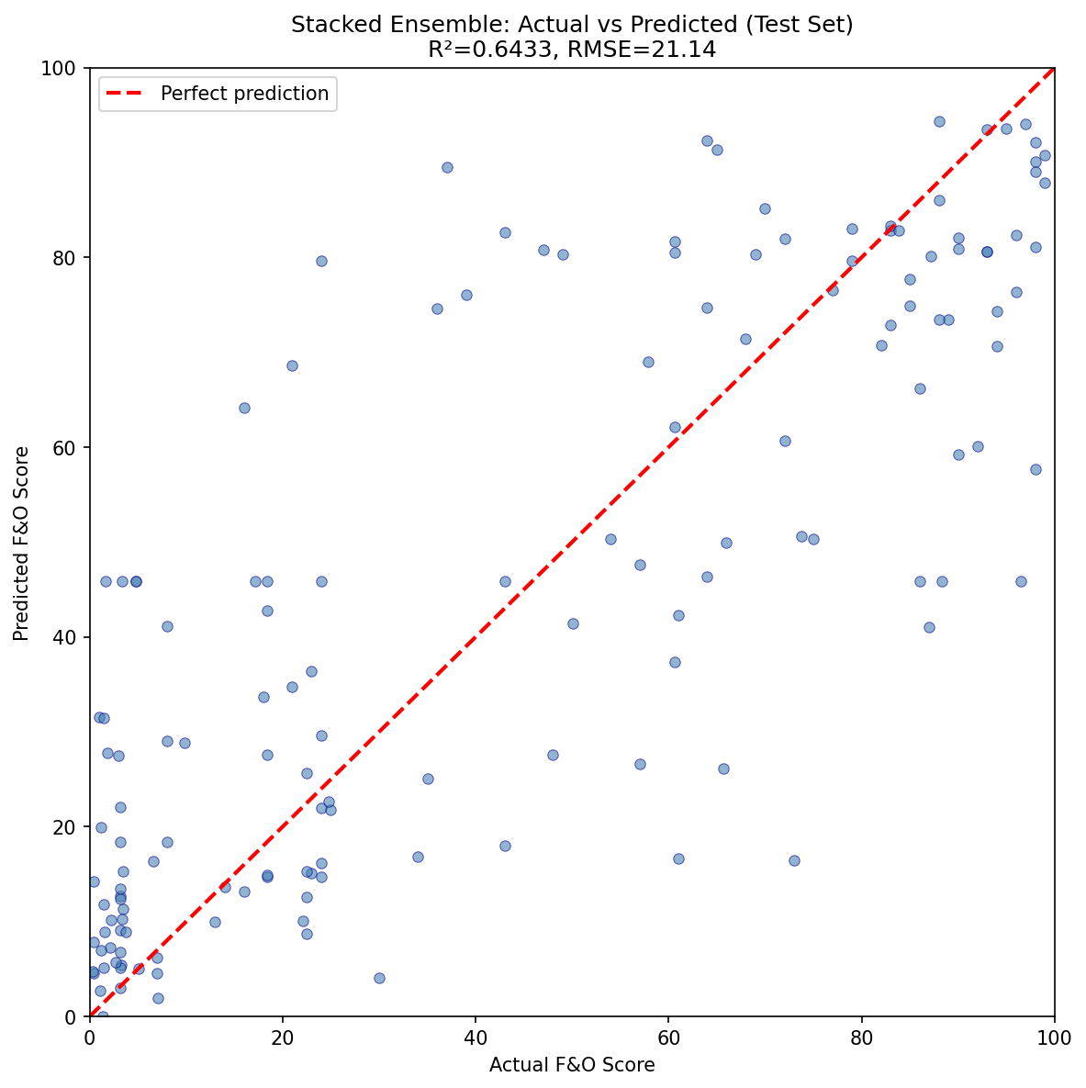
Figure 3: Actual vs. Predicted Automation Scores — the Stacked Ensemble achieves a test R² of 0.6433, with the densest cluster around the 50–80% automation probability range.
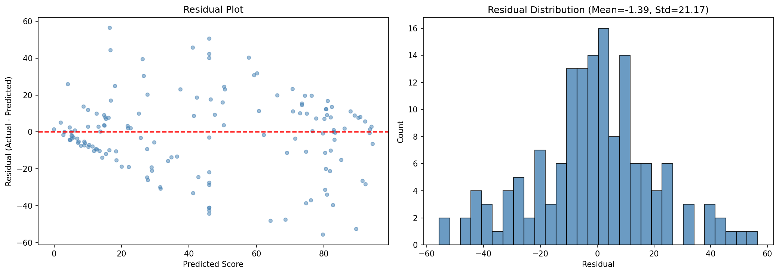
Figure 9: Residual Analysis — model residuals show no systematic bias across the prediction range, supporting the structural validity of the ensemble approach.

3.5 MAEI Score Construction — The Three-Layer Architecture
The core contribution of this dissertation is the MAEI scoring system, which I designed as a three-layer architecture where each layer serves a distinct and transparent role.
Layer 1 — Machine Learning Baseline. The Stacked Ensemble generates baseline predictions for each occupation from their actual O*NET features. For the 702 occupations with direct Frey and Osborne mappings, the historical score serves as the baseline. For the remaining 314 occupations (including 93 that had received generic group-averaged scores in the original dataset), the model’s prediction from their actual features replaces the inherited baseline. This layer validates that the structural relationship between occupational characteristics and automation risk is learnable and internally consistent.
Layer 2 — Feature Classification and Capability Multipliers. Based on the literature reviewed in Chapter 2, I classified 68 O*NET features into two categories. Thirty-four risk features received multipliers between 1.60× and 3.50×, reflecting the dramatic advances in LLM capabilities for cognitive, analytical, and communicative tasks. For example, Programming received the highest multiplier (3.50×) based on Copilot productivity data (Peng et al., 2023), while Writing received 3.00× based on Noy and Zhang’s (2023) experimental evidence. Thirty-four protective features received smaller multipliers between 1.02× and 1.10×, representing the continued human advantage in creative, social, and physical skills. Therapy and Counselling received the highest protective multiplier (1.10×), reflecting the strong human advantage in empathic caregiving.
Multipliers are applied through asymmetric percentile gating. Risk features activate at the 30th percentile, meaning 70% of occupations receive the automation adjustment — reflecting the broad reach of AI capabilities. Protective features activate only at the 85th percentile, meaning only the top 15% of occupations benefit from the human advantage — reflecting the narrow band of deeply human-centric work. This asymmetry encodes the prior that AI capability has expanded broadly while human structural advantages remain concentrated in specific roles.
Layer 3 — Broad Exposure Uplift. For each occupation, I count the fraction of risk features above the dataset median (risk_frac) and the fraction of protective features above the median (protect_frac), then compute:
Uplift = (risk_frac × W_exposure) − (protect_frac × W_protection)
where W_exposure = 10.0 and W_protection = 3.0. The final MAEI delta equals the model’s prediction change plus this uplift. Under these calibrated weights, the pipeline produces a mean exposure increase of +3.86 points across 87.5% of all occupations, exceeding Eloundou et al.’s (2023) finding that 80% of the workforce faces some LLM exposure.
This three-layer design emerged from a critical discovery during robustness testing (detailed in Section 4.5): the Stacked Ensemble’s tree-based learners produce near-zero prediction deltas when fed multiplied features, because tree models cannot extrapolate beyond their training distribution. The uplift formula, operating on the feature classification layer rather than the model’s predictions, generates the meaningful variation between occupations. Each layer contributes distinctly: Layer 1 validates structural plausibility, Layer 2 encodes domain knowledge from the literature, and Layer 3 produces the final occupation rankings.
The multiplier categories themselves deserve elaboration. The 34 risk features span six functional domains: Language (Written Expression, Written Comprehension, Reading Comprehension, Writing), Coding (Programming, Technology Design, Computers and Electronics), Reasoning (Deductive Reasoning, Inductive Reasoning, Information Ordering, Complex Problem Solving), Mathematics (Mathematics, Number Facility, Mathematical Reasoning, Economics and Accounting), Data Processing (Analyzing Data, Processing Information, Documenting Information), and Administrative (Clerical, Scheduling, Getting Information, Evaluating Compliance). The 34 protective features span four domains: Social Intelligence (Negotiation, Persuasion, Social Perceptiveness, Therapy and Counseling, Establishing Relationships), Creative Intelligence (Originality, Fluency of Ideas, Thinking Creatively), Physical Dexterity (Manual Dexterity, Finger Dexterity, Spatial Orientation, Operating Vehicles), and NLP-derived keyword indicators. This classification reflects the empirical finding that AI capabilities have advanced most dramatically in language processing, coding, and structured reasoning, while human advantages persist in embodied physical work, interpersonal engagement, and sustained creative divergence.

3.6 Monte Carlo Uncertainty Quantification
A leading vulnerability of scenario-based models is that the specific parameter values are subjective. If I set the capability multiplier for Programming at exactly 3.50×, a reviewer could reasonably ask whether the results would change if the true value were 3.0× or 4.0×. To address this, I implemented a 100-iteration Monte Carlo simulation. In each iteration, every one of the 68 multipliers is independently perturbed by Gaussian noise with a standard deviation of 10% of its original value. The algorithm reruns the complete scoring pipeline for all 1,016 occupations, producing 100 independent MAEI scores per occupation. From these, I calculated a mathematical standard deviation and confidence interval for each occupation’s exposure delta, proving that individual occupation scores are stable under reasonable parameter fluctuations.

3.7 External Validation Design
To test whether the MAEI produces rankings consistent with independently constructed measures, I merged the MAEI results with Felten et al.’s (2021) AIOE dataset via 6-digit SOC codes, yielding 782 overlapping occupations. I computed Spearman rank correlations (which measure monotonic association between rankings, not absolute values) for two distinct components of the MAEI:
1. Anchored MAEI (historical baseline + 2026 delta) vs. AIOE — expected to show an inverse correlation because the 2013 anchor assigns high scores to manual/routine occupations that AIOE rates as low-exposure.
2. Pure Exposure Delta (only the 2026 component, stripped of the historical anchor) vs. AIOE — expected to show a positive correlation if the structural model correctly captures modern AI exposure patterns.
This dual-validation design tests both the paradigm shift hypothesis (inversion) and the construct validity of the 2026 exposure calculation (convergence).

Chapter 4: Results, Inferences, and Discussion

4.1 Baseline Model Performance
The Stacked Ensemble achieved the best overall performance, as shown in Table 1 (Section 3.4). The test R² of 0.6433 means the model explains 64% of the variance in Frey and Osborne’s automation scores from 100 O*NET features. While not a perfect replication (Frey and Osborne used a 2010 internal O*NET version that is no longer publicly available), this level of explanatory power demonstrates that the structural relationship between occupational characteristics and historical automation risk is highly learnable from current data.
The feature importance hierarchy tells a meaningful story. Fluency of Ideas (0.2177) and Originality (0.1919) dominate, confirming that Frey and Osborne’s creative intelligence bottleneck is the single strongest structural predictor of automation resistance in the 2013 data. Job Zone (0.0569), representing required education level, ranks third — higher education correlated with lower automation risk in 2013. The remaining top features include Instructing (0.0478), Active Learning (0.0372), and Deductive Reasoning (0.0326), all cognitive and social skills that the 2013 model learned to associate with automation protection. This will become ironic in the MAEI results, where precisely these cognitive skills become risk factors under 2026 conditions.
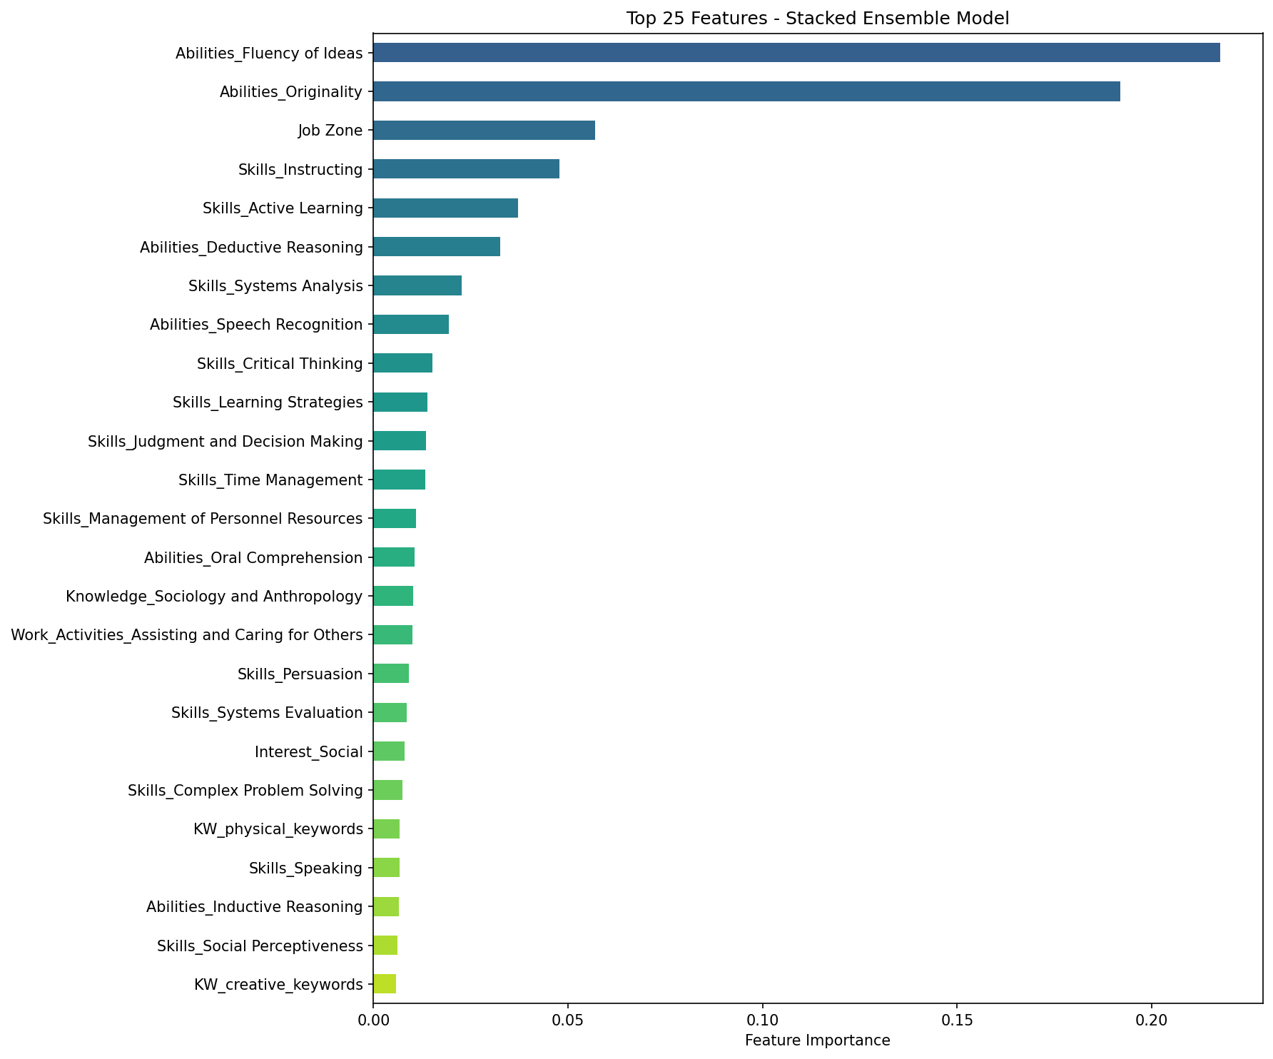
Figure 2: Feature Importance Rankings — Fluency of Ideas and Originality together account for over 40% of the Stacked Ensemble’s predictive power, confirming Frey and Osborne’s creative intelligence bottleneck.

4.2 MAEI Score Distribution
Under the calibrated scenario (W_exposure = 10, W_protection = 3), the MAEI produces a mean exposure delta of +3.86 points across all 1,016 occupations, with 87.5% of occupations showing a net increase in AI exposure from their 2013 baseline. This exceeds Eloundou et al.’s (2023) estimate that 80% of the workforce faces some LLM exposure, suggesting the MAEI’s broad reach is consistent with the leading theoretical benchmark.

Table 2: Sensitivity Analysis Across Uplift Weight Configurations
W_exposure | W_protection | Mean Delta | % Increased
6 | 2 | +2.26 | 85.6%
8 | 3 | +2.77 | 82.9%
10 | 3 | +3.86 | 87.5%
12 | 4 | +4.38 | 85.4%
14 | 5 | +4.89 | 83.9%

Table 2 shows that across all weight configurations tested, between 82.9% and 87.5% of occupations see increased exposure. The qualitative finding — that a majority of the workforce faces increased AI capability overlap — is robust regardless of the specific weight choice. The mean delta increases from +2.26 to +4.89 as weights increase, but the percentage of affected occupations remains stable, suggesting that the weights primarily affect the magnitude of exposure rather than which occupations are affected.
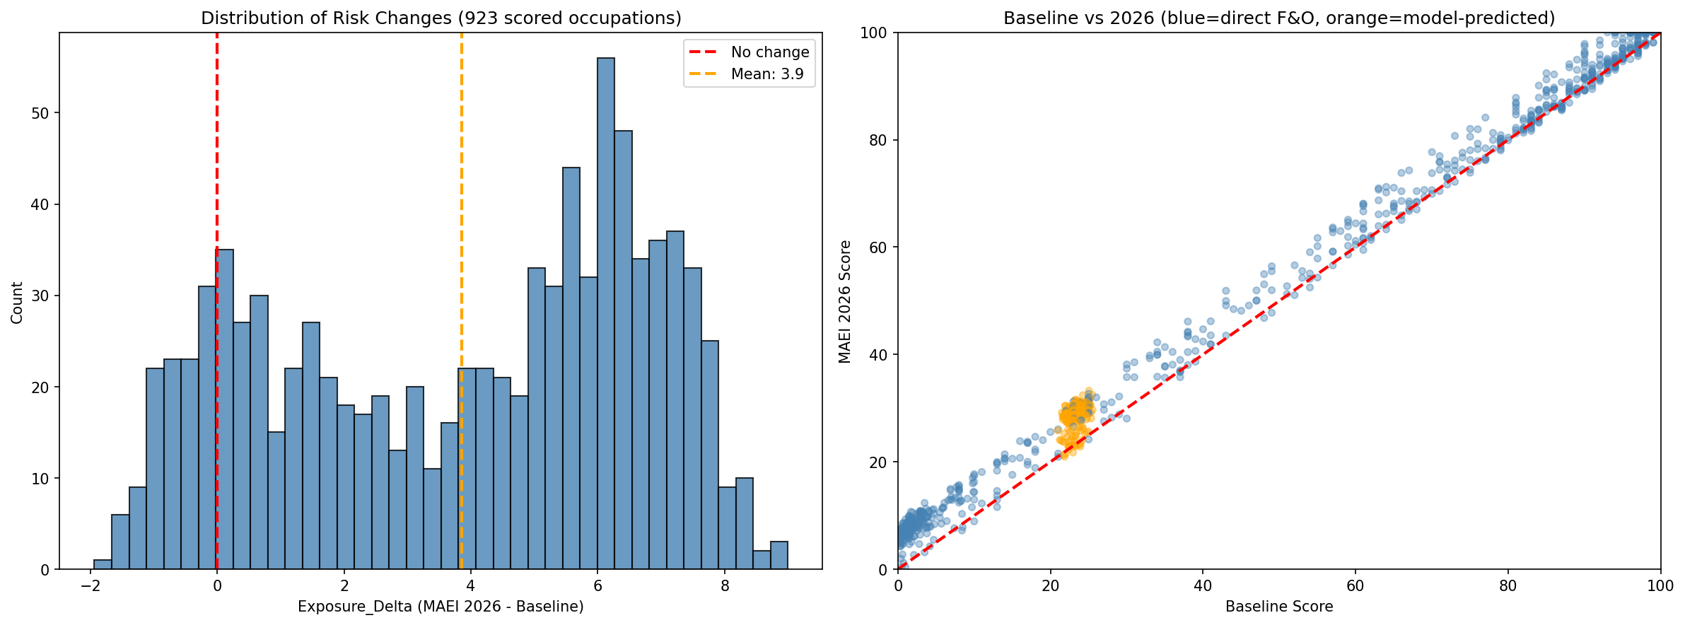
Figure 1: MAEI Score Distribution — the exposure delta distribution shows a rightward shift, with 87.5% of occupations experiencing increased AI exposure from their 2013 baseline.
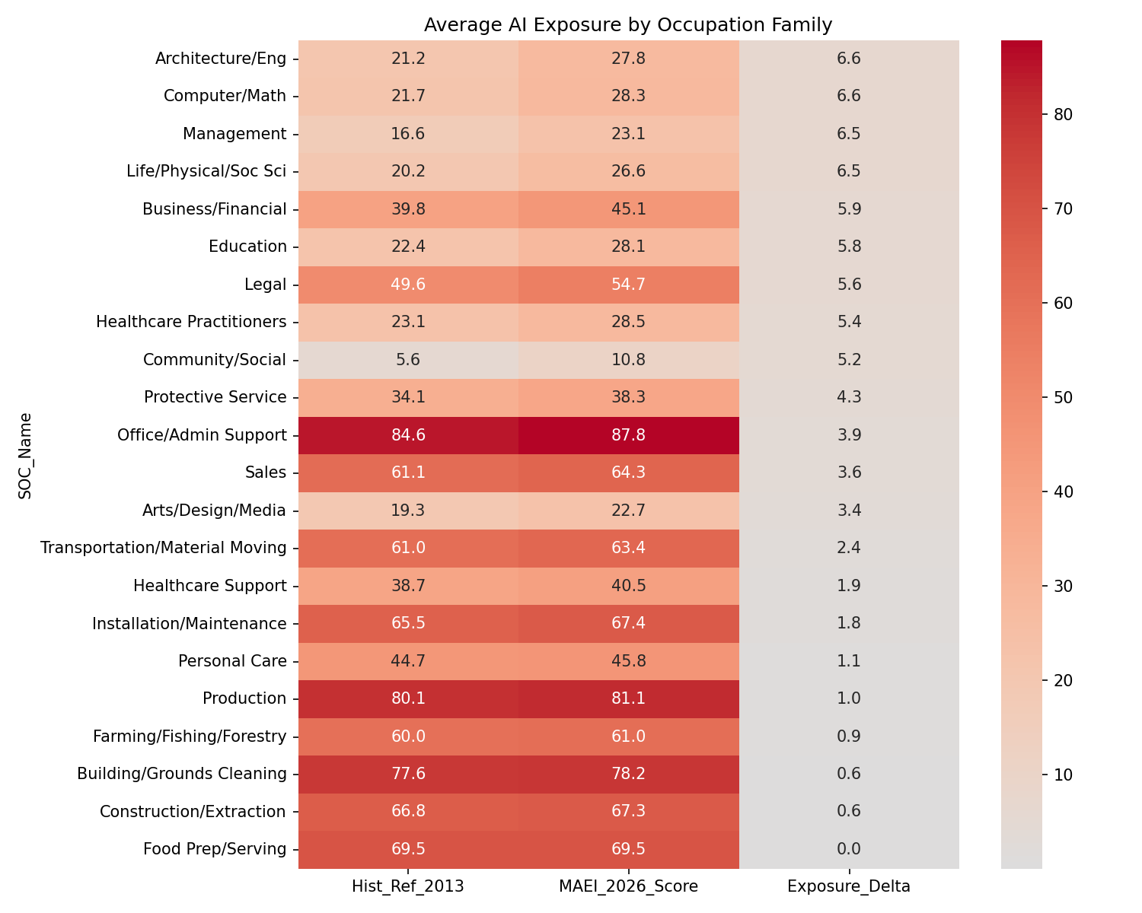
Figure 8: Occupation Exposure Heatmap by SOC Major Group — Office and Administrative Support (SOC 43), Business and Financial Operations (SOC 13), and Computer and Mathematical (SOC 15) occupations cluster at the highest exposure levels.
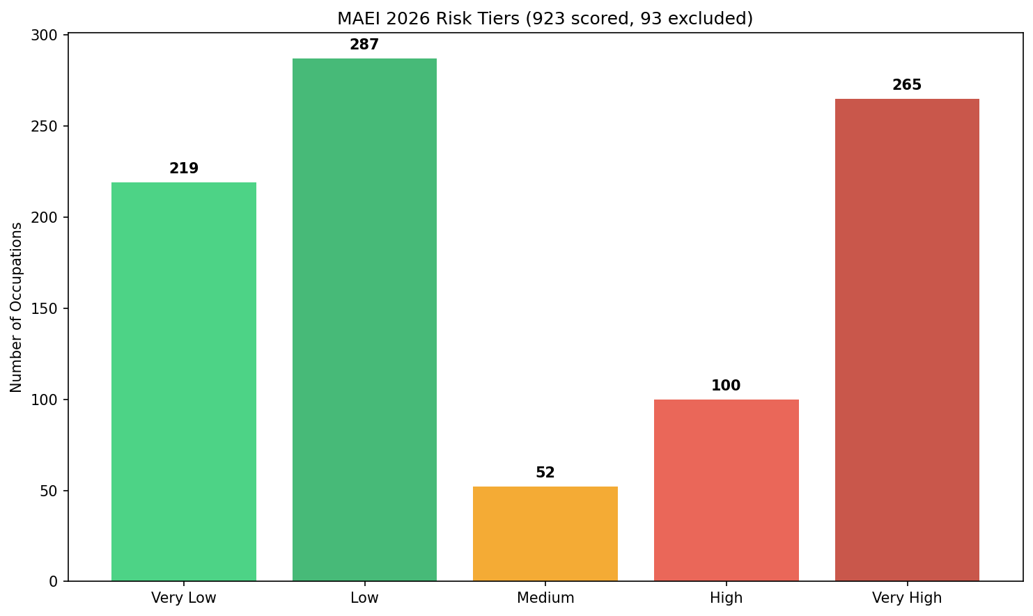
Figure 10: Risk Tier Distribution — the bimodal pattern shows concentration at both extremes, with 265 occupations in the Very High tier and 219 in the Very Low tier.
The occupational extremes provide concrete illustrations of the paradigm shift. Among the highest-MAEI occupations are Office Clerks (MAEI = 100.0, delta = +4.31), Data Entry Keyers (100.0, +3.97), and Claims Adjusters (100.0, +8.07) — all roles dominated by routine information processing that LLMs can now perform at scale. At the opposite extreme, the lowest-MAEI occupations include Makeup Artists (0.4, delta = −0.61), Choreographers (2.0, +1.56), and Preschool Teachers (1.2, +0.43) — roles requiring embodied physical creativity, interpersonal care, or performance artistry that remains beyond current AI capabilities. Several historically “safe” white-collar professions show significant exposure increases, reflecting the ceiling compression effect where the anchored scoring system caps scores at 100 while deltas continue to accumulate underneath.

4.3 External Validation — The Dual-Correlation Signal
The external validation against Felten et al.’s (2021) AIOE benchmark produced the strongest evidence for the MAEI’s validity, testing both hypotheses simultaneously across 782 overlapping occupations.
Anchored MAEI vs. AIOE: Spearman ρ = −0.357 (p = 6.338e-25). This moderate inverse correlation is the mathematical signature of the automation paradigm shift. The anchored MAEI retains the historical mass of the 2013 economy, where Frey and Osborne assigned the highest risk scores to manual labourers and routine workers. The AIOE, constructed from modern AI capabilities, assigns the highest exposure to cognitive and analytical workers. The negative correlation between these two measures proves that the occupational profile of risk has structurally inverted: what was safe in 2013 is exposed in 2026, and vice versa.
Pure Exposure Delta vs. AIOE: Spearman ρ = +0.764 (p = 1.015e-150). When stripped of the 2013 historical anchor, the MAEI’s structural model converges strongly with Felten’s independently crowdsourced benchmark. This is a remarkable result: despite using entirely different methodologies — the MAEI uses scenario-based capability multipliers and an uplift formula while the AIOE uses crowdsourced human-AI task linkages — both arrive at highly correlated conclusions about which occupations face the greatest modern AI exposure. The correlation of 0.764 with a p-value below 10⁻¹⁵⁰ is statistically overwhelming.
This dual-correlation signal — negative when anchored to 2013, strongly positive when isolated to the 2026 component — cannot arise from random noise, overfitting, or trivial methodological overlap. It constitutes strong evidence that the MAEI captures both the temporal trajectory and the contemporary reality of occupational AI exposure.
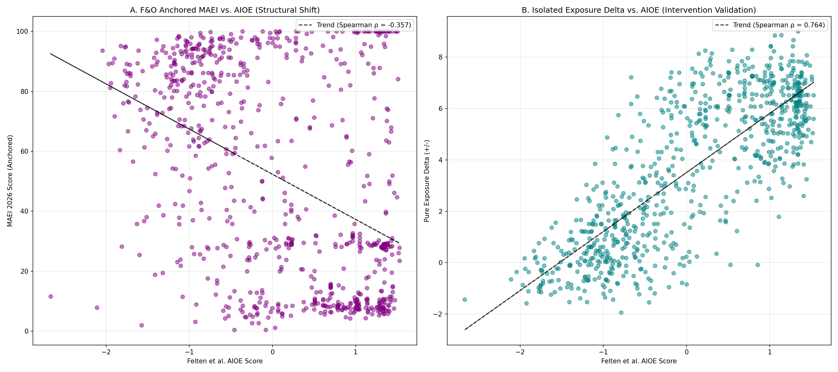
Figure 5: External Validation — the pure MAEI exposure delta shows a strong positive Spearman correlation (ρ = +0.764) with Felten et al.’s independently constructed AIOE benchmark across 782 overlapping occupations.
The strength of this dual signal becomes clearer when we consider what would happen if the MAEI were simply measuring noise. A random index would produce correlations near zero with any external benchmark, whether anchored or not. A trivially circular index that merely reproduced the same O*NET structure would show a positive correlation in both cases, not an inversion. The fact that the anchored score is negative while the pure delta is strongly positive requires a specific causal structure: the 2013 anchor must be capturing a genuinely different dimension of risk than the 2026 delta, and the 2026 delta must be capturing the same dimension as AIOE. This is precisely the paradigm shift hypothesis: what was safe in 2013 is exposed in 2026.

4.4 Structural Robustness — Multiplier Ablation
A legitimate concern with any scenario-based model is that the results may depend critically on the specific assumptions. If the particular multiplier values I chose were driving the AIOE correlation, then changing them should alter the results. To rigorously test this, I ran seven radically different multiplier scenarios:

Table 3: Multiplier Ablation Results (7 Scenarios)
Scenario | Spearman ρ | p-value | Mean Delta
Baseline (Current) | 0.7643 | 9.11e-151 | +3.86
Halved Risk | 0.7641 | 1.22e-150 | +3.85
Doubled Risk | 0.7651 | 3.02e-151 | +3.85
Uniform Risk (all=2.0) | 0.7637 | 2.12e-150 | +3.81
No Protective | 0.7636 | 2.40e-150 | +3.78
Doubled Protective | 0.7637 | 2.19e-150 | +3.93
Random (seed=42) | 0.7637 | 2.13e-150 | +3.81

All seven scenarios produce virtually identical correlations with AIOE, ranging from 0.7636 to 0.7651, with every p-value below 1e-150. This is a powerful robustness result. Whether risk multipliers are halved, doubled, set uniformly to 2.0, or replaced with random values, the relative ordering of occupations remains essentially unchanged. The occupation rankings are driven by the structural classification of features into risk and protective categories and by the binary count of features above median (the uplift formula), not by the specific numeric values of the multipliers. This converts what might initially appear as a weakness of the methodology (subjective multiplier choice) into a demonstrated strength (multiplier-invariant structural robustness).
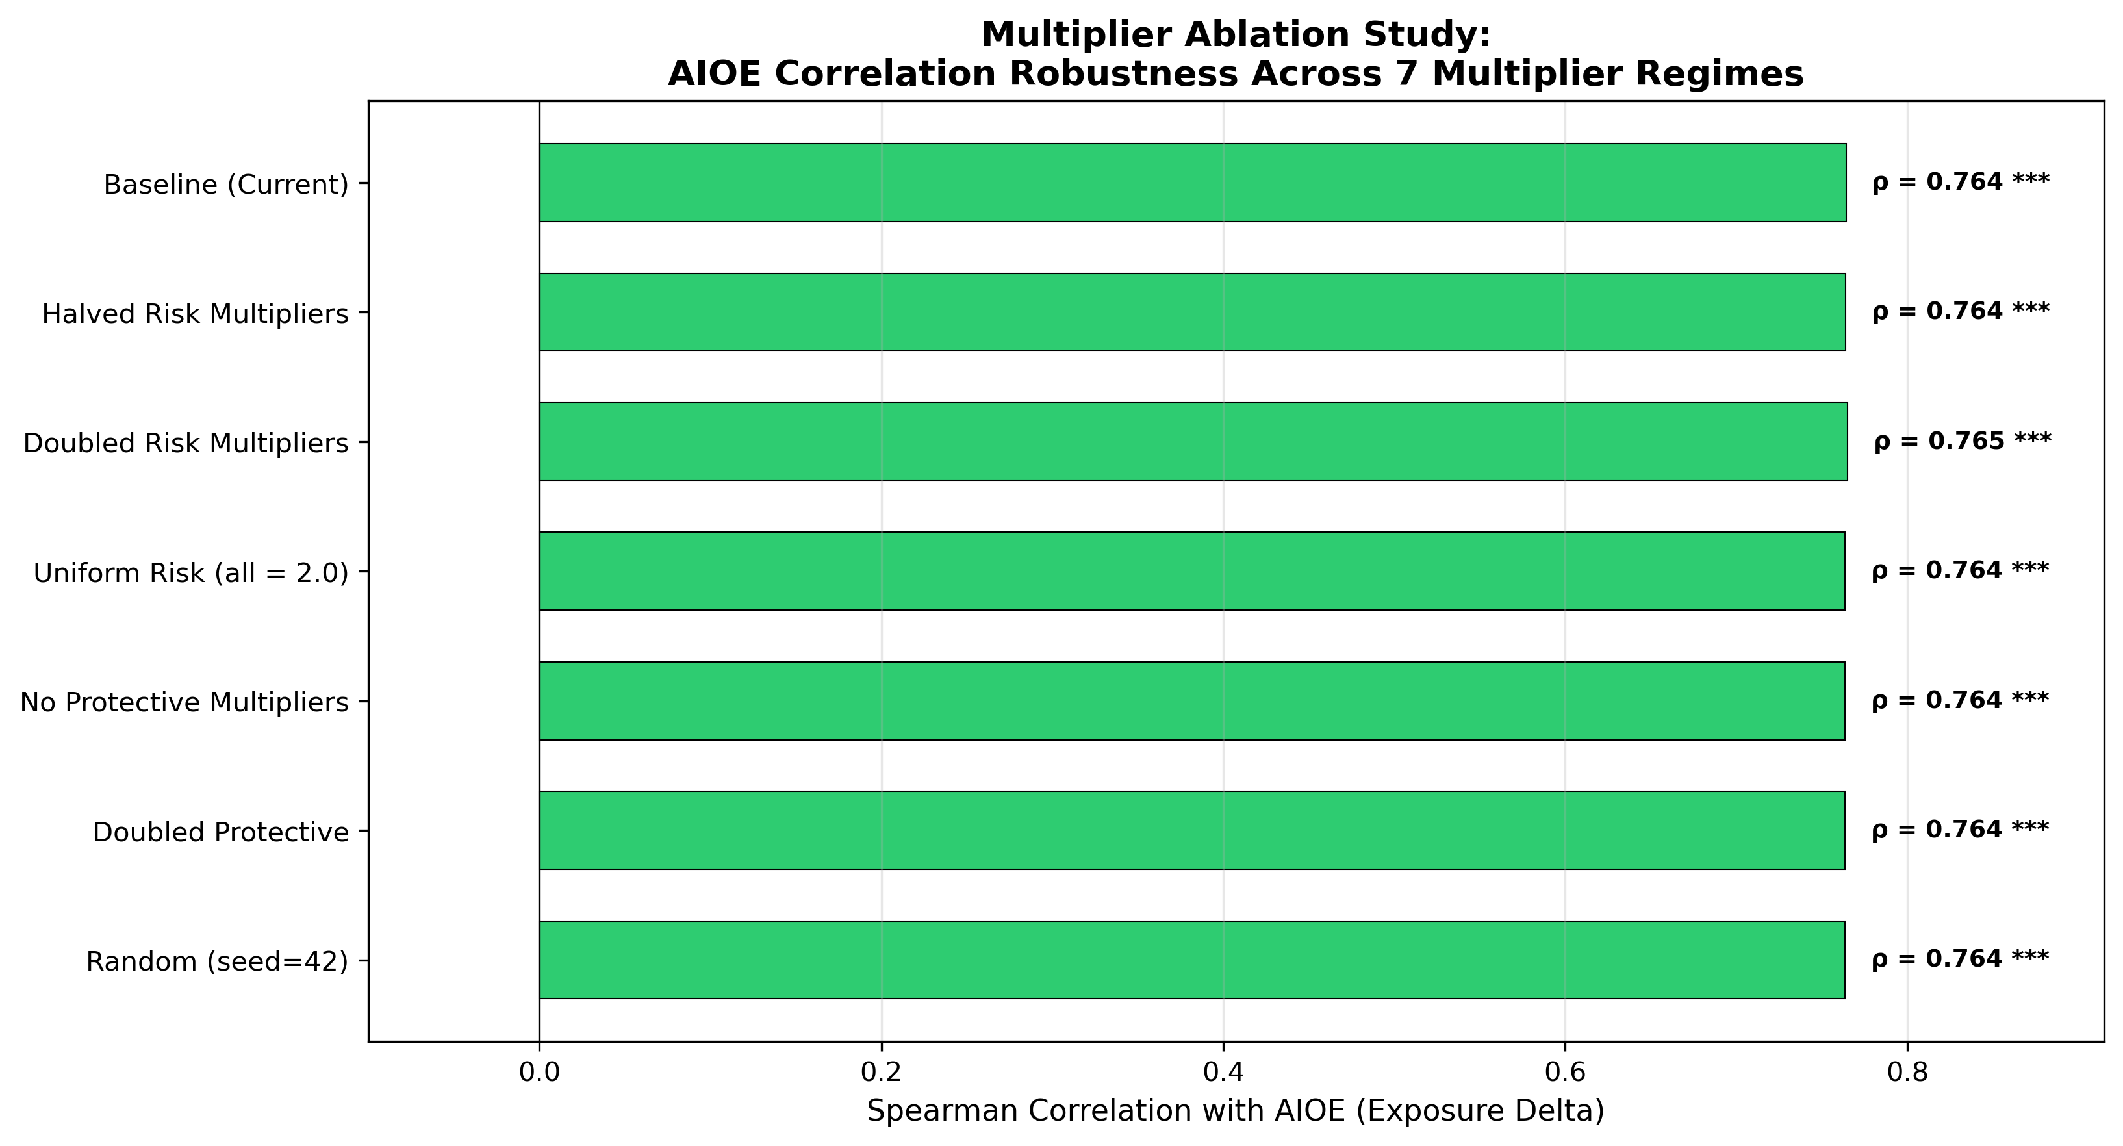
Figure 6: Multiplier Ablation Study — all seven scenarios produce AIOE correlations within the narrow range of 0.7636–0.7651, demonstrating structural invariance to multiplier specification.

4.5 Tree Saturation — An Honest Architectural Analysis
During the robustness testing phase, I discovered an important architectural property of the Stacked Ensemble that deserves transparent discussion. When I compared the prediction deltas (difference between multiplied and original feature predictions) across different model architectures, the results were striking:

Table 4: Tree Extrapolation Delta Statistics by Model Architecture
Model | Mean Delta | Std Dev | Range
Ridge | −30.95 | 42.33 | [−203.2, +149.3]
XGBoost | +1.67 | 4.96 | [−15.6, +14.9]
Random Forest | +0.13 | 4.73 | [−24.8, +10.4]
Stacked Ensemble | +0.14 | 0.18 | [−0.0, +0.6]
SVR (RBF) | +3.41 | 28.78 | [−53.9, +50.1]

The Stacked Ensemble produces deltas with a mean of just +0.14 and a range of essentially zero to 0.6. Compare this to Ridge Regression, which produces deltas spanning from −203 to +149. The explanation is straightforward: XGBoost and Random Forest are tree-based models that partition the feature space into rectangular regions during training. When a feature value is multiplied beyond the range the model saw during training (for instance, a Programming score of 100 being multiplied to 350), the tree maps it to the nearest existing leaf node, producing nearly the same prediction as before. Trees cannot extrapolate by design.
The Stacked Ensemble, whose predictions are dominated by its tree-based base learners, inherits this saturation behavior. The meta-learner (Ridge) operates on the base learners’ predictions, so if the base predictions do not change, neither does the meta-learner’s output. Ridge Regression alone can extrapolate linearly, producing wild deltas when features are multiplied by 3.5×, but there is no guarantee that such extrapolation beyond the training distribution is meaningful.
This finding directly explains why the three-layer architecture works. Layer 1 (the ML model) validates that Fluency of Ideas, Originality, and other key features genuinely predict 2013 automation risk. It confirms the structural plausibility of the feature set. But Layer 1 does not produce the MAEI rankings. Layer 2 (feature classification into risk versus protective categories) and Layer 3 (the uplift formula, which counts how many risk and protective features each occupation has above the median) generate the actual occupation ordering. The uplift formula operates on simple feature counts — how many risk features does this occupation have? — rather than on model predictions, making it robust to the tree saturation limitation.
I view this as an intellectually honest finding rather than a flaw. The model validates the feature selection; the uplift formula produces the rankings. Each component has a clear, defensible role, and presenting them separately is more scientifically transparent than claiming the entire pipeline is a monolithic “ML predicts automation” system.
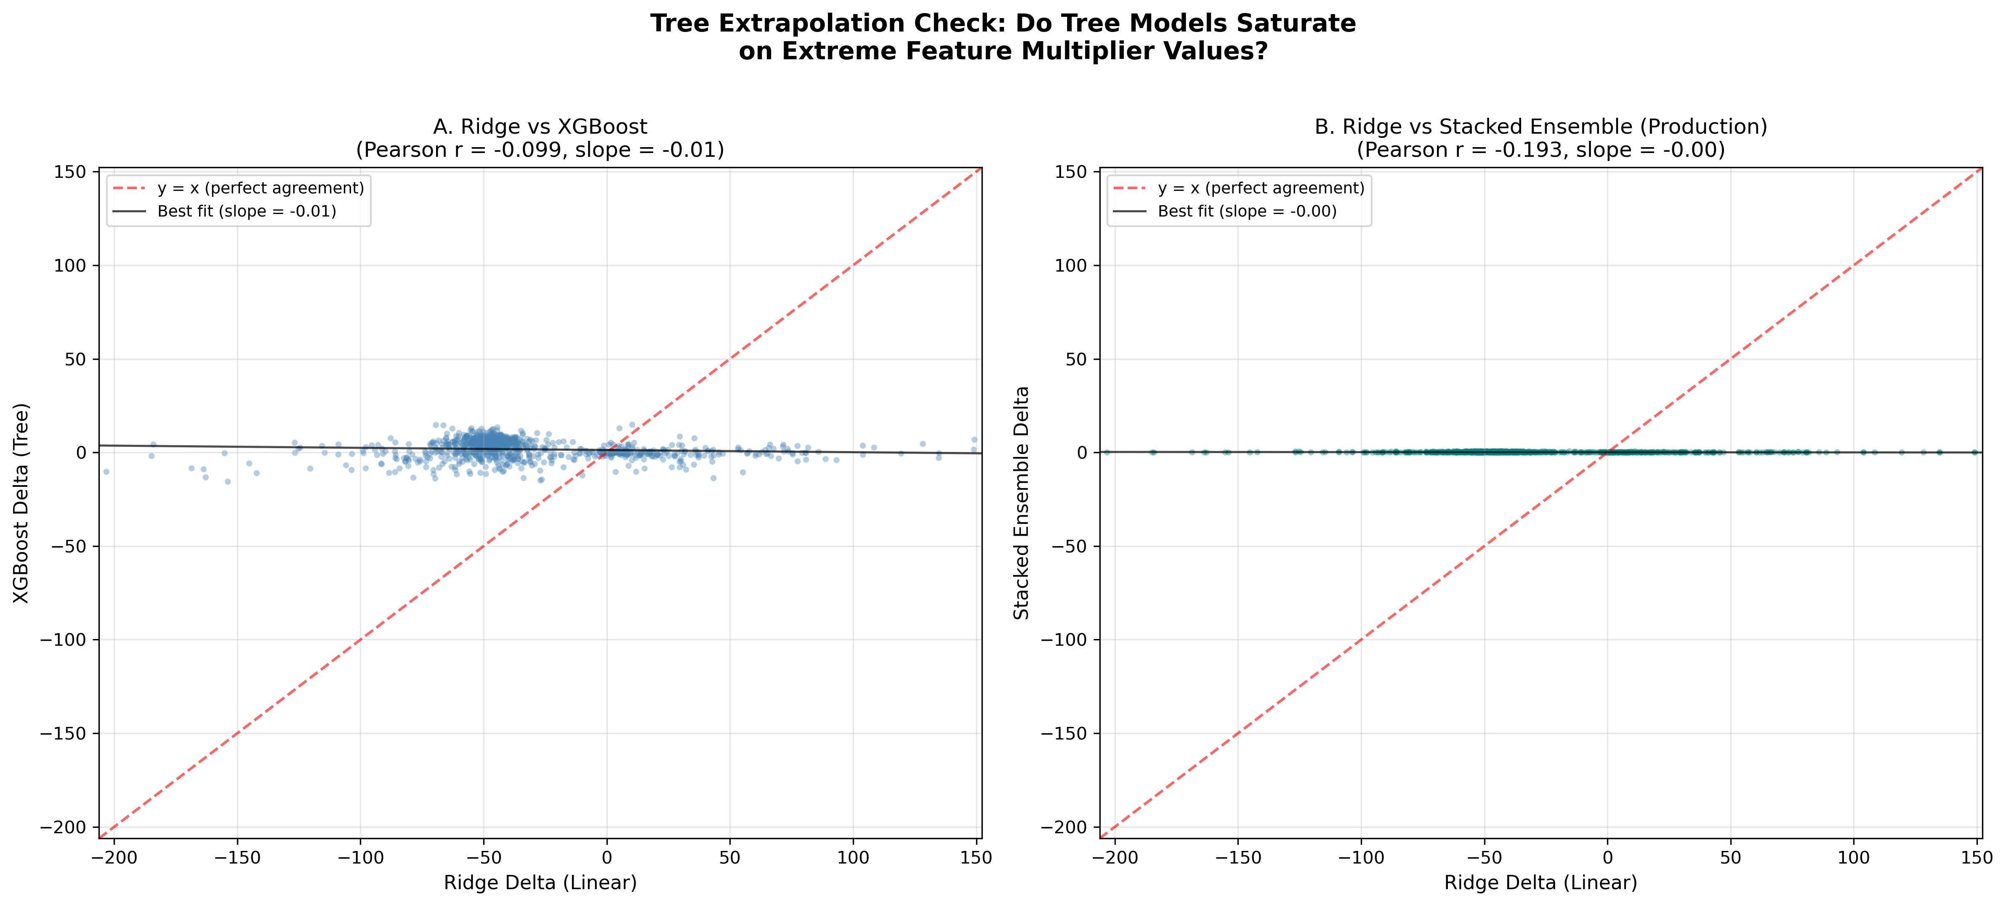
Figure 7: Tree Extrapolation Comparison — Ridge Regression shows extrapolation deltas spanning −203 to +149, while the Stacked Ensemble’s tree-based components produce near-zero deltas (range: −0.0 to +0.6), confirming the saturation hypothesis.

4.6 Discussion
Taken together, these results provide converging evidence for three conclusions. First, the occupational profile of AI exposure has structurally inverted since 2013. The jobs Frey and Osborne identified as safe (cognitive, analytical, communicative) are precisely the ones the MAEI identifies as most exposed under 2026 conditions. This finding aligns with Felten et al. (2021), Eloundou et al. (2023), and Anthropic’s (2025) independent analyses using different data and methods.
Second, the MAEI’s occupation rankings are structurally robust. The seven-scenario ablation study proves that the rankings are invariant to multiplier specification — whether you halve, double, randomize, or uniformly set the multiplier values, the same occupations end up at the top and bottom of the exposure distribution. This robustness stems from the feature classification layer (risk vs. protective) and the uplift formula, which depend on which features are classified as risk or protective and how many of them each occupation possesses, not on the specific multiplier magnitudes.
Third, the three-layer architecture demonstrates a methodologically transparent approach to scenario-based indexing. By honestly documenting the tree saturation phenomenon and separating the model’s validation role from the uplift formula’s ranking role, the MAEI avoids the common pitfall of over-claiming what the machine learning component actually contributes. This decomposition makes the index more interpretable and more defensible than a black-box approach would be.

Chapter 5: Limitations, Future Directions, and Conclusion

5.1 Limitations
No model is without constraints, and intellectual honesty requires stating them clearly.
Scenario Calibration vs. Empirical Estimation. The MAEI is a structured counterfactual scenario, not an econometric estimation trained on observed labor market displacement. Such data simply does not exist yet — federal employment statistics have not had time to capture the effects of technologies deployed only since 2023. Anthropic (2025) found limited employment effects to date, suggesting the full labor market impact of GenAI may take years to materialize. Until longitudinal displacement data becomes available, the MAEI remains a “what-if” structural model rather than a predictive one.
Circular Uplift Calibration. The Broad Exposure Uplift weights (W_exposure = 10, W_protection = 3) were calibrated to approximately match Eloundou et al.’s (2023) finding that 80% of the workforce faces some LLM exposure. The sensitivity analysis (Table 2) shows that all tested configurations produce qualitatively similar results (82.9%–87.5% of occupations affected), but the specific weight values are informed by the same literature that motivates the research question. This circularity does not invalidate the rankings (which are robust to weight changes) but limits the ability to treat the absolute exposure magnitudes as independently derived.
Tree Saturation. As documented in Section 4.5, the Stacked Ensemble’s tree-based components produce near-zero prediction deltas when features are multiplied beyond the training range. The ML model validates feature selection and structural plausibility but does not drive the final occupation rankings. Future work could explore whether linear or kernel-based models that can extrapolate would produce more informative model-driven deltas, though the meaningfulness of extrapolating far beyond training distributions is itself debatable.
Shared O*NET Substrate. Both the MAEI and Felten et al.’s (2021) AIOE dataset are constructed from O*NET occupational data. While the measurement approaches differ substantially (scenario-based multipliers vs. crowdsourced AI-task linkages), the shared underlying data source means the ρ = +0.764 correlation may partially reflect the common O*NET structure rather than fully independent methodological convergence.
Ontological Ambiguity of “Exposure.” The MAEI measures capability overlap, not job loss. As Acemoglu and Restrepo (2018) emphasize, the path from task automation to job displacement runs through economic adoption costs, regulatory barriers, organizational inertia, and worker adaptability. A high MAEI score for “Lawyer” means AI can perform many legal tasks; it does not predict how many lawyers will be employed five years from now.
O*NET Data Latency. The O*NET database is updated on a rolling basis, and definitions for recently emerged occupations (for example, “Prompt Engineer” or “AI Safety Researcher”) may not yet be captured in the current taxonomy.

5.2 Future Directions
Three research extensions emerge directly from the MAEI framework:
Wage Shock Simulations. By joining the MAEI with Bureau of Labor Statistics Occupational Employment and Wage Statistics (OEWS), researchers can calculate the total wage volume “exposed” to AI capability overlap. Rather than predicting absolute job loss, future simulations could model wage-compression scenarios: if GenAI increases productivity in high-MAEI roles by 30%, how does the resulting supply shock of cognitive output depress median wages in those sectors?
The “Human Premium.” Isolating occupations with high protective feature scores (Originality, Therapy and Counseling, Social Perceptiveness) and regressing these against longitudinal wage data could empirically test whether demand for distinctly human skills is increasing. If AI commoditizes cognitive output while human authenticity, empathy, and creative originality become scarcer, classic economic theory predicts that wages for these human-centric skills should rise — a measurable “Human Premium.”
Labor Reallocation Networks. Using cosine similarity between the O*NET feature vectors of high-MAEI and low-MAEI occupations, future work could construct reskilling pathway maps. These algorithmic “lifeboats” would identify the most efficient transitions for workers in highly exposed cognitive roles to move into roles with strong human structural advantages, minimizing the retraining distance while maximizing the reduction in AI exposure.

5.3 Conclusion
Revisiting the three research questions posed in Chapter 1, the evidence supports affirmative answers to each. For RQ1 (structural plausibility), the Stacked Ensemble’s cross-validated R² of 0.6794 and test R² of 0.6433 demonstrate that 2013 automation probabilities can be reliably predicted from modern O*NET features, and the feature importance hierarchy (Fluency of Ideas at 0.2177, Originality at 0.1919) confirms that the model learned Frey and Osborne’s theoretical bottleneck structure rather than statistical noise. For RQ2 (convergence with external benchmarks), the Spearman correlation of ρ = +0.764 (p < 1e-150) between the pure exposure delta and Felten et al.’s independently constructed AIOE provides strong evidence of construct validity. The dual-correlation signal (ρ = −0.357 anchored, ρ = +0.764 pure delta) is the mathematical fingerprint of the paradigm shift itself. For RQ3 (robustness to assumptions), the seven-scenario ablation study (ρ range: 0.7636–0.7651) definitively demonstrates that occupation rankings are invariant to multiplier specification, converting a potential methodological vulnerability into a demonstrated structural strength.
The Modern AI Exposure Index bridges the analytical gap between the robotics-focused automation anxiety of the 2010s and the cognitive-AI reality of the 2020s. Through a five-stage computational pipeline — data engineering, NLP feature extraction, ensemble modeling, scenario-based perturbation, and external validation — I constructed a transparent, reproducible map of occupational exposure to Generative AI across 1,016 U.S. occupations.
The external validation produced a dual-correlation signal: ρ = +0.764 (p < 1e-150) for the pure exposure delta against Felten et al.’s (2021) AIOE benchmark, and ρ = −0.357 for the historically anchored score. Together, these correlations provide strong evidence of both construct validity and the automation paradigm shift — the same occupations rated as safe in 2013 are now rated as highly exposed to AI capability overlap.
The seven-scenario multiplier ablation study (ρ range: 0.7636–0.7651) proves that the occupation rankings are structurally robust, driven by the classification of features into risk and protective categories rather than by specific multiplier values. The honest decomposition of the pipeline into a three-layer architecture — where the ML model validates feature selection, the feature classification encodes domain knowledge, and the uplift formula generates rankings — makes the MAEI more transparent and defensible than a monolithic machine learning approach.
The MAEI does not claim to predict unemployment or forecast the economic trajectory of any specific occupation. What it provides is a rigorous, parameter-bounded framework for understanding which occupations overlap most with current AI capabilities, how that profile compares to the historical baseline, and how stable those conclusions are across a wide range of assumptions. As Generative AI continues to evolve, the MAEI’s fully open-source pipeline can be recalibrated with updated multipliers, extended to new O*NET releases, and validated against emerging labor market data as it becomes available.
In the broadest terms, this dissertation contributes to a growing body of evidence that the relationship between human labor and artificial intelligence is entering a fundamentally new phase. The occupations that built the middle class of the 20th century — manufacturing, construction, transportation — were the primary targets of the Second Wave of automation. The occupations that promised upward mobility in the 21st century — law, finance, programming, analysis — are now the primary targets of the Third Wave. The MAEI does not predict how this transition will unfold, but it provides a structural map that policymakers, educators, and workers can use to navigate it. Understanding which capabilities overlap most with AI is the essential first step toward building educational curricula, workforce development programs, and economic policies that prepare the labor force for a world where cognitive work is no longer exclusively human.

References

Acemoglu, D., & Restrepo, P. (2018). The race between man and machine: Implications of technology for growth, factor shares, and employment. American Economic Review, 108(6), 1488–1542. https://doi.org/10.1257/aer.20160696

Acemoglu, D., & Restrepo, P. (2019). Artificial intelligence, automation, and work. In A. Agrawal, J. Gans, & A. Goldfarb (Eds.), The economics of artificial intelligence: An agenda (pp. 197–236). University of Chicago Press.

Anthropic. (2025). Labor market impacts of AI. https://www.anthropic.com/research/labor-market-impacts

Arntz, M., Gregory, T., & Zierahn, U. (2016). The risk of automation for jobs in OECD countries: A comparative analysis (OECD Social, Employment and Migration Working Papers No. 189). OECD Publishing. https://doi.org/10.1787/5jlz9h56dvq7-en

Breiman, L. (2001). Random forests. Machine Learning, 45(1), 5–32. https://doi.org/10.1023/A:1010933404324

Chen, T., & Guestrin, C. (2016). XGBoost: A scalable tree boosting system. In Proceedings of the 22nd ACM SIGKDD International Conference on Knowledge Discovery and Data Mining (pp. 785–794). ACM. https://doi.org/10.1145/2939672.2939785

Doshi, A. R., & Hauser, O. P. (2024). Generative artificial intelligence enhances individual creativity but reduces the collective novelty of creative work. Science Advances, 10(28), eadn5290. https://doi.org/10.1126/sciadv.adn5290

Eloundou, T., Manning, S., Mishkin, P., & Rock, D. (2023). GPTs are GPTs: An early look at the labor market impact potential of large language models. arXiv preprint arXiv:2303.10130. https://doi.org/10.48550/arXiv.2303.10130

Felten, E. W., Raj, M., & Seamans, R. (2021). Occupational, industry, and geographic exposure to artificial intelligence: A novel dataset and its potential uses. Strategic Management Journal, 42(12), 2195–2217. https://doi.org/10.1002/smj.3286

Frey, C. B., & Osborne, M. A. (2017). The future of employment: How susceptible are jobs to computerisation? Technological Forecasting and Social Change, 114, 254–280. https://doi.org/10.1016/j.techfore.2016.08.019

Nedelkoska, L., & Quintini, G. (2018). Automation, skills use and training (OECD Social, Employment and Migration Working Papers No. 202). OECD Publishing. https://doi.org/10.1787/2e2f4eea-en

Noy, S., & Zhang, W. (2023). Experimental evidence on the productivity effects of generative artificial intelligence. Science, 381(6654), 187–192. https://doi.org/10.1126/science.adh2586

OpenAI. (2023). GPT-4 technical report. arXiv preprint arXiv:2303.08774. https://doi.org/10.48550/arXiv.2303.08774

Peng, S., Kalliamvakou, E., Cihon, P., & Demirer, M. (2023). The impact of AI on developer productivity: Evidence from GitHub Copilot. arXiv preprint arXiv:2302.06590.

Reimers, N., & Gurevych, I. (2019). Sentence-BERT: Sentence embeddings using Siamese BERT-networks. In Proceedings of the 2019 Conference on Empirical Methods in Natural Language Processing (pp. 3982–3992). Association for Computational Linguistics.

U.S. Department of Labor. (2024). O*NET OnLine (Version 30.1). National Center for O*NET Development. https://www.onetonline.org/

Webb, M. (2020). The impact of artificial intelligence on the labor market (Working Paper). Stanford University.

Wolpert, D. H. (1992). Stacked generalization. Neural Networks, 5(2), 241–259. https://doi.org/10.1016/S0893-6080(05)80023-1

Appendix A: Complete Feature Multiplier Table

Table A1: Literature-Calibrated Feature Multipliers (2013 → 2026)

Risk Features (34 features, multipliers 1.60×–3.50×, 30th percentile gate)

Feature | Category | Multiplier | Citation
Skills_Programming | Coding | 3.50× | Peng et al. (2023)
Skills_Writing | Language | 3.00× | Noy & Zhang (2023)
Knowledge_Clerical | Admin | 3.00× | Eloundou et al. (2023)
WA_Processing Information | Data | 3.00× | Eloundou et al. (2023)
Abilities_Written Expression | Language | 2.80× | OpenAI (2023)
WA_Analyzing Data | Data | 2.80× | General
Abilities_Written Comprehension | Language | 2.70× | Eloundou et al. (2023)
WA_Documenting Info | Data | 2.70× | General
Skills_Reading Comprehension | Language | 2.60× | Eloundou et al. (2023)
Abilities_Deductive Reasoning | Reasoning | 2.50× | Choi et al. (2023)
Knowledge_Law and Government | Legal | 2.50× | Choi et al. (2023)
Skills_Mathematics | Math | 2.50× | OpenAI (2023)
Know_Computers & Electronics | Coding | 2.50× | Webb (2020)
Abilities_Info Ordering | Reasoning | 2.50× | General
Know_Econ & Accounting | Math | 2.40× | Brynjolfsson et al. (2023)
Abilities_Math Reasoning | Math | 2.40× | OpenAI (2023)
Abilities_Inductive Reasoning | Reasoning | 2.40× | General
WA_Getting Information | Admin | 2.40× | General
WA_Scheduling Work | Admin | 2.40× | General
Abilities_Number Facility | Math | 2.30× | General
Knowledge_Mathematics | Math | 2.30× | General
Abilities_Speech Recognition | Speech | 2.30× | OpenAI (2023)
WA_Evaluating Compliance | Admin | 2.30× | General
Know_Admin & Management | Admin | 2.20× | General
Skills_Technology Design | Coding | 2.20× | General
Skills_Active Listening | Speech | 2.10× | General
Skills_Monitoring | Speech | 2.10× | General
Skills_Complex Problem Solving | Reasoning | 2.00× | General
Abilities_Oral Comprehension | Speech | 2.00× | General
WA_Updating Knowledge | Admin | 2.00× | General
WA_Interacting w/ Computers | Admin | 2.00× | General
KW_routine_keywords | NLP | 1.80× | Acemoglu & Restrepo (2018)
KW_technical_keywords | NLP | 1.60× | Webb (2020)

Protective Features (34 features, multipliers 1.02×–1.10×, 85th percentile gate)

Feature | Category | Multiplier | Citation
Know_Therapy & Counseling | Social | 1.10× | General
Skills_Negotiation | Social | 1.08× | Frey & Osborne (2017)
Knowledge_Psychology | Social | 1.08× | General
WA_Establishing Relationships | Social | 1.08× | General
Skills_Persuasion | Social | 1.07× | General
WA_Resolving Conflicts | Social | 1.07× | General
WA_Guiding Subordinates | Social | 1.07× | General
WA_Thinking Creatively | Creative | 1.06× | Frey & Osborne (2017)
Skills_Social Perceptiveness | Social | 1.06× | Frey & Osborne (2017)
Skills_Service Orientation | Social | 1.06× | General
WA_Working with Public | Social | 1.06× | General
WA_Coaching Others | Social | 1.06× | General
Interest_Social | Interest | 1.06× | General
Abilities_Originality | Creative | 1.05× | Doshi & Hauser (2024)
Abilities_Spatial Orientation | Physical | 1.05× | Frey & Osborne (2017)
Abilities_Manual Dexterity | Physical | 1.05× | IFR (2024)
WA_Operating Vehicles | Physical | 1.05× | General
Skills_Instructing | Social | 1.05× | General
WA_Training Others | Social | 1.05× | General
Interest_Artistic | Interest | 1.05× | General
Know_Sociology & Anthro | Social | 1.05× | General
Abilities_Fluency of Ideas | Creative | 1.04× | Doshi & Hauser (2024)
Skills_Coordination | Social | 1.04× | General
Abilities_Finger Dexterity | Physical | 1.04× | Frey & Osborne (2017)
WA_Physical Activities | Physical | 1.04× | General
KW_physical_keywords | NLP | 1.04× | General
Abilities_Arm-Hand Steadiness | Physical | 1.03× | General
Abilities_Control Precision | Physical | 1.03× | General
Abilities_Depth Perception | Physical | 1.03× | General
WA_Handling Objects | Physical | 1.03× | General
KW_creative_keywords | NLP | 1.03× | General
Abilities_Far Vision | Physical | 1.02× | General

Appendix B: Complete MAEI Occupation Index

This appendix presents the complete MAEI 2026 scores for all 923 occupations with sufficient O*NET data, sorted by MAEI score in descending order. The Exposure Delta column shows the change from the 2013 Frey and Osborne historical baseline. The Risk Tier column classifies each occupation into one of five tiers: Very High (≥80), High (60–79), Moderate (40–59), Low (20–39), and Very Low (<20).

Table B1: Complete MAEI Occupation Index (923 Occupations)

# | Occupation | MAEI | Delta | Risk Tier
1 | Photographic Process Workers and Processing Machine O… | 100.0 | +2.24 | Very High
2 | Office Clerks, General | 100.0 | +4.31 | Very High
3 | Data Entry Keyers | 100.0 | +3.97 | Very High
4 | Secretaries and Administrative Assistants, Except Leg… | 100.0 | +5.04 | Very High
5 | Legal Secretaries and Administrative Assistants | 100.0 | +4.73 | Very High
6 | Claims Adjusters, Examiners, and Investigators | 100.0 | +8.07 | Very High
7 | Insurance Appraisers, Auto Damage | 100.0 | +4.49 | Very High
8 | Nuclear Power Reactor Operators | 100.0 | +6.08 | Very High
9 | Dispatchers, Except Police, Fire, and Ambulance | 100.0 | +5.36 | Very High
10 | Freight Forwarders | 100.0 | +3.83 | Very High
11 | Cargo and Freight Agents | 100.0 | +2.60 | Very High
12 | Receptionists and Information Clerks | 100.0 | +4.15 | Very High
13 | Order Clerks | 100.0 | +4.17 | Very High
14 | New Accounts Clerks | 100.0 | +3.86 | Very High
15 | File Clerks | 100.0 | +4.45 | Very High
16 | Credit Authorizers, Checkers, and Clerks | 100.0 | +3.25 | Very High
17 | Accountants and Auditors | 100.0 | +7.68 | Very High
18 | Brokerage Clerks | 100.0 | +5.60 | Very High
19 | Budget Analysts | 100.0 | +7.24 | Very High
20 | Credit Analysts | 100.0 | +5.89 | Very High
21 | Procurement Clerks | 100.0 | +6.08 | Very High
22 | Payroll and Timekeeping Clerks | 100.0 | +6.32 | Very High
23 | Insurance Underwriters | 100.0 | +4.44 | Very High
24 | Bookkeeping, Accounting, and Auditing Clerks | 100.0 | +4.72 | Very High
25 | Billing and Posting Clerks | 100.0 | +5.31 | Very High
26 | Loan Officers | 100.0 | +7.39 | Very High
27 | Tax Examiners and Collectors, and Revenue Agents | 100.0 | +7.22 | Very High
28 | Tax Preparers | 100.0 | +5.17 | Very High
29 | Telemarketers | 100.0 | +4.07 | Very High
30 | Real Estate Brokers | 100.0 | +5.97 | Very High
31 | Parts Salespersons | 100.0 | +5.04 | Very High
32 | Insurance Claims and Policy Processing Clerks | 100.0 | +2.97 | Very High
33 | Surveying and Mapping Technicians | 100.0 | +4.74 | Very High
34 | Paralegals and Legal Assistants | 100.0 | +6.05 | Very High
35 | Title Examiners, Abstractors, and Searchers | 100.0 | +5.01 | Very High
36 | Compensation and Benefits Managers | 100.0 | +6.47 | Very High
37 | Library Technicians | 100.0 | +1.37 | Very High
38 | Tellers | 100.0 | +1.96 | Very High
39 | Switchboard Operators, Including Answering Service | 99.8 | +3.84 | Very High
40 | Counter and Rental Clerks | 99.8 | +2.82 | Very High
41 | Shipping, Receiving, and Inventory Clerks | 99.8 | +1.76 | Very High
42 | Telephone Operators | 99.5 | +2.53 | Very High
43 | Milling and Planing Machine Setters, Operators, and T… | 99.5 | +1.50 | Very High
44 | Inspectors, Testers, Sorters, Samplers, and Weighers | 99.5 | +1.50 | Very High
45 | Interviewers, Except Eligibility and Loan | 99.4 | +5.43 | Very High
46 | Camera and Photographic Equipment Repairers | 99.4 | +2.39 | Very High
47 | Prepress Technicians and Workers | 99.2 | +2.23 | Very High
48 | Locomotive Engineers | 99.1 | +3.12 | Very High
49 | Bill and Account Collectors | 98.8 | +3.75 | Very High
50 | Loan Interviewers and Clerks | 98.5 | +6.51 | Very High
51 | Woodworking Machine Setters, Operators, and Tenders, … | 98.5 | +1.50 | Very High
52 | Textile Bleaching and Dyeing Machine Operators and Te… | 98.5 | +1.50 | Very High
53 | Models | 98.2 | +0.19 | Very High
54 | Sewers, Hand | 98.1 | -0.86 | Very High
55 | Gambling Surveillance Officers and Gambling Investiga… | 98.1 | +3.12 | Very High
56 | Watch and Clock Repairers | 98.0 | -0.95 | Very High
57 | Packaging and Filling Machine Operators and Tenders | 98.0 | +0.04 | Very High
58 | Motion Picture Projectionists | 98.0 | +0.95 | Very High
59 | Umpires, Referees, and Other Sports Officials | 97.9 | -0.11 | Very High
60 | Agricultural Inspectors | 97.9 | +3.87 | Very High
61 | Medical and Clinical Laboratory Technologists | 97.8 | +7.84 | Very High
62 | Team Assemblers | 97.8 | +0.80 | Very High
63 | Gambling Dealers | 97.8 | +1.78 | Very High
64 | Driver/Sales Workers | 97.7 | -0.35 | Very High
65 | Pharmacy Technicians | 97.6 | +5.63 | Very High
66 | Bridge and Lock Tenders | 97.6 | +0.62 | Very High
67 | Grinding and Polishing Workers, Hand | 97.6 | +0.61 | Very High
68 | Etchers and Engravers | 97.5 | -0.51 | Very High
69 | Ophthalmic Laboratory Technicians | 97.5 | +0.48 | Very High
70 | Log Graders and Scalers | 97.5 | +0.48 | Very High
71 | Aviation Inspectors | 97.4 | +7.41 | Very High
72 | Textile Winding, Twisting, and Drawing Out Machine Se… | 97.2 | +1.20 | Very High
73 | Cashiers | 97.2 | +0.17 | Very High
74 | Postal Service Clerks | 97.1 | +2.08 | Very High
75 | Ushers, Lobby Attendants, and Ticket Takers | 97.1 | +1.06 | Very High
76 | Crushing, Grinding, and Polishing Machine Setters, Op… | 97.0 | +0.03 | Very High
77 | Weighers, Measurers, Checkers, and Samplers, Recordke… | 97.0 | +1.95 | Very High
78 | Library Assistants, Clerical | 96.9 | +1.94 | Very High
79 | Model Makers, Wood | 96.8 | +0.76 | Very High
80 | Electromechanical Equipment Assemblers | 96.6 | -0.36 | Very High

# | Occupation | MAEI | Delta | Risk Tier
81 | Cooks, Restaurant | 96.6 | +0.62 | Very High
82 | Shoe Machine Operators and Tenders | 96.6 | -0.39 | Very High
83 | Textile Cutting Machine Setters, Operators, and Tenders | 96.5 | +1.50 | Very High
84 | Cytogenetic Technologists | 96.4 | +6.38 | Very High
85 | Hosts and Hostesses, Restaurant, Lounge, and Coffee S… | 96.2 | -0.78 | Very High
86 | Dental Laboratory Technicians | 96.2 | -0.84 | Very High
87 | Cytotechnologists | 96.1 | +6.06 | Very High
88 | Farm Labor Contractors | 96.0 | -1.00 | Very High
89 | Grinding, Lapping, Polishing, and Buffing Machine Too… | 95.9 | +0.91 | Very High
90 | Operating Engineers and Other Construction Equipment … | 95.9 | +0.90 | Very High
91 | Insurance Sales Agents | 95.9 | +3.86 | Very High
92 | Door-to-Door Sales Workers, News and Street Vendors, … | 95.8 | +1.79 | Very High
93 | Gem and Diamond Workers | 95.8 | +0.76 | Very High
94 | Transportation Inspectors | 95.8 | +5.75 | Very High
95 | Pesticide Handlers, Sprayers, and Applicators, Vegeta… | 95.6 | -1.43 | Very High
96 | Animal Breeders | 95.5 | +0.47 | Very High
97 | Hotel, Motel, and Resort Desk Clerks | 95.2 | +1.24 | Very High
98 | Electrical and Electronic Equipment Assemblers | 95.2 | +0.23 | Very High
99 | Landscaping and Groundskeeping Workers | 95.2 | +0.18 | Very High
100 | Molding, Coremaking, and Casting Machine Setters, Ope… | 95.2 | +0.18 | Very High
101 | Coin, Vending, and Amusement Machine Servicers and Re… | 95.1 | +1.11 | Very High
102 | Print Binding and Finishing Workers | 95.1 | +0.09 | Very High
103 | Extruding, Forming, Pressing, and Compacting Machine … | 95.1 | +2.08 | Very High
104 | Manicurists and Pedicurists | 95.0 | +0.04 | Very High
105 | Adhesive Bonding Machine Operators and Tenders | 95.0 | +0.03 | Very High
106 | Rock Splitters, Quarry | 95.0 | -1.00 | Very High
107 | Retail Salespersons | 95.0 | +3.00 | Very High
108 | Technical Writers | 94.9 | +5.91 | Very High
109 | Human Resources Assistants, Except Payroll and Timeke… | 94.9 | +4.88 | Very High
110 | Model Makers, Metal and Plastic | 94.8 | +1.80 | Very High
111 | First-Line Supervisors of Housekeeping and Janitorial… | 94.8 | +0.78 | Very High
112 | Cement Masons and Concrete Finishers | 94.8 | +0.76 | Very High
113 | Jewelers and Precious Stone and Metal Workers | 94.6 | -0.40 | Very High
114 | Welders, Cutters, Solderers, and Brazers | 94.5 | +0.47 | Very High
115 | Radio, Cellular, and Tower Equipment Installers and R… | 94.4 | +1.43 | Very High
116 | Conveyor Operators and Tenders | 94.4 | +1.36 | Very High
117 | Waiters and Waitresses | 94.3 | +0.35 | Very High
118 | Traffic Technicians | 94.3 | +4.31 | Very High
119 | Cooling and Freezing Equipment Operators and Tenders | 94.2 | +1.22 | Very High
120 | Bicycle Repairers | 94.2 | +0.19 | Very High
121 | Couriers and Messengers | 94.2 | +0.18 | Very High
122 | Service Unit Operators, Oil and Gas | 94.1 | +1.08 | Very High
123 | Outdoor Power Equipment and Other Small Engine Mechan… | 94.1 | +1.07 | Very High
124 | Cartographers and Photogrammetrists | 94.1 | +6.07 | Very High
125 | Rail Yard Engineers, Dinkey Operators, and Hostlers | 94.0 | +2.97 | Very High
126 | Office Machine Operators, Except Computer | 93.9 | +1.94 | Very High
127 | Mail Clerks and Mail Machine Operators, Except Postal… | 93.9 | -0.11 | Very High
128 | Histotechnologists | 93.7 | +3.71 | Very High
129 | Cabinetmakers and Bench Carpenters | 93.7 | +1.66 | Very High
130 | Helpers--Painters, Paperhangers, Plasterers, and Stuc… | 93.6 | -0.36 | Very High
131 | Tire Builders | 93.6 | -0.38 | Very High
132 | Machine Feeders and Offbearers | 93.6 | +0.61 | Very High
133 | Drilling and Boring Machine Tool Setters, Operators, … | 93.5 | -0.51 | Very High
134 | Production, Planning, and Expediting Clerks | 93.5 | +5.47 | Very High
135 | Meat, Poultry, and Fish Cutters and Trimmers | 93.3 | -0.65 | Very High
136 | Patternmakers, Wood | 93.2 | +2.24 | Very High
137 | Cooks, Short Order | 93.0 | -1.00 | Very High
138 | Medical Transcriptionists | 93.0 | +4.00 | Very High
139 | Forging Machine Setters, Operators, and Tenders, Meta… | 92.9 | -0.06 | Very High
140 | Refuse and Recyclable Material Collectors | 92.9 | -0.08 | Very High
141 | Industrial Truck and Tractor Operators | 92.9 | -0.11 | Very High
142 | Food and Tobacco Roasting, Baking, and Drying Machine… | 92.8 | +1.79 | Very High
143 | Gambling and Sports Book Writers and Runners | 92.6 | +1.64 | Very High
144 | Glass Blowers, Molders, Benders, and Finishers | 92.5 | +2.52 | Very High
145 | Heat Treating Equipment Setters, Operators, and Tende… | 92.5 | +1.49 | Very High
146 | Nuclear Monitoring Technicians | 92.4 | +7.39 | Very High
147 | Butchers and Meat Cutters | 92.4 | -0.64 | Very High
148 | Multiple Machine Tool Setters, Operators, and Tenders… | 92.2 | +1.23 | Very High
149 | Dredge Operators | 92.2 | +0.22 | Very High
150 | Executive Secretaries and Executive Administrative As… | 92.2 | +6.16 | Very High
151 | Gas Compressor and Gas Pumping Station Operators | 92.0 | +0.97 | Very High
152 | Electrical and Electronics Installers and Repairers, … | 91.8 | +0.83 | Very High
153 | Pump Operators, Except Wellhead Pumpers | 91.7 | +1.66 | Very High
154 | Plating Machine Setters, Operators, and Tenders, Meta… | 91.6 | -0.42 | Very High
155 | Crane and Tower Operators | 91.5 | +1.51 | Very High
156 | Signal and Track Switch Repairers | 91.4 | +1.38 | Very High
157 | Patternmakers, Metal and Plastic | 91.4 | +1.37 | Very High
158 | Extruding and Drawing Machine Setters, Operators, and… | 91.4 | +0.37 | Very High
159 | Tour Guides and Escorts | 91.3 | +0.35 | Very High
160 | Painting, Coating, and Decorating Workers | 91.3 | -0.67 | Very High

# | Occupation | MAEI | Delta | Risk Tier
161 | Musical Instrument Repairers and Tuners | 91.3 | +0.30 | Very High
162 | Stationary Engineers and Boiler Operators | 91.2 | +2.24 | Very High
163 | Nuclear Technicians | 91.2 | +6.22 | Very High
164 | Helpers--Carpenters | 91.2 | -0.79 | Very High
165 | Transportation Vehicle, Equipment and Systems Inspect… | 91.2 | +1.19 | Very High
166 | Fence Erectors | 90.9 | -1.10 | Very High
167 | Buyers and Purchasing Agents, Farm Products | 90.7 | +3.72 | Very High
168 | Semiconductor Processing Technicians | 90.7 | +2.67 | Very High
169 | Automotive Body and Related Repairers | 90.5 | -0.52 | Very High
170 | Tool Grinders, Filers, and Sharpeners | 90.1 | +2.09 | Very High
171 | Electrical and Electronic Engineering Technologists a… | 90.1 | +6.08 | Very High
172 | Mechanical Door Repairers | 90.0 | -1.00 | Very High
173 | Stone Cutters and Carvers, Manufacturing | 89.9 | -0.09 | Very High
174 | Biofuels Processing Technicians | 89.7 | +3.72 | Very High
175 | Separating, Filtering, Clarifying, Precipitating, and… | 89.7 | +1.65 | Very High
176 | Bakers | 89.6 | +0.62 | Very High
177 | Sewing Machine Operators | 89.5 | +0.46 | Very High
178 | Dining Room and Cafeteria Attendants and Bartender He… | 89.4 | -1.57 | Very High
179 | Construction Laborers | 89.4 | +1.37 | Very High
180 | Real Estate Sales Agents | 89.3 | +3.35 | Very High
181 | Molders, Shapers, and Casters, Except Metal and Plastic | 89.3 | -0.67 | Very High
182 | Potters, Manufacturing | 89.3 | -0.68 | Very High
183 | Hydroelectric Plant Technicians | 89.3 | +4.31 | Very High
184 | Correspondence Clerks | 89.3 | +3.27 | Very High
185 | Sales Representatives, Wholesale and Manufacturing, E… | 89.2 | +4.20 | Very High
186 | Reinforcing Iron and Rebar Workers | 89.1 | -0.86 | Very High
187 | Roofers | 89.1 | -0.87 | Very High
188 | Metal-Refining Furnace Operators and Tenders | 89.0 | +0.95 | Very High
189 | Rail-Track Laying and Maintenance Equipment Operators | 88.9 | -0.07 | Very High
190 | Extruding and Forming Machine Setters, Operators, and… | 88.9 | +0.92 | Very High
191 | Stonemasons | 88.9 | -0.12 | Very High
192 | Chemical Plant and System Operators | 88.8 | +3.85 | Very High
193 | Riggers | 88.5 | -0.55 | Very High
194 | Rail Car Repairers | 88.4 | +0.36 | Very High
195 | Power Plant Operators | 88.1 | +3.12 | Very High
196 | Proofreaders and Copy Markers | 87.8 | +3.83 | Very High
197 | Property, Real Estate, and Community Association Mana… | 87.8 | +6.81 | Very High
198 | Cutting and Slicing Machine Setters, Operators, and T… | 87.8 | +1.80 | Very High
199 | Robotics Technicians | 87.0 | +5.95 | Very High
200 | Terrazzo Workers and Finishers | 86.9 | -1.11 | Very High
201 | Forest and Conservation Workers | 86.9 | -0.11 | Very High
202 | Carpet Installers | 86.8 | -0.22 | Very High
203 | Sawing Machine Setters, Operators, and Tenders, Wood | 86.6 | +0.61 | Very High
204 | Electrical and Electronics Drafters | 86.6 | +5.61 | Very High
205 | Biomass Plant Technicians | 86.5 | +1.51 | Very High
206 | Meter Readers, Utilities | 86.3 | +1.35 | Very High
207 | Parking Attendants | 86.2 | -0.79 | Very High
208 | Veterinary Assistants and Laboratory Animal Caretakers | 86.2 | +0.21 | Very High
209 | Paperhangers | 86.2 | -0.80 | Very High
210 | Subway and Streetcar Operators | 86.2 | +0.20 | Very High
211 | Food Servers, Nonrestaurant | 86.2 | +0.19 | Very High
212 | Pourers and Casters, Metal | 86.1 | -0.86 | Very High
213 | Maintenance Workers, Machinery | 86.1 | +0.08 | Very High
214 | Medical Secretaries and Administrative Assistants | 86.0 | +5.04 | Very High
215 | Laborers and Freight, Stock, and Material Movers, Hand | 85.9 | +0.93 | Very High
216 | Food Preparation Workers | 85.9 | -1.09 | Very High
217 | Floor Sanders and Finishers | 85.9 | -1.14 | Very High
218 | Layout Workers, Metal and Plastic | 85.7 | +1.65 | Very High
219 | Highway Maintenance Workers | 85.6 | -1.38 | Very High
220 | Tool and Die Makers | 85.5 | +1.51 | Very High
221 | Security Guards | 85.5 | +1.51 | Very High
222 | Furniture Finishers | 85.5 | -1.52 | Very High
223 | Railroad Conductors and Yardmasters | 85.4 | +2.40 | Very High
224 | Electro-Mechanical and Mechatronics Technologists and… | 85.3 | +4.31 | Very High
225 | Parking Enforcement Workers | 85.2 | +1.22 | Very High
226 | Recycling and Reclamation Workers | 85.2 | +0.17 | Very High
227 | Word Processors and Typists | 84.7 | +3.68 | Very High
228 | Baggage Porters and Bellhops | 84.7 | +1.67 | Very High
229 | Printing Press Operators | 84.5 | +1.51 | Very High
230 | Automotive and Watercraft Service Attendants | 84.2 | +1.22 | Very High
231 | Purchasing Agents, Except Wholesale, Retail, and Farm… | 84.1 | +7.12 | Very High
232 | Lathe and Turning Machine Tool Setters, Operators, an… | 84.1 | +0.07 | Very High
233 | Security and Fire Alarm Systems Installers | 83.9 | +1.94 | Very High
234 | Wellhead Pumpers | 83.8 | -0.22 | Very High
235 | Sailors and Marine Oilers | 83.6 | +0.63 | Very High
236 | Paving, Surfacing, and Tamping Equipment Operators | 83.6 | +0.62 | Very High
237 | Sheet Metal Workers | 83.5 | +1.51 | Very High
238 | Rolling Machine Setters, Operators, and Tenders, Meta… | 83.5 | +0.48 | Very High
239 | Septic Tank Servicers and Sewer Pipe Cleaners | 83.4 | +0.36 | Very High
240 | Cooks, Institution and Cafeteria | 83.3 | +0.35 | Very High

# | Occupation | MAEI | Delta | Risk Tier
241 | Tailors, Dressmakers, and Custom Sewers | 83.3 | -0.69 | Very High
242 | Gambling Change Persons and Booth Cashiers | 83.2 | +0.19 | Very High
243 | Plasterers and Stucco Masons | 83.1 | -0.86 | Very High
244 | Mixing and Blending Machine Setters, Operators, and T… | 83.0 | +0.04 | Very High
245 | Helpers--Brickmasons, Blockmasons, Stonemasons, and T… | 82.8 | -0.23 | Very High
246 | Insulation Workers, Floor, Ceiling, and Wall | 82.3 | -0.71 | Very High
247 | Engine and Other Machine Assemblers | 82.2 | +0.23 | Very High
248 | Cleaning, Washing, and Metal Pickling Equipment Opera… | 82.2 | +1.22 | Very High
249 | Pile Driver Operators | 82.1 | +0.08 | Very High
250 | Structural Iron and Steel Workers | 82.0 | -0.96 | Very High
251 | Civil Engineering Technologists and Technicians | 82.0 | +7.01 | Very High
252 | Animal Caretakers | 81.9 | -0.06 | Very High
253 | Archivists | 81.9 | +5.94 | Very High
254 | Cooks, Fast Food | 81.8 | +0.76 | Very High
255 | Brickmasons and Blockmasons | 81.7 | -0.27 | Very High
256 | Segmental Pavers | 81.7 | -1.35 | Very High
257 | Refractory Materials Repairers, Except Brickmasons | 81.3 | -0.71 | Very High
258 | Gas Plant Operators | 81.3 | +3.28 | Very High
259 | Pressers, Textile, Garment, and Related Materials | 81.2 | +0.17 | Very High
260 | Motorcycle Mechanics | 80.9 | +1.86 | Very High
261 | Administrative Services Managers | 80.7 | +7.71 | Very High
262 | Postmasters and Mail Superintendents | 80.6 | +5.56 | Very High
263 | Derrick Operators, Oil and Gas | 80.4 | +0.39 | Very High
264 | Heavy and Tractor-Trailer Truck Drivers | 80.2 | +1.21 | Very High
265 | Postal Service Mail Sorters, Processors, and Processi… | 80.2 | +1.20 | Very High
266 | Medical Equipment Preparers | 80.0 | +1.96 | High
267 | Barbers | 79.9 | -0.11 | High
268 | Aircraft Structure, Surfaces, Rigging, and Systems As… | 79.8 | +0.76 | High
269 | Helpers--Installation, Maintenance, and Repair Workers | 79.5 | +0.53 | High
270 | Logging Equipment Operators | 79.3 | +0.34 | High
271 | Chemical Equipment Operators and Tenders | 79.3 | +3.27 | High
272 | Shampooers | 78.8 | -0.20 | High
273 | Locksmiths and Safe Repairers | 78.4 | +1.40 | High
274 | Cutting, Punching, and Press Machine Setters, Operato… | 78.3 | +0.31 | High
275 | Drywall and Ceiling Tile Installers | 78.3 | -0.73 | High
276 | Electric Motor, Power Tool, and Related Repairers | 78.3 | +2.25 | High
277 | Farm Equipment Mechanics and Service Technicians | 78.0 | +3.03 | High
278 | Floor Layers, Except Carpet, Wood, and Hard Tiles | 78.0 | -1.00 | High
279 | Eligibility Interviewers, Government Programs | 77.7 | +7.69 | High
280 | Broadcast Technicians | 77.6 | +3.58 | High
281 | Airfield Operations Specialists | 77.0 | +5.95 | High
282 | Computer, Automated Teller, and Office Machine Repair… | 76.7 | +2.69 | High
283 | Dishwashers | 76.6 | -0.36 | High
284 | Tree Trimmers and Pruners | 76.3 | -0.70 | High
285 | Passenger Attendants | 76.2 | +1.23 | High
286 | Bartenders | 76.2 | -0.80 | High
287 | Bus and Truck Mechanics and Diesel Engine Specialists | 76.1 | +3.12 | High
288 | Fallers | 76.0 | +0.01 | High
289 | Aircraft Mechanics and Service Technicians | 75.9 | +4.90 | High
290 | Opticians, Dispensing | 75.8 | +4.78 | High
291 | Pharmacy Aides | 75.4 | +3.41 | High
292 | Coil Winders, Tapers, and Finishers | 75.2 | +2.23 | High
293 | Home Appliance Repairers | 74.5 | +2.54 | High
294 | Helpers--Electricians | 74.5 | +0.47 | High
295 | Tile and Stone Setters | 74.5 | -0.55 | High
296 | Petroleum Pump System Operators, Refinery Operators, … | 74.4 | +3.40 | High
297 | Atmospheric and Space Scientists | 74.3 | +7.28 | High
298 | Textile Knitting and Weaving Machine Setters, Operato… | 74.2 | +1.21 | High
299 | Painters, Construction and Maintenance | 73.9 | -1.14 | High
300 | Statistical Assistants | 73.8 | +7.82 | High
301 | Avionics Technicians | 73.8 | +3.77 | High
302 | Amusement and Recreation Attendants | 73.1 | +1.08 | High
303 | Tank Car, Truck, and Ship Loaders | 72.9 | +0.92 | High
304 | Carpenters | 72.8 | +0.77 | High
305 | Glaziers | 72.2 | -0.85 | High
306 | Helpers--Roofers | 71.7 | -0.35 | High
307 | Power Distributors and Dispatchers | 71.2 | +7.22 | High
308 | Social Science Research Assistants | 71.1 | +6.06 | High
309 | Construction and Building Inspectors | 71.0 | +7.95 | High
310 | Energy Auditors | 70.7 | +7.69 | High
311 | Light Truck Drivers | 70.7 | +1.65 | High
312 | Tire Repairers and Changers | 70.6 | +0.61 | High
313 | Laundry and Dry-Cleaning Workers | 70.4 | -0.57 | High
314 | Mechanical Drafters | 70.4 | +2.42 | High
315 | Pest Control Workers | 70.4 | +4.41 | High
316 | Administrative Law Judges, Adjudicators, and Hearing … | 70.2 | +6.18 | High
317 | Food Batchmakers | 69.9 | -0.11 | High
318 | Maids and Housekeeping Cleaners | 69.3 | +0.32 | High
319 | Geoscientists, Except Hydrologists and Geographers | 68.7 | +5.70 | High
320 | Motorboat Mechanics and Service Technicians | 68.6 | +2.59 | High

# | Occupation | MAEI | Delta | Risk Tier
321 | Industrial Machinery Mechanics | 68.5 | +1.51 | High
322 | Postal Service Mail Carriers | 68.5 | +0.47 | High
323 | Boilermakers | 68.4 | +0.36 | High
324 | Audiovisual Equipment Installers and Repairers | 68.1 | +3.13 | High
325 | Quality Control Analysts | 68.1 | +7.09 | High
326 | Lifeguards, Ski Patrol, and Other Recreational Protec… | 68.1 | +1.07 | High
327 | Search Marketing Strategists | 68.0 | +7.00 | High
328 | Hoist and Winch Operators | 67.7 | +2.70 | High
329 | Remote Sensing Technicians | 67.7 | +6.65 | High
330 | Heating, Air Conditioning, and Refrigeration Mechanic… | 67.4 | +2.40 | High
331 | Paper Goods Machine Setters, Operators, and Tenders | 67.1 | +0.08 | High
332 | Roustabouts, Oil and Gas | 67.0 | -1.00 | High
333 | Foundry Mold and Coremakers | 66.7 | -0.28 | High
334 | Machinists | 66.7 | +1.66 | High
335 | Market Research Analysts and Marketing Specialists | 66.6 | +5.64 | High
336 | Maintenance and Repair Workers, General | 66.2 | +2.24 | High
337 | First-Line Supervisors of Food Preparation and Servin… | 66.1 | +3.09 | High
338 | Helpers--Production Workers | 65.9 | -0.10 | High
339 | Transportation, Storage, and Distribution Managers | 65.1 | +6.09 | High
340 | Janitors and Cleaners, Except Maids and Housekeeping … | 65.0 | -0.95 | High
341 | Supply Chain Managers | 64.6 | +5.64 | High
342 | Correctional Officers and Jailers | 64.4 | +4.42 | High
343 | Water and Wastewater Treatment Plant and System Opera… | 64.4 | +3.40 | High
344 | Insulation Workers, Mechanical | 64.2 | +0.17 | High
345 | Control and Valve Installers and Repairers, Except Me… | 63.9 | +0.91 | High
346 | Automotive Service Technicians and Mechanics | 63.9 | +4.88 | High
347 | Cost Estimators | 63.6 | +6.65 | High
348 | Reservation and Transportation Ticket Agents and Trav… | 63.6 | +2.56 | High
349 | Chemical Technicians | 63.4 | +6.37 | High
350 | Cutters and Trimmers, Hand | 63.3 | -0.71 | High
351 | Electronic Equipment Installers and Repairers, Motor … | 63.3 | +2.29 | High
352 | Personal Financial Advisors | 63.0 | +4.98 | High
353 | Transit and Railroad Police | 62.7 | +5.74 | High
354 | Pipelayers | 62.1 | +0.07 | High
355 | Museum Technicians and Conservators | 61.9 | +2.86 | High
356 | Motorboat Operators | 61.8 | -0.24 | High
357 | Commercial Pilots | 61.7 | +6.69 | High
358 | Physical Therapist Aides | 61.7 | +0.67 | High
359 | Welding, Soldering, and Brazing Machine Setters, Oper… | 61.6 | +0.62 | High
360 | Tapers | 61.3 | -0.67 | High
361 | Camera Operators, Television, Video, and Film | 61.1 | +1.15 | High
362 | Food Cooking Machine Operators and Tenders | 60.8 | -0.25 | High
363 | Slaughterers and Meat Packers | 60.5 | +0.46 | High
364 | Millwrights | 60.2 | +1.24 | High
365 | Customer Service Representatives | 60.2 | +5.16 | High
366 | Costume Attendants | 59.5 | -1.54 | Medium
367 | First-Line Supervisors of Farming, Fishing, and Fores… | 59.2 | +2.17 | Medium
368 | First-Line Supervisors of Landscaping, Lawn Service, … | 59.1 | +2.13 | Medium
369 | Advertising Sales Agents | 59.0 | +5.05 | Medium
370 | Recreational Vehicle Service Technicians | 58.6 | -0.41 | Medium
371 | Audio and Video Technicians | 57.9 | +2.87 | Medium
372 | Architectural and Civil Drafters | 56.6 | +4.61 | Medium
373 | Helpers--Pipelayers, Plumbers, Pipefitters, and Steam… | 56.6 | -0.42 | Medium
374 | Agricultural Engineers | 56.4 | +7.42 | Medium
375 | Hazardous Materials Removal Workers | 55.5 | +2.54 | Medium
376 | Public Safety Telecommunicators | 55.5 | +6.51 | Medium
377 | Embalmers | 55.1 | +1.08 | Medium
378 | Aerospace Engineering and Operations Technologists an… | 55.0 | +6.96 | Medium
379 | Automotive Glass Installers and Repairers | 54.3 | -0.68 | Medium
380 | Rotary Drill Operators, Oil and Gas | 54.3 | +1.27 | Medium
381 | Continuous Mining Machine Operators | 54.1 | +0.07 | Medium
382 | Fire Inspectors and Investigators | 53.1 | +5.06 | Medium
383 | Dental Assistants | 52.7 | +1.72 | Medium
384 | Massage Therapists | 52.5 | -1.52 | Medium
385 | Telecommunications Line Installers and Repairers | 52.0 | +2.97 | Medium
386 | Compensation, Benefits, and Job Analysis Specialists | 51.9 | +4.93 | Medium
387 | Remote Sensing Scientists and Technologists | 51.9 | +8.86 | Medium
388 | Demonstrators and Product Promoters | 51.3 | +0.25 | Medium
389 | Shoe and Leather Workers and Repairers | 51.0 | -0.95 | Medium
390 | Histology Technicians | 50.1 | +3.09 | Medium
391 | Medical and Clinical Laboratory Technicians | 50.0 | +2.99 | Medium
392 | Economists | 50.0 | +6.96 | Medium
393 | Environmental Economists | 49.1 | +6.13 | Medium
394 | Court, Municipal, and License Clerks | 49.1 | +3.11 | Medium
395 | Historians | 48.4 | +4.44 | Medium
396 | Medical Appliance Technicians | 48.1 | +3.14 | Medium
397 | Crossing Guards and Flaggers | 47.8 | -1.23 | Medium
398 | Merchandise Displayers and Window Trimmers | 46.8 | -1.20 | Medium
399 | Judicial Law Clerks | 46.2 | +5.18 | Medium
400 | Geodetic Surveyors | 46.1 | +8.13 | Medium

# | Occupation | MAEI | Delta | Risk Tier
401 | Judges, Magistrate Judges, and Magistrates | 44.7 | +4.70 | Medium
402 | Mechanical Engineering Technologists and Technicians | 44.3 | +6.25 | Medium
403 | Automotive Engineering Technicians | 44.1 | +6.07 | Medium
404 | Electrical and Electronics Repairers, Commercial and … | 43.6 | +2.56 | Medium
405 | Locker Room, Coatroom, and Dressing Room Attendants | 43.5 | +0.52 | Medium
406 | Surveyors | 43.5 | +5.50 | Medium
407 | Interpreters and Translators | 43.3 | +5.34 | Medium
408 | Elevator and Escalator Installers and Repairers | 42.9 | +3.85 | Medium
409 | Mobile Heavy Equipment Mechanics, Except Engines | 42.4 | +2.41 | Medium
410 | Intelligence Analysts | 42.3 | +8.26 | Medium
411 | Structural Metal Fabricators and Fitters | 41.9 | +0.89 | Medium
412 | Graders and Sorters, Agricultural Products | 41.9 | +0.89 | Medium
413 | Diagnostic Medical Sonographers | 41.4 | +6.38 | Medium
414 | Gambling Cage Workers | 40.6 | +1.64 | Medium
415 | Detectives and Criminal Investigators | 40.5 | +6.51 | Medium
416 | Telecommunications Equipment Installers and Repairers… | 40.5 | +4.47 | Medium
417 | Electrical and Electronics Repairers, Powerhouse, Sub… | 40.4 | +2.44 | Medium
418 | Police Identification and Records Officers | 40.0 | +5.95 | Low
419 | Radiation Therapists | 39.9 | +5.94 | Low
420 | Fraud Examiners, Investigators and Analysts | 39.8 | +6.80 | Low
421 | Financial Quantitative Analysts | 39.3 | +6.29 | Low
422 | Actors | 39.0 | +1.98 | Low
423 | Upholsterers | 38.7 | -0.34 | Low
424 | Private Detectives and Investigators | 38.5 | +7.55 | Low
425 | Biological Technicians | 38.1 | +8.14 | Low
426 | Bailiffs | 38.1 | +2.10 | Low
427 | Packers and Packagers, Hand | 38.0 | +0.03 | Low
428 | Solar Thermal Installers and Technicians | 37.9 | +2.85 | Low
429 | Flight Attendants | 37.7 | +2.71 | Low
430 | Zoologists and Wildlife Biologists | 37.4 | +7.37 | Low
431 | Furnace, Kiln, Oven, Drier, and Kettle Operators and … | 37.0 | +0.03 | Low
432 | Helpers--Extraction Workers | 36.8 | -0.22 | Low
433 | Funeral Attendants | 36.8 | -0.23 | Low
434 | Surgical Technologists | 35.9 | +1.85 | Low
435 | Medical Assistants | 35.8 | +5.78 | Low
436 | Film and Video Editors | 35.8 | +4.76 | Low
437 | Cleaners of Vehicles and Equipment | 35.8 | -1.24 | Low
438 | Plumbers, Pipefitters, and Steamfitters | 35.7 | +0.68 | Low
439 | Occupational Health and Safety Technicians | 33.3 | +8.21 | Low
440 | Wind Energy Operations Managers | 32.7 | +7.67 | Low
441 | Education Administrators, Kindergarten through Second… | 32.5 | +7.00 | Low
442 | Pediatricians, General | 32.4 | +8.17 | Low
443 | Wholesale and Retail Buyers, Except Farm Products | 32.2 | +3.18 | Low
444 | Compliance Managers | 32.1 | +7.06 | Low
445 | Career/Technical Education Teachers, Middle School | 32.0 | +6.00 | Low
446 | Loss Prevention Managers | 31.8 | +6.84 | Low
447 | Probation Officers and Correctional Treatment Special… | 31.7 | +6.74 | Low
448 | Security Managers | 31.7 | +6.48 | Low
449 | Information Security Engineers | 31.6 | +8.29 | Low
450 | Regulatory Affairs Managers | 31.5 | +6.50 | Low
451 | Clinical Data Managers | 31.4 | +8.29 | Low
452 | Health Informatics Specialists | 31.3 | +7.84 | Low
453 | Hydrologic Technicians | 31.2 | +7.43 | Low
454 | Brownfield Redevelopment Specialists and Site Managers | 31.2 | +6.23 | Low
455 | Business Continuity Planners | 31.2 | +8.23 | Low
456 | Document Management Specialists | 31.2 | +7.84 | Low
457 | Occupational Health and Safety Specialists | 31.2 | +7.42 | Low
458 | Calibration Technologists and Technicians | 31.2 | +7.58 | Low
459 | Disc Jockeys, Except Radio | 31.1 | +6.41 | Low
460 | First-Line Supervisors of Retail Sales Workers | 31.1 | +3.10 | Low
461 | Lighting Technicians | 31.1 | +6.30 | Low
462 | Medical Dosimetrists | 31.0 | +6.68 | Low
463 | Web and Digital Interface Designers | 31.0 | +6.55 | Low
464 | Geographers | 31.0 | +6.01 | Low
465 | Nurse Practitioners | 31.0 | +7.25 | Low
466 | Non-Destructive Testing Specialists | 30.9 | +6.95 | Low
467 | Facilities Managers | 30.9 | +7.01 | Low
468 | Special Education Teachers, Kindergarten | 30.9 | +6.10 | Low
469 | First-Line Supervisors of Material-Moving Machine and… | 30.9 | +7.65 | Low
470 | Bioinformatics Technicians | 30.7 | +7.68 | Low
471 | Precision Agriculture Technicians | 30.7 | +6.44 | Low
472 | Captains, Mates, and Pilots of Water Vessels | 30.7 | +3.73 | Low
473 | Environmental Science and Protection Technicians, Inc… | 30.7 | +7.27 | Low
474 | Special Education Teachers, Secondary School | 30.7 | +7.13 | Low
475 | Computer Systems Engineers/Architects | 30.7 | +7.26 | Low
476 | Database Administrators | 30.7 | +6.97 | Low
477 | Paramedics | 30.6 | +6.57 | Low
478 | Psychiatrists | 30.6 | +5.80 | Low
479 | Blockchain Engineers | 30.6 | +7.28 | Low
480 | Computer User Support Specialists | 30.6 | +7.41 | Low

# | Occupation | MAEI | Delta | Risk Tier
481 | School Bus Monitors | 30.6 | +5.53 | Low
482 | Nurse Anesthetists | 30.6 | +5.34 | Low
483 | Environmental Engineering Technologists and Technicians | 30.5 | +5.50 | Low
484 | Advanced Practice Psychiatric Nurses | 30.5 | +5.26 | Low
485 | Web Administrators | 30.5 | +7.55 | Low
486 | Information Security Analysts | 30.5 | +8.56 | Low
487 | Radiologists | 30.5 | +7.12 | Low
488 | Digital Forensics Analysts | 30.5 | +7.57 | Low
489 | Entertainment and Recreation Managers, Except Gambling | 30.5 | +7.20 | Low
490 | Clinical and Counseling Psychologists | 30.5 | +5.71 | Low
491 | Medical Records Specialists | 30.4 | +7.29 | Low
492 | Health Information Technologists and Medical Registrars | 30.4 | +7.43 | Low
493 | Cardiovascular Technologists and Technicians | 30.4 | +7.40 | Low
494 | Family Medicine Physicians | 30.4 | +7.87 | Low
495 | Computer Science Teachers, Postsecondary | 30.4 | +8.42 | Low
496 | Pediatric Surgeons | 30.3 | +6.02 | Low
497 | Computer Network Support Specialists | 30.3 | +6.20 | Low
498 | General Internal Medicine Physicians | 30.3 | +6.82 | Low
499 | Art Therapists | 30.2 | +5.36 | Low
500 | Appraisers of Personal and Business Property | 30.2 | +7.38 | Low
501 | Computer Systems Analysts | 30.1 | +7.85 | Low
502 | Physical Medicine and Rehabilitation Physicians | 30.1 | +6.26 | Low
503 | Survey Researchers | 30.1 | +7.12 | Low
504 | School Psychologists | 30.1 | +6.96 | Low
505 | Wind Energy Development Managers | 30.1 | +5.06 | Low
506 | Taxi Drivers | 30.1 | +6.40 | Low
507 | Security Management Specialists | 30.0 | +7.04 | Low
508 | Spa Managers | 30.0 | +6.18 | Low
509 | Computer Network Architects | 30.0 | +6.95 | Low
510 | Aircraft Service Attendants | 30.0 | +5.36 | Low
511 | Appraisers and Assessors of Real Estate | 29.9 | +5.76 | Low
512 | Orthopedic Surgeons, Except Pediatric | 29.8 | +6.02 | Low
513 | Emergency Medical Technicians | 29.7 | +6.27 | Low
514 | Special Education Teachers, Elementary School | 29.7 | +6.11 | Low
515 | Financial Risk Specialists | 29.7 | +6.30 | Low
516 | Medical Equipment Repairers | 29.7 | +2.69 | Low
517 | Explosives Workers, Ordnance Handling Experts, and Bl… | 29.7 | +4.16 | Low
518 | Funeral Home Managers | 29.6 | +5.79 | Low
519 | First-Line Supervisors of Security Workers | 29.6 | +4.91 | Low
520 | Clinical Nurse Specialists | 29.6 | +6.21 | Low
521 | Penetration Testers | 29.6 | +6.01 | Low
522 | Health Specialties Teachers, Postsecondary | 29.6 | +7.10 | Low
523 | Computer Hardware Engineers | 29.5 | +7.54 | Low
524 | Acute Care Nurses | 29.5 | +5.91 | Low
525 | Allergists and Immunologists | 29.5 | +5.64 | Low
526 | Special Education Teachers, Preschool | 29.5 | +4.54 | Low
527 | Forestry and Conservation Science Teachers, Postsecon… | 29.5 | +7.38 | Low
528 | Hospitalists | 29.5 | +6.60 | Low
529 | Exercise Physiologists | 29.5 | +6.09 | Low
530 | Sports Medicine Physicians | 29.4 | +5.53 | Low
531 | Obstetricians and Gynecologists | 29.4 | +6.30 | Low
532 | Biostatisticians | 29.4 | +7.41 | Low
533 | Career/Technical Education Teachers, Postsecondary | 29.4 | +5.55 | Low
534 | Nursing Instructors and Teachers, Postsecondary | 29.4 | +6.52 | Low
535 | Fundraising Managers | 29.4 | +5.92 | Low
536 | Neurologists | 29.4 | +5.86 | Low
537 | Special Education Teachers, Middle School | 29.4 | +6.10 | Low
538 | Geological Technicians, Except Hydrologic Technicians | 29.4 | +5.61 | Low
539 | Neurodiagnostic Technologists | 29.3 | +5.85 | Low
540 | Architecture Teachers, Postsecondary | 29.3 | +7.26 | Low
541 | Librarians and Media Collections Specialists | 29.3 | +5.65 | Low
542 | Statisticians | 29.3 | +7.25 | Low
543 | Registered Nurses | 29.2 | +5.67 | Low
544 | Fitness and Wellness Coordinators | 29.2 | +6.44 | Low
545 | Music Therapists | 29.2 | +3.84 | Low
546 | Business Teachers, Postsecondary | 29.2 | +6.98 | Low
547 | Software Quality Assurance Analysts and Testers | 29.2 | +7.68 | Low
548 | Recycling Coordinators | 29.1 | +4.62 | Low
549 | First-Line Supervisors of Entertainment and Recreatio… | 29.1 | +6.11 | Low
550 | First-Line Supervisors of Passenger Attendants | 29.1 | +6.27 | Low
551 | Financial and Investment Analysts | 29.1 | +6.11 | Low
552 | Solar Sales Representatives and Assessors | 29.1 | +4.11 | Low
553 | Psychology Teachers, Postsecondary | 29.1 | +6.97 | Low
554 | Database Architects | 29.1 | +5.20 | Low
555 | Communications Teachers, Postsecondary | 29.1 | +6.53 | Low
556 | Ophthalmologists, Except Pediatric | 29.1 | +5.07 | Low
557 | Agricultural Sciences Teachers, Postsecondary | 29.1 | +6.97 | Low
558 | Sales Representatives, Wholesale and Manufacturing, T… | 29.0 | +4.04 | Low
559 | Physics Teachers, Postsecondary | 29.0 | +6.96 | Low
560 | Nurse Midwives | 29.0 | +5.38 | Low

# | Occupation | MAEI | Delta | Risk Tier
561 | Tutors | 29.0 | +6.67 | Low
562 | Biological Science Teachers, Postsecondary | 28.9 | +6.52 | Low
563 | Midwives | 28.9 | +5.35 | Low
564 | Engineering Teachers, Postsecondary | 28.9 | +6.97 | Low
565 | Crematory Operators | 28.9 | +4.99 | Low
566 | Data Scientists | 28.9 | +6.59 | Low
567 | Psychiatric Aides | 28.9 | +4.34 | Low
568 | Critical Care Nurses | 28.9 | +5.60 | Low
569 | Legislators | 28.9 | +5.71 | Low
570 | Speech-Language Pathology Assistants | 28.8 | +5.80 | Low
571 | Skincare Specialists | 28.8 | -0.17 | Low
572 | Fundraisers | 28.8 | +5.55 | Low
573 | Library Science Teachers, Postsecondary | 28.8 | +6.67 | Low
574 | Geothermal Technicians | 28.8 | +4.32 | Low
575 | Emergency Medicine Physicians | 28.8 | +5.21 | Low
576 | Mathematical Science Teachers, Postsecondary | 28.8 | +6.67 | Low
577 | Recreation and Fitness Studies Teachers, Postsecondary | 28.8 | +6.53 | Low
578 | Family and Consumer Sciences Teachers, Postsecondary | 28.7 | +6.97 | Low
579 | Sales Representatives of Services, Except Advertising… | 28.6 | +5.56 | Low
580 | Dermatologists | 28.6 | +4.19 | Low
581 | Software Developers | 28.6 | +6.52 | Low
582 | Chemistry Teachers, Postsecondary | 28.6 | +6.52 | Low
583 | Environmental Science Teachers, Postsecondary | 28.6 | +6.83 | Low
584 | Orthoptists | 28.6 | +4.50 | Low
585 | Physicians, Pathologists | 28.6 | +5.77 | Low
586 | Naturopathic Physicians | 28.5 | +5.41 | Low
587 | Data Warehousing Specialists | 28.5 | +6.95 | Low
588 | Business Intelligence Analysts | 28.5 | +6.71 | Low
589 | Human Resources Specialists | 28.5 | +6.39 | Low
590 | Network and Computer Systems Administrators | 28.5 | +6.66 | Low
591 | Computer Programmers | 28.5 | +6.08 | Low
592 | News Analysts, Reporters, and Journalists | 28.4 | +6.52 | Low
593 | Computer and Information Research Scientists | 28.4 | +6.27 | Low
594 | Law Teachers, Postsecondary | 28.4 | +6.26 | Low
595 | Education Teachers, Postsecondary | 28.4 | +6.26 | Low
596 | History Teachers, Postsecondary | 28.4 | +6.21 | Low
597 | First-Line Supervisors of Gambling Services Workers | 28.3 | +4.46 | Low
598 | Social Work Teachers, Postsecondary | 28.3 | +6.10 | Low
599 | Acupuncturists | 28.3 | +5.05 | Low
600 | Retail Loss Prevention Specialists | 28.2 | +3.43 | Low
601 | Athletes and Sports Competitors | 28.2 | +0.23 | Low
602 | Atmospheric, Earth, Marine, and Space Sciences Teache… | 28.2 | +6.24 | Low
603 | English Language and Literature Teachers, Postsecondary | 28.2 | +5.78 | Low
604 | Sociology Teachers, Postsecondary | 28.2 | +6.52 | Low
605 | Gambling Managers | 28.2 | +4.17 | Low
606 | Radiologic Technologists and Technicians | 28.2 | +4.75 | Low
607 | Patient Representatives | 28.1 | +5.28 | Low
608 | Art, Drama, and Music Teachers, Postsecondary | 28.1 | +5.22 | Low
609 | Economics Teachers, Postsecondary | 28.1 | +6.22 | Low
610 | Urologists | 28.1 | +4.98 | Low
611 | Criminal Justice and Law Enforcement Teachers, Postse… | 28.1 | +5.67 | Low
612 | Wind Turbine Service Technicians | 28.1 | +2.75 | Low
613 | Cooks, Private Household | 28.1 | -1.94 | Low
614 | Food Science Technicians | 28.1 | +6.05 | Low
615 | Sustainability Specialists | 28.1 | +5.05 | Low
616 | Cardiologists | 28.0 | +5.66 | Low
617 | Preventive Medicine Physicians | 28.0 | +5.26 | Low
618 | Area, Ethnic, and Cultural Studies Teachers, Postseco… | 27.9 | +5.67 | Low
619 | Information Technology Project Managers | 27.9 | +5.50 | Low
620 | Anthropology and Archeology Teachers, Postsecondary | 27.9 | +5.65 | Low
621 | Surgical Assistants | 27.9 | +3.19 | Low
622 | Geography Teachers, Postsecondary | 27.9 | +6.25 | Low
623 | Genetic Counselors | 27.8 | +5.60 | Low
624 | Labor Relations Specialists | 27.8 | +4.22 | Low
625 | Anesthesiologists | 27.8 | +4.69 | Low
626 | Agents and Business Managers of Artists, Performers, … | 27.7 | +3.74 | Low
627 | Adapted Physical Education Specialists | 27.7 | +3.77 | Low
628 | Photonics Technicians | 27.7 | +3.71 | Low
629 | Project Management Specialists | 27.7 | +4.98 | Low
630 | Geographic Information Systems Technologists and Tech… | 27.7 | +5.63 | Low
631 | Web Developers | 27.6 | +4.75 | Low
632 | Community Health Workers | 27.6 | +5.34 | Low
633 | Aircraft Cargo Handling Supervisors | 27.6 | +4.22 | Low
634 | Occupational Therapy Aides | 27.6 | +0.55 | Low
635 | Foreign Language and Literature Teachers, Postsecondary | 27.5 | +5.36 | Low
636 | Video Game Designers | 27.4 | +5.07 | Low
637 | First-Line Supervisors of Helpers, Laborers, and Mate… | 27.4 | +5.03 | Low
638 | Magnetic Resonance Imaging Technologists | 27.4 | +4.39 | Low
639 | Teaching Assistants, Preschool, Elementary, Middle, a… | 27.3 | +4.79 | Low
640 | Philosophy and Religion Teachers, Postsecondary | 27.3 | +5.08 | Low

# | Occupation | MAEI | Delta | Risk Tier
641 | Political Science Teachers, Postsecondary | 27.0 | +4.49 | Low
642 | Hearing Aid Specialists | 26.6 | +2.40 | Low
643 | Online Merchants | 26.6 | +3.57 | Low
644 | Forest and Conservation Technicians | 26.6 | +2.61 | Low
645 | Computer Numerically Controlled Tool Operators | 26.4 | +2.68 | Low
646 | Teaching Assistants, Special Education | 26.1 | +1.88 | Low
647 | Actuaries | 26.1 | +5.05 | Low
648 | Computer Numerically Controlled Tool Programmers | 26.0 | +3.71 | Low
649 | First-Line Supervisors of Personal Service Workers | 26.0 | +3.18 | Low
650 | Court Reporters and Simultaneous Captioners | 25.8 | +4.87 | Low
651 | Solar Photovoltaic Installers | 25.8 | +1.94 | Low
652 | Weatherization Installers and Technicians | 25.7 | +3.12 | Low
653 | Morticians, Undertakers, and Funeral Arrangers | 25.6 | +0.67 | Low
654 | Epidemiologists | 25.6 | +5.55 | Low
655 | Farmworkers and Laborers, Crop, Nursery, and Greenhouse | 25.5 | +0.77 | Low
656 | Telecommunications Engineering Specialists | 25.4 | +2.03 | Low
657 | Substitute Teachers, Short-Term | 25.3 | +3.46 | Low
658 | Transportation Security Screeners | 25.2 | +0.64 | Low
659 | Fishing and Hunting Workers | 24.9 | +1.51 | Low
660 | Agricultural Technicians | 24.7 | +1.51 | Low
661 | Ophthalmic Medical Technicians | 24.7 | +1.86 | Low
662 | Airline Pilots, Copilots, and Flight Engineers | 24.7 | +6.67 | Low
663 | Ophthalmic Medical Technologists | 24.6 | +2.39 | Low
664 | Shuttle Drivers and Chauffeurs | 24.2 | +1.51 | Low
665 | Ambulance Drivers and Attendants, Except Emergency Me… | 24.2 | -0.82 | Low
666 | Stockers and Order Fillers | 24.1 | -0.11 | Low
667 | Bus Drivers, School | 24.1 | +2.68 | Low
668 | Teaching Assistants, Postsecondary | 24.1 | +2.84 | Low
669 | Adult Basic Education, Adult Secondary Education, and… | 24.0 | +5.04 | Low
670 | Farmworkers, Farm, Ranch, and Aquacultural Animals | 23.9 | +0.78 | Low
671 | Petroleum Engineers | 23.9 | +7.85 | Low
672 | Endoscopy Technicians | 23.8 | +2.25 | Low
673 | Railroad Brake, Signal, and Switch Operators and Loco… | 23.8 | +1.36 | Low
674 | Solar Energy Installation Managers | 23.8 | +6.77 | Low
675 | Phlebotomists | 23.7 | +1.94 | Low
676 | Middle School Teachers, Except Special and Career/Tec… | 23.5 | +6.52 | Low
677 | Financial Examiners | 23.5 | +6.52 | Low
678 | Roof Bolters, Mining | 23.4 | -0.50 | Low
679 | Coating, Painting, and Spraying Machine Setters, Oper… | 23.4 | +0.02 | Low
680 | Excavating and Loading Machine and Dragline Operators… | 23.2 | -0.64 | Low
681 | Loading and Moving Machine Operators, Underground Min… | 23.1 | +0.62 | Low
682 | Agricultural Equipment Operators | 23.0 | -0.07 | Low
683 | Nursing Assistants | 23.0 | -0.04 | Low
684 | Home Health Aides | 22.9 | +0.51 | Low
685 | Earth Drillers, Except Oil and Gas | 22.9 | -0.41 | Low
686 | Orderlies | 22.8 | -1.08 | Low
687 | Baristas | 22.8 | +0.50 | Low
688 | Timing Device Assemblers and Adjusters | 22.8 | +0.36 | Low
689 | Bus Drivers, Transit and Intercity | 22.3 | -0.09 | Low
690 | Public Relations Specialists | 22.3 | +4.30 | Low
691 | Commercial Divers | 21.9 | +3.85 | Low
692 | Fast Food and Counter Workers | 21.7 | -1.23 | Low
693 | Animal Control Workers | 21.5 | +0.54 | Low
694 | Personal Care Aides | 21.5 | -0.48 | Low
695 | Anesthesiologist Assistants | 21.4 | +7.41 | Low
696 | Fiberglass Laminators and Fabricators | 21.3 | -0.41 | Low
697 | Dental Hygienists | 20.9 | -0.91 | Low
698 | Concierges | 20.9 | -0.08 | Low
699 | Desktop Publishers | 20.7 | +4.74 | Low
700 | Physician Assistants | 20.6 | +6.65 | Low
701 | Kindergarten Teachers, Except Special Education | 20.6 | +5.58 | Low
702 | Mining and Geological Engineers, Including Mining Saf… | 20.6 | +6.57 | Low
703 | Optometrists | 20.1 | +6.08 | Low
704 | First-Line Supervisors of Construction Trades and Ext… | 20.0 | +3.01 | Low
705 | Nuclear Medicine Technologists | 20.0 | +6.97 | Very Low
706 | Urban and Regional Planners | 19.8 | +6.80 | Very Low
707 | Management Analysts | 19.5 | +6.53 | Very Low
708 | Firefighters | 19.5 | +2.47 | Very Low
709 | Manufactured Building and Mobile Home Installers | 18.9 | +0.87 | Very Low
710 | Social and Human Service Assistants | 18.4 | +5.35 | Very Low
711 | Air Traffic Controllers | 18.1 | +7.10 | Very Low
712 | Electrical Engineers | 17.7 | +7.71 | Very Low
713 | Electricians | 17.6 | +2.58 | Very Low
714 | Chemists | 17.4 | +7.41 | Very Low
715 | Customs and Border Protection Officers | 17.0 | +7.22 | Very Low
716 | Physicists | 16.2 | +6.23 | Very Low
717 | Police and Sheriff's Patrol Officers | 16.0 | +6.18 | Very Low
718 | Environmental Compliance Inspectors | 15.7 | +7.69 | Very Low
719 | Regulatory Affairs Specialists | 15.5 | +7.48 | Very Low
720 | Food Scientists and Technologists | 15.3 | +7.63 | Very Low

# | Occupation | MAEI | Delta | Risk Tier
721 | Equal Opportunity Representatives and Officers | 15.1 | +7.08 | Very Low
722 | Financial Managers | 15.0 | +8.07 | Very Low
723 | Government Property Inspectors and Investigators | 14.8 | +6.80 | Very Low
724 | Treasurers and Controllers | 14.7 | +7.79 | Very Low
725 | Customs Brokers | 14.6 | +6.64 | Very Low
726 | Sound Engineering Technicians | 14.6 | +1.58 | Very Low
727 | Compliance Officers | 14.5 | +6.46 | Very Low
728 | Travel Agents | 14.4 | +4.49 | Very Low
729 | Broadcast Announcers and Radio Disc Jockeys | 14.3 | +4.35 | Very Low
730 | Dietetic Technicians | 13.7 | +0.71 | Very Low
731 | Nuclear Engineers | 13.5 | +6.50 | Very Low
732 | Fish and Game Wardens | 13.3 | +5.35 | Very Low
733 | First-Line Supervisors of Non-Retail Sales Workers | 13.3 | +5.81 | Very Low
734 | General and Operations Managers | 13.1 | +4.04 | Very Low
735 | Investment Fund Managers | 13.0 | +6.11 | Very Low
736 | Chefs and Head Cooks | 13.0 | +2.97 | Very Low
737 | Self-Enrichment Teachers | 12.9 | -0.08 | Very Low
738 | Construction Managers | 12.9 | +5.80 | Very Low
739 | Respiratory Therapists | 12.8 | +6.24 | Very Low
740 | Food Service Managers | 12.7 | +4.42 | Very Low
741 | Graphic Designers | 12.7 | +4.47 | Very Low
742 | Coroners | 12.4 | +4.40 | Very Low
743 | Animal Scientists | 12.4 | +6.28 | Very Low
744 | Computer and Information Systems Managers | 12.3 | +8.85 | Very Low
745 | Hairdressers, Hairstylists, and Cosmetologists | 12.3 | +1.25 | Very Low
746 | Dancers | 11.6 | -1.43 | Very Low
747 | Electrical Power-Line Installers and Repairers | 11.5 | +1.84 | Very Low
748 | Arbitrators, Mediators, and Conciliators | 11.5 | +5.50 | Very Low
749 | Sociologists | 11.5 | +5.56 | Very Low
750 | Licensed Practical and Licensed Vocational Nurses | 11.3 | +5.52 | Very Low
751 | Bioengineers and Biomedical Engineers | 11.3 | +7.57 | Very Low
752 | Farmers, Ranchers, and Other Agricultural Managers | 11.2 | +6.49 | Very Low
753 | Health Education Specialists | 11.1 | +6.56 | Very Low
754 | Validation Engineers | 10.9 | +7.98 | Very Low
755 | Biomass Power Plant Managers | 10.8 | +7.84 | Very Low
756 | Transportation Planners | 10.8 | +6.79 | Very Low
757 | Astronomers | 10.8 | +6.68 | Very Low
758 | Purchasing Managers | 10.7 | +7.71 | Very Low
759 | Aerospace Engineers | 10.7 | +9.00 | Very Low
760 | Industrial Engineering Technologists and Technicians | 10.7 | +7.68 | Very Low
761 | Environmental Scientists and Specialists, Including H… | 10.7 | +7.37 | Very Low
762 | Editors | 10.6 | +5.08 | Very Low
763 | Transportation Engineers | 10.6 | +8.67 | Very Low
764 | Environmental Restoration Planners | 10.6 | +7.26 | Very Low
765 | Health and Safety Engineers, Except Mining Safety Eng… | 10.5 | +7.68 | Very Low
766 | Manufacturing Engineers | 10.5 | +7.56 | Very Low
767 | Nanotechnology Engineering Technologists and Technici… | 10.4 | +7.41 | Very Low
768 | Biofuels Production Managers | 10.4 | +7.40 | Very Low
769 | Hydroelectric Production Managers | 10.4 | +7.36 | Very Low
770 | Radio Frequency Identification Device Specialists | 10.3 | +7.84 | Very Low
771 | Mathematicians | 10.3 | +5.62 | Very Low
772 | Nannies | 10.3 | +1.90 | Very Low
773 | Lawyers | 10.2 | +6.67 | Very Low
774 | Bioinformatics Scientists | 9.9 | +8.43 | Very Low
775 | Molecular and Cellular Biologists | 9.9 | +8.41 | Very Low
776 | Fire-Prevention and Protection Engineers | 9.9 | +7.11 | Very Low
777 | Political Scientists | 9.8 | +5.93 | Very Low
778 | Advertising and Promotions Managers | 9.8 | +5.93 | Very Low
779 | Meeting, Convention, and Event Planners | 9.7 | +6.04 | Very Low
780 | Solar Energy Systems Engineers | 9.7 | +8.29 | Very Low
781 | Landscape Architects | 9.7 | +5.15 | Very Low
782 | Veterinarians | 9.7 | +5.85 | Very Low
783 | Environmental Engineers | 9.6 | +7.83 | Very Low
784 | Prosthodontists | 9.6 | +4.09 | Very Low
785 | Human Factors Engineers and Ergonomists | 9.6 | +6.68 | Very Low
786 | Geothermal Production Managers | 9.5 | +6.53 | Very Low
787 | Quality Control Systems Managers | 9.5 | +6.52 | Very Low
788 | Civil Engineers | 9.5 | +7.58 | Very Low
789 | Geneticists | 9.5 | +7.97 | Very Low
790 | Media Programming Directors | 9.5 | +7.27 | Very Low
791 | Water/Wastewater Engineers | 9.4 | +7.48 | Very Low
792 | Marine Engineers and Naval Architects | 9.3 | +8.29 | Very Low
793 | Conservation Scientists | 9.2 | +7.55 | Very Low
794 | Industrial Ecologists | 9.1 | +5.80 | Very Low
795 | Water Resource Specialists | 9.1 | +7.25 | Very Low
796 | Art Directors | 9.0 | +6.69 | Very Low
797 | Industrial Engineers | 9.0 | +6.07 | Very Low
798 | Producers and Directors | 9.0 | +6.77 | Very Low
799 | Residential Advisors | 9.0 | +2.56 | Very Low
800 | Architectural and Engineering Managers | 9.0 | +7.26 | Very Low

# | Occupation | MAEI | Delta | Risk Tier
801 | Animal Trainers | 8.9 | -1.09 | Very Low
802 | Industrial Production Managers | 8.9 | +5.88 | Very Low
803 | Climate Change Policy Analysts | 8.8 | +5.53 | Very Low
804 | Pharmacists | 8.8 | +7.55 | Very Low
805 | Credit Counselors | 8.7 | +4.69 | Very Low
806 | Robotics Engineers | 8.7 | +7.28 | Very Low
807 | First-Line Supervisors of Office and Administrative S… | 8.7 | +7.27 | Very Low
808 | Energy Engineers, Except Wind and Solar | 8.7 | +7.27 | Very Low
809 | Microsystems Engineers | 8.7 | +7.25 | Very Low
810 | Curators | 8.7 | +7.97 | Very Low
811 | Nanosystems Engineers | 8.6 | +7.24 | Very Low
812 | Soil and Plant Scientists | 8.6 | +6.52 | Very Low
813 | Range Managers | 8.6 | +6.96 | Very Low
814 | First-Line Supervisors of Production and Operating Wo… | 8.6 | +6.95 | Very Low
815 | Physical Therapists | 8.5 | +6.42 | Very Low
816 | Forensic Science Technicians | 8.5 | +7.55 | Very Low
817 | Training and Development Managers | 8.5 | +7.85 | Very Low
818 | Travel Guides | 8.5 | +2.77 | Very Low
819 | Operations Research Analysts | 8.4 | +4.95 | Very Low
820 | Hydrologists | 8.4 | +7.02 | Very Low
821 | Forest Fire Inspectors and Prevention Specialists | 8.4 | +3.58 | Very Low
822 | Biologists | 8.3 | +6.82 | Very Low
823 | Logistics Analysts | 8.3 | +7.11 | Very Low
824 | Materials Engineers | 8.3 | +6.21 | Very Low
825 | First-Line Supervisors of Correctional Officers | 8.3 | +5.79 | Very Low
826 | Orthodontists | 8.3 | +5.98 | Very Low
827 | Microbiologists | 8.2 | +6.96 | Very Low
828 | Logistics Engineers | 8.2 | +6.96 | Very Low
829 | Biochemists and Biophysicists | 8.1 | +5.40 | Very Low
830 | Automotive Engineers | 8.1 | +6.99 | Very Low
831 | Electronics Engineers, Except Computer | 8.1 | +5.56 | Very Low
832 | Medical and Health Services Managers | 8.0 | +7.28 | Very Low
833 | Photonics Engineers | 8.0 | +6.56 | Very Low
834 | Securities, Commodities, and Financial Services Sales… | 8.0 | +6.35 | Very Low
835 | Psychiatric Technicians | 7.9 | +3.64 | Very Low
836 | Secondary School Teachers, Except Special and Career/… | 7.9 | +7.11 | Very Low
837 | Natural Sciences Managers | 7.9 | +6.08 | Very Low
838 | Commercial and Industrial Designers | 7.9 | +4.18 | Very Low
839 | Farm and Home Management Educators | 7.9 | +7.12 | Very Low
840 | Ship Engineers | 7.9 | +3.77 | Very Low
841 | Exercise Trainers and Group Fitness Instructors | 7.8 | -0.65 | Very Low
842 | Interior Designers | 7.8 | +5.60 | Very Low
843 | Mechatronics Engineers | 7.8 | +6.36 | Very Low
844 | Chief Executives | 7.8 | +6.25 | Very Low
845 | Clinical Research Coordinators | 7.7 | +5.94 | Very Low
846 | Child, Family, and School Social Workers | 7.7 | +4.93 | Very Low
847 | Chiropractors | 7.7 | +4.98 | Very Low
848 | Poets, Lyricists and Creative Writers | 7.7 | +3.87 | Very Low
849 | Mechanical Engineers | 7.7 | +6.57 | Very Low
850 | Lodging Managers | 7.7 | +7.26 | Very Low
851 | First-Line Supervisors of Police and Detectives | 7.7 | +7.21 | Very Low
852 | Musicians and Singers | 7.6 | +0.23 | Very Low
853 | Substance Abuse and Behavioral Disorder Counselors | 7.6 | +4.32 | Very Low
854 | Media Technical Directors/Managers | 7.6 | +5.41 | Very Low
855 | Public Relations Managers | 7.6 | +6.10 | Very Low
856 | Elementary School Teachers, Except Special Education | 7.5 | +7.11 | Very Low
857 | Education Administrators, Postsecondary | 7.5 | +6.53 | Very Low
858 | Marketing Managers | 7.5 | +6.09 | Very Low
859 | Social and Community Service Managers | 7.5 | +6.82 | Very Low
860 | Materials Scientists | 7.5 | +5.36 | Very Low
861 | Dietitians and Nutritionists | 7.4 | +7.04 | Very Low
862 | Instructional Coordinators | 7.3 | +6.91 | Very Low
863 | Fuel Cell Engineers | 7.3 | +6.22 | Very Low
864 | Rehabilitation Counselors | 7.3 | +6.37 | Very Low
865 | Architects, Except Landscape and Naval | 7.3 | +5.49 | Very Low
866 | Medical Scientists, Except Epidemiologists | 7.3 | +6.81 | Very Low
867 | Biofuels/Biodiesel Technology and Product Development… | 7.2 | +5.54 | Very Low
868 | Emergency Management Directors | 7.2 | +6.92 | Very Low
869 | Childcare Workers | 7.2 | -1.19 | Very Low
870 | Orthotists and Prosthetists | 7.2 | +6.85 | Very Low
871 | Directors, Religious Activities and Education | 7.2 | +4.65 | Very Low
872 | Wind Energy Engineers | 7.1 | +5.66 | Very Low
873 | Education and Childcare Administrators, Preschool and… | 7.0 | +6.54 | Very Low
874 | Career/Technical Education Teachers, Secondary School | 7.0 | +6.10 | Very Low
875 | Neuropsychologists | 6.9 | +6.51 | Very Low
876 | First-Line Supervisors of Firefighting and Prevention… | 6.8 | +6.47 | Very Low
877 | Marriage and Family Therapists | 6.8 | +5.41 | Very Low
878 | Speech-Language Pathologists | 6.8 | +6.14 | Very Low
879 | Chief Sustainability Officers | 6.7 | +5.21 | Very Low
880 | Sales Managers | 6.7 | +5.41 | Very Low

# | Occupation | MAEI | Delta | Risk Tier
881 | Writers and Authors | 6.7 | +2.87 | Very Low
882 | Human Resources Managers | 6.7 | +6.10 | Very Low
883 | Industrial-Organizational Psychologists | 6.7 | +5.45 | Very Low
884 | Audiologists | 6.6 | +6.30 | Very Low
885 | Park Naturalists | 6.5 | +4.92 | Very Low
886 | Anthropologists and Archeologists | 6.4 | +5.66 | Very Low
887 | Veterinary Technologists and Technicians | 6.4 | +3.51 | Very Low
888 | First-Line Supervisors of Mechanics, Installers, and … | 6.4 | +6.08 | Very Low
889 | Special Effects Artists and Animators | 6.3 | +4.81 | Very Low
890 | Sales Engineers | 6.3 | +5.84 | Very Low
891 | Educational, Guidance, and Career Counselors and Advi… | 6.2 | +5.30 | Very Low
892 | Fashion Designers | 6.1 | +4.03 | Very Low
893 | Talent Directors | 6.1 | +3.92 | Very Low
894 | Logisticians | 6.1 | +4.92 | Very Low
895 | Dentists, General | 6.1 | +5.62 | Very Low
896 | Coaches and Scouts | 5.9 | +4.63 | Very Low
897 | Chemical Engineers | 5.9 | +4.22 | Very Low
898 | Occupational Therapists | 5.8 | +5.43 | Very Low
899 | Clinical Neuropsychologists | 5.8 | +5.34 | Very Low
900 | Training and Development Specialists | 5.7 | +4.34 | Very Low
901 | Mental Health Counselors | 5.7 | +5.19 | Very Low
902 | Podiatrists | 5.6 | +5.13 | Very Low
903 | Foresters | 5.5 | +4.71 | Very Low
904 | Floral Designers | 5.5 | +0.79 | Very Low
905 | Clergy | 5.3 | +4.48 | Very Low
906 | Recreational Therapists | 5.2 | +4.91 | Very Low
907 | Physical Therapist Assistants | 5.1 | +3.31 | Very Low
908 | Low Vision Therapists, Orientation and Mobility Speci… | 5.0 | +4.62 | Very Low
909 | Oral and Maxillofacial Surgeons | 4.8 | +4.49 | Very Low
910 | Athletic Trainers | 4.8 | +4.06 | Very Low
911 | Occupational Therapy Assistants | 4.7 | +1.89 | Very Low
912 | Music Directors and Composers | 4.6 | +3.14 | Very Low
913 | Set and Exhibit Designers | 4.6 | +4.05 | Very Low
914 | Mental Health and Substance Abuse Social Workers | 4.3 | +4.04 | Very Low
915 | Fine Artists, Including Painters, Sculptors, and Illu… | 4.3 | +0.07 | Very Low
916 | Healthcare Social Workers | 4.2 | +3.89 | Very Low
917 | Craft Artists | 3.1 | -0.35 | Very Low
918 | Recreation Workers | 2.7 | +2.13 | Very Low
919 | Photographers | 2.7 | +0.56 | Very Low
920 | Choreographers | 2.0 | +1.56 | Very Low
921 | Preschool Teachers, Except Special Education | 1.2 | +0.43 | Very Low
922 | Fabric and Apparel Patternmakers | 0.4 | -0.06 | Very Low
923 | Makeup Artists, Theatrical and Performance | 0.4 | -0.61 | Very Low

