LAB 06

SCRIPTING FUNDAMENTALS

AARYAN SINGH

TO: ROB LORENZ  2022-07-29

1. TESTING CHROME DRIVER:

import time

from selenium import webdriver

driver = webdriver.Chrome('C:\\Users\\hp\\Desktop\\SEM 2\\SCRIPTING REPOS\\chrome_driver\\chromedriver.exe')  # Optional argument, if not specified will search path.

driver.get('http://www.google.com/');

time.sleep(5) # Let the user actually see something!

search_box = driver.find_element_by_name('q')

search_box.send_keys('ChromeDriver')

search_box.submit()

time.sleep(5) # Let the user actually see something!

driver.quit()

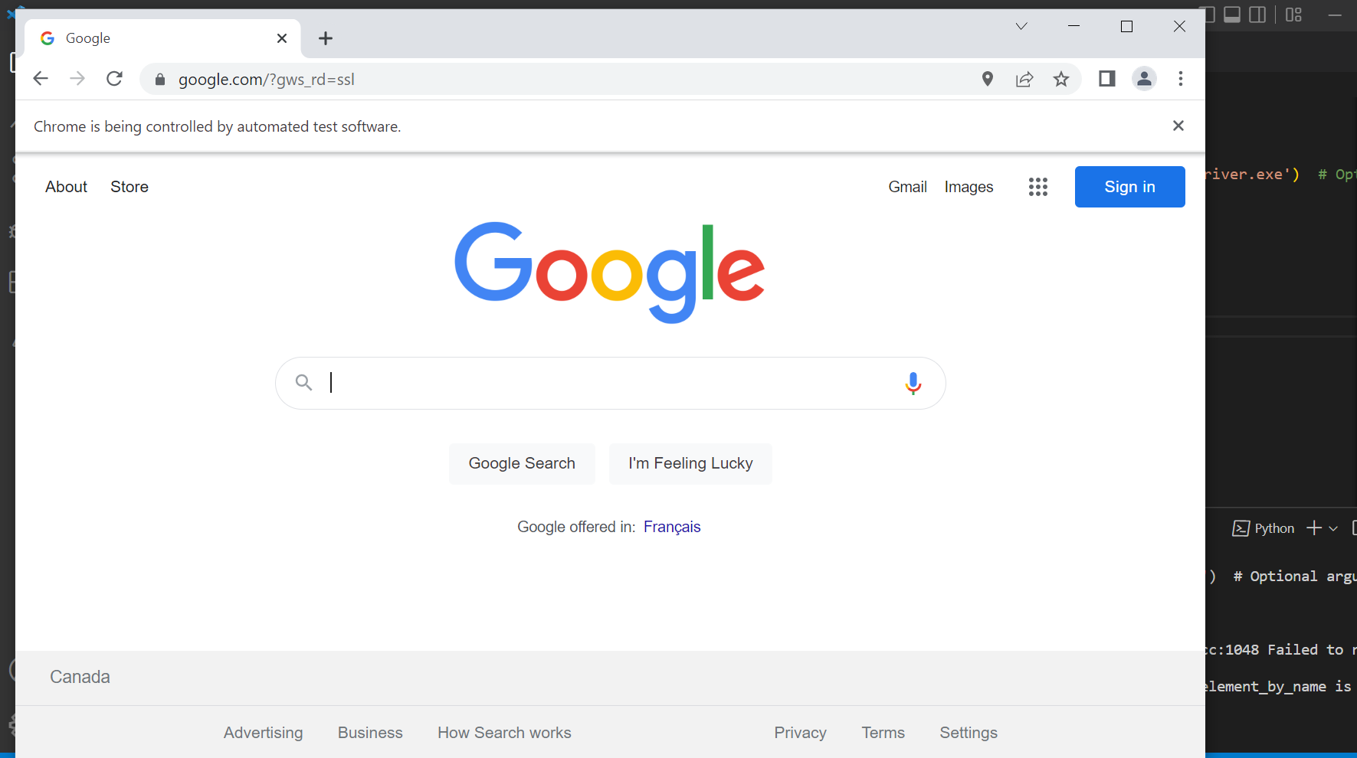

1. GETTING THE ICO:

import requests

url = 'https://static.xx.fbcdn.net/rsrc.php/yD/r/d4ZIVX-5C-b.ico'

r = requests.get(url, allow_redirects=True)

open('d4ZIVX-5C-b.ico', 'wb').write(r.content)



1. LOGGING INTO A WEBSITE AND DOWNLOADING A FILE:

from getpass import getpass

from selenium import webdriver

username = input("Your Username:  ")

password = getpass("Your password:  ")

driver = webdriver.Chrome('C:\\Users\\hp\\Desktop\\SEM 2\\SCRIPTING REPOS\\chrome_driver\\chromedriver.exe')

url = ("https://manybooks.net/mnybks-login-form")

driver.get(url)

username_place = driver.find_element_by_name("email")

username_place.send_keys(username)

password_place = driver.find_element_by_name("pass")

password_place.send_keys(password)

login_button = driver.find_element_by_name("op")

login_button.submit()

driver.get("https://manybooks.net/titles/tzusun132132.html")

driver.find_element_by_link_text("download").submit()

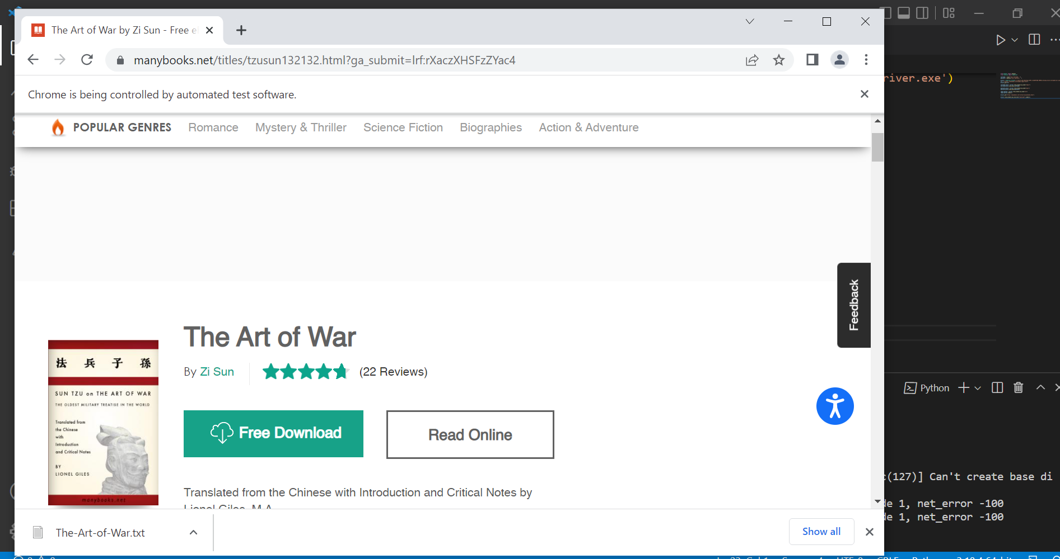

It downloaded the required file.

REFERENCES:  
none used