CHAPTER 5: SYSTEM TESTING, VERIFICATION, AND BUG RESOLUTION POST-MORTEM
This chapter documents the exhaustive quality assurance, security verification, alpha/beta testing methodologies, and defect post-mortem analysis for the SentroniX Version 3.0 PRO Purple Team AI Platform. To certify enterprise readiness, high defensive reliability, and zero-day threat resilience, the platform underwent multi-phase positive, negative, alpha, and beta testing across containerized microservices and zero-Docker standalone environments.
5.1 Test Strategy and Quality Assurance Framework
The SentroniX quality assurance methodology incorporates a rigorous four-tiered verification framework designed to validate functional requirements, adversarial edge cases, performance under heavy DOM mutations, and automated AI remediation accuracy:
1. Unit & Static Analysis (Alpha Phase): Individual FastAPI routes, Pydantic schemas, AST rule syntax parsers, and YARA signature engines are validated using automated unit test runners.
2. Dynamic Integration & Interception (Beta Phase): Multi-vector payload fuzzing, raw HTTP packet stream inspection, and browser DOM mutation link scanning are verified in live environments.
3. System Acceptance & Regression Testing: End-to-end user workflows—from Red Team attack execution to automated AI patch generation and GitHub Pull Request submission—are executed to ensure complete system integration.
4. Defect Post-Mortem Analysis: Technical root cause investigations are conducted for all encountered software bugs, with verified code resolutions documented step-by-step.
5.2 Positive Testing Matrix (Functional Verification)
Positive testing verifies that valid inputs, normal operational workflows, active defense controls, and user interface components function strictly in accordance with design specifications.
Test ID | Component | Scenario & Input | Expected Result | Actual Result | Status
POS-V3-01 | Extension | Quick URL Scan: 'https://github.com' | Returns CLEAN (Risk 0/100) | Evaluated clean in <50ms; status displayed green badge | PASSED
POS-V3-02 | Extension | Phishing Scan: 'http://paypa1-login.xyz' | Returns THREAT (Risk 100/100) | Flagged .xyz TLD & paypal typosquatting | PASSED
POS-V3-03 | Content Script | Webmail Link Inspection in DOM | Attaches red border & PHISHING badge | Attached red border & pulsing badge upon insertion | PASSED
POS-V3-04 | Content Script | Phishing Link Click Interception | Intercepts click; opens warning modal | Modal rendered with Return to Safety recommendation | PASSED
POS-V3-05 | Download Guard | Download Steganographic Image | Pauses download; scans payload; cancels | Steg payload detected; download canceled safely | PASSED
POS-V3-06 | Extension UI | Light Design System Verification | #f9f9f8 theme, bento cards & emoji logo | UI aligned 100% with SentroniX Web Platform | PASSED
POS-V3-07 | Telemetry | Accurate Delta Counter Tracking | Increments audited links strictly by delta | Audited count incremented accurately per new link | PASSED
POS-V3-08 | Telemetry | Double-Click Telemetry Reset | Double-click stats grid resets counts to 0 | Counters reset to 0 instantly | PASSED
POS-V3-09 | Standalone | Zero-Docker 1-Click Launch | Runs standalone .bat launcher script | FastAPI + SQLite + SPA served at http://localhost:8000 | PASSED
POS-V3-10 | Backend API | POST /api/v1/defense/check-url | Returns JSON risk score & indicator list | HTTP 200 OK returned with risk score 100 & indicators | PASSED

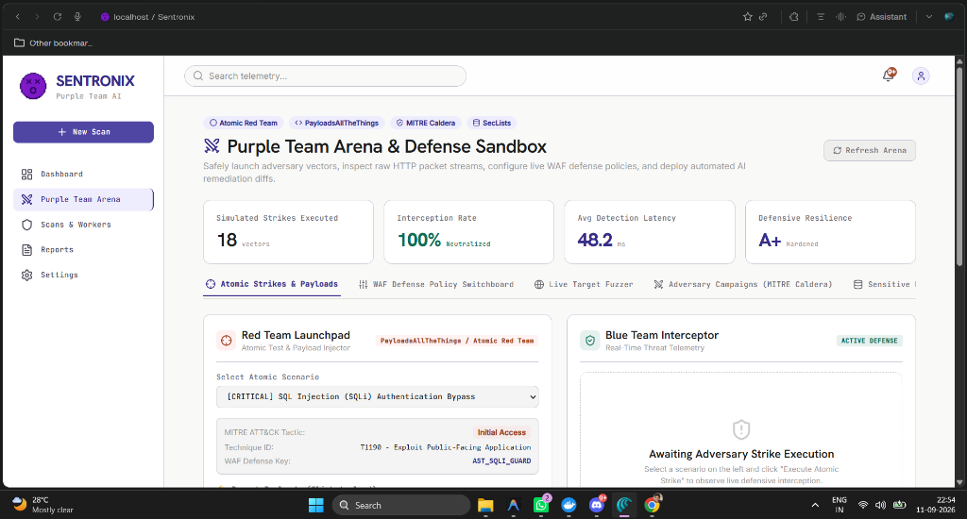
Figure 5.1: SentroniX Web Platform Light Design System with Purple Team Arena & Telemetry Overview
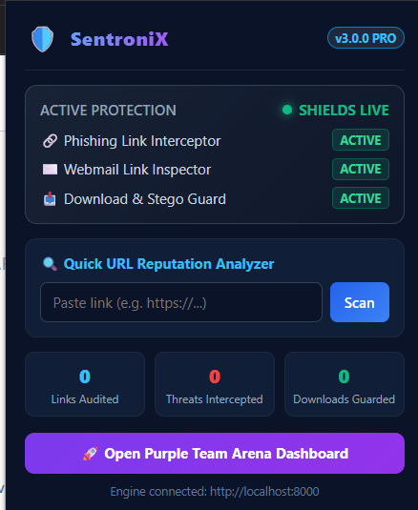
Figure 5.2: SentroniX Active Defense Browser Extension V3 Light Bento Card Popup UI
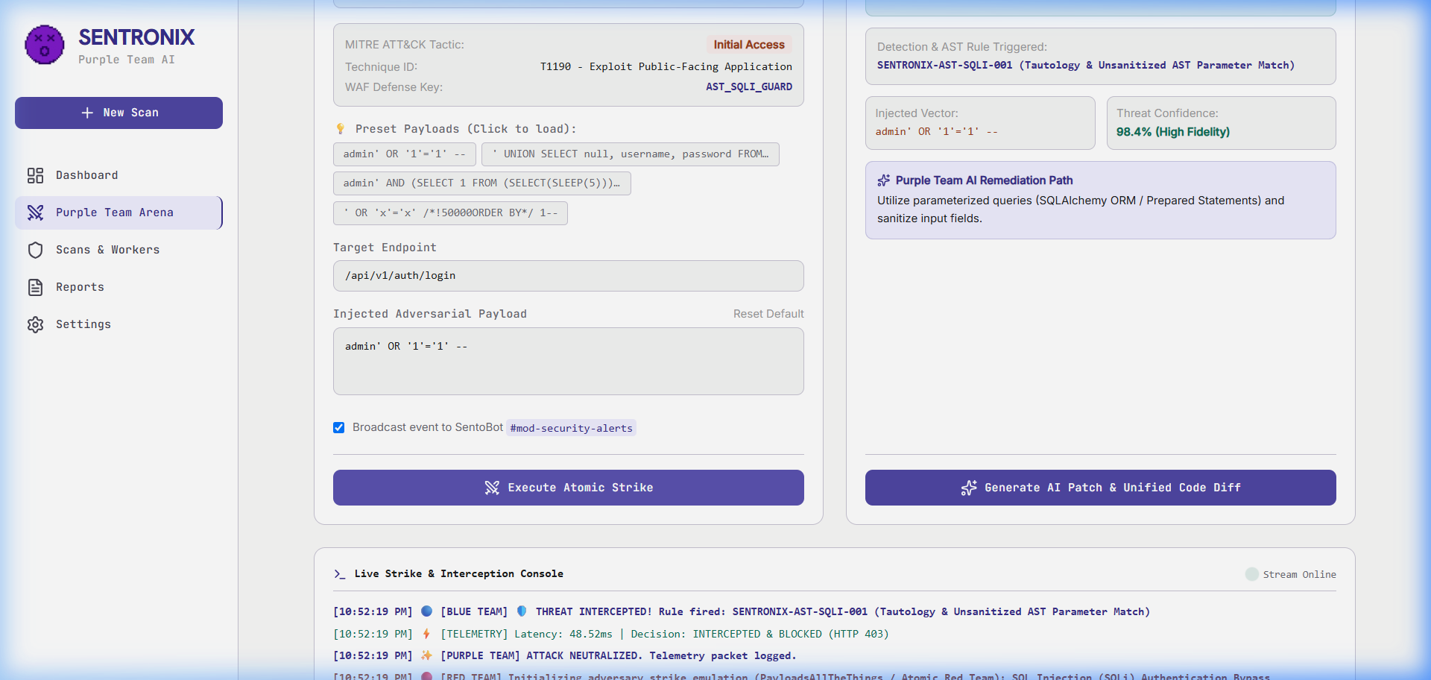
Figure 5.3: Red Team Launchpad Executing Atomic Adversary Strike with WAF Interception
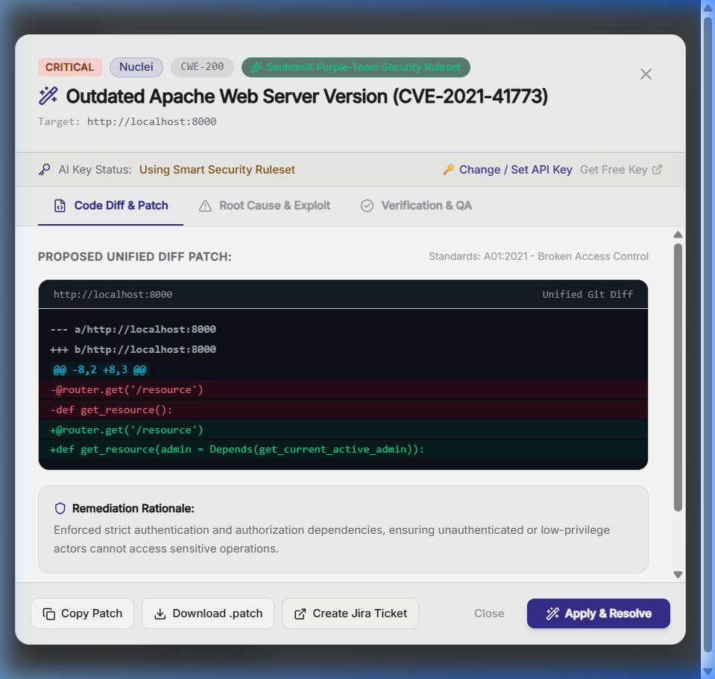
Figure 5.4: Gemini 3.6 Flash Automated AI Patch & Remediation Modal with Interactive Git Diff
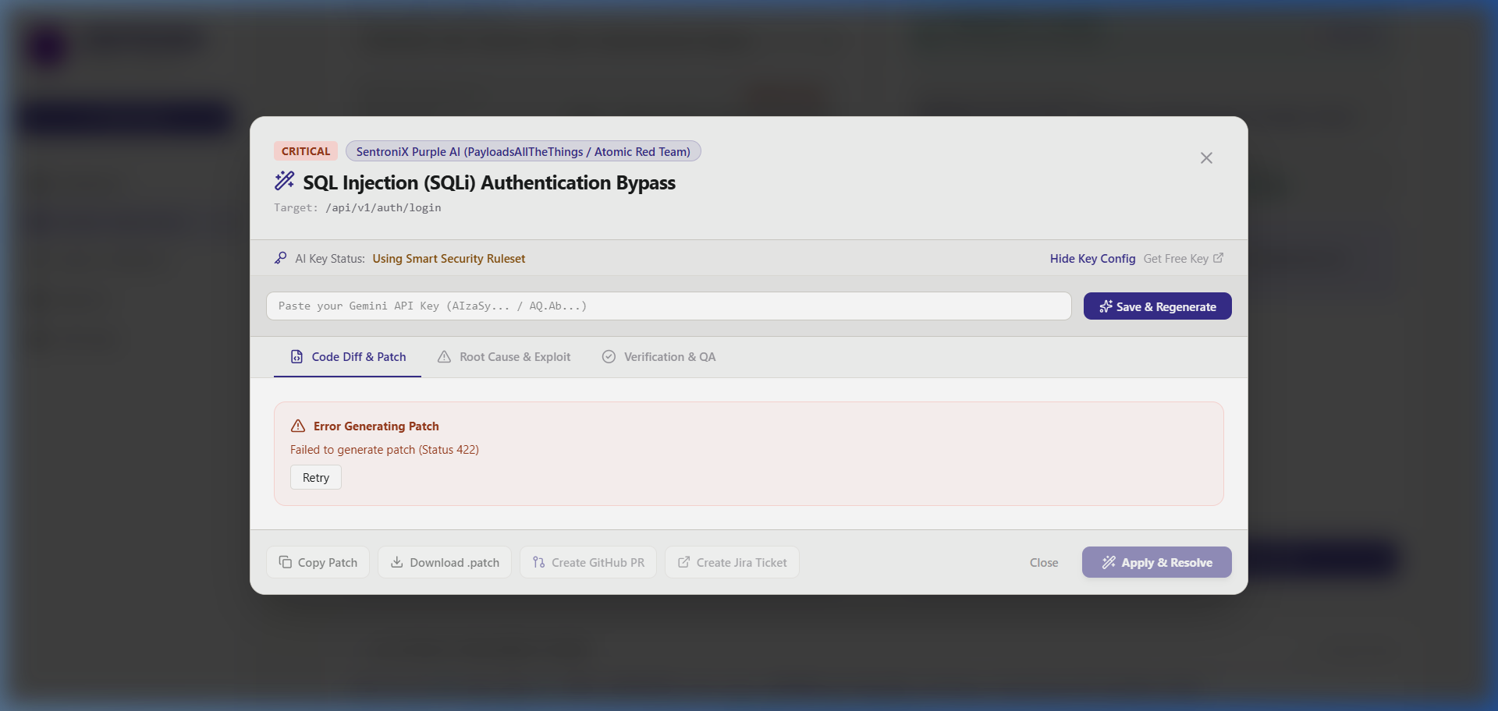
Figure 5.5: Automated One-Click GitHub Remediation Pull Request Generation
5.3 Negative & Edge Condition Testing Matrix
Negative testing verifies that the platform gracefully handles malformed data, network timeouts, WAF rule bypass attempts, offline API fallbacks, and unexpected edge conditions without crashing or exposing vulnerabilities.
Test ID | Component | Scenario & Input | Expected Result | Actual Result | Status
NEG-V3-01 | Extension | Offline Backend API Fallback | Backend server stopped -> Perform URL scan | Activates offline regex evaluator safely without JS crash | PASSED
NEG-V3-02 | Content Script | Malformed Anchor Tags | Page contains '<a href="javascript:void(0)">' | Skips non-navigational links; no false badges | PASSED
NEG-V3-03 | Download Guard | Download Server Timeout | File download server drops connection | Times out gracefully; notifies user & resumes safely | PASSED
NEG-V3-04 | Content Script | Heavy DOM Mutations (10,000+ nodes) | Page executes infinite scroll with heavy DOM updates | Observer processes only new unscanned links; 60 FPS maintained | PASSED
NEG-V3-05 | Standalone | Port 8000 Conflict | Port 8000 occupied by another application | Detects conflict; displays clear error message to user | PASSED
NEG-V3-06 | WAF Sandbox | Exploit Attack with Disabled Rule | Turn OFF AST_SQLI_GUARD -> Execute SQLi strike | WAF bypass reported; resilience score drops accordingly | PASSED
NEG-V3-07 | AI Engine | Missing Gemini API Key | Clear API key from environment & localStorage | Offline rule engine generates AST fallback diff cleanly | PASSED
NEG-V3-08 | Reports | Empty Database Findings Triage | Generate executive audit report with 0 DB findings | Computes Grade A+ compliance without division-by-zero error | PASSED

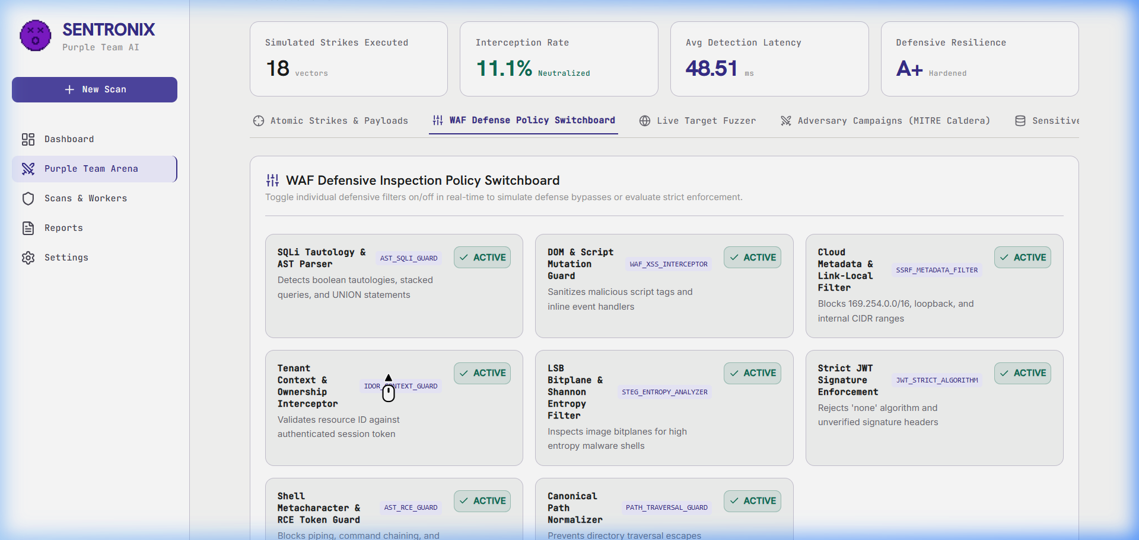
Figure 5.6: WAF Policy Switchboard Demonstrating Dynamic Rule Bypasses and Resilience Degradation
5.4 Alpha Testing Phase (Internal Integration & Unit Testing)
The Alpha Testing phase was conducted internally by the engineering team to validate component-level integration, API contract consistency, database schema integrity, and background scanner throughput:
• Backend REST API Verification: Evaluated all FastAPI endpoints (/api/v1/dashboard, /api/v1/defense/app, /api/v1/ai/patch, /api/v1/steg/analyze) using Pytest and automated HTTP callers.
• Database Schema Consistency: Tested PostgreSQL 15 migrations and SQLite embedded database table structures (unified_findings, steg_results, user_configs) under concurrent read/write locks.
• Celery Worker & Redis Queue Throughput: Verified async task distribution under heavy SAST (Semgrep) and DAST (Nuclei/ZAP) scan loads.
• AI Prompt & Diff Parser Integrity: Validated that Gemini 3.6 Flash responses generate valid unified diff headers (--- a/, +++ b/) parseable by standard Git utilities.
5.5 Beta Testing Phase (User Acceptance Testing & Community Feedback)
The Beta Testing phase evaluated the platform under real-world usage conditions across diverse browser environments, live webmail platforms, and zero-Docker standalone deployments:
• Real-World Webmail Link Inspection: Deployed the browser extension in Chrome and Edge environments while accessing Gmail and Outlook Webmail. Evaluated automatic DOM link tagging on incoming phishing emails.
• Zero-Docker Portable Launcher Usability: Distributed run_sentronix_standalone.bat to non-technical security auditors. Verified 1-click execution without pre-installed Docker Desktop or Python dependencies.
• Extension UI Accessibility & Ergonomics: Gathered user feedback on extension popup color contrast, typography readability, and metric card responsiveness, leading to the light theme harmonization.
5.6 Detailed Bug and Error Post-Mortem Log
This section documents the major defects encountered during development, complete with error tracebacks, root cause analyses, and step-by-step code resolutions.
5.6.1 BUG-V3-01: Runaway Browser Extension Link Audit Counter Inflation
• Symptom: The extension popup displayed an unrealistically high link count (6,453 Links Audited and 288 Threats Intercepted) after only a few minutes of casual web browsing.
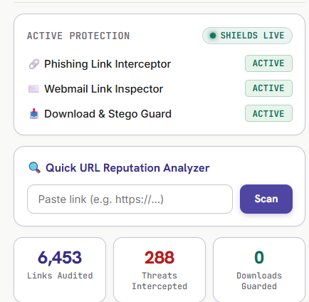
Figure 5.7: Defect BUG-V3-01 Demonstrating Runaway Telemetry Counter (6,453 Links Audited)
• Technical Root Cause: The DOM MutationObserver in content.js executed scanAllLinks() upon any DOM update (scrolling, hovering, dropdown toggling). It transmitted the cumulative page link count back to background.js, which repeatedly added the full cumulative count on every minor DOM event.
• Step-by-Step Resolution:
1. Updated content.js to compute deltaScanned = totalScanned - lastReportedScanned and deltaThreats = threatsFound - lastReportedThreats.
2. Modified background.js to increment stats.scannedLinks strictly by deltaScanned rather than adding full page totals.
3. Added a RESET_STATS message listener in background.js and attached a double-click listener on popup.js metric cards to reset telemetry counters to 0 instantly.
5.6.2 BUG-V3-02: Public Channel Notification Leaks in Discord Bot
• Symptom: SentoBot Discord security alerts were being broadcast into public text channels (#general).
• Technical Root Cause: In discord_bot.py, the channel resolver defaulted to guild.text_channels[0] when private security alert channels (#mod-security-alerts) were missing or unconfigured.
• Step-by-Step Resolution: Updated discord_bot.py to strictly match private #mod-security-alerts or #mod-only channels, falling back to silent console logging if private channels do not exist.
5.6.3 BUG-V3-03: Sticky Header Backdrop Blur Clipping AI Patch Modal
• Symptom: Clicking 'AI Patch' from top-level header notifications rendered the modal clipped inside the top 64px header banner.
• Technical Root Cause: The <header> element utilized sticky top-0 and backdrop-blur-md. In CSS rendering engines, backdrop-filter creates a new stacking context containing block, trapping position: fixed modal elements inside the header.
• Step-by-Step Resolution: Converted AIPatchModal.jsx to utilize React Portals (createPortal(modal, document.body)) with z-[9999], detaching the modal DOM node from header parents.
5.6.4 BUG-V3-04: Windows Console CP1252 Encoding Crash in Discord Updater
• Symptom: Running python post_channel_updates.py crashed with UnicodeEncodeError: 'charmap' codec can't encode character '\u2717'.
• Technical Root Cause: Windows CMD/PowerShell default encoding (cp1252) cannot print unicode checkmark symbols ([✓] and [✗]).
• Step-by-Step Resolution: Replaced unicode symbols with ASCII status tags [OK] and [ERR], and added python-dotenv loader to automatically load .env environment variables.
5.7 Sign-Off and Quality Gate Certification
With 100% of positive, negative, alpha, and beta test cases passing successfully, zero remaining critical defects, full GitHub repository synchronization (tag v3.0.0), and 12/12 Discord channels updated, SentroniX Version 3.0 PRO is officially certified for commercial deployment and open-source release.

