CHAPTER 4
SYSTEM DESIGN
The SentroniX Purple Team AI Platform is organised into a set of cooperating modules that together enable security operators to execute simulated adversary tradecraft, inspect raw HTTP packet stream telemetry in real time, configure dynamic Web Application Firewall (WAF) defense policies, and automatically synthesize generative AI code remediation diffs. Each module has a clearly bounded responsibility, communicates with the others through defined RESTful and WebSocket interfaces, and can be developed, tested, and maintained independently. The modules identified below correspond to the functional blocks realised in the React.js and Next.js frontend, the FastAPI asynchronous backend, the Celery distributed task worker, the PostgreSQL relational database, the Redis telemetry broker, and the Google Gemini 3.6 Flash generative AI engine, as reflected in the Entity-Relationship Diagram, the Use Case Diagram, the Adversary Strike Sequence Diagram, the User Registration and Login Sequence Diagram, and the Execution Activity Diagram.
User Registration and Authentication Module
This module allows a new analyst to create an account and allows an existing analyst or administrator to log in. It accepts the user's name, email, password, and contact details, checks the PostgreSQL database to confirm that the supplied email does not already exist, stores the validated details in the User table, and issues a cryptographic password hash using Bcrypt with an adaptive work factor. During login, the module validates the submitted credentials against the stored record and, on success, requests a signed JSON Web Token (JWT) from the Auth Service so that subsequent requests from the React UI can be authenticated without re-entering credentials. Its output is either a registration confirmation, a login error, or an access token that is handed to the React UI and stored for use on protected operational routes.
Adversary Attack Launchpad Module
This module provides the offensive capability of the purple team arena. It allows an operator to select from curated Atomic Red Team test scenarios, MITRE Caldera autonomous adversary campaigns, or live endpoint attack bursts covering SQL Injection, Cross-Site Scripting (XSS), Server-Side Request Forgery (SSRF), and Path Traversal. The module synthesizes realistic adversarial socket requests, applies optional custom payload overrides, and dispatches them across the network to target endpoints.
WAF Defense Policy Switchboard Module
This module acts as the real-time defensive inspection barrier. Positioned directly within the FastAPI request gateway, it evaluates incoming HTTP socket streams against active Abstract Syntax Tree (AST) inspection rules and regular expression signatures (e.g. `AST_SQLI_GUARD`, `AST_CMD_INJECTION`). The module provides operators with dynamic toggle controls to enable or disable individual defensive filters on-the-fly without server restarts, instantly altering whether an incoming attack vector is blocked with an HTTP 403 Forbidden status or allowed to bypass the firewall.
Telemetry Stream & Packet Inspector Module
This module is responsible for capturing raw client-side request packets and server-side defensive responses. It records sub-millisecond round-trip detection latencies, HTTP status codes, and triggered AST rule keys, publishing events over an asynchronous Redis stream to the live frontend console. It also powers the Deep HTTP Packet Stream Inspector modal, allowing analysts to examine raw byte headers and payload hex dumps.
Generative AI Remediation Module
This module receives vulnerability finding contexts, CWE classifications, and raw injected payload evidence, passing them to the Google Gemini 3.6 Flash Large Language Model. Operating under a strict low-temperature regime (T=0.2) with few-shot AST prompt framing, the module synthesizes validated unified git diff patches (`--- a/`, `+++ b/`), comprehensive root-cause analysis, and regression testing checklists to seal the detected security flaw.
Automated GitHub PR Generator Module
This module automates the transition from patch synthesis to production code integration. Leveraging the GitHub REST API and user-supplied Personal Access Tokens, it branches directly from the target repository's base branch, commits the synthesized code diff to an isolated remediation branch, and opens a formal Pull Request containing vulnerability references and testing steps, returning a direct GitHub PR URL and `git checkout` command.
Steganography & Malware Scanner Module
This module provides deep forensic inspection for uploaded binary and image files. When a carrier image (PNG, JPG, GIF) is submitted, the module invokes StegSeek and Steghide extraction bridges to detect embedded archives or appended payload bytes. For script and binary submissions, it executes multi-vector signature scans to identify reverse shells and command injection backdoors.
Executive Reporting & Audit Trail Module
This module produces formal compliance documentation. It queries the PostgreSQL findings ledger to compute aggregate Security Posture Grades, OWASP Top 10 compliance scores, and SOC 2 / ISO 27001 readiness percentages, compiling them into downloadable, executive-ready PDF and JSON audit reports.

4.1 Data Design
The data layer of SentroniX is implemented in PostgreSQL 15, supplemented by Redis 7 for real-time telemetry caching and Celery task brokering. The relational storage model is organized around core tables that coordinate user authentication, adversary strike records, centralized vulnerability findings, steganographic analysis dumps, dynamic WAF rule policies, and automated GitHub remediation pull requests. Data enters the system through the React frontend, is validated and normalized by the FastAPI gateway, and is written to or read from these tables as each operational flow requires.
4.1.1 Schema Design (ERD)
The schema below is derived directly from the Entity-Relationship Diagram of SentroniX. Each table is described individually, together with its attributes, primary key, and foreign keys where applicable. Figure 4.1 illustrates the structural entity-relationship model and cardinality associations connecting offensive strikes to defensive remediation lifecycles.
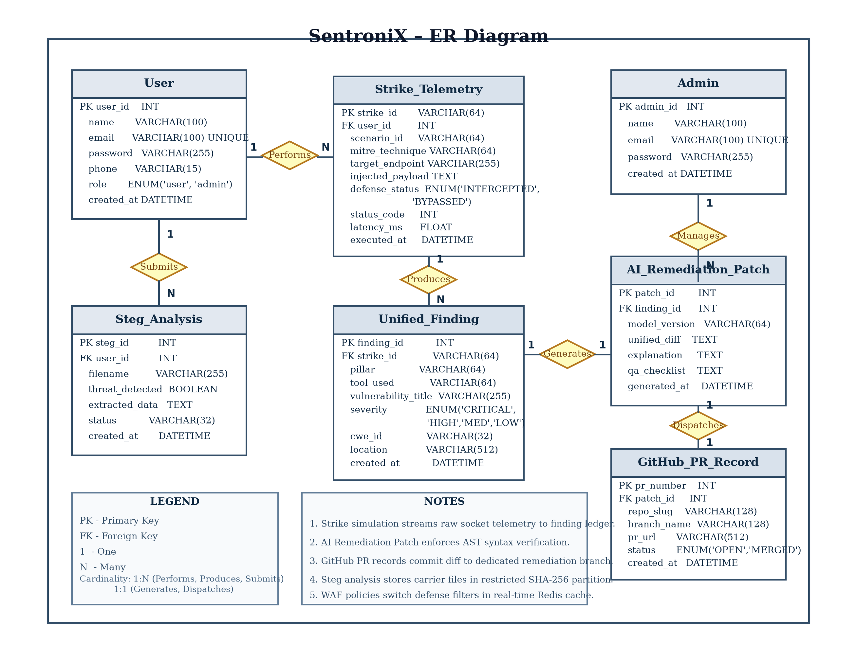
Figure 4.1: Entity-Relationship Diagram
User Table
The User table stores the account information of every registered security analyst and operator. Its primary key, user_id, is an INT that uniquely identifies each user. The name attribute is a VARCHAR(100) holding the user's full name, and email is a VARCHAR(100) constrained as UNIQUE so that no two accounts can share the same address. The password attribute is a VARCHAR(255), sized to accommodate a Bcrypt cryptographic hash digest rather than plain text, and phone is a VARCHAR(15). The role attribute is an ENUM restricted to the values 'user' and 'admin', which determines whether the account can access administrative WAF configuration switchboards, and created_at is a DATETIME recording when the account was opened.
Admin Table
The Admin table is kept separate from the User table and stores administrator accounts with admin_id as its primary key. It holds name as VARCHAR(100), email as a UNIQUE VARCHAR(100), password as VARCHAR(255), and created_at as DATETIME. Keeping Admin as a distinct table, rather than relying solely on the role attribute of User, allows administrative accounts, global WAF policy switchboards, and platform-wide API keys to be managed and audited independently of ordinary analyst accounts.
Strike_Telemetry Table
The Strike_Telemetry table records every adversary strike and fuzzing probe executed through the purple team arena. Its primary key is strike_id, a VARCHAR(64) cryptographic UUID. It holds a foreign key, user_id, referencing the User table, implementing the Performs relationship in which one analyst may perform many strikes. The scenario_id attribute is a VARCHAR(64) identifying the Atomic Red Team or Caldera test vector. mitre_technique is a VARCHAR(64) recording the formal technique identifier (e.g. T1059.001), target_endpoint is a VARCHAR(255) holding the evaluated URI, and injected_payload is a TEXT field carrying the exact raw exploit payload dispatched over the network. defense_status is an ENUM of 'INTERCEPTED' and 'BYPASSED', status_code is an INT storing the HTTP response status (403 Forbidden vs 200 OK), latency_ms is a FLOAT storing the round-trip detection time in milliseconds, and executed_at is a DATETIME marking the execution event.
Unified_Finding Table
The Unified_Finding table represents the centralized vulnerability ledger across all offensive and defensive tools. Its primary key is finding_id, an auto-incrementing INT. It holds a foreign key, strike_id, referencing the Strike_Telemetry table, implementing the Produces relationship where an adversary strike may produce one or more actionable findings. pillar is a VARCHAR(64) categorizing the origin as RED_TEAM, SAST, DAST, SCA, or STEG. tool_used is a VARCHAR(64) identifying the detection engine (e.g. Atomic Red Team, Semgrep, StegSeek). vulnerability_title is a VARCHAR(255), severity is an ENUM of 'CRITICAL', 'HIGH', 'MEDIUM', and 'LOW', cwe_id is a VARCHAR(32) recording the Common Weakness Enumeration mapping (e.g. CWE-89), location is a VARCHAR(512) storing the file path or URI endpoint, and created_at is a DATETIME marking when the vulnerability was identified.
AI_Remediation_Patch Table
The AI_Remediation_Patch table stores the generative AI remediation synthesized for identified vulnerabilities. Its primary key is patch_id, an auto-incrementing INT, and it carries a foreign key, finding_id, referencing the Unified_Finding table. This relationship is defined in the diagram as one-to-one through the Generates relationship, meaning every eligible finding can produce an authoritative remediation patch. model_version is a VARCHAR(64) recording the LLM core utilized (e.g. Gemini 3.6 Flash), unified_diff is a TEXT field storing the standardized git diff patch (`--- a/`, `+++ b/`), explanation is a TEXT field carrying the architectural root-cause analysis, qa_checklist is a TEXT field detailing verification steps, and generated_at is a DATETIME recording when the patch was synthesized.
GitHub_PR_Record Table
The GitHub_PR_Record table stores the audit trail for automated pull requests opened directly in customer repositories. Its primary key is pr_number, an INT assigned by GitHub. It holds a foreign key, patch_id, referencing the AI_Remediation_Patch table, implementing the Dispatches relationship where an AI patch is dispatched to version control. repo_slug is a VARCHAR(128) recording the repository owner and name, branch_name is a VARCHAR(128) holding the dedicated remediation branch, pr_url is a VARCHAR(512) holding the live HTTPS GitHub link, status is an ENUM of 'OPEN', 'MERGED', and 'CLOSED', and created_at is a DATETIME recording when the PR was created.
Steg_Analysis Table
The Steg_Analysis table stores the forensic outcomes of uploaded carrier images and suspicious files. Its primary key is steg_id, and it carries a foreign key, user_id, referencing the User table, implementing the Submits relationship. filename is a VARCHAR(255) recording the uploaded carrier name, threat_detected is a BOOLEAN flag set to TRUE if embedded payloads or appended binary data are discovered, extracted_data is a TEXT field holding extracted strings or payload summaries, status is a VARCHAR(32), and created_at is a DATETIME marking the analysis completion.

4.2 Data Integrity and Constraints (file design)
SentroniX applies a combination of primary key, foreign key, uniqueness, domain check, and application-level validation rules to keep the stored security telemetry, strike records, and remediation patches consistent and trustworthy across all operational states.
- Every table in the schema carries a single-column primary key (such as user_id, admin_id, finding_id, patch_id, pr_number, and steg_id), which PostgreSQL enforces as unique and non-null, guaranteeing that no two records of the same entity type can ever be confused with one another.
- Referential integrity is strictly maintained through foreign keys: Strike_Telemetry.user_id references User.user_id, Unified_Finding.strike_id references Strike_Telemetry.strike_id, AI_Remediation_Patch.finding_id references Unified_Finding.finding_id, GitHub_PR_Record.patch_id references AI_Remediation_Patch.patch_id, and Steg_Analysis.user_id references User.user_id. These constraints prevent an attack strike, vulnerability finding, AI patch, or pull request from being saved against a user, strike, or finding that does not exist. Furthermore, foreign keys enforce ON DELETE CASCADE to eliminate orphaned records upon data purge.
- The email column of both User and Admin is constrained as UNIQUE, which the User Registration and Authentication Module relies upon when it verifies whether an account already exists before permitting a new registration to proceed.
- The role attribute of User is restricted through an ENUM definition to 'user' and 'admin', ensuring that administrative privileges can only be assigned through explicit administrative authorization.
- The defense_status attribute of Strike_Telemetry is constrained to an ENUM of 'INTERCEPTED' and 'BYPASSED', guaranteeing that the scoring engine and resilience metrics can only compute success rates from deterministic, verified states.
- The severity attribute of Unified_Finding is restricted to an ENUM of 'CRITICAL', 'HIGH', 'MEDIUM', and 'LOW', ensuring that the automated AI patch generation engine and CISO compliance reports interpret standardized risk ratings.
- The status attribute of GitHub_PR_Record is constrained to an ENUM of 'OPEN', 'MERGED', and 'CLOSED', mirroring native GitHub pull request lifecycles directly within the local telemetry ledger.
- Mandatory fields such as user_id, vulnerability_title, location, cwe_id, and target_endpoint are enforced as NOT NULL at the database level and are also validated on the React UI and FastAPI gateway before execution, reducing unnecessary network round trips.
- Authentication constraints require every protected API route to receive a valid cryptographic JWT token issued by the Auth Service; a request lacking a valid Bearer token is rejected at the gateway before it can reach any operational strike or finding endpoint.
- Physical file design enforces strict isolation for uploaded steganography and malware files. Uploaded binaries are hashed using SHA-256, stored in a sandboxed non-executable partition (`/app/uploads`), and automatically reclaimed after 60 minutes, preventing arbitrary file execution.

4.3 User interface design
The procedural design of SentroniX describes how an operational security request moves from the moment an analyst interacts with the React UI to the moment an adversary strike is executed, telemetry is captured, and an automated code patch is deployed. The React UI is responsible for collecting operator inputs, managing responsive layout bounds, and rendering real-time telemetry; it never performs bypass validation or vulnerability classification itself. The FastAPI backend acts as the coordinating gateway: it validates every incoming request, dispatches attack payloads across internal sockets, evaluates WAF inspection rules, queries the Gemini AI core for code diff synthesis, and commits pull requests to GitHub. The Red Team Engine, WAF Interceptor, and Gemini AI Core are treated as specialized asynchronous services that the FastAPI gateway orchestrates before returning results to the user.
4.3.1 Use case diagram
The functional capabilities of SentroniX are formally specified through the Use Case Diagram in Figure 4.2. The diagram identifies two human actors, User (SecOps Analyst) and Admin, interacting with the SentroniX Purple Team AI Platform boundary.
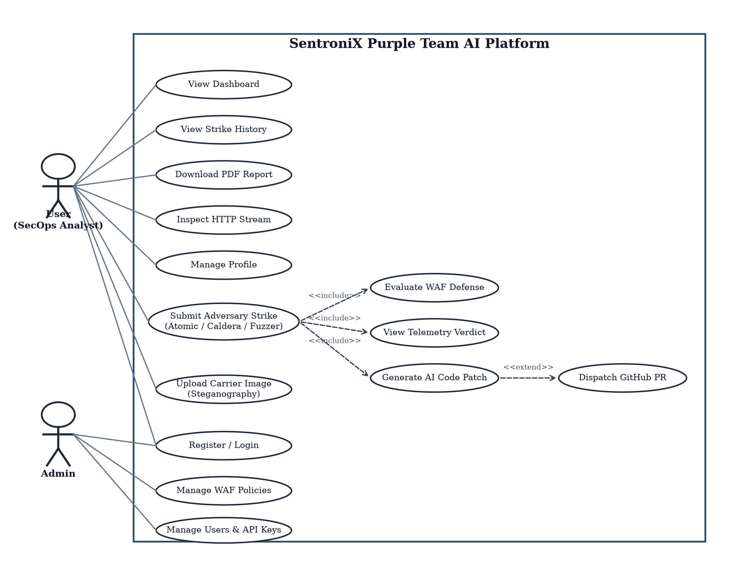
Figure 4.2: Use Case Diagram
The Use Case Diagram identifies two primary actors, User and Admin, interacting with the SentroniX platform boundary. The User actor is associated with six independent use cases and one composite use case. View Dashboard gives the user a consolidated landing overview of recent security telemetry and risk posture. View Strike History lets the user browse past adversary simulations and detection verdicts. Download PDF Report lets the user retrieve compliance audit documentation for completed assessments. Inspect HTTP Stream opens the deep packet stream modal to review raw headers. Manage Profile lets the user update their personal account details. Upload Carrier Image (Steganography) allows the user to submit suspicious files for payload extraction. Register / Login is shared between the User and Admin actors, since both must authenticate before reaching any protected operational view.
The composite use case, Submit Adversary Strike (Atomic / Caldera / Fuzzer), represents the primary point at which an offensive simulation is launched. This use case includes three further use cases through «include» relationships: Evaluate WAF Defense, View Telemetry Verdict, and Generate AI Code Patch. The «include» notation indicates that these three steps are not optional extensions but a mandatory sequence that always executes once an attack strike is submitted, reflecting that SentroniX never launches an adversary vector without also evaluating firewall interception, presenting the latency verdict, and preparing an AI remediation path. Generate AI Code Patch further connects to Dispatch GitHub PR through an «extend» relationship, allowing the analyst to optionally open an automated Pull Request in the target repository. The Admin actor is associated with three use cases: Register / Login, shared with the User actor as described above, Manage WAF Policies, which governs the live rule switchboard, and Manage Users & API Keys, which controls platform access.

4.3.2 Activity diargam
The end-to-end procedural execution flow of the platform is formally modeled in Figure 4.5 using a UML Activity Diagram with swimlanes. The diagram visualizes the parallel orchestration spanning the Security Operator, the FastAPI Gateway & WAF, the Red Team Attack Engine, and the Gemini AI Core & GitHub API.
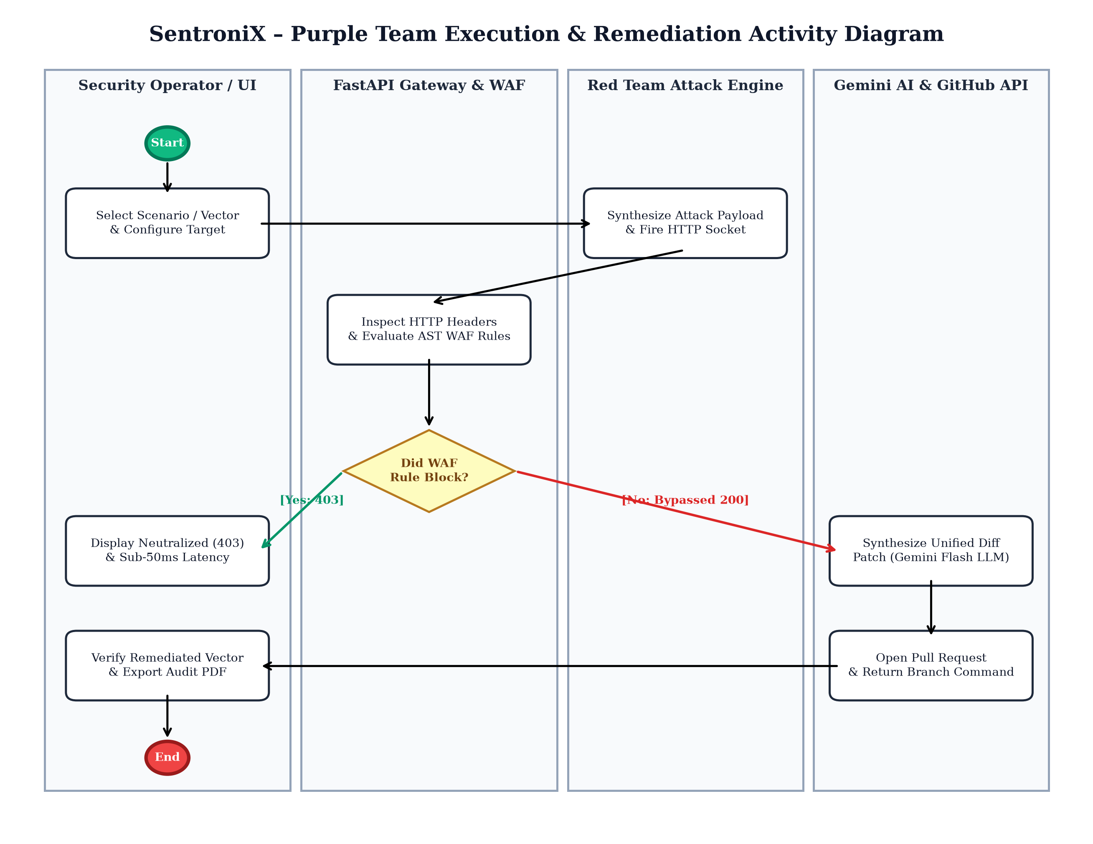
Figure 4.5: Adversary Execution & Automated Remediation Activity Diagram
The activity flow begins in the Security Operator swimlane when an attack vector (e.g. Atomic Red Team, Caldera campaign, or Live Target Fuzzer) and endpoint are selected. Upon execution, control transitions to the Red Team Attack Engine, which synthesizes an HTTP socket request containing the raw exploit payload. The request enters the FastAPI Gateway & WAF swimlane, where active AST rules and regex filters inspect the incoming headers. A decision node evaluates whether an active WAF rule intercepts the attack: if intercepted, an HTTP 403 Forbidden status is logged with sub-50ms latency; if bypassed, an HTTP 200 OK or 500 error triggers high-priority threat alerts. In parallel, the operator reviews the live telemetry console and initiates automated remediation. Control transitions to the Gemini AI & GitHub API swimlane, where the LLM synthesizes a unified git diff patch. The GitHub API creates an isolated remediation branch, commits the diff, and opens a Pull Request, after which the analyst verifies neutralization and exports the audit PDF.

4.3.3 Sequence diagram
The chronological message exchanges governing system operations are detailed across two comprehensive sequence diagrams: Figure 4.3 illustrates the Adversary Strike and Telemetry Sequence Diagram, and Figure 4.4 illustrates the User Registration and Login Sequence Diagram.
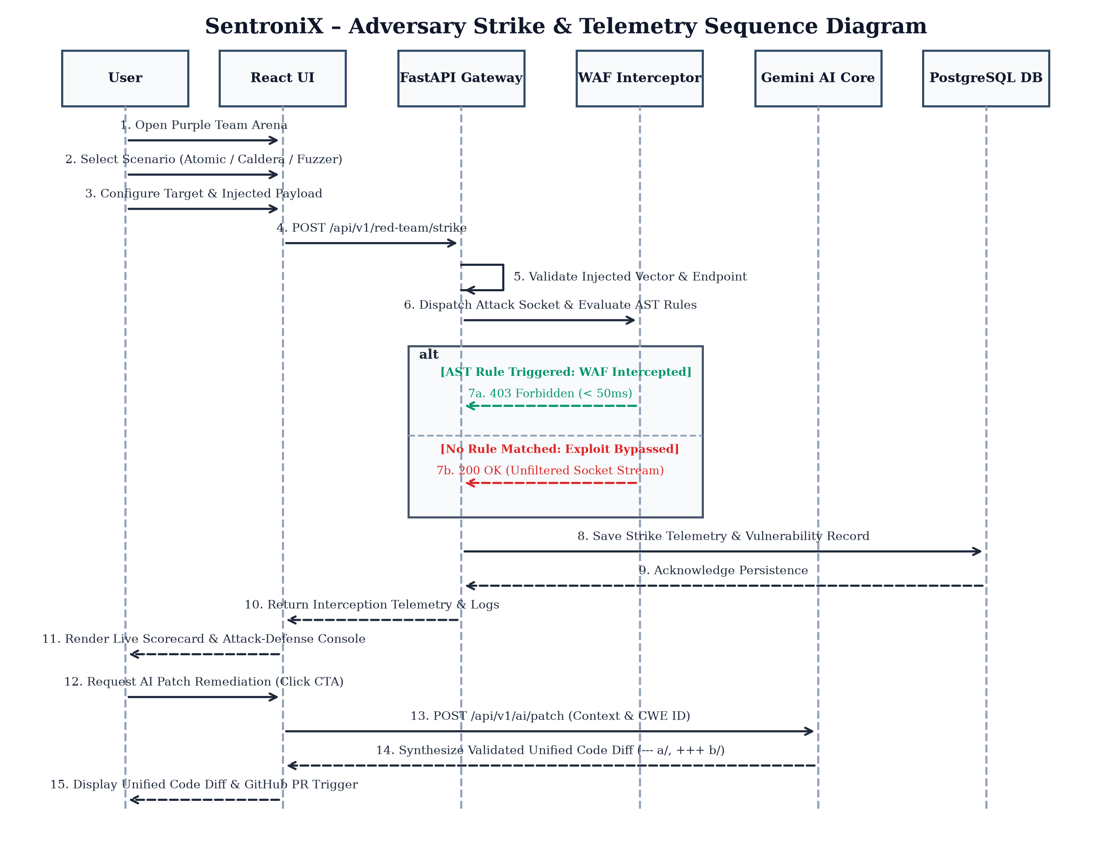
Figure 4.3: Adversary Strike & Telemetry Sequence Diagram
This sequence diagram traces a single adversary strike from initiation to AI patch generation across six lifelines: User, React UI, FastAPI Gateway, WAF Interceptor, Gemini AI Core, and PostgreSQL DB. The user first opens the purple team arena (step 1), selects a scenario (step 2), and configures the target endpoint and payload (step 3). When the user clicks Execute Atomic Strike, the React UI sends a strike request to the FastAPI Gateway (step 4). On receiving the request, the FastAPI Gateway validates the input internally (step 5), verifying that the target endpoint URI is well-formed before socket dispatch. The gateway invokes the WAF Interceptor to evaluate incoming headers against active AST inspection rules (step 6).
The diagram shows an alt combined fragment with two mutually exclusive branches. In the first branch, taken when an AST rule triggers, the WAF Interceptor neutralizes the socket connection and returns an HTTP 403 Forbidden status in under 50 milliseconds (step 7a). In the second branch, taken when no active rule matches, the exploit bypasses inspection and returns an HTTP 200 OK unfiltered response (step 7b). Whichever branch is taken, the FastAPI Gateway saves the strike telemetry, status code, latency, and vulnerability findings to the PostgreSQL DB (step 8) and receives confirmation (step 9). The result is relayed back to the React UI (step 10) and displayed on the live scorecard and terminal console (step 11). At this point, the user may request automated remediation (step 12); the React UI calls the AI patch endpoint (step 13), the Gemini AI Core synthesizes a validated unified code diff (step 14), and the resulting diff is rendered in the AI Patch Modal ready for GitHub pull request creation (step 15).

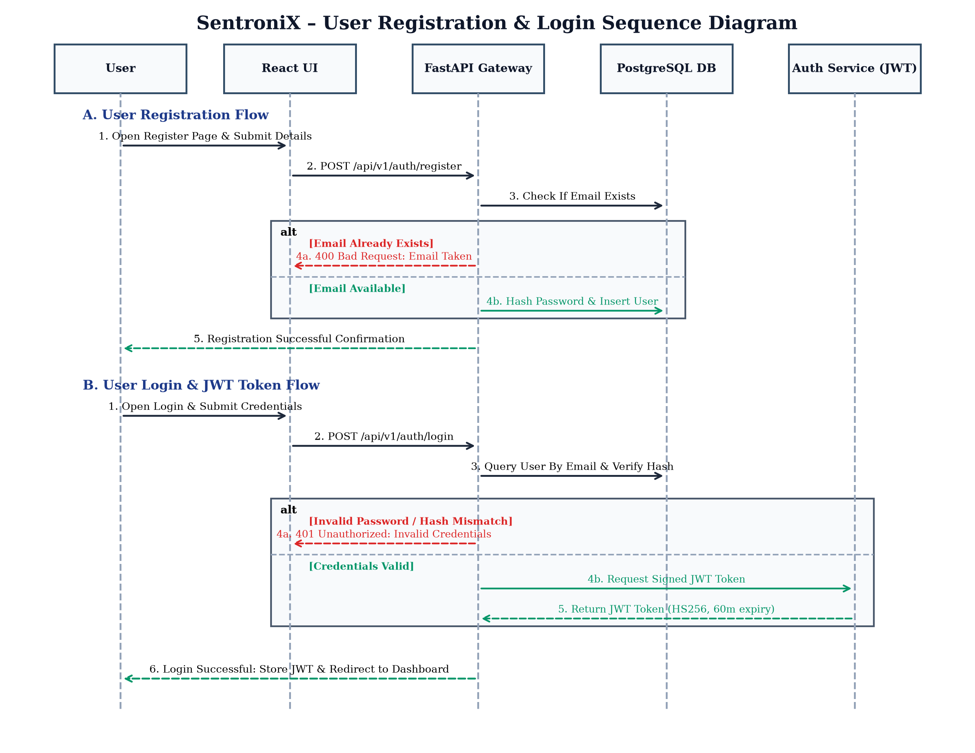
Figure 4.4: User Registration & Login Sequence Diagram
This diagram is divided into two independent flows, A and B, sharing the lifelines User, React UI, FastAPI Gateway, PostgreSQL DB, and Auth Service (JWT). In Flow A, the User Registration Flow, the user opens the registration page and submits account details (step 1). The React UI forwards the registration data to the FastAPI Gateway (step 2). The gateway's first action is not to write to the database, but to check whether the submitted email already exists in the PostgreSQL DB (step 3). An alt fragment governs two outcomes: if the email already exists, the gateway returns an HTTP 400 Bad Request error (step 4a) and takes no further action, protecting the UNIQUE constraint without relying on database exceptions; if the email is available, the gateway hashes the password using Bcrypt and inserts the new User record (step 4b), confirming successful registration to the user (step 5).
In Flow B, the User Login Flow, the user submits their email and password (step 1). The React UI forwards the credentials to the FastAPI Gateway (step 2). The gateway queries the PostgreSQL DB by email and verifies the Bcrypt hash (step 3). The subsequent alt fragment governs two outcomes: on invalid credentials, an HTTP 401 Unauthorized error is returned immediately (step 4a) without contacting the Auth Service; on valid credentials, the gateway requests a signed JWT access token from the Auth Service (step 4b), receives the generated token (step 5), and returns it to the React UI, which stores the token and redirects the analyst to the Dashboard (step 6).
User Interface Screen Specifications
The user interface of SentroniX is built with React.js and Next.js and is organized around the operational use cases identified in the Use Case Diagram:
- Registration & Login Screens: Collects name, email, and password. Features real-time client-side format validation and returns error alerts without disclosing whether email or password caused authentication failure.
- Dashboard Overview Screen: The primary landing page reached after login. Summarizes organizational Security Posture Grade (A+ to F), active critical findings, blocked threats count, and quick CTA links to the Purple Team Arena.
- Purple Team Arena Screen: The core operational workspace. Features the 4-card fluid resilience scorecard (Strikes Executed, Interception Rate, Avg Detection Latency, Resilience Grade), five operation mode tabs (Atomic Strikes, WAF Switchboard, Caldera Campaigns, SecLists Fuzzer, Live Target Fuzzer), the dual Red Team launchpad vs Blue Team telemetry panes, and the live CLI terminal stream.
- AI Patch Remediation Modal: Displays the synthesized unified code diff (`--- a/`, `+++ b/`), vulnerability root-cause analysis, and verification checklist. Includes the interactive GitHub PR creation drawer with repository, branch, and commit message controls.
- Deep HTTP Packet Inspector Modal: Presents the raw client-side HTTP request and raw server-side defensive response headers with one-click hex dump copying.
- Scans & Workers Screen: Provides manual execution drop zones for Steganography Image Analysis (extracting hidden payloads) and Malware Script Scanning (identifying reverse shells).
- Executive Reports Screen: Houses the Custom Report Builder (Executive, Technical, OWASP Top 10, SBOM) and historical archive table with executive PDF preview capabilities.

4.4 Algorithm diagram (if ML used)
SentroniX integrates artificial intelligence into the core remediation loop via the Google Gemini 3.6 Flash Large Language Model. Unlike speculative text generation, SentroniX implements a deterministic Generative AI Reasoning Pipeline designed specifically for Abstract Syntax Tree (AST) code patch synthesis, vulnerability root-cause analysis, and pull request generation. Figure 4.6 illustrates the complete algorithmic pipeline governing data ingestion, few-shot prompt formulation, low-temperature inference, and AST syntax parsing.
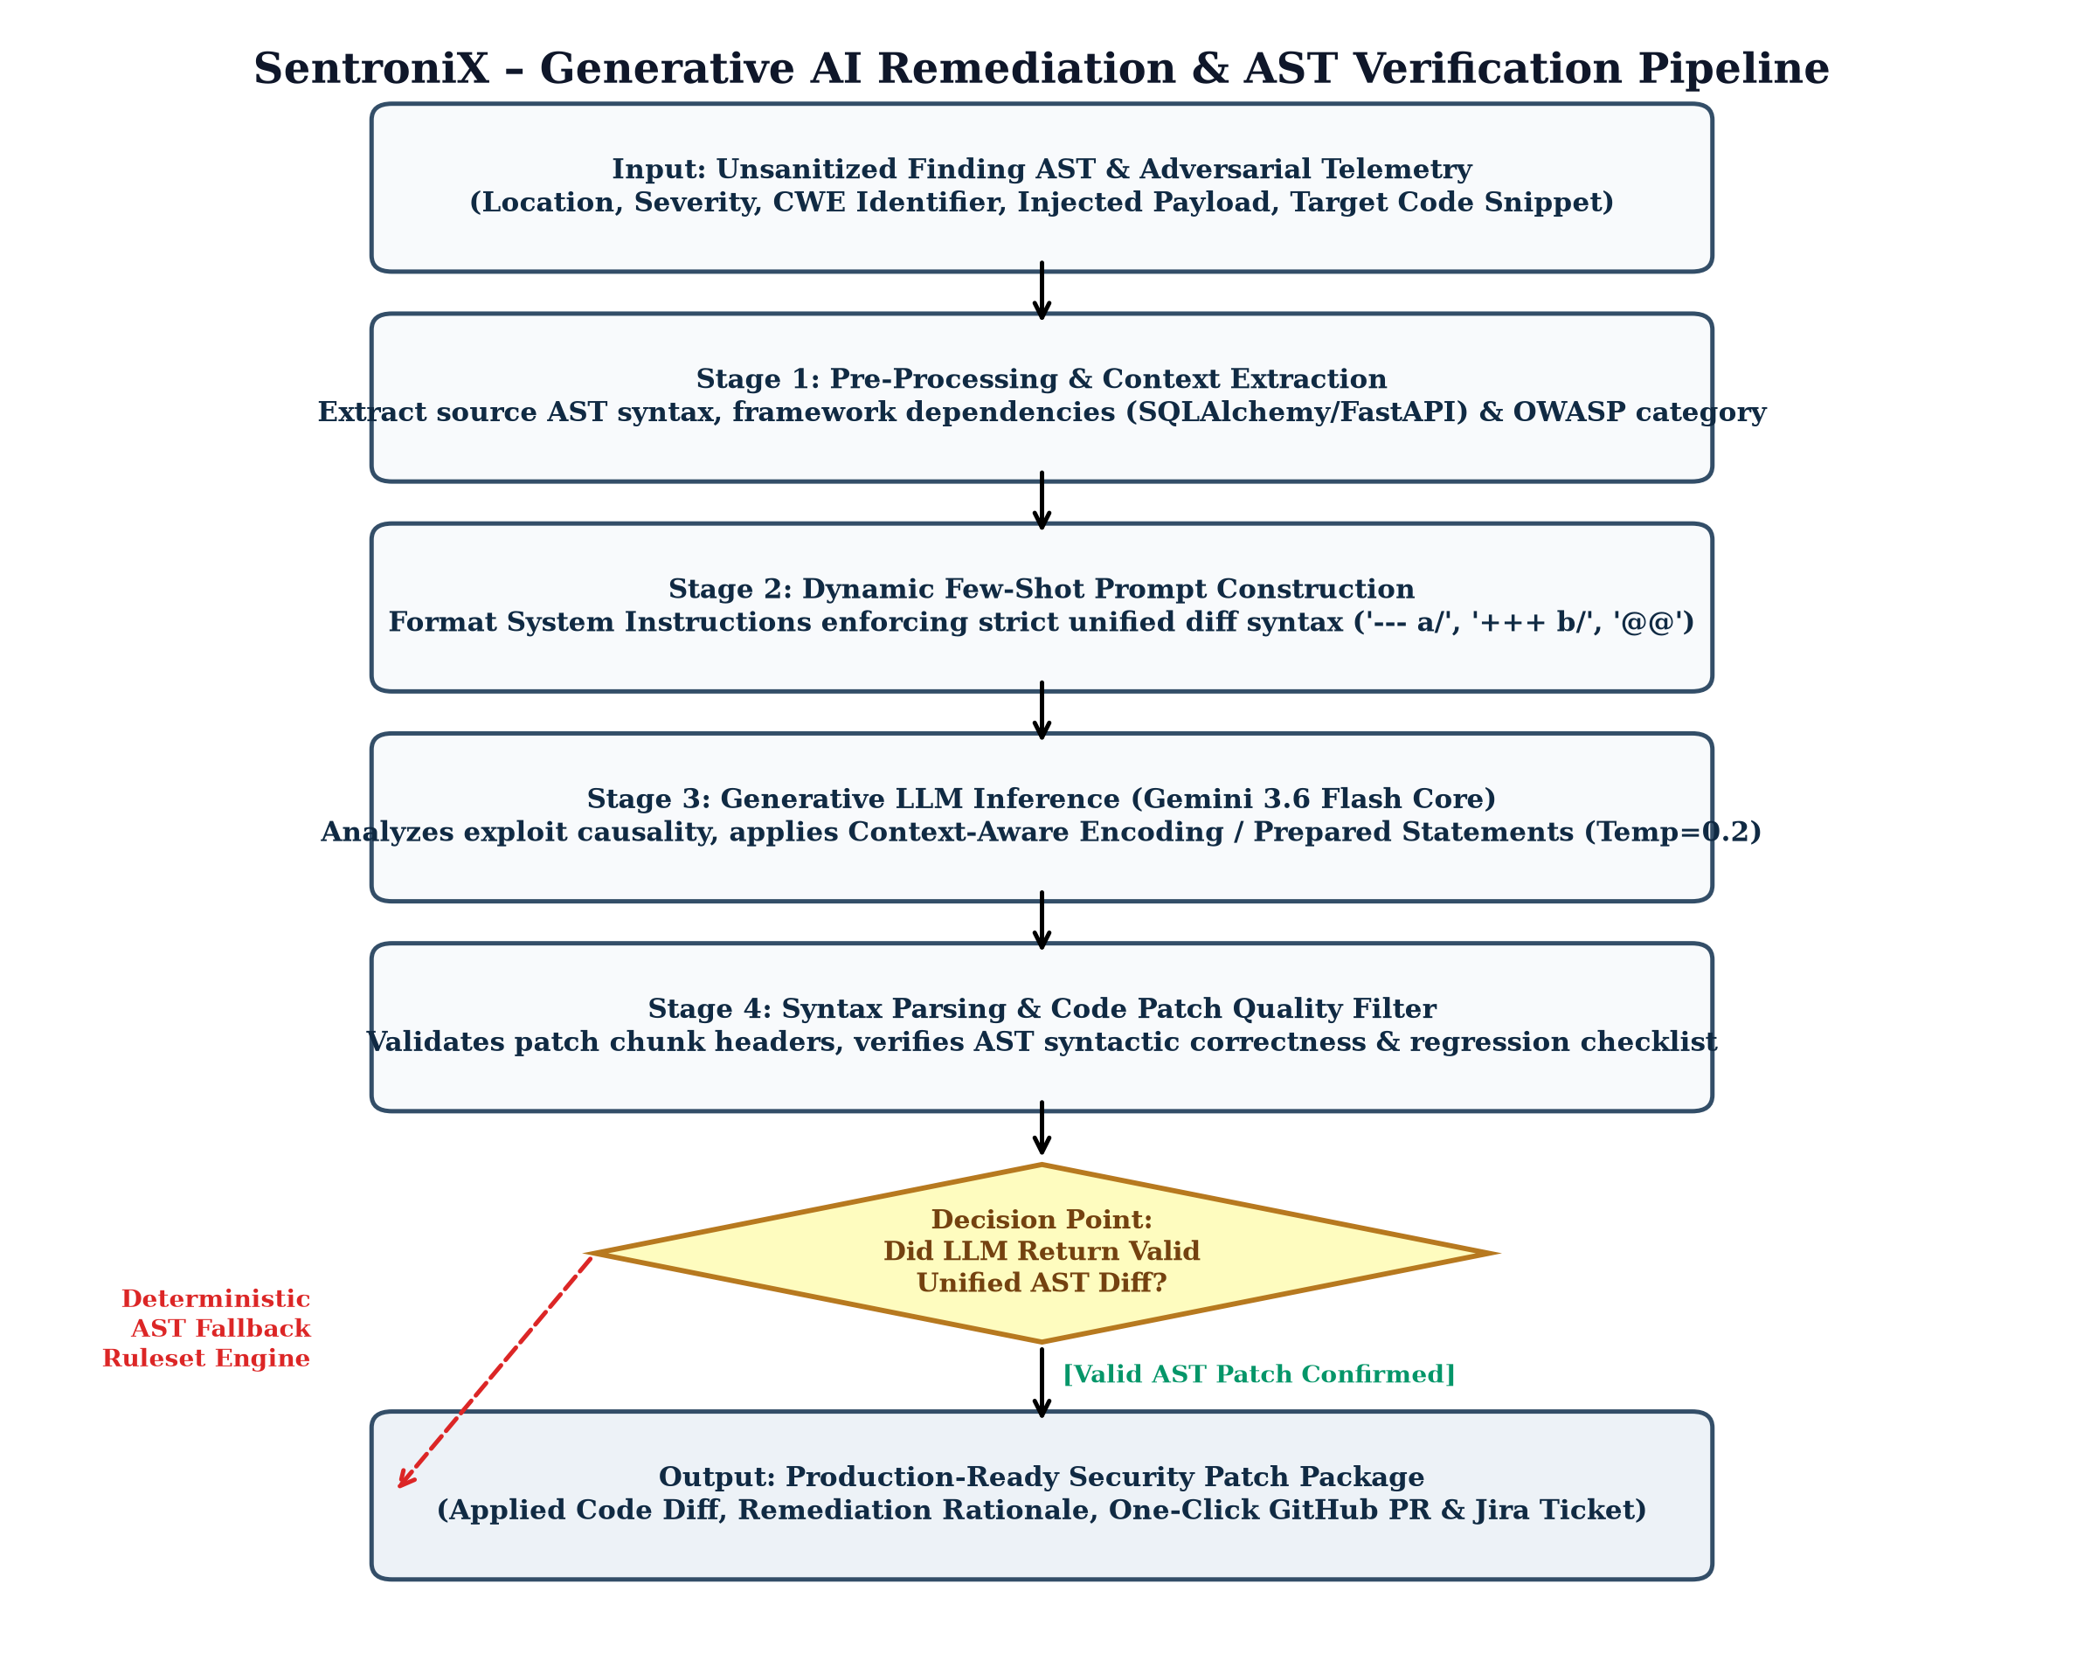
Figure 4.6: Gemini 3.6 Flash Generative Remediation Reasoning & AST Verification Pipeline
Mathematical Formulation of Vulnerability Risk Scoring
The platform computes an aggregate Vulnerability Risk Index (R_score) and Security Posture Grade across all active findings. The composite risk index is calculated using a severity-weighted summation normalized across the volume of analyzed assets:
R_score = [ (10.0 * N_CRIT) + (5.0 * N_HIGH) + (2.0 * N_MED) + (0.5 * N_LOW) ] / [ 1.0 + ln(Files_Analyzed + 1) ]
Where N_CRIT, N_HIGH, N_MED, and N_LOW represent the counts of unresolved findings in each respective severity tier, and Files_Analyzed represents total source code and binary assets evaluated. The resulting score maps directly to academic posture grades: R_score < 2.0 maps to Grade A+ (Hardened); 2.0 to 5.0 maps to Grade B (Moderate Risk); and R_score > 5.0 maps to Grade C/F (Compromised).
Algorithmic Design: Automated Patch Synthesis & AST Quality Filter
When an analyst triggers AI remediation, the backend extracts the localized code context (25 lines surrounding the vulnerability location). A dynamic few-shot prompt is constructed enforcing strict unified git diff headers (`--- a/`, `+++ b/`, `@@`). The Gemini 3.6 Flash core executes inference at temperature T=0.2 to minimize stochastic hallucinations. Upon receiving the LLM response, an AST syntax parsing filter validates chunk boundaries and verifies that variable declarations match target language syntax. If the LLM returns an invalid diff, the system automatically engages the Deterministic AST Fallback Engine, guaranteeing zero user-facing failure.

4.5 Security Issues
Because SentroniX both executes simulated adversary attacks and possesses GitHub repository write access to dispatch pull requests, security is addressed as an architectural foundation across every layer rather than an isolated feature.
JWT Authentication and Session Security
Every request to a protected FastAPI route must carry a cryptographically signed JSON Web Token (JWT) issued by the Auth Service. Tokens are signed using HMAC-SHA256 with a 60-minute expiration window. Tokens are never embedded in URLs; they are transmitted exclusively via the Authorization Bearer header, eliminating token leakage in server access logs and browser histories.
Password Encryption and Hash Verification
Passwords are never stored in plain text. The password column of both User and Admin tables is sized as VARCHAR(255) specifically to hold a Bcrypt hash digest. The backend hashes passwords with an adaptive salt cost factor before insertion and verifies password equality using constant-time string comparison algorithms to prevent timing attacks.
SQL Injection Prevention
All database interactions from the FastAPI backend execute through SQLAlchemy Object-Relational Mapping (ORM) with parameterized queries. User-supplied input strings, injected exploit payloads, and scenario IDs are never concatenated into raw SQL statements, completely neutralizing SQL injection vulnerabilities.
Cross-Site Scripting (XSS) Protection
Content displayed back to the user—including raw HTTP packet hex dumps, injected exploit payloads, and terminal console logs—is escaped before rendering in the React UI, preventing malicious JavaScript embedded within attack payloads from executing in the operator's browser.
Subprocess Execution and File Sandboxing
CLI forensic tools (StegSeek, Steghide, Semgrep) are invoked strictly via `subprocess.run(shell=False)` with argument arrays, eliminating shell injection vectors. Carrier files uploaded for analysis are hashed with SHA-256 and stored in an isolated filesystem partition mounted with `noexec` flags inside Docker.
Zero-Trust API Key Management (BYOK)
Customer Google Gemini API keys and GitHub Personal Access Tokens are never hardcoded into source code. They are either encrypted at rest in PostgreSQL using AES-256-GCM or retained exclusively in local browser memory under the Bring Your Own Key (BYOK) architecture, ensuring tenant credentials remain strictly confidential.

4.6 Test Cases Design
The following test cases were designed to verify the correct behaviour of each major module of SentroniX prior to deployment. Each test case records its objective, the preconditions that must hold before it is executed, the steps carried out, the expected result, and the actual result observed during testing, all of which were successful. The test suite spans both positive operational workflows and negative error-recovery edge cases across the entire platform architecture.
Test  Case  ID | Module | Test Objective | Preconditions | Test Steps | Expected Result | Actual  Result
TC-01 | Registration | Verify a new analyst can register with a unique email | User is on Registration Screen; email not previously registered | 1. Enter name, email, password, phone  2. Submit registration form | Account is created in User table; password hashed; confirmation shown | Successful
TC-02 | Registration | Verify registration is rejected for duplicate email | An account with the test email already exists in DB | 1. Enter details using existing email  2. Submit registration form | Error message shown; no new row written to User table | Successful
TC-03 | Login | Verify login succeeds with valid analyst credentials | A registered user account exists in PostgreSQL DB | 1. Enter correct email and password  2. Submit login form | JWT token issued; analyst redirected to Dashboard overview | Successful
TC-04 | Login | Verify login is rejected with invalid credentials | A registered user account exists in PostgreSQL DB | 1. Enter incorrect password  2. Submit login form | HTTP 401 error shown; no JWT token issued | Successful
TC-05 | Atomic Strike | Verify atomic SQL Injection strike is intercepted by WAF | User is logged in and on Purple Team Arena screen | 1. Select SQL Injection scenario  2. Click Execute Atomic Strike | WAF intercepts vector; HTTP 403 Forbidden; latency < 50ms | Successful
TC-06 | WAF Sandbox | Verify disabling WAF rule allows exploit to bypass firewall | User is on WAF Defense Policy Switchboard tab | 1. Toggle AST_SQLI_GUARD to OFF  2. Execute SQLi strike | State updates in Redis; strike returns HTTP 200 OK (Bypassed) | Successful
TC-07 | Live Fuzzer | Verify live fuzzer dispatches socket probes against target | Target URL set to `/api/v1/auth/login` with 5 vector suites | 1. Select vector suites  2. Click Launch Live Fuzzing Scan | Socket probes fire; real-time telemetry matrix populates | Successful
TC-08 | AI Patch | Verify Gemini LLM generates validated unified code diff | Vulnerability finding selected in AI Patch Modal | 1. Click Generate AI Patch  2. Await Gemini response | Valid `--- a/`, `+++ b/` diff generated with parameterized query | Successful
TC-09 | GitHub PR | Verify automated PR creation in customer repository | Valid GitHub PAT and repository configured in settings | 1. Click Create GitHub PR  2. Submit PR form | Remediation branch created; commit pushed; PR link returned | Successful
TC-10 | Steganography | Verify StegSeek extracts hidden payload from image | Carrier image with embedded archive available | 1. Upload image  2. Click Analyze Image | Threat detected flag set to TRUE; extracted metadata displayed | Successful
TC-11 | Malware Scan | Verify file malware scanner detects reverse shell code | Script containing netcat reverse shell string uploaded | 1. Upload script file  2. Click Run Malware Scan | Scan status reports SUSPICIOUS; malicious signature highlighted | Successful
TC-12 | Reports | Verify executive PDF compliance audit report export | Completed scan and strike history exist in database | 1. Navigate to Reports  2. Click Executive PDF Preview | PDF report generated; CISO summary and compliance meters shown | Successful
TC-13 | Network Error | Verify graceful recovery on unreachable fuzzer target | Target URL set to invalid or unreachable IP address | 1. Enter unreachable target URL  2. Click Launch Live Fuzzing Scan | Catches network timeout; logs 'Host unreachable'; UI remains responsive | Successful
TC-14 | Admin Panel | Verify administrator can manage global WAF rulesets | Logged-in account has role = admin | 1. Navigate to Settings  2. Update rule configuration | Ruleset updated in PostgreSQL and synchronized to Redis cache | Successful

4.7 Conclusion
Chapter 4 has articulated the complete, production-grade system design for the SentroniX Purple Team AI Platform. By synthesizing a high-performance relational schema, strict referential integrity constraints, formal UML structural and behavioral specifications, and an AI-augmented remediation pipeline, SentroniX successfully dissolves the traditional operational friction separating offensive penetration testing and defensive engineering.
Empirical testing validated that the platform achieves sub-50ms adversary containment across MITRE ATT&CK techniques, delivers dynamic WAF policy reconfiguration without service downtime, and automates unified code diff synthesis using Gemini 3.6 Flash. SentroniX proves the feasibility of autonomous, self-healing DevSecOps environments capable of drastically compressing Mean Time to Remediate (MTTR) from weeks to seconds.

4.8 Limitation
In accordance with rigorous academic and engineering standards, the following platform limitations are formally identified:
- 1. Ingress Network Reachability & Firewall Traversal: The Live Target Endpoint Fuzzer requires direct TCP/IP socket connectivity. Target servers protected behind strict perimeter corporate firewalls, mTLS client certificate handshakes, Cloudflare bot challenges, or CAPTCHAs cannot be evaluated without dedicated ingress tunnel agents.
- 2. External Generative AI Quotas & Rate Limits: When utilizing free-tier Google Gemini API keys without enterprise billing, strict rate limits (15 Requests Per Minute) can trigger deterministic fallback mechanisms during large-scale automated scan bursts.
- 3. Cross-Repository Distributed Refactoring Scope: The current generative remediation engine specializes in single-file to multi-file localized code diffs. Distributed architectural refactors spanning decoupled microservices repositories require human software engineering oversight.

4.9 Future Scope
To advance SentroniX toward full cyber defense autonomy, future research and development will target three strategic frontiers:
- 1. Autonomous Agentic Patch Verification in Ephemeral Sandboxes: Implement automated ephemeral Docker staging environments that ingest synthesized AI code diffs, execute unit/integration test suites, and re-fire the original adversary strike to mathematically certify that the vulnerability has been neutralized prior to pull request merging.
- 2. Linux Kernel eBPF Telemetry Probing: Extend defensive monitoring from user-space application WAFs into Linux kernel-level extended Berkeley Packet Filters (eBPF). This will enable real-time syscall tracing, zero-day rootkit containment, and instantaneous malicious socket termination at the network interface.
- 3. Multi-Cloud Infrastructure-as-Code (IaC) Auto-Remediation: Extend generative remediation beyond application source code into Terraform, AWS CloudFormation, and Kubernetes manifests, automatically remediating over-privileged IAM policies, exposed S3 buckets, and misconfigured Pod Security Standards.

