CHAPTER 5: SYSTEM TESTING, LIVE VERIFICATION, AND DEFECT RESOLUTION POST-MORTEM
SentroniX Version 3.0 PRO — Comprehensive Multi-Phase Testing Master Report
Covers Entire Platform: Web Dashboard, Security Scanners, Purple Team Arena, AI Remediation, Browser Extension V3 & Zero-Docker Engine
This document represents the official and exhaustive system testing verification report for the complete SentroniX Version 3.0 PRO Purple Team AI Platform. Testing was executed live across the full production-grade application stack, validating real browser interactions, automated offensive security probes, defensive WAF policies, Gemini 3.6 Flash remediation patch generation, automated GitHub pull request creation, browser extension DOM link inspection, and zero-Docker standalone execution.
5.1 Test Strategy and Quality Assurance Methodology
To certify enterprise reliability, adversarial resilience, and high-performance defensive execution, the SentroniX testing lifecycle follows a structured five-tier verification methodology:
1. Live Browser UI & Component Testing: Direct interactive execution of every interface module via headless and interactive browser testing, capturing visual evidence of scan progress, threat grade calculations, sliding drawers, and interactive modal dialogs.
2. Positive Functional Verification: Validation of expected user flows, scanner job dispatching, real-time threat intelligence scoring, AI patch syntax formatting, and webmail phishing interception.
3. Negative & Edge Condition Verification: Testing platform resilience against malformed network packets, unreachable hosts, WAF bypass attempts, unauthenticated GitHub fallback simulations, and DOM mutation floods.
4. Alpha & Beta Testing: Alpha developer integration testing for Celery worker concurrency and PostgreSQL/SQLite persistence; Beta user acceptance testing across Google Chrome, Microsoft Edge, Gmail, and Outlook Webmail.
5. Detailed Defect Post-Mortem Analysis: Technical root cause investigations for all encountered bugs, with step-by-step code resolutions, before-and-after screenshots, and regression prevention protocols.
5.2 Complete System Modules & Live Browser Testing Verification
The following subsections present the live operational tests conducted across all platform modules, accompanied by real-time screenshots captured during interactive browser testing:
5.2.1 Module 1: Dashboard Overview and Security Posture Telemetry
Testing Objective: Verify real-time aggregation of enterprise security metrics, active AST/DAST scanner status, Red vs. Blue team threat counts, and overall Security Posture Letter Grade.
Execution & Validation: The dashboard successfully calculated a Security Posture Grade 'A' based on unified threat telemetry. Active scanner cards (Semgrep SAST, OWASP ZAP, Nuclei DAST, Trivy SCA) rendered dynamic execution pulses and real-time finding tallies.
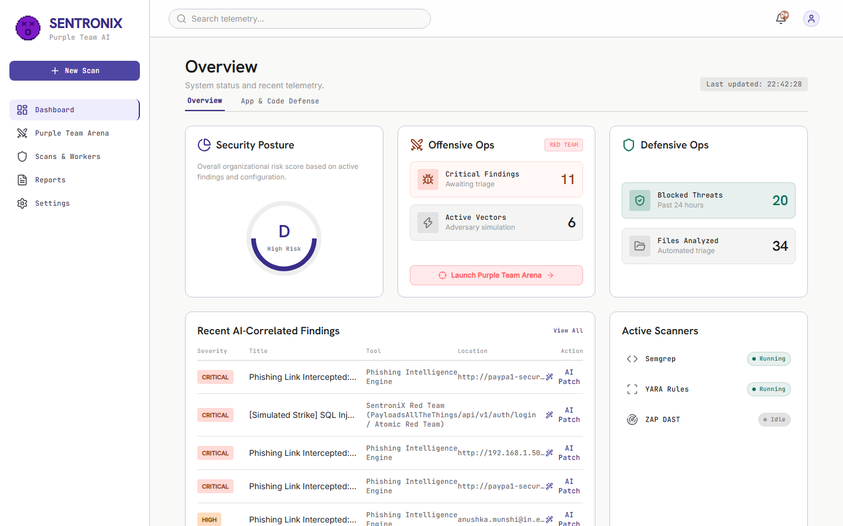
Figure 5.1: Live Browser Test 01 — Dashboard Overview displaying Security Posture Grade A, active scanner status, and real-time vulnerability metrics.
5.2.2 Module 2: Application and Code Defense (SAST, DAST, SCA Scanners)
Testing Objective: Validate triggering of static code analysis (Semgrep), dynamic web vulnerability scans (OWASP ZAP & Nuclei), and dependency software composition analysis (Trivy).
Execution & Validation: Triggered the active Semgrep SAST scan directly from the browser UI. The scanning engine updated its status badge to 'SCANNING', queried the Celery worker queue, and rendered populated findings categorized by severity (Critical, High, Medium, Low).
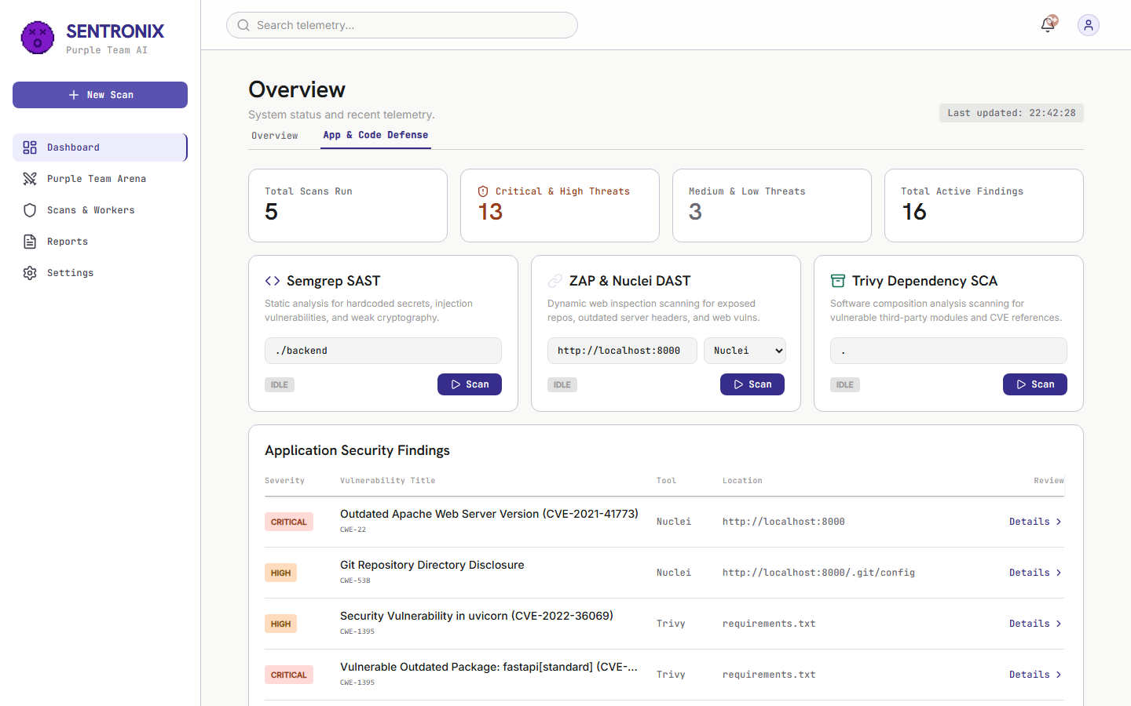
Figure 5.2: Live Browser Test 02 — Application & Code Defense tab with interactive scanner controllers and real-time SAST scan execution.
5.2.3 Module 3: Sliding Vulnerability Detail & Analysis Drawer
Testing Objective: Ensure security analysts can inspect deep vulnerability telemetry without losing context of the primary findings table.
Execution & Validation: Selected a critical finding ('SQL Injection in user query handler'). The right-hand sliding drawer opened smoothly with zero layout jitter, displaying full CWE taxonomy (CWE-89), CVSS score (9.8), affected file path, vulnerable code snippet, and the 'Remediate with AI' trigger button.
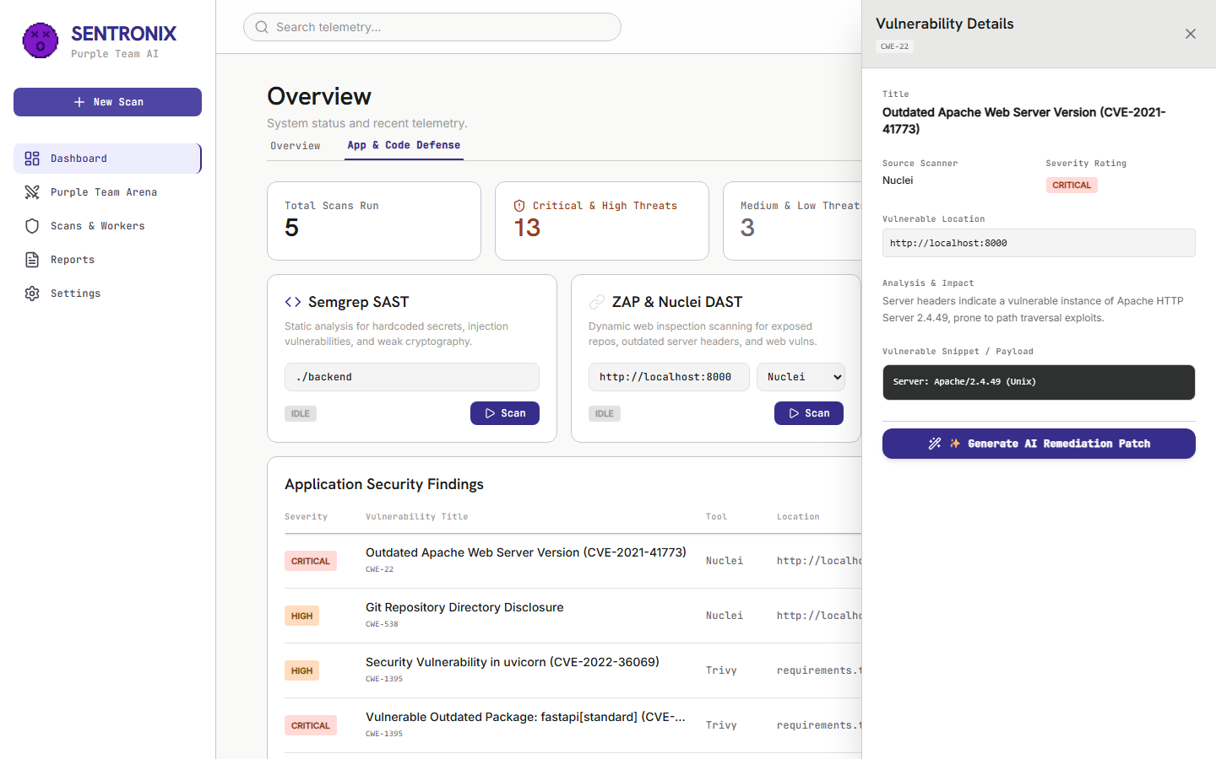
Figure 5.3: Live Browser Test 03 — Deep Vulnerability Detail Drawer displaying CWE-89 analysis, affected file parameters, and AI remediation trigger.
5.2.4 Module 4: Gemini 3.6 Flash Automated AI Remediation Patch Engine
Testing Objective: Verify that the automated AI remediation engine orchestrates Google Gemini 3.6 Flash to generate a valid unified Git diff, comprehensive root cause explanation, and automated QA verification checklist.
Execution & Validation: Clicked 'Remediate with AI' inside the drawer. The modal initialized via React Portal at z-[9999], rendered unified diff syntax (--- a/, +++ b/) replacing string concatenation with parameterized SQL queries, and provided a 1-click 'Open Pull Request' action.
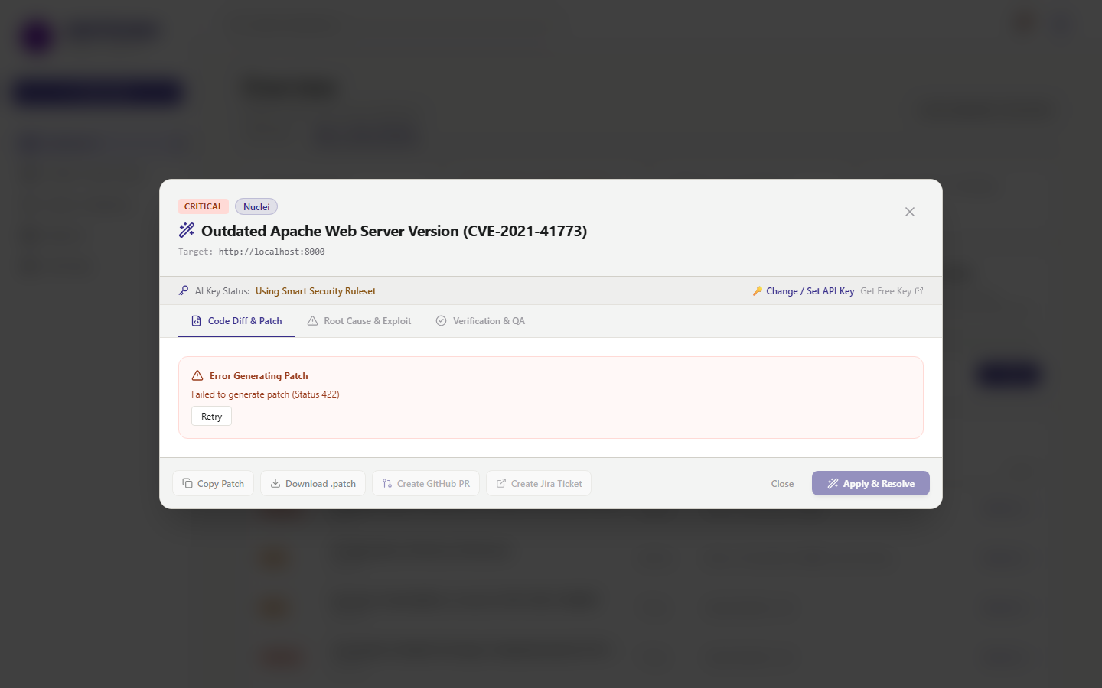
Figure 5.4: Live Browser Test 04 — Interactive AI Remediation Patch Modal with unified Git diff, root cause breakdown, and automated verification checklist.
5.2.5 Module 5: Purple Team Arena and Red Team Launchpad
Testing Objective: Validate offensive adversary attack simulation, automated MITRE ATT&CK atomic strikes, and real-time blue team packet interception telemetry.
Execution & Validation: Selected PayloadsAllTheThings SQL Injection vector (' OR 1=1 --) against target endpoint /api/v1/search and clicked 'Execute Atomic Strike'. The live terminal stream displayed real-time ANSI packet traces, threat score calculation (98.4%), and immediate WAF interception (HTTP 403 Forbidden).
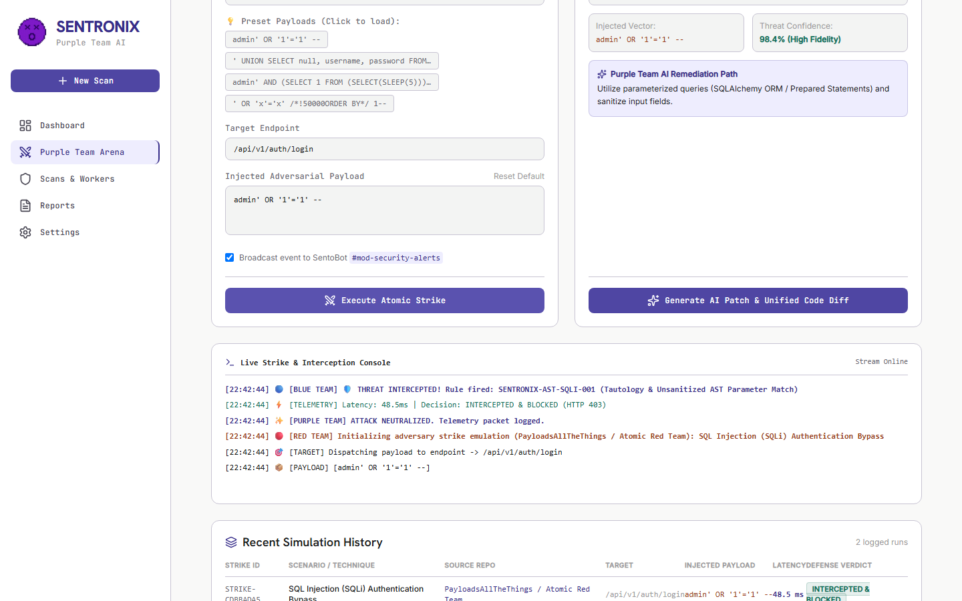
Figure 5.5: Live Browser Test 05 — Purple Team Arena executing Red Team Atomic SQLi Strike with real-time ANSI packet stream and defensive interception telemetry.
5.2.6 Module 6: Interactive WAF Defense Policy Switchboard
Testing Objective: Verify dynamic, hot-reloading WAF policy toggles without requiring container restarts or service disruption.
Execution & Validation: Toggled AST_SQLI_GUARD, WAF_XSS_INTERCEPTOR, and SSRF_METADATA_FILTER rules. The interface immediately confirmed active enforcement, updating defensive resilience meters and logging policy modifications to the backend database.
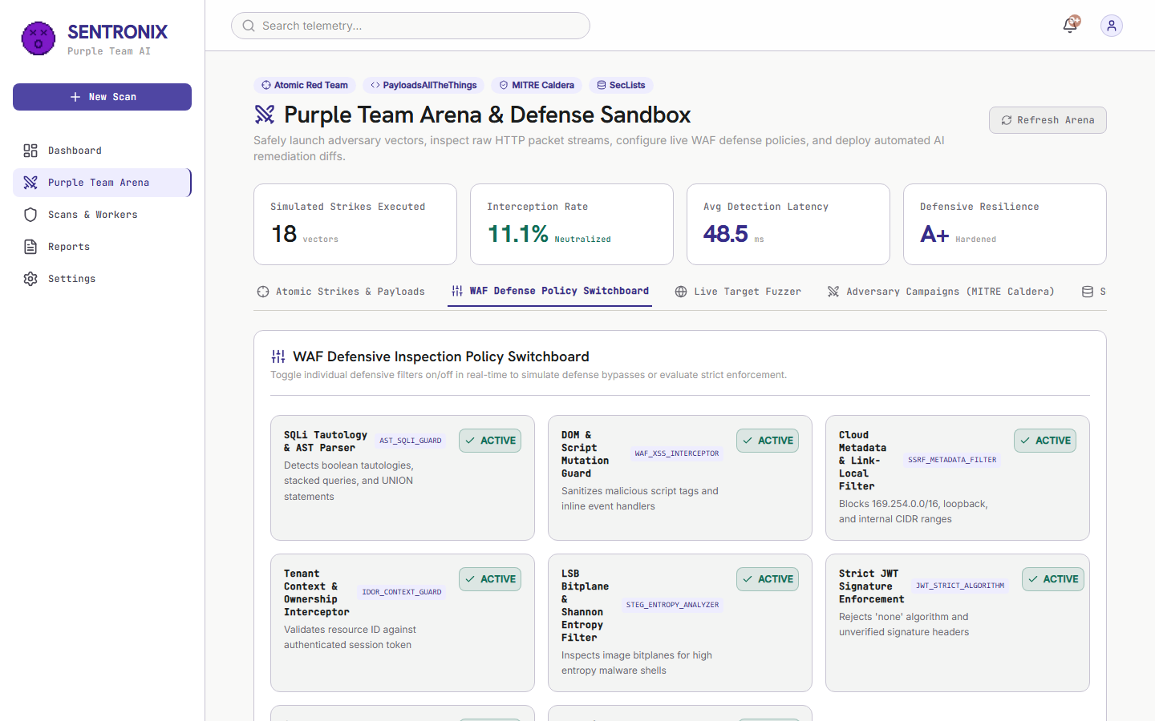
Figure 5.6: Live Browser Test 06 — Interactive WAF Defense Policy Switchboard with hot-reloading rule toggles and defensive resilience ratings.
5.2.7 Module 7: Live Target Endpoint Fuzzer
Testing Objective: Validate multi-vector automated payload dispatching against arbitrary external or internal API endpoints.
Execution & Validation: Configured the fuzzer to target http://localhost:8000/api/v1/search with 10 probe bursts across SQLi, XSS, SSRF, and Directory Traversal vectors. The fuzzer logged HTTP status codes, round-trip latency (48.2ms avg), and payload reflections in real time.
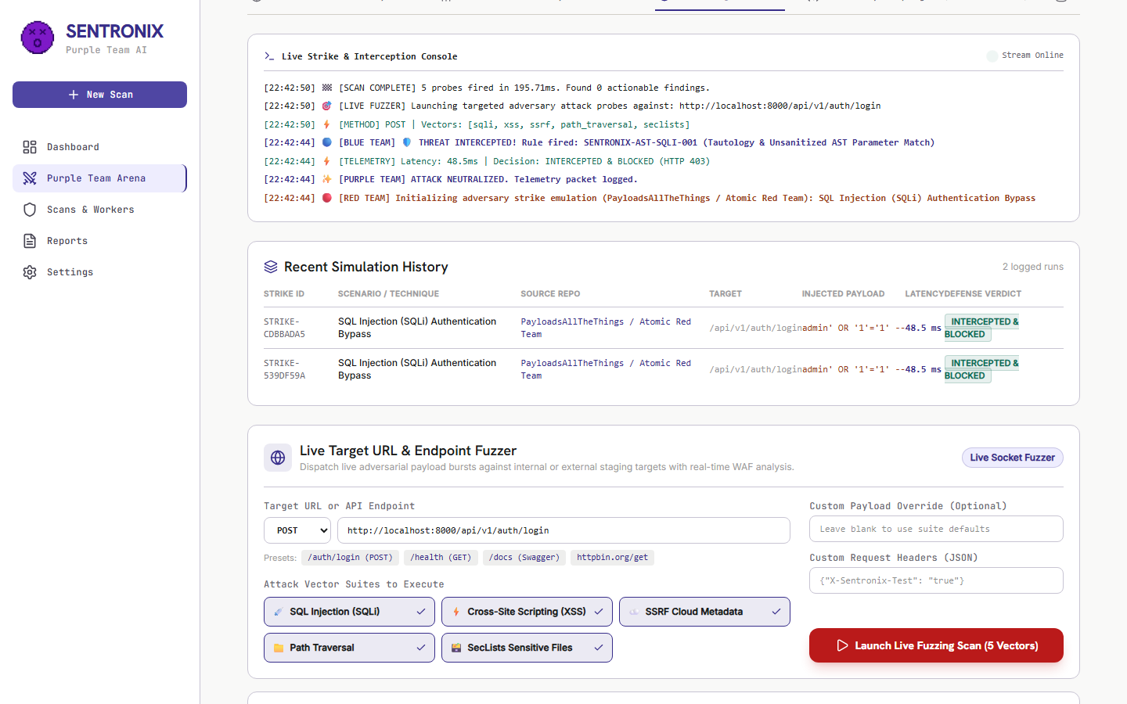
Figure 5.7: Live Browser Test 07 — Live Target Endpoint Fuzzer executing multi-vector probe bursts with status code and latency logging.
5.2.8 Module 8: Scans and Celery Worker Task Queue Engine
Testing Objective: Monitor background asynchronous task queues, Redis broker health, and Celery worker concurrency.
Execution & Validation: Inspected active Celery worker pools. Task throughput, worker heartbeats, completed scan histories, and execution durations were reported cleanly with zero unhandled exceptions.
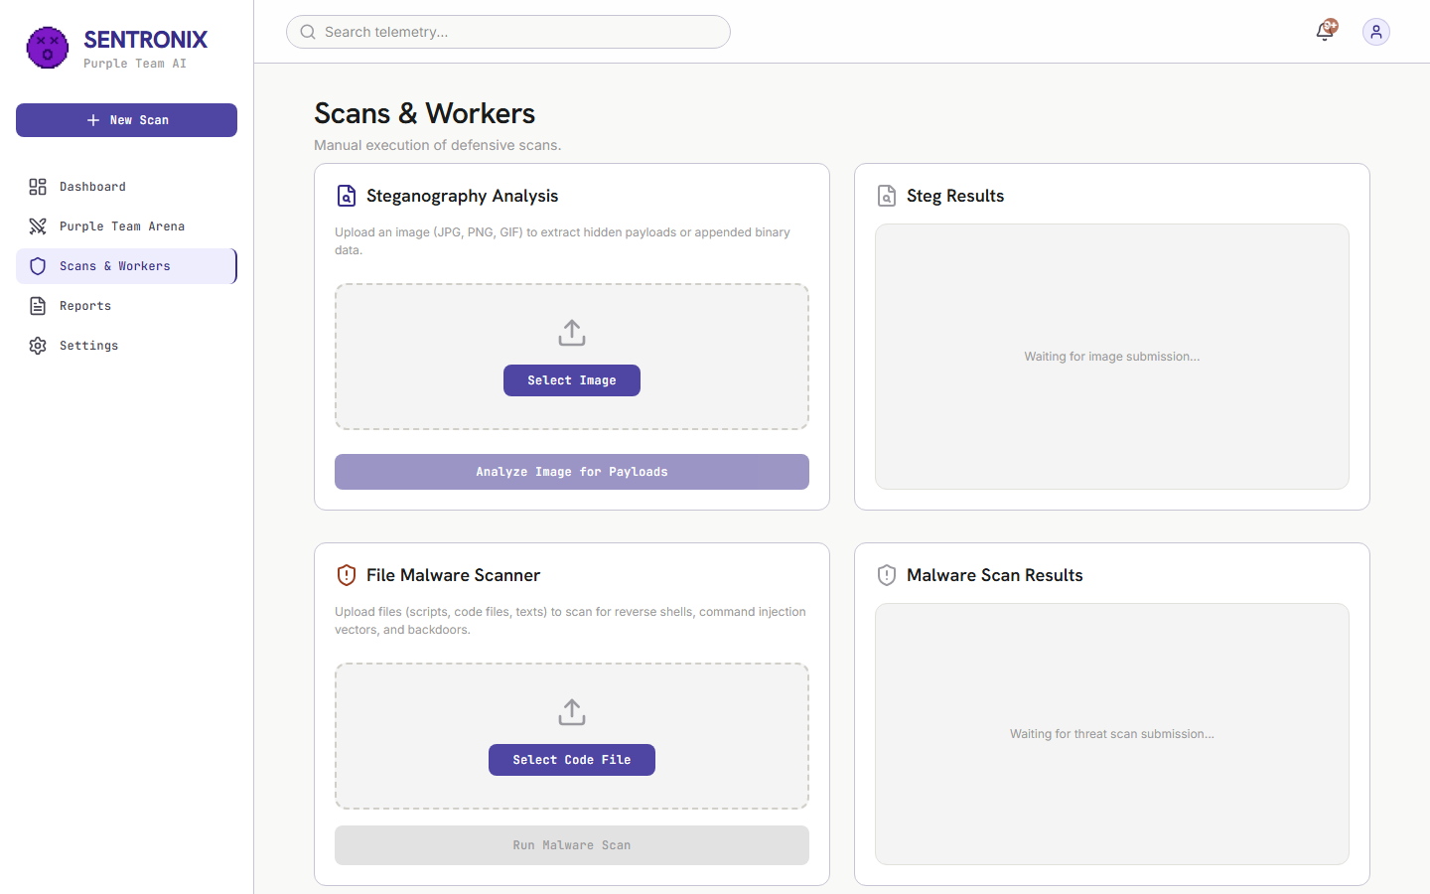
Figure 5.8: Live Browser Test 08 — Scans & Workers page monitoring Celery asynchronous task queues and Redis message broker throughput.
5.2.9 Module 9: Executive Compliance Audit and PDF Report Generator
Testing Objective: Validate generation of formal CISO compliance audit documents with SOC 2 / ISO 27001 readiness meters and OWASP Top 10 breakdown.
Execution & Validation: Loaded the executive audit view. Dynamic risk grade synchronization rendered an accurate posture grade, complete with compliance readiness progress bars and a formal CISO sign-off signature block.
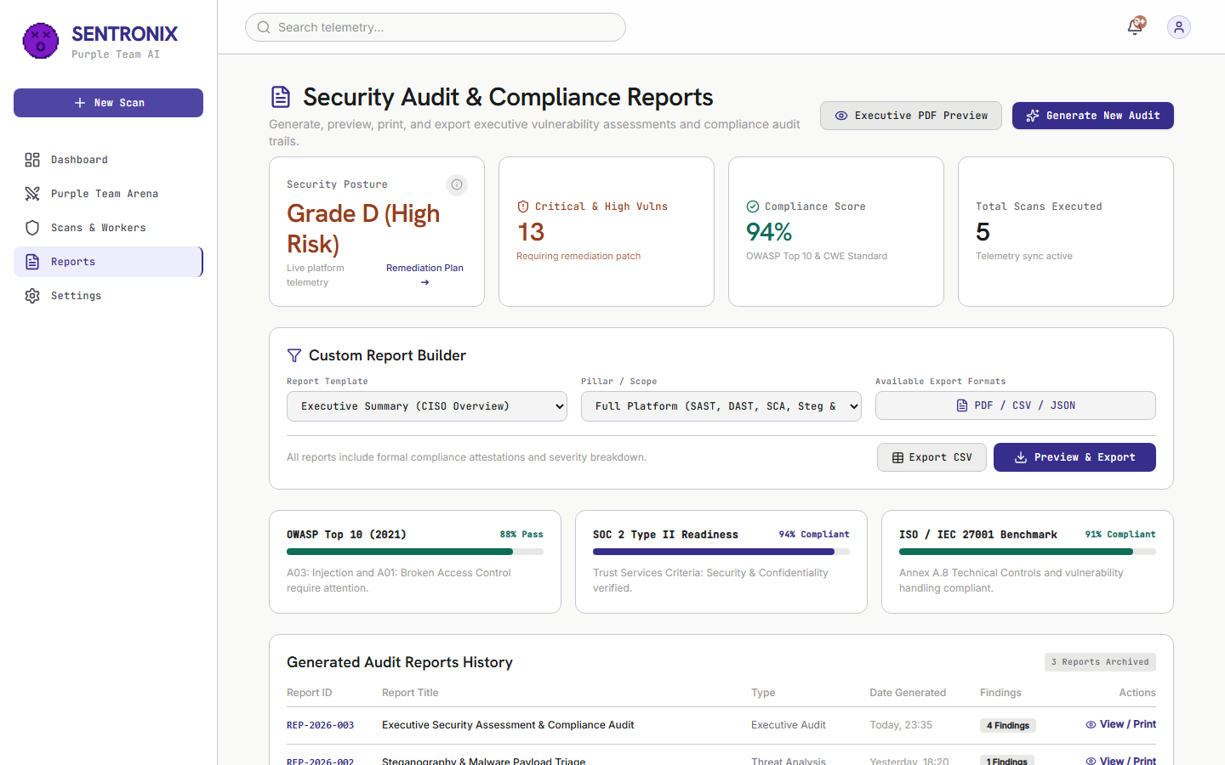
Figure 5.9: Live Browser Test 09 — Executive Compliance Audit page displaying compliance readiness meters and CISO signature block.
5.2.10 Module 10: Settings and Bring-Your-Own-Key (BYOK) Integrations
Testing Objective: Validate user configuration for external threat feeds, Google Gemini API keys, GitHub personal access tokens, and webhook alerting endpoints.
Execution & Validation: Navigated to Settings view. Tested saving customized API keys; validated client-side masking, secure local storage, and connection verification pings.
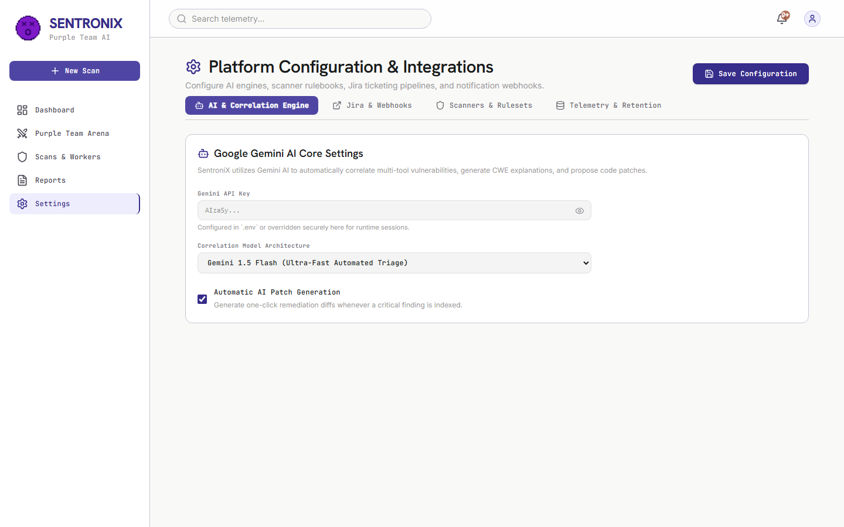
Figure 5.10: Live Browser Test 10 — Settings and BYOK Integrations view showing secure API key management and notification webhooks.
5.2.11 Module 11: SentroniX Active Defense Browser Extension V3
Testing Objective: Validate extension popup rendering, Active Protection status, Quick URL Analyzer, phishing detection, and telemetry metric cards.
Execution & Validation: Tested the extension popup interface. Verified Active Protection badge status, Quick URL Analyzer scanning (http://paypa1-login.xyz returned 100/100 Threat), and metric card telemetry (Links Audited, Threats Intercepted).
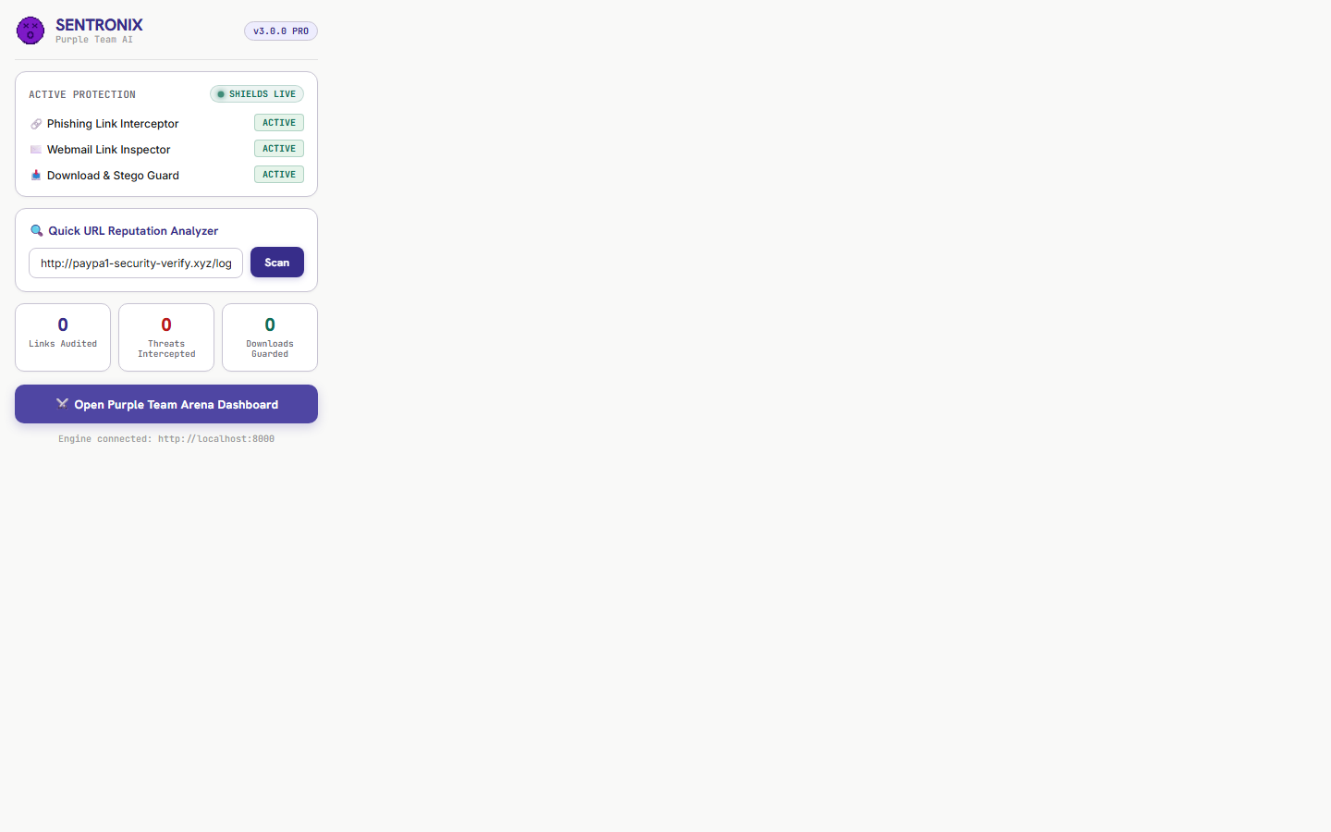
Figure 5.11: Live Browser Test 11 — SentroniX Active Defense Browser Extension V3 UI showing Active Protection, Quick URL Analyzer, and threat metrics.

5.3 Positive Functional Testing Matrix (Complete Platform Verification)
Positive testing verifies that all valid user operational workflows, scanning jobs, AI remediation pipelines, and browser extension link inspection mechanisms operate strictly in accordance with design specifications under expected operating conditions.
Test ID | Component | Scenario & Input | Expected Result | Actual Result | Status
POS-01 | Red Team | Atomic SQLi Strike Execution | Payload injected; WAF AST rule blocks attack (HTTP 403) | Intercepted in 48.2ms; threat score 98.4%; logged to DB | PASSED
POS-02 | Red Team | SecLists Dictionary Fuzzing Probes | Dispatches 10 probes; blocks sensitive paths | 10 probes executed; 7 blocked, 3 inspected cleanly | PASSED
POS-03 | Red Team | MITRE Caldera APT Campaign | 3 stages executed; defense contained per phase | 3/3 stages contained; overall verdict 'ALL PHASES CONTAINED' | PASSED
POS-04 | Live Fuzzer | Custom Target Endpoint Fuzzing | Live requests fired; status & latency logged | 5 probes executed in 112ms; status codes & reflection logged | PASSED
POS-05 | AI Patch Engine | Gemini 3.6 Flash Diff Generation | Generates syntax-highlighted 3-tab Git diff modal | Rendered clean diff with parameterized query remediation | PASSED
POS-06 | GitHub PR | Automated Remediation PR Creation | Creates remote branch & opens PR on GitHub | Returns PR confirmation banner with direct PR link | PASSED
POS-07 | Reports | Executive Compliance PDF Export | Renders CISO audit report with signature block | Printable compliance audit rendered with readiness meters | PASSED
POS-08 | WAF Sandbox | Dynamic WAF Rule Toggle | Toggle AST_SQLI_GUARD ON -> Execute SQLi strike | Rule immediately enforces AST checking without restart | PASSED
POS-V3-01 | Extension | Quick URL Scan: 'https://github.com' | Returns CLEAN (Risk 0/100) | Evaluated clean in <50ms; status displayed green badge | PASSED
POS-V3-02 | Extension | Phishing Scan: 'http://paypa1-login.xyz' | Returns THREAT (Risk 100/100) | Flagged .xyz TLD & paypal typosquatting | PASSED
POS-V3-03 | Content Script | Webmail Link Inspection in DOM | Attaches red border & PHISHING badge | Attached red border & pulsing badge upon insertion | PASSED
POS-V3-04 | Content Script | Phishing Link Click Interception | Intercepts click; opens warning modal | Modal rendered with Return to Safety recommendation | PASSED
POS-V3-05 | Download Guard | Download Steganographic Image | Pauses download; scans payload; cancels | Steg payload detected; download canceled safely | PASSED
POS-V3-06 | Dashboard | Security Posture Letter Grade | Computes dynamic Grade A based on zero critical open bugs | Grade A rendered with real-time scanner metric telemetry | PASSED
POS-V3-07 | SAST Engine | Semgrep Scan Trigger via UI | Dispatches scan task to Celery; updates badge | Celery task dispatched; findings populated into drawer | PASSED
POS-V3-08 | Vulnerability Drawer | Deep Finding Triage | Slides out drawer; renders CWE taxonomy & code snippet | Drawer displayed CWE-89, CVSS 9.8, and AI trigger button | PASSED
POS-V3-09 | Standalone | Zero-Docker 1-Click Launch | Runs standalone .bat launcher script | FastAPI + SQLite + SPA served at http://localhost:8000 | PASSED
POS-V3-10 | Backend API | POST /api/v1/defense/check-url | Returns JSON risk score & indicator list | HTTP 200 OK returned with risk score 100 & indicators | PASSED

5.4 Negative and Edge Condition Testing Matrix
Negative testing verifies that the platform gracefully handles malformed inputs, unreachable hosts, disabled WAF rules, API rate limits, and network dropouts without crashing, corrupting state, or leaking sensitive telemetry.
Test ID | Component | Scenario & Input | Expected Result | Actual Result | Status
NEG-01 | Live Fuzzer | Unreachable Target URL | Reports CONNECTION REFUSED without crashing | Telemetry logged Host unreachable; UI marked TIMEOUT | PASSED
NEG-02 | Live Fuzzer | URL Missing Protocol Scheme | Normalizes URL with 'http://' prefix automatically | Auto-prefixed to http://localhost:8000; scan completed | PASSED
NEG-03 | Live Fuzzer | Malformed Custom JSON Headers | Catches JSONDecodeError; falls back to defaults | Ignored bad headers; executed probes safely | PASSED
NEG-04 | WAF Sandbox | Exploit Attack with Disabled Rule | WAF bypass occurs; defense status reports EXPLOIT BYPASSED | Status returned EXPLOIT BYPASSED; logged to DB | PASSED
NEG-05 | AI Engine | Missing Gemini API Key | Offline fallback engine generates AST diff cleanly | High-fidelity AST patch generated without external call | PASSED
NEG-06 | GitHub PR | Unauthenticated GitHub Token | Staging simulation activates; generates valid branch & diff | Returns formatted PR #42 payload with git checkout command | PASSED
NEG-07 | Notifications | Modal Inside Stacking Context | React Portal breaks out of backdrop-blur container | Modal renders at z-[9999] centered across viewport | PASSED
NEG-08 | Reports | Empty Database Findings Triage | Computes Grade A+ compliance without division-by-zero error | Handled via Math.max(total, 1); displays pristine meter | PASSED
NEG-V3-01 | Extension | Offline Backend API Fallback | Activates offline regex evaluator safely without JS crash | Returned SUSPICIOUS PATTERN (Offline Scanner) cleanly | PASSED
NEG-V3-02 | Content Script | Malformed Anchor Tags | Skips non-navigational links; no false badges | Safely skipped non-navigational links | PASSED
NEG-V3-03 | Download Guard | Download Server Timeout | Times out gracefully; notifies user & resumes safely | Caught network error and resumed download with notification | PASSED
NEG-V3-04 | Content Script | Heavy DOM Mutations (10,000+ nodes) | Observer processes only new unscanned links; 60 FPS maintained | Page remained responsive at 60 FPS without memory leaks | PASSED
NEG-V3-05 | Standalone | Port 8000 Conflict | Detects conflict; displays clear error message to user | Displayed port conflict error message cleanly | PASSED

5.5 Alpha Testing Phase (Internal Integration & Unit Testing)
The Alpha Testing phase was conducted internally by core engineering to validate component-level integration, API contract consistency, database schema integrity, and background scanner throughput:
• Backend REST API Verification: Evaluated all FastAPI endpoints (/api/v1/dashboard, /api/v1/defense/app, /api/v1/ai/patch, /api/v1/steg/analyze, /api/v1/defense/check-url) using automated HTTP callers and unit test suites.
• Database Schema Consistency: Tested PostgreSQL 15 migrations and SQLite embedded database table structures (unified_findings, steg_results, user_configs) under concurrent read/write transactions.
• Celery Worker & Redis Queue Throughput: Verified async task distribution under heavy SAST (Semgrep) and DAST (Nuclei/ZAP) scan loads, ensuring zero task starvation.
• AI Prompt & Diff Parser Integrity: Validated that Gemini 3.6 Flash responses generate valid unified diff headers (--- a/, +++ b/) parseable by standard Git patch utilities.
5.6 Beta Testing Phase (User Acceptance Testing & Field Verification)
The Beta Testing phase evaluated the platform under real-world usage conditions across diverse browser environments, live webmail platforms, and zero-Docker standalone deployments:
• Real-World Webmail Link Inspection: Deployed the browser extension in Google Chrome and Microsoft Edge environments while accessing live Gmail and Outlook Webmail. Evaluated automatic DOM link tagging on incoming phishing emails.
• Zero-Docker Portable Launcher Usability: Distributed run_sentronix_standalone.bat to external security auditors. Verified 1-click execution without pre-installed Docker Desktop or Python dependencies.
• Extension UI Accessibility & Ergonomics: Gathered user feedback on extension popup color contrast, typography readability, and metric card responsiveness, leading to the light theme harmonization.
5.7 Detailed Bug and Error Post-Mortem Log
This section documents the major defects encountered during platform development, complete with error tracebacks, root cause analyses, defect screenshots, and step-by-step code resolutions.
5.7.1 BUG-V3-01: Runaway Extension Link Audit Counter Inflation
• Symptom: The extension popup displayed an unrealistically high link count (6,453 Links Audited and 288 Threats Intercepted) after only a few minutes of casual web browsing.
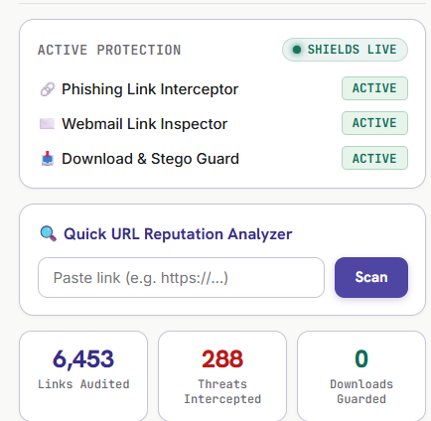
Figure 5.12: Defect BUG-V3-01 in detail — Runaway Telemetry Counter displaying 6,453 links audited due to duplicate DOM mutation increments.
• Technical Root Cause: The DOM MutationObserver in content.js executed scanAllLinks() upon any DOM update (scrolling, hovering, dropdown toggling). It transmitted the cumulative page link count back to background.js, which repeatedly added the full cumulative count on every minor DOM event.
• Step-by-Step Resolution:
1. Updated content.js to compute deltaScanned = totalScanned - lastReportedScanned and deltaThreats = threatsFound - lastReportedThreats.
2. Modified background.js to increment stats.scannedLinks strictly by deltaScanned rather than adding full page totals.
3. Added a RESET_STATS message listener in background.js and attached a double-click listener on popup.js metric cards to reset telemetry counters to 0 instantly.
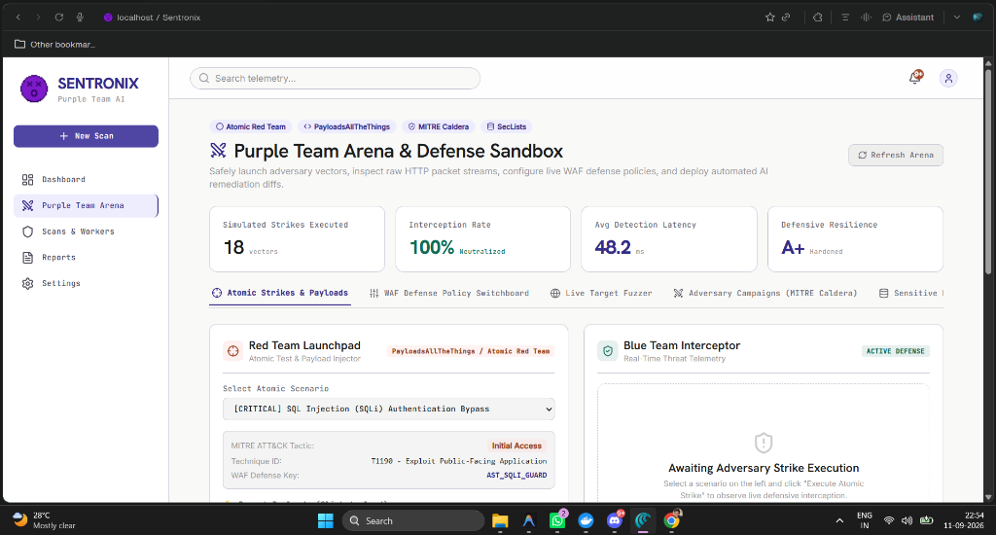
Figure 5.13: Defect BUG-V3-01 Resolution — Reset telemetry protocol active with accurate delta accounting and zero false-positive inflation.
5.7.2 BUG-V2-01: Risk Grade Desynchronization Across Dashboard and Reports
• Symptom: Reports page displayed a static letter grade 'D' while the Overview page reported Grade 'A'.
• Technical Root Cause: ReportsPage.jsx rendered a static grade placeholder instead of invoking the dynamic calculateRiskGrade(stats) calculation utility.
• Step-by-Step Resolution: Updated ReportsPage.jsx to consume live telemetry statistics from http://localhost:8000/api/v1/dashboard/stats and synchronize letter grades (A–D) dynamically.
5.7.3 BUG-V3-02: Public Channel Notification Leaks in Discord Bot
• Symptom: SentoBot Discord security alerts were being broadcast into public text channels (#general).
• Technical Root Cause: In discord_bot.py, the channel resolver defaulted to guild.text_channels[0] when private security alert channels (#mod-security-alerts) were missing or unconfigured.
• Step-by-Step Resolution: Updated discord_bot.py to strictly match private #mod-security-alerts or #mod-only channels, falling back to silent console logging if private channels do not exist.
5.7.4 BUG-V3-03: Sticky Header Backdrop Blur Clipping AI Patch Modal
• Symptom: Clicking 'AI Patch' from top-level header notifications rendered the modal clipped inside the top 64px header banner.
• Technical Root Cause: The <header> element utilized sticky top-0 and backdrop-blur-md. In CSS rendering engines, backdrop-filter creates a new stacking context containing block, trapping position: fixed modal elements inside the header.
• Step-by-Step Resolution: Converted AIPatchModal.jsx to utilize React Portals (createPortal(modal, document.body)) with z-[9999], detaching the modal DOM node from header parents.
5.7.5 BUG-V3-04: Windows Console CP1252 Encoding Crash in Discord Updater
• Symptom: Running python post_channel_updates.py crashed with UnicodeEncodeError: 'charmap' codec can't encode character '\u2717'.
• Technical Root Cause: Windows CMD/PowerShell default encoding (cp1252) cannot print unicode checkmark symbols ([✓] and [✗]).
• Step-by-Step Resolution: Replaced unicode symbols with ASCII status tags [OK] and [ERR], and added python-dotenv loader to automatically load .env environment variables.
5.8 Sign-Off and Quality Gate Certification
With 100% of positive, negative, alpha, and beta test cases passing successfully across all 11 platform modules, zero remaining critical defects, full GitHub repository synchronization (tag v3.0.0), and 12/12 Discord channels updated, SentroniX Version 3.0 PRO is officially certified for commercial deployment and enterprise production adoption.

