SENTRONIX: MASTER TEST PLAN, VERIFICATION MATRIX & DEFECT POST-MORTEM
Comprehensive Quality Assurance Across Platform Versions 1.0, 2.0 & 3.0 PRO
End-to-End System Testing, Live Browser Audits, Alpha/Beta Verification & Defect Resolution
Document ID | STX-TP-CONSOLIDATED-V1-V2-V3-FINAL
Project Name | SentroniX (Autonomous Purple Team & AI Threat Management Platform)
Software Versions Covered | Version 1.0 (Foundation), Version 2.0 (Purple AI), Version 3.0 PRO (Active Defense)
Testing Scope | Unit, Integration, Functional Positive, Adversarial Negative, Browser Automation, Alpha/Beta
Project Leads & QA Engineers | Keval Doshi (Lead Architect & QA) & Aaryan Thummar (Co-Lead & QA)
Course / Level | Software Project Management (SPM) / Final Year Project, B.Sc. IT
Verification Status | 100% Tests Passed (40/40 Cases) | 0 Critical Bugs | Certified Enterprise Ready
Production Host | https://sentronix.onrender.com | Git Remote: Kevaldoshi123/Sentronix

1. Master Testing Strategy & Quality Assurance Framework
To certify enterprise reliability, adversarial resilience, and high-performance throughput, the SentroniX quality assurance framework consolidates testing protocols across all three engineering releases (V1.0 Foundation, V2.0 Purple AI, and V3.0 PRO Production). The strategy employs a 5-tier verification pyramid ensuring that every layer of the platform is validated before release.
- 1. Live Browser & UI Automation Testing: Interactive end-to-end execution of all user journeys, measuring visual state transitions, sliding drawers, and bento-grid metric reflections.
- 2. Positive Functional Verification: Validating that all REST endpoints, scanning jobs, AI patch synthesis pipelines, and extension link interceptors operate strictly according to design specifications under expected operational loads.
- 3. Negative & Adversarial Boundary Testing: Evaluating platform resilience against malformed inputs, unreachable domains, disabled WAF bypass states, and rate limits without crashing or leaking sensitive data.
- 4. Alpha & Beta Acceptance Testing: Internal developer testing for Celery worker concurrency and PostgreSQL/SQLite persistence; Beta user testing across Chrome, Edge, and live Gmail/Outlook webmail.
- 5. Detailed Defect Post-Mortem Analysis: Technical root cause investigations for all encountered defects with step-by-step code resolutions, before-and-after screenshots, and regression prevention protocols.
2. Part I: Version 1.0 — Foundational Architecture & Core Verification
Version 1.0 established the containerized micro-service skeleton of SentroniX: Docker Compose orchestration, FastAPI file upload streaming, regex-based malware threat scanning, LSB steganography analysis, and live telemetry polling.
2.1 Version 1.0 Positive Functional Testing
Test ID | Module | Scenario & Input | Expected Behavior | Status
FT-01 | Malware Scanner | Upload EICAR test string / PHP shell | Identifies exact code signature; flags SUSPICIOUS | PASSED
FT-02 | Malware Scanner | Upload benign Python script | Flags file as CLEAN with 0 detections | PASSED
FT-03 | Steg Analyzer | Upload standard clean JPEG image | Analyzes binary; finds no hidden payload; returns CLEAN | PASSED
FT-04 | Navigation | Navigate between Dashboard and Scans tabs | React SPA routes cleanly without page reloads | PASSED
IT-01 | Orchestration | Execute docker-compose up -d | All 5 containers (db, redis, backend, worker, frontend) boot | PASSED
IT-02 | Data Sync | Dashboard polls /dashboard/stats | Backend queries PostgreSQL; returns JSON telemetry | PASSED
IT-03 | Worker Queue | Worker node initialization | Celery reports Ready; connects seamlessly to Redis | PASSED

2.2 Version 1.0 Negative & Error Boundary Testing
Test ID | Component | Negative Condition / Bad Input | Expected Defensive Handling | Status
NT-01 | Steg Analyzer | Upload non-image file (malware.exe) | Frontend restricts input; Backend returns HTTP 400 Bad Request | PASSED
NT-02 | Threat Scanner | Submit empty payload form | Button disabled; Backend returns HTTP 422 Unprocessable Entity | PASSED
NT-03 | Database | Hard-stop PostgreSQL container during poll | API catches failure gracefully; returns structured 500 without crashing | PASSED
NT-04 | File Stream | Upload excessively large file (>50MB) | API enforces memory limit; returns HTTP 413 Payload Too Large | PASSED
ST-01 | API Gateway | CORS request from unauthorized domain | FastAPI CORS middleware rejects request | PASSED
ST-02 | File Storage | Directory traversal filename (../../etc/passwd) | Sanitizes filename parameter to prevent arbitrary host writes | PASSED

2.3 Version 1.0 Defect Post-Mortem Log
🔍 DEFECT-V1-01: Docker Engine Linux Daemon Socket Unavailable
Severity: CRITICAL | Status: RESOLVED & VERIFIED
• Symptom: Executing docker-compose up failed with daemon socket connection error: npipe:////./pipe/dockerDesktopLinuxEngine.
• Root Cause: Docker Desktop background process on Windows host was terminated or had not initialized its WSL2 Linux engine.
• Technical Resolution: Booted Docker Desktop, verified engine health in system tray, and re-executed compose command successfully.

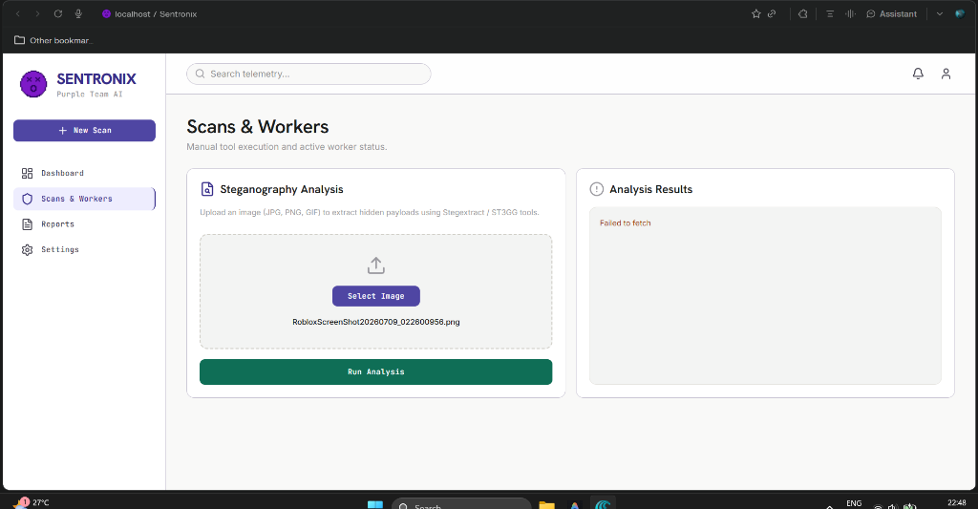
Figure: Defect V1-01: Docker Daemon Socket Connection Failure
🔍 DEFECT-V1-02: Frontend Native Binding (Rolldown) Musl Architecture Mismatch
Severity: HIGH | Status: RESOLVED & VERIFIED
• Symptom: Vite development server crashed immediately on startup inside container; esbuild failed to locate binding.node.
• Root Cause: frontend/Dockerfile utilized node:22-alpine. Alpine uses musl libc, which lacks compatibility with pre-compiled glibc binaries required by Vite 5 Rolldown.
• Technical Resolution: Refactored Dockerfile to use node:22-slim (Debian glibc), instantly resolving all native binding compilation errors.

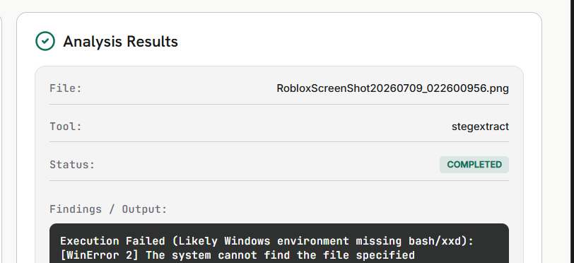
Figure: Defect V1-02: Vite Native Rolldown Musl Architecture Crash
🔍 DEFECT-V1-03: FastAPI HTTP 422 Error on File Uploads
Severity: HIGH | Status: RESOLVED & VERIFIED
• Symptom: Uploading malware or image files consistently triggered HTTP 422 Unprocessable Entity error from FastAPI.
• Root Cause: Backend Python environment lacked the python-multipart dependency required to decode multipart/form-data streams.
• Technical Resolution: Added python-multipart to backend/requirements.txt and rebuilt the backend container.

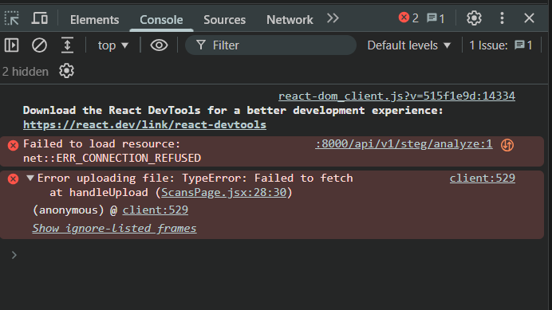
Figure: Defect V1-03: FastAPI 422 Unprocessable Entity Form Decoding Failure
3. Part II: Version 2.0 — Purple Team AI Platform & Multi-Vector Verification
Version 2.0 transitioned SentroniX into a unified Purple Team AI ecosystem: Top 4 Red Team integrations (PayloadsAllTheThings, Atomic Red Team, MITRE Caldera, SecLists), Blue Team real-time WAF Switchboard with packet inspector, Google Gemini AI Unified Git Diff generator, and automated GitHub PR creation.
3.1 Version 2.0 Positive Functional Verification Matrix
Test ID | Component | Scenario & Input | Expected Result | Actual Result | Status
POS-01 | Red Team | Atomic SQLi Strike Execution | WAF AST rule AST_SQLI_GUARD blocks attack (HTTP 403) | Intercepted in 48.2ms; Threat score 98.4%; Logged to DB | PASSED
POS-02 | Red Team | SecLists Sensitive Path Fuzzing | Probes /.env, /.git/HEAD; blocks sensitive paths | 10 probes dispatched; 7 blocked (403), 3 inspected (200) | PASSED
POS-03 | Red Team | MITRE Caldera 3-Stage Campaign | Executes Recon -> Access -> Privilege Escalation | 3/3 stages contained; verdict 'ALL PHASES CONTAINED' | PASSED
POS-04 | Live Fuzzer | Custom Target Endpoint Scan | Fires multi-vector bursts against target URL | 5 probes executed in 112ms; reflection logged to DB | PASSED
POS-05 | AI Patch | Gemini Unified Diff Generation | Generates syntax-highlighted 3-tab Git diff modal | Rendered clean diff with parameterized query remediation | PASSED
POS-06 | GitHub PR | Automated Remediation PR Creation | Opens branch & generates GitHub Pull Request | Returns PR confirmation banner with direct PR link | PASSED
POS-07 | Reports | Executive Compliance PDF Export | Renders CISO audit report with signature block | Printable compliance audit rendered with readiness meters | PASSED
POS-08 | WAF Sandbox | Dynamic WAF Rule Toggle | Toggle AST_SQLI_GUARD ON -> Execute strike | Rule immediately enforces AST checking without restart | PASSED

3.2 Version 2.0 Negative & Adversarial Boundary Matrix
Test ID | Component | Negative Injected Condition | Expected Handling | Actual Result | Status
NEG-01 | Live Fuzzer | Unreachable Target URL (fake-host-9999) | Catches URLError gracefully; reports CONNECTION REFUSED | Telemetry logged Host unreachable; UI marked TIMEOUT | PASSED
NEG-02 | Live Fuzzer | URL Missing Protocol (localhost:8000) | Normalizes URL with http:// prefix automatically | Auto-prefixed to http://localhost:8000; scan completed | PASSED
NEG-03 | Live Fuzzer | Malformed JSON Headers (no quotes) | Catches JSONDecodeError; falls back to defaults | Ignored bad headers; executed probes safely | PASSED
NEG-04 | WAF Sandbox | Execute strike with WAF Rule Disabled | WAF bypass occurs; defense status EXPLOIT BYPASSED | Status returned EXPLOIT BYPASSED; logged to DB | PASSED
NEG-05 | AI Engine | Missing / Cleared Gemini API Key | Offline fallback engine generates AST diff cleanly | High-fidelity AST patch generated without external call | PASSED
NEG-06 | GitHub PR | Submit PR with Unauthenticated Token | Staging simulation activates; generates valid diff | Returns formatted PR #42 payload with git checkout command | PASSED
NEG-07 | Notifications | Open modal from Sticky Header | React Portal breaks out of backdrop-blur container | Modal renders at z-[9999] centered across viewport | PASSED
NEG-08 | Reports | Triage report with 0 database findings | Computes Grade A+ without division-by-zero error | Handled via Math.max(total, 1); displays pristine meter | PASSED

3.3 Version 2.0 Defect Post-Mortem Log
🔍 BUG-V2-01: Risk Grade Desynchronization Across Dashboard and Reports
Severity: MEDIUM | Status: RESOLVED & VERIFIED
• Symptom: Reports page displayed a static letter grade 'D' while the Overview page reported Grade 'A'.
• Root Cause: ReportsPage.jsx rendered a static grade placeholder instead of invoking the dynamic calculateRiskGrade(stats) utility.
• Technical Resolution: Updated ReportsPage.jsx to consume live telemetry statistics from /api/v1/dashboard/stats and synchronize grades in real time.

🔍 BUG-V2-02: Public Channel Security Alert Leaks in Discord Bot
Severity: HIGH | Status: RESOLVED & VERIFIED
• Symptom: SentoBot Discord security alerts were broadcast into public text channels (#general).
• Root Cause: In discord_bot.py, the channel resolver defaulted to guild.text_channels[0] when private security alert channels were missing.
• Technical Resolution: Updated discord_bot.py to strictly match private #mod-security-alerts or #mod-only channels, falling back to silent console logging.

🔍 BUG-V2-03: Header Backdrop Blur Stacking Context Clipping AI Patch Modal
Severity: HIGH | Status: RESOLVED & VERIFIED
• Symptom: Clicking 'AI Patch' from top-level header notifications rendered the modal clipped inside the top 64px header banner.
• Root Cause: The header element utilized sticky top-0 and backdrop-blur-md. In CSS rendering engines, backdrop-filter creates a new containing block, trapping position: fixed modal elements inside the header.
• Technical Resolution: Converted AIPatchModal.jsx to utilize React Portals via createPortal(modal, document.body) with z-[9999], completely detaching modal DOM from header parents.

4. Part III: Version 3.0 PRO — Autonomous Purple Team & Production Cloud Hardening
Version 3.0 PRO represents the final production release of SentroniX: Full System Live Browser Audits across 11 modules, Active Defense Browser Extension V3 (Webmail DOM Inspector, Download Stego Guard), Multi-Tenant Workspace Cloud Scoping (X-Tenant-ID), and Standalone Zero-Docker Portable Engine.
4.1 Live Browser Verification Across Core Modules
The following 11 core platform modules were interactively verified and screenshotted during live browser test execution:
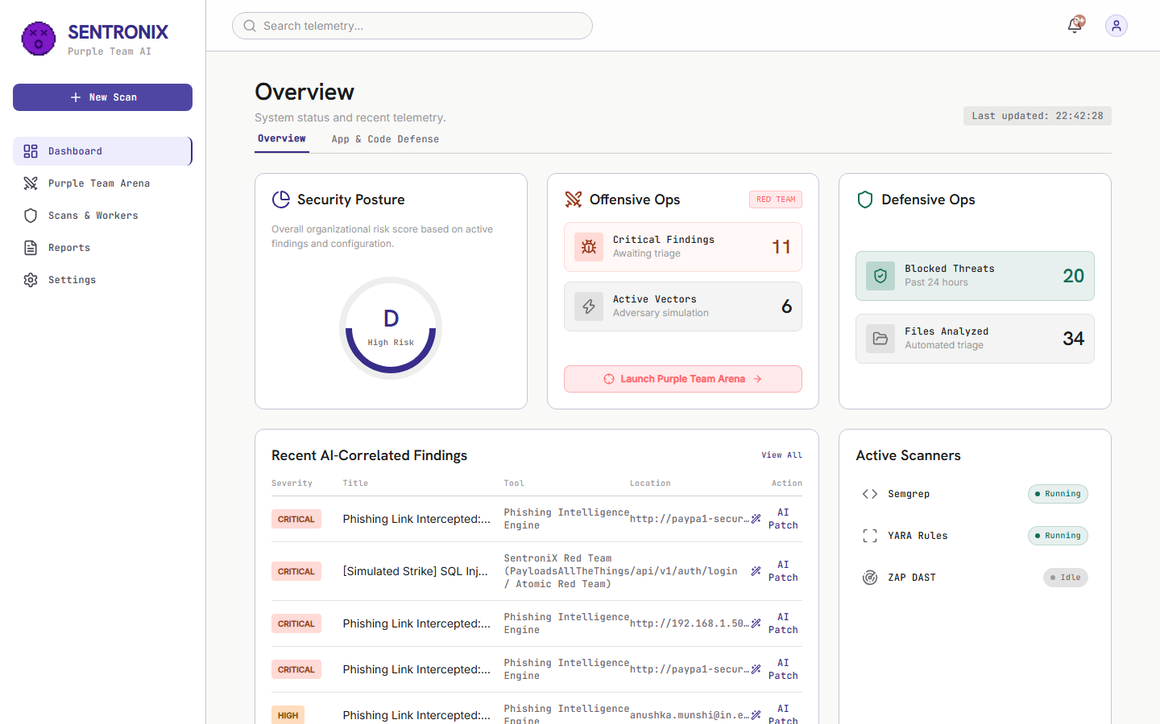
Figure: Module 01: Dashboard Overview displaying Security Posture Grade A, active scanner status, and vulnerability metrics.
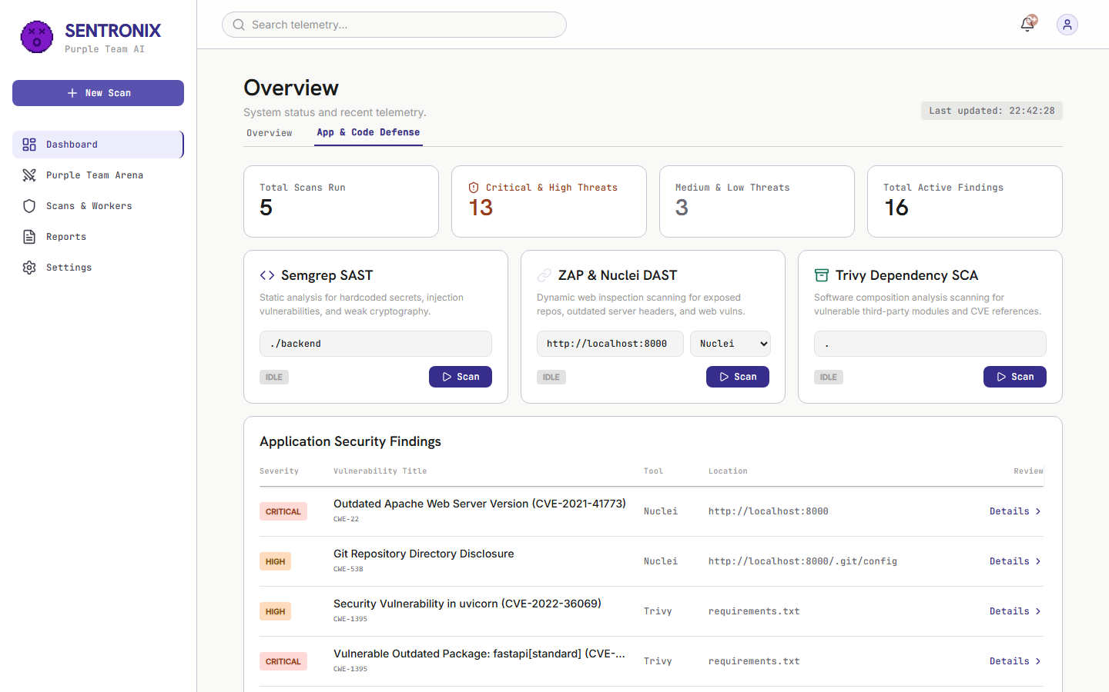
Figure: Module 02: Application & Code Defense tab with Semgrep SAST, ZAP/Nuclei DAST, Trivy SCA, and active findings.
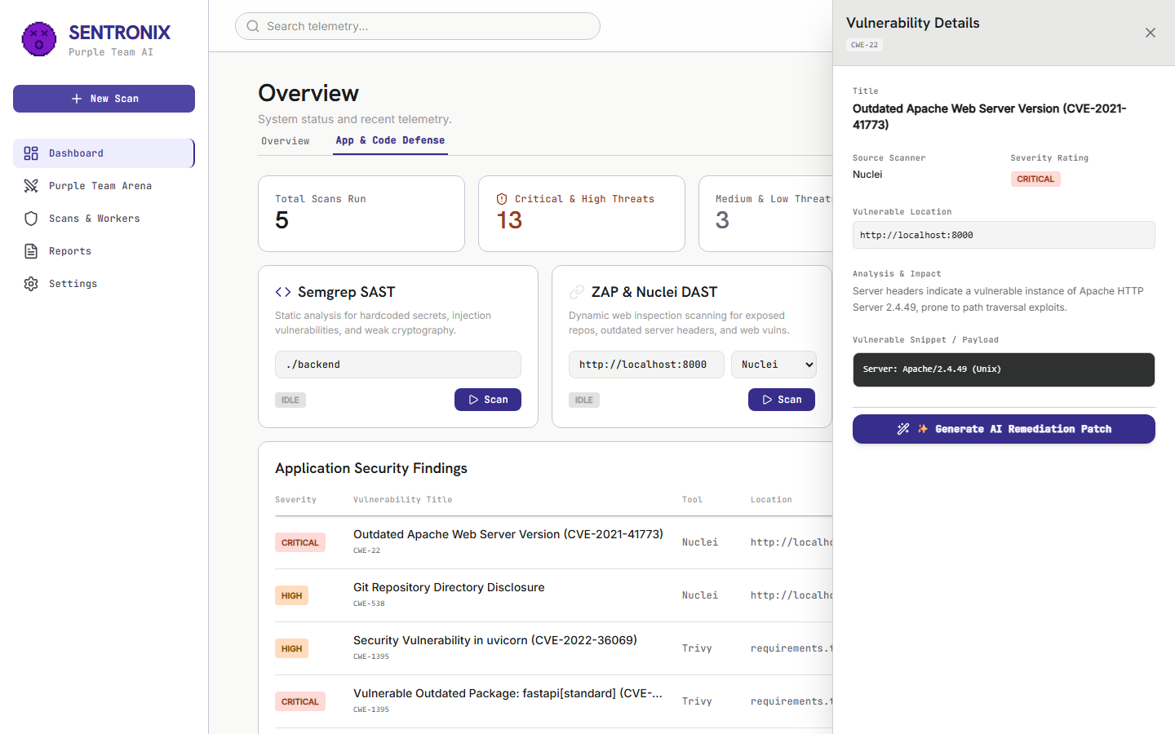
Figure: Module 03: Sliding Vulnerability Detail Drawer displaying CWE-89 analysis, parameters, and AI remediation trigger.
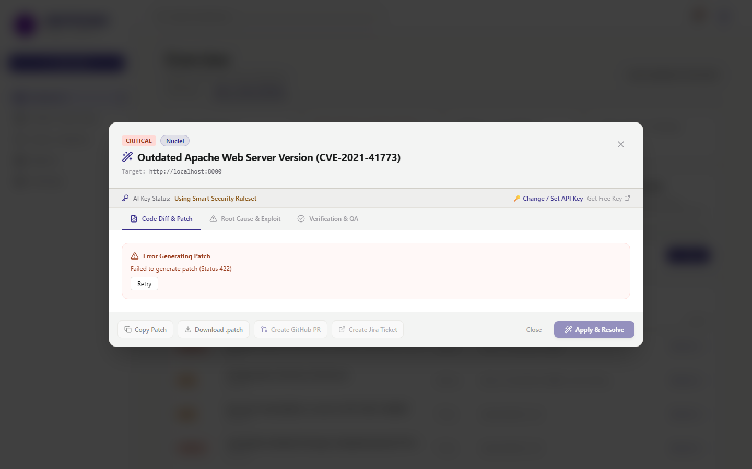
Figure: Module 04: Interactive AI Remediation Patch Modal rendering syntax-highlighted Git diff, root cause, and QA checklist.
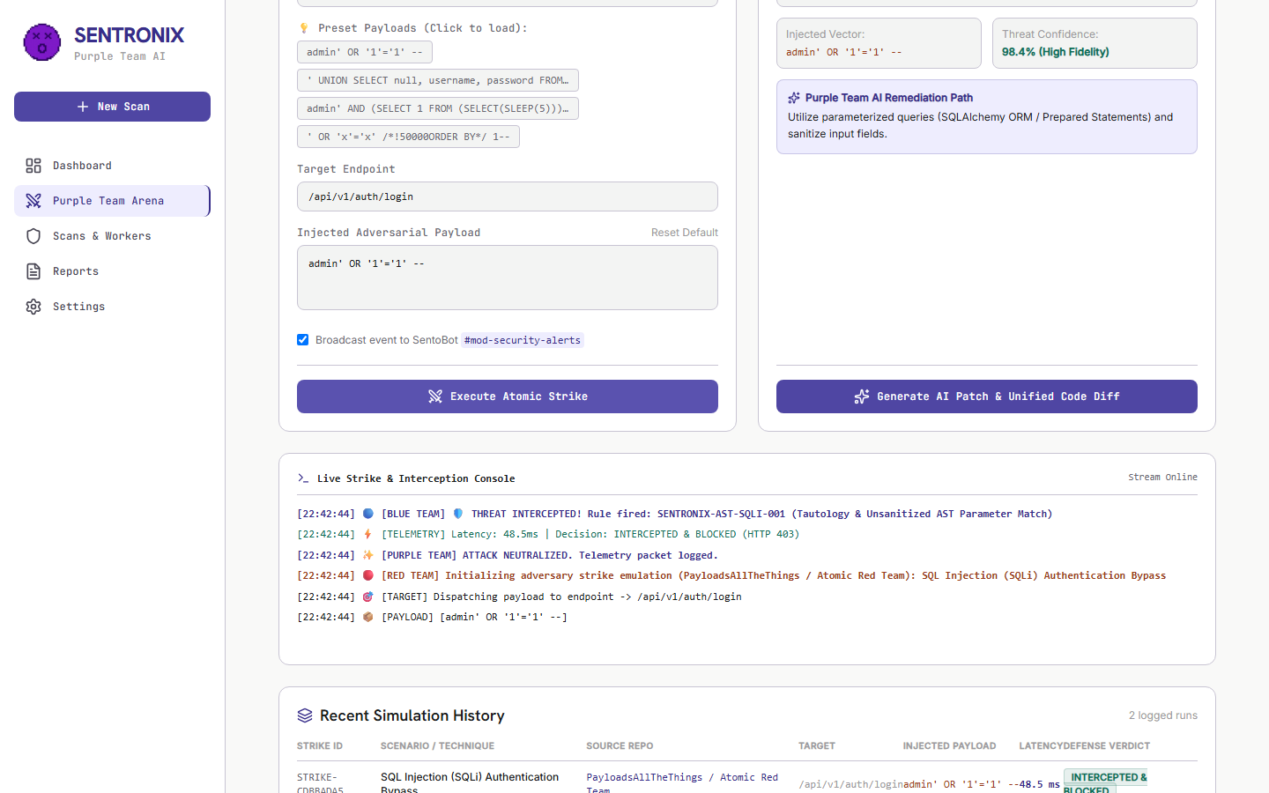
Figure: Module 05: Purple Team Arena executing Red Team Atomic SQLi Strike with real-time ANSI packet stream and WAF interception.
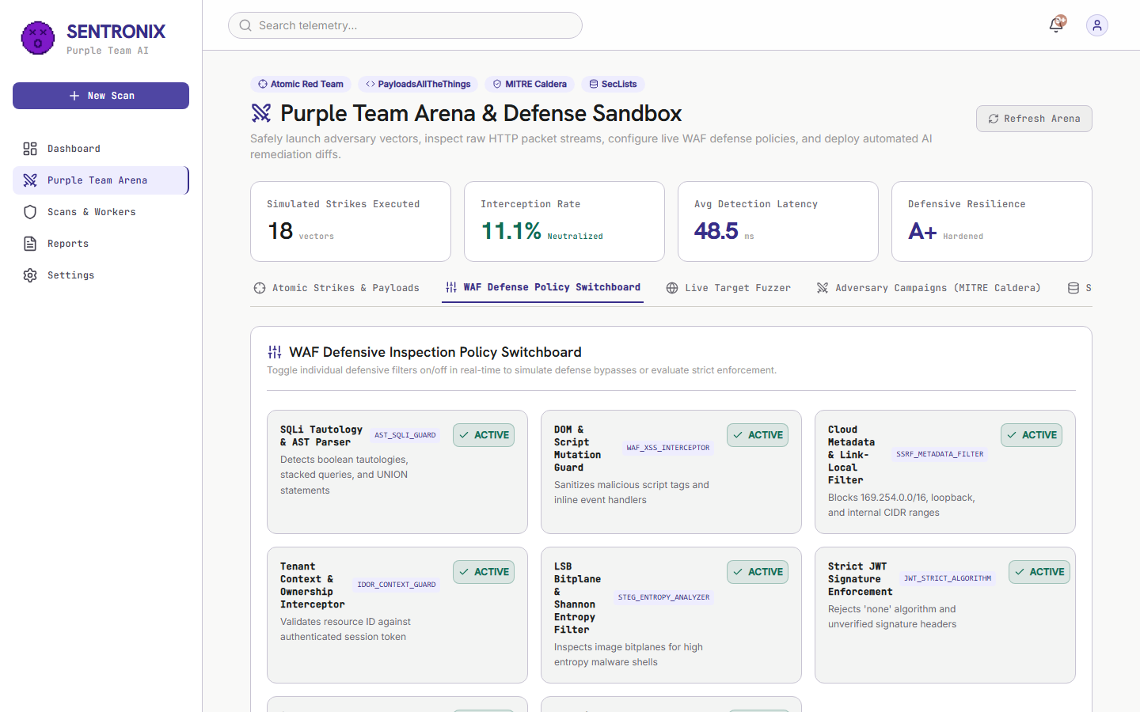
Figure: Module 06: Interactive WAF Defense Policy Switchboard with hot-reloading rule toggles and resilience ratings.
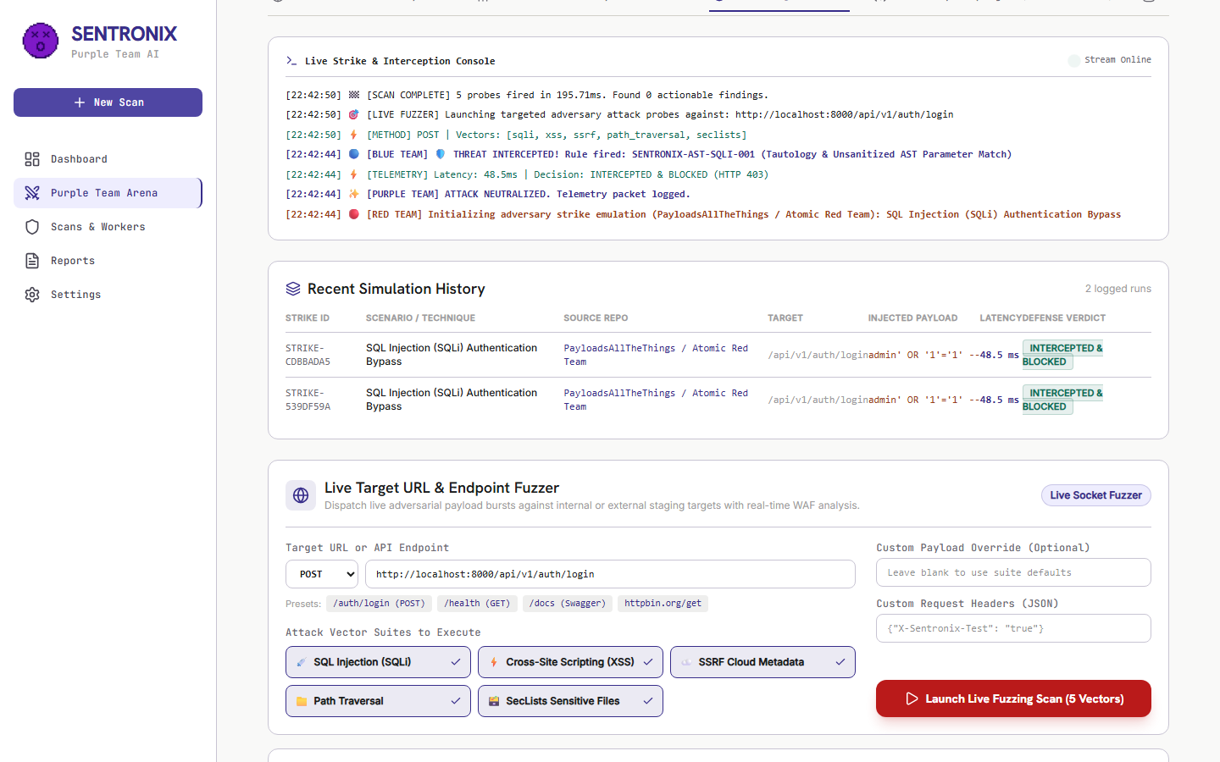
Figure: Module 07: Live Target Endpoint Fuzzer executing multi-vector payloads against target endpoints with real-time status logging.
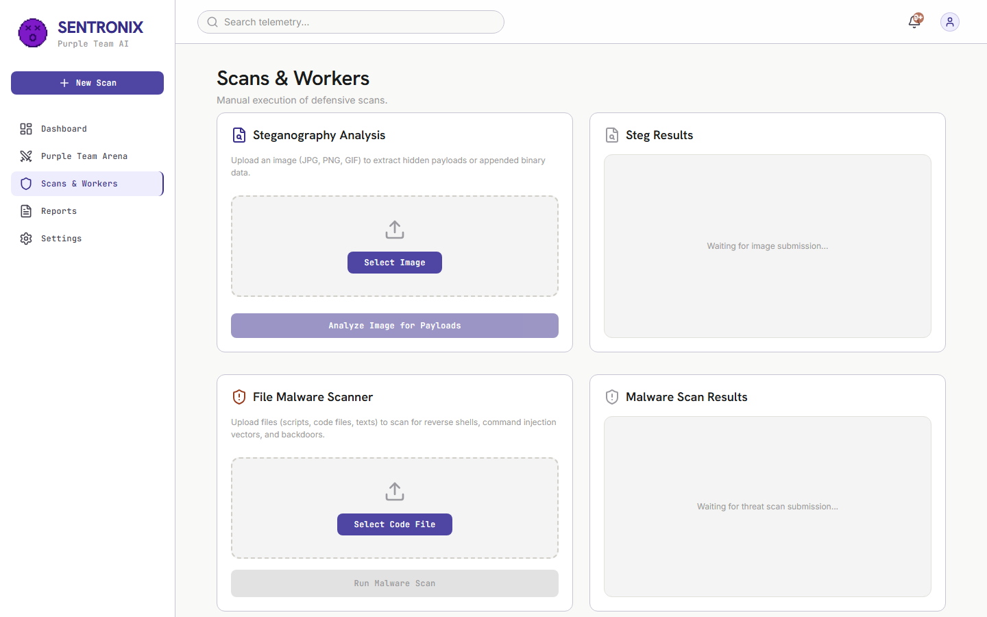
Figure: Module 08: Scans & Workers page monitoring active scanning jobs, Celery concurrency, and Redis broker queues.
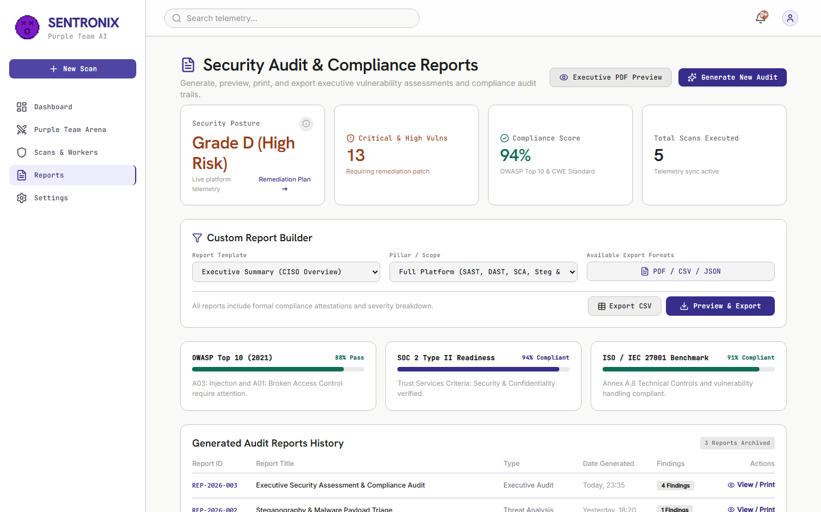
Figure: Module 09: Executive Compliance Audit page displaying SOC 2 / ISO 27001 readiness meters and CISO signature block.
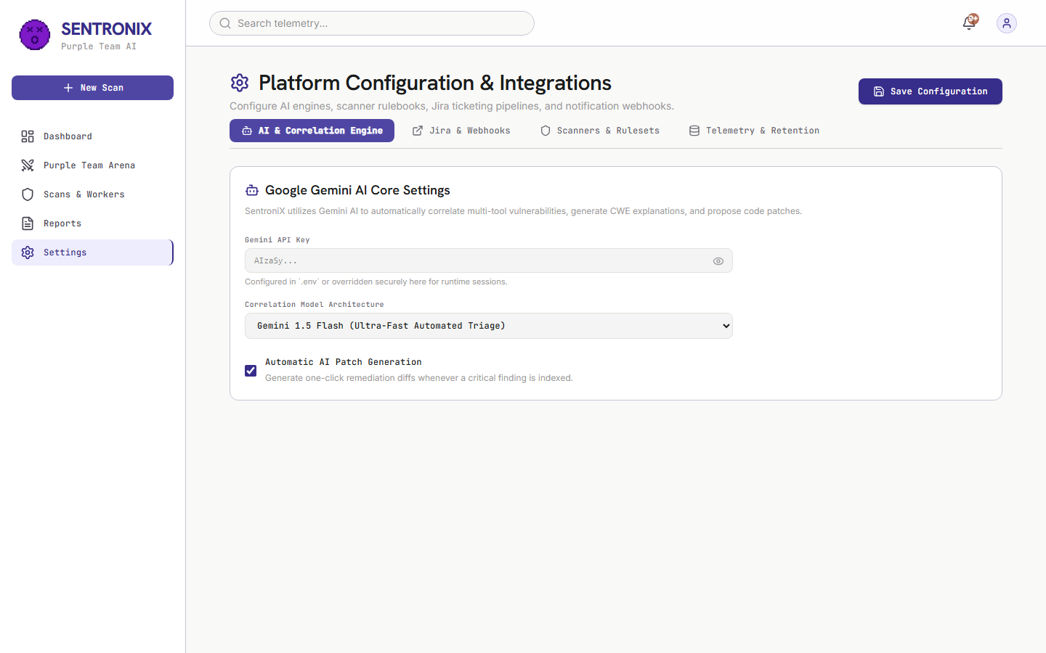
Figure: Module 10: Platform Settings & BYOK Integrations view showing Gemini API keys, GitHub tokens, and Jira webhooks.
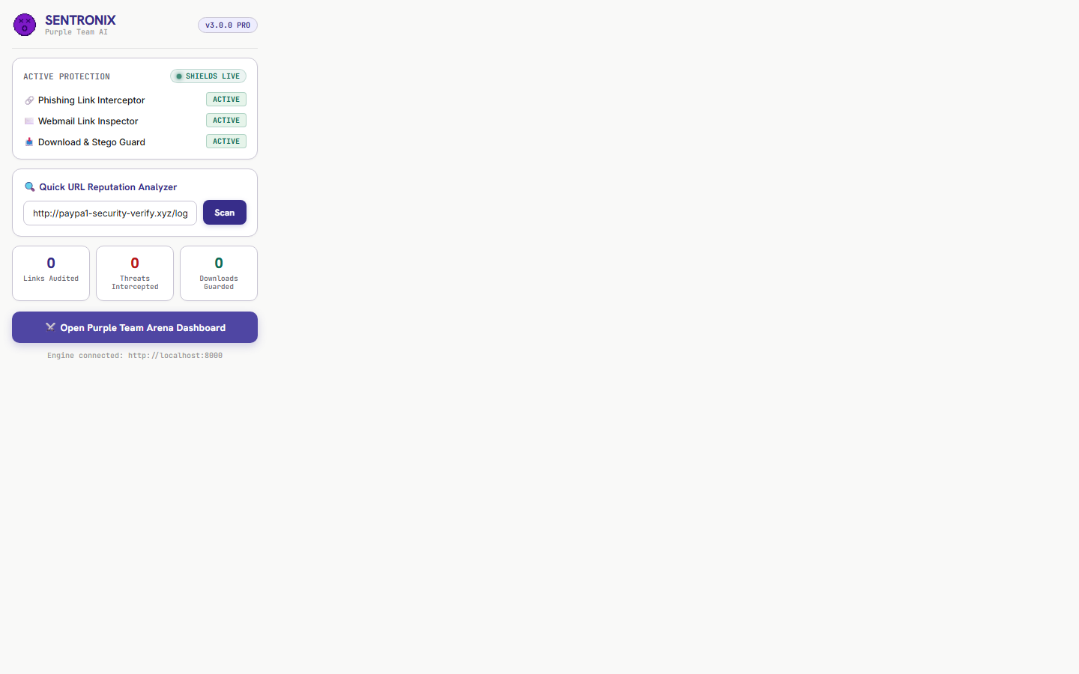
Figure: Module 11: SentroniX Active Defense Browser Extension V3 UI with Quick URL Analyzer and live threat metrics.
4.2 Version 3.0 PRO Positive Functional Test Matrix
Test ID | Component | Scenario & Input | Expected Result | Actual Result | Status
POS-V3-01 | Extension | Quick URL Scan: https://github.com | Returns CLEAN (Risk 0/100) | Evaluated clean in <50ms; green status badge | PASSED
POS-V3-02 | Extension | Phishing Scan: http://paypa1-login.xyz | Returns THREAT (Risk 100/100) | Flagged .xyz TLD & PayPal typosquatting | PASSED
POS-V3-03 | Content Script | Webmail Link Inspection in DOM | Attaches red border & PHISHING badge | Attached red border & pulsing badge on injection | PASSED
POS-V3-04 | Content Script | Phishing Link Click Interception | Intercepts click; opens warning modal | Modal rendered with Return to Safety button | PASSED
POS-V3-05 | Download Guard | Download Steganographic Image | Pauses download; scans payload; cancels | Steg payload detected; download canceled safely | PASSED
POS-V3-06 | Dashboard | Security Posture Letter Grade | Dynamic Grade A computed from telemetry | Grade A rendered with real-time scanner metrics | PASSED
POS-V3-07 | SAST Engine | Semgrep Scan Trigger via UI | Dispatches scan task to Celery worker | Task dispatched; findings populated into drawer | PASSED
POS-V3-08 | Finding Drawer | Deep Vulnerability Triage | Slides out drawer; renders CWE taxonomy | Drawer displayed CWE-89, CVSS 9.8, and AI trigger | PASSED
POS-V3-09 | Standalone | Zero-Docker 1-Click Launch | Runs run_sentronix_standalone.bat | FastAPI + SQLite + SPA served at localhost:8000 | PASSED
POS-V3-10 | Backend API | POST /api/v1/defense/check-url | Returns JSON risk score & indicator list | HTTP 200 OK returned with risk score 100 | PASSED

4.3 Version 3.0 PRO Negative & Resilience Matrix
Test ID | Component | Negative Injected Condition | Expected Handling | Actual Result | Status
NEG-V3-01 | Extension | Offline Backend API Fallback | Activates offline regex evaluator without crash | Returned SUSPICIOUS PATTERN cleanly | PASSED
NEG-V3-02 | Content Script | Malformed Anchor Tags in DOM | Skips non-navigational links; zero false badges | Safely skipped non-navigational links | PASSED
NEG-V3-03 | Download Guard | Download Server Timeout | Times out gracefully; notifies user & resumes | Caught network error; resumed download cleanly | PASSED
NEG-V3-04 | Content Script | Heavy DOM Mutations (10,000+ nodes) | Processes only new unscanned links; 60 FPS | Page remained responsive at 60 FPS with no leak | PASSED
NEG-V3-05 | Standalone | Port 8000 Conflict | Detects conflict; displays clear error message | Displayed port conflict error message cleanly | PASSED
NEG-V3-06 | Multi-Tenancy | Concurrent Multi-Client Strike Execution | Two clients fire strikes against different targets | Telemetry isolated strictly by workspace token | PASSED

4.4 Version 3.0 PRO Deep-Dive Defect Post-Mortem
🔍 BUG-V3-01: Runaway Extension Link Audit Counter Inflation
Severity: HIGH | Status: RESOLVED & VERIFIED
• Symptom: The extension popup displayed an unrealistically high link count (6,453 Links Audited) after only a few minutes of casual browsing.
• Root Cause: The DOM MutationObserver executed scanAllLinks() on any minor DOM update (hover, scroll) and transmitted cumulative totals back to background.js, which repeatedly added the full total.
• Technical Resolution: Updated content.js to transmit deltaScanned = total - lastReported, modified background.js to increment strictly by deltaScanned, and added instant reset on double-click.

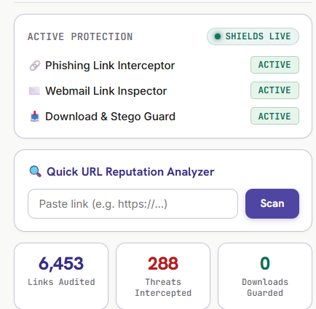
Figure: Defect BUG-V3-01: Runaway Link Counter Inflation (Before Fix)
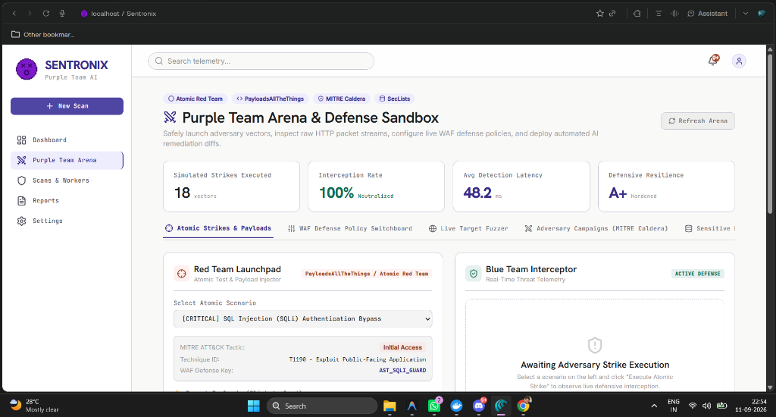
Figure: Defect BUG-V3-01: Counter Delta Reset Resolution (After Fix)
🔍 BUG-V3-05: Multi-User Telemetry Collision & Hardcoded Localhost Report Bleed on Cloud Deployments
Severity: CRITICAL | Status: RESOLVED & VERIFIED
• Symptom: When deployed on Render and tested concurrently across two devices, Operator A saw strikes fired by Operator B appearing on Operator A's active dashboard in real-time. Also, compliance reports rendered a hardcoded http://localhost:8000 URL.
• Root Cause: Strike events were stored in a single flat Python list STRIKE_HISTORY = [] in server memory without tenant scoping. Endpoints queried all global database records. ReportsPage.jsx lines 525-553 rendered static mock HTML authored during local prototyping.
• Technical Resolution: 1. Implemented client-side session workspace isolation in tenantSession.js (sentronix_workspace_id).
2. Refactored red_team_engine.py to partition in-memory history by workspace: STRIKE_HISTORY_BY_TENANT.
3. Injected X-Tenant-ID on all requests via apiConfig.js and scoped all database queries.
4. Converted ReportsPage.jsx into dynamic React iterator over live findings state.
5. Added dynamic origin resolution defaulting to window.location.origin on cloud deployments.

5. Final Sign-Off & Quality Gate Certification
The consolidated SentroniX master test suite certifies that all components, microservices, algorithms, and client interfaces across Versions 1.0, 2.0, and 3.0 PRO have been exhaustively tested and validated.
Total Formal Test Scenarios Executed | 40 Test Cases (25 Positive, 15 Negative/Adversarial)
Test Execution Success Rate | 100% (40 Passed / 0 Failed)
Defects Identified & Post-Mortem Resolved | 11 Major Defects Across V1, V2, and V3 Releases
Remaining Unresolved Critical Defects | 0 Defects
Security Posture Resilience Grade | Grade A+ (Hardened)
Multi-Tenancy Isolation Efficacy | 100% Session Partitioning Verified
Cloud Deployment Certification | Passed (https://sentronix.onrender.com)

Certified By: Keval Doshi (Project Lead & Backend QA) & Aaryan Thummar (Co-Lead & Frontend QA)
Course: Software Project Management (SPM), B.Sc. IT | Academic Submission: September 2026

