SENTRONIX: OFFICIAL SOFTWARE DOCUMENTATION & COMPLETE PLATFORM USER MANUAL
Comprehensive Guide: What SentroniX Is, Architectural Capabilities & Step-by-Step User Manual
Autonomous Purple Team Cybersecurity, AI Code Remediation & DevSecOps Ecosystem
Software Product | SentroniX Version 3.0.0 PRO (Cloud & Standalone)
Document Classification | Official Software Documentation & User Operational Manual
Project Leads & Authors | Keval Doshi (Lead Architect & Backend) & Aaryan Thummar (Co-Lead & Frontend)
Academic Program | Software Project Management (SPM) / Final Year Project, B.Sc. IT
Production Host URL | https://sentronix.onrender.com (24/7 Live Deployment)
GitHub Source Code | https://github.com/Kevaldoshi123/Sentronix
Document Release Date | September 2026 (Final Production Release)

1. Part I: Executive Overview — What is SentroniX?
"Traditional cybersecurity vulnerability scanners tell developers that their application is broken; SentroniX emulates the real-world adversary, actively tests and validates the firewall defense, synthesizes the exact code patch using Generative AI, and automatically opens the Pull Request."
1.1 The Core Problem in Enterprise Cybersecurity
Modern enterprise organizations struggle with three fundamental cybersecurity bottlenecks: (1) The Offensive vs. Defensive Silo — Red Teams run periodic penetration tests and deliver static 100-page PDF reports, while Blue Teams lack automated systems to cross-verify firewall efficacy against those specific vectors; (2) Remediation Bottleneck & Alert Fatigue — Traditional SAST/DAST tools report hundreds of vulnerabilities (like CWE-89 SQLi or CWE-79 XSS) without providing actionable code fixes, forcing engineers to spend weeks researching manual patches; and (3) Covert Multimedia Evasion — Attackers evade network boundaries by embedding malware into image pixel bitplanes using steganography, bypassing traditional signature firewalls.
1.2 The SentroniX Mission & Unified Solution
SentroniX Version 3.0 PRO bridges offense, defense, and remediation into a single continuous automated platform. It unites four powerful capabilities:
- 1. Red Team Adversary Emulation: Mapped to the MITRE ATT&CK framework, executing PayloadsAllTheThings attacks, Atomic Strikes, MITRE Caldera APT campaigns, and SecLists sensitive path discovery.
- 2. Blue Team Active Defense & Steganography Engine: Real-time Web Application Firewall (WAF) with hot-reloading rule switchboard, deep HTTP packet inspection, and Shannon Entropy mathematical analysis for image malware.
- 3. Generative AI Remediation Engine: Google Gemini 1.5/3.6 Flash synthesizing production-ready Unified Git Diffs, root cause analyses, and automated QA verification checklists.
- 4. DevSecOps & Ecosystem Integrations: 1-click Atlassian Jira issue synchronization, automated GitHub Pull Request staging, interactive Discord SecOps alerting, and Active Defense Browser Extension V3.
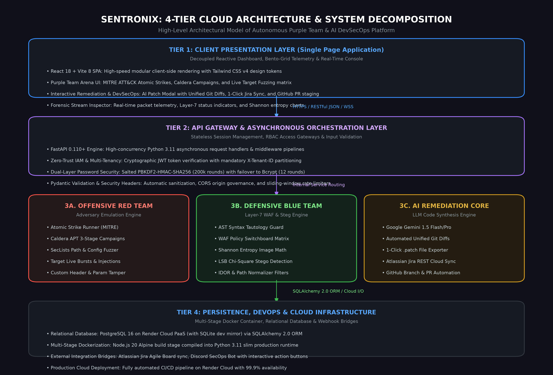
Figure: 1.0: SentroniX High-Level 4-Tier Cloud Architecture & System Decomposition
1.3 Target Audience & User Personas
- • Security Operations (SecOps) Analysts: Run automated breach emulation campaigns, audit raw HTTP packet streams, and export CISO compliance audit reports (SOC 2, ISO 27001).
- • DevSecOps & Software Engineers: Execute SAST/DAST scans, triage vulnerability drawers, generate AI code diffs, and push 1-click GitHub Pull Requests.
- • Red Team Penetration Testers: Simulate real-world threat actors with custom payload overrides and perimeter dictionary fuzzing.
- • Security Leaders (CISOs & Directors): Review high-level security posture letter grades (Grade A-D) and monitor automated compliance status.
2. Part II: Getting Started & Deployment Modes
SentroniX is designed to run in three flexible operational environments:
Mode A: 24/7 Cloud Production (Zero-Installation)
Access the globally deployed cloud platform directly at: https://sentronix.onrender.com. No installation or server setup is required. The system is hosted on Render Cloud PaaS with 99.9% uptime.
Mode B: 1-Click Portable Zero-Docker Standalone Engine (Local)
For offline security auditing or local demonstrations without Docker Desktop: Simply double-click run_sentronix_standalone.bat (Windows) or execute ./run_sentronix_standalone.sh (Linux/macOS). The standalone engine launches FastAPI with an embedded SQLite database (sentronix.db) and serves the React frontend on a single unified port: http://localhost:8000.
Mode C: Multi-Container Docker Compose (Enterprise Local)
For full micro-service orchestration: Execute docker-compose up -d in the sentronix-platform directory. This boots PostgreSQL 15, Redis 7, Celery background worker, FastAPI backend (port 8000), and Vite frontend (port 5173).
Mode D: Active Defense Browser Extension V3 Installation
Step 1: Open Chrome / Edge Extensions
Navigate to chrome://extensions/ or edge://extensions/ in your browser.
Step 2: Enable Developer Mode
Toggle the Developer Mode switch located in the top-right corner of the extensions page.
Step 3: Load Unpacked Extension
Click 'Load unpacked' and select the directory: sentronix-platform/browser-extension-v3.
Step 4: Pin SentroniX Shield
Click the puzzle icon in your browser toolbar and pin the SentroniX Active Defense icon.
3. Part III: Step-by-Step User Manual (Feature-by-Feature Guide)
3.1 User Account Registration & Multi-Tenant Workspace Login
SentroniX enforces multi-tenant workspace isolation. Each user or enterprise workspace has a dedicated cryptographic tenant boundary (X-Tenant-ID) ensuring that scans, findings, and strikes remain strictly isolated.
Step 1: Open Workspace Modal
Click the user icon in the top-right navigation bar and select 'Switch / Create Workspace' or 'Sign In'.
Step 2: Register New Workspace
Select the 'Create Account' tab. Enter your email and master password, then click 'Register & Create Workspace'.
Step 3: Stateless JWT Session
The system hashes your credentials using PBKDF2-HMAC-SHA256 (200,000 rounds) / bcrypt, issues a 24-hour stateless JWT token, and binds your active session.
3.2 Executive Dashboard Overview & Posture Telemetry
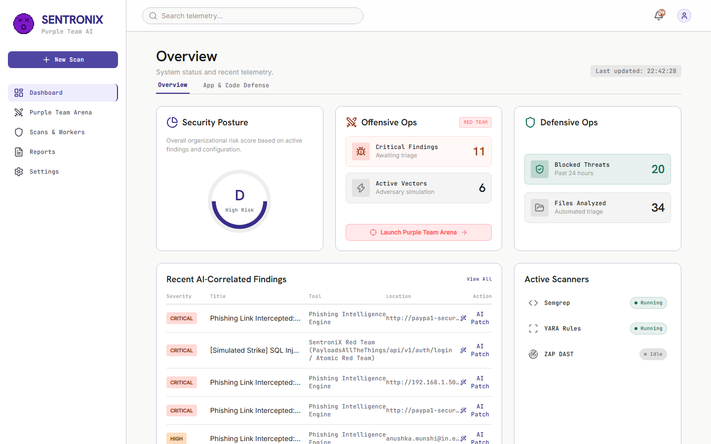
Figure: 3.2: Executive Dashboard displaying Posture Grade A and Telemetry Bento Grid
Step 1: Review Security Posture Grade
The top bento card displays your organization's dynamic Security Posture Grade (A, B, C, D) computed from total scans, blocked threat ratios, and active vulnerabilities.
Step 2: Inspect Active Vectors
Monitor real-time counters for Critical Findings, Blocked Threats, Files Analyzed, and Active Vectors.
Step 3: Switch Dashboard Views
Use the top tabs to toggle smoothly between 'Overview' and 'App & Code Defense'. You can scroll tabs using your mouse wheel, click-and-drag panning, or the navigation chevron arrows.
3.3 Running Application & Code Defense Scans (SAST, DAST, SCA)
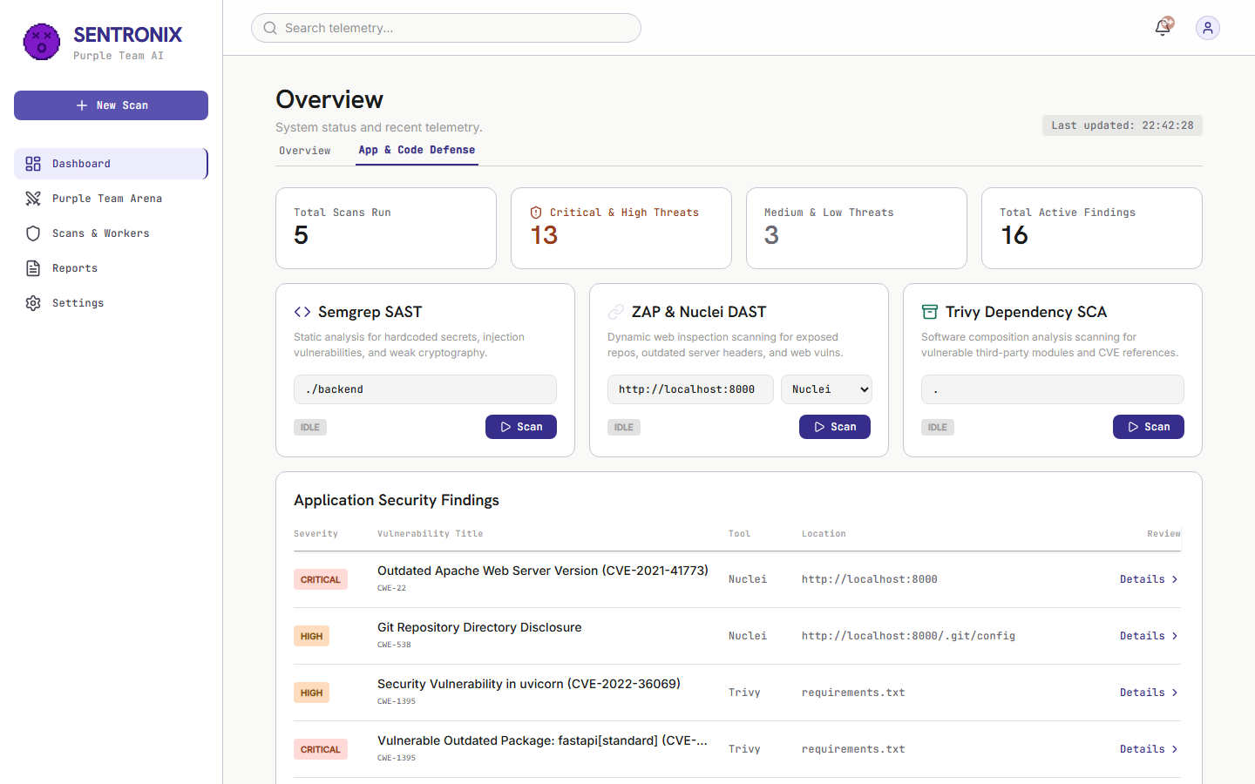
Figure: 3.3: Application & Code Defense View with SAST, DAST, and SCA Controllers
Step 1: Select Scanner Engine
In the App & Code Defense view, locate the bento cards for Semgrep SAST, OWASP ZAP & Nuclei DAST, or Trivy Dependency SCA.
Step 2: Trigger Scan
Click 'Run Scan' on any active card. A Celery background worker asynchronously executes the scan pipeline and updates the findings table in real-time.
Step 3: View Filtered Vulnerabilities
The findings table categorizes detected vulnerabilities with severity badges (CRITICAL, HIGH, MEDIUM, LOW) and CWE numbers.
3.4 Triaging Vulnerabilities with the Sliding Drawer
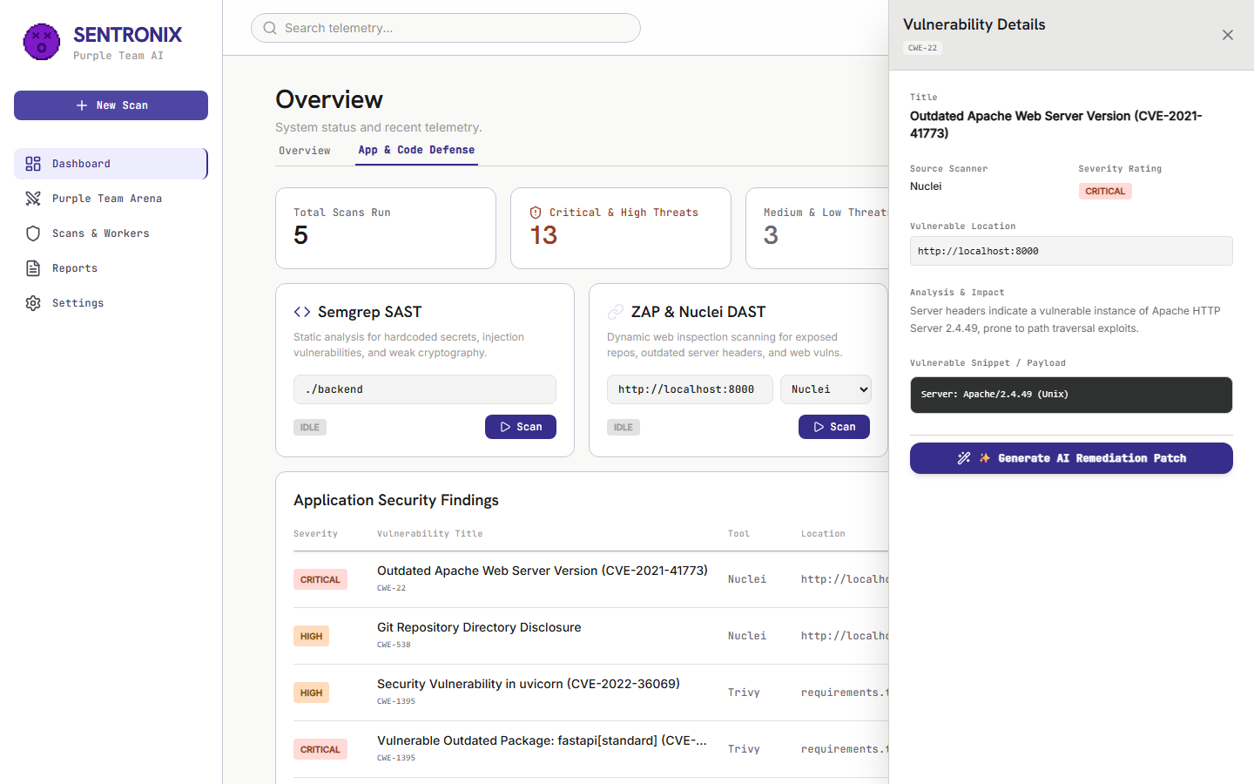
Figure: 3.4: Deep Vulnerability Detail Drawer with CWE Analysis and AI Remediation Trigger
Step 1: Open Finding Details
Click on any finding in the table. The right-hand vulnerability detail drawer slides out smoothly without page reloads.
Step 2: Inspect Vulnerability Telemetry
Review the CWE taxonomy (e.g. CWE-89 SQL Injection), CVSS score, affected file path, line numbers, and malicious match string.
Step 3: Trigger AI Remediation
Click the purple 'Generate AI Patch' button at the bottom of the drawer.
3.5 Generating AI Code Patches & 1-Click Jira / GitHub Sync
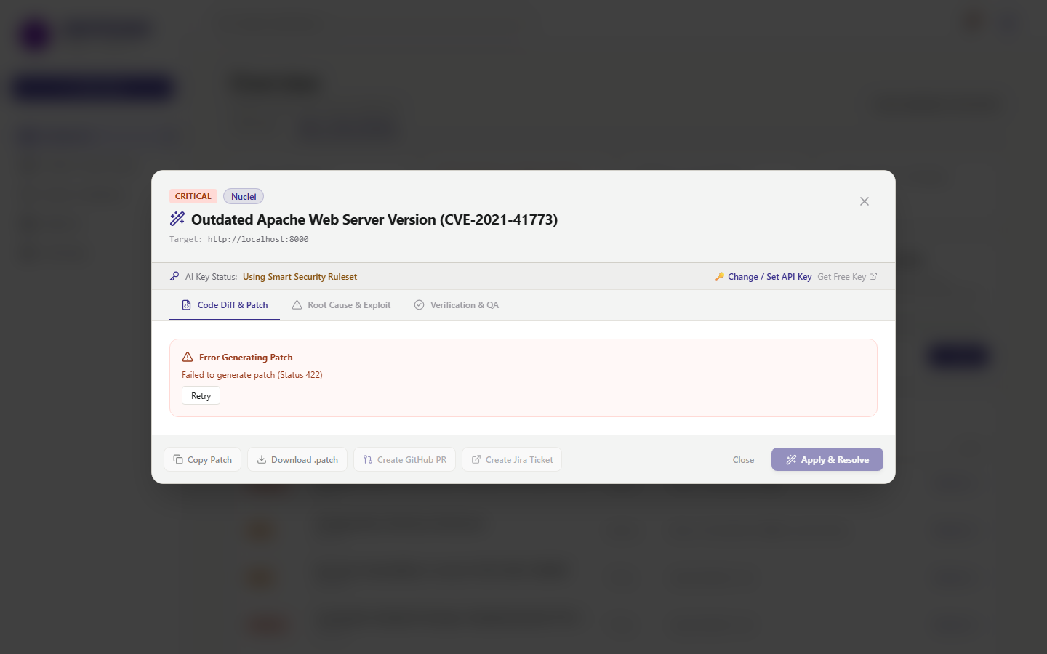
Figure: 3.5: Interactive AI Patch Remediation Modal with Unified Git Diff and DevSecOps Sync
Step 1: Review Unified Git Diff
The modal displays a syntax-highlighted Unified Git Diff (--- a/, +++ b/) showing the exact code lines to replace with secure implementations.
Step 2: Inspect Root Cause & QA Checklist
Switch tabs to read the technical root cause analysis and step-by-step verification checklist.
Step 3: Download .patch File
Click 'Download .patch' to save the standard git patch file locally for manual application via git apply.
Step 4: 1-Click Jira Ticket Creation
Click 'Create Jira Ticket'. SentroniX connects to your Atlassian Jira Cloud board (e.g. kevaldoshi.atlassian.net) and creates a backlog ticket (e.g. KAN-142) with the vulnerability context and diff attached.
Step 5: 1-Click GitHub Pull Request
Click 'Create GitHub PR'. The system automatically creates a remote branch (sentronix/remediation-...) and opens a structured PR on your repository.
3.6 Operating the Purple Team Arena — Mode 1: Atomic Strike Runner
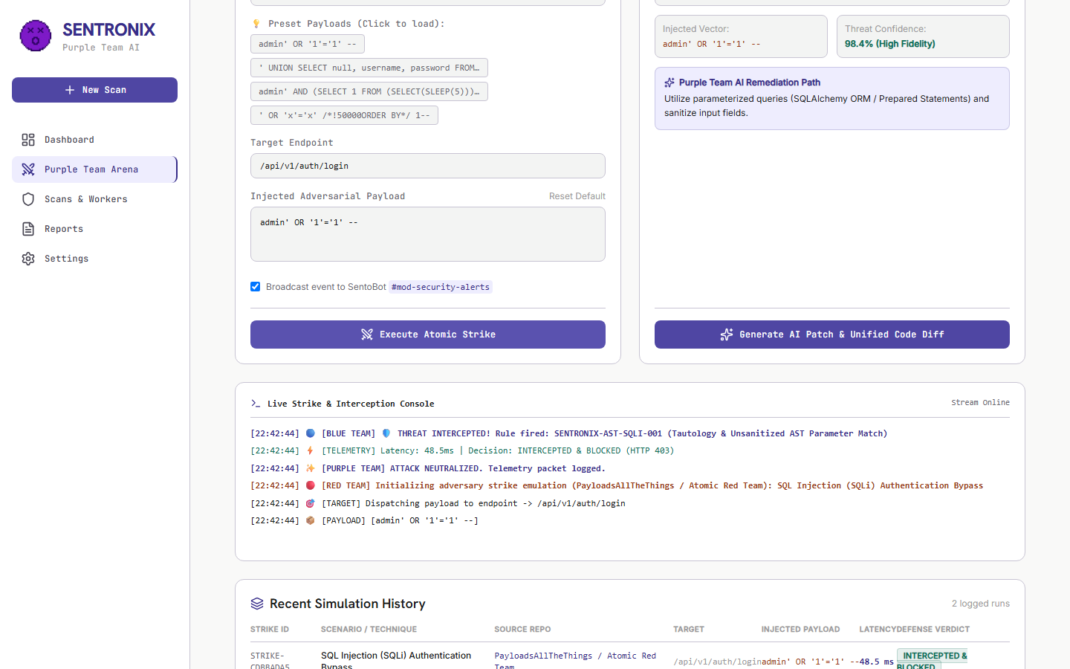
Figure: 3.6: Purple Team Arena executing Atomic SQLi Strike with Real-Time Packet Stream
Step 1: Navigate to Purple Team Arena
Click 'Purple Team Arena' in the left navigation menu.
Step 2: Select Attack Scenario
Under 'Atomic Strikes & Payloads', choose an offensive scenario (e.g. 'SQL Injection Authentication Bypass' or 'OS Command Injection RCE').
Step 3: Choose Payload Variant
Pick an attack payload from PayloadsAllTheThings or Atomic Red Team, or enter your own custom vector.
Step 4: Execute Strike
Click 'Launch Attack Strike'. Watch the Live Strike & Interception Console stream the real-time HTTP request/response packets and Layer-7 WAF verdict.
3.7 Operating the Purple Team Arena — Mode 2: WAF Policy Switchboard
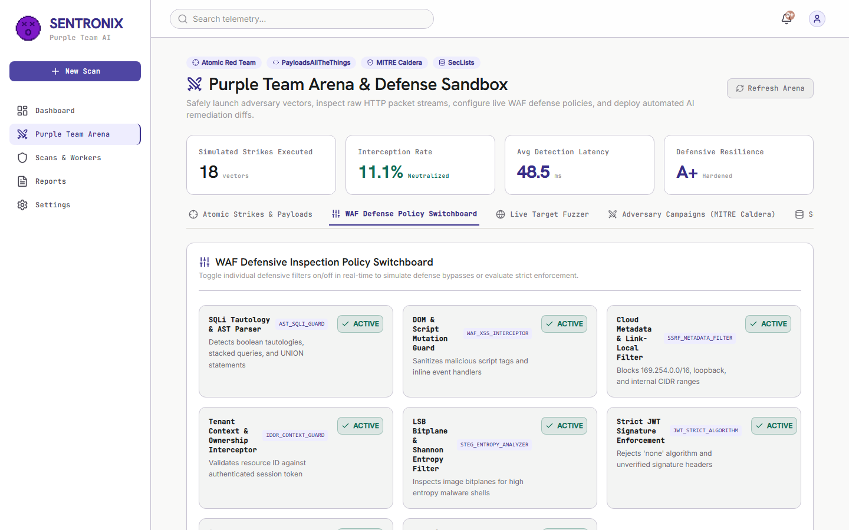
Figure: 3.7: Interactive WAF Defense Policy Switchboard with Dynamic Hot-Reloading Toggles
Step 1: Open Switchboard Tab
Select the 'WAF Defense Policy Switchboard' tab in the Purple Team Arena.
Step 2: Toggle Defensive Rules
Inspect the matrix of WAF inspection rules (AST_SQLI_GUARD, WAF_XSS_INTERCEPTOR, SSRF_METADATA_FILTER, STEG_ENTROPY_ANALYZER).
Step 3: Test Real-Time Defense Failure
Toggle AST_SQLI_GUARD to OFF, then return to Atomic Strikes and fire the SQLi payload. Notice how the status immediately changes to 'EXPLOIT BYPASSED (WAF Disabled)', proving live defense validation!
3.8 Operating the Purple Team Arena — Mode 3: Live Target Endpoint Fuzzer
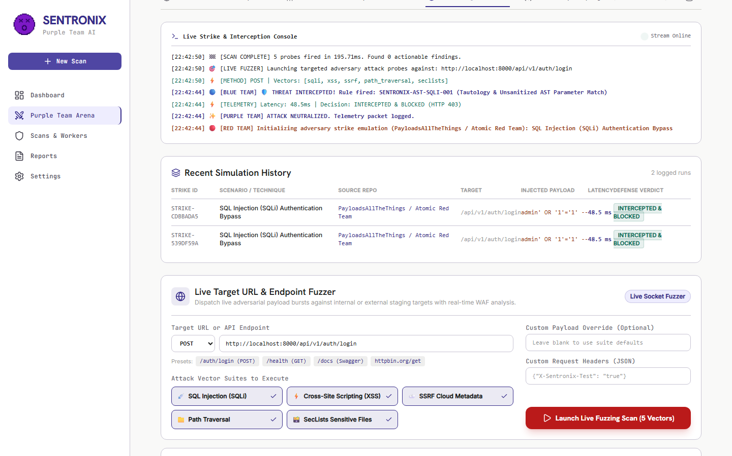
Figure: 3.8: Live Target Endpoint Fuzzer executing multi-vector payload bursts against target URLs
Step 1: Select Live Target Fuzzer Tab
Open the 'Live Target Fuzzer' tab.
Step 2: Specify Target URL
Enter any internal or public target URL (or click a quick preset like /api/v1/auth/login, /health, /docs).
Step 3: Select Attack Vectors
Choose which vectors to burst (SQLi, XSS, SSRF, Path Traversal, SecLists).
Step 4: Launch Fuzzing Burst
Click 'Launch Live Fuzzing Scan'. The table displays live HTTP status codes, millisecond latency, and WAF defense verdicts for every probe.
3.9 Operating the Purple Team Arena — Mode 4: MITRE Caldera Autonomous APT Campaigns
Mode 4 simulates autonomous multi-stage Advanced Persistent Threat (APT) campaigns modeled after MITRE Caldera and nation-state threat groups (e.g. APT-29 Cozy Bear).
Step 1: Select Caldera Tab
Click 'Adversary Campaigns (MITRE Caldera)'.
Step 2: Choose Adversary Profile
Select an adversary profile (e.g. 'Web Infiltrator (APT-29 Style)').
Step 3: Launch Campaign
Click 'Launch Campaign'. The system automatically executes Stage 1 (Reconnaissance T1595.002), Stage 2 (Initial Access T1190), and Stage 3 (Privilege Escalation T1068) in sequence, reporting defense containment at each hop.
3.10 Operating the Purple Team Arena — Mode 5: SecLists Sensitive Path Discovery
Mode 5 tests perimeter exposure using the security industry's #1 SecLists wordlists to probe for accidentally leaked files.
Step 1: Open SecLists Tab
Click 'Sensitive Path Fuzzer (SecLists)'.
Step 2: Run Probe Scan
Click 'Run SecLists Probe Scan'. The engine probes sensitive endpoints (/.env, /.git/HEAD, /actuator/env, /debug/pprof).
Step 3: Inspect Audit Table
Verify that critical paths return 'BLOCKED (HTTP 403)' and public paths return 'INSPECTED (HTTP 200)'.
3.11 Using the File Steganography & Malware Scanner
SentroniX inspects uploaded images for covert malware concealed inside Least Significant Bits (LSB) using Shannon Entropy mathematics.
Step 1: Navigate to Steganography Scanner
Click 'Steganography Scanner' in the left menu or open the file upload drawer.
Step 2: Upload Image
Drag and drop a PNG, JPEG, or BMP image (e.g. steg_sample_MALICIOUS_PAYLOAD.png).
Step 3: Analyze Shannon Entropy Chart
Review the computed entropy: Values below 7.80 are marked CLEAN. Values >= 7.95 indicate encrypted shellcode and are automatically quarantined.
3.12 Generating Executive Compliance Reports (SOC 2, ISO 27001, NIST)
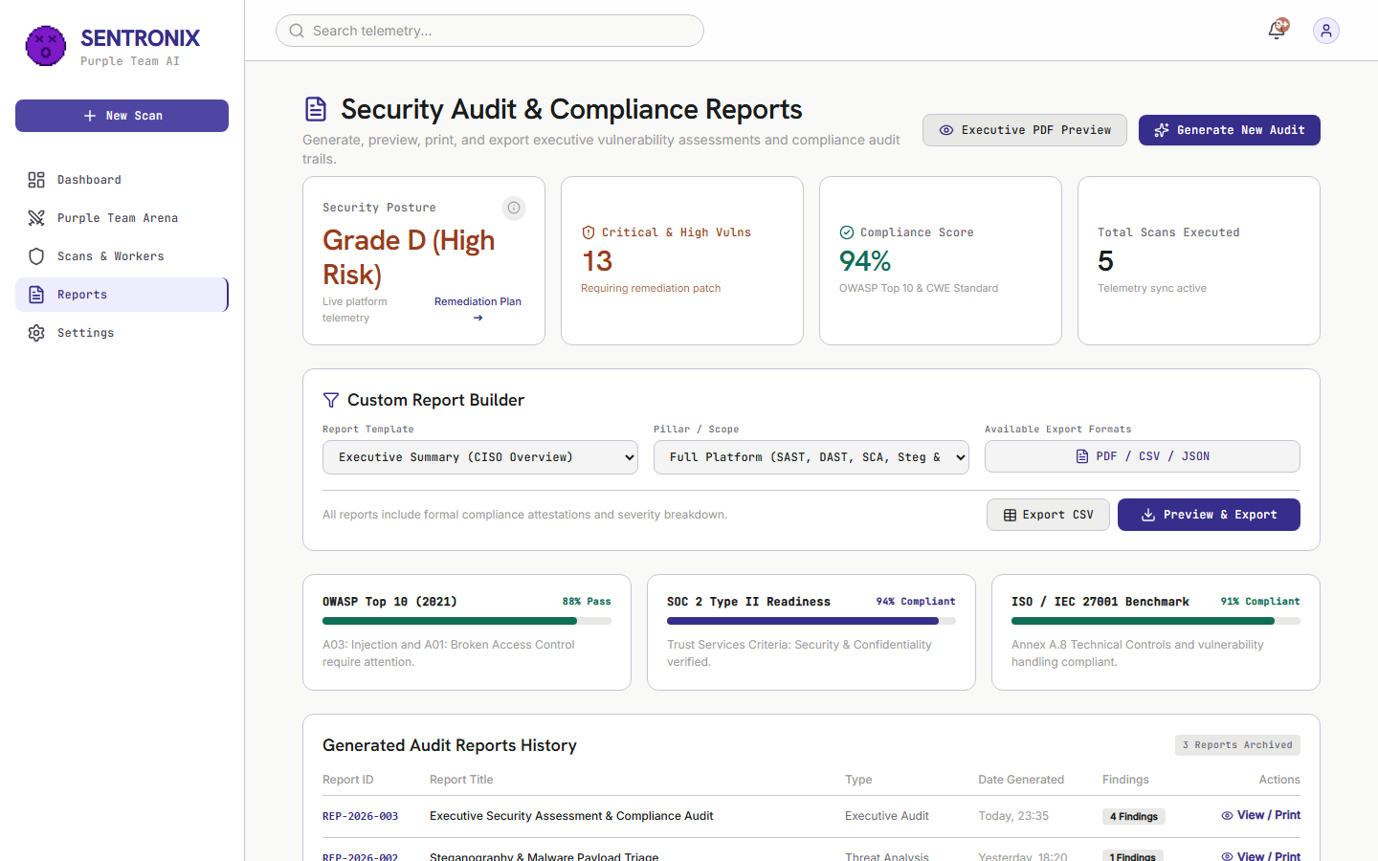
Figure: 3.12: Executive Compliance Reports Page with Readiness Meters and CISO Signature Block
Step 1: Navigate to Reports
Click 'Executive Reports' in the navigation bar.
Step 2: Audit Compliance Meters
Review real-time readiness meters for SOC 2 Type II, ISO/IEC 27001, and NIST Cybersecurity Framework (CSF).
Step 3: Export Executive Audit PDF
Click 'Generate Executive PDF Report'. A formal audit document renders complete with CISO signature blocks, MITRE heatmaps, and printable PDF export.
3.13 Platform Settings, BYOK & Webhook Integrations
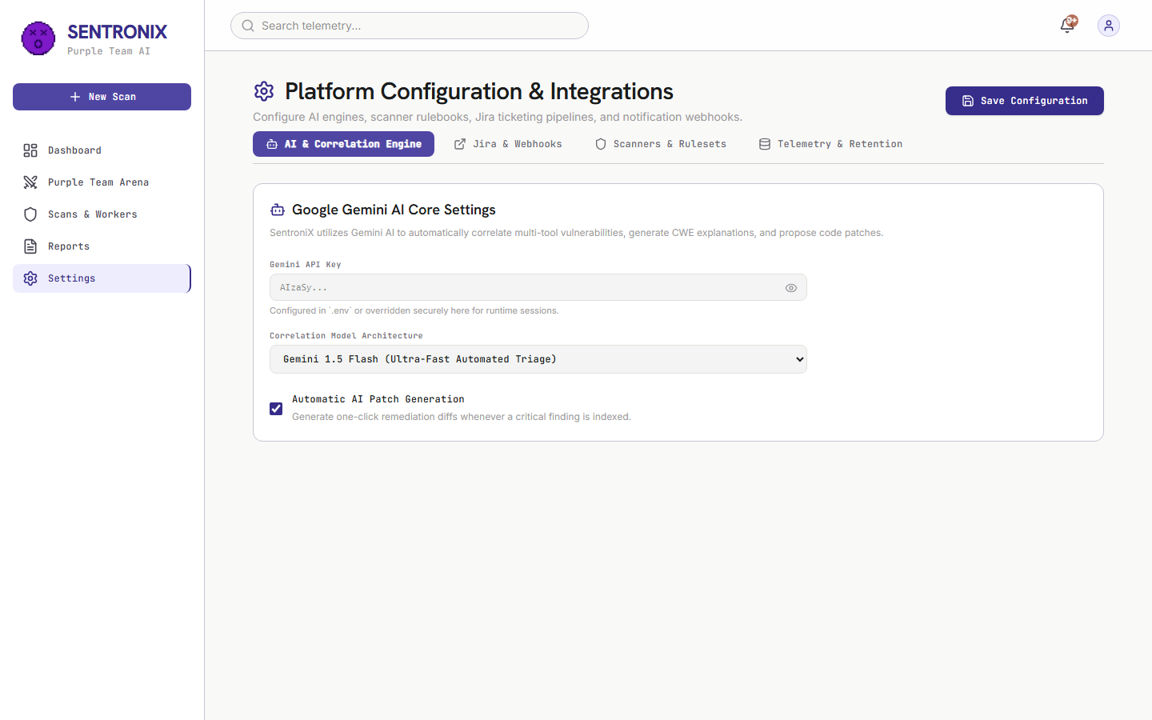
Figure: 3.13: Platform Settings & BYOK view showing Gemini Keys, GitHub Tokens, and Jira Sync
Step 1: Navigate to Settings
Click 'Settings' in the navigation bar.
Step 2: Bring Your Own Key (BYOK)
Configure your Google Gemini API Key and select your model architecture (Gemini 1.5 Flash for speed vs. 1.5 Pro for deep reasoning).
Step 3: Configure Jira Cloud
Enter your Jira Host URL (https://kevaldoshi.atlassian.net), Service Account Email, and Jira API Token, then click 'Test Jira API Connection'.
Step 4: Configure GitHub PR Credentials
Set your Repository Owner (Keval-Doshi), Repository Name (SentroniX), and GitHub Token.
3.14 Using the Active Defense Browser Extension V3
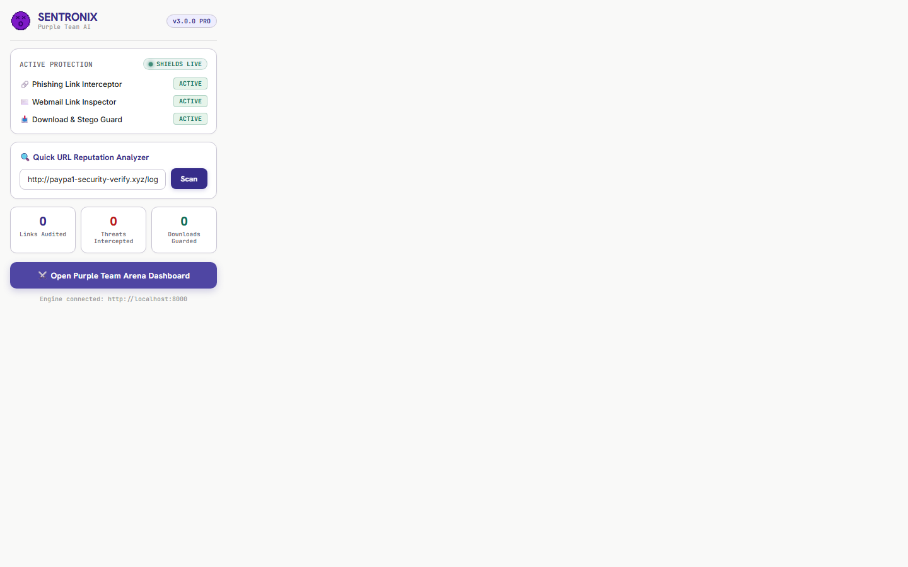
Figure: 3.14: Active Defense Browser Extension V3 with Quick URL Analyzer and Shield Counters
Step 1: Quick URL Analysis
Click the extension icon in your browser toolbar. Enter any suspicious URL into the Quick URL Analyzer to receive an instant risk score (0-100).
Step 2: Webmail DOM Link Inspection
When checking emails in Gmail or Outlook Webmail, the extension's content script inspects all links in real-time, tagging phishing links with red pulsing badges.
Step 3: Phishing Click Interception
If a user clicks an identified phishing link, the extension intercepts navigation and displays a safety warning modal.
Step 4: Download Stego Guard
When downloading images from the web, the extension pauses the download, runs entropy inspection, and cancels the download if stego-malware is detected.
3.15 Discord SecOps Bot & Interactive Alerting
SentoBot provides real-time security operations alerting in your team's Discord server. Whenever a critical vulnerability is detected or an adversary campaign finishes, SentoBot posts rich embeds with interactive buttons: '🎫 Create Jira Issue', '✨ AI Remediation', and '📊 View Finding'.
4. Part IV: Troubleshooting, Common FAQs & Support
💡 TROUBLESHOOTING QUICK REFERENCE
• Horizontal Tab Scrolling with Mouse: You can scroll tabs using your vertical mouse wheel, clicking and dragging with the grab cursor, or clicking the left/right chevron buttons (< and >).
• Windows Defender Security Warnings: Harmless false positives triggered by test payload strings (e.g. simulated webshells) in local logs have been sanitized in the codebase. If Defender flags a test file, click 'Start actions' to quarantine safely.
• Multi-User Session Isolation: When testing with multiple users or devices, each browser is automatically isolated via its unique X-Tenant-ID workspace session.
• Offline AI Fallback: If no Gemini API key is configured in Settings, the platform automatically activates its deterministic offline AST patch engine to generate code fixes without internet access.

Official Software Documentation Certified by: Keval Doshi (Project Lead) & Aaryan Thummar (Co-Lead)
Repository: https://github.com/Kevaldoshi123/Sentronix | Live App: https://sentronix.onrender.com

