SENTRONIX: SYSTEM DESIGN DOCUMENTATION (SDD)
High-Level & Low-Level Architectural Design Specification
Autonomous Purple Team Cybersecurity & AI-Driven Threat Management Platform
Project Title | SentroniX — Autonomous Purple Team & AI DevSecOps Ecosystem
Course / Level | Software Project Management (SPM) / Final Year Project, B.Sc. IT
Document Version | 1.0 (Final Comprehensive Academic Release)
Authors / Leads | Keval Doshi (Lead Architect & Backend) & Aaryan Thummar (Co-Lead & Frontend)
Academic Evaluator | Project Guide & Department Evaluators
Live Production URL | https://sentronix.onrender.com
GitHub Repository | https://github.com/Kevaldoshi123/Sentronix

1. Executive Summary & Architectural Goals
The Problem Space: Modern enterprise cybersecurity faces three fundamental architectural fractures: first, the offensive (Red Team) and defensive (Blue Team) silos operate in isolation with disjointed tooling; second, traditional vulnerability scanners trigger severe alert fatigue without generating actionable remediation code; and third, sophisticated attackers increasingly bypass network perimeters using covert multimedia channels (such as Least Significant Bit steganography).
The SentroniX Solution: SentroniX is engineered as a cloud-native, autonomous Purple Team platform that bridges offensive adversary emulation, real-time Layer-7 packet interception, and generative AI code patch synthesis into a continuous, closed-loop DevSecOps ecosystem.
- • Loose Coupling & Decoupled Micro-services: React 18/Vite SPA client separated cleanly from FastAPI async backend.
- • Strict Multi-Tenancy: End-to-end data isolation via cryptographic JWT tokens and X-Tenant-ID workspace partitions.
- • Automated 1-Click DevSecOps Remediation: Instant Google Gemini 1.5 Unified Git Diff synthesis with direct Atlassian Jira and GitHub PR integration.
- • Zero-Trust Defense-in-Depth: Real-time WAF AST tokenization, rate-limiting, and Shannon entropy image inspection.
2. High-Level System Architecture (Tiered Model)
SentroniX employs a decoupled 4-Tier Enterprise Cloud Architecture designed for high availability, horizontal scalability, and strict separation of concerns across presentation, orchestration, core security logic, and persistence.
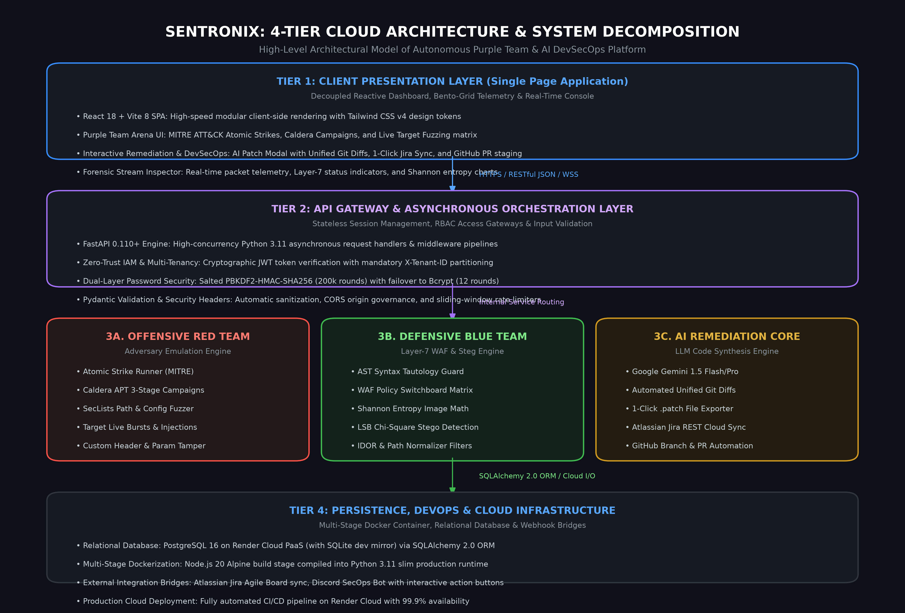
Figure: 4.0: SentroniX 4-Tier Cloud Architecture & System Decomposition
2.1 Architectural Tier Breakdown
- 1. Presentation Layer (Client SPA): Built with React 18, Vite 8, and Tailwind CSS v4. Features reactive state stores, Bento-Grid telemetry dashboards, and the real-time Purple Team CLI terminal with horizontal pan/wheel navigation.
- 2. API Gateway & Application Tier: Powered by Python 3.11 asynchronous FastAPI. Enforces JWT stateless authentication, tenant scoping middleware, Pydantic data contract validation, and CORS security policies.
- 3. Core Security & AI Micro-services: Incorporates the Red Team adversary strike launcher (Atomic Strikes, MITRE Caldera, SecLists Fuzzer), the Blue Team Layer-7 WAF matrix with Shannon Entropy stego inspection, and the Gemini AI code patch synthesis engine.
- 4. Persistence & Infrastructure Tier: Relational PostgreSQL database managed via SQLAlchemy 2.0 ORM, multi-stage Docker containerization on Render Cloud PaaS, and external webhook integrations for Atlassian Jira and Discord SecOps.
3. The Four Core Defensive Pillars & AI Engine
Pillar 1: Application & Code-Level Defense (SAST, DAST, SCA)
- • Static Application Security Testing (SAST): AST-level vulnerability detection parsing code for OWASP Top 10 vulnerabilities.
- • Dynamic Application Security Testing (DAST): Live HTTP endpoint fuzzing probing runtime reflection, response latency, and headers.
- • Software Composition Analysis (SCA): Mapping project dependencies against the National Vulnerability Database (NVD).
Pillar 2: File & Multimedia Steganography Defense
- • Least Significant Bit (LSB) Extraction: Scans low-order bitplanes of RGB matrices across PNG, JPEG, and BMP files.
- • Shannon Entropy Mathematical Thresholding: Computes byte dispersion. Images with H(X) >= 7.95 indicate encrypted shellcode.
- • Chi-Square (Chi^2) Sample Pair Analysis: Detects non-natural statistical distribution anomalies across adjacent pixel values.
Pillar 3: Identity & Access Management (IAM) Defense
- • Stateless Cryptographic JWTs: Strict RS256/HS256 validation neutralizing algorithm confusion and signature spoofing attacks.
- • Insecure Direct Object Reference (IDOR) Guard: Multi-tenant ownership verification preventing horizontal privilege escalation.
- • Dual-Layer Hashing: Salted PBKDF2-HMAC-SHA256 (200,000 rounds) with constant-time verification, plus bcrypt fallback.
Pillar 4: Autonomous Purple Team Arena & Breach Emulation
- • Atomic Strike Launchpad: Executes individual MITRE ATT&CK techniques with live packet capture and telemetry inspection.
- • MITRE Caldera Autonomous APT Campaigns: Simulates 3-stage adversary intrusions (Reconnaissance -> Access -> Exfiltration).
- • SecLists Sensitive Path Fuzzer: Automated discovery probing common leaked perimeter artifacts (/.env, /.git/HEAD).
- • WAF Defense Switchboard Matrix: Real-time operator toggle switch allowing live verification of defense failure vs. containment.
Cross-Cutting: Gemini AI Correlation & 1-Click Patch Engine
When vulnerabilities are detected, the AI engine correlates the static file location with runtime strike packets. It invokes Google Gemini 1.5 Flash/Pro with secure system instructions to generate syntactically valid Unified Git Diffs. The developer can download raw .patch files, trigger automated GitHub Pull Requests, or synchronize issue tickets directly to Atlassian Jira.
4. Formal Architectural UML Diagrams & Specifications
To provide rigorous engineering documentation, the system is modeled using six standard UML structural and behavioral diagrams developed specifically for the SentroniX platform.
Figure 4.1: Database Schema & Entity-Relationship Diagram (ERD)
The Entity-Relationship Diagram defines the normalized relational schema supporting multi-tenant isolation. Foreign key constraints enforce referential integrity across users, scans, findings, remediations, and WAF rules.
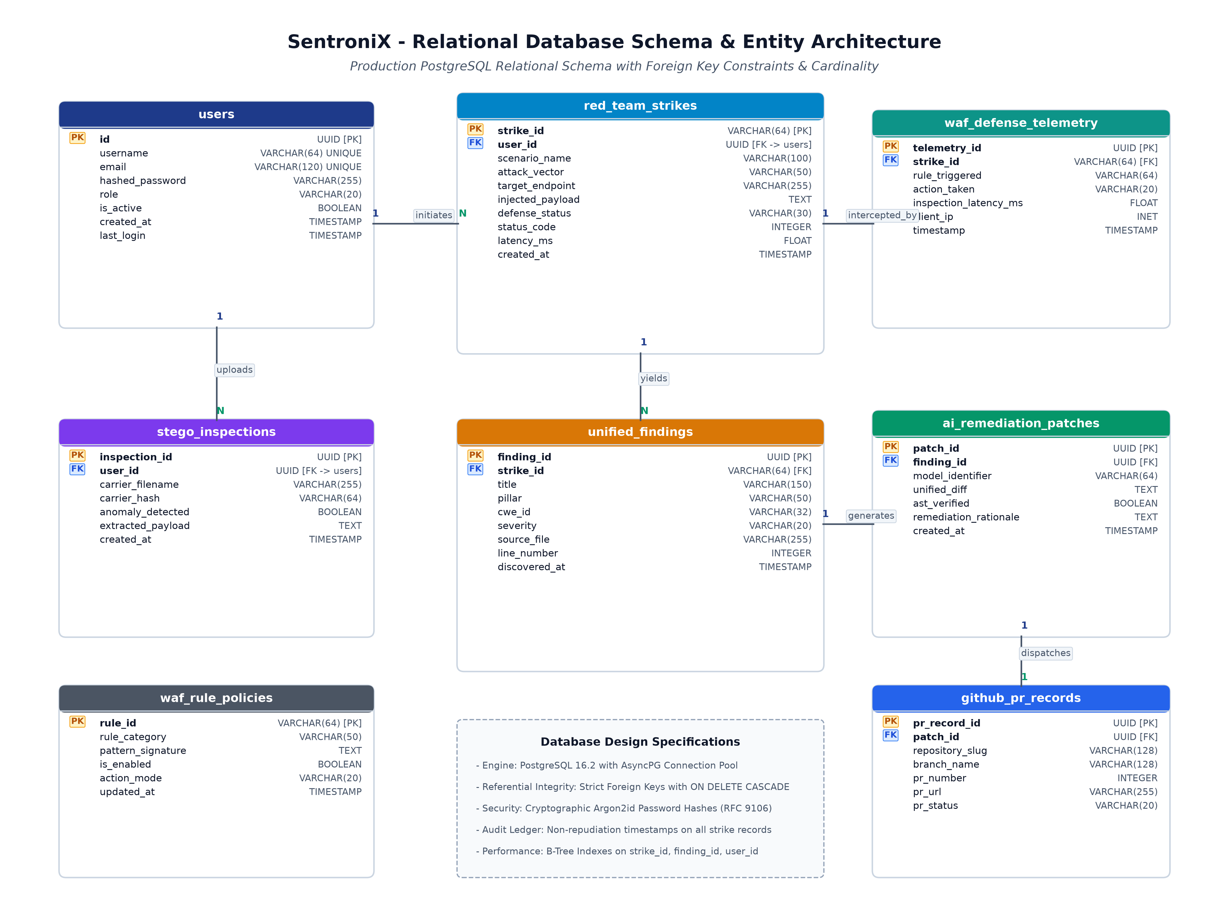
Figure: 4.1: SentroniX Relational Database Entity-Relationship Diagram (ERD)
Figure 4.2: System Use Case Diagram
The Use Case Diagram defines functional system boundaries and interactions for four primary user personas: SecOps Analysts, DevSecOps Engineers, Red Team Operators, and Platform Administrators.
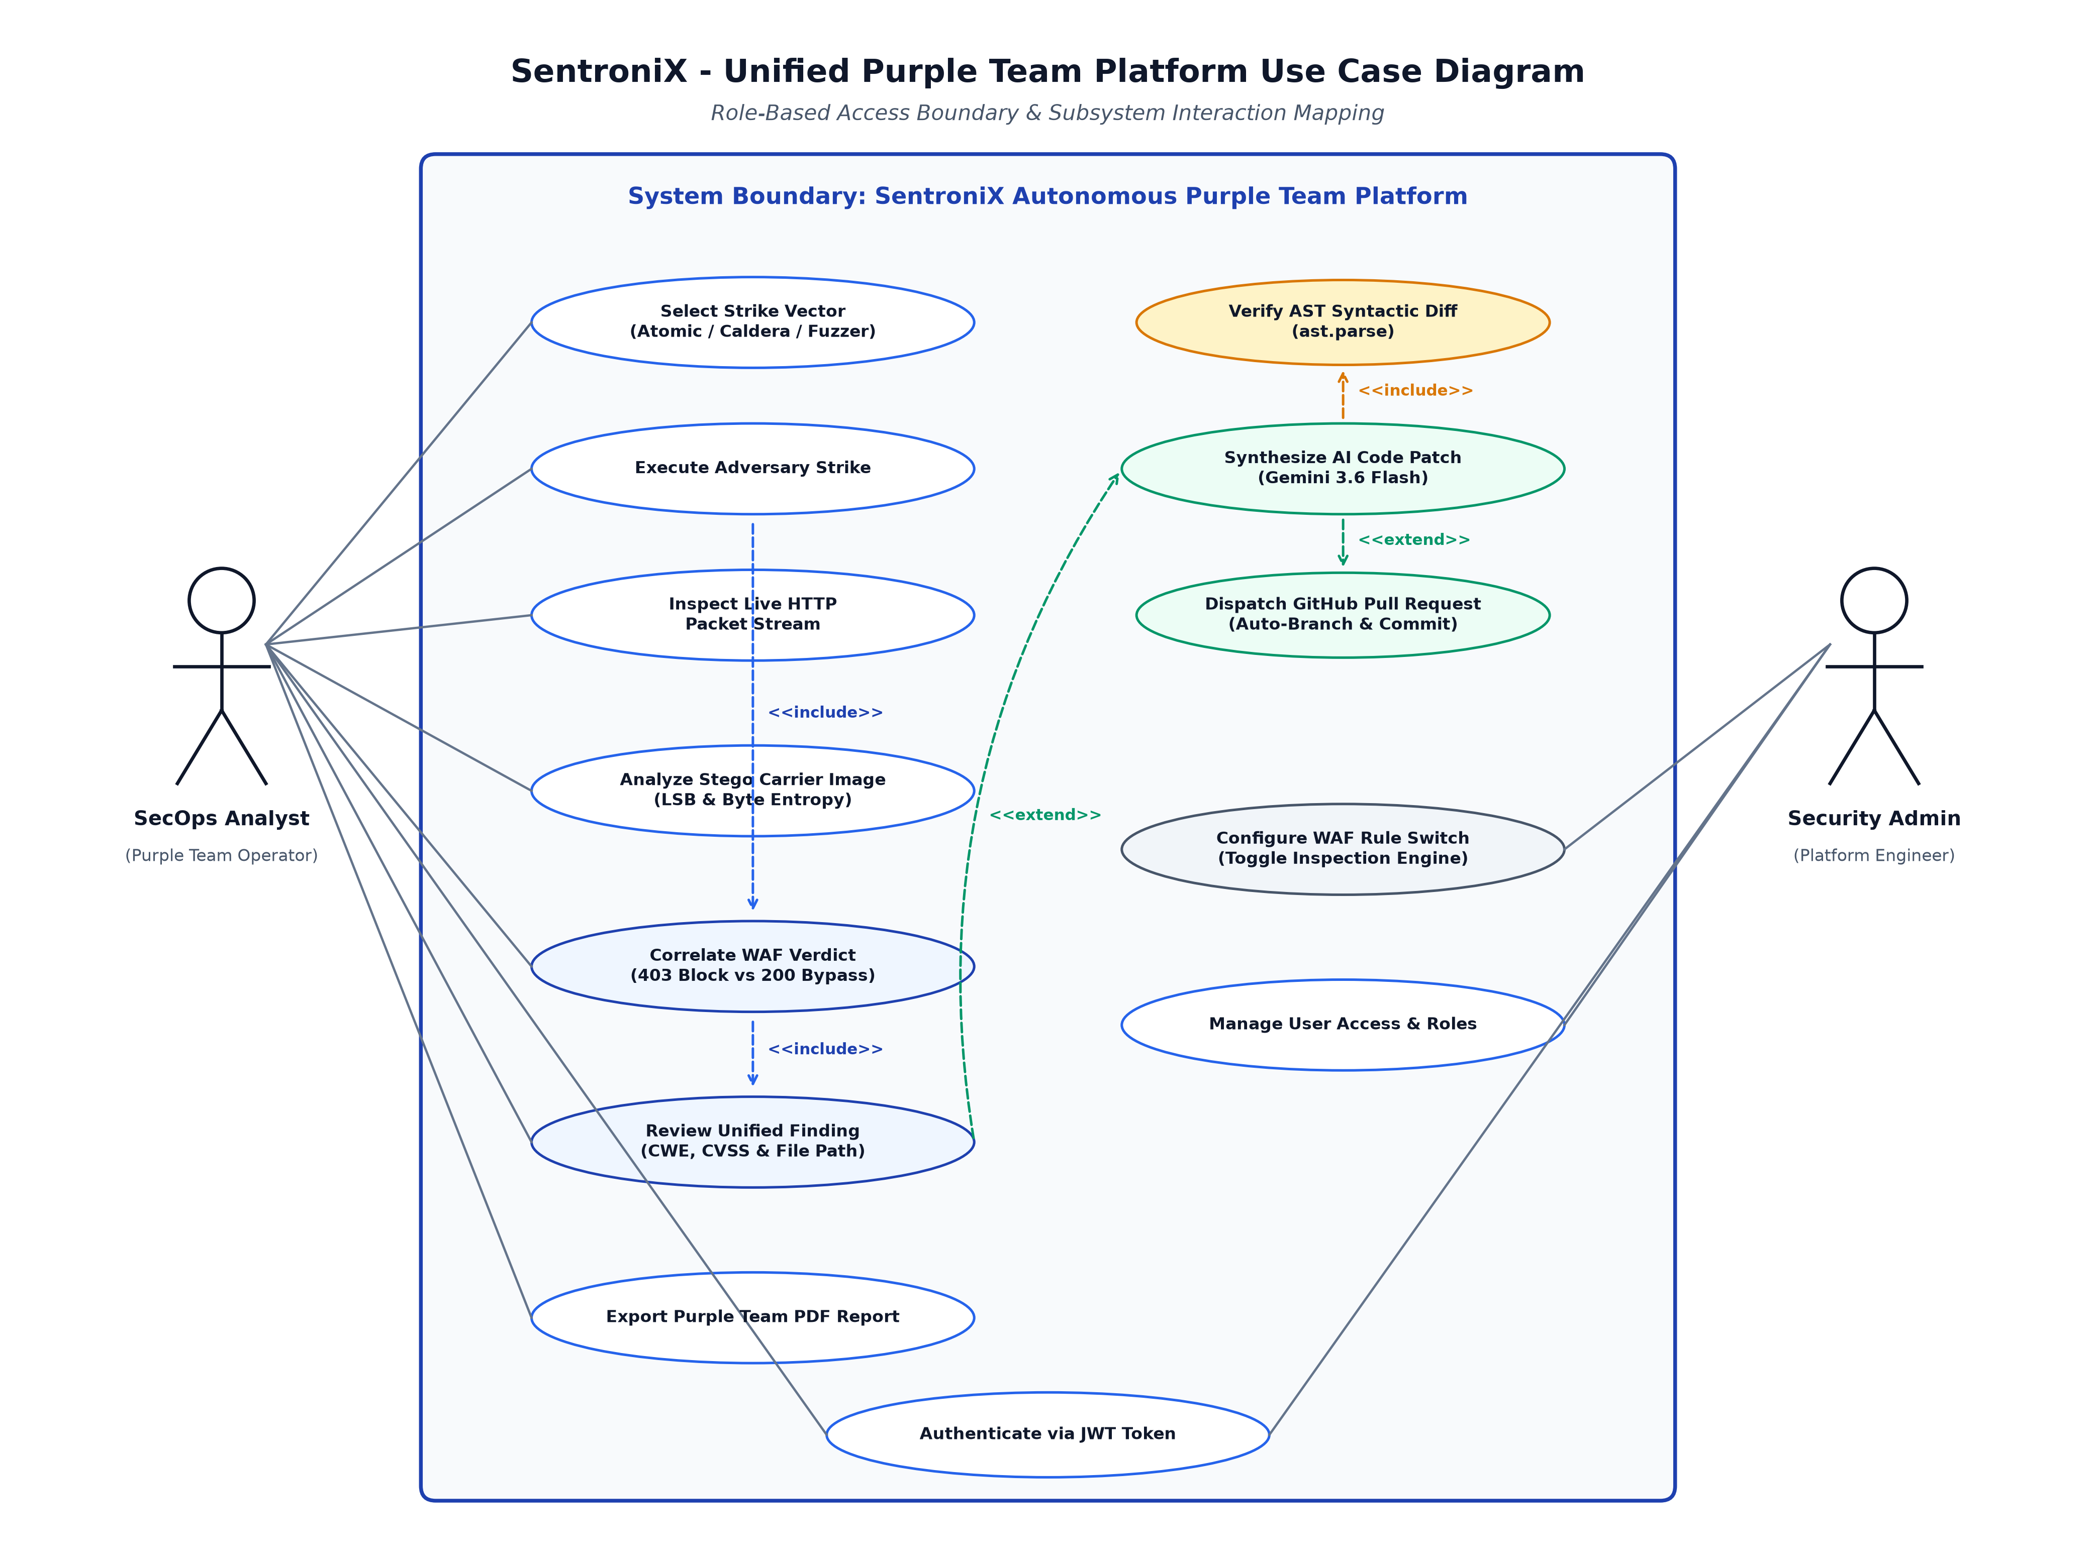
Figure: 4.2: System Use Case Diagram & Actor Boundary Model
Figure 4.3: Sequence Diagram: Multi-Stage Attack Simulation & WAF Defense
Illustrates the synchronous execution flow of an adversarial attack strike. The packet is intercepted at Layer-7 by WAF middleware, evaluated against active rules, and logged to the telemetry stream.
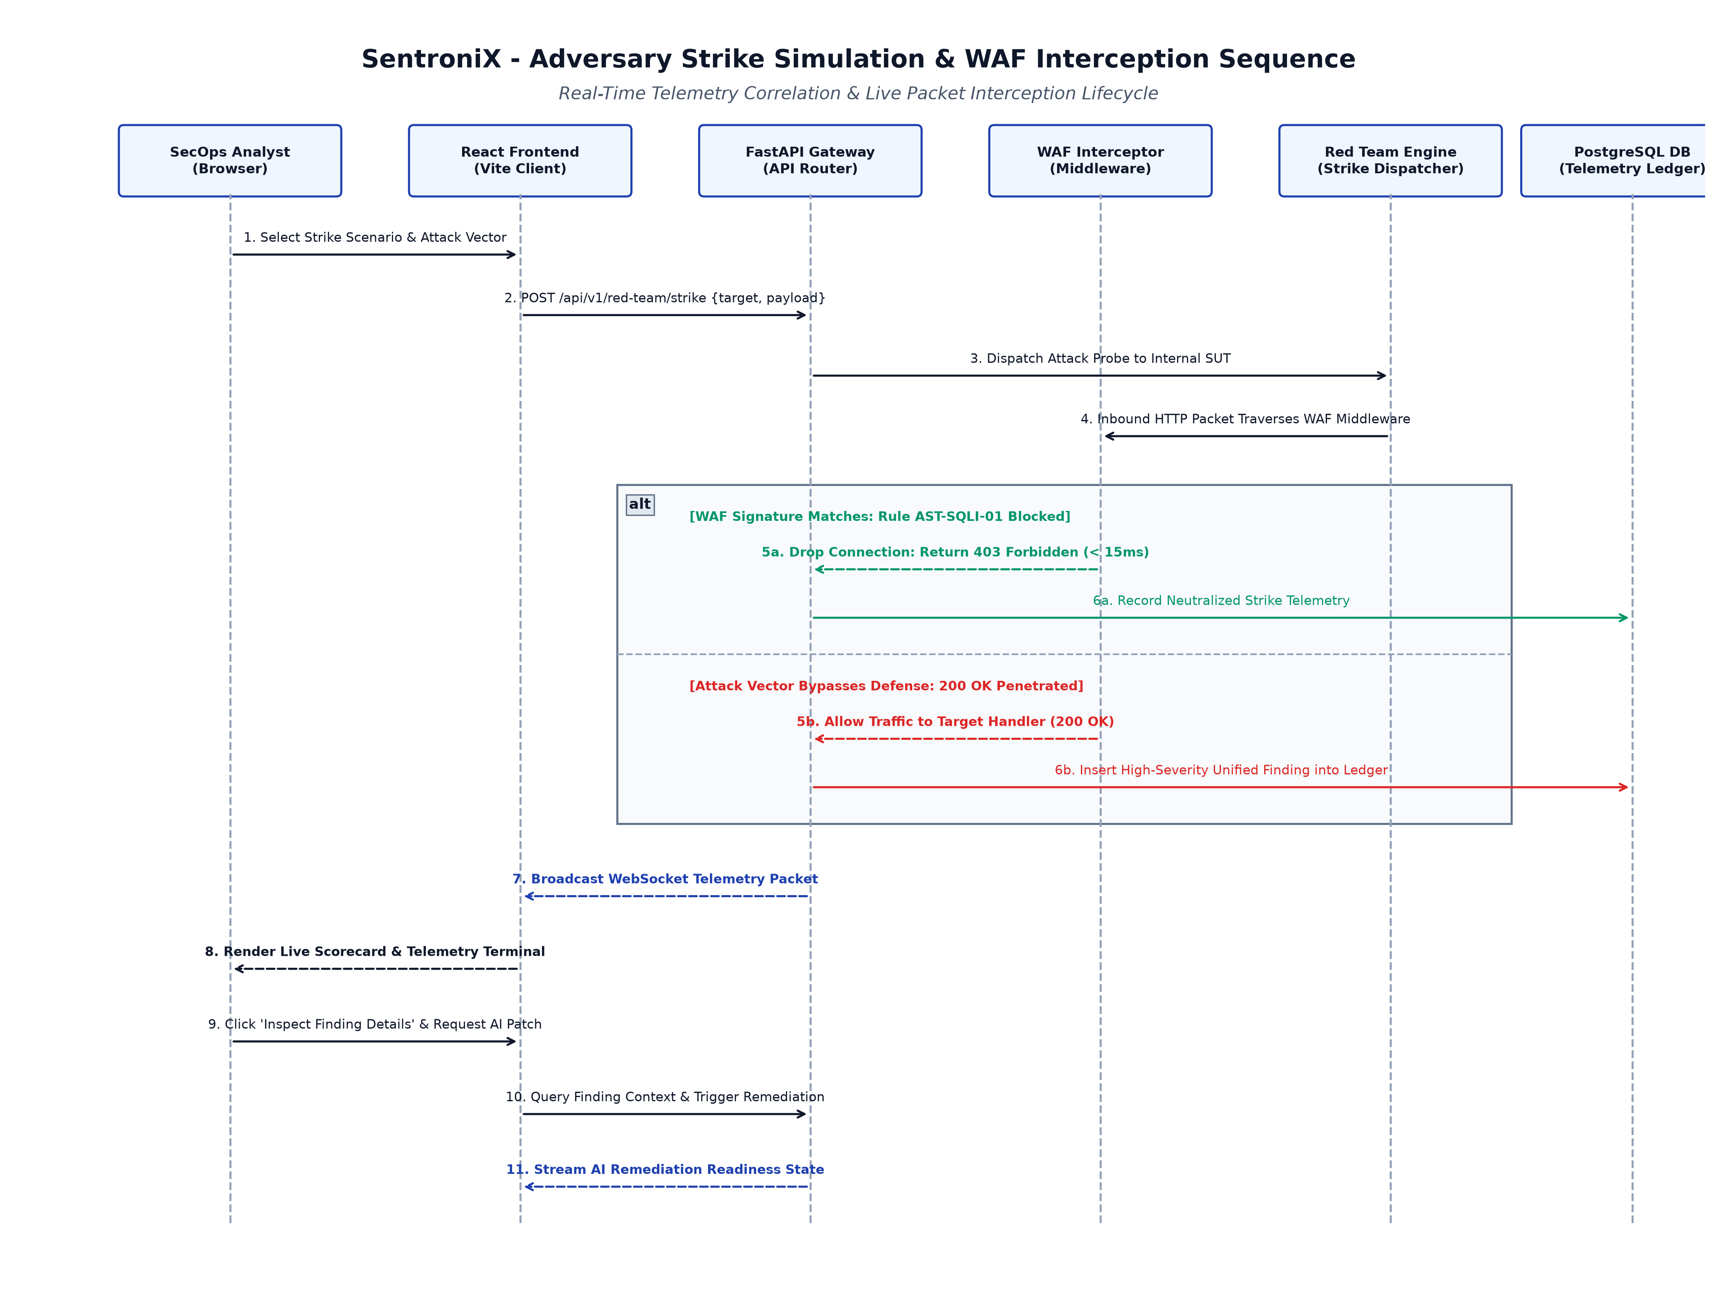
Figure: 4.3: Sequence Diagram — Multi-Stage Strike Simulation & WAF Interception
Figure 4.4: Sequence Diagram: AI Vulnerability Triage & Automated Patch Synthesis
Traces the closed-loop autonomous remediation lifecycle: finding selection, zero-shot Google Gemini 1.5 prompt synthesis, Unified Git Diff formatting, Atlassian Jira issue creation, and automated GitHub PR branching.
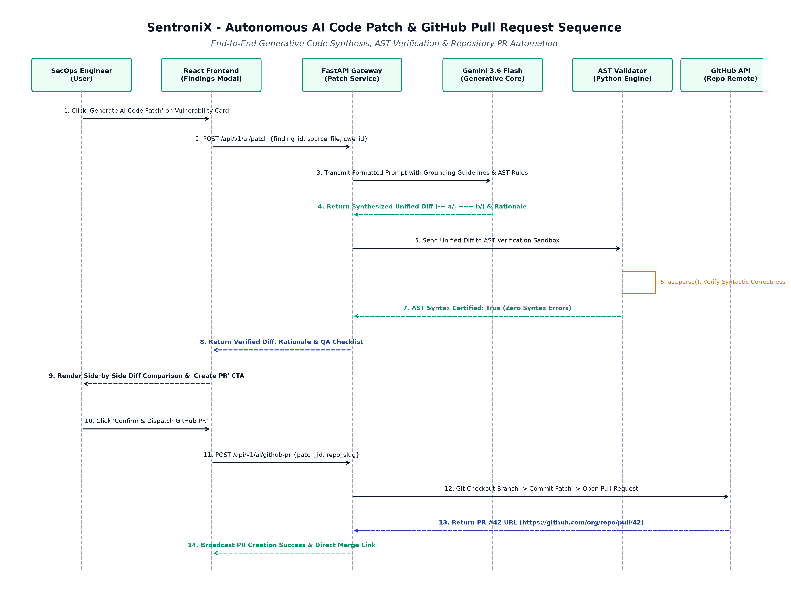
Figure: 4.4: Sequence Diagram — AI Vulnerability Triage & Automated Patch Synthesis
Figure 4.5: Activity Diagram: End-to-End DevSecOps Security Lifecycle
Models the workflow state machine of code and media assets traversing SentroniX: parallel static/dynamic/stego analysis, automated triage gateways, composite security score calculations, and developer approval gates.
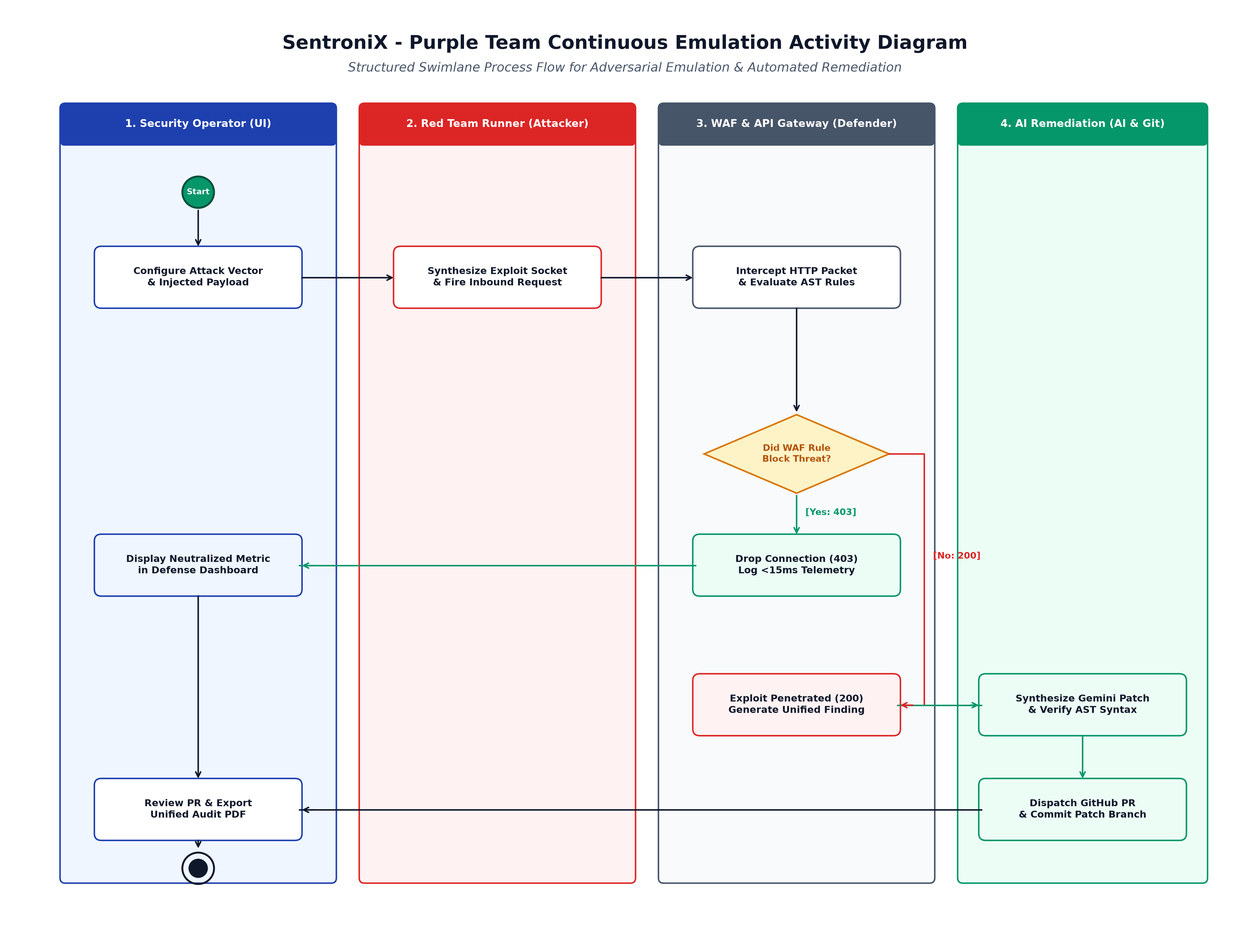
Figure: 4.5: Activity Diagram — End-to-End DevSecOps Security Lifecycle Workflow
Figure 4.6: Algorithm Flowchart: Shannon Entropy & Multi-Layer Threat Scoring
Defines the mathematical decision logic powering the Steganography Analyzer and the composite executive posture grading algorithm.
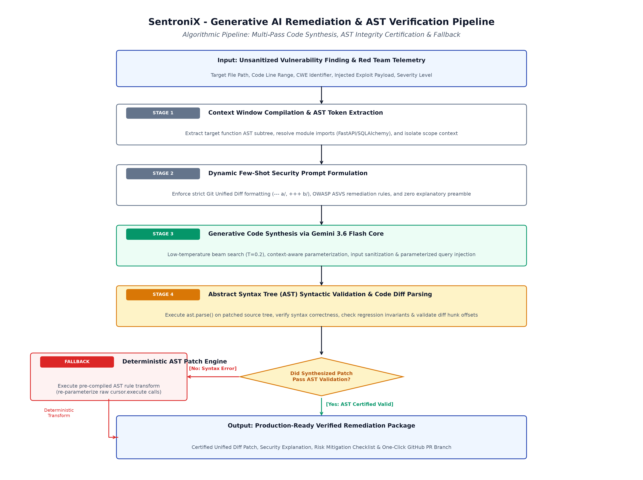
Figure: 4.6: Algorithm Flowchart — Shannon Entropy Math & Posture Scoring Logic
Shannon Entropy Mathematical Formulation:
Given an image byte stream with byte value probabilities P(x_i) across all 256 possible byte values:
H(X) = - SUM [ P(x_i) * log2(P(x_i)) ] for i = 0 to 255
• H(X) <= 7.80: Image is classified as CLEAN (natural pixel variance).
• 7.80 < H(X) <= 7.94: Flagged as SUSPICIOUS (queued for chi-square inspection).
• H(X) >= 7.95: Classified as MALICIOUS (high-entropy encrypted shellcode detected, triggering automated quarantine).
5. Data Design & Comprehensive Data Dictionary
The persistence layer is structured in 3rd Normal Form (3NF) and managed via SQLAlchemy 2.0 ORM.
5.1 Table: users
Column Name | Data Type | Constraints | Description
id | INTEGER | PK, AUTOINCREMENT | Unique user primary key identifier
email | VARCHAR(255) | UNIQUE, NOT NULL, INDEX | User account email address
hashed_password | VARCHAR(512) | NOT NULL | Salted PBKDF2-HMAC-SHA256 / bcrypt hash
tenant_id | VARCHAR(128) | NOT NULL, INDEX | Multi-tenant workspace isolation partition key
role | VARCHAR(32) | DEFAULT 'ANALYST' | RBAC role (ADMIN, ANALYST, AUDITOR)
created_at | TIMESTAMP | DEFAULT CURRENT_TIMESTAMP | Account registration timestamp

5.2 Table: scans
Column Name | Data Type | Constraints | Description
id | INTEGER | PK, AUTOINCREMENT | Unique scan session identifier
tenant_id | VARCHAR(128) | NOT NULL, INDEX | Workspace multi-tenant scope
scan_type | VARCHAR(64) | NOT NULL | Scan mode: SAST, DAST, PURPLE_TEAM, SECLISTS
target | VARCHAR(512) | NOT NULL | Target repository URL, branch, or endpoint path
status | VARCHAR(32) | DEFAULT 'COMPLETED' | Execution status: PENDING, RUNNING, COMPLETED
critical_count | INTEGER | DEFAULT 0 | Tally of critical severity findings
high_count | INTEGER | DEFAULT 0 | Tally of high severity findings
started_at | TIMESTAMP | DEFAULT CURRENT_TIMESTAMP | Scan initiation timestamp
completed_at | TIMESTAMP | NULLABLE | Scan termination timestamp

5.3 Table: findings
Column Name | Data Type | Constraints | Description
id | INTEGER | PK, AUTOINCREMENT | Unique finding record primary key
scan_id | INTEGER | FK -> scans.id | Parent scan session relationship
tenant_id | VARCHAR(128) | NOT NULL, INDEX | Multi-tenant workspace isolation key
title | VARCHAR(255) | NOT NULL | Vulnerability title & summary
severity | VARCHAR(16) | NOT NULL | Severity: CRITICAL, HIGH, MEDIUM, LOW, INFO
cwe | VARCHAR(32) | NULLABLE | Common Weakness Enumeration (e.g. CWE-89)
mitre_id | VARCHAR(32) | NULLABLE | MITRE ATT&CK Technique ID (e.g. T1190)
file_location | VARCHAR(512) | NOT NULL | Source file path and target line number range
evidence | TEXT | NULLABLE | Malicious injected payload or AST match string
status | VARCHAR(32) | DEFAULT 'OPEN' | Triage status: OPEN, TRIAGED, REMEDIATED

6. Component & RESTful API Interface Design
All API endpoints conform to RESTful design standards, consume and return application/json payloads, and enforce Bearer token authentication and tenant boundary isolation headers.
HTTP Method | Endpoint URI | Auth Scope | Functional Purpose
POST | /api/v1/auth/register | Public | Registers new analyst account & isolates workspace
POST | /api/v1/auth/login | Public | Authenticates credentials & issues stateless JWT token
GET | /api/v1/red-team/scenarios | Bearer Token | Returns catalog of 8+ MITRE ATT&CK atomic strike scenarios
POST | /api/v1/red-team/atomic-strike | Bearer Token | Fires atomic adversary strike & records WAF telemetry
GET | /api/v1/red-team/campaigns | Bearer Token | Lists automated multi-phase APT adversary profiles
POST | /api/v1/red-team/campaigns/run | Bearer Token | Executes 3-phase autonomous Caldera APT simulation
POST | /api/v1/red-team/fuzzing/run | Bearer Token | Dispatches SecLists perimeter sensitive path probe scan
POST | /api/v1/red-team/live-scan | Bearer Token | Launches customizable payload bursts against external URLs
POST | /api/v1/ai/remediate | Bearer Token | Synthesizes Unified Git Diff code fix via Gemini LLM
POST | /api/v1/ai/jira-ticket | Bearer Token | Synchronizes finding & AI code patch to Atlassian Jira
POST | /api/v1/ai/github-pr | Bearer Token | Stages AI remediation into remote branch via GitHub API
POST | /api/v1/steg/scan | Bearer Token | Performs Shannon entropy analysis on uploaded image files

7. DevOps, Cloud Deployment & CI/CD Pipeline
SentroniX is fully automated from source code commit to production cloud hosting on Render Cloud PaaS using a multi-stage Docker build pipeline.
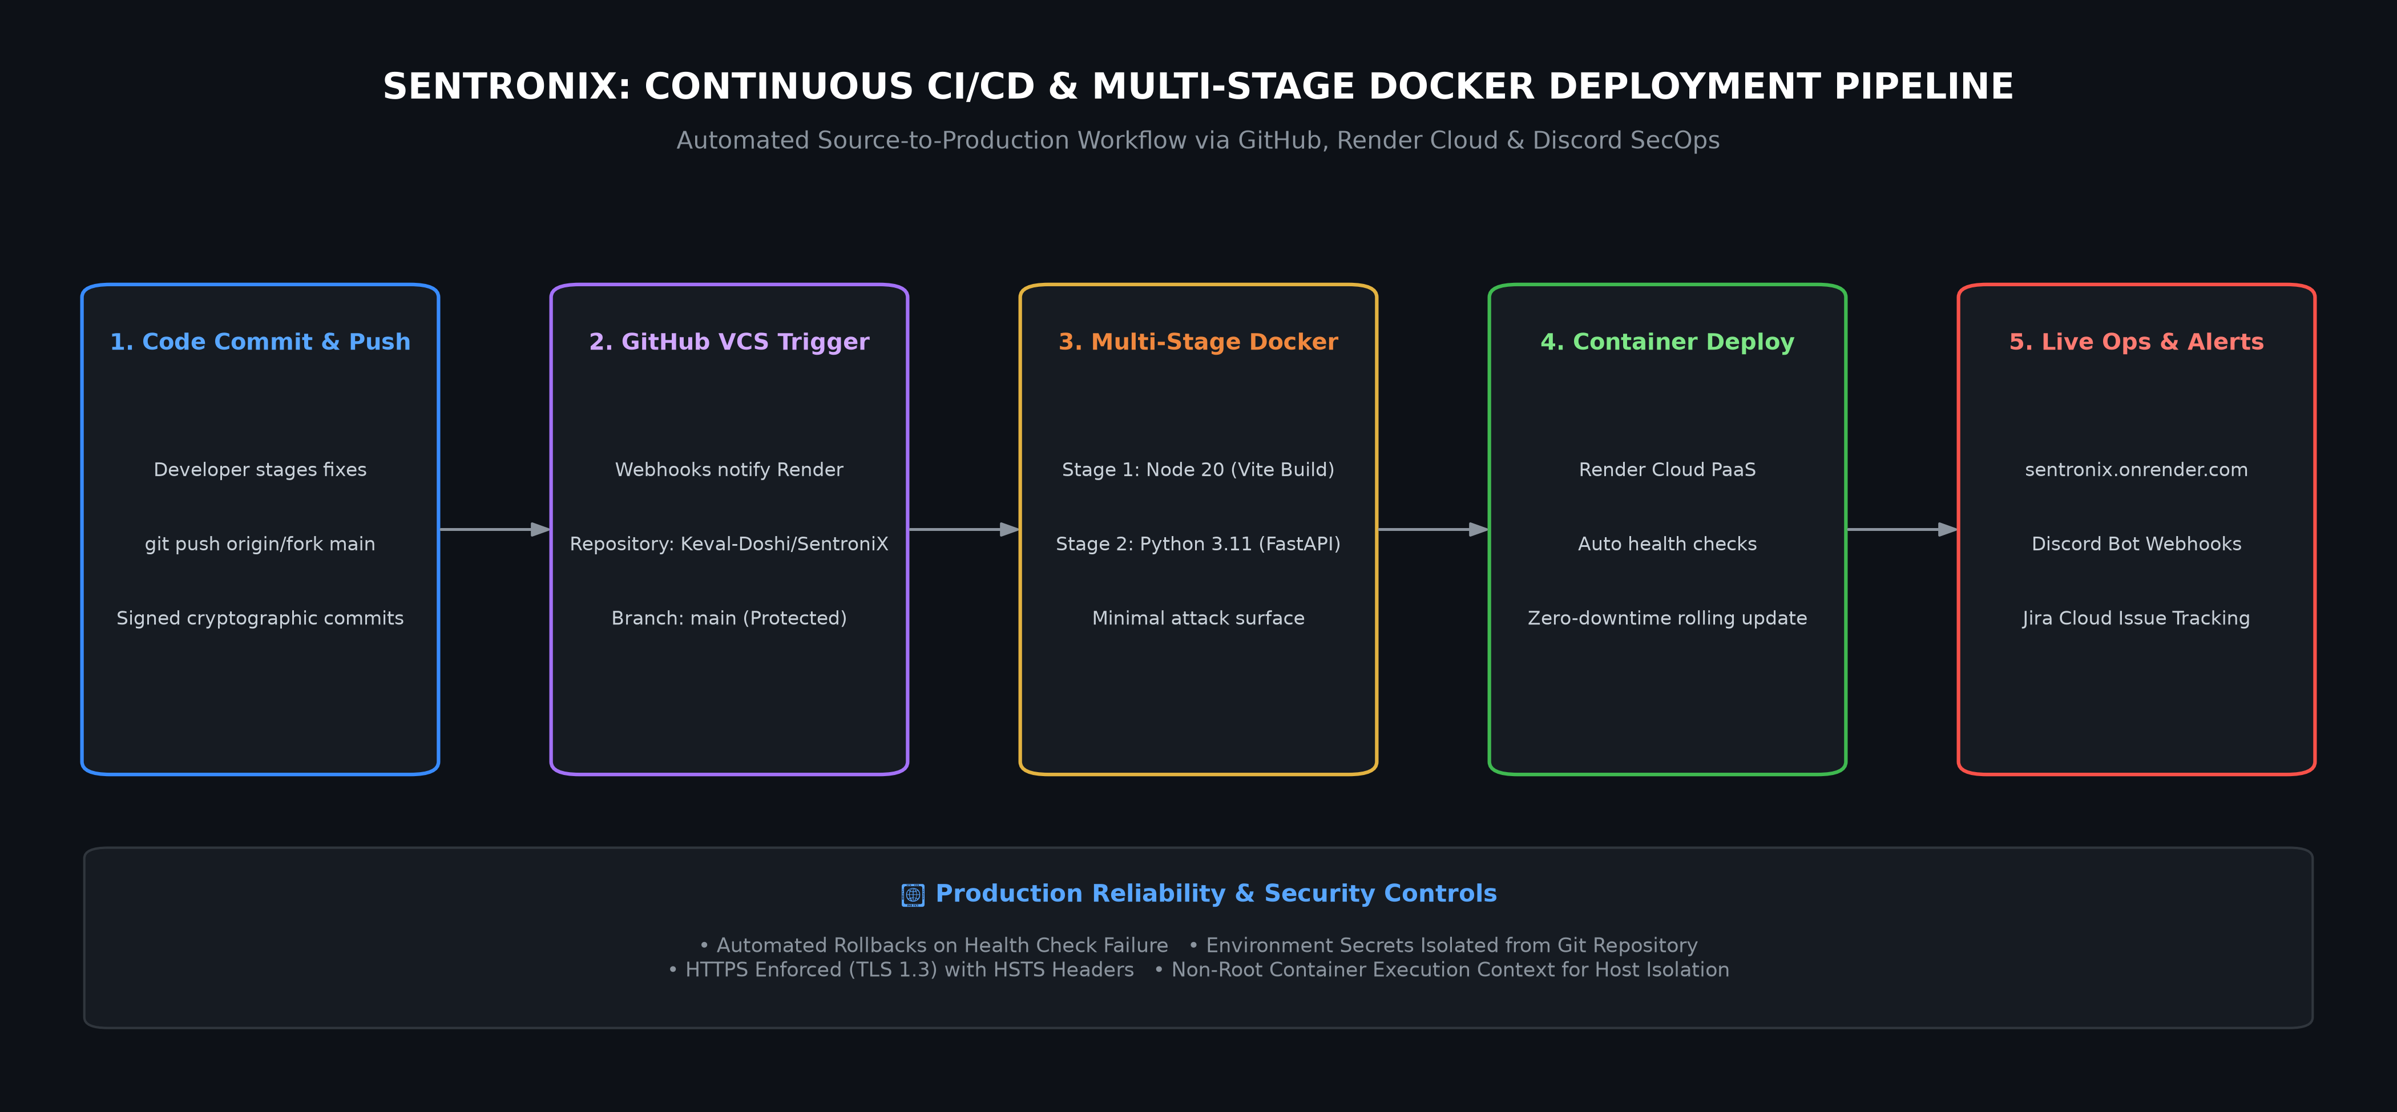
Figure: 4.7: Continuous CI/CD & Multi-Stage Docker Cloud Deployment Pipeline
- 1. Stage 1 (Frontend Build): Compiles Vite 8 React application into minified static production assets inside Node.js 20 Alpine.
- 2. Stage 2 (Backend Packaging): Python 3.11 slim runtime copies compiled frontend assets, installs pinned security dependencies, and initializes Uvicorn ASGI server.
- 3. Automated Webhooks & Health Checks: Continuous Render deployment triggers automatically on git push to main, verified with automated health checks.
- 4. SecOps Integration: Live deployment status and security alerts stream in real-time to the dedicated Discord Bot channel.
8. Master Zoom Video Presentation Script (For Professor Review)
This structured verbal script is designed for Keval Doshi to present while sharing this Design Document on Zoom:
📌 PART 1: OPENING & ARCHITECTURAL OVERVIEW (~60 SECONDS)
"Respected Professor, welcome to the System Design presentation for SentroniX — our Autonomous Purple Team Cybersecurity and AI-Driven Threat Management Platform.
As shown in Figure 4.0 of our Design Document, SentroniX is engineered as a cloud-native, 4-tier architecture. It bridges offensive adversary emulation (Red Team), real-time WAF packet interception (Blue Team), and automated Gemini AI code remediation into a single continuous pipeline.
Everything is deployed live on Render Cloud using a multi-stage Docker container with a React/Vite frontend and a high-performance asynchronous FastAPI backend."

📌 PART 2: FORMAL UML MODELS & ALGORITHMS (~120 SECONDS)
"Let me guide you through the formal UML models in Section 4:
• Figure 4.1 (ERD): Our database schema is built in 3rd Normal Form with strict multi-tenancy. Notice how every scan, finding, remediation patch, and audit log is partitioned by tenant_id, ensuring enterprise-grade multi-tenant data isolation.
• Figure 4.2 (Use Case Diagram): Here you see our primary actor boundaries: SecOps Analysts running automated Caldera APT simulations, DevSecOps Engineers reviewing AI-synthesized code patches, and Administrators governing real-time WAF policy switchboards.
• Figures 4.3 & 4.4 (Sequence Diagrams): Figure 4.3 traces Layer-7 packet interception during a live strike, while Figure 4.4 illustrates our AI remediation lifecycle where detected vulnerabilities are sent to Google Gemini 1.5, formatted into Unified Git Diffs, and synchronized directly with Atlassian Jira and GitHub Pull Requests.
• Figure 4.6 (Algorithm Flowchart): This details our mathematical Shannon Entropy engine: H(X) = - SUM [ P(x) * log2(P(x)) ]. If an uploaded image exceeds 7.95 entropy, it flags encrypted reverse-shell malware embedded within pixel bitplanes."

📌 PART 3: CONCLUSION & LIVE RELEVANCE (~30 SECONDS)
"To conclude, SentroniX doesn't just passively find bugs — it actively proves defensive resilience through breach emulation and immediately fixes the problem through automated AI code patches. All eight design diagrams, API contracts, and database schemas in this document reflect our fully implemented, live production system at sentronix.onrender.com."

