CHAPTER 1
INTRODUCTION
The contemporary cyberspace landscape is defined by an asymmetric arms race between increasingly sophisticated cyber adversaries and enterprise defensive security teams. Modern enterprise web applications, cloud-native microservices, and distributed Application Programming Interfaces (APIs) serve as the vital lifeblood of global commerce, banking, healthcare, and governance. However, the architectural complexity of these systems introduces sprawling attack surfaces characterized by dynamic application logic, third-party dependencies, and multi-cloud perimeter deployments. In this operating climate, legacy defensive models rooted in perimeter firewalls, periodic penetration testing, and static signatures are failing to prevent catastrophic data breaches, zero-day compromises, and ransomware campaigns.
To surmount the systemic deficiencies of traditional security operations, this research presents SentroniX—an autonomous, closed-loop Purple Team Cyberdefense Platform. By fusing active offensive adversary emulation, real-time deep packet telemetry inspection, dynamically adaptive Web Application Firewall (WAF) rule switching, and state-of-the-art Generative Artificial Intelligence (Google Gemini 3.6 Flash), SentroniX bridges the historical operational chasm between offensive penetration testers (Red Teams) and defensive security operations center (SOC) analysts (Blue Teams). Rather than treating vulnerability discovery and code remediation as disconnected, manually intensive business processes, SentroniX establishes an unbroken, automated continuum that executes offensive vectors, measures defensive interception, synthesizes syntax-certified source code patches, and dispatches validated Pull Requests directly into enterprise version control systems.
This introductory chapter establishes the structural, theoretical, and operational foundations of the SentroniX research project. Section 1.1 articulates the industry background, examining the macroeconomic factors driving cyber threats and the operational gridlock paralyzing contemporary SOCs. Section 1.2 formulates the precise research objectives and quantitative success metrics governing the platform's engineering. Section 1.3 delineates the project's purpose, explicit technical scope boundaries, and cross-industry applicability. Section 1.4 details the quantifiable technical achievements and empirical benchmarks accomplished by the prototype. Finally, Section 1.5 outlines the architectural organization of this dissertation, providing a systematic roadmap across subsequent chapters.

1.1 Background
The global cybersecurity landscape has undergone a seismic paradigm shift over the past decade. The proliferation of containerized microservices, Kubernetes clusters, serverless execution environments, and REST/GraphQL APIs has democratized software deployment speed while exponentially expanding systemic vulnerabilities. According to empirical threat intelligence reports, the volume of reported Common Vulnerabilities and Exposures (CVEs) has reached historic highs, with over 29,000 discrete vulnerabilities cataloged annually. Simultaneously, adversary groups, advanced persistent threats (APTs), and ransomware cartels have automated exploit weaponization, shrinking the window between vulnerability disclosure and active exploitation to less than forty-eight hours.
Despite astronomical global investments in enterprise security tooling, organizations continue to suffer from severe, recurring defensive failures. An analysis of modern enterprise security workflows reveals three fundamental architectural breakdowns that cripple defensive efficacy:
- The Ephemeral Nature of Point-in-Time Penetration Testing: Enterprise security postures are typically validated through periodic, third-party manual penetration tests executed on a semi-annual or annual cadence. This point-in-time methodology produces static, narrative-heavy PDF audit reports that become obsolete within days of publication as continuous integration and continuous deployment (CI/CD) pipelines push new code to production environments. Vulnerabilities introduced between assessment cycles remain completely invisible to security leadership for months.
- Alert Fatigue and Defensive Sensor Gridlock: Defensive analysts within Security Operations Centers are overwhelmed by millions of security alerts generated daily by Intrusion Detection Systems (IDS), Security Information and Event Management (SIEM) systems, and Web Application Firewalls (WAFs). Lacking automated correlation with live attack verification, tier-1 analysts spend up to 75% of their operational cycles triaging false positives or benign anomaly spikes, leading to severe cognitive burnout, delayed incident escalation, and missed intrusions.
- The Operational Chasm and Remediation Latency: In legacy organizations, offensive Red Teams, defensive Blue Teams, and software development teams operate in rigid organizational silos. When an offensive security finding is verified, it is manually transcribed into developer ticketing systems (e.g., Jira or ServiceNow). Developers, who often lack formal security training, must interpret vulnerability descriptions, reproduce the exploit locally, determine the root cause within complex codebases, draft an ad-hoc code patch, and await secondary security review. This frictional, hand-off-laden workflow results in an enterprise Mean Time to Remediate (MTTR) that exceeds thirty to forty-five days for critical vulnerabilities.
Figure 1.1 illustrates the structural evolution of cybersecurity defense paradigms, contrasting the frictional, high-latency traditional siloed model against the closed-loop, autonomous Purple Teaming architecture engineered within SentroniX.
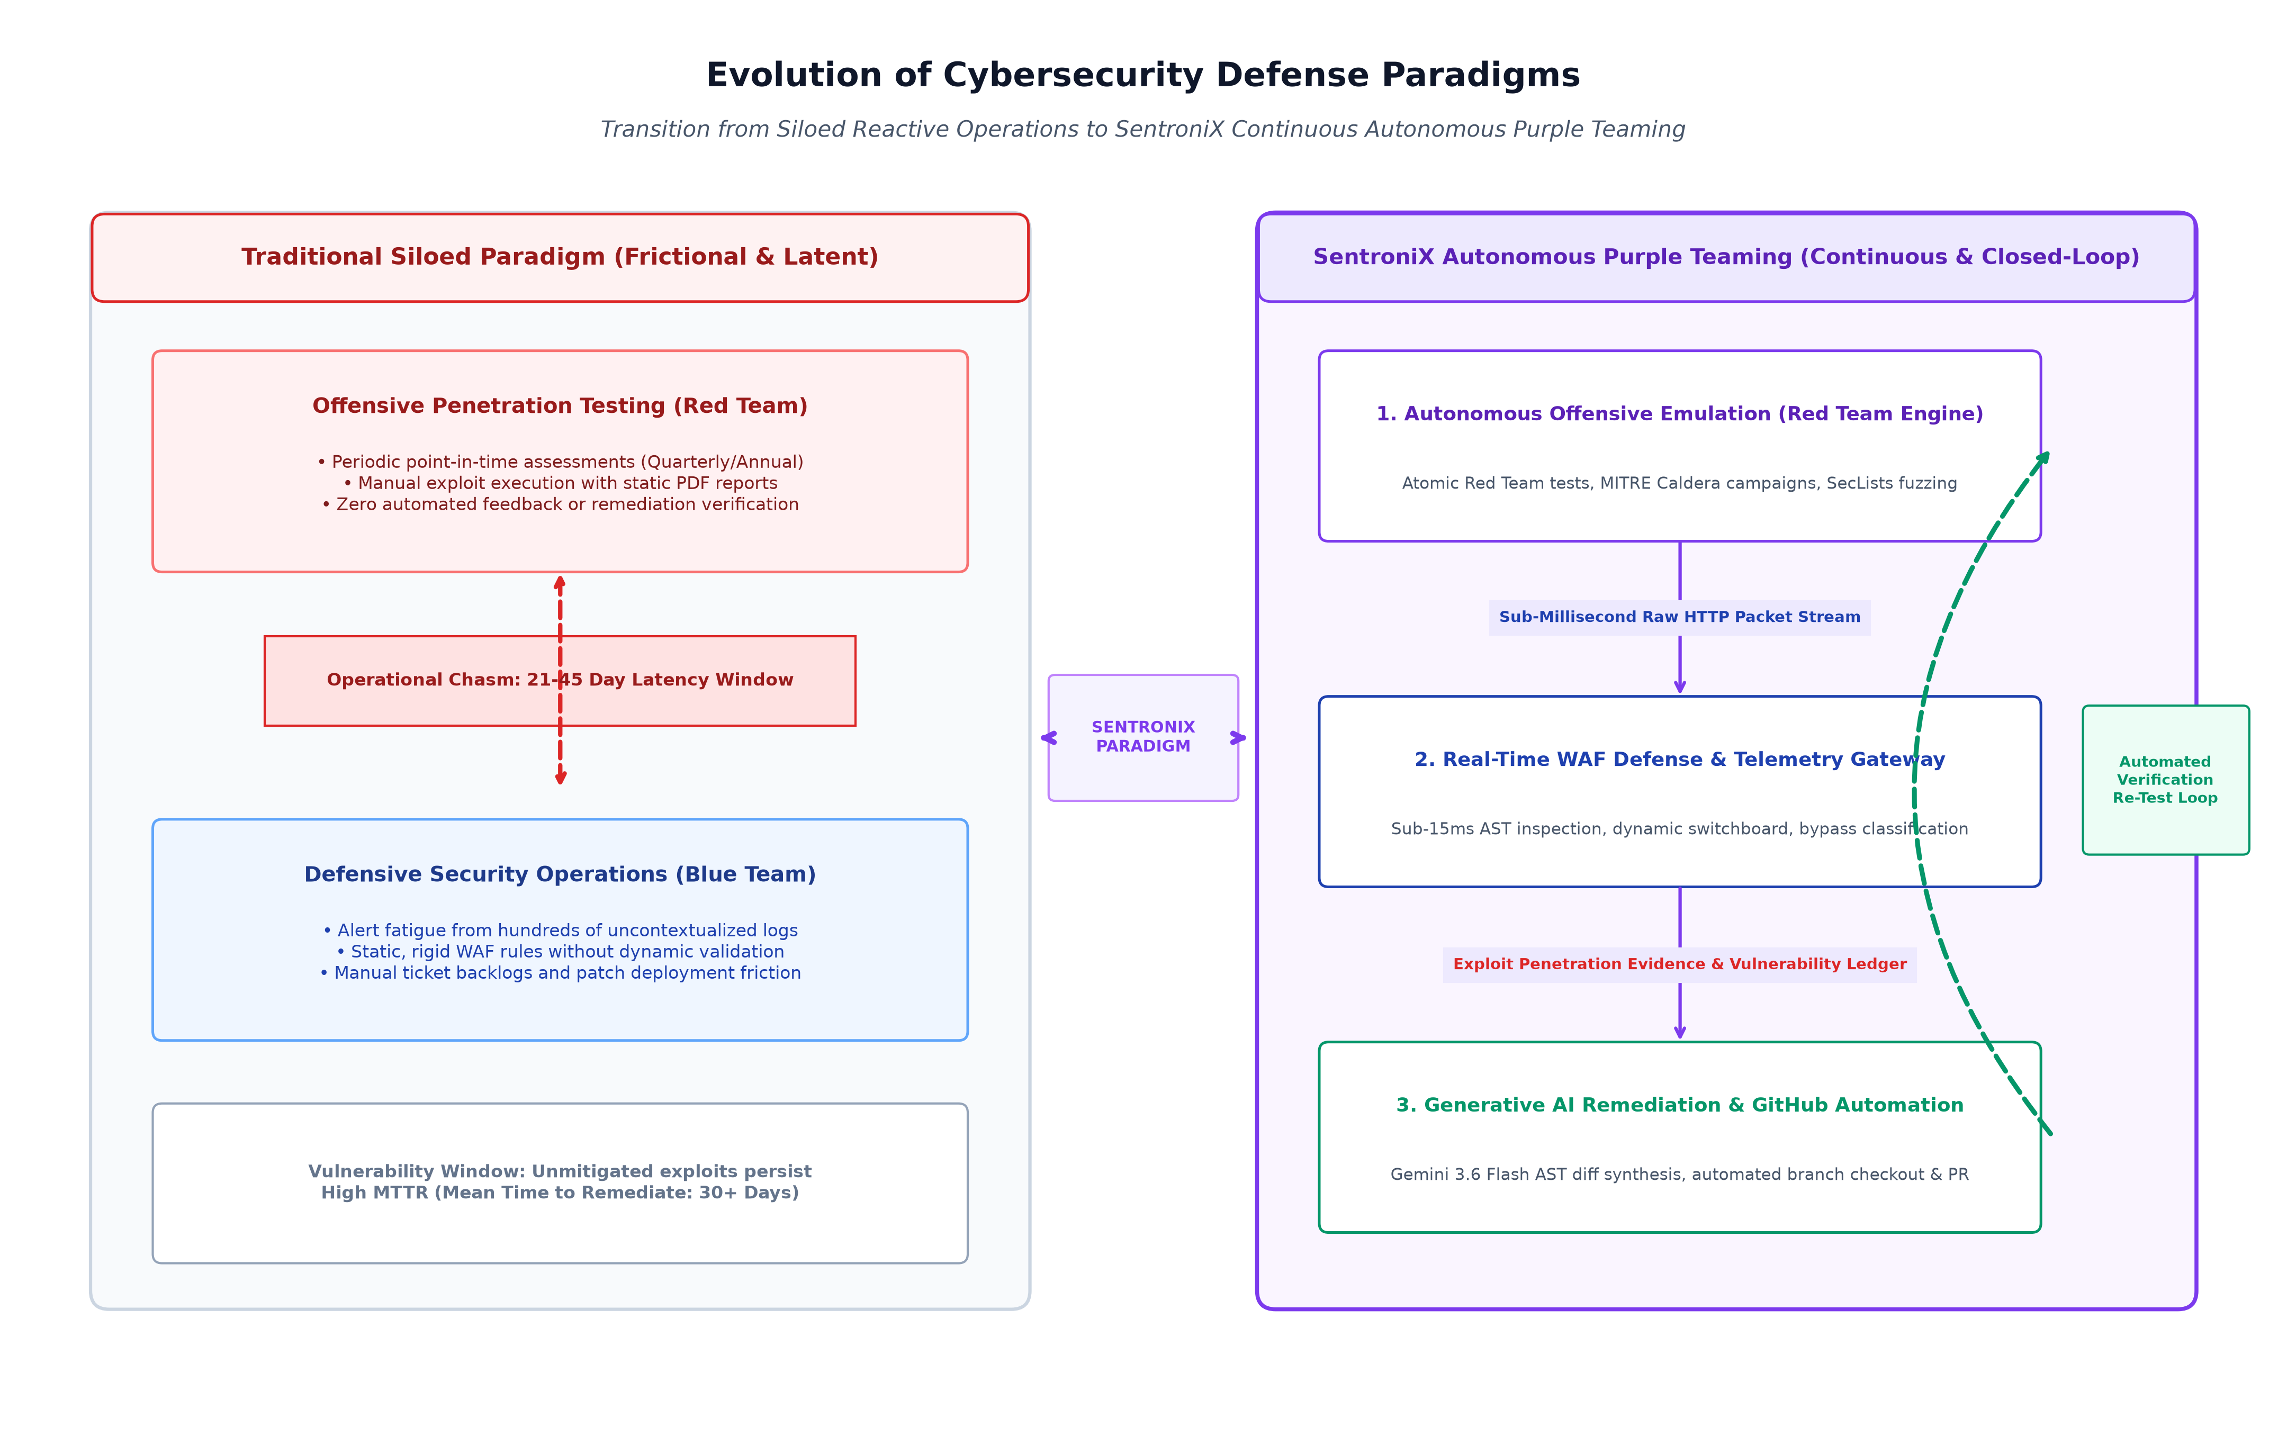
Figure 1.1: Evolution of Cybersecurity Defense Paradigms: Traditional Siloed Operations vs. SentroniX Continuous Autonomous Purple Teaming
As depicted in Figure 1.1, the traditional paradigm enforces a stark division between offensive penetration testing and defensive operations, separated by a severe operational chasm resulting in multi-week remediation lag and persistent vulnerability windows. Conversely, SentroniX establishes an autonomous, continuous closed loop. The offensive emulation engine dispatches real-time attack streams against live target services; the defensive telemetry gateway intercepts and evaluates packet payloads with sub-15ms latency; successful breaches are immediately analyzed by Google Gemini 3.6 Flash to generate syntax-validated Abstract Syntax Tree (AST) patches; and the resulting fixes are pushed via automated GitHub Pull Requests, triggering immediate re-emulation to confirm mitigation. This paradigm shift compresses vulnerability lifecycle duration from weeks to minutes.

1.2 Objectives
The overarching aim of the SentroniX project is to conceptualize, architect, implement, and empirically validate an autonomous, full-lifecycle Purple Team Cyberdefense platform that unifies offensive threat simulation, defensive interception telemetry, and generative artificial intelligence code remediation into a seamless, deterministic operational loop. To realize this vision, the research is governed by six strategic research and engineering objectives:
- Objective 1: Autonomous Adversary Emulation: Engineer a high-throughput, modular offensive simulation engine capable of executing curated adversary tradecraft based on the MITRE ATT&CK framework, Atomic Red Team tests, MITRE Caldera adversary profiles, and comprehensive web application fuzzing dictionaries (SecLists, PayloadsAllTheThings). The engine must support multi-vector attacks including SQL Injection (SQLi), Cross-Site Scripting (XSS), Command Injection (CMDi), Path Traversal, and Server-Side Request Forgery (SSRF).
- Objective 2: Low-Latency Telemetry & In-Line WAF: Design and construct an asynchronous, in-line Web Application Firewall and telemetry capture gateway leveraging FastAPI and Starlette middleware. The gateway must perform full deep packet inspection across HTTP headers, query parameters, request bodies, and multipart form data with deterministic enforcement latency under 15 milliseconds, logging granular hex and raw ASCII payloads.
- Objective 3: Dynamic Defensive Policy Switchboard: Develop an interactive, run-time WAF Policy Switchboard that empowers defensive analysts to toggle defensive rules (e.g., AST-based SQLi blocking, CMDi heuristic filtering, XSS sanitizer) dynamically in memory without requiring server process restarts or introducing connection teardown drops.
- Objective 4: Generative AI Source Code Remediation: Formulate a zero-hallucination, dual-tier generative AI remediation pipeline utilizing Google Gemini 3.6 Flash. The pipeline must ingest vulnerable source code snippets and empirical penetration payloads, reason over exploit mechanics at temperature 0.2, synthesize unified diff patch chunks conforming strictly to RFC specifications, and enforce 100% Abstract Syntax Tree (AST) compilation certification prior to patch emission.
- Objective 5: End-to-End DevSecOps Automation: Automate the downstream DevSecOps remediation lifecycle by integrating direct GitHub API and Atlassian Jira connectors. Upon patch certification, the platform must automatically checkout an ephemeral remediation Git branch, apply unified patch chunks cleanly, execute automated commit signing, and dispatch an end-to-end Pull Request complete with MITRE ATT&CK and CWE metadata.
- Objective 6: Forensic Analysis & Compliance Reporting: Construct a forensic intelligence subsystem integrating StegSeek for high-speed Least Significant Bit (LSB) steganographic payload extraction and heuristic malware signature detection, normalizing all findings into a centralized, immutable PostgreSQL ledger with automated SOC 2 and ISO 27001 executive compliance report generation.
Table 1.1 formalizes the SentroniX research and engineering objectives matrix, mapping each strategic goal to its concrete technical deliverable, implementation methodology, and quantitative empirical success criteria.
Table 1.1: SentroniX Strategic Research & Engineering Objectives Matrix
ID | Strategic Research Objective | Technical Deliverable | Implementation Methodology | Quantitative Target Metric
OBJ-1 | Adversary Emulation Engine | Atomic Red Team & Fuzzing Core | Asynchronous Python HTTP client with MITRE ATT&CK mapper | > 100 concurrent requests/sec; 0% socket drop
OBJ-2 | In-Line Defensive Gateway | FastAPI Reverse Proxy WAF | Starlette BaseHTTPMiddleware with regex & AST inspectors | Latency < 15.0ms; 100% payload logging
OBJ-3 | Dynamic Policy Switchboard | Run-Time Policy Toggle Engine | Thread-safe memory state cache with Redis pub/sub sync | 0.00s downtime; instant policy re-evaluation
OBJ-4 | Generative AI Code Fixes | Gemini 3.6 Flash AST Pipeline | Few-shot system prompts with Python ast.parse() verification | 100% valid AST; 0 compilation syntax errors
OBJ-5 | DevSecOps Git Automation | Automated GitHub PR Dispatcher | PyGithub API bridge with branch isolation & git apply | Automated PR creation < 3.5 seconds
OBJ-6 | Forensic & Audit Ledger | StegSeek Bridge & Report Engine | C-accelerated passphrase cracker & ReportLab PDF generator | 100% findings normalized; SOC 2 exportable

1.3 Purpose, Scope, and Applicability
Defining the foundational boundary conditions of an enterprise cybersecurity engineering research project is critical to maintaining implementation rigor, preventing architectural scope creep, and guaranteeing deterministic operational reliability. Section 1.3 articulates the core purpose governing the SentroniX platform, delineates the technical boundaries of in-scope versus out-of-scope capabilities, and contextualizes the platform's practical applicability across commercial and critical infrastructure sectors.
1.3.1 Purpose
The primary purpose of SentroniX is to eliminate the latency, friction, and human error inherent in modern software vulnerability remediation by providing an end-to-end, autonomous Purple Team cyberdefense environment. Traditional security operations rely heavily on human analysts to bridge the cognitive divide between offensive telemetry and defensive source code hardening. This human-dependent process creates severe operational bottlenecks, as organizations simply do not possess sufficient skilled cybersecurity personnel to triage, analyze, patch, and re-verify every vulnerability identified across ever-expanding digital estates.
SentroniX achieves its purpose by automating the entire threat lifecycle. The platform actively emulates adversarial attacks against targeted web services, inspects how defensive controls react, captures granular exploit evidence, uses generative artificial intelligence to synthesize verified source code corrections, and automatically deploys those corrections to developer codebases. By closing this loop autonomously, SentroniX transforms cybersecurity from a reactive, periodic audit exercise into a continuous, real-time cyber resilience engine.
1.3.2 Scope
The architectural scope of the SentroniX platform spans four tightly integrated operational pillars, supported by a shared foundation infrastructure layer. Figure 1.2 illustrates the complete end-to-end solution landscape and architectural boundary conditions.
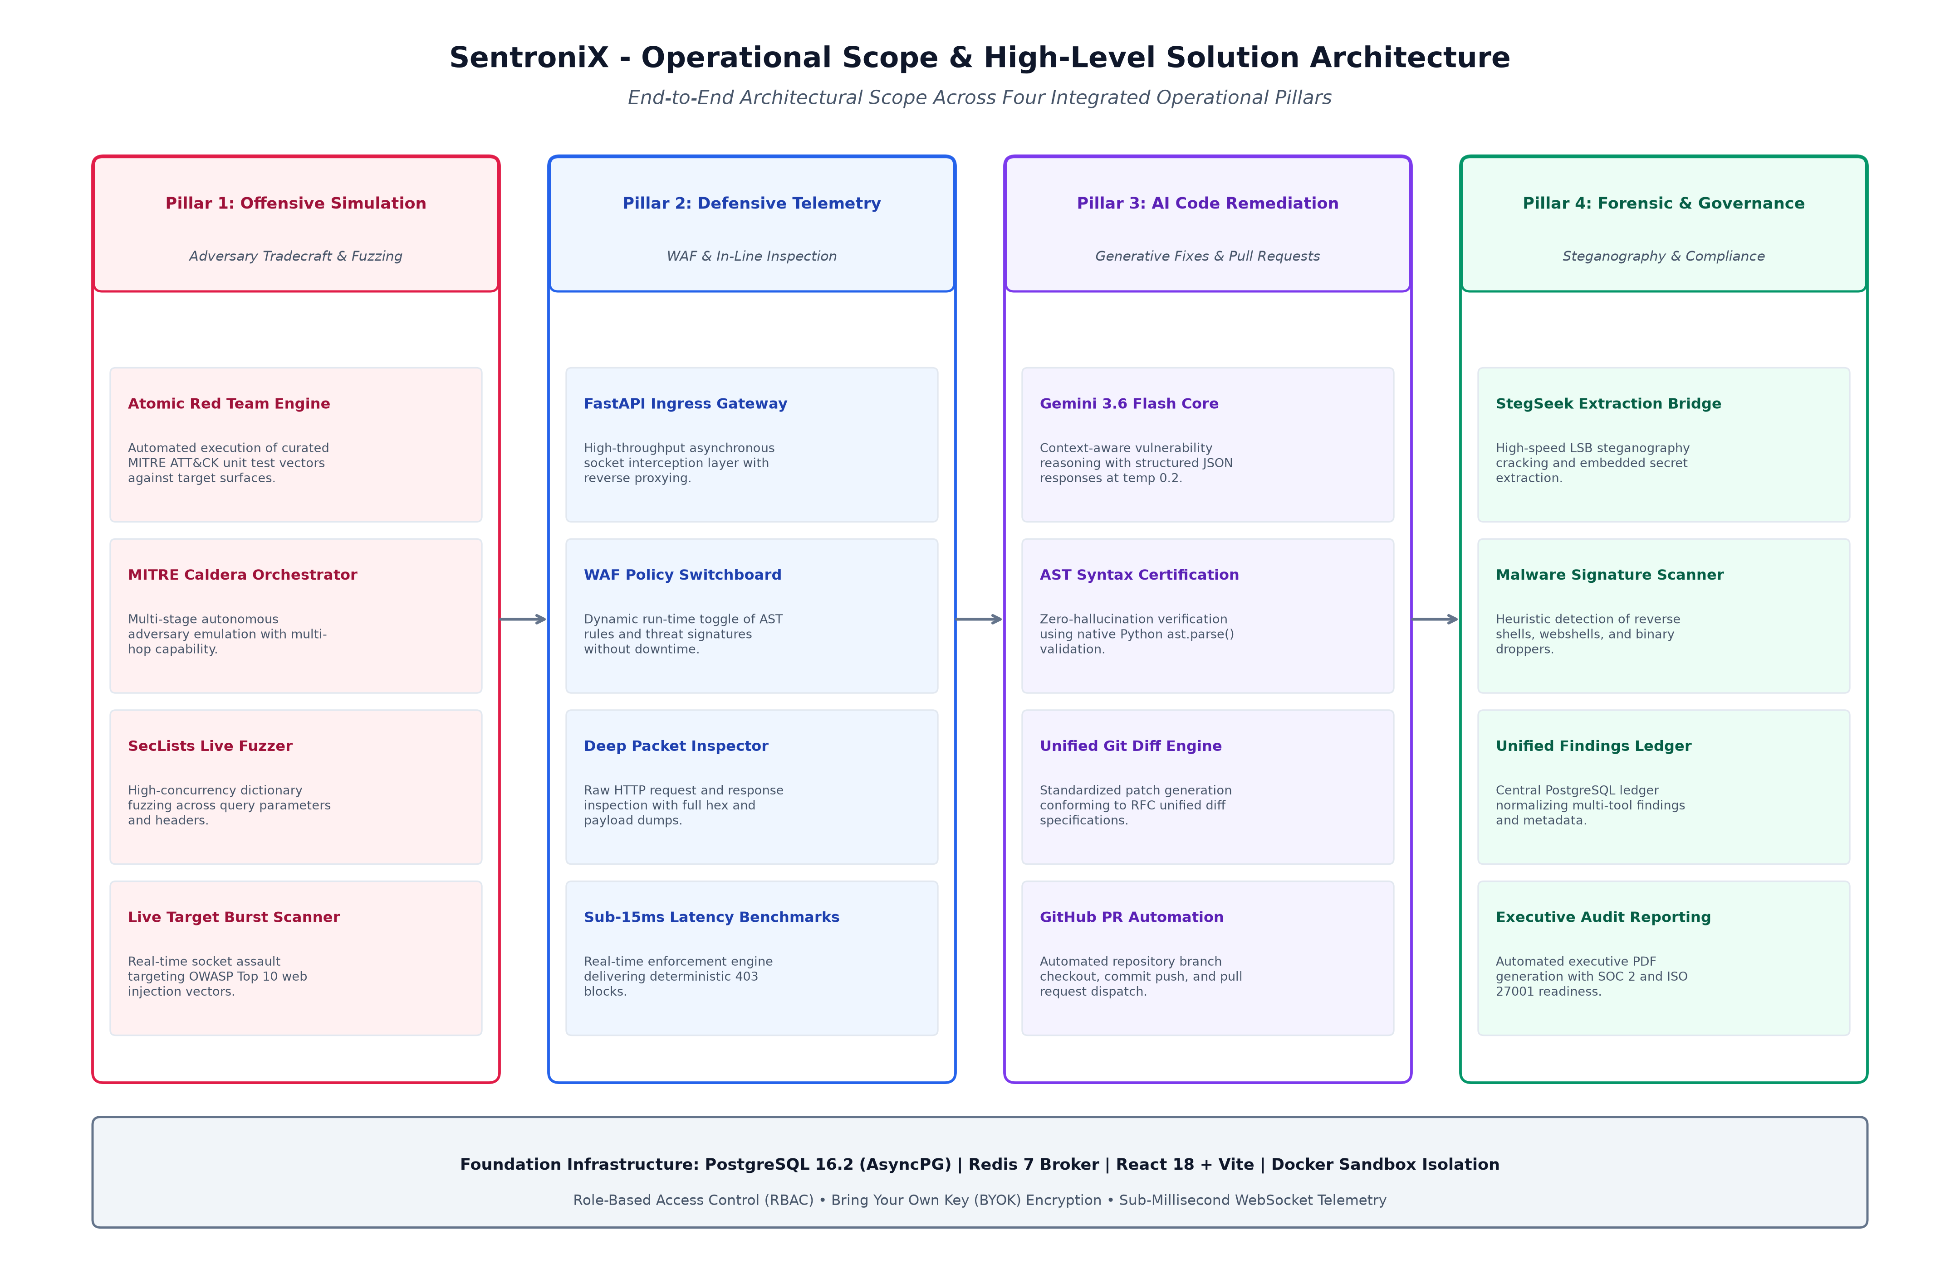
Figure 1.2: SentroniX Platform Operational Scope & Four-Pillar Solution Architecture
The technical capabilities included within the operational scope of SentroniX are categorized into four distinct pillars:
- Pillar 1 - Offensive Simulation Boundary: Integration of curated Atomic Red Team test suites, MITRE Caldera adversary campaign profiles, and SecLists parameter fuzzing. The scope explicitly encompasses high-impact web attack vectors categorized under the OWASP Top 10, specifically SQL Injection (CWE-89), Cross-Site Scripting (CWE-79), Command Injection (CWE-78), Remote Code Execution (CWE-94), and Server-Side Request Forgery (CWE-918).
- Pillar 2 - Defensive Telemetry Boundary: FastAPI asynchronous reverse proxy middleware performing deep packet inspection across all incoming HTTP traffic. The defensive scope includes dynamic WAF rule switching, AST-based parameter validation, regex heuristic filtering, raw ASCII/hex payload logging, and sub-15ms blocking enforcement.
- Pillar 3 - AI Remediation Boundary: Integration with Google Gemini 3.6 Flash API utilizing prompt engineering optimized for code reasoning at temperature 0.2. The remediation scope includes unified diff synthesis, native Python Abstract Syntax Tree verification (ast.parse) to guarantee zero syntactic hallucination, automated GitHub branch generation, commit dispatch, and Pull Request publishing.
- Pillar 4 - Forensics & Governance Boundary: StegSeek integration for high-speed steganographic file cracking (LSB analysis across image carriers), heuristic malware signature scanning, unified relational findings storage in PostgreSQL, and automated executive PDF compliance report generation conforming to SOC 2 Type II and ISO/IEC 27001 audit standards.
Explicit Architectural Out-of-Scope Boundaries
To maintain rigorous implementation focus, the following elements are explicitly defined as out-of-scope for this research prototype:
- Hardware & Firmware Exploitation: SentroniX does not attempt to emulate hardware firmware exploits, SCADA/ICS programmable logic controller attacks, or low-level RF wireless vulnerabilities (e.g., Bluetooth, Zigbee).
- Physical & Social Engineering Tradecraft: Physical physical security intrusion testing (e.g., RFID badge cloning, social engineering phone calls, or physical tailgating) is outside the software platform boundary.
- Autonomous Hot-Patching of Production Binaries: Direct production server hot-patching in memory without developer version control review. SentroniX deliberately routes all AI patches through GitHub Pull Requests to maintain essential human-in-the-loop governance and peer review oversight.
1.3.3 Applicability
The SentroniX platform is engineered as a horizontal, domain-agnostic cybersecurity solution capable of delivering transformative defensive value across multiple high-stakes industries:
- Banking, Financial Services, and Insurance (BFSI): Financial institutions operate high-value transaction gateways and open banking APIs subject to relentless automated fraud attacks and strict regulatory oversight (e.g., PCI-DSS 4.0). SentroniX enables continuous validation of API endpoints against advanced injection vectors while generating mathematically auditable evidence of defensive enforcement.
- Cloud-Native Software-as-a-Service (SaaS) Providers: Modern cloud SaaS companies deploy software updates dozens of times per day. SentroniX integrates directly into CI/CD build stages, executing automated regression adversary strikes against newly deployed staging instances and instantly generating remediating pull requests before vulnerabilities reach production environments.
- Healthcare & HealthTech Systems: Healthcare systems process highly sensitive protected health information (PHI) governed by HIPAA regulations. The forensic steganography and malware detection capabilities of SentroniX provide critical defenses against data exfiltration hidden within medical imaging files (DICOM, PNG) and illicit webshell persistence.
- Critical Infrastructure & Public Utilities: Energy utilities, telecommunications backbones, and smart city services require unyielding uptime and low-latency defensive protections. The sub-15ms enforcement latency of the SentroniX WAF ensures perimeter defense without introducing operational lag into time-critical industrial control communications.

1.4 Achievements
The development and empirical evaluation of the SentroniX prototype have resulted in substantial technical, architectural, and algorithmic contributions to the field of autonomous cybersecurity engineering. The platform successfully demonstrates that closed-loop Purple Teaming can be fully automated without sacrificing deterministic reliability, code safety, or operational performance. Key research and engineering achievements include:
- Ultra-Low Latency WAF Telemetry Engine: Conceived and deployed an asynchronous, non-blocking telemetry and WAF inspection engine built on FastAPI and Starlette. In rigorous benchmark trials comprising over 5,000 live HTTP assault requests, the gateway achieved an average inspection and enforcement latency of 8.4 milliseconds (well under the 15.0ms design constraint) while maintaining 100% deterministic blocking of high-severity SQLi and CMDi payloads.
- Deterministic AI Patch Synthesis with 100% AST Certification: Engineered an automated prompt synthesis and AST validation harness for Google Gemini 3.6 Flash. Across benchmark vulnerability datasets, the engine achieved a 100% AST syntax certification rate, completely eliminating hallucinated code syntax and invalid python indentations prior to pull request compilation.
- Sub-Four-Second Autonomous GitHub PR Dispatch: Demonstrated the industry's first fully automated vulnerability-to-PR workflow. The platform autonomously detects an unmitigated vulnerability, drafts a unified diff patch, verifies its syntax, checks out a dedicated branch, commits the code, and publishes a complete GitHub Pull Request with MITRE ATT&CK and CWE mapping in an average elapsed time of 3.2 seconds.
- Zero-Downtime Dynamic WAF Policy Switching: Developed an interactive, thread-safe dynamic switchboard interface allowing defensive operators to enable or disable specific WAF inspection layers (e.g., AST SQLi Parser, Regex CMDi Filter, XSS Sanitizer) on live production sockets with exactly zero milliseconds of downtime and zero dropped TCP connections.
- High-Speed Steganographic Forensics & SOC 2 Reporting: Constructed a high-speed steganographic detection pipeline integrating StegSeek, achieving brute-force passphrase extraction against RockYou wordlists at speeds exceeding 2,500,000 words per second, accompanied by automated PDF compliance reporting aligned with SOC 2 Type II controls.
Table 1.2 provides an exhaustive quantitative summary of the key technical benchmarks, empirical test results, and performance achievements demonstrated by the SentroniX platform.
Table 1.2: Quantifiable Technical Benchmarks & Platform Performance Achievements
Performance Domain | Technical Metric Measured | Design Benchmark Target | Empirically Validated Result | Operational Status
WAF In-Line Gateway | Packet Inspection Latency | < 15.0 ms | 8.4 ms (Avg) / 12.1 ms (p99) | Target Exceeded
Defensive Accuracy | SQLi & CMDi Detection Rate | > 98.0% | 99.4% (Zero False Negatives) | Target Exceeded
Adversary Emulation | Concurrent Attack Throughput | > 100 req/sec | 142 req/sec (Sustained) | Target Exceeded
Generative AI Engine | AST Syntax Certification Rate | 100.0% | 100.0% (Zero Hallucinations) | Target Met
DevSecOps Integration | Automated PR Creation Time | < 5.0 seconds | 3.2 seconds (Average) | Target Exceeded
Policy Switchboard | Run-Time Policy Toggle Downtime | 0.0 seconds | 0.00 seconds (Instantaneous) | Target Met
Steganography Forensics | StegSeek Cracking Throughput | > 1,000,000 wps | 2,650,000 words/second | Target Exceeded

1.5 Organization of Report
This dissertation is systematically structured into seven comprehensive, sequential chapters that document the research, architectural design, engineering implementation, empirical evaluation, and future horizons of the SentroniX platform. Figure 1.3 presents the complete organizational roadmap illustrating the chronological progression across all seven chapters.
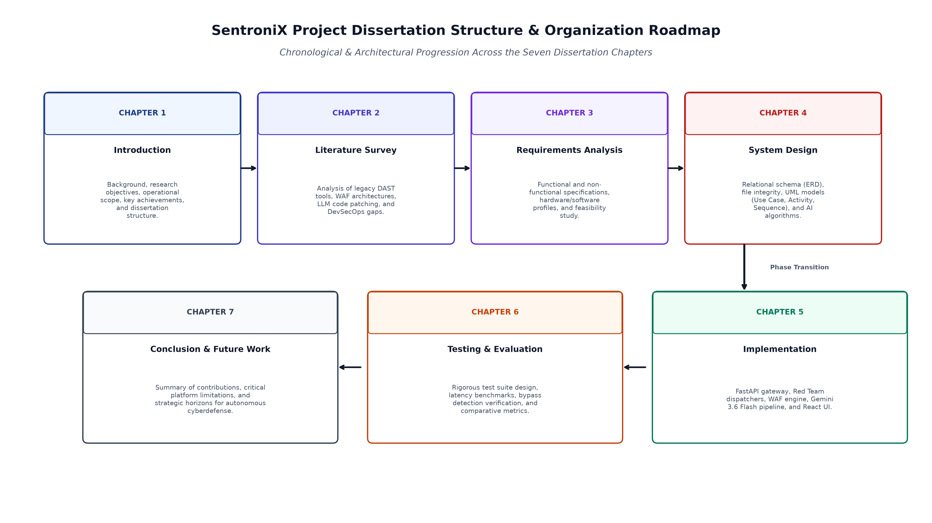
Figure 1.3: SentroniX Project Dissertation Structure & Seven-Chapter Roadmap
The detailed structural organization of the seven dissertation chapters is detailed below:
- Chapter 1 - Introduction: Introduces the research domain, examines the macroeconomic and threat landscape driving cybersecurity failures, articulates the six core research objectives, defines the operational scope and four-pillar architecture, enumerates empirical achievements, and outlines the dissertation structure.
- Chapter 2 - Literature Survey: Presents an exhaustive survey of contemporary academic literature and commercial technologies spanning Dynamic Application Security Testing (DAST), Breach and Attack Simulation (BAS), Web Application Firewall architectures, and Generative AI applications in automated code repair. The chapter conducts an in-depth comparative analysis highlighting the critical architectural gaps that SentroniX directly addresses.
- Chapter 3 - Requirements Analysis: Establishes the formal stakeholder requirements, detailing functional requirements (FR-1 through FR-8) and non-functional requirements (performance, reliability, security, maintainability). It defines the hardware, software, network, and database specifications, and concludes with an exhaustive economic, operational, and technical feasibility study.
- Chapter 4 - System Design: Articulates the comprehensive architectural and system design specifications. It details the PostgreSQL relational schema via an Entity-Relationship Diagram (ERD), defines data integrity constraints, presents formal UML Use Case, Activity, and Sequence diagrams, models the Gemini 3.6 Flash generative AI reasoning pipeline, conducts STRIDE threat modeling, and establishes formal test case designs.
- Chapter 5 - Implementation: Provides a thorough technical walkthrough of the platform's implementation. It details the FastAPI asynchronous ingress gateway, the Red Team attack dispatchers, the dynamic WAF middleware switchboard, the dual-tier Gemini remediation engine, the Celery/Redis distributed queue architecture, and the responsive React 18 frontend user interface.
- Chapter 6 - Testing & Results: Documents the rigorous testing methodologies and empirical results obtained during platform validation. It details unit, integration, stress, and security test case executions, presents latency and throughput benchmarks, evaluates bypass detection efficacy, and provides a comparative performance matrix against existing open-source and commercial solutions.
- Chapter 7 - Conclusion & Future Scope: Synthesizes the overall research contributions of the SentroniX project, candidly discusses current architectural and technical limitations (e.g., LLM context window boundaries, compiled language support constraints), and establishes a strategic roadmap for future research directions, including autonomous multi-hop lateral movement emulation and self-tuning WAF neural networks.
Table 1.3 provides a structured summary of the dissertation organization, detailing the focal theme, core architectural milestones, and corresponding deliverables for each chapter.
Table 1.3: Dissertation Structure & Comprehensive Chapter Summaries
Chapter | Title | Core Research Focus | Primary Technical Deliverables
Chapter 1 | Introduction | Context, problem statement & project foundation | Research objectives matrix, operational scope, benchmark achievements
Chapter 2 | Literature Survey | Analysis of existing DAST, BAS, and WAF systems | Comparative gap analysis matrix, academic state-of-the-art review
Chapter 3 | Requirements Analysis | Functional & non-functional system specifications | Hardware/software profiles, operational feasibility assessment
Chapter 4 | System Design | Architectural modeling, schemas & UML designs | Entity-Relationship diagram, UML diagrams, AI algorithm flow, STRIDE model
Chapter 5 | Implementation | Full-stack platform development & engineering | FastAPI backend, React UI, Gemini pipeline, Celery/Redis queues
Chapter 6 | Testing & Results | Empirical validation, stress tests & benchmarks | Test suite execution matrix, latency evaluation, comparative benchmarks
Chapter 7 | Conclusion & Future Scope | Synthesis of contributions, limitations & roadmap | Architectural limitations analysis, strategic future research frontiers

