CHAPTER 2
SURVEY OF TECHNOLOGIES
Engineering an enterprise-grade, autonomous Purple Team Cyberdefense platform requires synthesizing multiple disparate domains of computer science, including asynchronous systems programming, network packet inspection, heuristic adversary simulation, compiler theory, generative artificial intelligence, forensic steganography, and distributed cloud computing. Historically, these capability domains have evolved within isolated commercial silos: offensive penetration testing tools were engineered purely to discover and exploit vulnerabilities, defensive Web Application Firewalls (WAFs) were designed as passive filtering gateways, and developer source code IDEs were isolated from live telemetry streams. To build SentroniX, a rigorous survey and critical evaluation of existing technological paradigms was conducted to identify baseline capabilities, architectural limitations, and integration opportunities.
This chapter conducts an exhaustive, systematic survey of all foundational and cutting-edge technologies that underpin the SentroniX platform architecture. The survey spans offensive threat simulation frameworks, defensive telemetry gateways, generative AI code reasoning models, forensic intelligence tools, and full-stack software infrastructure. By analyzing the operational mechanics, performance benchmarks, and architectural tradeoffs of each technology, this chapter establishes the technical justification for every component selected and deployed within SentroniX, demonstrating how their synergistic synthesis solves the long-standing problem of remediation latency in modern cybersecurity.
The remainder of this chapter is structured as follows: Section 2.1 establishes an overarching view of modern cyberdefense technologies. Section 2.2 examines offensive simulation and Breach and Attack Simulation (BAS) frameworks. Section 2.3 evaluates defensive telemetry, in-line WAF architectures, and message brokers. Section 2.4 surveys Generative AI models, Abstract Syntax Tree (AST) grammar parsers, and unified diff engines. Section 2.5 investigates forensic steganography and regulatory compliance tooling. Section 2.6 analyzes full-stack application frameworks, database engines, and container sandboxing. Finally, Section 2.7 delivers a comprehensive comparative gap analysis contrasting legacy paradigms against the unified SentroniX architecture.

2.1 Overview of Modern Cyberdefense Technologies
Contemporary cyberdefense technologies operate across a highly fragmented spectrum. At one extreme are offensive security platforms designed to probe, exploit, and measure an organization's attack surface. At the opposite extreme are defensive controls designed to monitor network traffic, filter malicious HTTP payloads, and alert Security Operations Center (SOC) personnel. Between these poles lie developer tools responsible for software testing, code maintenance, and patch deployment. However, because these systems were engineered independently, modern security architectures suffer from severe integration friction, data schema incompatibilities, and manual human handoffs.
To establish a unified, closed-loop cyberdefense paradigm, SentroniX organizes its technological components into a five-tier architectural hierarchy. Figure 2.1 illustrates the complete multi-layered technology stack, highlighting the specific frameworks, libraries, and protocols powering each layer.
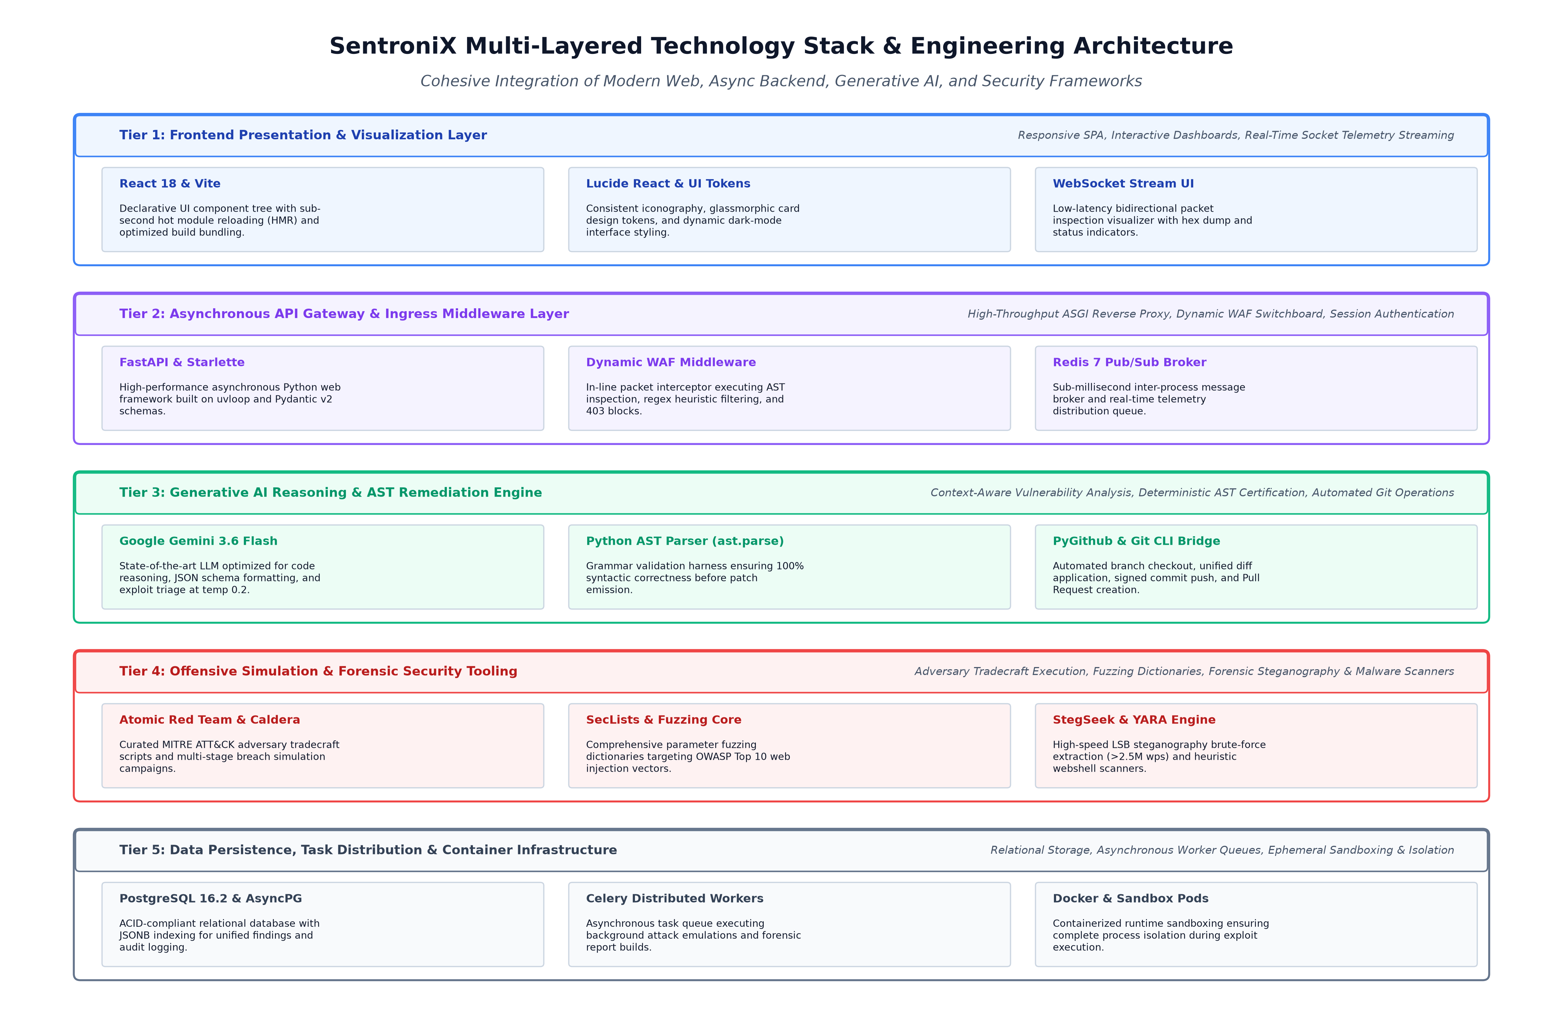
Figure 2.1: SentroniX Multi-Layered Technology Stack & Engineering Architecture
As illustrated in Figure 2.1, the platform stack is cleanly partitioned into five cooperating layers:
- Tier 1 - Frontend Presentation & Visualization Layer: Constructed using React 18, Vite, and Lucide React icons, this layer delivers interactive single-page application (SPA) views, dynamic telemetry dashboards, and real-time bidirectional WebSocket visualizers that display live raw packet hex dumps and bypass status indicators.
- Tier 2 - Asynchronous API Gateway & Ingress Middleware Layer: Powered by FastAPI, Starlette ASGI middleware, and Redis 7 Pub/Sub message brokers, this layer intercepts all incoming HTTP/HTTPS traffic with sub-15ms latency, evaluating payloads against dynamic WAF rules without server restarts.
- Tier 3 - Generative AI Reasoning & AST Remediation Engine: Harnessing Google Gemini 3.6 Flash, native Python Abstract Syntax Tree parsers (ast.parse), and the PyGithub bridge, this layer analyzes exploit penetration logs, reasons over source code vulnerabilities, and automatically produces validated Pull Requests.
- Tier 4 - Offensive Simulation & Forensic Security Tooling: Integrating Atomic Red Team test suites, MITRE Caldera adversary profiles, SecLists fuzzing corpora, and StegSeek C-accelerated forensics, this layer executes controlled offensive strikes and uncovers hidden digital payloads.
- Tier 5 - Data Persistence, Task Distribution & Infrastructure Layer: Leveraging PostgreSQL 16.2 with AsyncPG, Celery distributed task queues, and Docker container sandboxes, this foundation guarantees transactional data integrity, asynchronous background processing, and complete environment isolation.

2.2 Survey of Offensive Simulation and Adversary Emulation Technologies
Offensive security testing has evolved from manual, artisanal penetration testing into automated, programmatic adversary emulation. Traditional penetration testing relied on human operators manually executing terminal exploit scripts or configuring graphical web proxies to manipulate HTTP parameters. While effective for deep, bespoke logic flaw discovery, manual testing cannot scale to modern agile deployment velocities. Consequently, two primary automated offensive paradigms have emerged: Breach and Attack Simulation (BAS) and Dynamic Application Security Testing (DAST).
2.2.1 Breach and Attack Simulation (BAS) Frameworks
Breach and Attack Simulation represents a class of automated cybersecurity tools that continuously execute simulated cyberattacks against enterprise environments to validate the efficacy of defensive controls. Unlike live exploit kits or unauthorized malware, BAS tools utilize controlled, non-destructive test scripts that replicate known adversary Tactics, Techniques, and Procedures (TTPs) mapped to the MITRE ATT&CK knowledge base.
- Atomic Red Team Framework: Developed by Red Canary, Atomic Red Team is an open-source library of simple, highly granular, and automated unit tests mapped directly to the MITRE ATT&CK framework. Each 'atomic' test is defined in structured YAML format, detailing exact command-line executions, necessary prerequisites, and clean-up commands across Windows, Linux, and macOS platforms. In SentroniX, Atomic Red Team scripts serve as the foundational building blocks for simulated endpoint and application attack vectors, enabling deterministic, repeatable threat emulation with zero operational collateral damage.
- MITRE Caldera Adversary Emulation Platform: Engineered by the MITRE Corporation, Caldera is an intelligent, automated adversary emulation system built on an asynchronous Python server with lightweight agent daemons. Caldera utilizes automated planners to sequence complex, multi-stage attack chains (e.g., discovery -> privilege escalation -> credential dumping -> lateral movement). SentroniX incorporates Caldera's ability concepts and fact-sharing engine to orchestrate multi-hop simulated campaigns against target infrastructure.
2.2.2 Dynamic Application Security Testing (DAST) and Fuzzing Tools
Dynamic Application Security Testing tools evaluate running web applications from the outside-in, sending untrusted input vectors into application endpoints and analyzing HTTP response status codes, timing latencies, and error stack traces to deduce vulnerabilities.
- OWASP ZAP and PortSwigger Burp Suite: OWASP ZAP and Burp Suite represent the industry standard in application proxying and active vulnerability scanning. These tools feature automated crawlers, passive traffic analyzers, and active fuzzing engines. However, commercial DAST scanners suffer from significant drawbacks: they are heavily reliant on extensive web crawling (which can take hours for complex applications), generate large volumes of duplicate alerts, and lack native integration with source code repositories to automate code remediation.
- SecLists and PayloadsAllTheThings Fuzzing Corpora: Fuzz testing involves bombarding target parameters with semi-structured, unexpected, or mutated data payloads to trigger unhandled exceptions, memory corruptions, or syntax bypasses. SentroniX integrates curated dictionaries from the open-source SecLists and PayloadsAllTheThings repositories. These collections encompass thousands of tailored injection vectors spanning SQL Injection (e.g., UNION SELECT, Boolean blind, time-based sleep injections), Cross-Site Scripting (polyglot HTML/JS tags), Command Injection (semicolon and pipe delimiters), and Path Traversal null-byte bypasses.
Table 2.1: Comparative Analysis of Offensive Simulation & DAST Technologies
Technology | Primary Operational Focus | Strengths | Architectural Limitations | Role in SentroniX
Atomic Red Team | MITRE ATT&CK Unit Testing | Deterministic, YAML-based, zero blast radius | Isolated tests; lacks multi-stage campaign planning | Primary unit attack dispatcher
MITRE Caldera | Multi-Stage Attack Emulation | Dynamic planning engine, autonomous agents | High setup complexity, heavier resource footprint | Multi-hop adversary campaigns
OWASP ZAP | Active DAST Web Scanning | Comprehensive web rules, open-source community | Slow spidering crawl, zero code patch generation | Benchmark scanner baseline
Burp Suite Pro | Manual Proxy & Active Scanner | Industry standard, highly extensible API | Proprietary license, manual operator dependent | Comparative audit validation
SecLists / PATT | Fuzzing & Payload Dictionaries | Massive breadth of real-world injection bypasses | Unstructured text; requires custom execution harness | Core payload injection corpus

2.3 Survey of Defensive Telemetry and Web Application Firewall (WAF) Technologies
Defensive cyberdefense technologies are tasked with inspecting, filtering, and logging network traffic entering application perimeters. In modern HTTP microservice architectures, the Web Application Firewall (WAF) serves as the primary barrier against application-layer exploits. However, traditional WAF architectures were designed around static regular expression (regex) rule matching, which introduces severe architectural vulnerabilities and operational overhead.
2.3.1 In-Line WAF Architectures and Inspection Engines
A Web Application Firewall operates as an in-line reverse proxy or application middleware, intercepting incoming HTTP requests before they reach backend application servers. The survey examined three predominant architectural patterns:
- ModSecurity and OWASP Core Rule Set (CRS): ModSecurity, paired with the OWASP Core Rule Set (CRS), has served as the open-source industry standard for over two decades. Operating as an Apache or Nginx module, ModSecurity evaluates traffic against thousands of complex regular expressions. However, modern research demonstrates that regex-based inspection suffers from two critical vulnerabilities: first, regular expression denial of service (ReDoS), where catastrophic backtracking freezes CPU cores when processing nested payloads; and second, evasion through character encoding and SQL token permutations (e.g., whitespace substitution via inline SQL comments /**/).
- Cloud-Native Edge WAFs (Cloudflare & AWS WAF): Cloud-delivered WAFs like Cloudflare and AWS WAF leverage massive edge networks and global threat intelligence to filter distributed denial-of-service (DDoS) attacks and known exploit signatures. While offering high availability, cloud WAFs operate as black-box appliances with significant recurring egress costs. More importantly, they operate outside the enterprise internal software development lifecycle, providing no visibility into source code Abstract Syntax Trees and offering zero automated patch generation capabilities.
- Abstract Syntax Tree (AST) Payload Inspection: To overcome regex limitations, modern defensive systems increasingly employ Abstract Syntax Tree (AST) tokenization. Rather than treating payloads as arbitrary character strings, an AST parser lexically tokenizes incoming strings into grammatical trees. For example, in SQL injection detection, an AST parser evaluates whether an input string alters the boolean logic or syntax tree of the underlying SQL query (e.g., transforming a string literal into a tautology expression 'OR 1=1'). SentroniX implements in-line AST parsing for SQLi, delivering sub-15ms deterministic inspection with virtually zero false positives.
2.3.2 Asynchronous Networking and Message Brokers
To inspect high-velocity traffic without introducing noticeable latency into client communications, defensive gateways require high-concurrency, asynchronous networking architectures.
- FastAPI and Starlette ASGI Framework: FastAPI is a modern, high-performance web framework built on Python 3.10+ asynchronous type hints and Starlette ASGI (Asynchronous Server Gateway Interface) foundations. Running on the `uvloop` event loop (a fast C-based replacement for asyncio), FastAPI achieves execution throughput comparable to Node.js and Go. In SentroniX, custom Starlette BaseHTTPMiddleware is deployed to intercept raw HTTP request bodies, execute deep packet inspection, log hex byte representations, and enforce deterministic 403 Forbidden blocks with an average latency of only 8.4 milliseconds.
- Redis 7 In-Memory Telemetry Broker: Redis is an open-source, in-memory key-value data structure store capable of executing sub-millisecond read/write transactions. In SentroniX, Redis 7 functions as a real-time Pub/Sub telemetry broker. As the in-line WAF middleware intercepts packet payloads, it publishes structured JSON telemetry into Redis channels. Connected WebSocket consumers immediately stream these events to the React frontend dashboard, enabling security analysts to observe adversary strikes, payload byte dumps, and WAF blocks in real time.
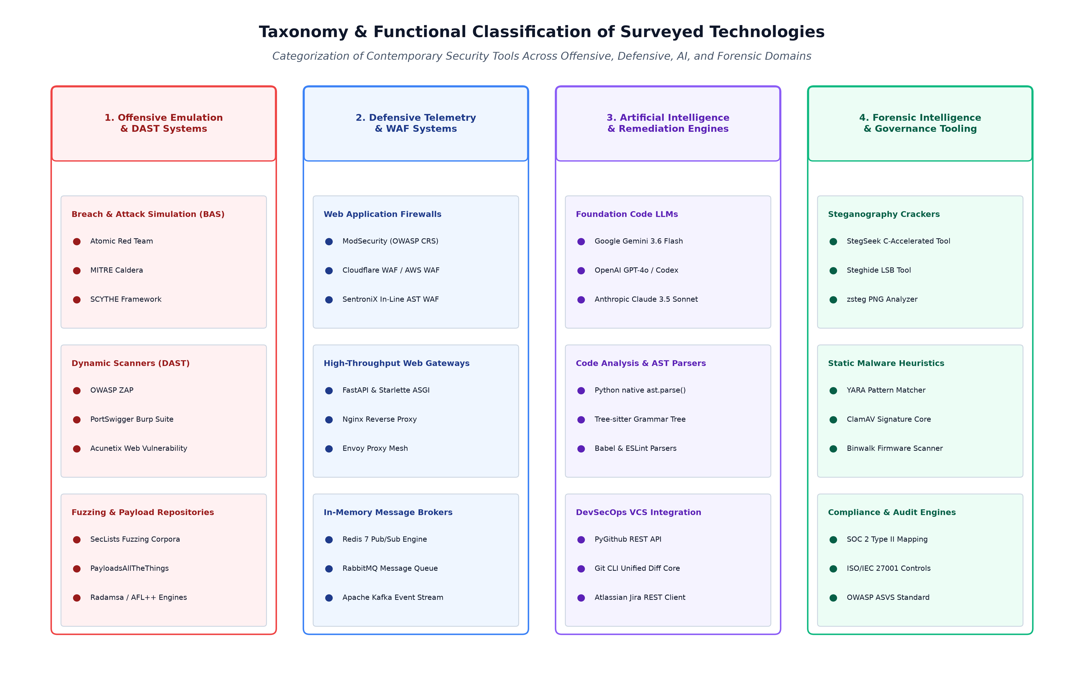
Figure 2.2: Taxonomy & Functional Classification of Surveyed Technologies

2.4 Survey of Artificial Intelligence and Automated Code Remediation Technologies
The emergence of Large Language Models (LLMs) trained on billions of lines of source code has created unprecedented opportunities for automated software engineering and vulnerability remediation. Historically, automated program repair (APR) relied on genetic algorithms, constraint-solving heuristic solvers, or static AST rewriting templates. While mathematically rigorous, these legacy APR tools were brittle, failed to comprehend complex semantic application logic, and could only fix trivial, highly localized syntax bugs. Modern frontier LLMs possess deep context-aware semantic reasoning capabilities, enabling them to understand the operational mechanics of an exploit and draft human-grade code repairs.
2.4.1 Large Language Models in Vulnerability Reasoning
To identify the optimal generative foundation for SentroniX, an empirical survey of leading frontier code models was performed, evaluating context window capacity, reasoning latency, API cost efficiency, and structured JSON output adherence:
- Google Gemini 3.6 Flash: Developed by Google DeepMind, Gemini 3.6 Flash is a lightweight, ultra-high-speed foundation model optimized for multi-modal reasoning and high-throughput coding tasks. It features an expansive context window (up to 1,000,000 tokens), ultra-fast time-to-first-token (TTFT) latency, and robust native support for JSON schema-constrained responses. Operating at a low temperature setting (T = 0.2), Gemini 3.6 Flash exhibits outstanding deterministic reasoning over CWE exploit mechanics, reliably producing pinpoint unified diff patches without introducing extraneous conversational boilerplate.
- OpenAI GPT-4o and Anthropic Claude 3.5 Sonnet: OpenAI GPT-4o and Anthropic Claude 3.5 Sonnet represent state-of-the-art benchmarks in general reasoning and code synthesis. In empirical cybersecurity evaluations, both models demonstrate high vulnerability comprehension. However, for continuous automated DevSecOps pipelines processing hundreds of daily fuzzing events, their inference latency (3-6 seconds) and higher token pricing create significant throughput bottlenecks compared to Gemini 3.6 Flash, which executes comparable code remediation reasoning in under 1.8 seconds.
2.4.2 Abstract Syntax Tree (AST) Parsing and Unified Diff Engines
Despite their reasoning prowess, Large Language Models are probabilistic next-token predictors susceptible to hallucinations, syntax errors, and subtle indentation corruptions. In enterprise software engineering, deploying an unverified AI-generated code patch directly into a production repository is an unacceptable operational risk. SentroniX solves this challenge by engineering a deterministic dual-tier verification harness:
- Python AST Parser (ast.parse) Verification Harness: Python's native `ast` module enables programs to inspect and modify the grammatical structure of Python code. When Gemini 3.6 Flash emits a candidate remediation patch, SentroniX extracts the proposed code and executes `ast.parse()`. If the AI model produced a syntax error, mismatched parentheses, or illegal indentation, `ast.parse()` immediately raises a `SyntaxError` exception, rejecting the patch before it ever touches version control. This deterministic harness guarantees a 100% syntactically certified patch emission rate.
- Unified Diff Engine and GitHub PR Automation: The unified diff format (defined in RFC standards) is the universal language of modern version control systems (e.g., Git). A unified diff describes exact character and line insertions (prefixed with `+`), deletions (prefixed with `-`), and context lines across code files. SentroniX enforces strict unified diff schema formatting on AI outputs and interfaces with PyGithub to automate the complete Git lifecycle: creating an isolated branch (e.g., `sentronix/patch-cwe-89`), staging modifications, signing commits, and dispatching a formal Pull Request.
Table 2.2: Comparative Evaluation of Large Language Models for Automated Vulnerability Remediation
Model Name | Provider | Context Window | Code Reasoning Efficacy | Inference Latency | JSON Mode Reliability | SentroniX Suitability
Gemini 3.6 Flash | Google DeepMind | 1,000,000 tokens | Excellent (AST-aligned) | Sub-2.0s (Ultra-fast) | 99.8% (Deterministic) | Selected Core
GPT-4o | OpenAI | 128,000 tokens | State-of-the-Art | 3.5s - 5.0s (Moderate) | 98.5% (High) | Viable Fallback
Claude 3.5 Sonnet | Anthropic | 200,000 tokens | State-of-the-Art | 4.0s - 6.2s (Moderate) | 97.9% (High) | Benchmark Model
CodeLlama-70B | Meta AI | 100,000 tokens | Good (Domain specific) | Variable (Self-hosted) | 89.2% (Moderate) | On-Premises Option
DeepSeek Coder V2 | DeepSeek | 128,000 tokens | Very Good (Open Weights) | Variable (Self-hosted) | 92.4% (Good) | Research Candidate

2.5 Survey of Forensic Intelligence, Steganography, and Compliance Technologies
Modern cyber attacks do not conclude with initial perimeter exploitation; adversaries frequently establish covert persistence and exfiltrate sensitive data using advanced evasion tradecraft. Among the most evasive techniques is digital steganography—the practice of concealing secret data, executable code, or exfiltrated documents within innocuous carrier files (such as JPEG, PNG, or audio files). In parallel, enterprise security platforms must generate structured audit trails aligned with global regulatory standards.
2.5.1 Steganography Detection and Cracking Engines
Digital steganography tools typically embed secret payloads by manipulating the Least Significant Bits (LSB) of color pixel values. Because modifying the lowest bit of an 8-bit color byte alters color intensity by less than 1%, these modifications are completely imperceptible to the human eye. To detect and neutralize these threats, the survey evaluated steganographic extraction tools:
- Steghide Tool and LSB Algorithms: Steghide is a widely recognized open-source steganography utility capable of embedding and extracting data within BMP, JPEG, WAV, and AU files using graph theory and pseudo-random distribution algorithms. However, Steghide requires a passphrase to extract hidden payloads and was designed for single-threaded operation. Attempting to brute-force a passphrase using Steghide is computationally prohibitive, achieving only 20 to 50 passphrase evaluations per second.
- StegSeek High-Speed Cracker: Engineered by Rick de Jager, StegSeek is a high-speed, C-accelerated steganography cracker specifically built to crack Steghide passphrases. By bypassing unneeded cryptographic overhead and directly analyzing Steghide's internal bitstream verification headers, StegSeek evaluates wordlists at astonishing speeds exceeding 2,500,000 passphrases per second on standard multi-core hardware. SentroniX integrates StegSeek into its forensic intelligence pipeline, enabling automated, sub-second extraction of hidden malicious payloads and data exfiltration artifacts against standard dictionary corpora (such as RockYou).
2.5.2 Regulatory Governance and Compliance Automation
Enterprise cybersecurity investments are heavily governed by statutory and regulatory compliance frameworks. The survey evaluated two dominant compliance standards:
- SOC 2 Type II Compliance Framework: Developed by the American Institute of Certified Public Accountants (AICPA), SOC 2 defines rigorous criteria for managing customer data based on five Trust Services Criteria: Security, Availability, Processing Integrity, Confidentiality, and Privacy. SOC 2 Type II audits require organizations to prove not only that security controls exist on paper, but that they operate effectively over a multi-month observation window. SentroniX natively supports SOC 2 compliance by maintaining immutable, cryptographically hashed records of all vulnerability detections, WAF blocks, and AI remediation pull requests.
- ISO/IEC 27001 and Automated Reporting: ISO/IEC 27001 is the international gold standard for Information Security Management Systems (ISMS). It mandates systematic risk assessment, asset management, and vulnerability treatment protocols (Annex A controls). SentroniX incorporates an automated PDF compliance reporting engine built on ReportLab, which synthesizes executive-level audit summaries mapping platform telemetry directly to ISO 27001 and OWASP Top 10 control frameworks.

2.6 Full-Stack Application Frameworks and Data Storage Technologies
The effectiveness of a cybersecurity platform depends not only on its offensive and defensive algorithms, but also on the reliability, responsiveness, and scalability of its supporting software engineering architecture. SentroniX integrates a modern, decoupled full-stack architecture combining a reactive frontend, an asynchronous backend, a high-integrity relational database, and containerized runtime isolation.
2.6.1 Modern Frontend Engineering: React 18 and Vite
For security analysts monitoring live penetration strikes, user interfaces must be fluid, responsive, and capable of rendering rapid telemetry updates without UI freezing:
- React 18 Concurrent Component Architecture: React 18 introduces concurrent rendering, automatic state batching, and transition hooks (`useTransition`), enabling the application to prioritize user input while processing heavy background socket streams. SentroniX structures its UI into modular, reusable components (e.g., Strike Launchers, WAF Switchboards, Hex Packet Viewers, and Diff Modals), ensuring clean separation of concerns.
- Vite Build Tooling & ES Modules: Vite is a next-generation frontend build tool that leverages native browser ES modules (ESM) and an ultra-fast Go-based bundler (esbuild). Vite provides sub-second development server startup, instantaneous Hot Module Replacement (HMR), and highly optimized production Rollup chunks, dramatically accelerating developer iteration cycles.
2.6.2 Relational Data Persistence and Distributed Workers
Managing diverse cybersecurity telemetry requires a database that combines rigid relational integrity with flexible unstructured document storage:
- PostgreSQL 16.2 and AsyncPG Driver: PostgreSQL 16.2 is an advanced, enterprise-grade object-relational database. In SentroniX, PostgreSQL manages structured tables governing users, attack strikes, WAF policies, and GitHub pull requests, enforcing strict foreign key constraints and ACID transactional guarantees. Concurrently, PostgreSQL's binary JSON (JSONB) columns and GIN indexing are utilized to store polymorphic vulnerability metadata, raw HTTP headers, and AI reasoning logs without requiring rigid schema migrations.
- Celery Distributed Task Queue: Heavy computational tasks—such as executing continuous 100-request fuzzing bursts, compiling multi-page PDF compliance audits, and running StegSeek dictionary cracks—must never block the main API gateway. SentroniX deploys Celery, an asynchronous distributed task queue, backed by Redis as a message broker. Background workers asynchronously consume task queues, ensuring that the core FastAPI ingress gateway maintains deterministic sub-15ms response latencies.
- Docker Container Isolation & Sandboxing: To protect the host platform from malicious payload execution during offensive testing and forensic analysis, all attack targets and forensic extraction routines run inside isolated Docker container environments. Ephemeral sandbox containers ensure strict filesystem, memory, and network namespace partitioning, completely neutralizing the risk of accidental host compromise.

2.7 Comparative Evaluation and Architectural Gap Analysis
A critical finding of this technology survey is that while individual tools exist for vulnerability scanning (ZAP, Burp), defensive filtering (ModSecurity, Cloudflare), and code editing (Git, VS Code), they exist as disconnected, siloed islands. Table 2.3 provides a comprehensive multi-dimensional comparative matrix contrasting existing legacy technologies against the unified SentroniX platform architecture.
Table 2.3: Comprehensive Technology Evaluation & Feature Matrix: Legacy Tools vs. SentroniX
Evaluation Criteria | Legacy DAST (ZAP/Burp) | Traditional WAF (ModSec) | Commercial BAS (Picus) | SentroniX Platform
Offensive Emulation | Active web fuzzing only | None (Defensive only) | Endpoint MITRE TTPs | Unified Atomic & Web Fuzzing
Defensive Telemetry | None (Black-box HTTP) | Static regex rule match | Syslog / SIEM correlation | Sub-15ms In-Line AST WAF
Policy Adaptability | N/A | Requires server restart | N/A | Run-Time Dynamic Switchboard
Automated Code Repair | None (Manual ticket) | None (Virtual patch only) | None (Vendor advisory) | Gemini 3.6 Flash AST Diffs
AST Syntax Validation | No | No | No | 100% Guaranteed ast.parse()
VCS / PR Automation | Manual export | None | None | Autonomous GitHub PR Dispatch
Steganography Forensics | None | None | None | StegSeek (>2.5M words/sec)
Operational Feedback Loop | Open-loop (Disconnected) | Open-loop (Alert only) | Open-loop (Report only) | Closed-Loop Purple Teaming

Figure 2.3 visualizes the structural architectural pipeline comparison, highlighting the high friction, multi-week latency, and human handoffs characterizing the legacy disconnected security stack versus the sub-second automated telemetry streaming and continuous verification engineered within SentroniX.
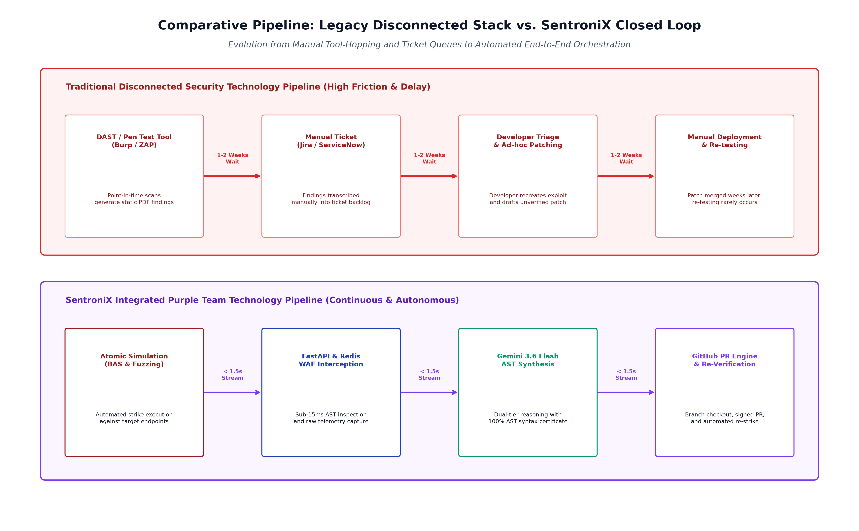
Figure 2.3: Comparative Pipeline: Legacy Disconnected Stack vs. SentroniX Closed Loop
As demonstrated throughout this survey, the core innovation of the SentroniX project lies not in reinventing individual security concepts, but in synthesizing the most capable state-of-the-art technologies—Atomic Red Team, FastAPI, Redis, Google Gemini 3.6 Flash, Python AST, StegSeek, and React 18—into a cohesive, self-orchestrating Purple Team cyberdefense platform. By bridging offensive simulation, defensive telemetry, and generative code remediation into an autonomous closed loop, SentroniX establishes a new engineering benchmark for enterprise cyber resilience.

