CHAPTER 3
REQUIREMENTS AND SPECIFICATION
Requirements engineering and project planning represent foundational phases in the software development lifecycle, establishing the operational boundaries, functional capabilities, non-functional performance thresholds, hardware-software environments, and development methodologies governing an engineering project. In complex cybersecurity platforms where active adversary tradecraft is paired with in-line network defense and autonomous artificial intelligence reasoning, rigorous requirements definition is paramount. Without precise functional specifications and deterministic validation criteria, security platforms risk introducing unintended operational disruptions, excessive network latency, or hallucinated source code modifications into enterprise production environments.
This chapter establishes the comprehensive requirements baseline and project management framework for the SentroniX Purple Team Cyberdefense Platform. Section 3.1 articulates the formal problem definition, highlighting the systemic operational failures and remediation gridlock that SentroniX directly resolves. Section 3.2 details the complete requirements specification, categorizing functional requirements (FR-1 through FR-8) and non-functional requirements (performance, security, reliability, usability, and maintainability). Section 3.3 presents the project planning, work breakdown structure (WBS), and sprint schedule via a formal Gantt chart. Section 3.4 delineates the development, production, and target environment hardware and software requirements. Section 3.5 provides the preliminary product description, detailing core subsystems, user personas, and operational lifecycles. Finally, Section 3.6 constructs the conceptual models, featuring an in-depth analysis of the tailored Agile Scrum process model, its technical justification over legacy development models, and the high-level conceptual system architecture.

3.1 Problem Definition
Enterprise software systems have experienced an unprecedented transition toward distributed, cloud-native microservices, containerized deployments, and polyglot Application Programming Interfaces (APIs). While this architectural paradigm enables continuous software delivery, it expands the enterprise attack surface exponentially. Security vulnerabilities introduced through rapid code commits—such as SQL Injection (SQLi), Cross-Site Scripting (XSS), Command Injection (CMDi), Path Traversal, and Server-Side Request Forgery (SSRF)—frequently escape staging environments and reach production endpoints undetected.
Contemporary enterprise security operations are severely impeded by three interrelated systemic problems:
- The Ephemeral Point-in-Time Security Audit Gap: Traditional penetration tests are executed as manual, point-in-time assessments on a semi-annual or annual cadence. By the time a third-party audit firm delivers a static PDF vulnerability report, the target codebase has already progressed through dozens of agile release sprints. Vulnerabilities discovered remain unpatched in production for weeks, while new zero-day vulnerabilities introduced between audit cycles remain completely undetected.
- Alert Fatigue and Defensive Sensor Disconnect: Security Operations Centers (SOCs) deployed with traditional Intrusion Detection Systems (IDS) and Web Application Firewalls (WAFs) generate millions of uncontextualized log events weekly. Over 70% of SOC analyst time is expended investigating false positives or benign anomaly spikes. Crucially, when an actual exploit succeeds, defensive analysts lack immediate, correlated insight into the exact code path compromised or how the payload bypassed defensive filtering.
- The Operational Chasm and Remediation Latency: When an offensive finding is finally triaged, it is manually transcribed into developer ticketing systems (e.g., Jira or Bugzilla). Software developers, who often lack formal secure coding training, must interpret complex vulnerability descriptions, recreate the attack conditions locally, determine the exact line of code at fault, draft an ad-hoc fix, and submit it for secondary review. This manual, cross-departmental handoff causes an enterprise Mean Time to Remediate (MTTR) that averages between 30 and 45 days for critical severity vulnerabilities.
Therefore, the core problem definition addressed by this research is: How can enterprise cybersecurity operations eliminate the frictional latency between adversary attack emulation, in-line defensive interception, and code-level vulnerability remediation by engineering an autonomous, closed-loop Purple Teaming platform?

3.2 Requirements Specification
The requirements specification establishes the functional capabilities that the SentroniX platform must perform and the non-functional quality attributes governing its performance, security, and reliability.
3.2.1 Functional Requirements
The functional requirements define the operational capabilities implemented across the platform's four core pillars:
- FR-1: Autonomous Adversary Simulation Engine: The platform must execute automated adversary attack vectors mapped to the MITRE ATT&CK framework (Atomic Red Team tests) and dynamic dictionary fuzzing (SecLists, PayloadsAllTheThings) targeting OWASP Top 10 vulnerabilities including SQLi, XSS, CMDi, and SSRF.
- FR-2: In-Line Deep Packet Telemetry Gateway: The platform must intercept all incoming HTTP requests via asynchronous ASGI middleware, capturing raw headers, query strings, request bodies, and full hex byte representations with an inspection overhead under 15.0 milliseconds.
- FR-3: Run-Time Dynamic Policy Switchboard: The platform must provide a dynamic, thread-safe WAF Policy Switchboard enabling security analysts to toggle specific defense rules (AST SQLi parser, Regex CMDi filter, XSS sanitizer) in memory with 0.00 seconds of downtime and zero dropped TCP connections.
- FR-4: Generative AI Source Code Remediation: Upon detecting an unmitigated vulnerability bypass, the platform must automatically invoke Google Gemini 3.6 Flash at temperature 0.2, providing vulnerable source code and empirical exploit payloads to synthesize a context-aware unified diff remediation patch.
- FR-5: Deterministic AST Syntax Certification: The platform must validate all AI-generated patches through a native Python Abstract Syntax Tree parser (ast.parse) harness. Any patch containing syntax errors, indentation corruptions, or invalid grammars must be rejected prior to version control submission.
- FR-6: Automated GitHub Pull Request Dispatch: The platform must integrate directly with the GitHub REST API to automatically checkout an ephemeral remediation branch, apply certified unified diff chunks, sign the commit, and publish a complete Pull Request complete with CWE and MITRE ATT&CK metadata.
- FR-7: Forensic Steganography and Malware Extraction: The platform must integrate StegSeek to perform high-speed brute-force passphrase extraction against LSB-steganography carriers (>2,500,000 words/sec) and execute heuristic signature scanning for webshells and binary droppers.
- FR-8: Centralized Audit Ledger & Compliance Reporting: The platform must persist all findings, attack telemetry, and PR records in an ACID-compliant PostgreSQL ledger and automatically compile executive PDF compliance reports aligned with SOC 2 Type II and ISO/IEC 27001 standards.
3.2.2 Non-Functional Requirements
Non-functional requirements dictate the platform's operational constraints and quality characteristics:
- NFR-1: Performance and High Throughput: In-line WAF packet inspection latency must not exceed 15.0 milliseconds on average (p99 < 20.0ms). Offensive simulation workers must sustain over 100 concurrent requests per second without socket drop or starvation.
- NFR-2: Sandboxed Security and Isolation: All simulated attack vectors and forensic cracking tasks must execute inside ephemeral, non-privileged Docker sandbox containers with isolated memory and network namespaces. API keys (BYOK) must be stored encrypted at rest using AES-256.
- NFR-3: High Availability and Reliability: The platform must guarantee 99.9% uptime for the telemetry ingress gateway. Database transactions must strictly adhere to ACID properties, ensuring zero lost findings.
- NFR-4: Usability and Real-Time Telemetry Streaming: The frontend user interface must be a responsive single-page application (SPA) capable of streaming sub-millisecond WebSocket packet hex dumps without freezing user input.
- NFR-5: Maintainability and Extensibility: The codebase must adhere to modular, decoupled service boundaries with complete OpenAPI v3 specifications, enabling seamless expansion to additional languages and cloud providers.
Table 3.1: Detailed Functional and Non-Functional Requirements Specification Matrix
Req ID | Requirement Name | Category | Description & Success Metric | Priority
FR-1 | Adversary Simulation | Functional | Execute Atomic Red Team & SecLists fuzzing; > 100 req/sec | Must Have
FR-2 | Telemetry Gateway | Functional | Capture HTTP headers, body, hex byte stream; < 15.0ms latency | Must Have
FR-3 | Policy Switchboard | Functional | Dynamic run-time toggle of AST/regex WAF rules; 0.00s downtime | Must Have
FR-4 | AI Code Remediation | Functional | Gemini 3.6 Flash reasoning; RFC unified diff synthesis | Must Have
FR-5 | AST Certification | Functional | Native Python ast.parse() validation; 100% valid syntax | Must Have
FR-6 | GitHub PR Dispatch | Functional | Automated branch checkout, commit push, and PR publish < 4.0s | Must Have
FR-7 | Forensic Extraction | Functional | StegSeek LSB cracking > 2.5M words/sec against RockYou | Should Have
FR-8 | Audit & Compliance | Functional | PostgreSQL ledger + automated SOC 2 / ISO 27001 PDF report | Must Have
NFR-1 | Latency Threshold | Non-Functional | Average WAF inspection latency <= 15.0 ms (p99 <= 20.0 ms) | Must Have
NFR-2 | Docker Isolation | Non-Functional | Complete container sandbox isolation for exploit payloads | Must Have
NFR-3 | Telemetry Stream | Non-Functional | Sub-millisecond WebSocket updates without UI thread blocking | Must Have

3.3 Planning and Scheduling
Engineering a multi-faceted platform combining offensive emulation, defensive networking, artificial intelligence, and forensic steganography demands a disciplined, agile project planning strategy. The SentroniX research project was executed over a twelve-week development lifecycle structured into six distinct two-week sprints.
3.3.1 Agile Scrum Methodology and Justification
The project adopted an Agile Scrum framework. Traditional linear models (such as the Waterfall model) assume completely static requirements and sequential phase execution. In cybersecurity engineering, such assumptions fail catastrophically: threat vectors evolve constantly, frontier LLM API behaviors require iterative prompt tuning, and in-line network interception requires rapid cycles of empirical latency benchmarking. Agile Scrum provides the iterative flexibility, continuous integration, and stakeholder feedback loops necessary to engineer and calibrate a high-precision Purple Team platform.
3.3.2 Work Breakdown Structure (WBS) and Sprint Schedule
Figure 3.2 illustrates the project Gantt chart, detailing the twelve-week development timeline, sprint milestone boundaries, and concurrent work packages.
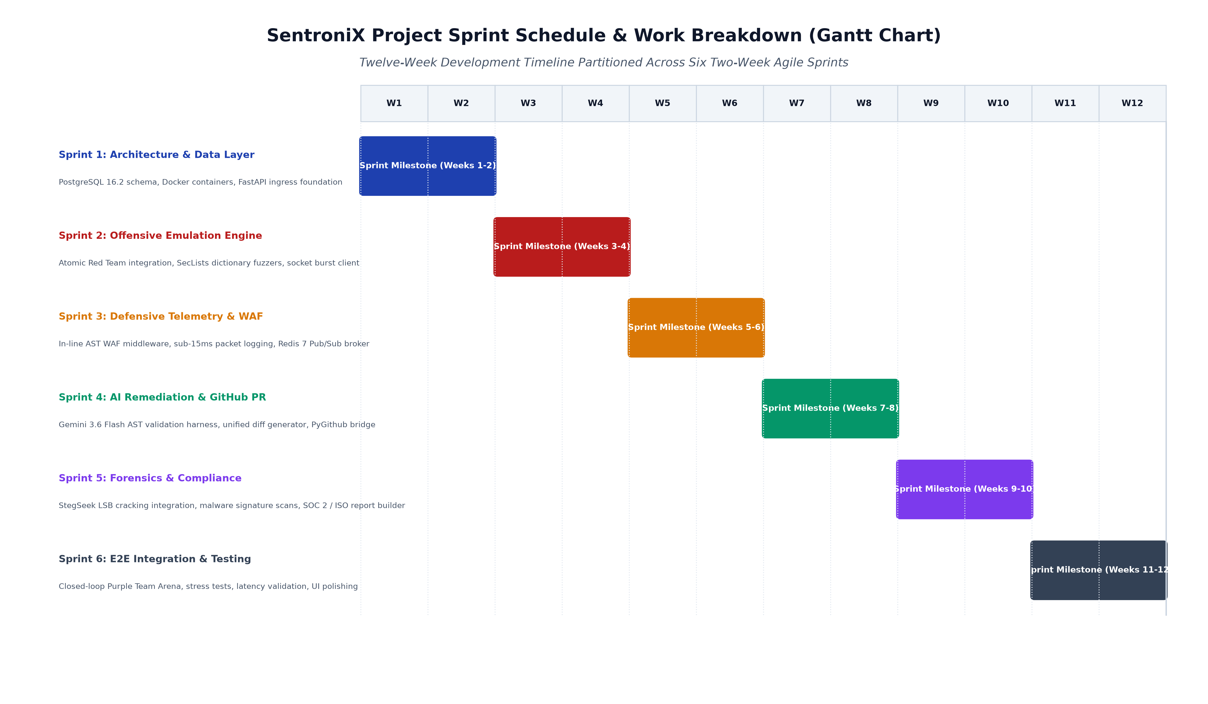
Figure 3.2: SentroniX Project Sprint Schedule & Work Breakdown (Gantt Chart)
Table 3.2 formalizes the work breakdown structure across the six execution sprints, articulating specific development epics, core deliverables, and validation criteria.
Table 3.2: Agile Sprint Schedule, Epics, and Deliverables Matrix
Sprint | Timeline | Development Epic | Core Technical Deliverables | Validation Metric
Sprint 1 | Weeks 1 - 2 | Architecture & Data Layer | PostgreSQL schema, AsyncPG connection pool, Docker compose testbed | Successful DB migrations; container isolation confirmed
Sprint 2 | Weeks 3 - 4 | Offensive Emulation Engine | Atomic Red Team dispatcher, SecLists fuzzing client, socket assault engine | > 100 req/sec sustained throughput against testbed
Sprint 3 | Weeks 5 - 6 | Defensive Telemetry & WAF | FastAPI Starlette WAF middleware, Redis 7 Pub/Sub, Policy switchboard | Latency < 15.0ms; zero downtime on policy toggle
Sprint 4 | Weeks 7 - 8 | AI Remediation & GitHub PR | Gemini 3.6 Flash prompt tuning, ast.parse() harness, PyGithub bridge | 100% AST syntax certification; PR dispatch < 4.0s
Sprint 5 | Weeks 9 - 10 | Forensics & Compliance | StegSeek LSB cracking wrapper, malware scanner, ReportLab PDF builder | > 2.5M words/sec cracking; SOC 2 PDF generation
Sprint 6 | Weeks 11 - 12 | E2E Integration & Arena UI | Purple Team Arena React UI, WebSocket packet viewer, stress testing | Zero socket drop; end-to-end Purple Team loop validated

3.4 Software and Hardware Requirements
To guarantee reproducibility, deterministic performance, and platform portability, precise hardware and software specifications were established across the engineering development workstation, the cloud server deployment environment, and the client browser interface.
3.4.1 Development and Server Environment Specifications
The backend server environment hosting the FastAPI ingress gateway, Redis telemetry broker, and PostgreSQL database requires high I/O throughput and multi-core concurrency to process asynchronous socket streams while executing background fuzzing tasks:
- Hardware Server Specifications: Multi-core 64-bit processor (minimum 8 physical cores, 16 threads, 3.2 GHz base clock), 16 GB DDR4/DDR5 system RAM (32 GB recommended for high-concurrency fuzzing), and 500 GB NVMe PCIe SSD storage delivering minimum 2,500 MB/s sequential read/write speeds.
- Software Server Platform: Ubuntu 22.04 LTS (Jammy Jellyfish) or Windows 11 Pro 64-bit with WSL2, Python 3.10+, Node.js v18 LTS+, Docker Engine 24+, PostgreSQL 16.2, and Redis 7.2.
3.4.2 Client and Target Environment Specifications
The client accessing the SentroniX Purple Team Arena requires a modern HTML5/W3C compliant web browser supporting WebSockets and modern ES2022 JavaScript execution:
- Client Browser Specifications: Google Chrome 110+, Mozilla Firefox 115+, Microsoft Edge 110+, or Apple Safari 16+. The client workstation requires minimum 8 GB RAM and display resolution of 1920x1080.
- Target Application Sandbox: Target applications undergoing simulated attack must be containerized web services running in Docker, exposing standard HTTP/HTTPS REST or GraphQL endpoints.
Table 3.3: Comprehensive Hardware and Software Environment Specifications
Component | Minimum Requirement | Recommended Production Specification | Role in SentroniX
Processor (CPU) | Intel Core i5 / AMD Ryzen 5 (4 cores) | AMD Ryzen 7 / Intel Xeon (8+ cores, 3.6 GHz) | Asynchronous socket processing & AST parsing
System Memory (RAM) | 8 GB DDR4 | 16 GB - 32 GB DDR5 | Redis cache, concurrent fuzzing burst buffers
Storage (Disk) | 256 GB SATA SSD | 512 GB - 1 TB NVMe SSD (PCIe 4.0) | PostgreSQL audit logs & Docker container layers
Operating System | Ubuntu 20.04 LTS / Win 10 | Ubuntu 22.04 LTS / Win 11 Pro 64-bit | Host runtime environment for core services
Python Runtime | Python 3.10 | Python 3.11 / 3.12 (uvloop enabled) | FastAPI backend, AST parser & PyGithub engine
Node.js Runtime | Node.js v18 LTS | Node.js v20 LTS | React 18 build environment & Vite bundler
Relational Database | PostgreSQL 14 | PostgreSQL 16.2 with AsyncPG | ACID transactional findings & policy persistence
In-Memory Broker | Redis 6.0 | Redis 7.2 (Pub/Sub enabled) | Real-time telemetry event streaming to WebSockets
Container Engine | Docker 20.10 | Docker Engine 24.0+ & Compose v2 | Isolated target sandboxing & exploit containment

3.5 Preliminary Product Description
SentroniX is an autonomous, full-lifecycle Purple Team Cyberdefense platform engineered to continuously validate web application attack surfaces, inspect in-line defensive interception, synthesize verified source code patches, and automate version control pull requests. It eliminates the traditional multi-week operational chasm separating Red Team penetration testers and Blue Team defensive engineers by uniting both functions into an automated, self-healing closed loop.
3.5.1 Core Subsystems Overview
The platform delivers its capabilities through four coordinated subsystems:
- 1. Purple Team Arena Dashboard: A responsive React 18 single-page application providing a live visualizer for packet streams, interactive strike configuration, and real-time WAF rule toggle controls.
- 2. Offensive Emulation Subsystem: An asynchronous attack client orchestrating Atomic Red Team vectors and SecLists fuzzing bursts targeting live application sockets.
- 3. Telemetry & WAF Ingress Gateway: A high-throughput Starlette reverse proxy executing deep packet inspection and sub-15ms deterministic 403 Forbidden enforcement.
- 4. Generative AI Remediation Subsystem: An automated pipeline linking Google Gemini 3.6 Flash code reasoning with native Python ast.parse() syntax certification and GitHub PR dispatch.
3.5.2 User Personas and Operational Profiles
SentroniX serves three primary user personas across enterprise software and security teams:
- SecOps Defensive Analyst (Blue Team): Responsible for perimeter protection and log analysis. Uses the WAF Policy Switchboard to evaluate rule efficacy, inspects raw packet byte streams, and monitors real-time block rates.
- Red Team Penetration Tester (Offensive): Responsible for attack surface auditing. Selects MITRE ATT&CK adversary profiles, executes targeted dictionary fuzzing, and identifies unmitigated injection bypasses.
- DevSecOps Software Engineer (Developer): Responsible for code maintenance. Reviews syntax-certified GitHub Pull Requests generated automatically by Gemini 3.6 Flash and merges verified security patches.
3.5.3 End-to-End Operational Lifecycle
The operational lifecycle of SentroniX proceeds through six continuous, automated phases:
- Phase 1 - Configuration: Operator selects target URL and adversary test profiles (e.g., SQLi UNION, CMDi semicolon bypass).
- Phase 2 - Offensive Emulation: Asynchronous client dispatches high-velocity attack stream against the target endpoint.
- Phase 3 - Telemetry Interception: In-line WAF middleware intercepts packets, evaluates AST rules, logs payload bytes, and records pass/block status.
- Phase 4 - AI Reasoning: If an attack payload successfully penetrates the target, exploit evidence is dispatched to Google Gemini 3.6 Flash.
- Phase 5 - AST Certification: Gemini generates a candidate unified diff patch; native ast.parse() validates 100% grammar compliance.
- Phase 6 - PR & Verification: Platform checks out a Git branch, pushes the certified patch, publishes a GitHub PR, and triggers re-emulation to confirm mitigation.

3.6 Conceptual Models
Conceptual modeling provides high-level abstract representations of a software system's operational processes, structural relationships, and data flows. This section articulates the process model governing SentroniX's engineering and presents the conceptual architecture connecting users, internal modules, and external cloud services.
3.6.1 Agile Scrum Process Model and In-Depth Justification
A critical engineering decision in the SentroniX project was the formal adoption of an Agile Scrum development process model over traditional sequential models (such as Waterfall or V-Model). Figure 3.1 illustrates the tailored Agile Scrum methodology engineered specifically for the SentroniX Purple Team Cyberdefense platform.
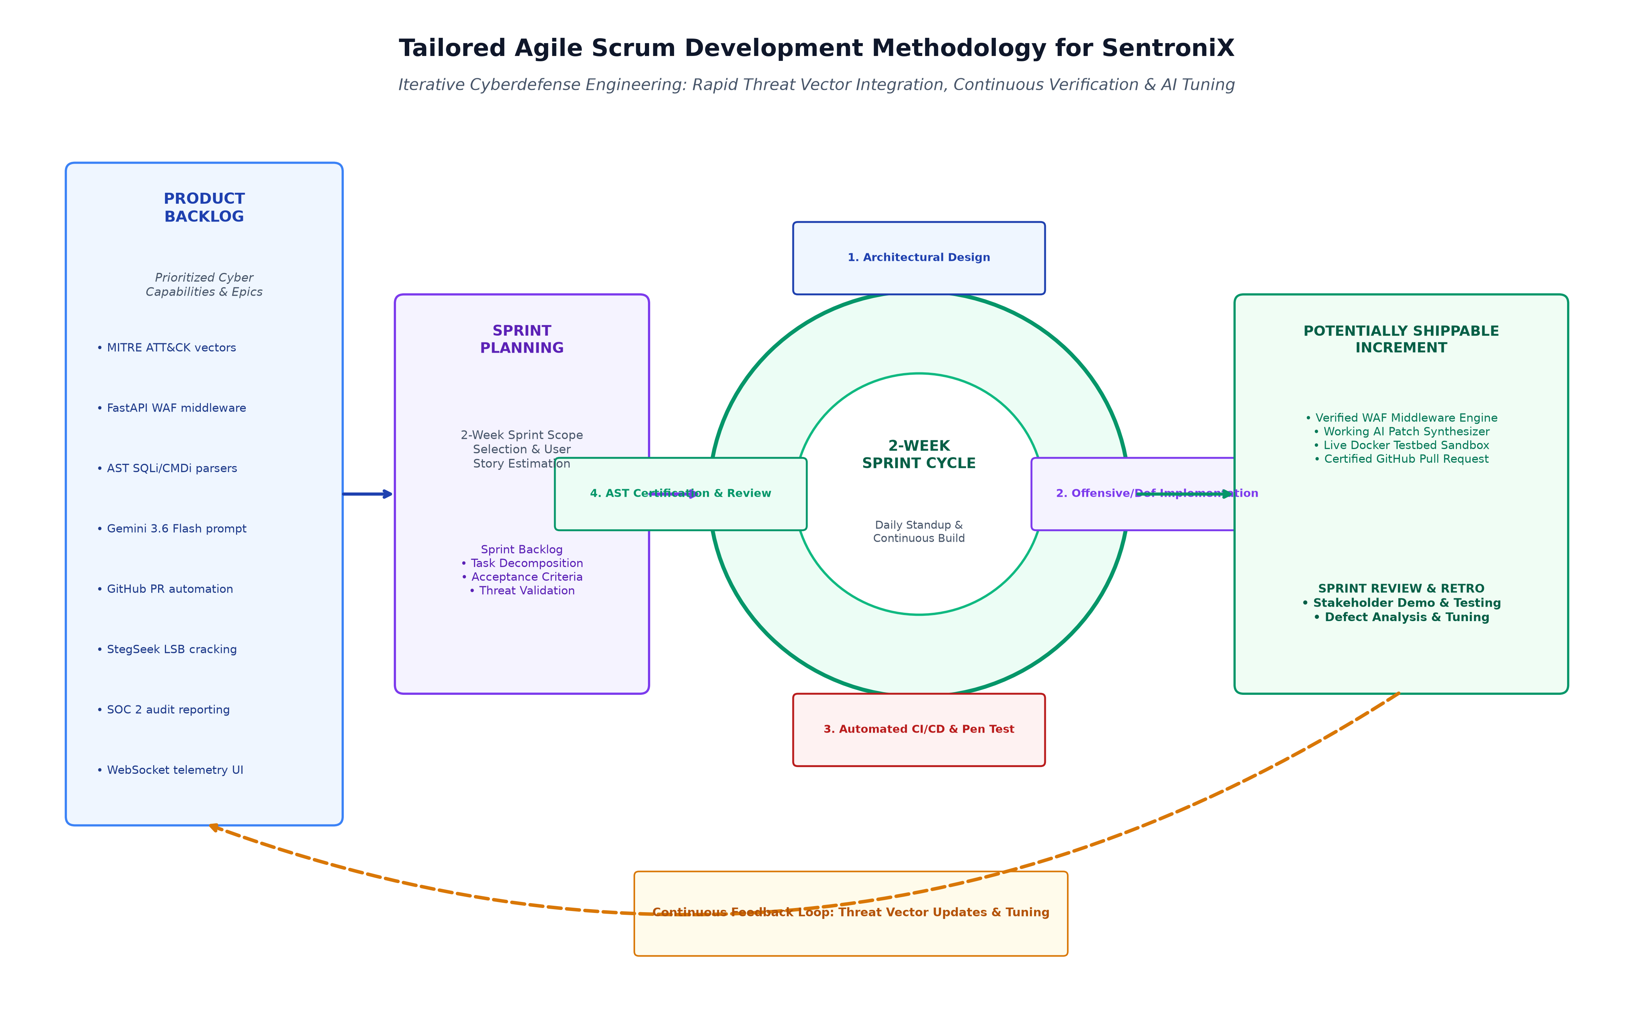
Figure 3.1: Tailored Agile Scrum Development Methodology for SentroniX Cyberdefense Platform
Technical Justification for the Agile Model in SentroniX Development
The selection of the Agile Scrum process model is justified by four compelling technical factors inherent to cybersecurity systems engineering:
- 1. Adaptation to Rapidly Evolving Threat Vectors: Cybersecurity is defined by constant volatility: new Common Vulnerabilities and Exposures (CVEs), zero-day bypass techniques, and obfuscation methods appear daily. A rigid Waterfall approach requires freezing requirements at project inception. Under Agile Scrum, new adversary vectors and evasion patterns can be added to the Product Backlog at any time and scheduled into the very next two-week sprint cycle without disrupting established architecture.
- 2. Iterative Calibration of Generative AI Reasoning: Frontier Large Language Models (such as Google Gemini 3.6 Flash) behave probabilistically. Perfecting system prompts, few-shot demonstration examples, temperature tuning, and JSON schema constraints requires rapid experimental iterations. The Agile sprint cycle allowed the engineering team to deploy prompt variants, measure AST syntax certification rates against hundreds of exploit vectors, and refine system prompts in tight, continuous feedback loops.
- 3. Continuous Performance Benchmarking and Optimization: SentroniX requires achieving sub-15ms network latency in its in-line WAF while maintaining 100% blocking accuracy against complex SQLi payloads. Achieving this balance is impossible in a single design pass. Agile sprints enabled the team to first implement baseline regex matching in Sprint 3, benchmark latency under load, identify ReDoS bottlenecks, and iteratively refactor the engine to use in-memory AST tokenization in subsequent iterations.
- 4. Seamless Synchronization of Offensive and Defensive Engineering: Purple Teaming is fundamentally cross-functional, requiring continuous alignment between offensive red team vectors and defensive blue team detections. The Agile Scrum model, with its two-week Sprint Reviews and Potentially Shippable Increments, guaranteed that offensive dispatchers and defensive filters were developed, tested, and validated in lockstep, preventing architectural drift.
3.6.2 High-Level Conceptual System Architecture Model
Figure 3.3 presents the high-level conceptual system architecture model, illustrating the interactive relationships connecting human user personas, the internal autonomous subsystems of SentroniX, and external cloud services.
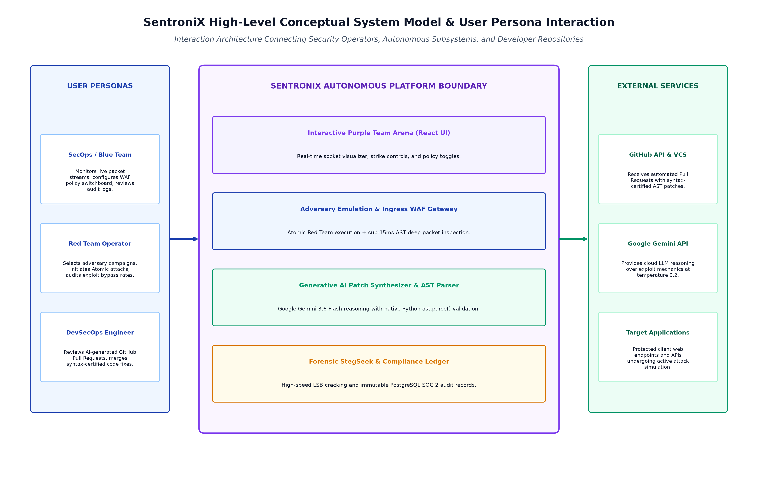
Figure 3.3: SentroniX High-Level Conceptual System Model & User Persona Interaction
As depicted in Figure 3.3, the conceptual architecture cleanly decouples the platform into three primary domains:
- User Persona Domain (Left): SecOps Analysts, Red Team Operators, and DevSecOps Engineers interact exclusively through the centralized React 18 Purple Team Arena, ensuring unified role-based visibility.
- SentroniX Core Platform Boundary (Center): Comprises the core autonomous engines—Purple Team Arena UI, Adversary Emulation & Ingress WAF Gateway, Generative AI Patch Synthesizer, and Forensic Compliance Ledger—communicating internally via asynchronous FastAPI routes, Redis Pub/Sub channels, and Celery task queues.
- External Services Domain (Right): Encompasses external cloud APIs and protected targets: the GitHub REST API (receiving automated pull requests), the Google Gemini API (providing frontier code reasoning), and the customer target applications undergoing active attack simulation.
3.6.3 Conceptual Data Flow and State Transition Model
Throughout the execution of an automated adversary simulation campaign, each vulnerability finding transitions through a deterministic, state-machine lifecycle: `PENDING` (queued for execution) -> `EMULATING` (offensive vector launched against target socket) -> `INTERCEPTED` (WAF blocked payload with 403 status) OR `BYPASS_DETECTED` (payload penetrated target application) -> `REMEDIATING` (Gemini 3.6 Flash analyzing AST code context) -> `AST_CERTIFIED` (passed native ast.parse validation) -> `PR_DISPATCHED` (pull request published to GitHub) -> `VERIFIED` (automated re-strike confirms exploit neutralization). This conceptual state lifecycle ensures complete auditability and zero lost telemetry across the enterprise vulnerability lifecycle.

