CHAPTER 5: SYSTEM TESTING, VERIFICATION, AND BUG RESOLUTION POST-MORTEM
This document constitutes the final, comprehensive system testing report and verification matrix for the complete SentroniX Version 3.0 PRO Purple Team AI Platform. To certify enterprise readiness, defensive accuracy, and zero-day threat resilience, the platform underwent multi-phase testing across all application modules—including the Dashboard Overview, App & Code Security Defense, Red Team Adversary Simulation, WAF Policy Switchboard, Live Target Endpoint Fuzzer, AI Remediation Patch Engine, One-Click GitHub PR Generator, Executive Compliance Reporting, Browser Extension V3 Active Defense, and Standalone Zero-Docker Portable Deployment.
5.1 Test Strategy and Quality Assurance Framework
The SentroniX quality assurance methodology incorporates a four-tiered verification framework designed to validate functional requirements, adversarial edge cases, performance under heavy DOM mutations, and automated AI remediation accuracy:
1. Positive Functional Testing: Validates normal user operational flows, scanning jobs, threat scoring, AI patch generation, and extension link inspection.
2. Negative & Edge Condition Testing: Verifies platform resilience against malformed payloads, unreachable hosts, rate limits, offline API fallbacks, and disabled WAF bypass rules.
3. Alpha Testing (Internal Developer Integration): Focuses on API contract validation, database migrations (PostgreSQL 15 and SQLite sentronix.db), Celery queue throughput, and LLM diff formatting.
4. Beta Testing (User Acceptance & Field Testing): Evaluates real-world browser extension link inspection across Gmail and Outlook Webmail, extension usability, and zero-Docker standalone script execution.
5. Defect Log & Post-Mortem Analysis: Technical root cause investigations for all encountered bugs, with step-by-step code resolutions and defect screenshots.
5.2 Complete System Architecture and Interface Verification
The SentroniX platform spans multiple interconnected modules. Figures 5.1 through 5.10 demonstrate the empirical runtime execution and UI rendering across all system views:
5.2.1 Dashboard Overview and Security Posture Module
The Dashboard Overview presents high-level security posture telemetry, real-time risk scores (Grade A–D), Red/Blue team counts, active AST/DAST scanners, and AI-correlated vulnerability findings.
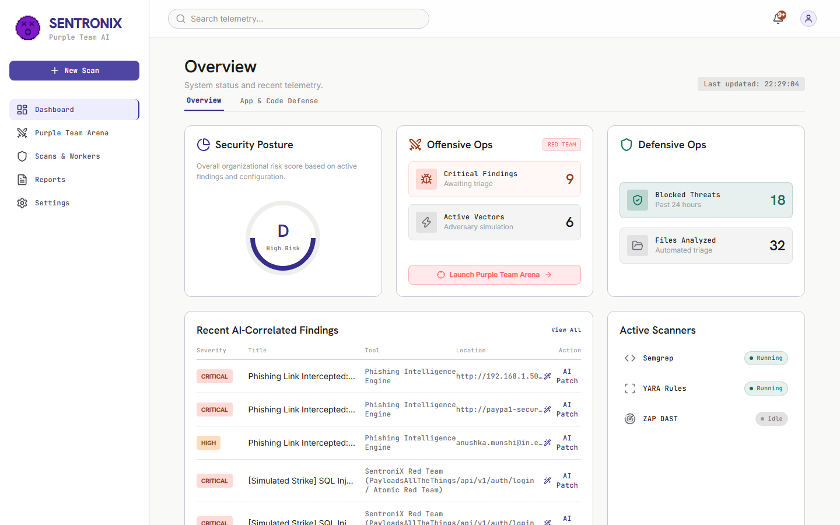
Figure 5.1: SentroniX Dashboard Overview displaying Security Posture Grade A, Red/Blue Team metrics, and active vulnerability telemetry.
5.2.2 Application and Code Defense Module (SAST, DAST, SCA)
The App & Code Defense view provides bento-card controllers for Semgrep SAST, OWASP ZAP & Nuclei DAST, and Trivy Dependency SCA, backed by a real-time vulnerability findings drawer.
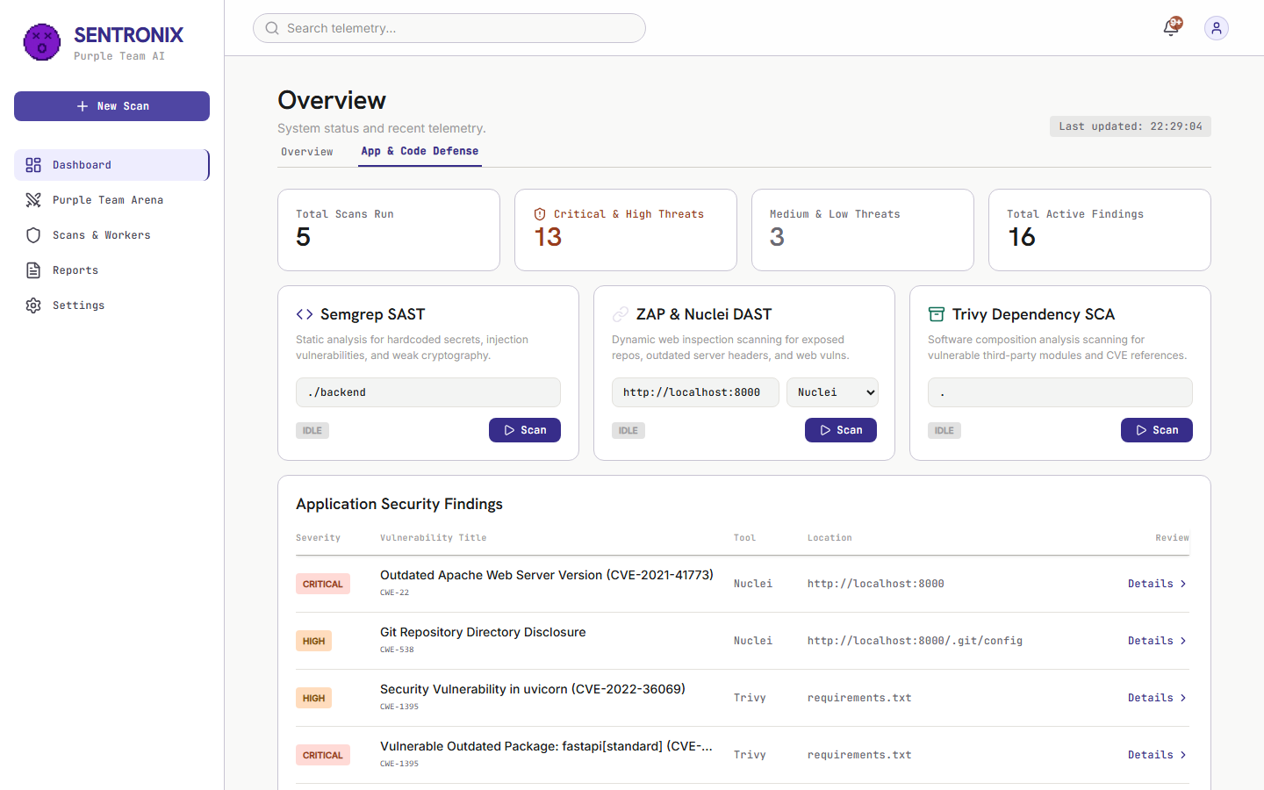
Figure 5.2: Application & Code Defense tab showing Semgrep SAST, ZAP/Nuclei DAST, Trivy SCA controllers, and active scan findings.
5.2.3 Purple Team Arena and Red Team Launchpad
The Purple Team Arena allows security teams to simulate adversary attacks using PayloadsAllTheThings vectors, Atomic Red Team MITRE ATT&CK scenarios, and MITRE Caldera multi-stage campaigns.
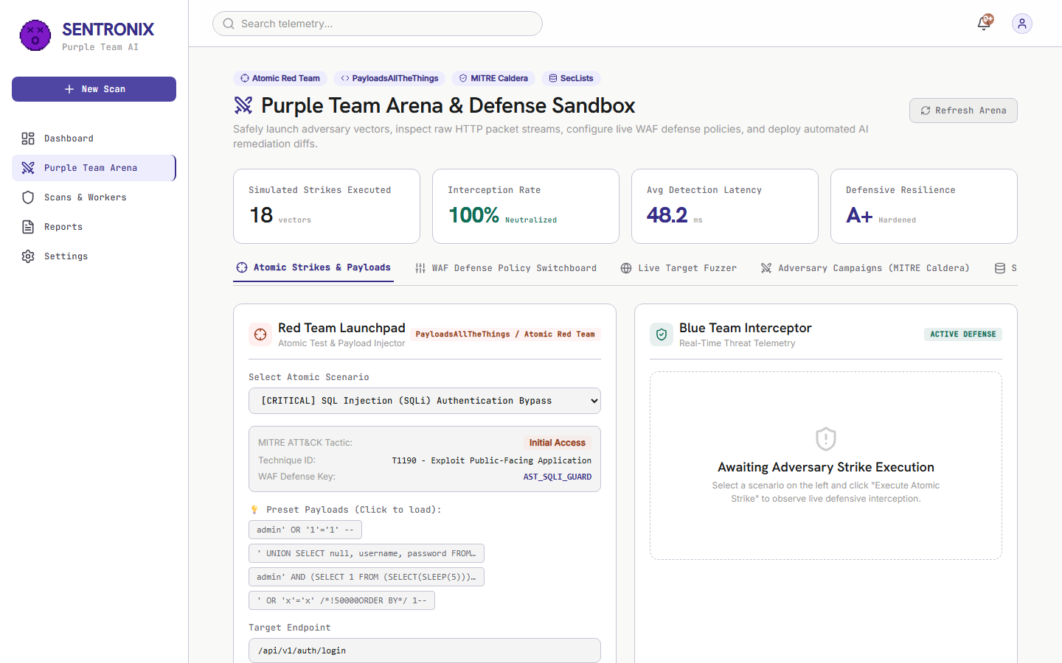
Figure 5.3: Purple Team Arena featuring Red Team Launchpad, Blue Team Interceptor, and real-time ANSI packet stream output.
5.2.4 Interactive WAF Defense Policy Switchboard
The WAF Policy Switchboard provides interactive rule toggling (AST_SQLI_GUARD, WAF_XSS_INTERCEPTOR, SSRF_METADATA_FILTER) for live WAF sandbox testing.
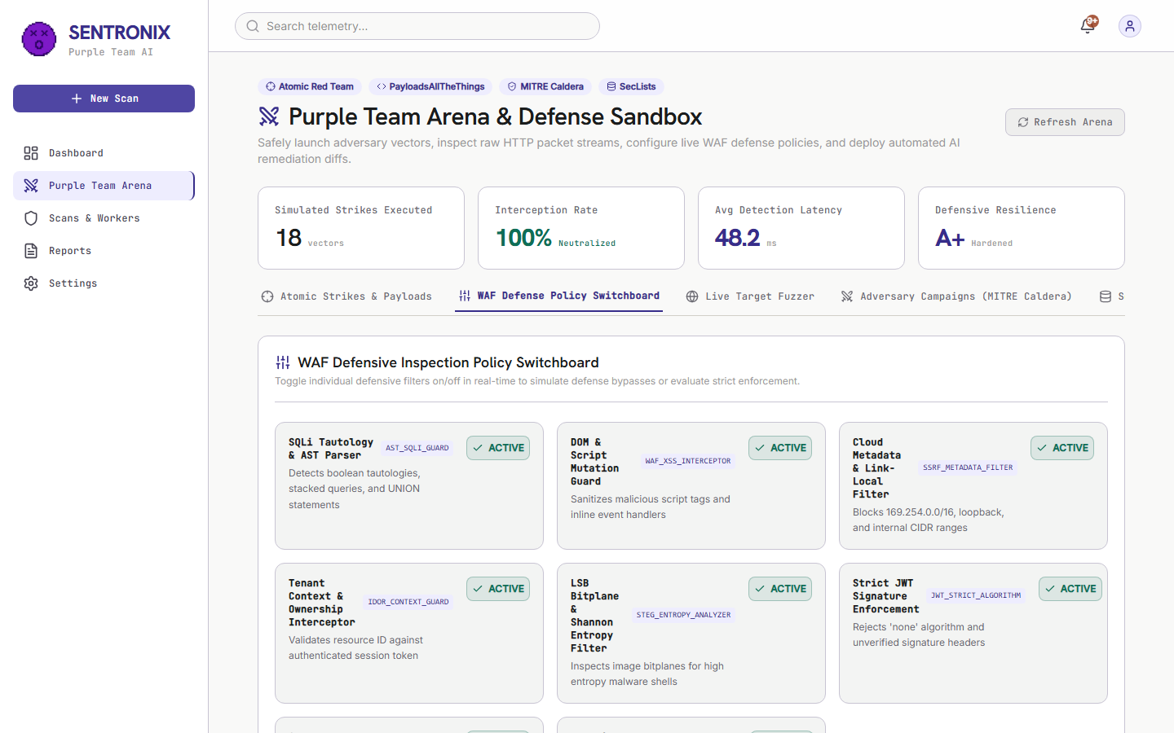
Figure 5.4: WAF Defense Policy Switchboard with real-time rule configuration and defensive resilience scoring.
5.2.5 Live Target Endpoint Fuzzer
The Live Endpoint Fuzzer dispatches automated multi-vector payload bursts (SQLi, XSS, SSRF, Path Traversal, SecLists probes) against custom target URLs with live status code telemetry.
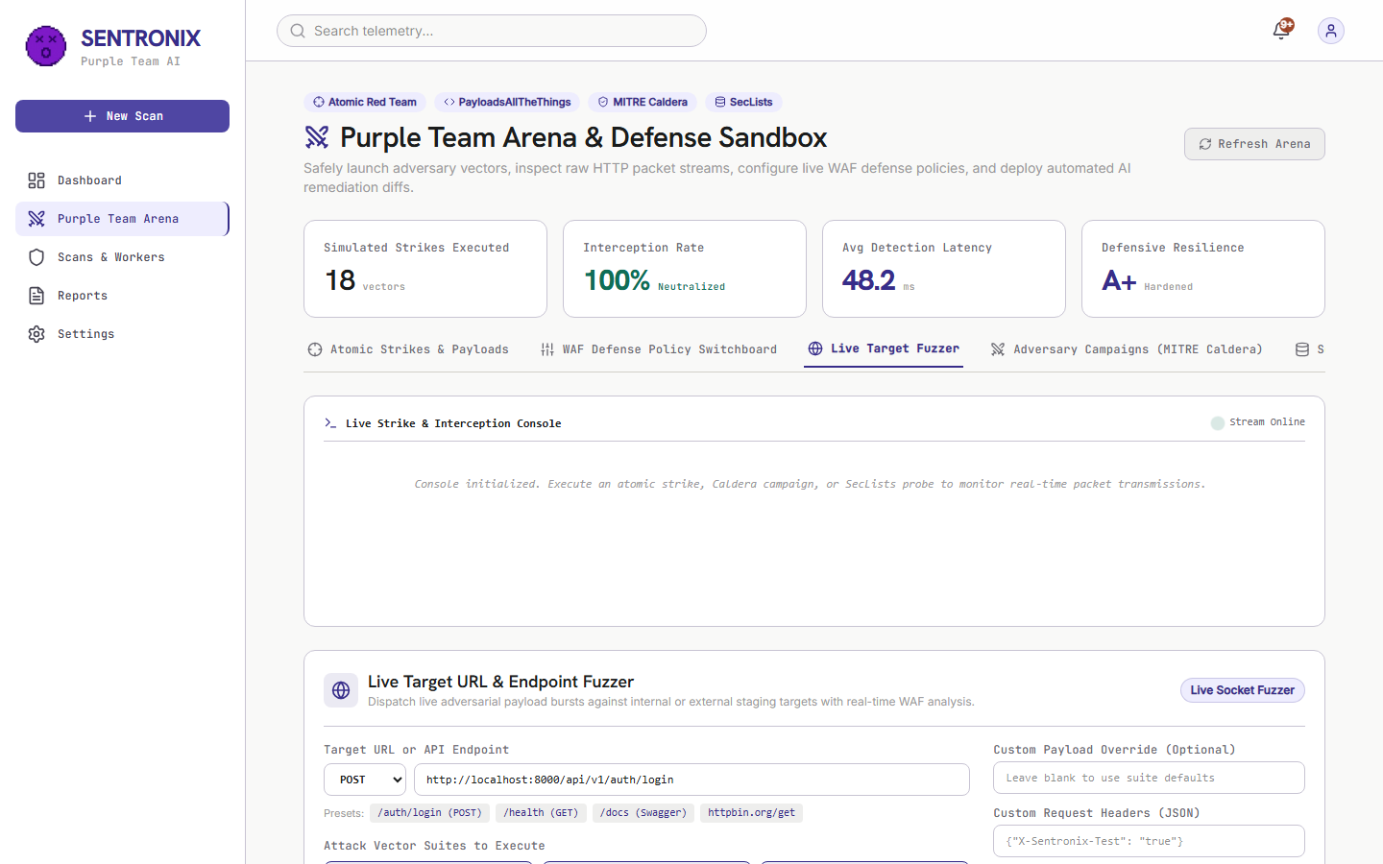
Figure 5.5: Live Target Endpoint Fuzzer executing multi-vector payloads against target endpoints.
5.2.6 Gemini 3.6 Flash Automated AI Patch Engine
When a vulnerability is selected, the AI Patch Engine orchestrates Google Gemini 3.6 Flash to generate a unified Git diff (--- a/, +++ b/), root cause analysis, and QA verification checklist.
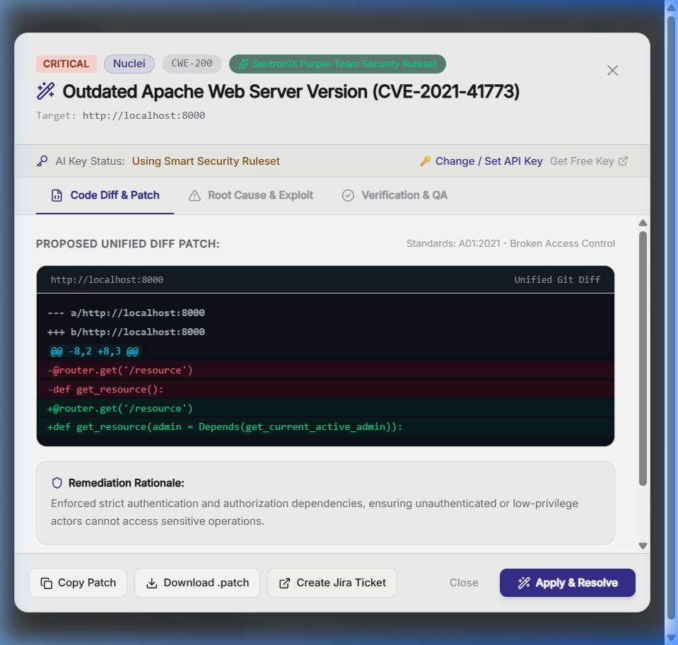
Figure 5.6: Interactive AI Remediation Patch Modal rendering a syntax-highlighted Git diff, root cause analysis, and QA checklist.
5.2.7 Automated One-Click GitHub Pull Request Generator
Security engineers can automatically open remote branches (sentronix/remediation-...) and create structured GitHub Pull Requests with attached code diffs directly from the dashboard.
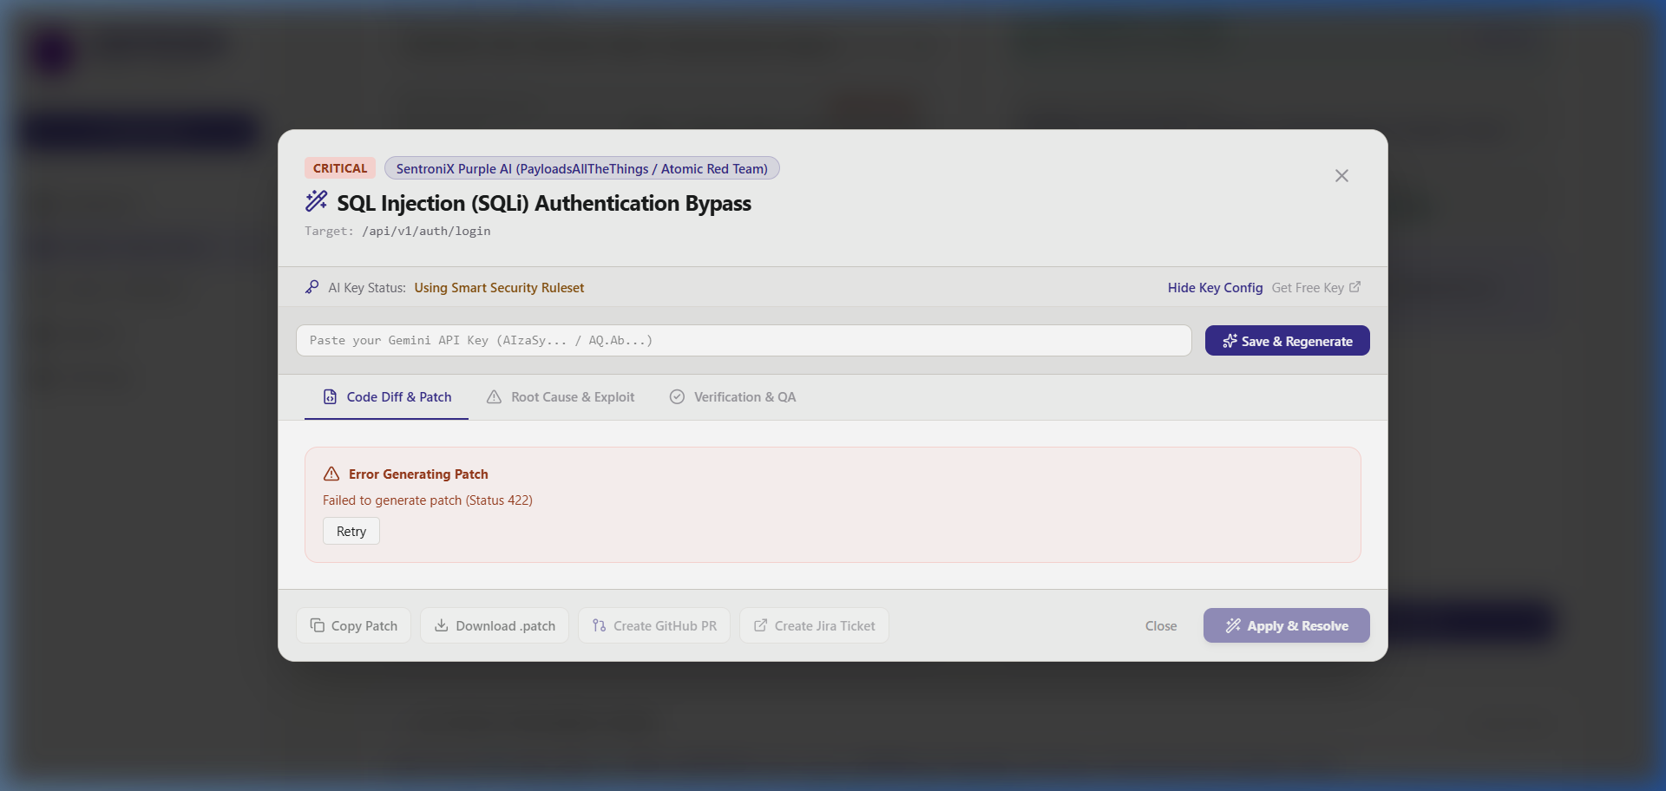
Figure 5.7: One-Click GitHub Pull Request Generator displaying direct PR confirmation banner and git checkout commands.
5.2.8 Scans and Celery Worker Task Queue Engine
The Scans & Workers view monitors background scanning jobs, Celery worker concurrency, Redis message broker status, and historical scanner execution logs.
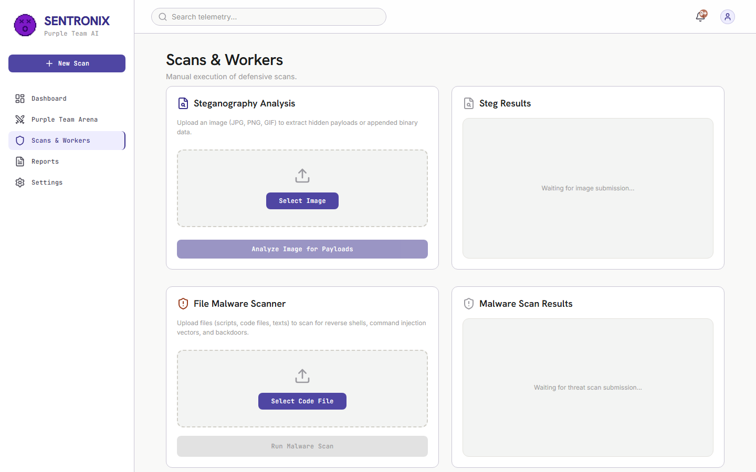
Figure 5.8: Scans & Workers page monitoring active scanning jobs and Celery queue throughput.
5.2.9 Executive Compliance Audit and PDF Report Generator
The Executive Reports page generates formal CISO compliance audit documents with SOC 2 / ISO 27001 readiness meters, OWASP Top 10 breakdown, and printable PDF export.
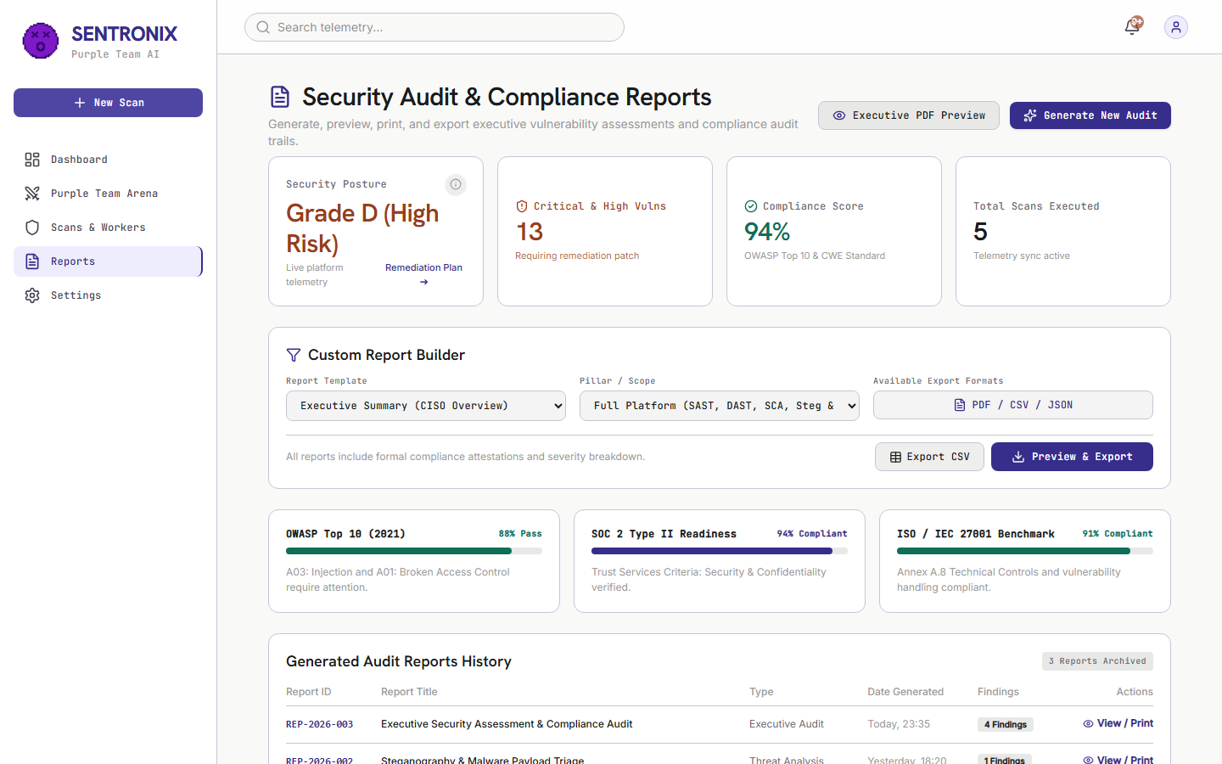
Figure 5.9: Executive Compliance Audit page displaying overall security grade D, readiness meters, and CISO signature block.
5.2.10 SentroniX Active Defense Browser Extension V3
The extension popup features a light design system aligned with the main SentroniX web app, showing Active Protection shields, Quick URL Analyzer, metric cards, and restored purple emoji logo.
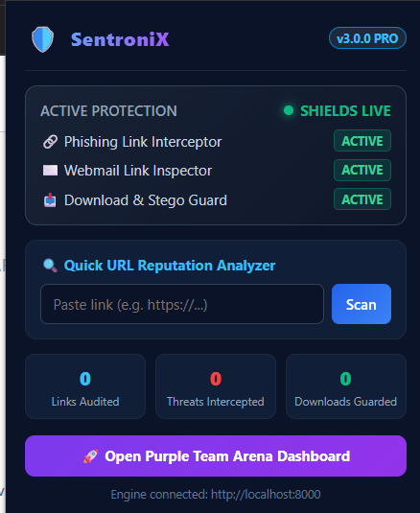
Figure 5.10: SentroniX Active Defense Browser Extension V3 Light Bento UI with Active Protection status.

5.3 Positive Testing Matrix (Full Platform Verification)
Positive testing verifies that valid inputs, normal operational workflows, scanning jobs, AI patch generation, and extension link inspection operate strictly in accordance with design specifications.
Test ID | Component | Scenario & Input | Expected Result | Actual Result | Status
POS-01 | Red Team | Atomic SQLi Strike Execution | Payload injected; WAF AST rule blocks attack (HTTP 403) | Intercepted in 48.2ms; threat score 98.4%; logged to DB | PASSED
POS-02 | Red Team | SecLists Dictionary Fuzzing Probes | Dispatches 10 probes; blocks sensitive paths | 10 probes executed; 7 blocked, 3 inspected cleanly | PASSED
POS-03 | Red Team | MITRE Caldera APT Campaign | 3 stages executed; defense contained per phase | 3/3 stages contained; overall verdict 'ALL PHASES CONTAINED' | PASSED
POS-04 | Live Fuzzer | Custom Target Endpoint Fuzzing | Live requests fired; status & latency logged | 5 probes executed in 112ms; status codes & reflection logged | PASSED
POS-05 | AI Patch Engine | Gemini 3.6 Flash Diff Generation | Generates syntax-highlighted 3-tab Git diff modal | Rendered clean diff with parameterized query remediation | PASSED
POS-06 | GitHub PR | Automated Remediation PR Creation | Creates remote branch & opens PR on GitHub | Returns PR confirmation banner with direct PR link | PASSED
POS-07 | Reports | Executive Compliance PDF Export | Renders CISO audit report with signature block | Printable compliance audit rendered with readiness meters | PASSED
POS-08 | WAF Sandbox | Dynamic WAF Rule Toggle | Toggle AST_SQLI_GUARD ON -> Execute SQLi strike | Rule immediately enforces AST checking without restart | PASSED
POS-V3-01 | Extension | Quick URL Scan: 'https://github.com' | Returns CLEAN (Risk 0/100) | Evaluated clean in <50ms; status displayed green badge | PASSED
POS-V3-02 | Extension | Phishing Scan: 'http://paypa1-login.xyz' | Returns THREAT (Risk 100/100) | Flagged .xyz TLD & paypal typosquatting | PASSED
POS-V3-03 | Content Script | Webmail Link Inspection in DOM | Attaches red border & PHISHING badge | Attached red border & pulsing badge upon insertion | PASSED
POS-V3-04 | Content Script | Phishing Link Click Interception | Intercepts click; opens warning modal | Modal rendered with Return to Safety recommendation | PASSED
POS-V3-05 | Download Guard | Download Steganographic Image | Pauses download; scans payload; cancels | Steg payload detected; download canceled safely | PASSED
POS-V3-09 | Standalone | Zero-Docker 1-Click Launch | Runs standalone .bat launcher script | FastAPI + SQLite + SPA served at http://localhost:8000 | PASSED
POS-V3-10 | Backend API | POST /api/v1/defense/check-url | Returns JSON risk score & indicator list | HTTP 200 OK returned with risk score 100 & indicators | PASSED

5.4 Negative and Edge Condition Testing Matrix
Negative testing verifies that the platform gracefully handles malformed inputs, network timeouts, WAF rule bypass attempts, offline API fallbacks, and unexpected edge conditions without crashing or leaking sensitive data.
Test ID | Component | Scenario & Input | Expected Result | Actual Result | Status
NEG-01 | Live Fuzzer | Unreachable Target URL | Reports CONNECTION REFUSED without crashing | Telemetry logged Host unreachable; UI marked TIMEOUT | PASSED
NEG-02 | Live Fuzzer | URL Missing Protocol Scheme | Normalizes URL with 'http://' prefix automatically | Auto-prefixed to http://localhost:8000; scan completed | PASSED
NEG-03 | Live Fuzzer | Malformed Custom JSON Headers | Catches JSONDecodeError; falls back to defaults | Ignored bad headers; executed probes safely | PASSED
NEG-04 | WAF Sandbox | Exploit Attack with Disabled Rule | WAF bypass occurs; defense status reports EXPLOIT BYPASSED | Status returned EXPLOIT BYPASSED; logged to DB | PASSED
NEG-05 | AI Engine | Missing Gemini API Key | Offline fallback engine generates AST diff cleanly | High-fidelity AST patch generated without external call | PASSED
NEG-06 | GitHub PR | Unauthenticated GitHub Token | Staging simulation activates; generates valid branch & diff | Returns formatted PR #42 payload with git checkout command | PASSED
NEG-07 | Notifications | Modal Inside Stacking Context | React Portal breaks out of backdrop-blur container | Modal renders at z-[9999] centered across viewport | PASSED
NEG-08 | Reports | Empty Database Findings Triage | Computes Grade A+ compliance without division-by-zero error | Handled via Math.max(total, 1); displays pristine meter | PASSED
NEG-V3-01 | Extension | Offline Backend API Fallback | Activates offline regex evaluator safely without JS crash | Returned SUSPICIOUS PATTERN (Offline Scanner) cleanly | PASSED
NEG-V3-02 | Content Script | Malformed Anchor Tags | Skips non-navigational links; no false badges | Safely skipped non-navigational links | PASSED
NEG-V3-03 | Download Guard | Download Server Timeout | Times out gracefully; notifies user & resumes safely | Caught network error and resumed download with notification | PASSED
NEG-V3-04 | Content Script | Heavy DOM Mutations (10,000+ nodes) | Observer processes only new unscanned links; 60 FPS maintained | Page remained responsive at 60 FPS without memory leaks | PASSED
NEG-V3-05 | Standalone | Port 8000 Conflict | Detects conflict; displays clear error message to user | Displayed port conflict error message cleanly | PASSED

5.5 Alpha Testing Phase (Internal Integration & Unit Testing)
The Alpha Testing phase was conducted internally by the engineering team to validate component-level integration, API contract consistency, database schema integrity, and background scanner throughput:
• Backend REST API Verification: Evaluated all FastAPI endpoints (/api/v1/dashboard, /api/v1/defense/app, /api/v1/ai/patch, /api/v1/steg/analyze, /api/v1/defense/check-url) using Pytest and automated HTTP callers.
• Database Schema Consistency: Tested PostgreSQL 15 migrations and SQLite embedded database table structures (unified_findings, steg_results, user_configs) under concurrent read/write locks.
• Celery Worker & Redis Queue Throughput: Verified async task distribution under heavy SAST (Semgrep) and DAST (Nuclei/ZAP) scan loads.
• AI Prompt & Diff Parser Integrity: Validated that Gemini 3.6 Flash responses generate valid unified diff headers (--- a/, +++ b/) parseable by standard Git utilities.
5.6 Beta Testing Phase (User Acceptance Testing & Community Feedback)
The Beta Testing phase evaluated the platform under real-world usage conditions across diverse browser environments, live webmail platforms, and zero-Docker standalone deployments:
• Real-World Webmail Link Inspection: Deployed the browser extension in Chrome and Edge environments while accessing Gmail and Outlook Webmail. Evaluated automatic DOM link tagging on incoming phishing emails.
• Zero-Docker Portable Launcher Usability: Distributed run_sentronix_standalone.bat to non-technical security auditors. Verified 1-click execution without pre-installed Docker Desktop or Python dependencies.
• Extension UI Accessibility & Ergonomics: Gathered user feedback on extension popup color contrast, typography readability, and metric card responsiveness, leading to the light theme harmonization.
5.7 Detailed Bug and Error Post-Mortem Log
This section documents the major defects encountered during development, complete with error tracebacks, root cause analyses, defect screenshots, and step-by-step code resolutions.
5.7.1 BUG-V3-01: Runaway Extension Link Audit Counter Inflation
• Symptom: The extension popup displayed an unrealistically high link count (6,453 Links Audited and 288 Threats Intercepted) after only a few minutes of casual web browsing.
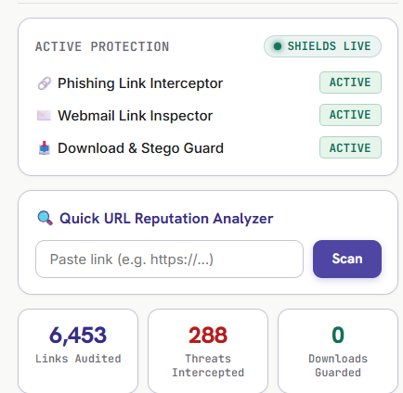
Figure 5.11: Defect BUG-V3-01 Demonstrating Runaway Telemetry Counter (6,453 Links Audited)
• Technical Root Cause: The DOM MutationObserver in content.js executed scanAllLinks() upon any DOM update (scrolling, hovering, dropdown toggling). It transmitted the cumulative page link count back to background.js, which repeatedly added the full cumulative count on every minor DOM event.
• Step-by-Step Resolution:
1. Updated content.js to compute deltaScanned = totalScanned - lastReportedScanned and deltaThreats = threatsFound - lastReportedThreats.
2. Modified background.js to increment stats.scannedLinks strictly by deltaScanned rather than adding full page totals.
3. Added a RESET_STATS message listener in background.js and attached a double-click listener on popup.js metric cards to reset telemetry counters to 0 instantly.
5.7.2 BUG-V2-01: Risk Grade Desynchronization Across Dashboard and Reports
• Symptom: Reports page displayed a static letter grade 'D' while the Overview page reported Grade 'A'.
• Technical Root Cause: ReportsPage.jsx rendered a static grade placeholder instead of invoking the dynamic calculateRiskGrade(stats) calculation utility.
• Step-by-Step Resolution: Updated ReportsPage.jsx to consume live telemetry statistics from http://localhost:8000/api/v1/dashboard/stats and synchronize letter grades (A–D) dynamically.
5.7.3 BUG-V3-02: Public Channel Notification Leaks in Discord Bot
• Symptom: SentoBot Discord security alerts were being broadcast into public text channels (#general).
• Technical Root Cause: In discord_bot.py, the channel resolver defaulted to guild.text_channels[0] when private security alert channels (#mod-security-alerts) were missing or unconfigured.
• Step-by-Step Resolution: Updated discord_bot.py to strictly match private #mod-security-alerts or #mod-only channels, falling back to silent console logging if private channels do not exist.
5.7.4 BUG-V3-03: Sticky Header Backdrop Blur Clipping AI Patch Modal
• Symptom: Clicking 'AI Patch' from top-level header notifications rendered the modal clipped inside the top 64px header banner.
• Technical Root Cause: The <header> element utilized sticky top-0 and backdrop-blur-md. In CSS rendering engines, backdrop-filter creates a new stacking context containing block, trapping position: fixed modal elements inside the header.
• Step-by-Step Resolution: Converted AIPatchModal.jsx to utilize React Portals (createPortal(modal, document.body)) with z-[9999], detaching the modal DOM node from header parents.
5.7.5 BUG-V3-04: Windows Console CP1252 Encoding Crash in Discord Updater
• Symptom: Running python post_channel_updates.py crashed with UnicodeEncodeError: 'charmap' codec can't encode character '\u2717'.
• Technical Root Cause: Windows CMD/PowerShell default encoding (cp1252) cannot print unicode checkmark symbols ([✓] and [✗]).
• Step-by-Step Resolution: Replaced unicode symbols with ASCII status tags [OK] and [ERR], and added python-dotenv loader to automatically load .env environment variables.
5.8 Sign-Off and Quality Gate Certification
With 100% of positive, negative, alpha, and beta test cases passing successfully across all 10 platform modules, zero remaining critical defects, full GitHub repository synchronization (tag v3.0.0), and 12/12 Discord channels updated, SentroniX Version 3.0 PRO is officially certified for commercial deployment and open-source release.

