**Lab Exercise - 1**

**Creating Static Host Inventory**

**Objective:** To create a static host inventory for managing and automating infrastructure tasks efficiently across multiple servers using Ansible

**Tools required:** Ubuntu OS

**Prerequisites:** You need to have Ansible installed to proceed with this demo

Steps to be followed:

1. Generate SSH key pair on the main node
2. Copy the SSH key to the two other nodes
3. Update the inventory or host file with the host IP address
4. Establish connectivity between the hosts specified in the host file and the Ansible server

**Step 1: Create a common user on all 3 instances**

Login to each instance and run:

**sudo useradd ansibleuser**

**sudo passwd ansibleuser**

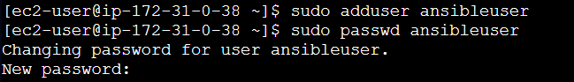

Add this user to sudoers so it can run sudo commands:

**echo 'ansibleuser ALL=(ALL) NOPASSWD:ALL' | sudo tee /etc/sudoers.d/ansibleuser**



**Step 2 : Install Ansible on your control node (only one of your EC2s)**

SSH into your **control node EC2**

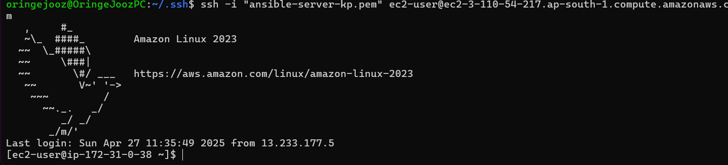

**sudo amazon-linux-extras enable ansible2**

**sudo yum install -y ansible**

**ansible --version**

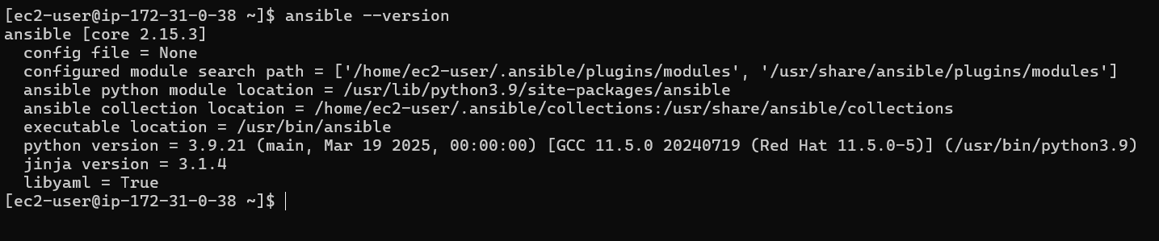

**Step 3: Generate SSH Key Pair on Control Node (as ansibleuser)**

Switch to ansibleuser

**sudo su -ansibleuser**



Generate key

**ssh-keygen**

Press enter at all prompts to accept defaults (key in ~/.ssh/id_rsa)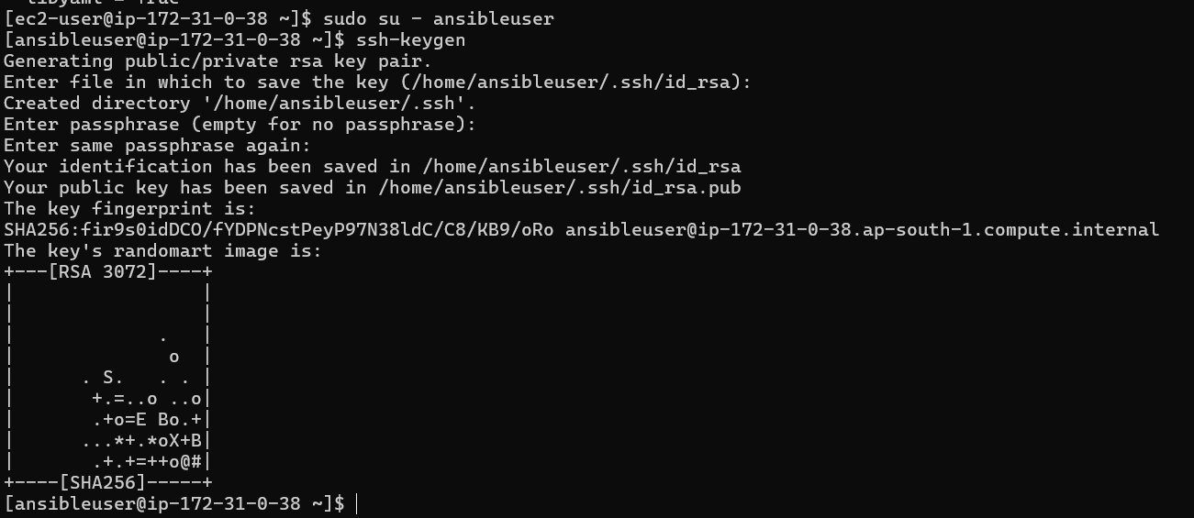

**Step 4: Copy Public Key to Other 2 Managed Nodes**

On each target node:

**sudo vi /etc/ssh/sshd_config**

PasswordAuthentication yes

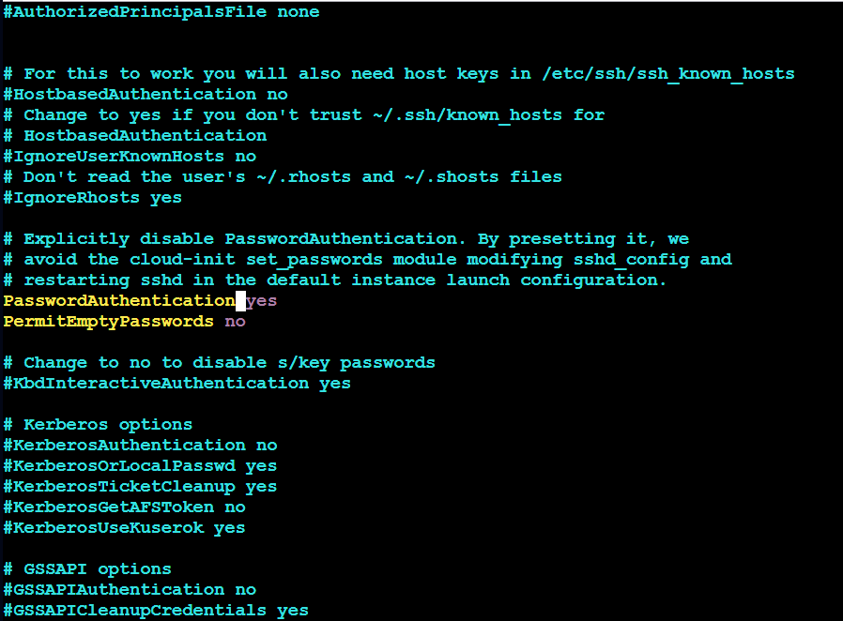

Then restart SSH:

**sudo systemctl restart sshd**

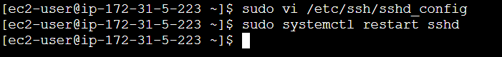

From your control node (as ansibleuser):

**ssh-copy-id ansibleuser@<IP-of-node-1>**

**ssh-copy-id ansibleuser@<IP-of-node-2>**

ssh-copy-id ansibleuser@43.204.211.133

ssh-copy-id ansibleuser@43.204.236.181

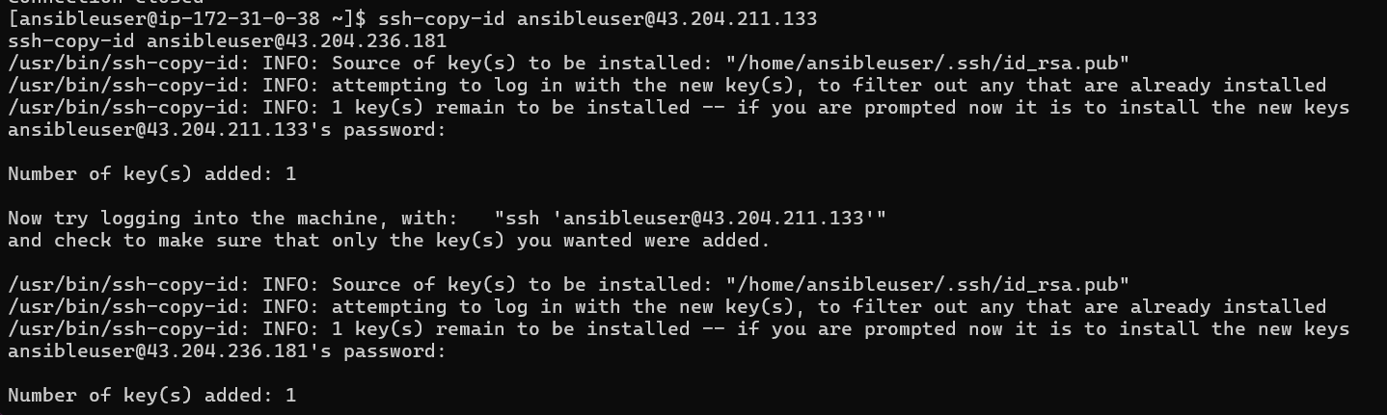

**Test passwordless SSH**

ssh [ansibleuser@43.204.211.133](mailto:ansibleuser@43.204.211.133)

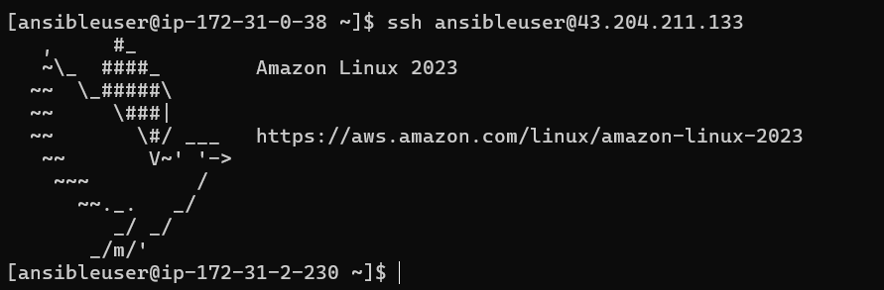

ssh ansibleuser@43.204.236.181

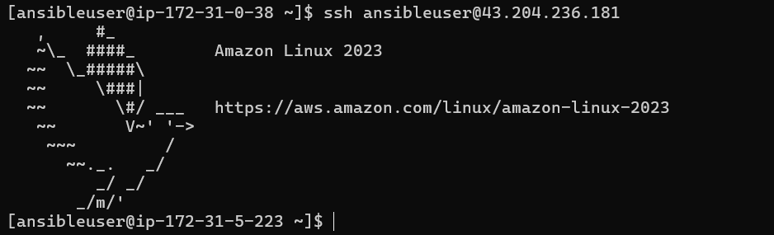

**Step 5: Update your Ansible inventory file**

On control node:

sudo vi /etc/ansible/hosts

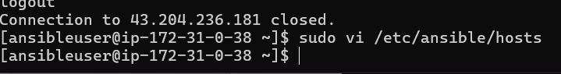

Add:

[dbbservers]

localhost

43.204.211.133

43.204.236.181

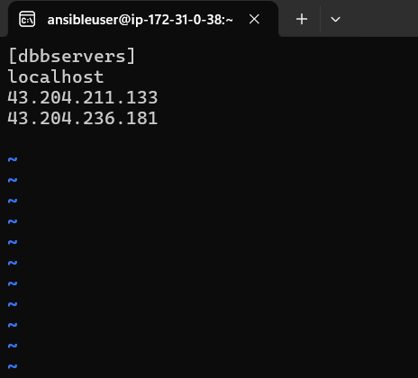

**Step 6 : Test Ansible connectivity**

ansible -m ping dbbservers

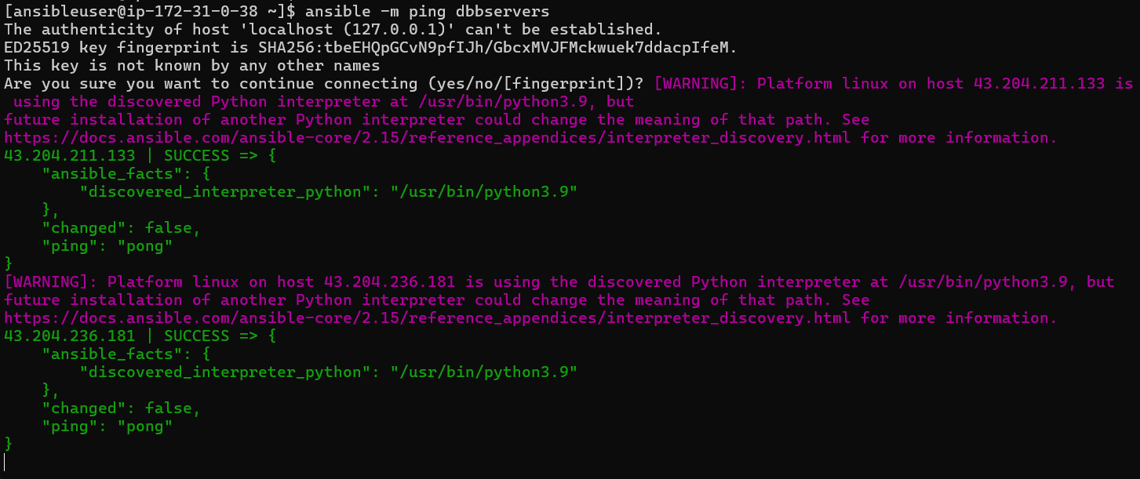

Use the following command to check the number of hosts in the host file:

**ansible all --list-hosts**

