**Lab Exercise 02**

**Working** **With Hosts and Groups**

**Objective:** To work with hosts both individually and in groups for streamlined management and deployment across your network infrastructure

**Tools required:** Ubuntu OS

**Prerequisites:** You need to have Ansible, and the nodes connected with it installed to proceed with this demo. Refer Demo 1 of Lesson 3.

Steps to be followed:

1. List the hosts present in your host file
2. Create a file on the host
3. Remove the file from the host
4. Create and remove the file on the hosts using the group
5. Update the hosts using the group

**Step 1: List the hosts present in your host file**

1. Use the following command to list the hosts in your inventory file:

**ansible all --list-hosts**

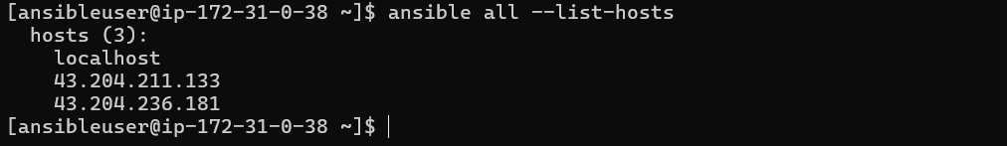

**Step 2: Create a file on the host**

* 1. Use the following command to list the contents of the current working directory:  
     **ansible 43.204.211.133 -a "ls"  
     (Replace the IP accordingly)**

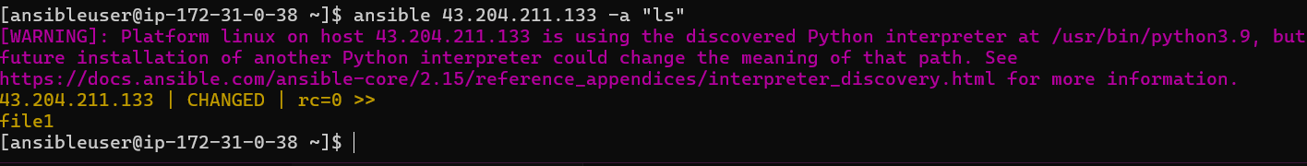

* 1. Use the following command to create a file named **file1** on the host:  
     **ansible 43.204.211.133 -a "touch file1"**



**Step 3: Remove the file from the host**

**3.1 Remove file1**

ansible 43.204.211.133 -a "rm file1"

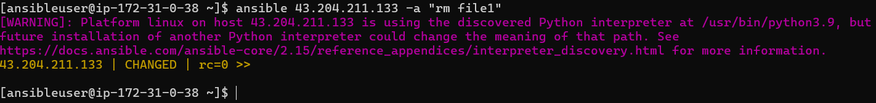

**Step 4: Create and remove the file on hosts using the group**

**4.1 Create a file Ansible_learners on both hosts (assuming your group is dbservers in /etc/ansible/hosts)**

ansible dbservers -a "touch Ansible_learners"

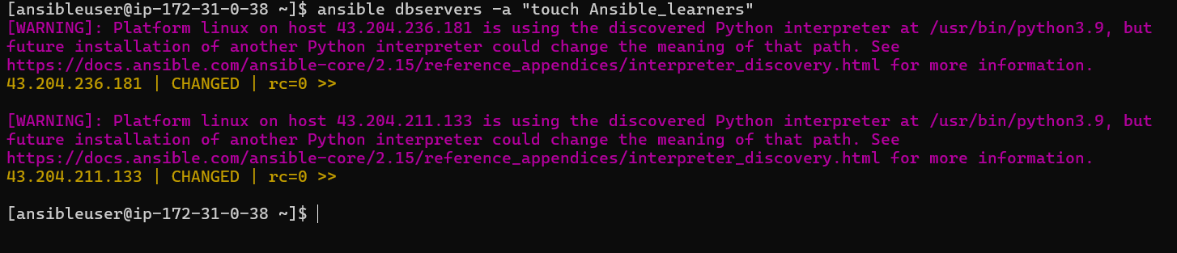

**4.2 List contents in the current directory on both hosts**

ansible dbservers -a "ls"

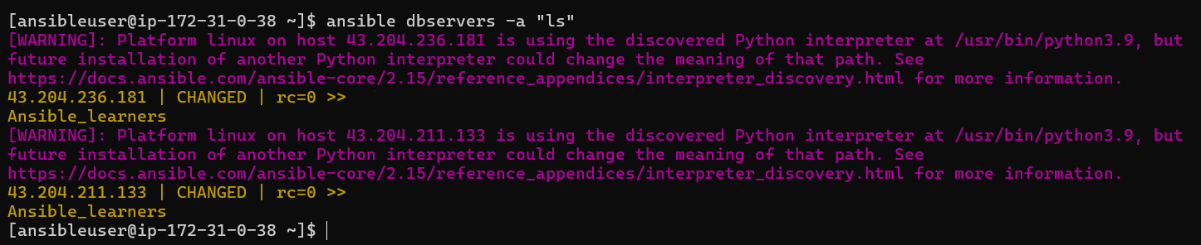

**4.3 Remove Ansible_learners from both hosts**

ansible dbservers -a "rm Ansible_learners"

