

Submitted to :

Dr. Hitesh Kumar Sharma

Submitted by :

Akash Chauhan

500105955

Hb1

# EXPERIMENT 2

Lab Exercise: Working With Hosts and Groups

Steps to be followed:

1. List the hosts present in your host file

2. Create a file on the host

3. Remove the file from the host

4. Create and remove the file on the hosts using the group

5. Update the hosts using the group

Step 1: List the hosts present in your host file

1.1 Use the following command to list the hosts in your inventory file:

ansible all --list-hosts

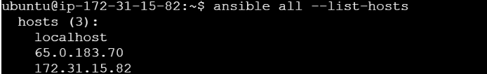

Step 2: Create a file on the host

2.1 Use the following command to list the contents of the current working directory: ansible 172.31.44.85 -a "ls"



2.2 Use the following command to create a file named file1 on the host: ansible 13.126.129.191 -a "touch file1"

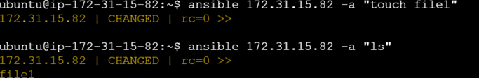

Step 3: Remove the file from the host

3.1 Now, run the following command to remove the file from the host: ansible 13.126.129.191 -a "rm file1”

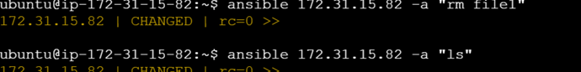

Step 4: Create and remove the file on the hosts using the group

4.1 Run the following command to create a new file on both the hosts using the group: ansible dbservers -a "touch Ansible_learners"

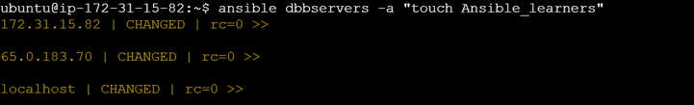

4.2 Use the following command to list the contents of the current working directory of all the hosts present in the group: ansible dbservers -a "ls"

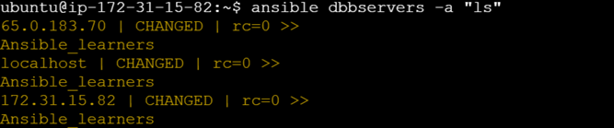

4.3 Run the following command to remove the file on both hosts using the group: ansible dbservers -a "rm Ansible_learners"

