

Submitted to :

Dr. Hitesh Kumar Sharma

Submitted by :

Akash Chauhan

500105955

Hb1

# EXPERIMENT 1

Lab Exercise: Creating Static Host Inventory

Steps to be followed:

1. Generate SSH key pair on the main node

2. Copy the SSH key on the other two nodes

3. Update the host file with the host IP address

4. Establish connectivity between specified hosts and the Ansible server

5. Gather System Information Using Ad-Hoc Commands

Step 1: Establish connectivity between specified hosts and the Ansible server

* 1. Run the following command to verify connectivity to all servers listed under the webservers group in your Ansible hosts file: ansible -m ping dbservers

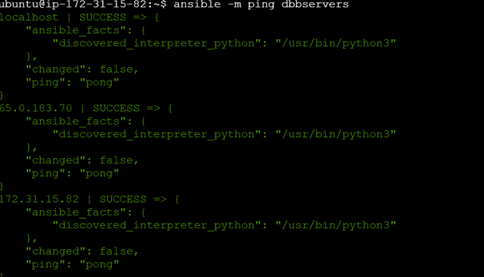

* 1. Use the following command to check the number of hosts in the host file: ansible all --list-hosts

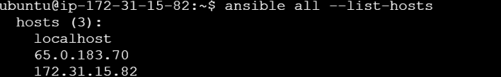

Step 2: Gather System Information Using Ad Hoc Commands

2.1 Run the following command to obtain the uptime from all managed hosts using an ad hoc command: ansible all -m shell -a uptime

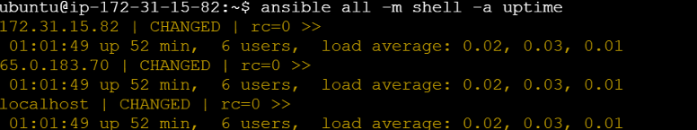

2.2 Similarly, execute the below command to obtain detailed information about memory usage on all hosts: ansible all -m shell -a "free -m"

