

Submitted to :

Dr. Hitesh Kumar Sharma

Submitted by :

Akash Chauhan

500105955

Hb1

# EXPERIMENT 4

Lab Exercise: Executing Ansible Modules

Steps to be followed:

1. Use Ansible modules for server configuration

Step 1: Use Ansible modules for server configuration

1.1 Run the following command using the setup module to collect and display detailed

system information about the servers: ansible -m setup dbbservers

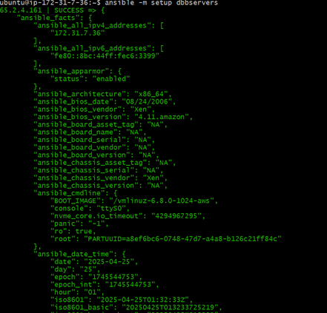

1.2 Run the following command using the shell module to retrieve server hostnames: ansible dbbservers -m shell -a 'hostname'

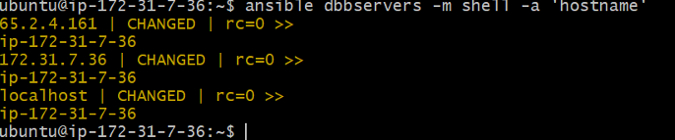

1.3 Run the following command using the apt module to install Git on servers: ansible dbbservers -m apt -a 'name=git state=present update_cache=true' –become

