

System Provisioning and

# Configuration Management Lab

**EXPERIMENT 4**

**Lab Exercise: Executing Ansible Modules**

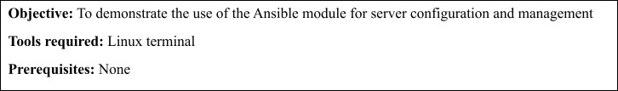

**Steps to be followed:**

1. Use Ansible modules for server configuration

**Step 1: Use Ansible modules for server configuration**

* 1. Run the following command using the **setup** module to collect and display detailed system information about the servers: **ansible -m setup dbbservers**

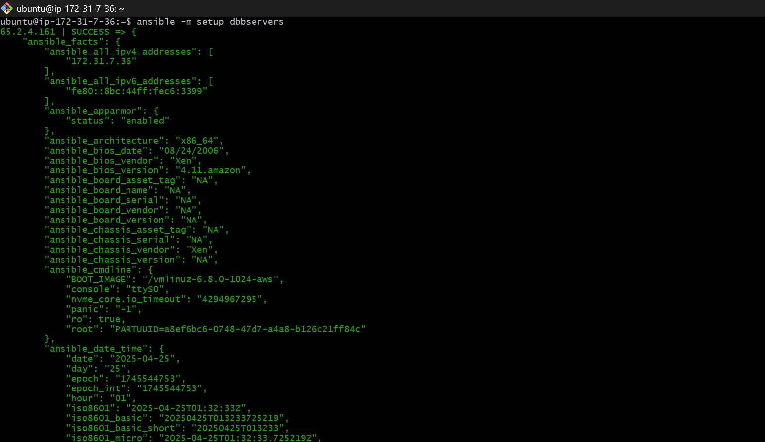

* 1. Run the following command using the **shell** module to retrieve server hostnames: **ansible dbbservers -m shell -a 'hostname'**

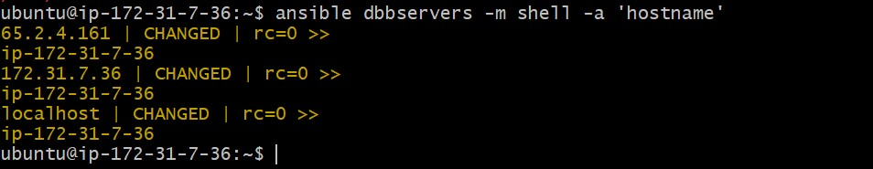

* 1. Run the following command using the **apt** module to install Git on servers: **ansible dbbservers -m apt -a 'name=git state=present update_cache=true' --become**

