Lab Exercise 01 Creating Static Host Inventory

By: Stuti Sehgal  
500107063  
R2142221190  
B2  
Steps to be followed:

**Objective:** To create a static host inventory for managing and automating infrastructure tasks efficiently across multiple servers using Ansible

**Tools required:** Ubuntu OS

**Prerequisites:** You need to have Ansible installed to proceed with this demo

1. Generate SSH key pair on the main node
2. Copy the SSH key to the two other nodes
3. Update the inventory or host file with the host IP address
4. Establish connectivity between the hosts specified in the host file and the Ansible server

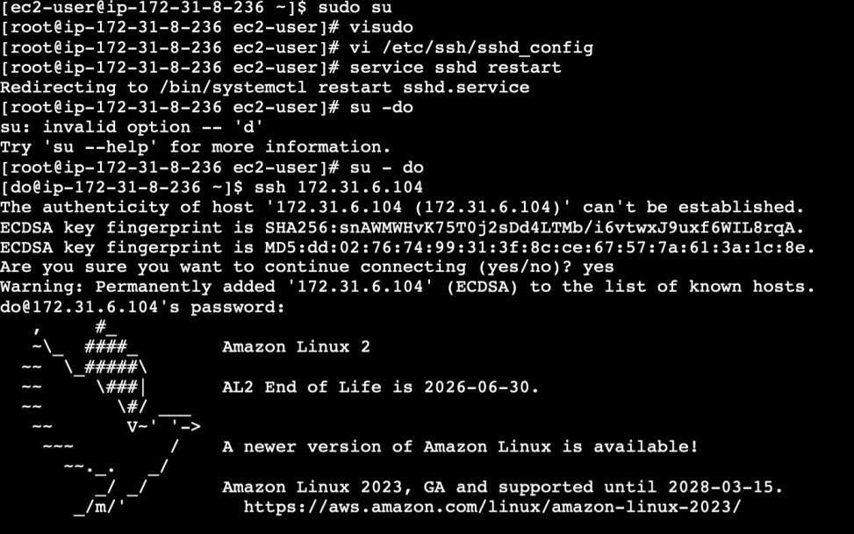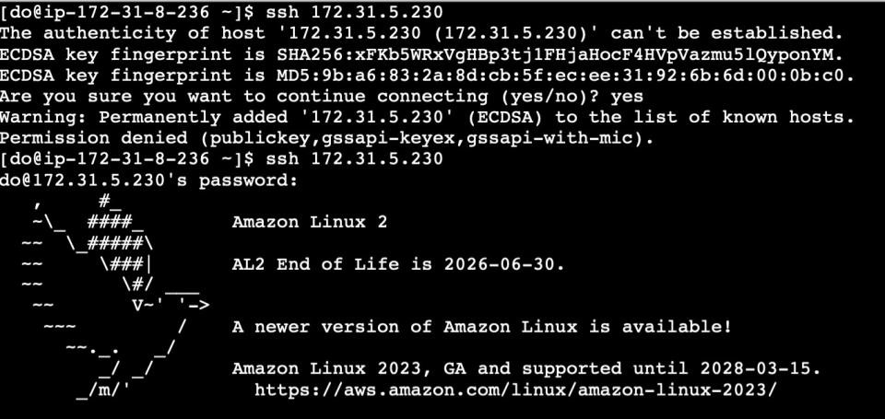

# Step 1: Generate SSH key pair on the main node

1. Use the following command to generate the SSH key on the Ansible server:

**ssh-keygen**

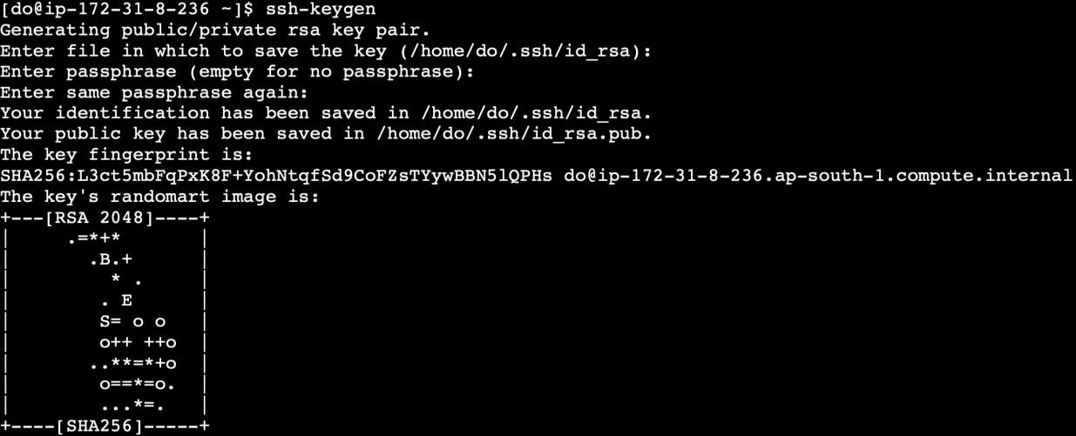

# Step 2: Copy the SSH key to the other two nodes

1. Use the following command to copy the public key to a file named **authorized_keys**

in localhost:

## cat .ssh/id_rsa.pub >> .ssh/authorized_keys

1. Run the following command to go to the **.ssh** directory of the Ansible server:

## cd .ssh

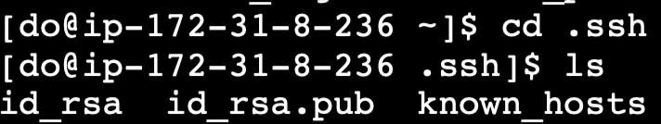

1. Run the following command to copy the public key to another node that will connect to the Ansible server:

## ssh-copy-id username@ip -p 22

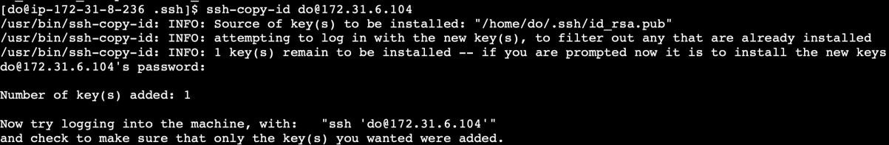

**Note**: You must use a **username@ip** with your node and IP username, which are provided in the lab credential.

1. Execute the following command to exit the **.ssh** directory of the Ansible server:

**cd**

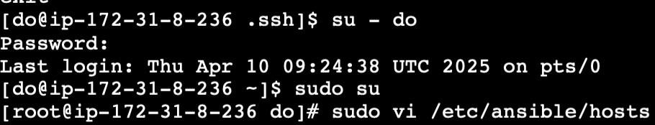

# Step 3: Update the inventory or host file with the host IP address

1. Use the following command to open the Ansible inventory file and add the host localhost to it:

## sudo vi /etc/ansible/hosts



1. When the file opens, add the three lines of code below to the end of the file:

**[dbbservers] localhost:22 172.31.5.76:22**

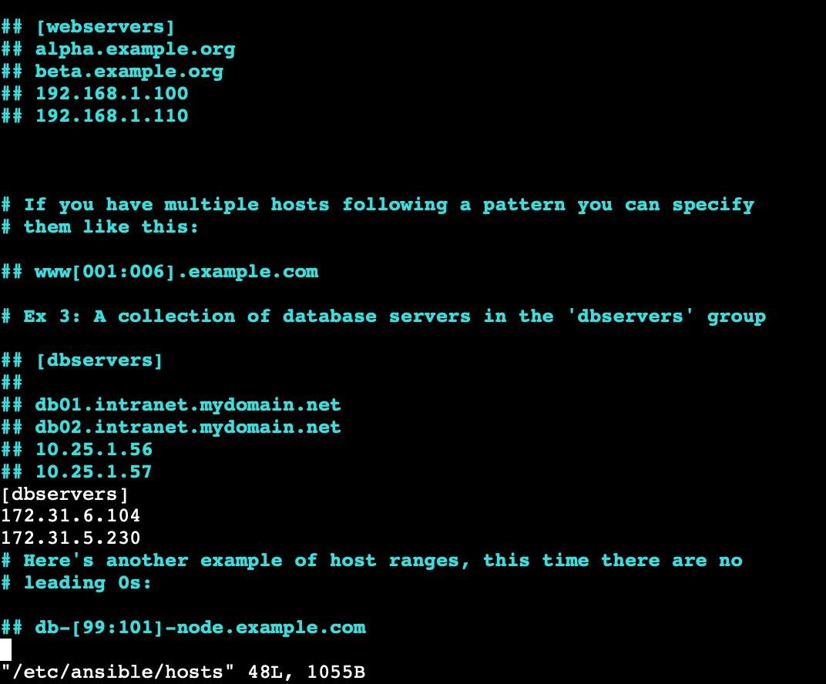

**Note:** Press **esc**, then write **:wq** and press **enter** to save the file.

# Step 4: Establish connectivity between the hosts specified in the host file and the Ansible server

1. Run the following command to copy the public key to another node that will connect to the Ansible server:

## ansible -m ping dbservers



1. Use the following command to check the number of hosts in the host file:

## ansible all --list-hosts

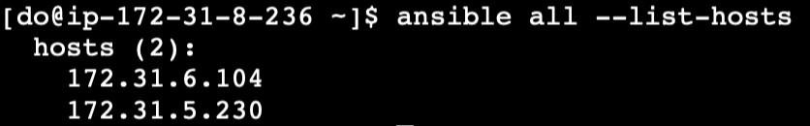

By following these steps, you have successfully created a static host inventory for managing and automating infrastructure tasks efficiently across multiple servers using Ansible.