Lab Exercise 04 Executing Ansible Modules  
By: Stuti Sehgal  
500107063  
R2142221190  
B2

**Objective:** To demonstrate the use of the Ansible module for server configuration and management

**Tools required:** Linux terminal

**Prerequisites:** None

Steps to be followed:

1. Use Ansible modules for server configuration

**Step 1: Use Ansible modules for server configuration**

1. Run the following command using the **setup** module to collect and display detailed system information about the servers:

# ansible -m setup dbservers

1. Run the following command using the **shell** module to retrieve server hostnames:

# ansible dbservers -m shell -a ‘hostname’

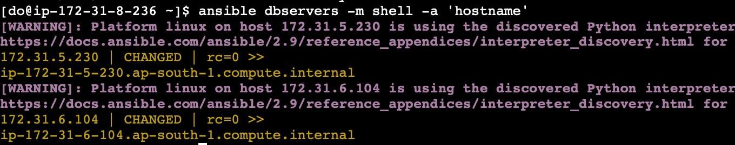

1. Run the following command using the **apt** module to install Git on servers:

**ansible dbservers -m yum -a 'name=git state=present' - -become**

