

System Provisioning and Configuration Management Lab

*Submitted To:*

**Submitted by:  
Vrinda Gupta  
500109760  
R2142221329  
Devops B2(NH)**

***Dr. Hitesh Kumar Sharma***

**EXPERIMENT 1**

**Lab Exercise: Creating Static Host Inventory**

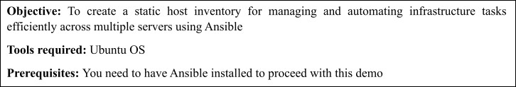

**Steps to be followed:**

1. Generate SSH key pair on the main node
2. Copy the SSH key to the two other nodes
3. Update the inventory or host file with the host IP address
4. Establish connectivity between the hosts specified in the host file and the Ansible server

**Step 1: Launch EC2 Instance**

1. Go to AWS Console → EC2 → Launch instance
2. OS: **Ubuntu 22.04** or similar
3. Instance type: **t2.micro** (Free Tier)
4. Enable **port 22 (SSH)** in Security Group

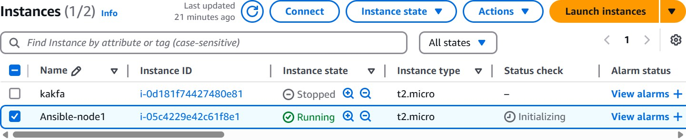

◻Install Ansible on EC2: Once you're logged into the instance: **sudo apt update**

**sudo apt install ansible -y**

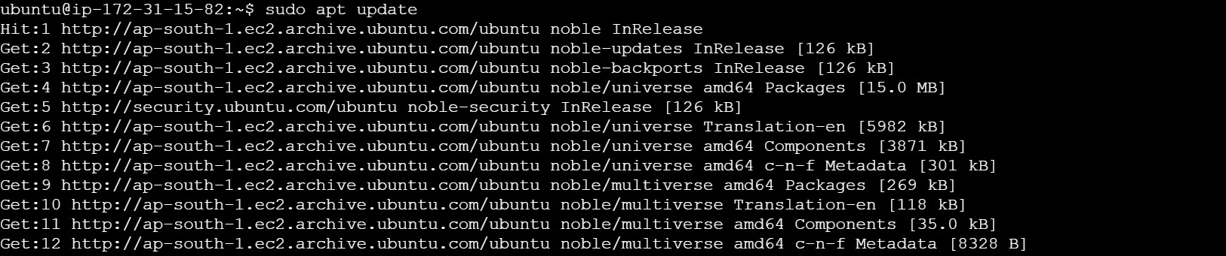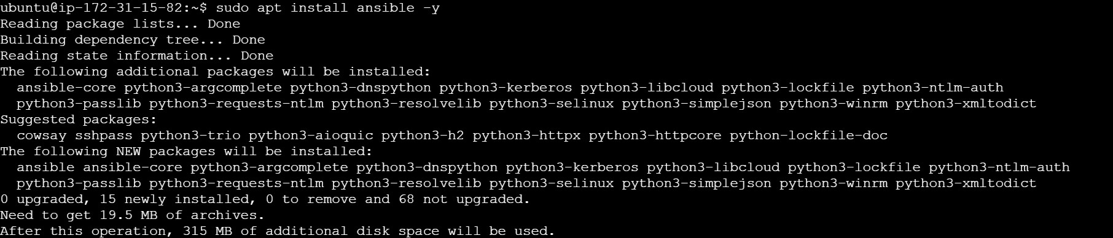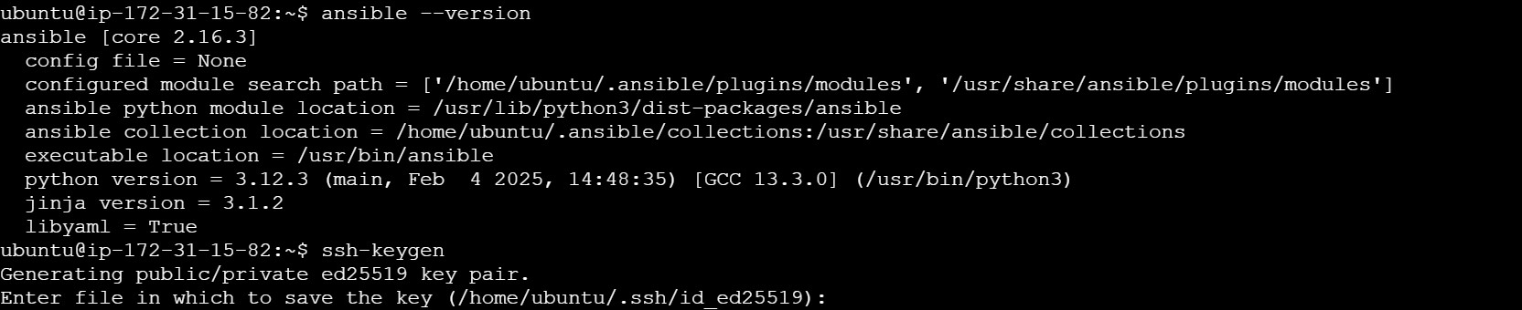

**Step 2: Generate SSH key pair on the main node**

* 1. Use the following command to generate the SSH key on the Ansible server: **ssh-keygen**

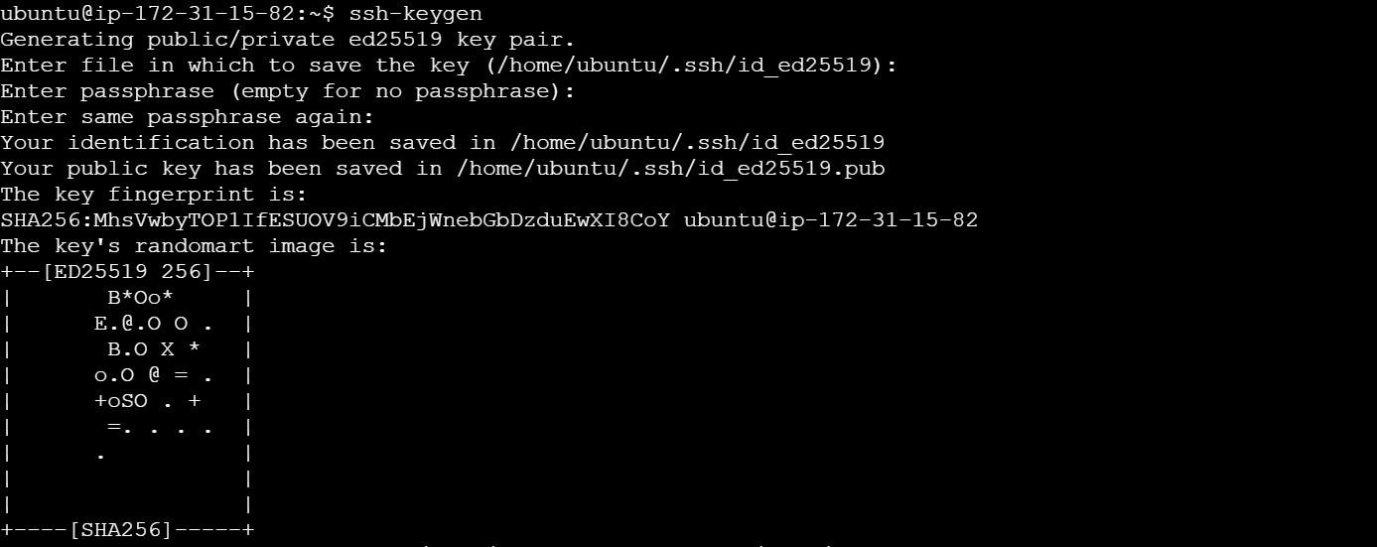

**Step 3: Copy the SSH key to the other two nodes**

* 1. Use the following command to copy the public key to a file named **authorized_keys** in localhost: **cat ~/.ssh/id_ed25519.pub >> ~/.ssh/authorized_keys**



* 1. Run the following command to go to the **.ssh** directory of the Ansible server: **cd .ssh**



* 1. Run the following command to copy the public key to another node that will connect to the Ansible server: **ssh-copy-id username@ip -p 22**

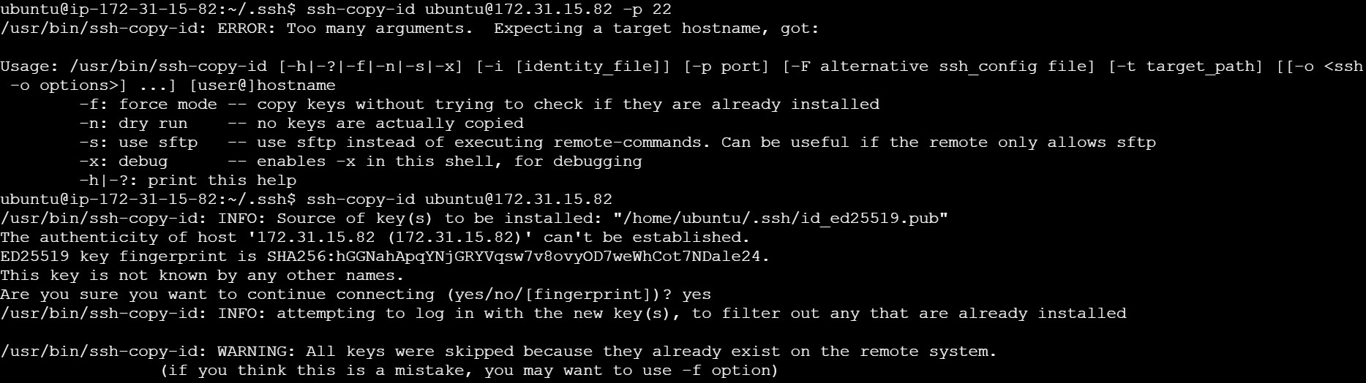

* 1. Execute the following command to exit the **.ssh** directory of the Ansible server: **cd**



**Step 4: Update the inventory or host file with the host IP address**

* 1. Use the following command to open the Ansible inventory file and add the host localhost to it: **sudo vi /etc/ansible/hosts**



* 1. When the file opens, add the three lines of code below to the end of the file:

**[dbbservers] localhost 65.0.183.70**

**172.31.15.82**

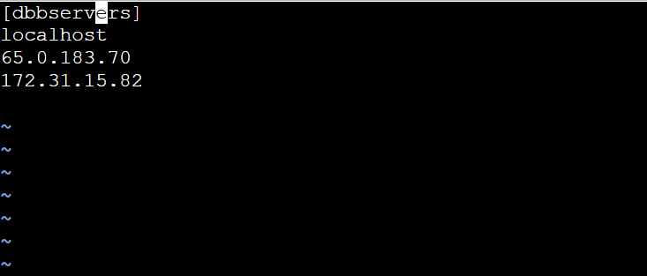

**Step 5: Establish connectivity between the hosts specified in the host file and the Ansible server**

* 1. Run the following command to copy the public key to another node that will connect to the Ansible server: **ansible -m ping dbbservers**

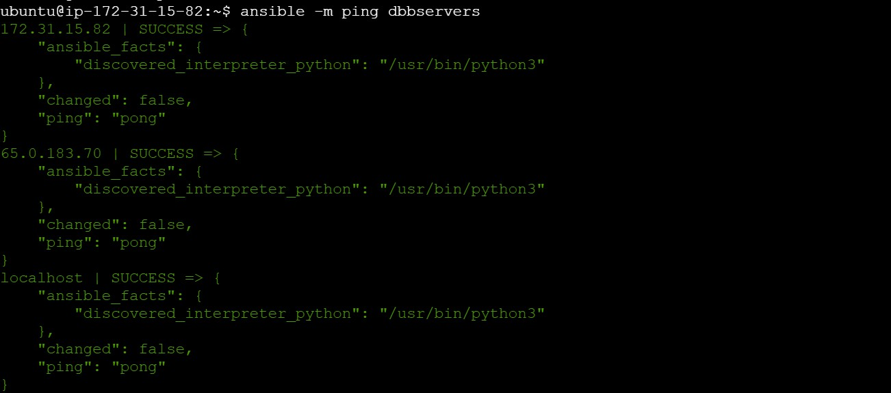

* 1. Use the following command to check the number of hosts in the host file: **ansible all**

**--list-hosts**

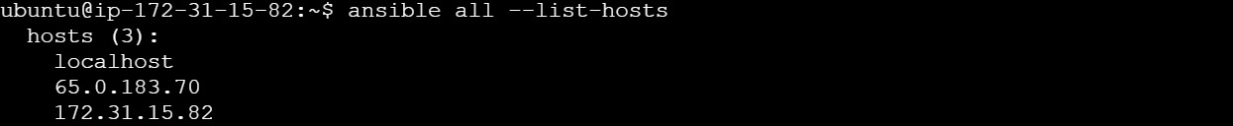

By following these steps, you have successfully created a static host inventory for managing and automating infrastructure tasks efficiently across multiple servers using Ansible.