EXPERIMENT -3.3

Aim:

To implement a class hierarchy in C++ where Person is the base class, and Student and Teacher are subclasses, showing inheritance and method overriding.

Code:

#include <iostream>

using namespace std;

// Base Class

class Person {

protected:

string name;

int age;

public:

Person(string n, int a) {

name = n;

age = a;

}

void display() {

cout << "Name: " << name << ", Age: " << age << endl;

}

};

// Derived Class: Student

class Student : public Person {

string course;

public:

Student(string n, int a, string c) : Person(n, a) {

course = c;

}

void display() {

cout << "Student -> Name: " << name << ", Age: " << age

<< ", Course: " << course << endl;

}

};

// Derived Class: Teacher

class Teacher : public Person {

string subject;

public:

Teacher(string n, int a, string s) : Person(n, a) {

subject = s;

}

void display() {

cout << "Teacher -> Name: " << name << ", Age: " << age

<< ", Subject: " << subject << endl;

}

};

// Main Function

int main() {

Student s1("Rahul", 20, "Computer Science");

Teacher t1("Meera", 35, "Mathematics");

s1.display();

t1.display();

return 0;

}

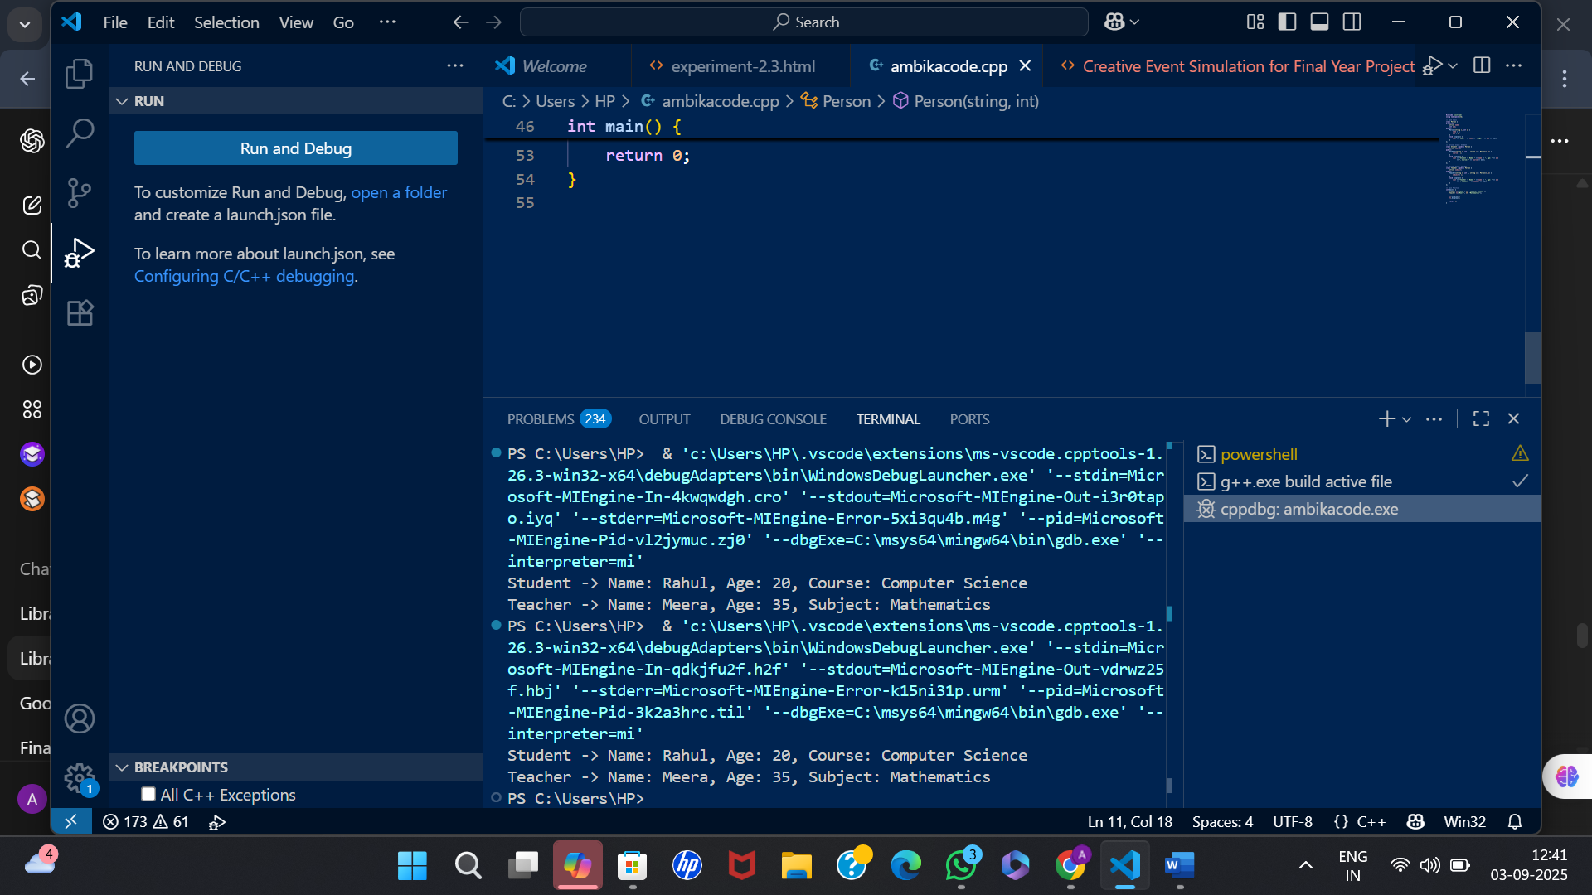OUTPUT: