LAB 2

- From your web browser visit https://netacad.com/. And goto login.


- In the login page, click on sign up and select sign up with google and select your google account.


- Then select your country and enter your birth year and month and again enter your full name.


- Agree to the terms and conditions and continue
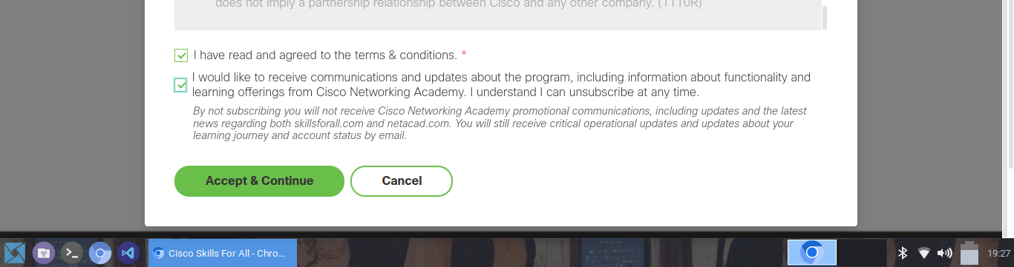

- You will be redirected to a home page. Select the Resources and click on Download Packet Tracer.
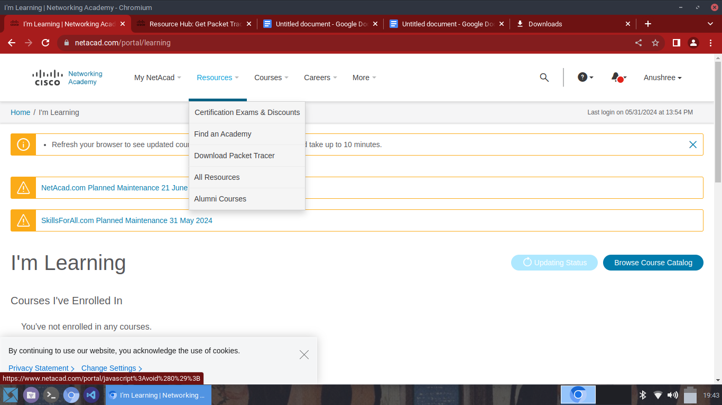

- Scroll down until you see the download links and click the link suitable for your operating system. I am using debian so I selected Ubuntu.
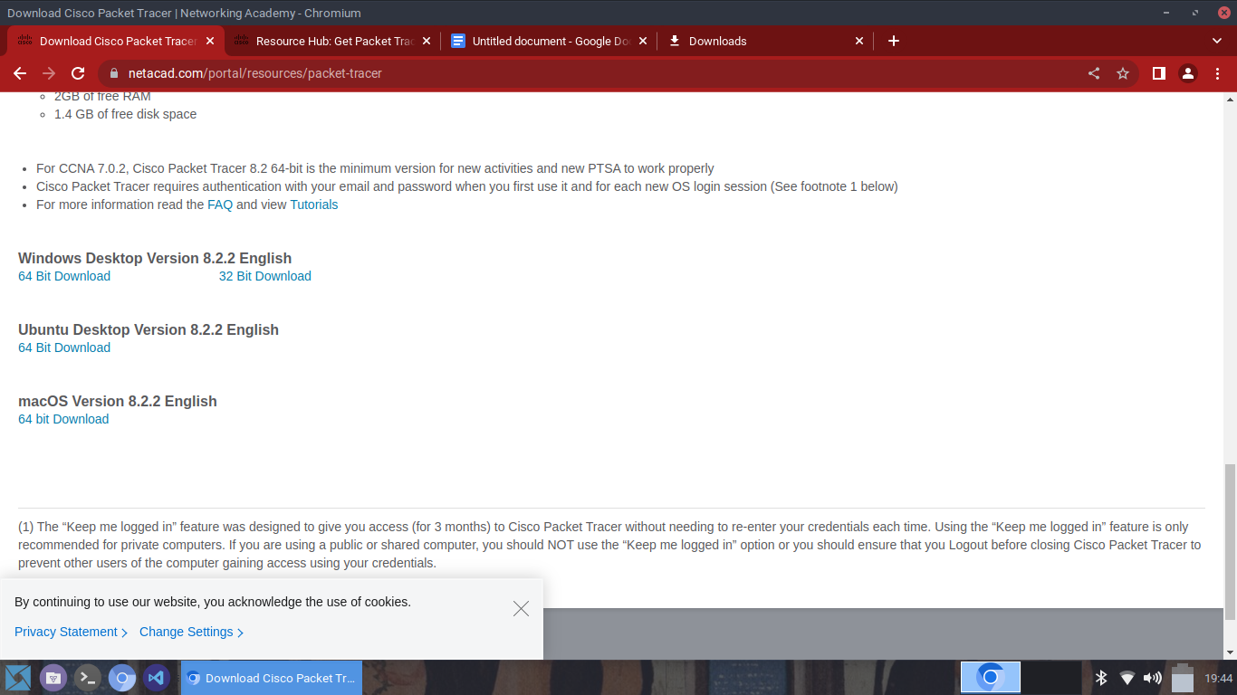

- Once it has completed downloading, open the terminal and navigate to the Downloads directory.
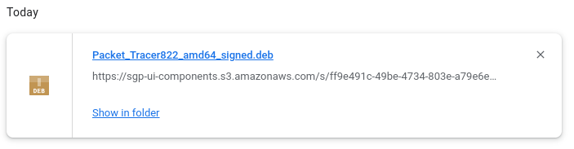
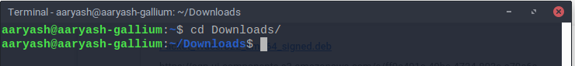

- Now install the .deb package with the following command.
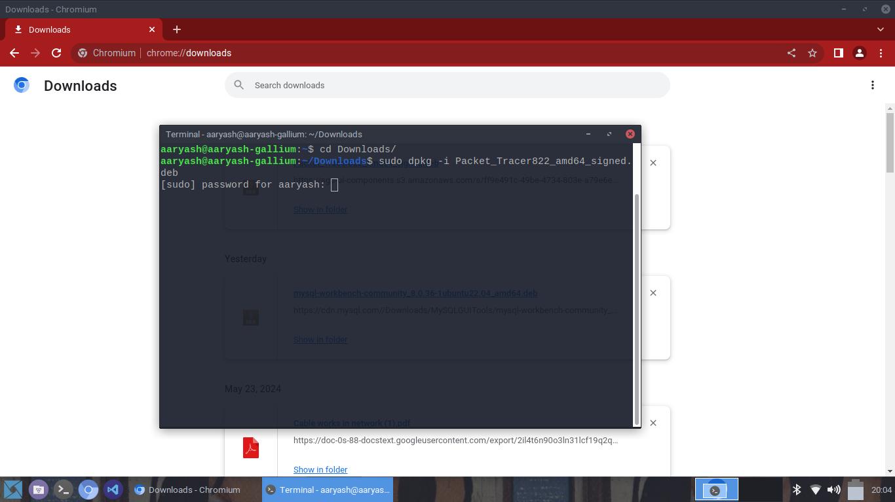

- Agree to the license agreements
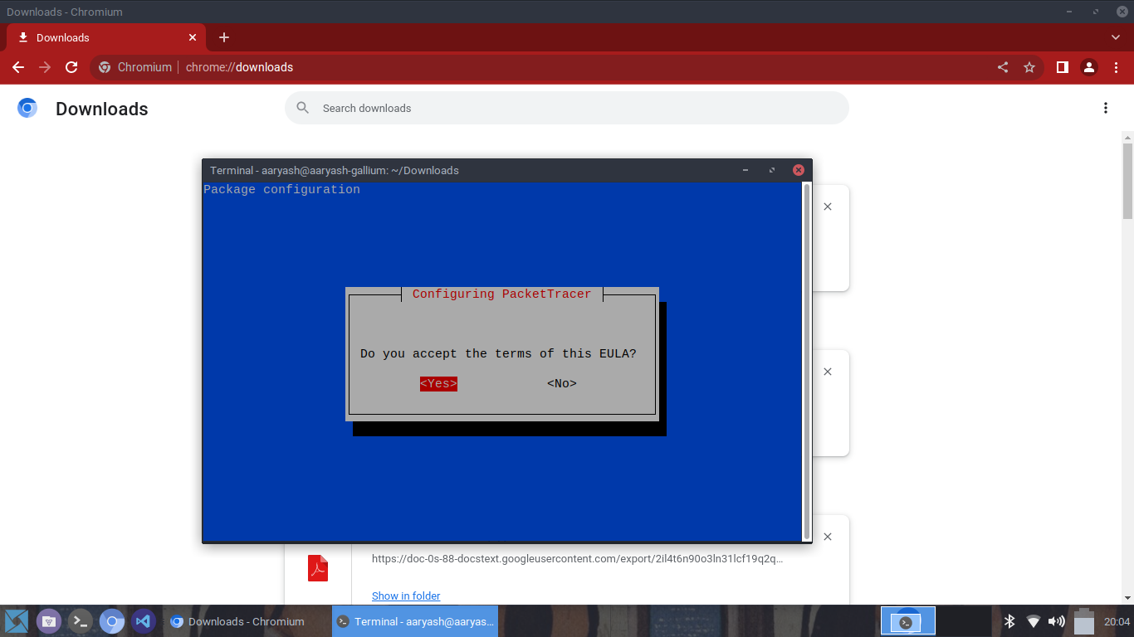

- If you face any error due to missing dependencies then fix it as follows
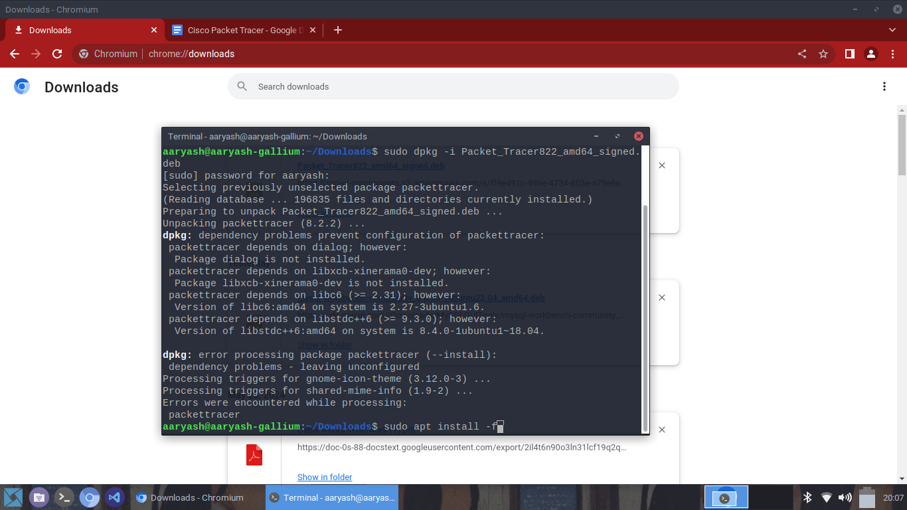

- After the dependencies are installed, reinstall the package.
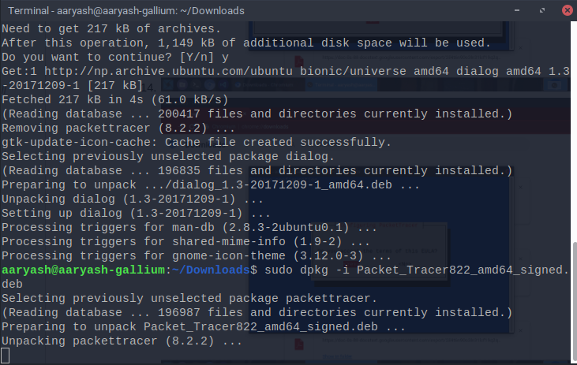

- After successful installation, enter packettracer to open packet tracer.
