This is the link to the docker hub: https://hub.docker.com/repository/docker/aarzoo183/dockerexercise/general

Step 0: Docker and Docker Compose installed, MongoDB image pulled, project files verified in Archive directory
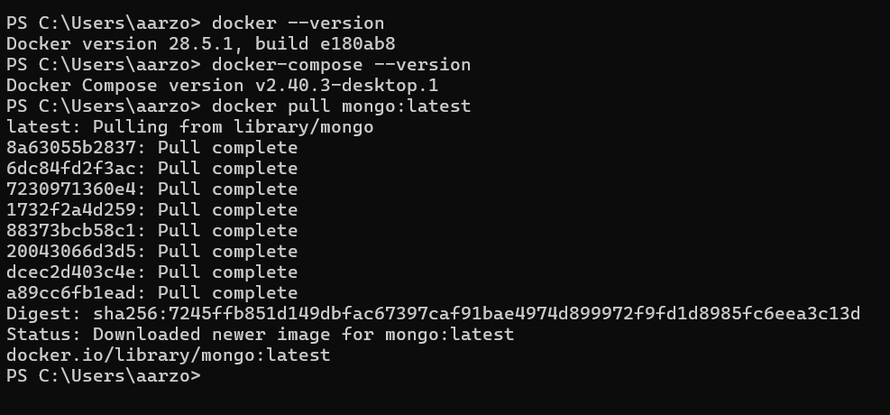
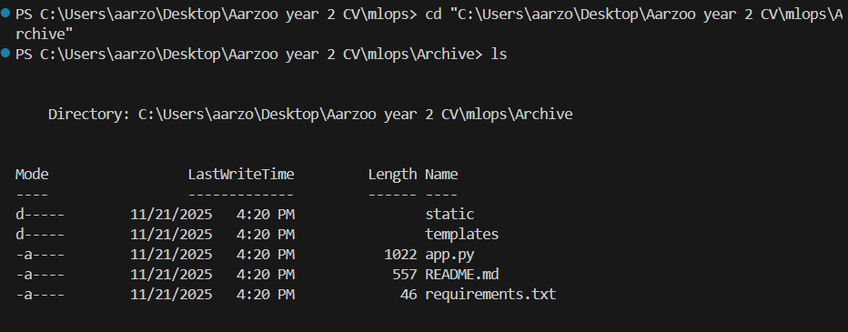
Exercise 1: Dockerize the Flask App
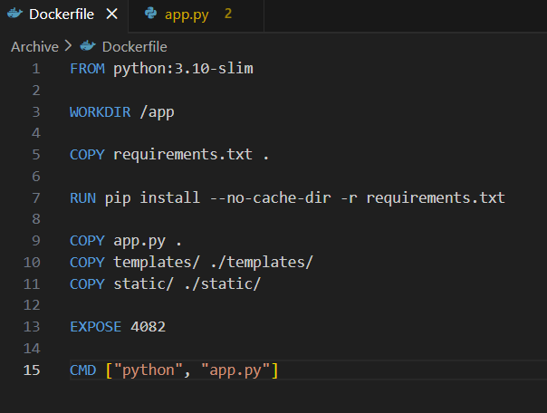
Dockerfile created with Python base image, exposes port 4082, and runs Flask application.
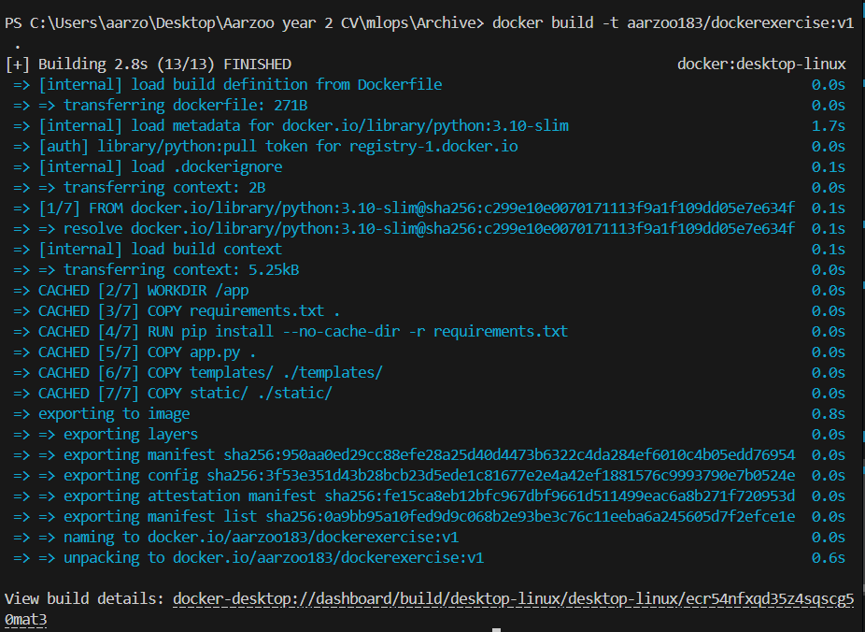
The Docker image was built successfully! All the layers completed without errors, and the aarzoo183/dockerexercise:v1 image is now ready to run.
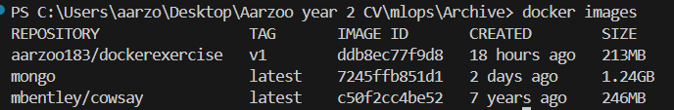
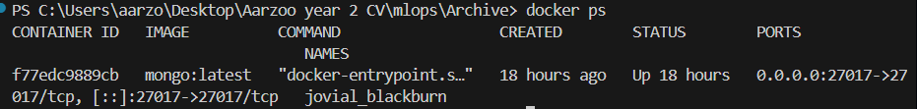
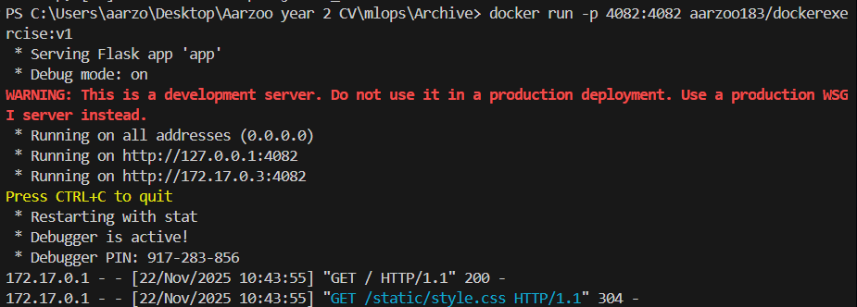
The Docker image is listed, MongoDB is running, and the Flask app started successfully on port 4082.

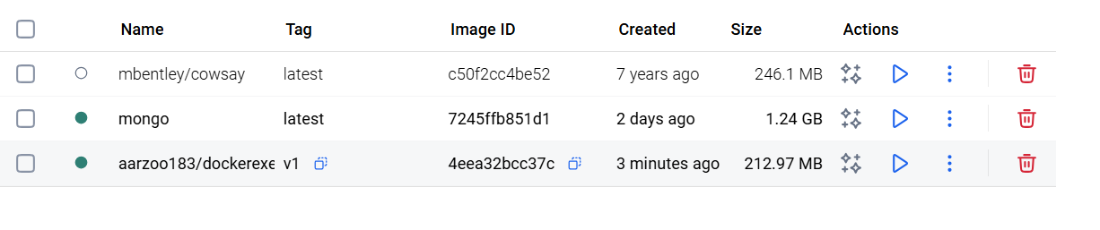
image is now available in Docker Desktop alongside MongoDB and other images.
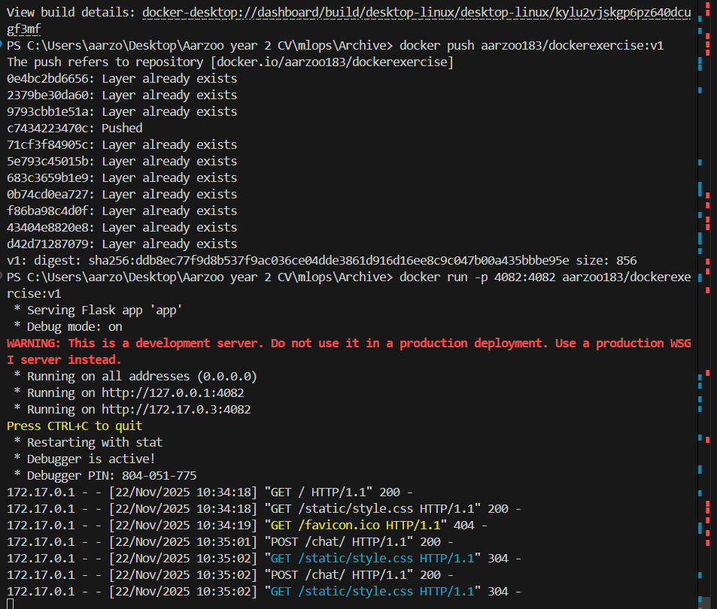
The Flask app is running smoothly and responding to web requests after being successfully pushed to Docker Hub.
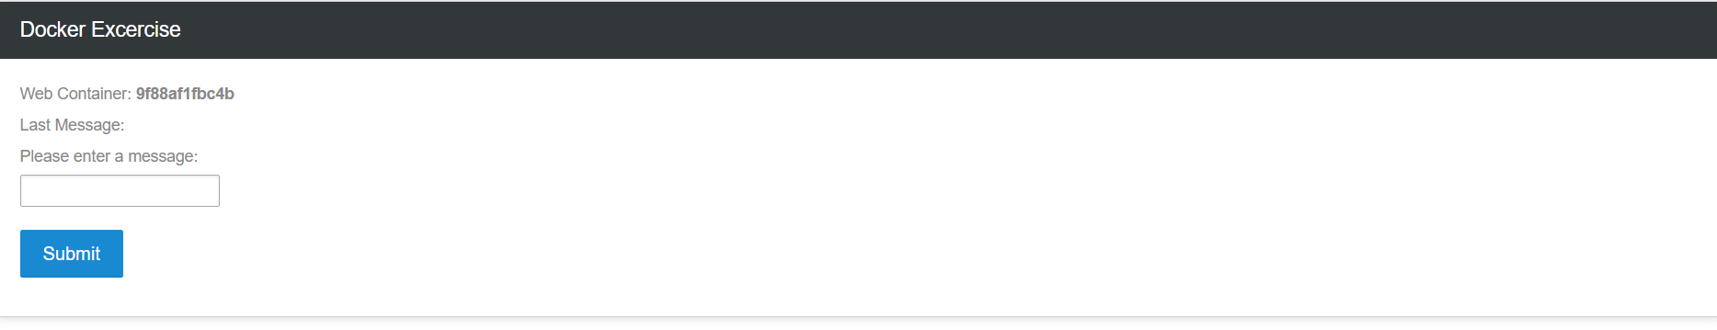
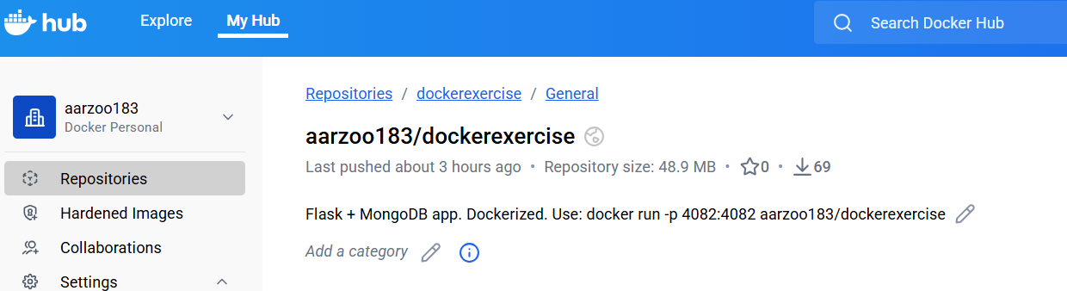
The Docker image is now live on Docker Hub with a clear description.
Exercise 2:
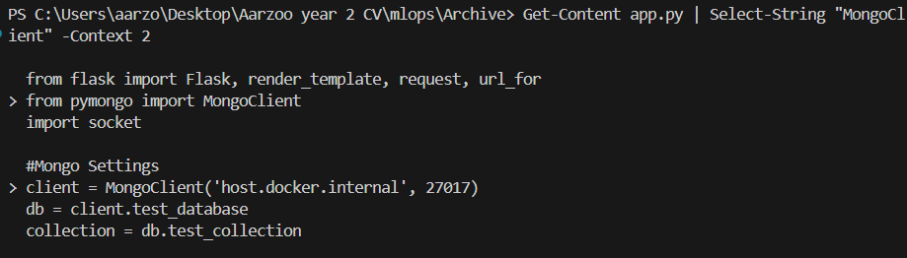
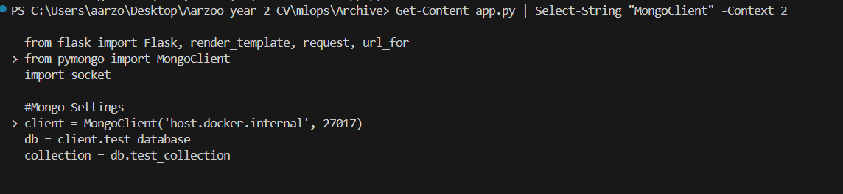
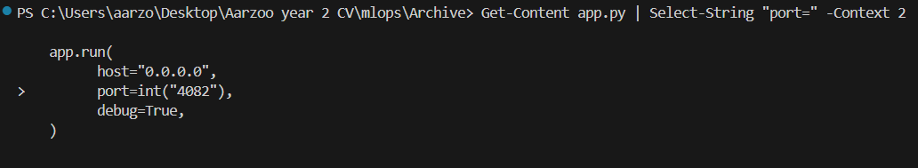
This screenshots shows the process of modifying the app.py file to change the MongoDB connection from 'host.docker.internal' to 'db' for Docker Compose compatibility.
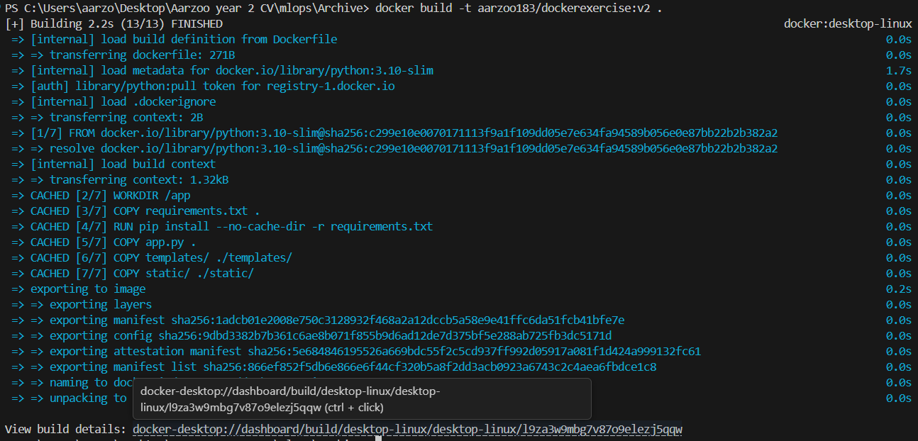
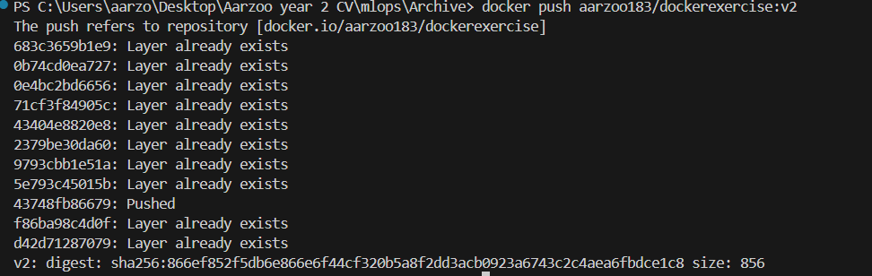
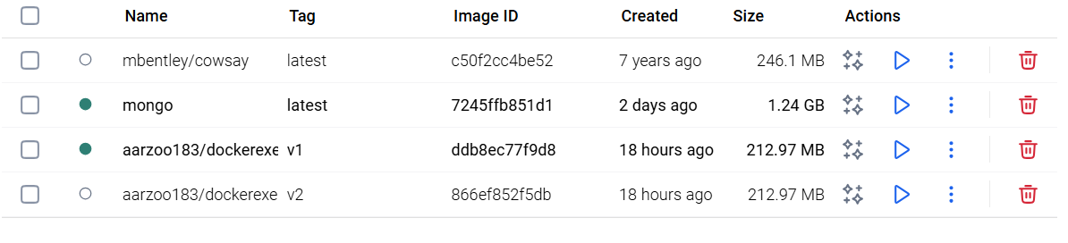
The screenshot captures the complete process of building the version 2 Docker image and uploading it to Docker Hub. First, the system builds the new image then pushes all the components to the repository. Finally, the last screenshot both the v1 and v2 images successfully stored in Docker Desktop, ready for deployment with Docker Compose.
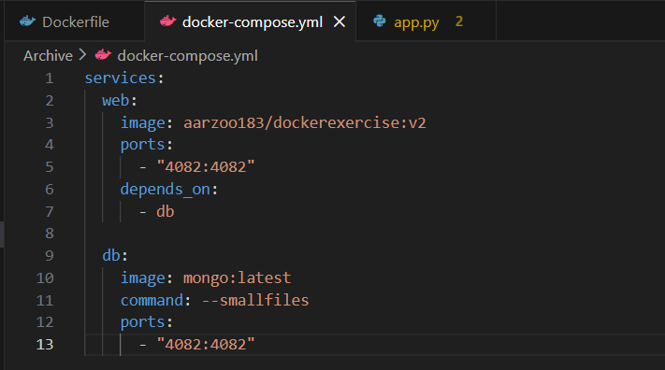
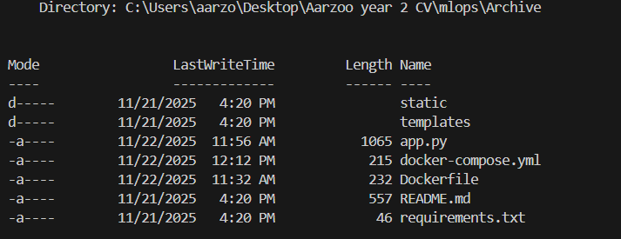
This screenshot shows the docker-compose.yml file configuration and project directory structure. The compose file defines two services - the Flask app using the v2 image on port 4082, and MongoDB with port settings. All project files are present in the Archive directory, and the system is stops to run the containers to prepare for Docker Compose deployment.
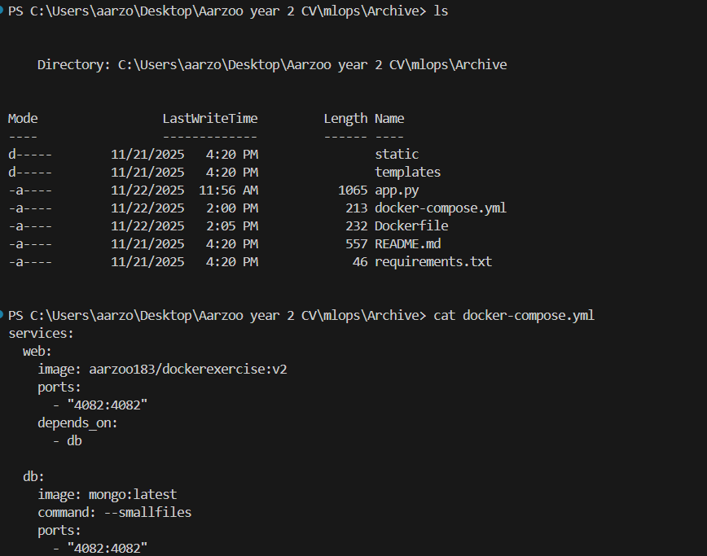
The Archive folder now contains all the essential project files, and the docker-compose.yml is set up to run both the Flask app and MongoDB together.
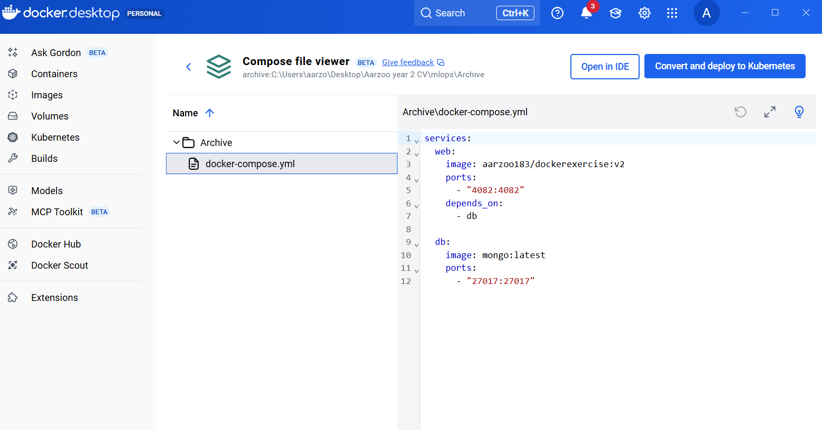
The docker-compose.yml file is now correctly configured in Docker Desktop, showing both the Flask app on port 4082 and MongoDB on port 27017.

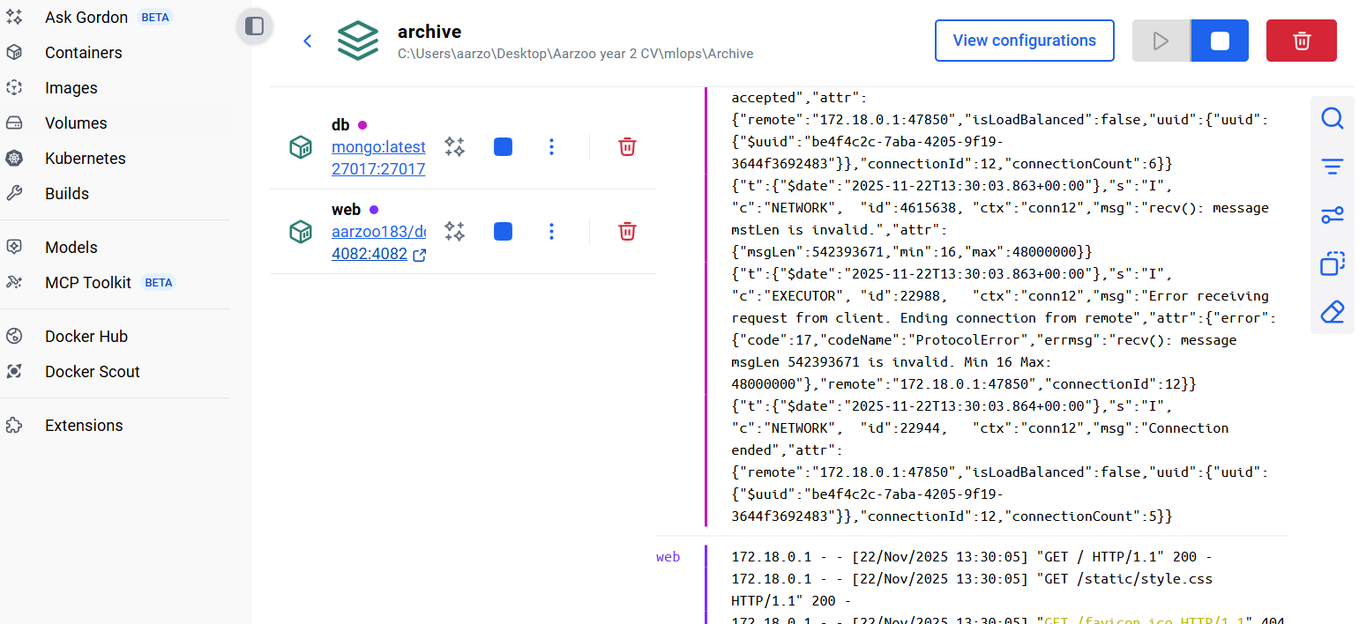
I could now go to the portal directly after clicking on the web link on the docker desktop.
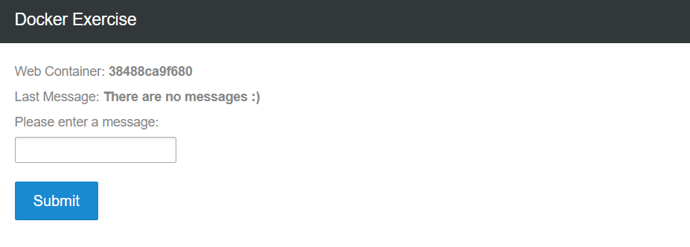
The web link opens to this.

