Amazon.com, Inc

Software Requirements Specification

For Online Shopping

Version 1.0

Revision History

|  |  |  |  |
| --- | --- | --- | --- |
| **Date** | **Version** | **Description** | **Author** |
| 10/18/18 | 1.0 | Initial document | Sepribo Taylor-Harry |
|  |  |  |  |
|  |  |  |  |
|  |  |  |  |

Table of Contents

1. Introduction 4

1.1 Purpose 4

1.2 Scope 4

1.3 Definitions, Acronyms and Abbreviations 4

1.4 References 5

1.5 Overview 5

2. Overall Description 5

2.1 Use-Case Model Survey 5

2.2 Assumptions and Dependencies 6

3. Specific Requirements 7

3.1 Use-Case Reports 7

3.2 Supplementary Requirements 12

4. Supporting Information 13

Software Requirements Specification

# Introduction

Technology giant Amazon.com is considered the largest online retailer in the world mainly measured by revenue and market capital. With separate retail websites spread across different continents such as; Americas, Europe, Asian and Australia. The tech giant is looking to simplify its online shopping system to make it user friendly and very easy to use for everyone.

Amazon.com, Inc. has contracted with Staylor LLC to create a user-friendly online shopping system. Staylor LLC specializes in front and backend web and UX design, with a proven track record for delivering creative world class websites, something very important to Amazon.com.

This document is the Software Requirement Specification (SRS) for the online shopping system. It will outline all of the agreed upon features of the online shopping system.

## Purpose

The purpose of the Software Requirement Specification is to provide a clear, documented model of the requirements for the online shopping system, that will provide top level use cases for a web customer making purchases online. This will be used by Staylor LLC to design the application and deliver it to Amazon.com by end of Fall 2018.

The web design will implement several Use Cases, which are shown in Section 3. The Use Case inventory is as follows:

1. Login
2. Search item
3. Browse item
4. View and Select item
5. Buy item now
6. Add to shopping cart
7. View shopping cart
8. Proceed to checkout
9. Enter method of delivery
10. Make payment
11. Review and order item

## Scope

The application to be created is an online shopping system. It will perform basic functions that will allow the Web customer actor uses some web site to make purchases online. Top level use cases are View Items, Make Purchase and Client Register.

Web Customer actor uses the Amazon web site to make purchases online. Top level use cases are View Items, Make Purchase and Client Register. View Items use case could be used by customer as top-level use case if customer only wants to find and see some products. This use case could also be used as a part of Make Purchase use case. Client Register use case allows customer to register on the web site, for example to get some coupons or be invited to private sales. Note, that Checkout use case is included use case not available by itself - checkout is part of making purchase.

## Definitions, Acronyms and Abbreviations

Definitions, Acronyms and Abbreviations (Glossary):

There are a variety of terms used in this Software Requirement Specification relating to the feature being designed. Most of the terms are self-explanatory and are common to online shopping. However, for completeness, all terms related to the feature are provided.

* Website – A address that is connected to the internet to provide one or more web pages or other content.
* Online – Connected to a computer network or accessible by computer
* Browse – Reading superficially or at random
* Search – The activity of looking thoroughly in order to find something
* Shopping cart – A handcart that holds items (groceries or other goods) while shopping.
* Checkout – Confirm and pay goods (or services) using a payment facility

**Risk Analysis:**

There are a several risk factors to consider when developing this feature. As mentioned earlier, it is important that the feature be completed by the Fall of 2018. This is the key window to allow Amazon.com, Inc. to prepare for holiday shopping season. To address this risk, Staylor LLC is attempting to complete the feature by mid-Fall. This will provide extra time if any major issue arise that may slow down the project.

A secondary risk to this software project is requirement change. Amazon.com, Inc. could post modifications to the initial requirements that might inauspiciously affect this project. Staylor LLC will attempt to create a very flexible software design that will allow changes to the application quickly and easily.

## References

1. Michael, B. (2006) SRS Use Case Examples.pdf Retrieved from <https://learn.umuc.edu/d2l/le/content/333090/viewContent/12628156/View>
2. Online Shopping - UML Use Case Diagram Example. (n.d) Retrieved from <https://www.uml-diagrams.org/examples/online-shopping-use-case-diagram-example.html>
3. Online Shopping System (Use Case Diagram (UML)) (2016) Retrieved from <https://creately.com/diagram/example/iarnweil1/Online%20Shopping%20System%20>

## Overview

The following Software Requirement Specification is broken down into two major sections: Overall Description and Specific Requirements. The Overall Description describes the requirements at a high level, while the Specific Requirements describe all of the relevant requirements of the system.

# Overall Description

The online shopping system allows the actor (web customer) to use the Amazon website to make purchases online. The top-level features are to allow the actor to browse the website as a guest user or log in as a registered user. The browse and search items can be used by customer as primary feature use case if the customer only wants to find and see some products. The search and browse Items use case is extended by several optional use cases - customer may search for items, browse catalog, view and select these items, add them to shopping cart and view the shopping cart. All these use cases are extending use cases because they provide some optional functions allowing customer to find item.

The second set of features allows the actor to make purchase. The make purchase use case requires the customer to either use the buy item now option with one click payment authentication and verification (available only to registered users) to place the order or go through the checkout use case. In the checkout use case, customer provide the shipping address, and then specific the method of payment which can be done either by using credit card or with bank account. After providing the payment method, customer will review and order item.

## Use-Case Model Survey

There are 11 Use Cases that make up the requirements for this system. The detailed Use

Cases are in section 3.

|  |  |
| --- | --- |
| **Use case** | **Description** |
| Login | Login as registered user to the website |
| Search items | Could be used if only customer wants to find products. |
| Browse items | Could be used if only customer wants to browse item catalog. |
| View and Select item | Used to find and select product to purchase |
| Buy item now | Quick way for registered users to easily order an item |
| Add to shopping cart | Add a selected item to the shopping cart |
| View shopping cart | View item(s) in shopping cart |
| Proceed to checkout | Select this option to get to the payment and checkout use case |
| Enter method of delivery | Used by customer to specify where item will be delivered |
| Make payment | Make payment for the item in the shopping cart |
| Review and order item | Review and order item in the shopping |

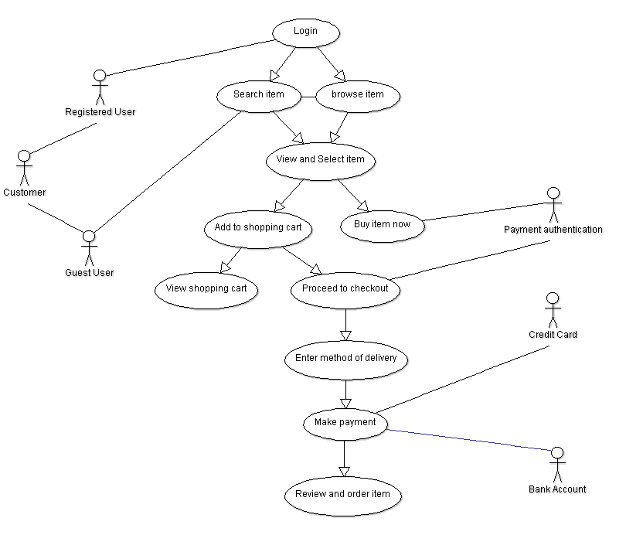

Figure 1: Amazon.com Online Shopping System UML Diagram

## Assumptions and Dependencies

1. All items are bought as new.
2. The 1-Click ordering for the user has been configured.
3. The user is using a valid credit card to make payment.
4. Ship to address is the only delivery method.

# Specific Requirements

The Specific Requirements section will provide the Use Case Reports specifying the 11

Use Cases that make up this system. The Use Cases in the section contains both internal

and external pre and post conditions.

## Use-Case Reports

**Use Case Name: Login**

**Summary:** The login feature allows the actor of the software to use the website as a registered user.

**Preconditions:** create an account.

**Triggers:** Actor selects the sign in button.

**Basic course of events (Scenario):**

Internal Precondition: The sign in windows is displayed

|  |  |  |
| --- | --- | --- |
| **Actor** | **System** | **Screen** |
| 1. The actor selects to sign in |  |  |
|  | 1. The website email (phone for mobile account) and password |  |
| 1. Actor completes fields and select sign in |  |  |
|  | 1. The website validates actor as registered user |  |

Internal Post Condition:

1. Actor confirmed by system as registered user.

2. Customer can proceed to use website.

**Alternative paths:**

Actor search item and browse catalog as guest user.

Internal Precondition: None

|  |  |  |
| --- | --- | --- |
| **Actor** | **System** | **Screen** |
| 1. Actor search item and browse catalog as guest user. |  |  |

Internal Post Condition:

1. Customer can proceed to use website.

**Use Case Name: Search items**

**Summary:** The search items allows the actor of the software to find products on the website.

**Preconditions:** None.

**Triggers:** Actor clicks on the search box.

**Basic course of events (Scenario):**

Internal Precondition: None

|  |  |  |
| --- | --- | --- |
| **Actor** | **System** | **Screen** |
| 1. The actor type in keyword of the item |  |  |
|  | 1. The website display list of possible items related to keyword |  |
| 1. The actor clicks search icon |  |  |
|  | 1. The website returns selected results base on the keyword |  |

Internal Post Condition:

1. Customer view list of results to find the product

**Use Case Name: Browse items**

**Summary:** The search items allows the actor of the software to browse items in the catalog on the website.

**Preconditions:** None.

**Triggers:** Actor select the ‘category’ down arrow.

**Basic course of events (Scenario):**

Internal Precondition: A drop down arrow showing product category is shown

|  |  |  |
| --- | --- | --- |
| **Actor** | **System** | **Screen** |
| 1. The actor clicks the catalog list icon. |  |  |
|  | 1. The website displays catalog item by category |  |
| 1. Actor select a catalog from the list |  |  |
|  | 1. The website displays items in the selected category |  |

Internal Post Condition:

1. Customer view list of results to find the product

**Use Case Name: View and Select item**

**Summary:** The view and select item feature allows the actor to of the software find and select product he/she wants to purchase.

**Preconditions:** None.

**Triggers:** Actor select an item from the selected result.

**Basic course of events (Scenario):**

Internal Precondition: Website shows product details

|  |  |  |
| --- | --- | --- |
| **Actor** | **System** | **Screen** |
| 1. Actor view result list and select an item. |  |  |
|  | 1. Website shows item in detail |  |

Internal Post Condition:

1. Customer can either buy item now or add item to shopping cart.

**Use Case Name: Buy item now**

**Summary:** The buy item now feature allows the actor of the software quickly order item using 1-Clicking ordering.

**Preconditions:** Actor need to 'Turn on 1-Click ordering for this browser' to use the feature.

**Triggers:** Actor selects the ‘Buy Now’ button.

**Basic course of events (Scenario):**

Internal Precondition: The system authenticates user and process order

|  |  |  |
| --- | --- | --- |
| **Actor** | **System** | **Screen** |
| 1. Actor clicks on the ‘Buy Now’ button (only available to registered users) |  |  |
|  | 1. The system authenticates user and order product |  |

Internal Post Condition:

1. The system confirms the order has been placed.

**Use Case Name: Add to shopping cart**

**Summary:** The add to shopping cart feature allows the actor of the software to create a new album in

the album library.

**Preconditions:** None.

**Triggers:** Actor clicks the ‘Add to Cart’ button.

**Basic course of events (Scenario):**

Internal Precondition: None

|  |  |  |
| --- | --- | --- |
| **Actor** | **System** | **Screen** |
| 1. Actor clicks the ‘Add to Cart’ button |  |  |
|  | 1. The system adds item to cart |  |

Internal Post Condition: Item becomes available for checkout

**Use Case Name: View shopping cart**

**Summary:** The view shopping cart feature allows the actor of the software to view list of items in the shopping cart.

**Preconditions:** None.

**Triggers:** Actor clicks the ‘edit your cart’ button.

**Basic course of events (Scenario):**

Internal Precondition: None

|  |  |  |
| --- | --- | --- |
| **Actor** | **System** | **Screen** |
| 1. Actor click ‘edit your cart’ button after adding item to cart |  |  |
|  | 1. The system displays list of items in the shopping cart |  |

Internal Post Condition: Actor reviews item in shopping cart

**Alternative paths:**

Actor click the cart icon on the top right of the screen to view shopping cart.

Internal Precondition: None

|  |  |  |
| --- | --- | --- |
| **Actor** | **System** | **Screen** |
| 1. Actor click the cart icon on the top right of the screen |  |  |
|  | 1. The system displays list of items in the shopping cart |  |

Internal Post Condition:

1. Actor reviews item in shopping cart.

**Use Case Name: Proceed to checkout**

**Summary:** The proceed to checkout feature allows the actor of the software to make payment and complete order.

**Preconditions:** None.

**Triggers:** Actor click the proceed to checkout button.

**Basic course of events (Scenario):**

Internal Precondition: None

|  |  |  |
| --- | --- | --- |
| **Actor** | **System** | **Screen** |
| 1. Actor click the proceed to checkout button |  |  |
|  | 1. The system displays the checkout window with summary of the order, payment and delivery method |  |

Internal Post Condition: Actor is ready to checkout item.

**Use Case Name: Enter method of delivery**

**Summary:** The enter method of delivery feature allows the actor of the software to specify where and how the item will be delivered.

**Preconditions:** None.

**Triggers:** Actor clicks on shipping address or the link ‘change’.

**Basic course of events (Scenario):**

Internal Precondition: None

|  |  |  |
| --- | --- | --- |
| **Actor** | **System** | **Screen** |
| 1. Actor clicks the shipping address or the link ‘change’ |  |  |
|  | 1. The system shows list of recently used address or an option to add a new address |  |
| 1. Actor select desired shipping address from list, or add a new address |  |  |

Internal Post Condition: Actor successfully specify method of delivery

**Use Case Name: Make payment**

**Summary:** The make payment feature allows the actor of the software to pay for item in the shopping cart.

**Preconditions:** None.

**Triggers:** Actor triggers the create album event.

**Basic course of events (Scenario):**

Internal Precondition: None

|  |  |  |
| --- | --- | --- |
| **Actor** | **System** | **Screen** |
| 1. Actor clicks the payment method or the link change’ |  |  |
|  | 1. The system shows list of credit/debit cards or an option to add a credit or debit card. |  |
|  | 1. The system shows other payment methods (actors) such as bank account, gift card and promotion code |  |
| 1. Actor select desired payment method from several options. |  |  |

Internal Post Condition: None

**Use Case Name: Review and order item**

**Summary:** The review and order item feature allow the actor of the software to complete the order.

**Preconditions:** None.

**Triggers:** Actor clicks the ‘place your order’ button.

**Basic course of events (Scenario):**

Internal Precondition: None

|  |  |  |
| --- | --- | --- |
| **Actor** | **System** | **Screen** |
| 1. Actor clicks the ‘place your order’ button |  |  |
|  | 1. The system orders the item. |  |

Internal Post Condition: Actor successfully ordered an item from the Amazon.com website

## Supplementary Requirements

There are a couple of non-functional requirements that are associated with this software

system. The website shall run on all browsers. The website shall support screen reader software for disabled people and follow 508 standards.

# Supporting Information

None.