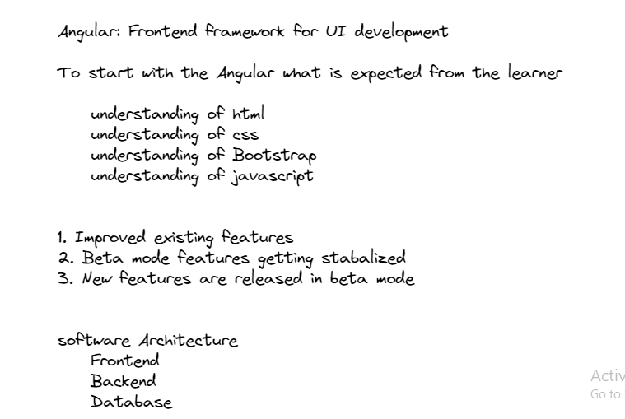

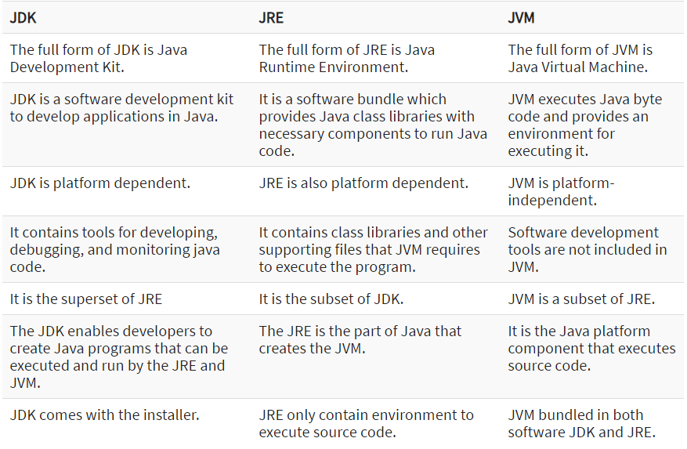

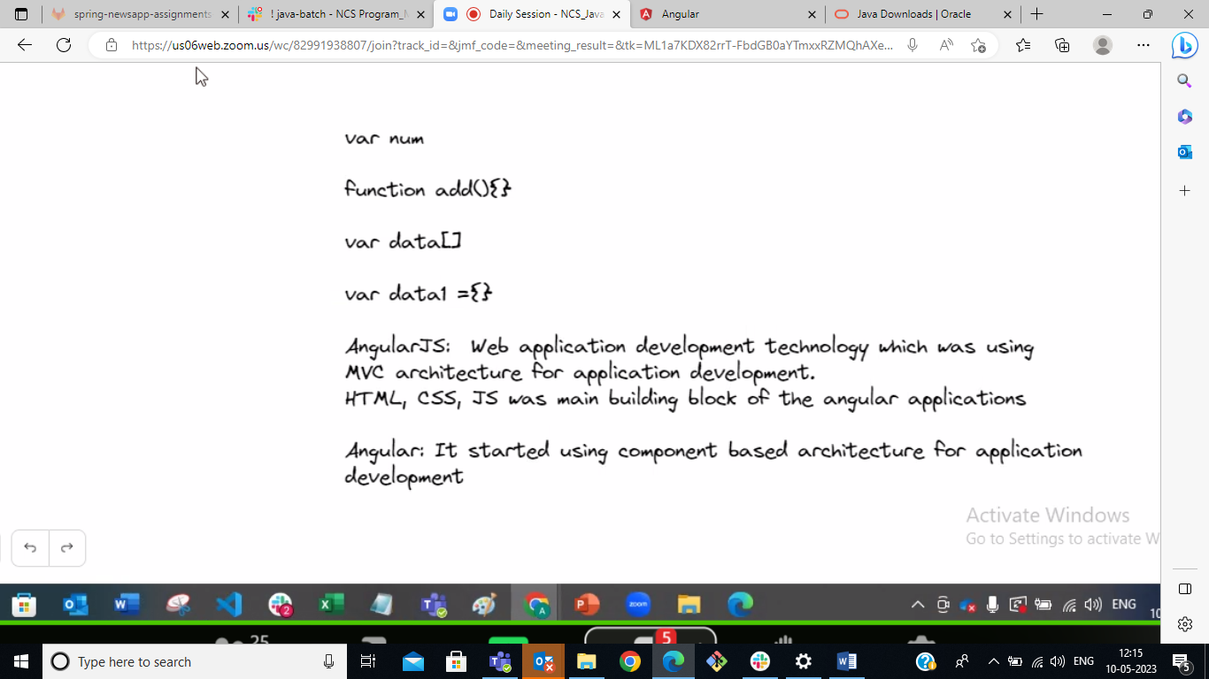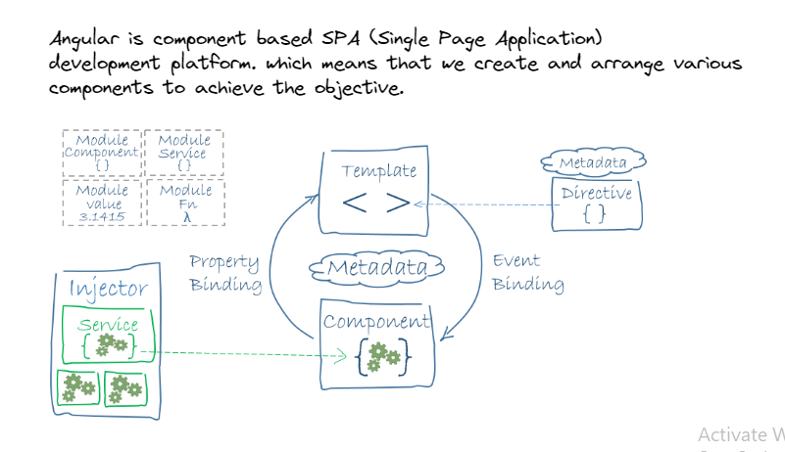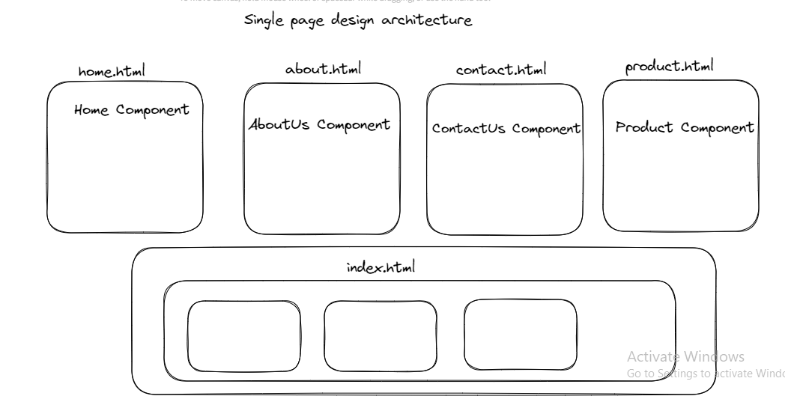

In html :

Selector name <app-root>

In Class : class name

Annotations🡪Decorators :it is give detailed info

Creating modeule: ng g m module_name

Creating component:

ng g c (name of component)student

4 file created and 1 file update

Replace in bootstrap

Change in html

Data binding:

Title variable change

{{}}🡪interpolation🡪one way data binding

Property binding:

[]

Event binding :

()

Every object 3 core phases:

Initialize

Service and destroy

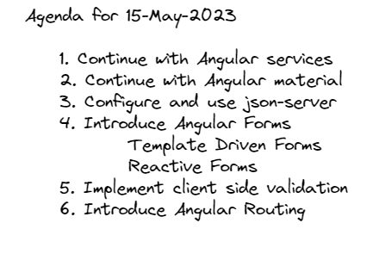

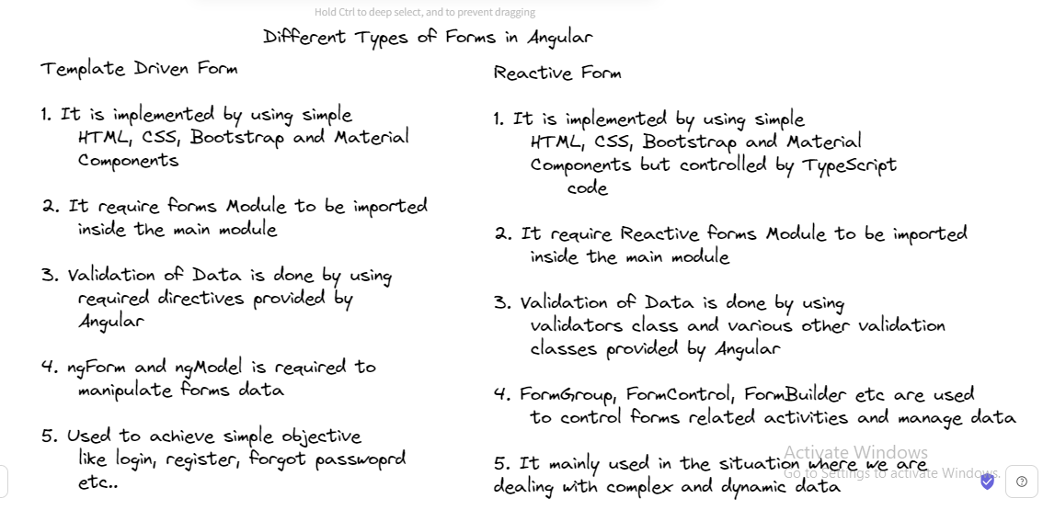

Input control reference :#upassnmae=ngModel

Steps:

HTML

 BrowserModule,

    MatToolbarModule,

    MatIconModule,

    MatSidenavModule,

    MatListModule,

    MatButtonModule,

    BrowserAnimationsModule,

    MatExpansionModule,

    MatFormFieldModule,

    ReactiveFormsModule ,

    FormsModule,

    HttpClientModule,

    MatInputModule,

    MatAutocompleteModule,

Cypress is JS library for e2e testing

