Resume

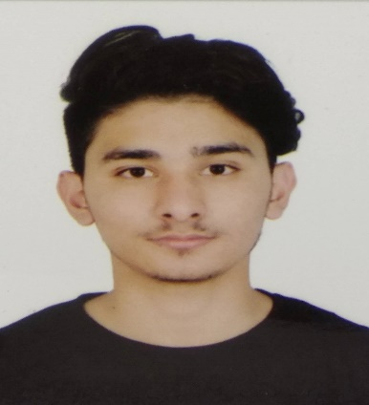

RAWAL AASHISH

E-mail: [Rawalaashish20@gmail.com](mailto:Rawalaashish20@gmail.com)

Mobile: +977-98465626110

**Career Objectives**

Seeking a challenging opportunity where I will be able to utilize my educational background, an ability to work well with people, which will allow me to grow personally and professionally.

**Personal Details**

Name : Aashish Rawal

Father’s Name : Tilak Rawal

Date of Birth : 05/04/1997

Permanent Address : Oligaun-9, Achham, Nepal

Contact Number : +977-9865626110

E-mail : [Rawalaashish20@gmail.com](mailto:Rawalaashish20@gmail.com)

Languages know : English, Hindi, and Nepali

Hobbies : traveling, coding and trying to discover new ideas to use in websites.

**Training**

**Shubutech Company, Chahabel**

Intern **4Th Feb- 3rd April**

Learning about the laravel framework.

**Skills**

* Laravel
* Core Php
* Java
* JavaScript

**Educational Background**

**Disciplinary Profile:** Bachelor in Information Technology (BIT)

**College:** Nepal Mega College (NMC)

**School:** VS Niketan School

**College:** Softwarica college of IT and E-commerce

|  |  |  |  |  |  |
| --- | --- | --- | --- | --- | --- |
| **S.no** | **Board** | **Main Subject/Stream** | **College** | **Year** | **Per (%)** |
| 1 | SLC | General | VS Niketan | 2014 | 69.57% |
| 2 | HSEB | Commerce | NMC | 2016 | 65.55% |
| 3 | NCC Exam | BIT | Softwarica college | 4th Sem Running | Running |