Testing Summary

Student Reference Portal
1. Login Testing
The login page is the entry point of the application. The team tested that each user can log in with their correct credentials and that the system correctly rejects wrong passwords. Access to the main page without logging in was also tested.
Test | Result
Login as student, tutor and admin with correct password | Pass
Login with wrong password | Pass
Open main page without logging in | Pass
Logout and try to go back | Pass

Login Test Screenshots
Login as Student
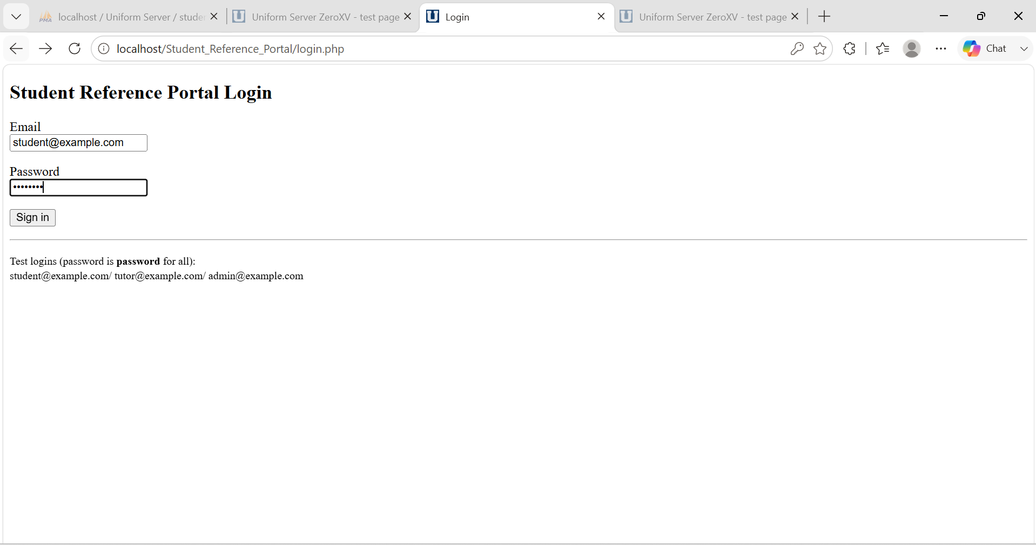
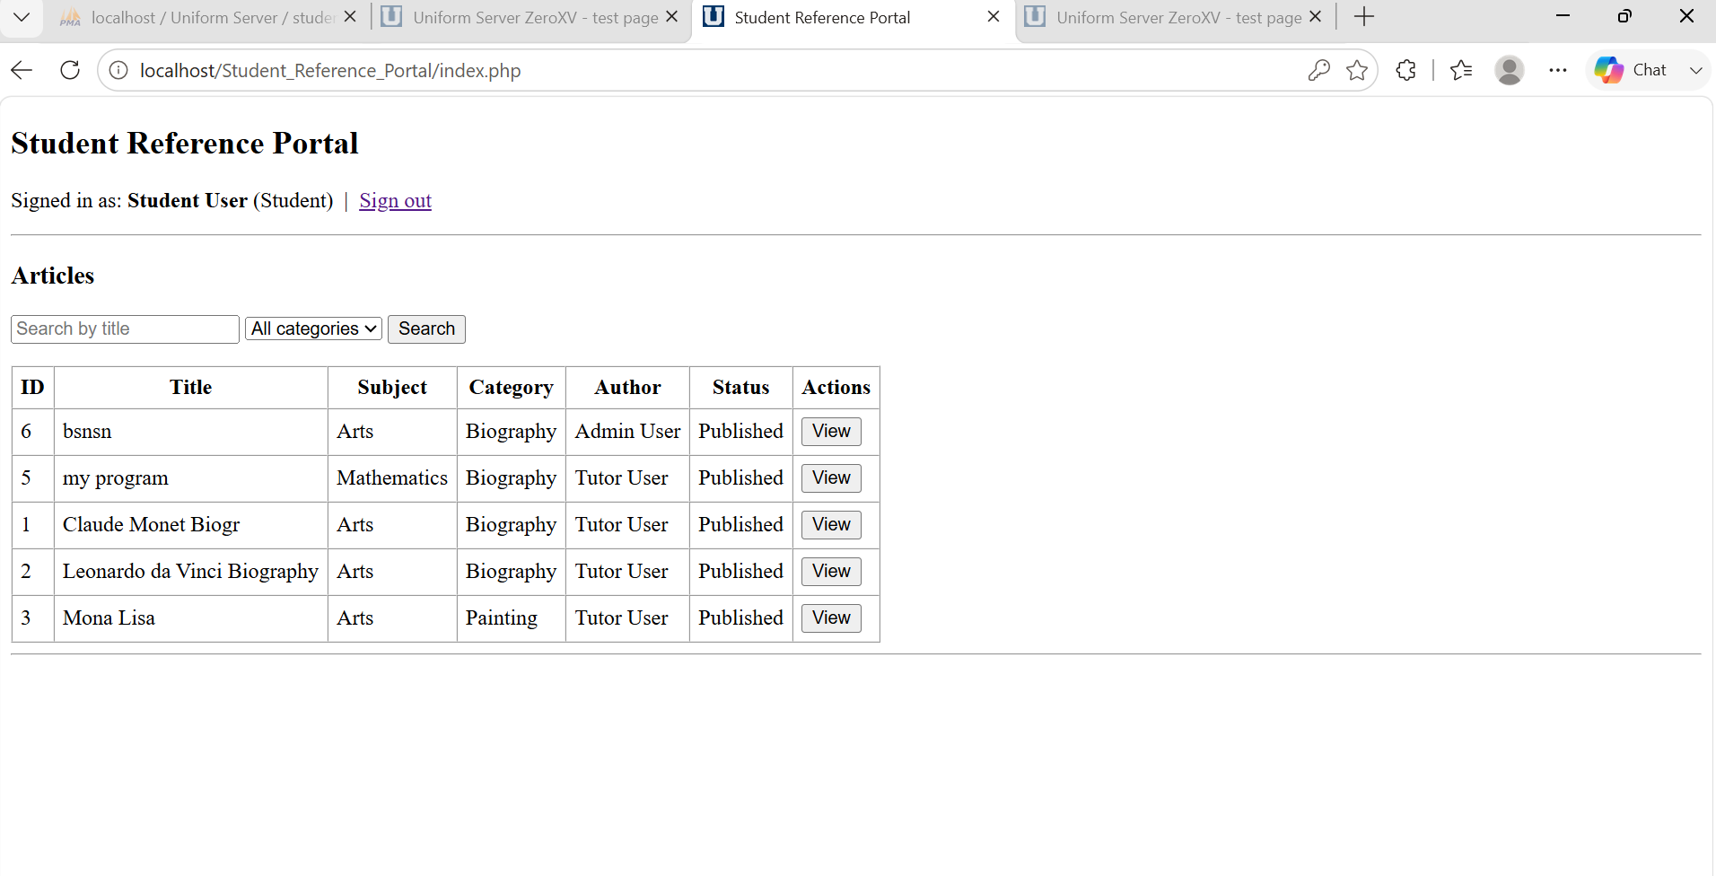
Login in as Tutor
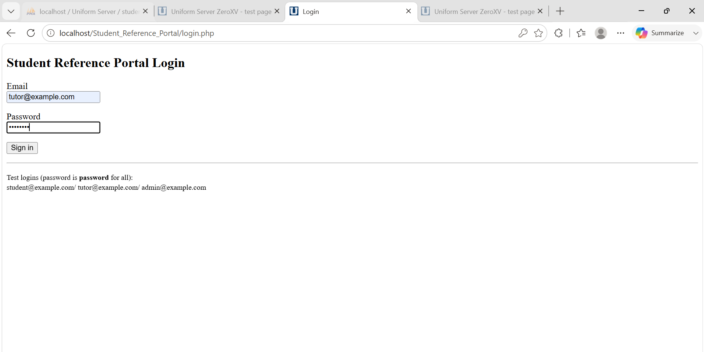

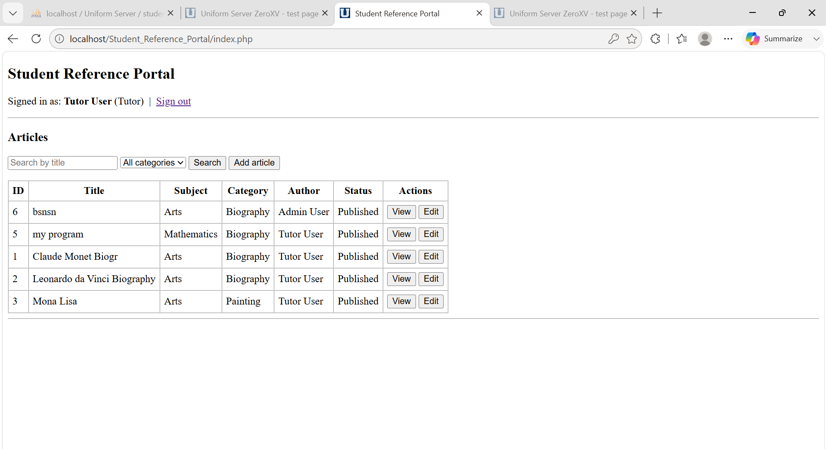
Login as Admin
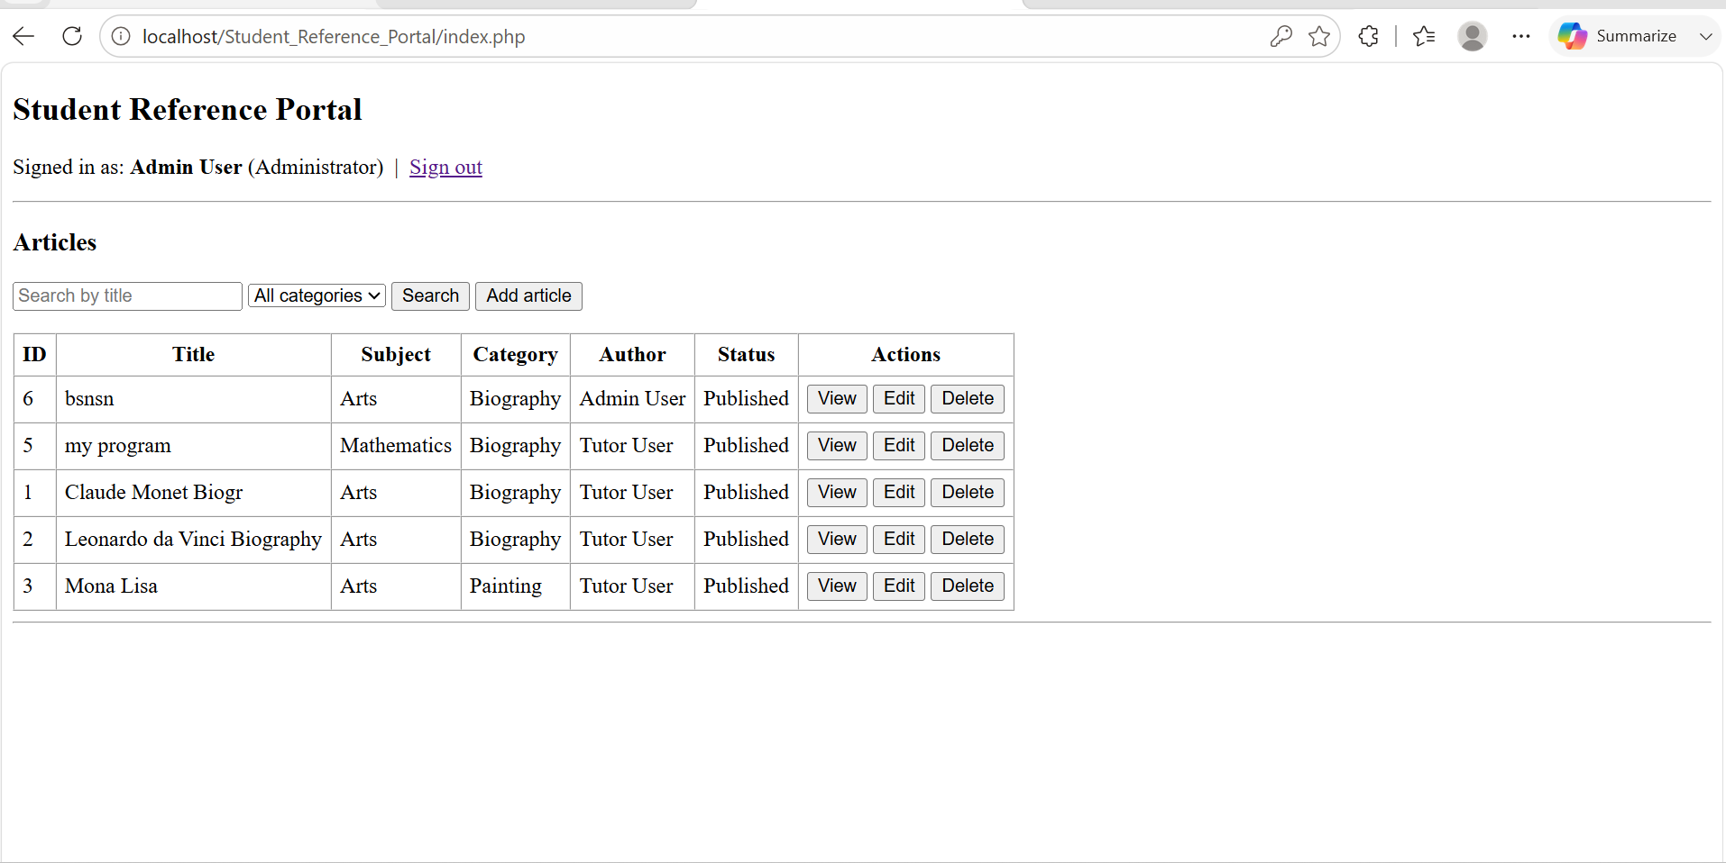

Login with Wrong Credentials
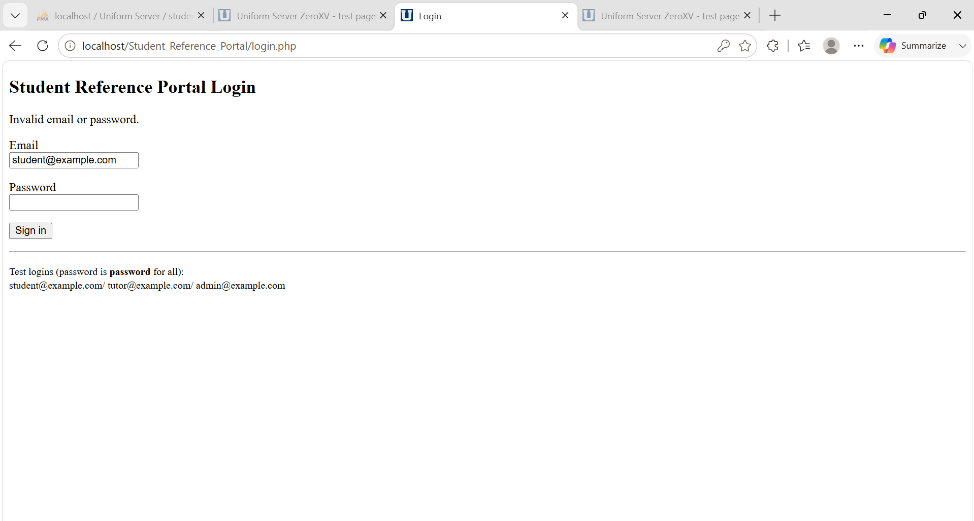

Logout
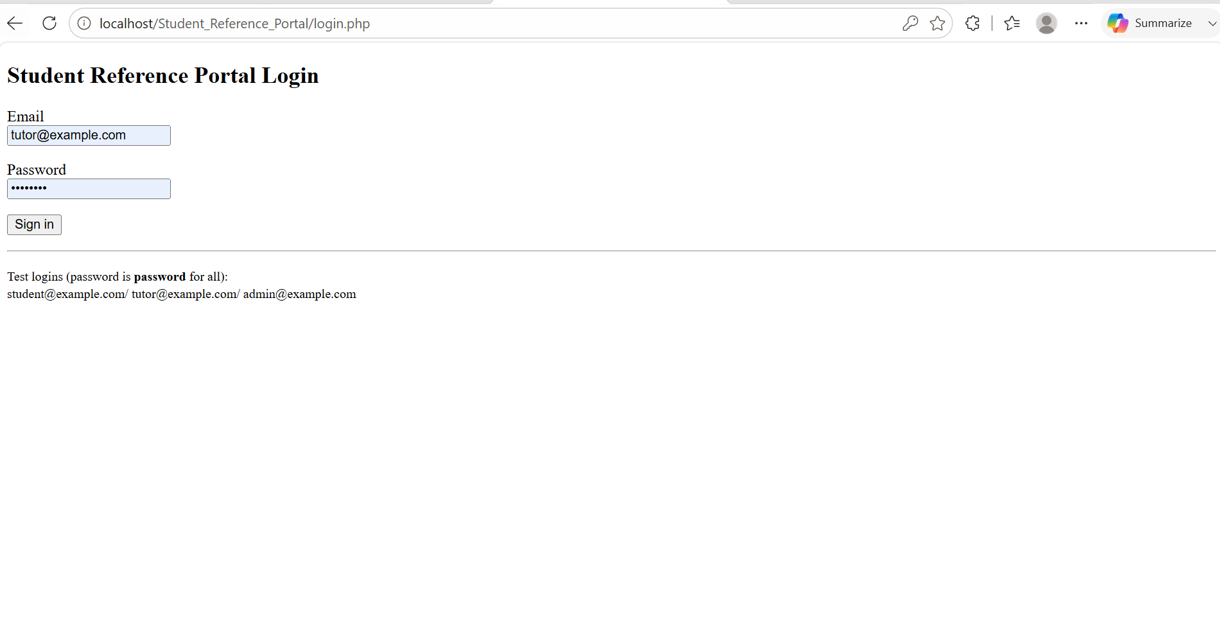

2. Browse and Search Testing
These are the two main features the client requested for students. The team confirmed that all users can see the article list, search by a word in the title, and filter by category after logging in.
Test | Result
All articles load on login | Pass
Search by keyword in title | Pass
Filter articles by category | Pass
View full content of an article | Pass

Testing Screenshots
All articles load on login
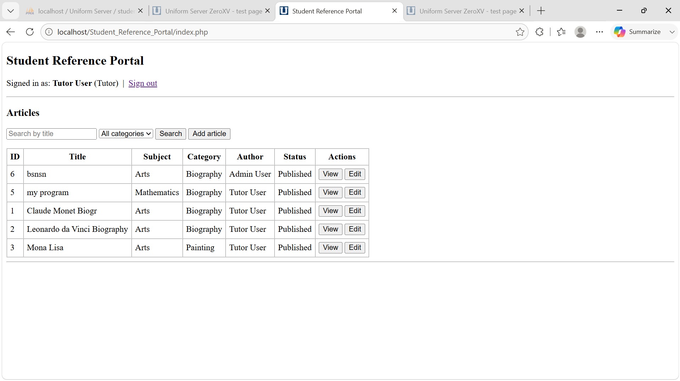
Search by keyword in title
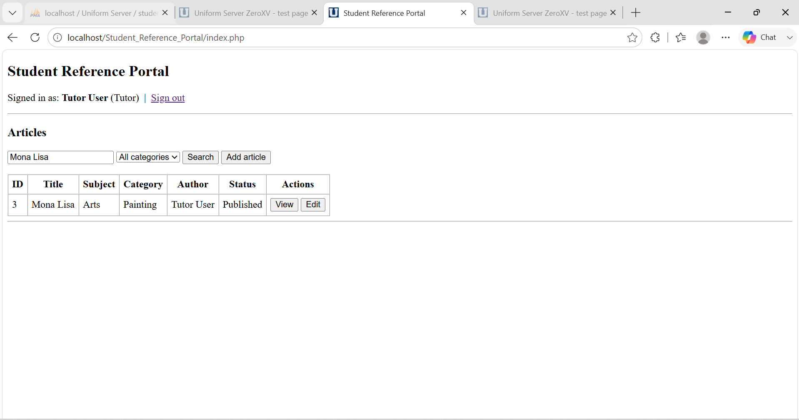
Filter By Category
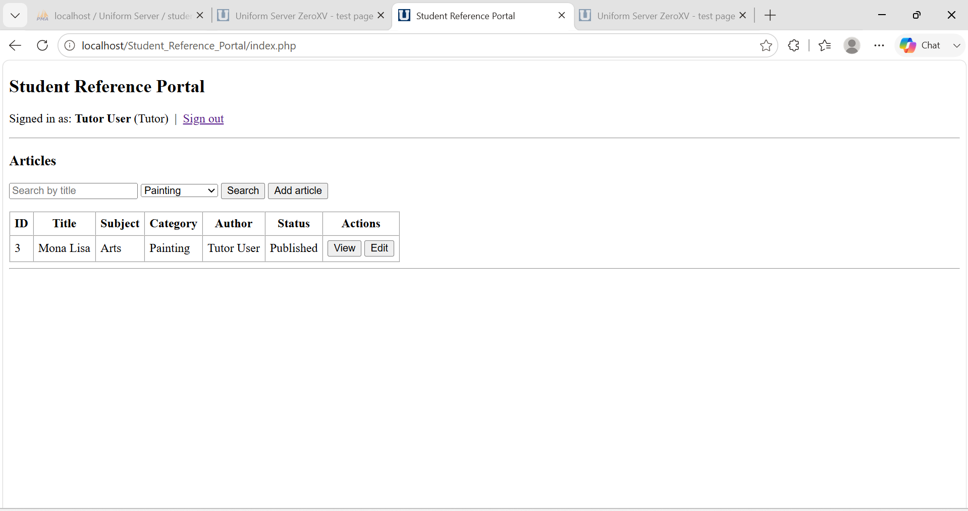
View Full Content
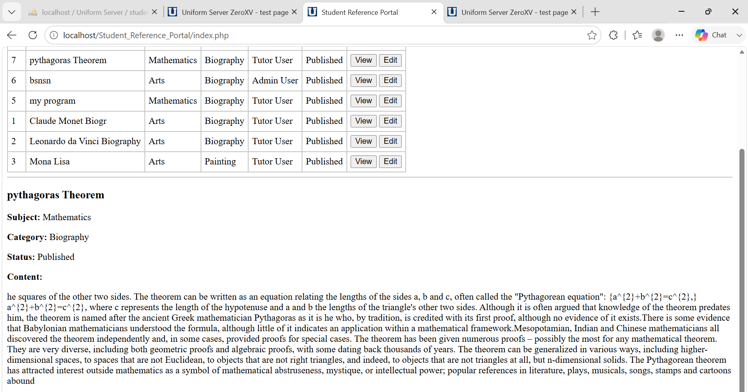

3. Add Article Testing
The client required that only tutors and administrators can add new articles. The team checked that the Add button does not appear for students and that a new article saved by a tutor or admin appears in the table immediately.
Test | Result
Add button hidden from student | Pass
Tutor and admin can add a new article | Pass
New article appears in table after saving | Pass

Test Screenshots
Add button hidden from student

Tutor and admin can add a new article
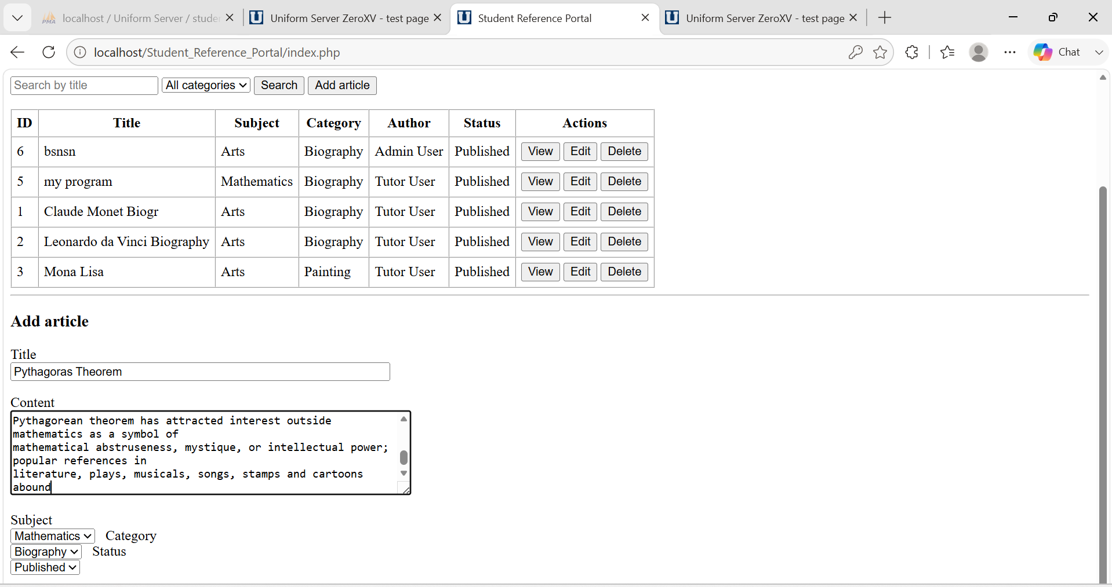

New Article Added Successfully
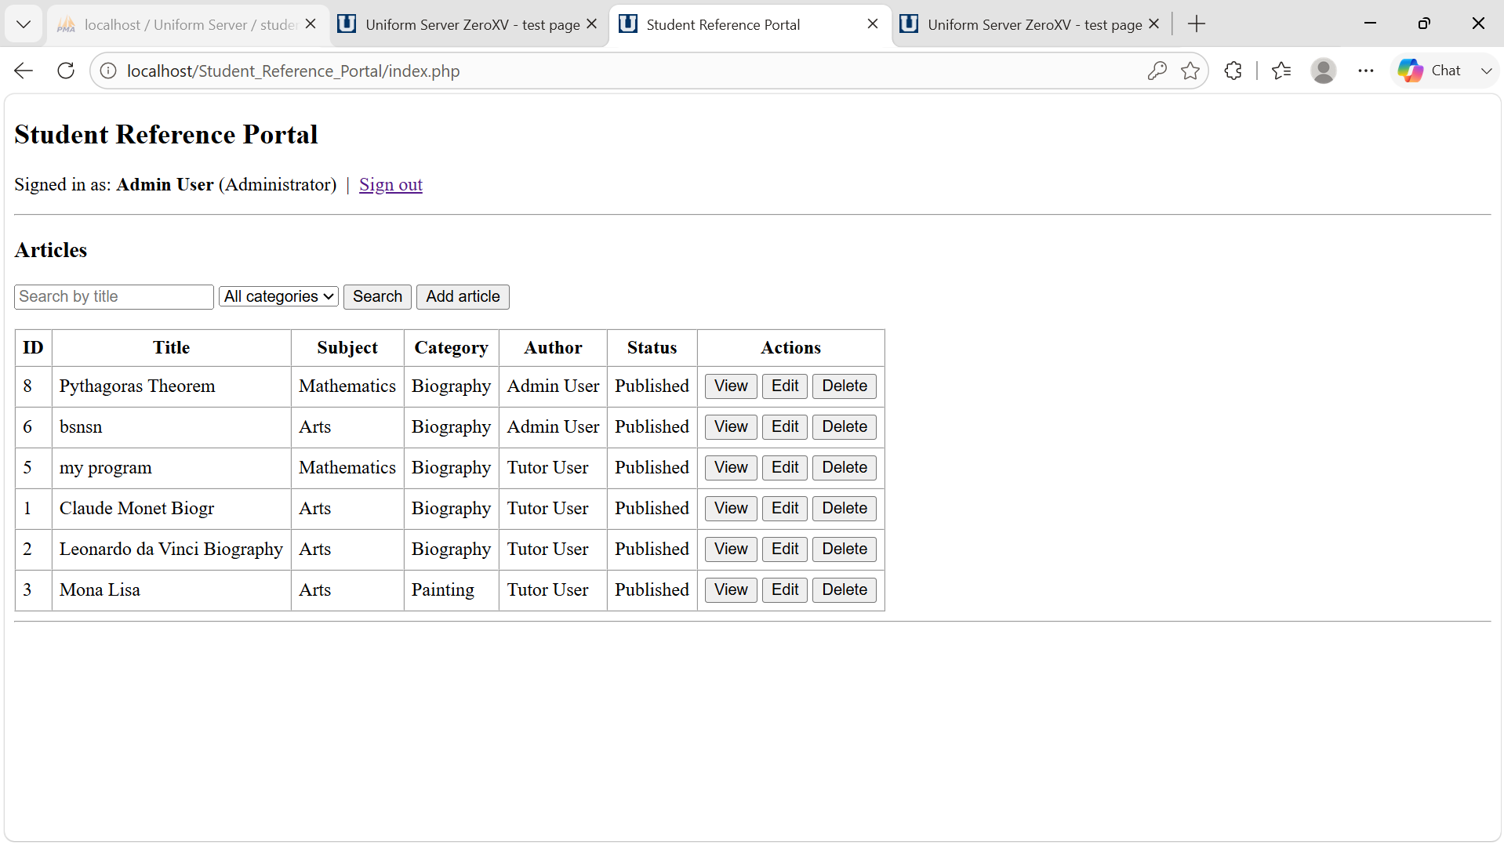

4. Edit Article Testing
The client required that tutors and administrators can update existing articles. The team confirmed that the Edit button is hidden from students and that changes made by a tutor or admin are saved correctly and reflected in the table.
Test | Result
Edit button hidden from student | Pass
Tutor and admin can edit an article | Pass
Changes saved and shown in table | Pass

Test Screenshots
Edit button hidden from studeTutor and admin can edit an article
Admin


Tutor
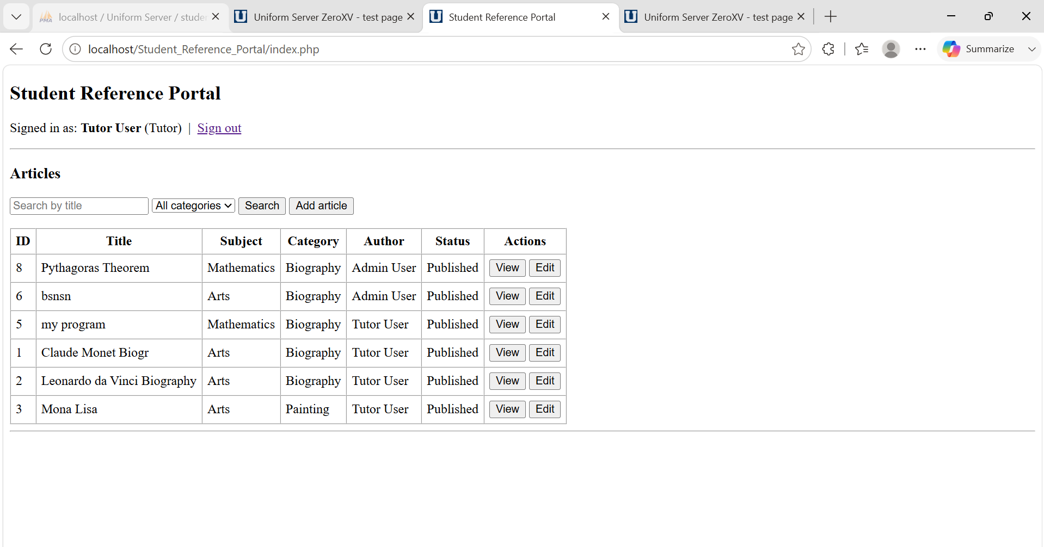
Successfully Edit ID:8 article Title to only Theorem
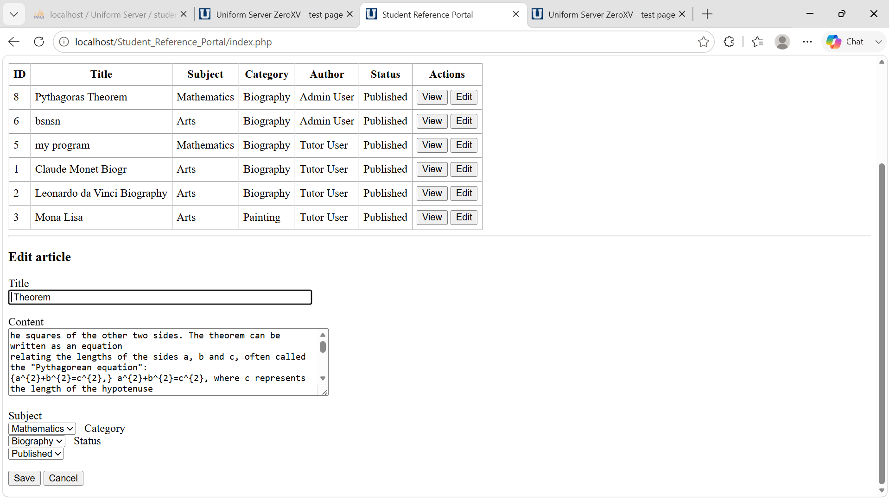
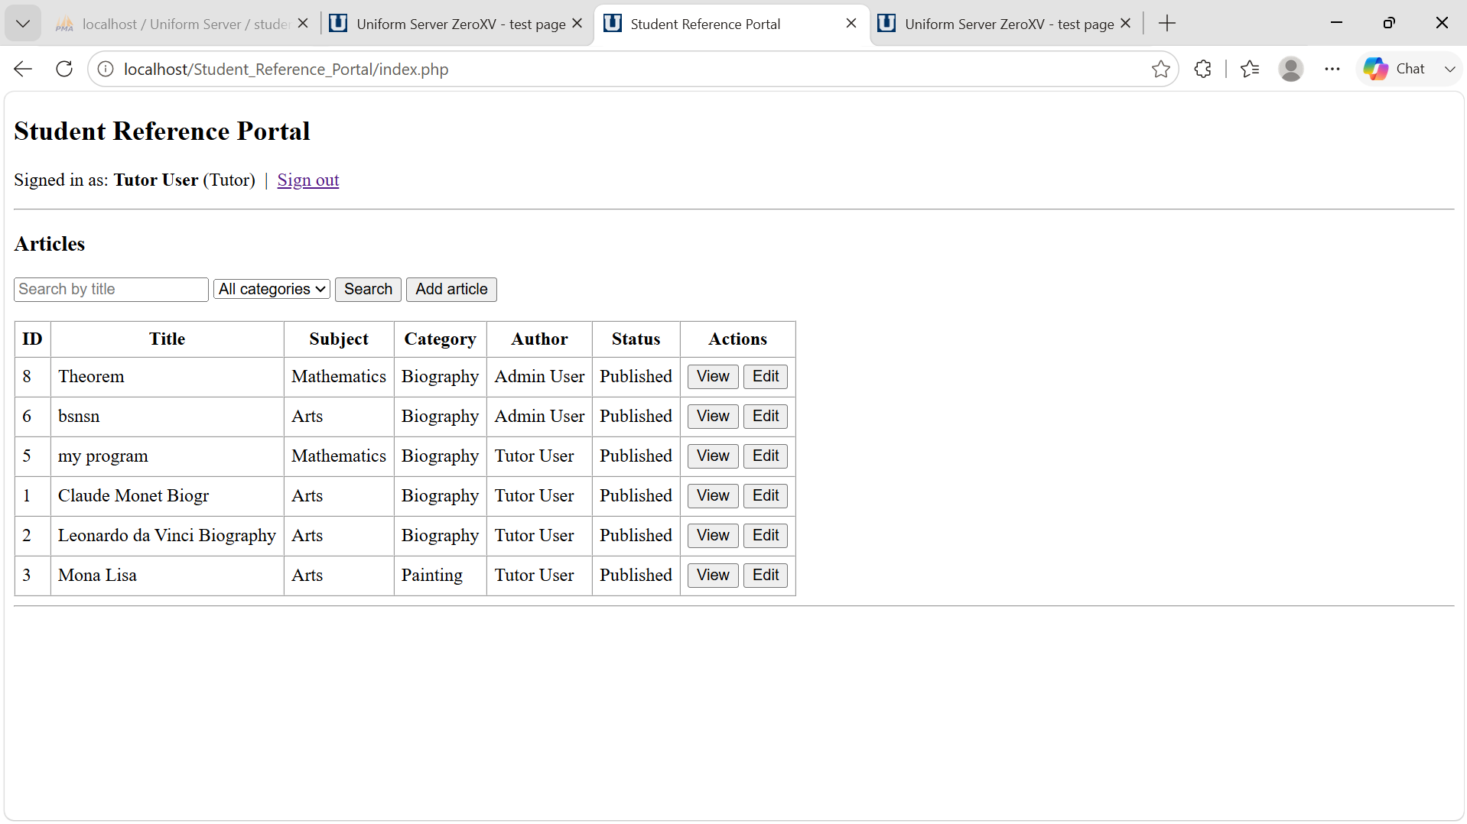

5. Delete Article Testing
The client required that only administrators can delete articles. The team confirmed that the Delete button is not visible to students or tutors and that when an admin deletes an article it is permanently removed from the table and the database.
Test | Result
Delete button hidden from student and tutor | Pass
Admin can delete an article | Pass
Deleted article removed from table | Pass

Test Screenshots
Delete button hidden from student and tutor
Tutor

Student

Deleted article removed from table (From Admin only)
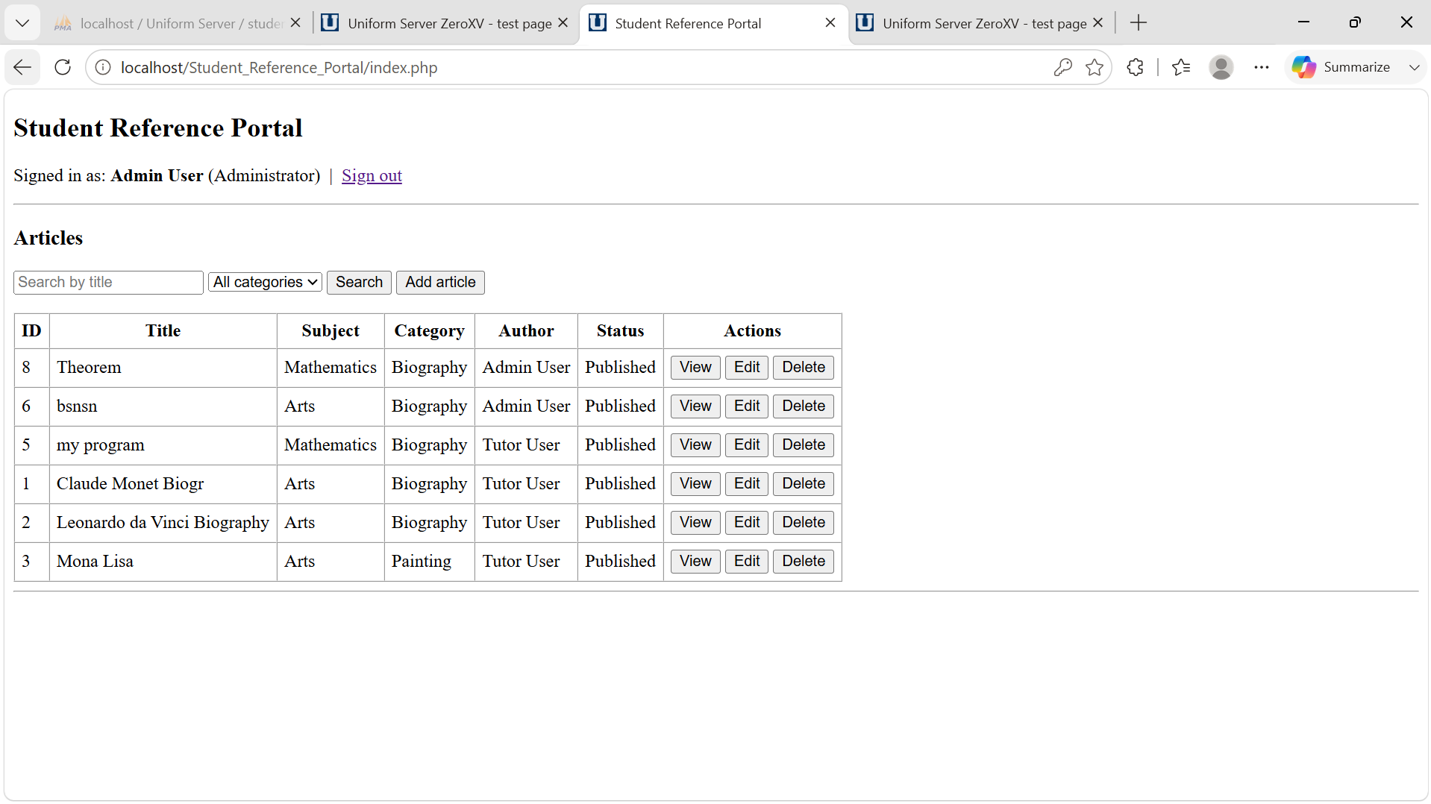
Deleted Article Title: Theorem
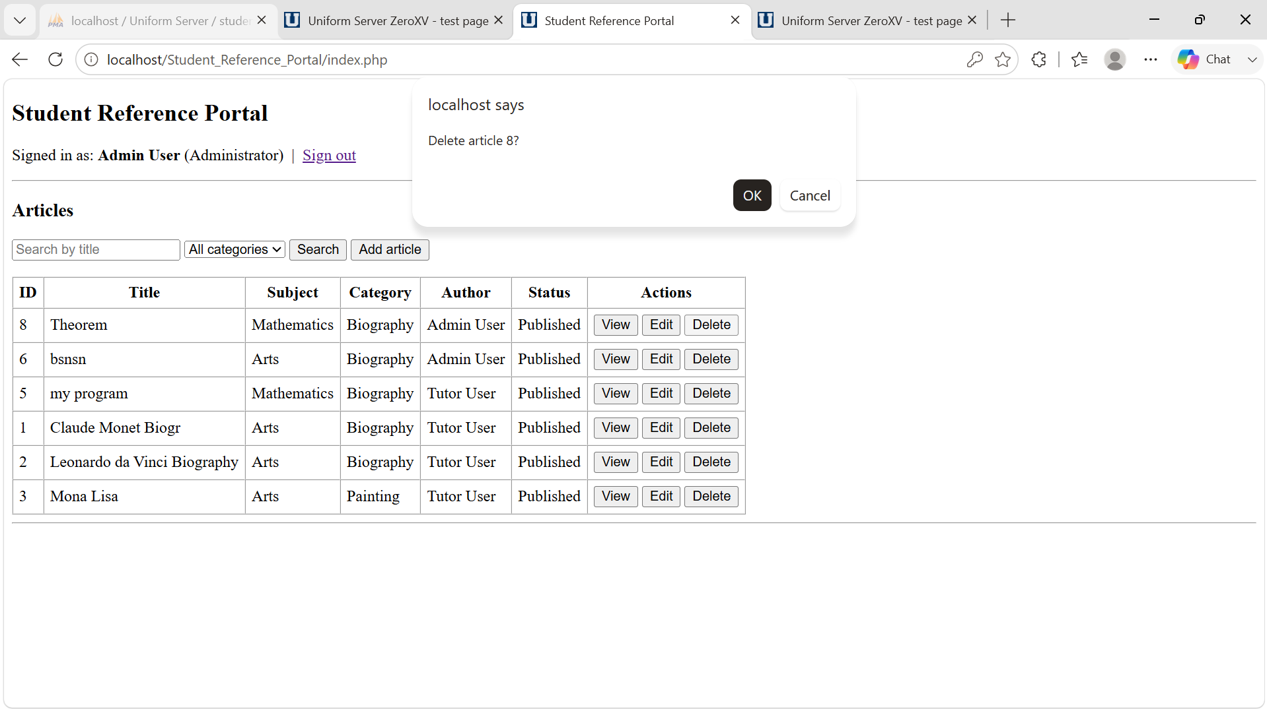

Successfully Deleted
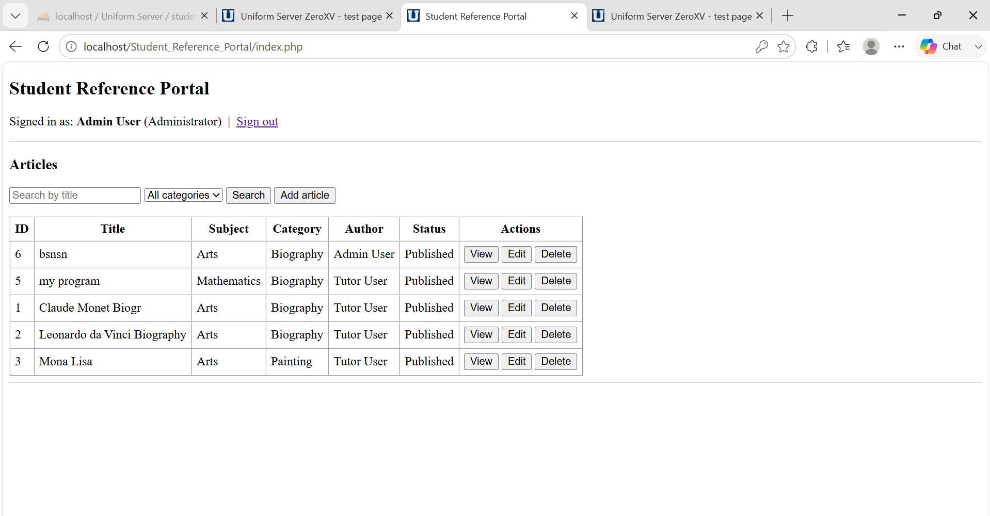

6. Security Testing
The team tested that role restrictions are enforced on the server and not just by hiding buttons on screen. A student or tutor who tries to call a restricted action directly is blocked by the server. SQL injection attempts in the search and login fields were also tested and handled safely by the prepared statements used in all database queries.

Test | Result
Student and tutor cannot delete via direct URL | Pass
SQL injection in search and login fields blocked | Pass
Passwords stored as hash not plain text | Pass

Testing Screenshots
Student and tutor cannot delete via direct URL
When try to delete through url access is denied for tutor and also denied for student as delete button is disable for the student and tutor.
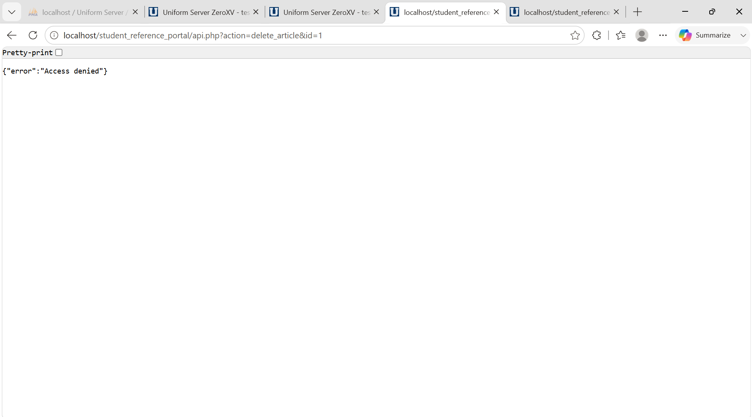

SQL injection in search and login fields blocked
Login Field:
Do not accept any kinds of string and characters
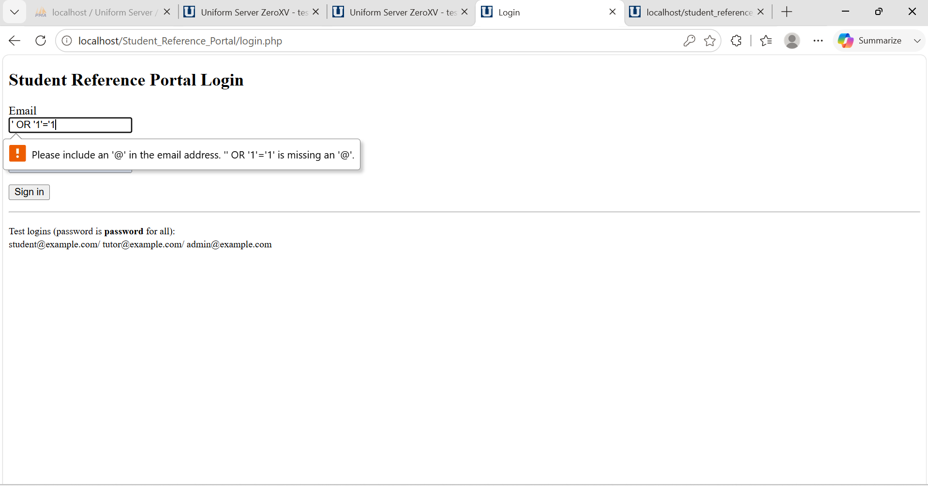
Search
Do not show any kinds of error as it return the nothing
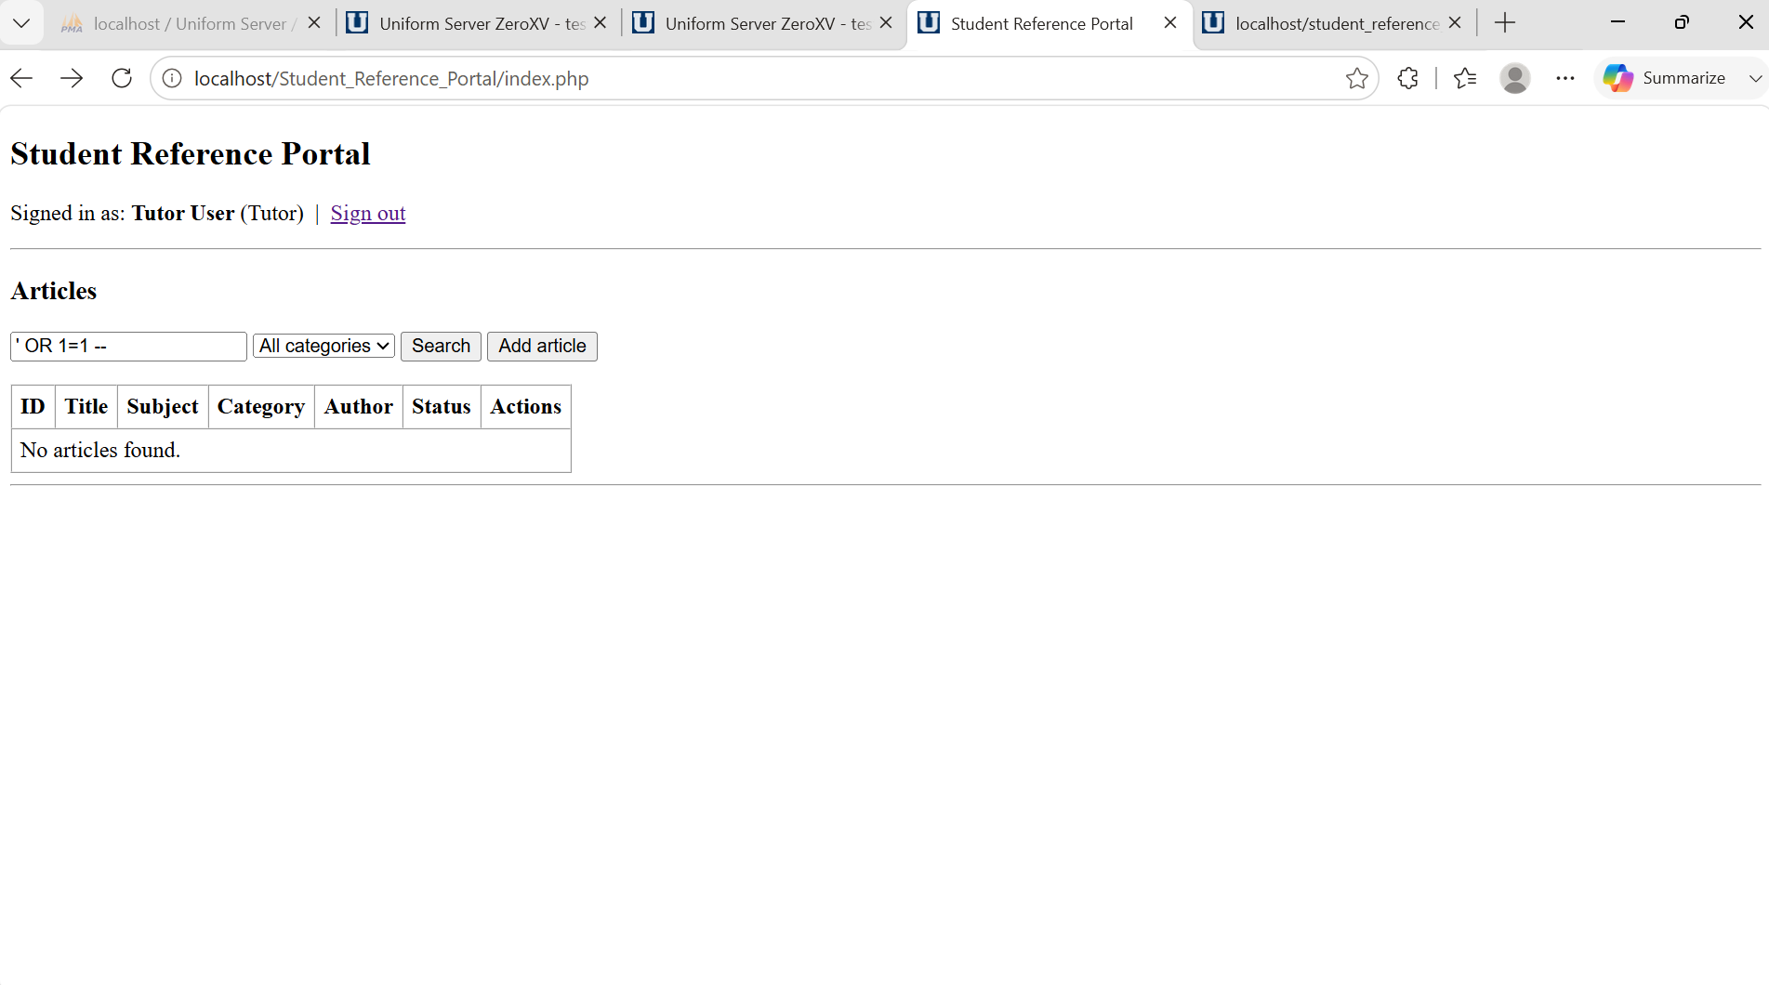7. User Experience Testing
The team checked the interface from the point of view of a first time user. Each role should see only what is relevant to them and the interface should respond clearly after every action without the user having to reload the page manually.
Test | Result
Role and name shown after login | Pass
Student sees only View button | Pass
Form and view panel scroll into view automatically | Pass
Table updates after every action without page reload | Pass

Test Screenshots
Role and name shown after login

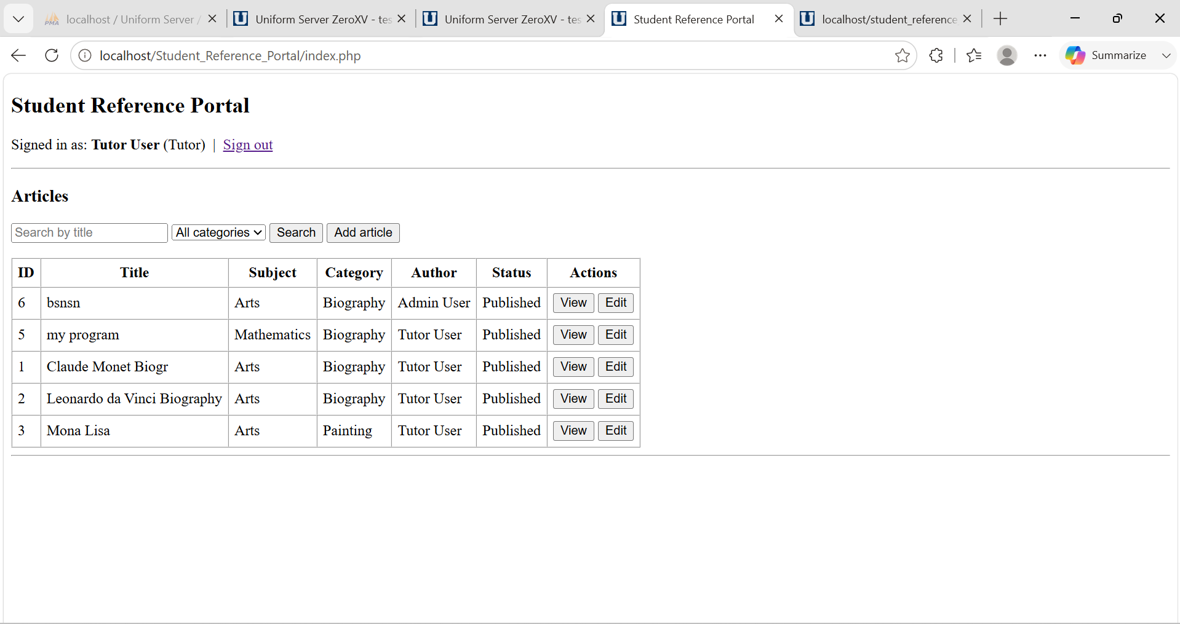
Student sees only View button
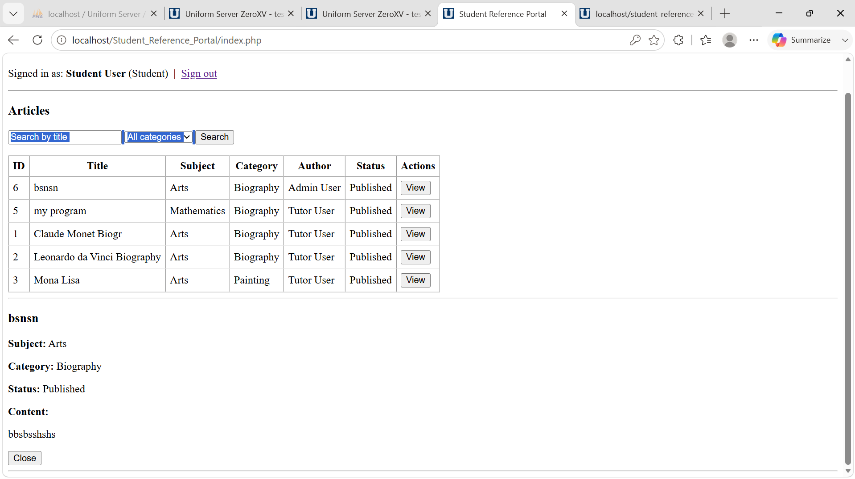
All others interface are user friendly and visible correctly in testing different functionality.

