Aim :

Write Python / R Program to convert from the following formats to HORUS format:

- Text delimited CSV to HORUS format.
- XML to HORUS Format
- JSON to HORUS Format

- Text delimited CSV to HORUS format.

Code :

import pandas as pd
sInputFileName=’Country_Code.csv’
InputData=pd.read_csv(sInputFileName,encoding="latin-1")
print('Input Data Values ===================================')
print(InputData)
print('=====================================================')
ProcessData=InputData
ProcessData.drop('ISO-2-CODE', axis=1,inplace=True)
ProcessData.drop('ISO-3-Code', axis=1,inplace=True)
ProcessData.rename(columns={'Country': 'CountryName'}, inplace=True)
ProcessData.rename(columns={'ISO-M49': 'CountryNumber'}, inplace=True)
ProcessData.set_index('CountryNumber', inplace=True)
ProcessData.sort_values('CountryName', axis=0, ascending=False, inplace=True)
print('Process Data Values =================================')
print(ProcessData)
print('=====================================================')
OutputData=ProcessData
sOutputFileName='HORUS-CSV-Country.csv'
OutputData.to_csv(sOutputFileName, index = False)
print('CSV to HORUS - Done')

Explaination :
- Import pandas for data analysis and manipulation.
- Read a csv file.
- Drop the columns which are not needed.
- Renaming the columns.
- Make the column as the table index.
- Sorting the values by Descending order.
- Make a csv file which will consist of all the output.

Output :

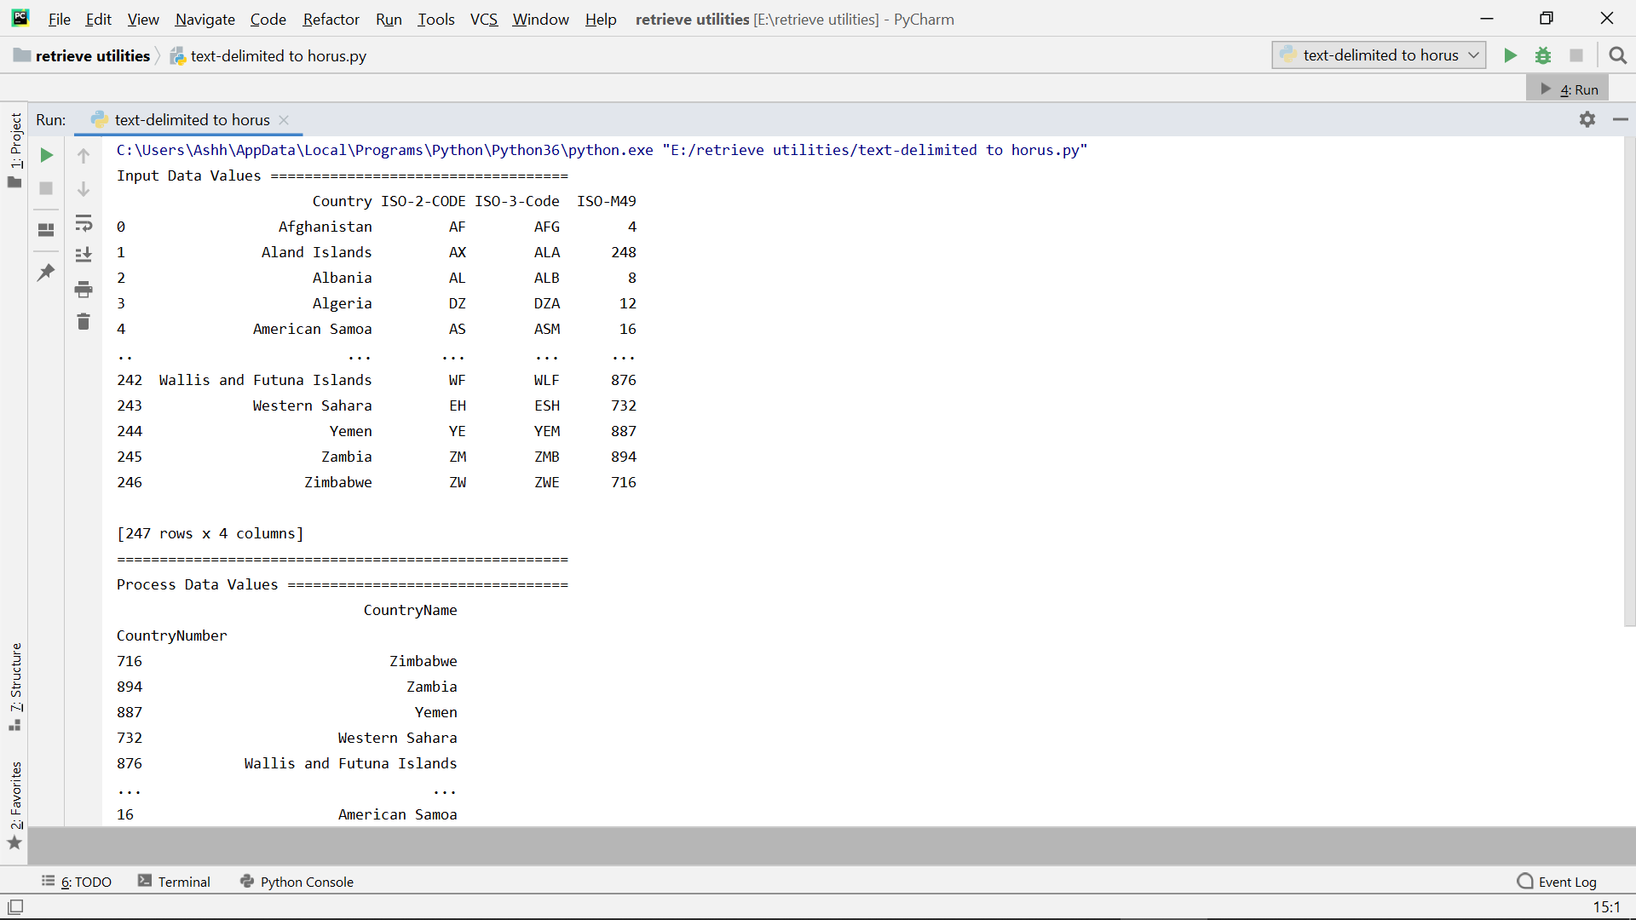

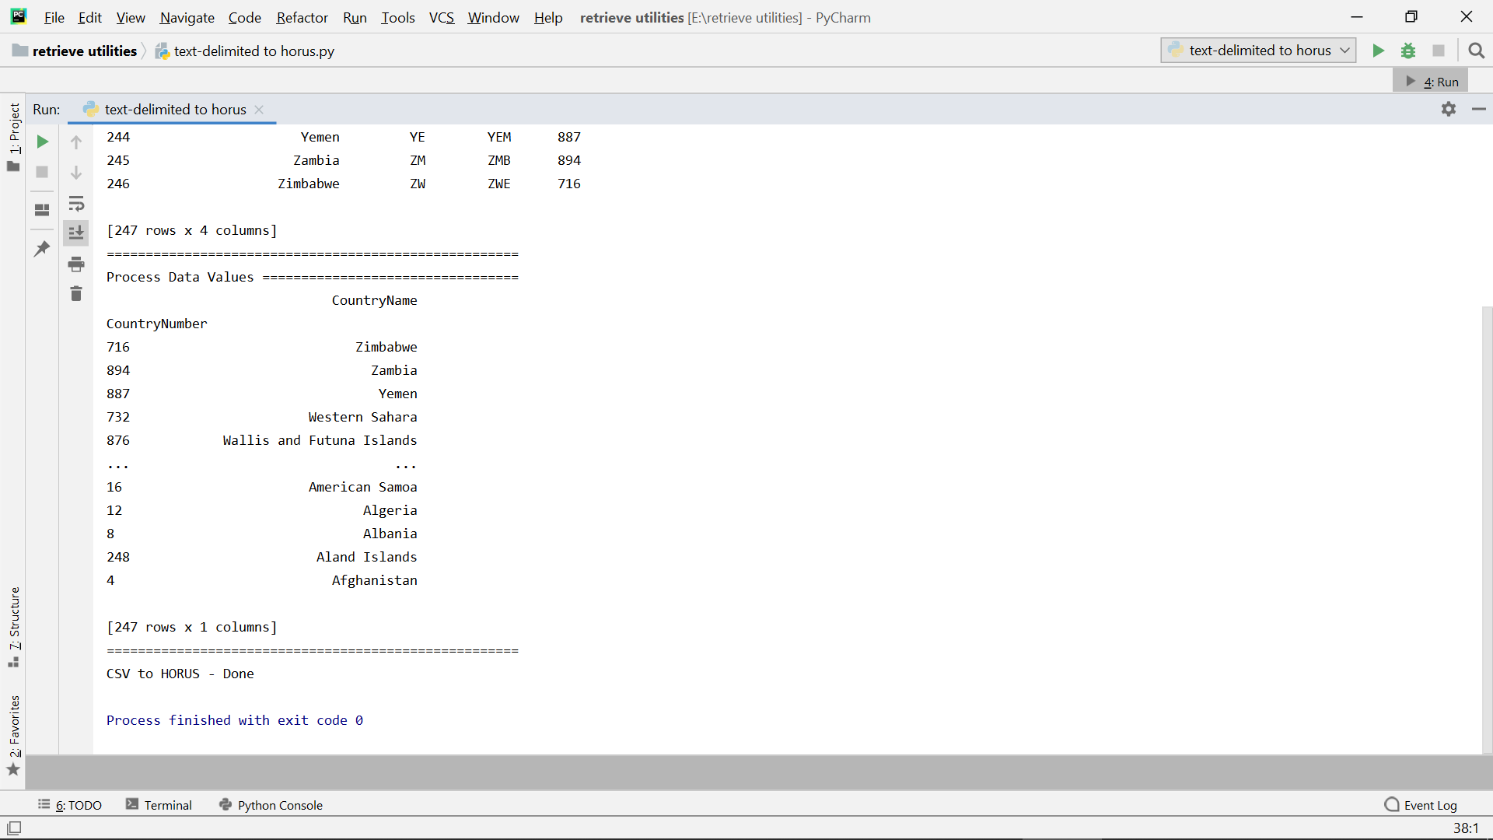

- XML to HORUS Format

Code :

import pandas as pd
import xml.etree.ElementTree as ET
def xml2df(xml):
root = ET.XML(xml)
all_records = []
for i, child in enumerate(root):
record = {}
for subchild in child:
record[subchild.tag] = subchild.text
all_records.append(record)
return pd.DataFrame(all_records)
sInputFileName='Country_code.xml'
InputData = open(sInputFileName, 'r').read()
print('=====================================================')
print('Input Data Values ===================================')
print('=====================================================')
print(InputData)
print('=====================================================')
ProcessDataXML=InputData
ProcessData=xml2df(ProcessDataXML)
ProcessData.drop('ISO-2-CODE', axis=1,inplace=True)
ProcessData.drop('ISO-3-Code', axis=1,inplace=True)
ProcessData.rename(columns={'Country': 'CountryName'}, inplace=True)
ProcessData.rename(columns={'ISO-M49': 'CountryNumber'}, inplace=True)
ProcessData.set_index('CountryNumber', inplace=True)
ProcessData.sort_values('CountryName', axis=0, ascending=False, inplace=True)
print('=====================================================')
print('Process Data Values =================================')
print('=====================================================')
print(ProcessData)
print('=====================================================')
OutputData=ProcessData
sOutputFileName='HORUS-XML-Country.csv'
OutputData.to_csv(sOutputFileName, index = False)
print('=====================================================')
print('XML to HORUS - Done')
print('=====================================================')

Explaination :

- Import pandas for data analysis and Import xml for working with xml data.
- Define function which will convert xml to dataframe.
- Reading a xml file.
- Convert xml to dataframe using defined function.
- Drop the columns which are not needed.

- Renaming the columns.

- Make the column as table index

- Sorting the values by Descending order.

- Make a csv file which will consist all the output.

Output :

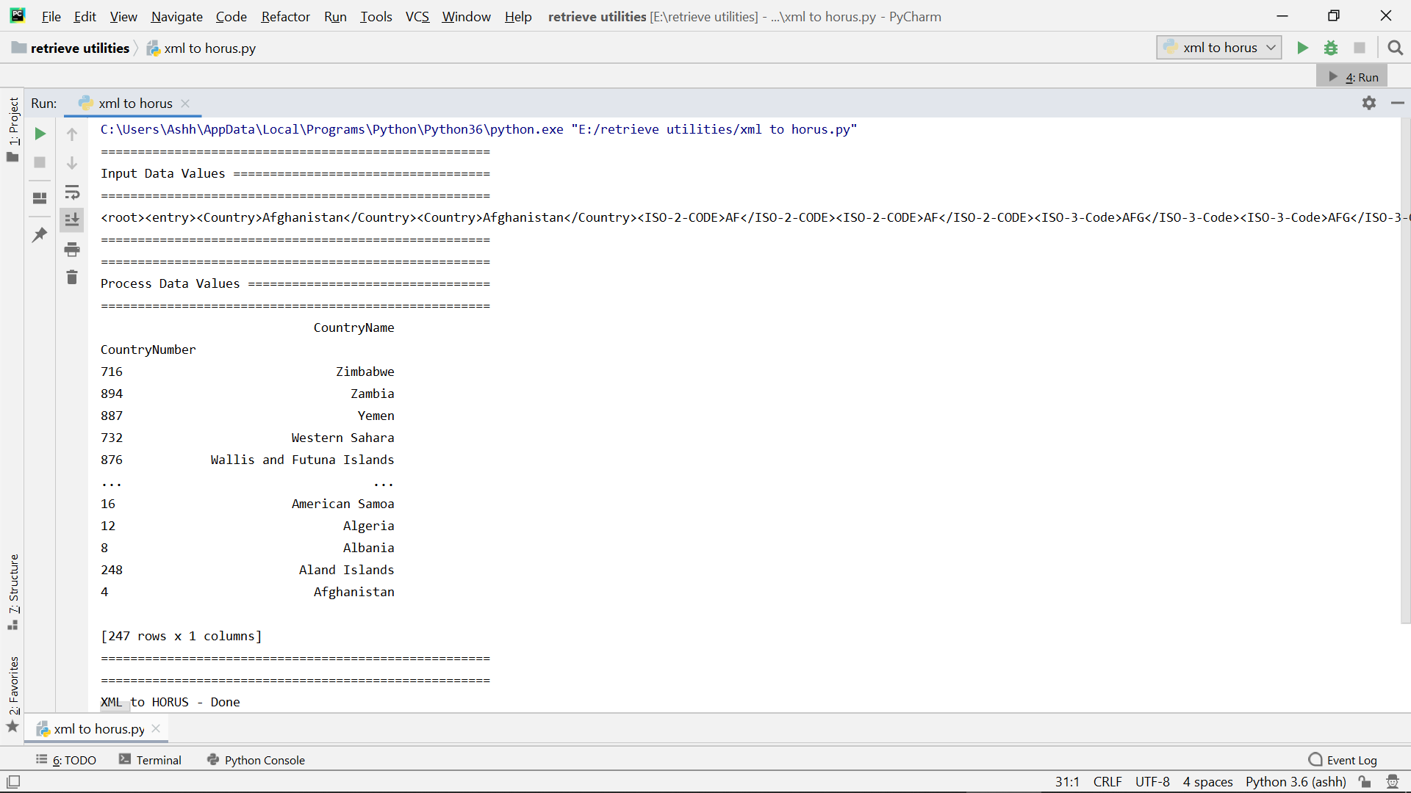

JSON to HORUS Format

Code :

import pandas as pd
sInputFileName='Country_Code.json'
InputData=pd.read_json(sInputFileName,
orient='index',
encoding="latin-1")
print('Input Data Values ===================================')
print(InputData)
print('=====================================================')
ProcessData=InputData
ProcessData.drop('ISO-2-CODE', axis=1,inplace=True)
ProcessData.drop('ISO-3-Code', axis=1,inplace=True)
ProcessData.rename(columns={'Country': 'CountryName'}, inplace=True)
ProcessData.rename(columns={'ISO-M49': 'CountryNumber'}, inplace=True)
ProcessData.set_index('CountryNumber', inplace=True)
ProcessData.sort_values('CountryName', axis=0, ascending=False, inplace=True)
print('Process Data Values =================================')
print(ProcessData)
print('=====================================================')
OutputData=ProcessData
sOutputFileName='HORUS-JSON-Country.csv'
OutputData.to_csv(sOutputFileName, index = False)
print('JSON to HORUS - Done')

Explaination :

- Import pandas for data analysis and manipulation.
- Read a json file.
- Drop the columns which are not needed.
- Renaming the columns.
- Make the column as the table index.
- Sorting the values by Descending order.
- Make a csv file which will consist of all the output.

Output :

