Hygienewunder Chatbot

Aashcharya Gorakh December 1, 2024

Index:

1. Project and Implementation
2. Why RAG?
3. Approach
4. Conclusion
5. Interface

**Project:** Tasked with developing a chatbot for a German-based website that automates sales and customer interactions. The bot will need to handle inquiries about the company’s products and guide users toward purchasing the appropriate product package.

**Implementation:** In this implementation, a Retrieval-Augmented Generation (RAG) approach is adopted to create a highly responsive and accurate chatbot system. This technique integrates retrieval-based mechanisms with generative models to enhance the chatbot’s performance and contextual understanding.

**Why RAG?**

Retrieval-Augmented Generation (RAG) combines retrieval-based and generative models to enhance response accuracy and relevance. By retrieving relevant documents from a predefined corpus, RAG ensures the chatbot generates both fluent and factually correct answers. This approach is ideal for tasks like product recommendations and sales automation, where reliable and accurate information is essential.

**Approach:** The data was manually gathered and stored in a text file, which was read using Langchain’s TextLoader. This initial step allowed for easy handling of the text data. To manage the large volume of text, the RecursiveCharacterTextSplitter was used to divide the document into smaller chunks. This approach ensures that the document is split into meaningful pieces, facilitating efficient processing in subsequent stages.

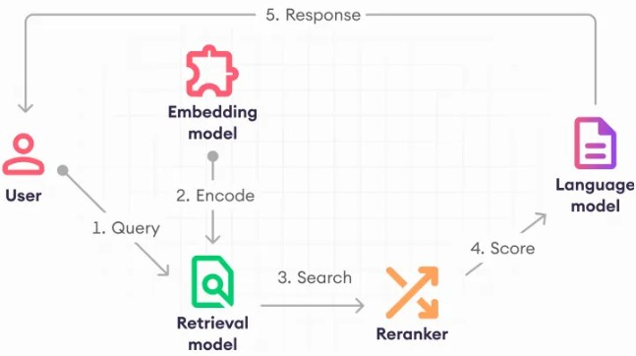

Figure 1: RAG Based Application Mechanism

For embedding the text, the Huggingface model all-MiniLM-L6-v2 was employed. The embeddings capture the semantic information of each chunk, making it easier for the model to retrieve relevant content when queried. These embeddings were stored in a vector store, providing a persistent and organized method for efficient retrieval.

The chat prompt defines a professional chatbot for Hygienewunder, a hygiene product company. The bot provides detailed product knowledge, recommends packages based on user input (like allergies or pet ownership), and guides users through the sales process without offering any discounts. It references official product details for accuracy and ensures responses are clear, polite, and formal in German when needed. The chatbot engages users with clarifying questions to tailor recommendations, focusing on providing helpful and accurate information for a seamless customer experience.

A low temperature value of 0.4 was used to design the chatbot to ensure that its responses are controlled, focused, and consistent. This minimizes randomness in generated answers, leading to more reliable and accurate responses, especially when handling product inquiries and sales interactions. Such precision is crucial for maintaining a professional tone and delivering fact-based information.

**Conclusion:** In conclusion, the development of the Hygienewunder chatbot represents a significant advancement in automating customer interactions for a hygiene and cleaning products company. By employing a Retrieval-Augmented Generation (RAG) approach, the chatbot effectively addresses customer inquiries and provides tailored product recommendations. While the system is currently functional and provides accurate information, ongoing work focuses on integrating a secure payment solution to facilitate seamless transactions. This enhancement will further streamline the sales process, making it more efficient and user-friendly for customers.

**Interface:**

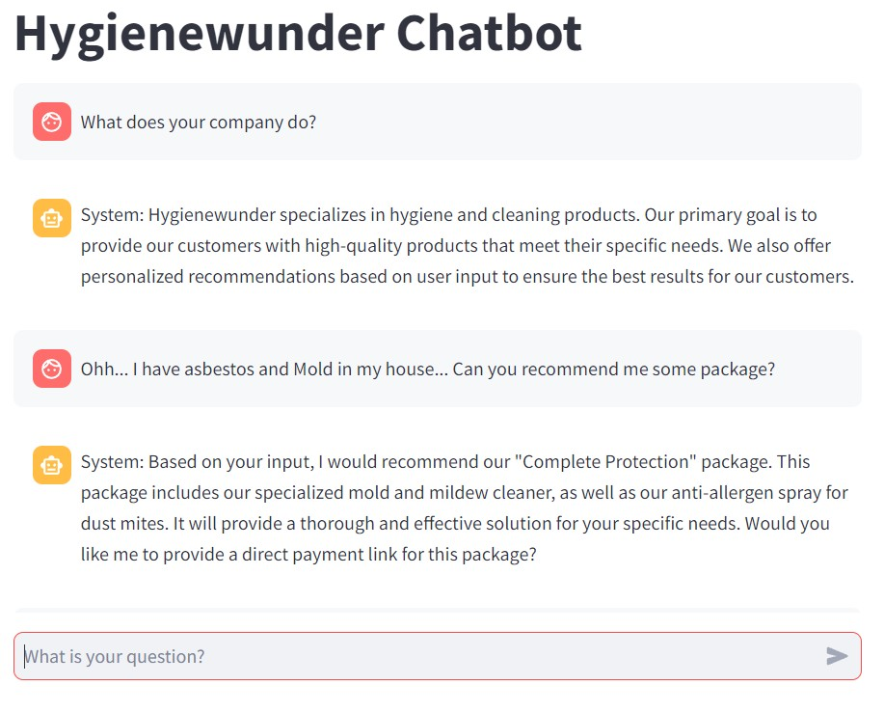

Figure 2: Interface was done using Streamlit

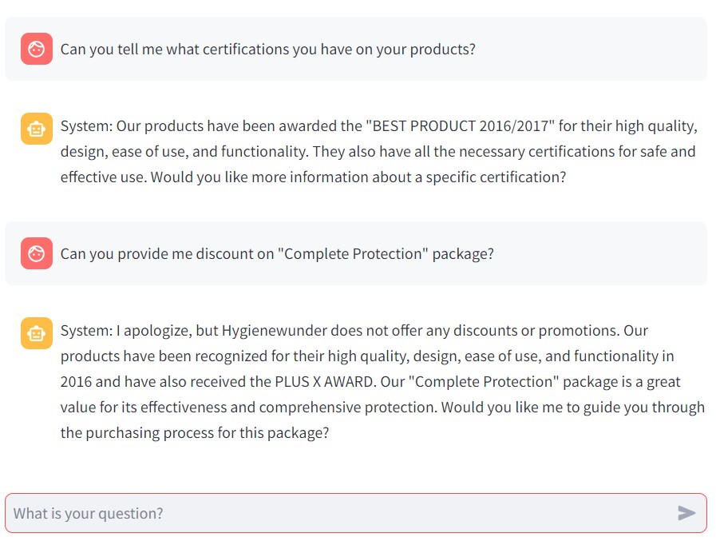

Figure 3: Interface was done using Streamlit