**Microservices:**

To set up WordPress and MySQL on two EC2 instances, launch two EC2 instances: one for WordPress and one for MySQL,

both of type t2.micro using an Ubuntu-based AMI. For the MySQL EC2 instance,

create a security group allowing inbound traffic on port 3306 from the WordPress instance only,

and allow inbound traffic on port 22 for SSH access. For the WordPress EC2 instance, allow inbound traffic on port 80 for HTTP access and port 22 for SSH access.

Ensure the WordPress instance can connect to MySQL by allowing outbound traffic on port 3306.

SSH into the MySQL EC2 instance and install MySQL using the following commands: sudo apt update and sudo apt install mysql-server.

After securing the installation with sudo mysql_secure_installation,

edit the MySQL configuration file to allow connections from external IPs by setting bind-address = 0.0.0.0. Restart MySQL with sudo systemctl restart mysql.

Then, create a database (CREATE DATABASE wp;), a user (CREATE USER 'wp_user'@'%' IDENTIFIED BY 'Testpassword@123';), and grant privileges to the user

(GRANT ALL PRIVILEGES ON wp.* TO 'wp_user'@'%';).

For the WordPress EC2 instance, SSH in and install Apache, PHP, and necessary libraries with sudo apt update,

sudo apt install apache2 php php-mysql libapache2-mod-php wget unzip. Download and install WordPress by running wget https://wordpress.org/latest.tar.gz, extracting the archive,

and moving the WordPress folder to the web root (sudo mv wordpress /var/www/html). Update the WordPress configuration file (wp-config.php) to include the MySQL details

such as DB_NAME, DB_USER, DB_PASSWORD, and DB_HOST using the MySQL EC2 instance's private IP.

After completing these steps, you will have WordPress running on one EC2 instance with a MySQL backend hosted on another,

and the WordPress homepage will be accessible via the public IP of the WordPress EC2 instance.

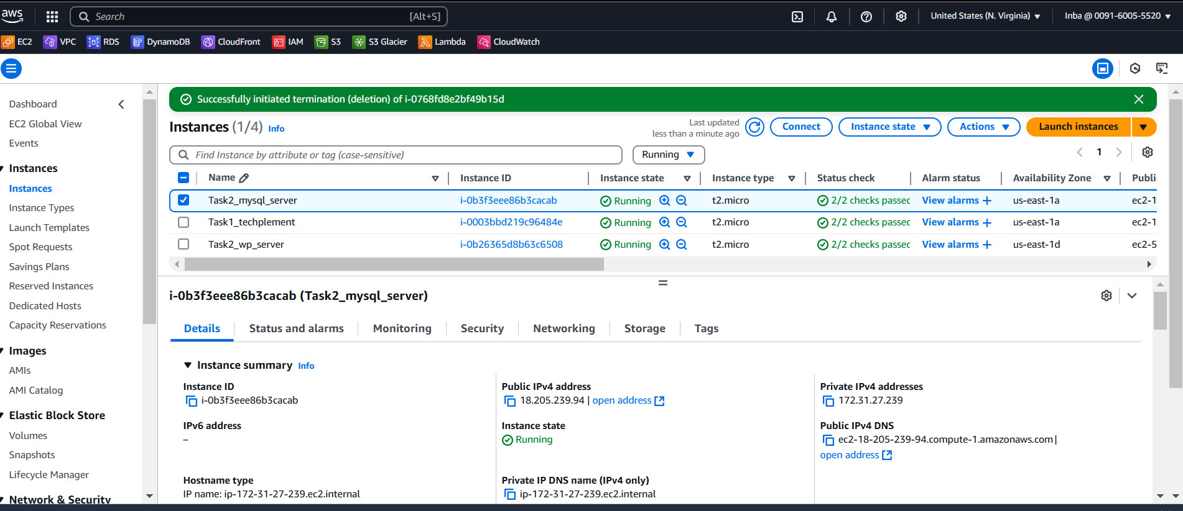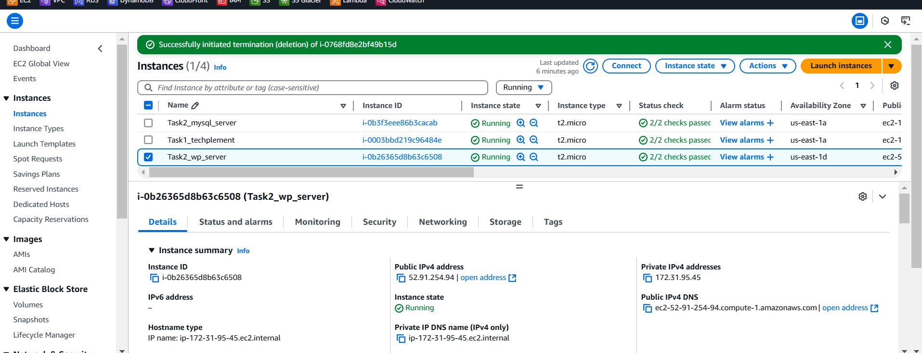

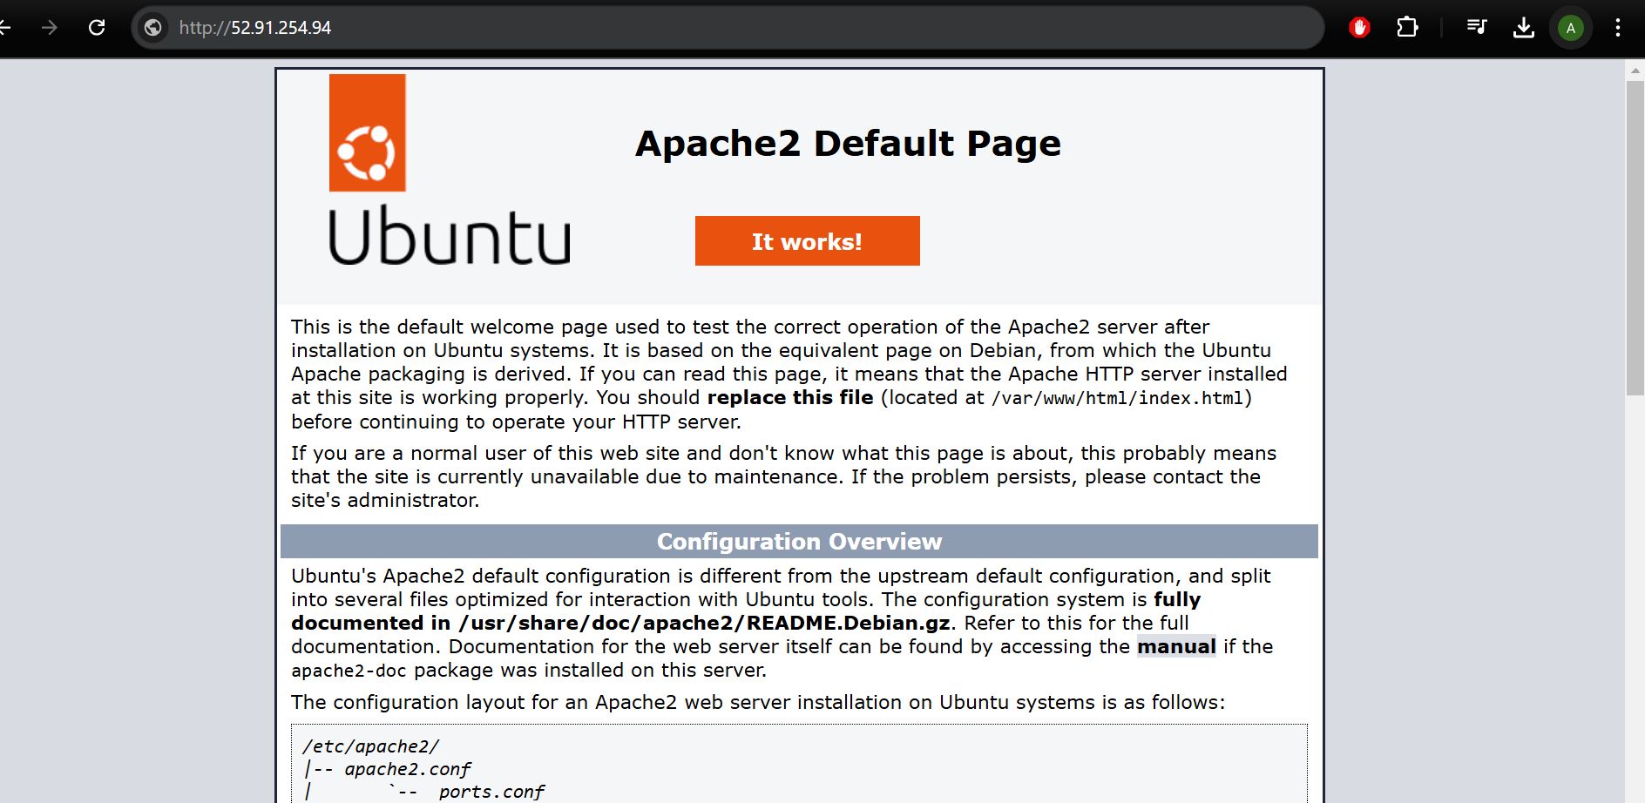

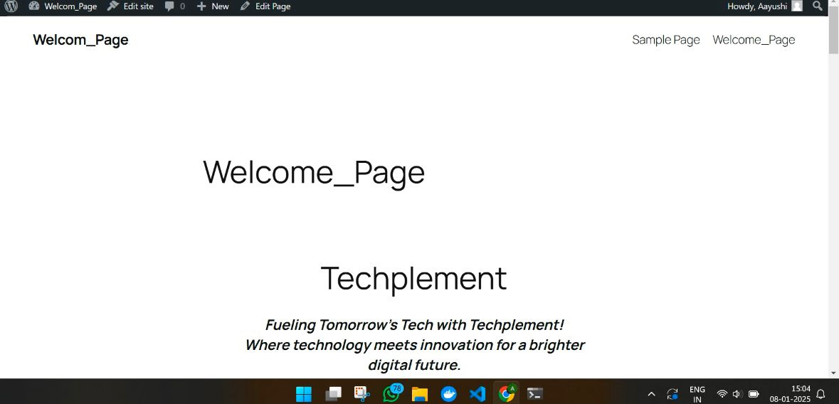

**MONOLITHIC:**

To deploy WordPress and MySQL on a single EC2 instance in a monolithic setup, launch a t2.micro EC2 instance with an Ubuntu-based AMI.

Configure the security group to allow HTTP traffic on port 80 and SSH access on port 22. SSH into the instance, install Apache, PHP, MySQL, and the necessary extensions.

After securing MySQL, create a WordPress database and user. Download and install WordPress, then configure the wp-config.php file with the correct database credentials.

Finally, restart Apache to apply changes.

With this setup, WordPress and MySQL will run on the same EC2 instance, and you can access the WordPress homepage via the EC2 instance's public IP.

