Enigma


B.S. (SE) Semester Project Report
CSS-2051 Data Structures and Algorithms

Submitted by:
Aisha Azhar 2024473
Sumaiya Jamal 2024526

July 2021

Department of Computer Science and Software Engineering

Jinnah University for Women
5-C Nazimabad, Karachi 74600

Table of Contents

Table of Contents 1
Project Summary 1
GitHub Link 3
Project Flow 3
Code Explanation 4
Screenshots 7

Project Summary

Unit 1: Objectives.
ENIGMA Encode the user input and provide a serial key through which we can decode the encoded data. Encoders perform exactly reverse operation than Decoder. Through this we can secure our data. Basically the main idea to design this platform is to provide user friendly environment. It also provides data hiding concept as it hides the actual data and generates the specific key.

Unit 2: Introduction.

ENIGMA mean something that is difficult to understand by individuals. ENIGMA is developed on JAVA with swing libraries to provide attractive GUI. Its user friendly to use but not that much easier to understand. It’s a combination of multiple Data Structures.

Unit 3: Description.

ENIGMA use Linked-List to store its data, ArrayList to randomly select the key, Hash table to fetch data from the key value. When we enter a string in main memory it converts the Lower-case alphabets to Upper Case then use ASCII key to convert the input into a keyword randomly. When we enter that keyword in decoding section it will display the hidden data.

DATA STRUCTURES USED:
There are two data structures used in the project Linked-List and Array. We used linked list to store data as it has no limitations which can cause limit to our data and linked-list uses non comparison based data which is more efficient when there is large data. A LinkedList can contain pretty much any type of data; Strings, Characters, Numbers. The elements can be unsorted or sorted, they can contain duplicate elements or all unique elements. Array List is also used as a data structure as ArrayList has direct reference to every element so it can get the nth element in constant time. An ArrayList, or dynamically resizing array, allows you to have the benefits of an array while offering flexibility in size. You won’t run out of space in the ArrayList since its capacity will grow as you insert elements.

GitHub Link
https://github.com/Aashi0123/Enigma.java.git

Project Flow
Start

Encode the string which user want

Input the string by user

Encoder the user value into Key

Decode the key which user want

Input the key by user

Decoder the user key into string

Stop

Code Explanation
At this phase user data will be converted into specific key i.e. key value is generated

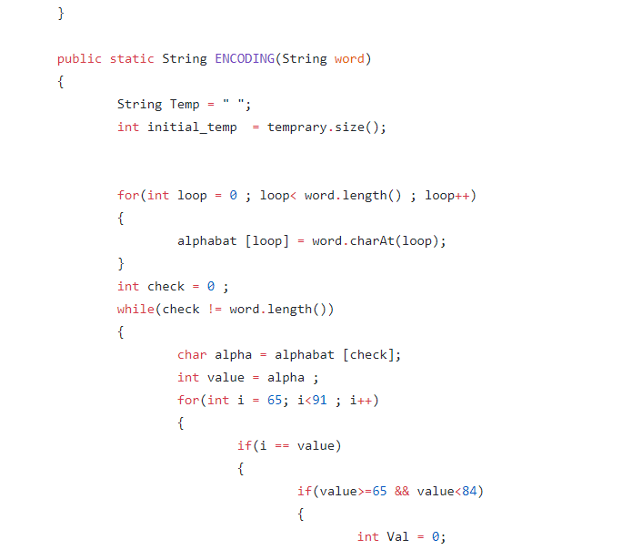

Now the key value is decoded into the actual string.
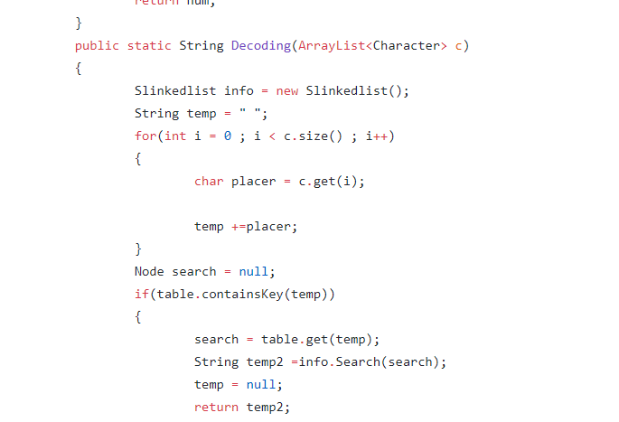

Screenshots

User will enter the code in string
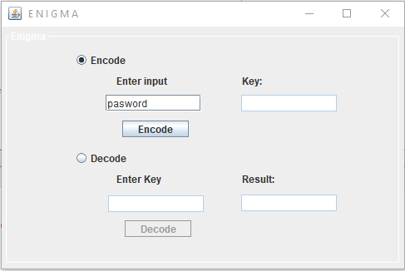

Specific key is generated for the string
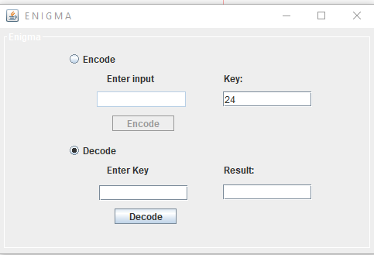

Here the user will enters the generated code in the decode section.
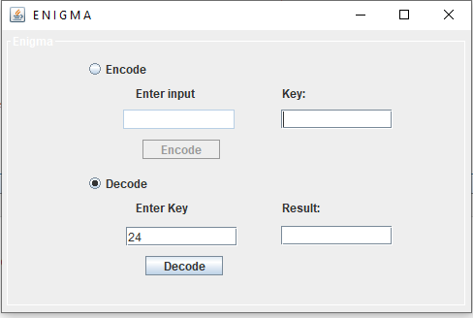

The actual string is generated from the key value
