Experiment 1

OBJECTIVE:- Design a LEX Code to count the number of lines, space, tab-meta character and rest of characters in a given Input pattern.

%{
#include<stdio.h>
int lc=0, sc=0, tc=0, ch=0; /*Global variables*/
%}

%%
\n lc++; //line counter
[ ] sc++; //space counter
\t tc++; //tab counter
. ch++; //characters counter
%%

int yywrap() {return 1;}
int main()
{
yylex();

printf("\nNo. of lines=%d", lc);
printf("\nNo. of spaces=%d", sc);
printf("\nNo. of tabs=%d", tc);
printf("\nNo. of characters=%d", ch);
}

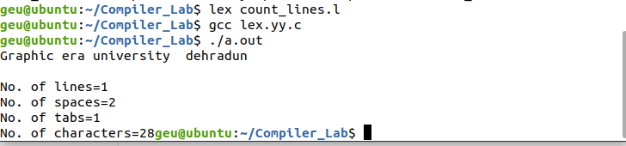

Experiment 2

OBJECTIVE:- Design a LEX Code to identify and print valid Identifier of C/C++ in given Input pattern.

%{
#include<stdio.h>
int c1=0; //count keywords
int c2=0; //valid identifiers
int c3=0; //invalid identifiers
%}
%%
auto|break|case|char|const|continue|default|do|double|else|enum|extern|float|for|goto|if|int|long|register|return|short|signed|sizeof|static|struct|switch|typedef|union|unsigned|void|volatile|while c1++;
^([a-zA-Z_])+([a-zA-Z0-9_]) c2++;
^. c3++;
%%
int yywrap(){
return 1;
}
int main()
{
yylex();
printf("NUMBER OF KEYWORDS -> %d",c1);
printf("\nNUMBER OF IDENTIFIERS -> %d",c2);
printf("\nINVALID IDENTIFIER -> %d\n",c3);
}

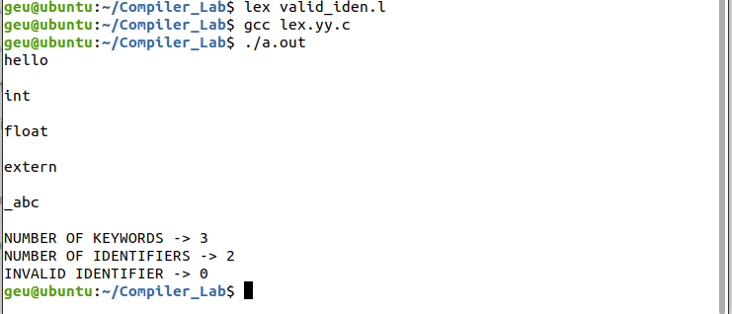

Experiment 3

OBJECTIVE:- Design a LEX Code to identify and print integer and float value in given Input pattern

%{
#include<stdio.h>
%}

%%
[0-9]+"."[0-9]+ {ECHO; printf("-->Decimal Number\n");}
[0-9]+ {ECHO; printf("-->Integer Number\n");}
%%

int yywrap()
{
return 1;
}

int main(void)
{
yylex();
return 0;
}

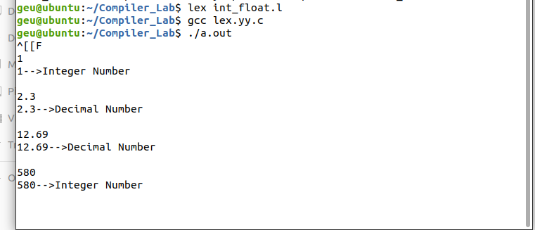

Experiment 4

OBJECTIVE:- Design a LEX Code for Tokenizing (Identify and print OPERATORS, SEPERATORS, KEYWORDS, IDENTIFERS) the following C-fragment:
int p=1,d=0,r=4;
float m=0.0, n=200.0;
while (p <= 3)
{ if(d==0)
{ m= m+n*r+4.5; d++; }
else
{ r++; m=m+r+1000.0; }
p++; }

%{
#include<stdio.h>
int cK=0; //count keywords
int cS=0; //count separators
int cO=0; //count operators
int cI=0; //count integer values
int cD=0; //count decimal values
%}
%%
auto|break|case|char|const|continue|default|do|double|else|enum|extern|float|for|goto|if|int|long|register|return|short|signed|sizeof|static|struct|switch|typedef|union|unsigned|void|volatile|while cK++;
[0-9]+ cI++;
[0-9]+"."[0-9]+ cD++;
"+"|"-"|""|"/"|"%"|"++"|"--"|"=="|"<"|"<="|">="|">"|"!="|"\||"|"&&"|"!"|"&"|"\|"|"^"|"~"|"&"|"<<"|">>"|"="|"+="|"-="|"="|"/="|"%="|"<<="|">>="|"&="|"^="|"\|=" cO++;
[" ,"]|[";"] cS++;
.
%%
int yywrap(){
return 1;
}
int main()
{

yylex();
printf("NUMBER OF KEYWORDS -> %d\n",cK);
printf("NUMBER OF INTEGERS -> %d\n",cI);
printf("NUMBER OF DECIMALS -> %d\n",cD);
printf("NUMBER OF SEPERATORS -> %d\n",cS);
printf("NUMBER OF OPERATORS -> %d\n",cO);
}
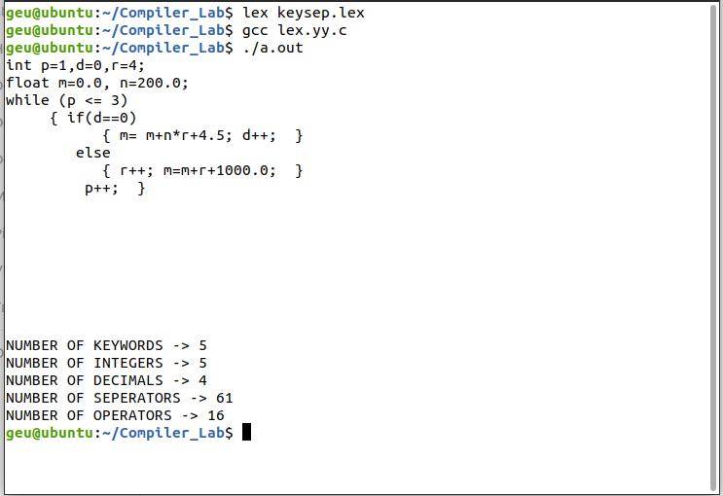

Experiment 5

OBJECTIVE:- Design a LEX Code to count and print the number of total characters, words, white spaces in given ‘Input.txt’ file.

%{
#include<stdio.h>
int lines=0, words=0,spaces=0,total=0;
%}

%%
\n { lines++; words++; total++;}
[\t ' '] {words++;total++;}
[" "] {spaces++;total++;}
%%

int yywrap()
{
return 1;
}

int main()
{
yyin = fopen("Input.txt","r");
yylex();
printf("LINES : %d WORDS : %d SPACES %d TOTAL: %d",lines, words, spaces, total);
return 0;
}

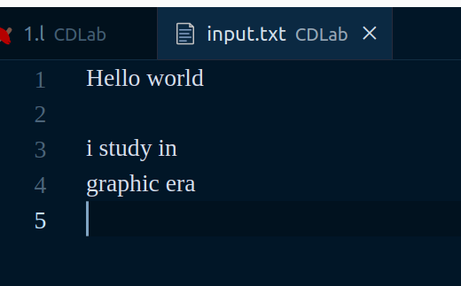

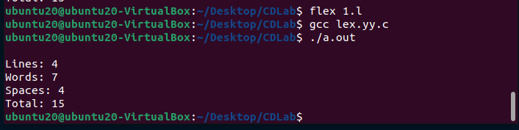

Experiment 6

OBJECTIVE:- Design a LEX Code to replace white spaces of ‘Input.txt’ file by a single blank character into ‘Output.txt’ file.

%{
#include<stdio.h>
%}

%%
. fprintf(yyout," ");
%%
int yywrap()
{
return 1;
}
int main()
{
yyin = fopen("input3.txt","r");
yyout = fopen("output3.txt","w");
yylex();
return 0;
}

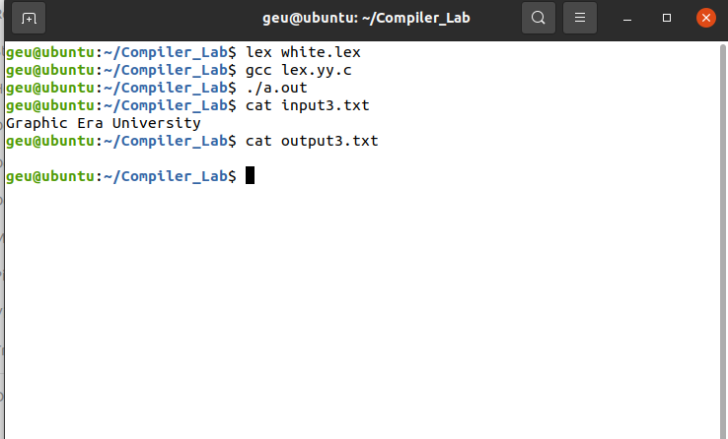

Experiment 7

OBJECTIVE:- Design a LEX Code to remove the comments from any C-Program given at run-time and store into ‘out.c’ file.

%{
#include<stdio.h>
%}
%%
\/\/(.*) { };
\/\*(.*\n)*.*\*\/ { };
%%
int yywrap()
{
return 1;
}
int main()
{
yyin=fopen("input.txt","r");
yyout=fopen("output.txt","w");
yylex();
return 0;
}
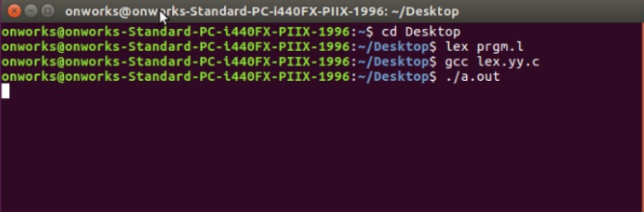

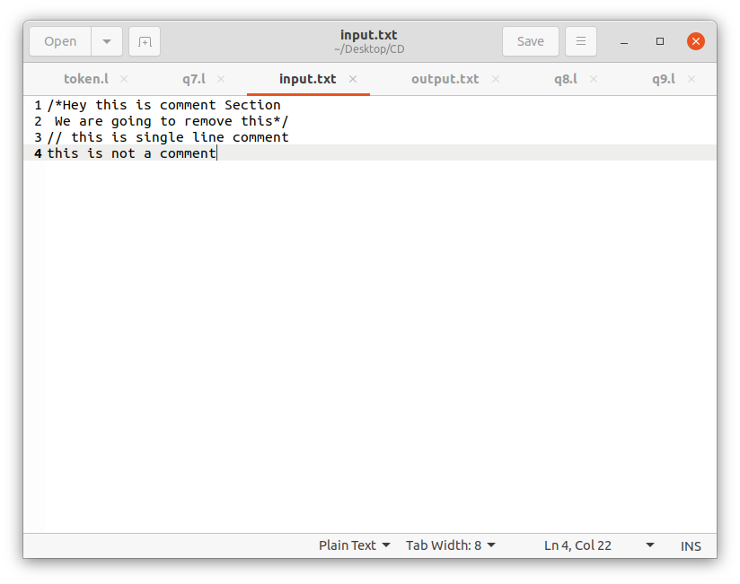

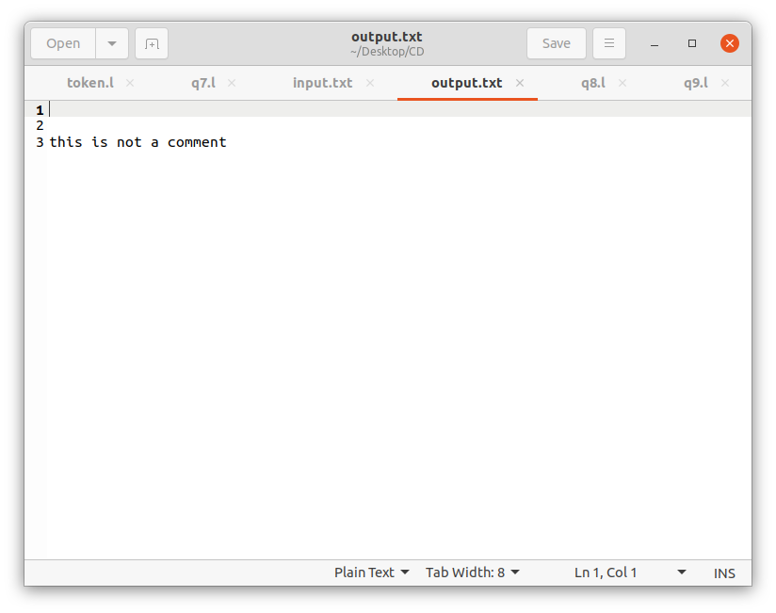

Experiment 8

OBJECTIVE:- Design a LEX Code to extract all html tags in the given HTML file at run time and store into Text file given at run time.

%{
#include<stdio.h>
%}

%%
"<"[^>]*> {fprintf("%s\n",yytext);}
. ;
%%

int yywrap()
{
return 1;
}

int main()
{
yyin = fopen("input.txt","r");
yylex();
return 0;
}

