**Database User Guide**

Group 2

**1. Before you start:**

**Please unzip the data dictionary and open the data_dictionary.html to view the Data Dictionary**

a) Log into SQL Developer.

b) Create table, views, triggers, sequences, and procedures, packages, functions, by typing start <pathname>\G2_eggshell.sql and hit enter at the SQL> prompt.

Make sure you type: ***SET SERVEROUTPUT ON*** before running the following procedures, functions, etc.

**2. Option update**

Basically, if a buyer wants to change options for different stages, an update will be made in the column *stage* of the BUYER_CHOICE table. Then the trigger print_option_change will be fired and print out the result about whether the buyer should pay more cost or could save cost regarding this opinion stage change.

A sample output:

SQL> UPDATE buyer_choice

2 SET stage = 7

3 WHERE choice_id = 1;

Old option: option 1027 at stage 4

New option: option 1027 at stage 7

The buyer should pay $225 more for changing the option.

**3. Staff leaves**

When staff leaves Eggshell, before the data in the STAFF table are deleted, the trigger staff_deleting will find out all related constructions, sales and choices and set the *staff_id* in charge to NULL. Simply DELETE FROM staff WHERE staff_id = 1; and check tables BUYER_CHOICE, CONSTRUCTION or SALES to confirm related *staff_id* are changed to null.

A sample output:

SQL> DELETE FROM staff

2 WHERE staff_id = 1;

The deleting staff has follow buyer_choice job:

CHOICE ID CHOICE DATE LOT ID

1 26-MAY-20 1

2 02-MAY-19 1

3 02-OCT-20 2

The deleting staff has follow sales job:

SALES ID SALES DATE LOT ID

1 24-MAY-19 1

2 24-JAN-19 2

The deleting staff has follow construction job:

PROGRESS ID STAGE HOUSE ID

**4. Display house details**

The procedure display_house_style(subdivision_id, style_id) is already compiled in ***G2_eggshell.sql***so simply by typing execute display_house_style(1,1) will print out house style details of subdivision with ID = 1 and style with ID = 1.

A sample output:

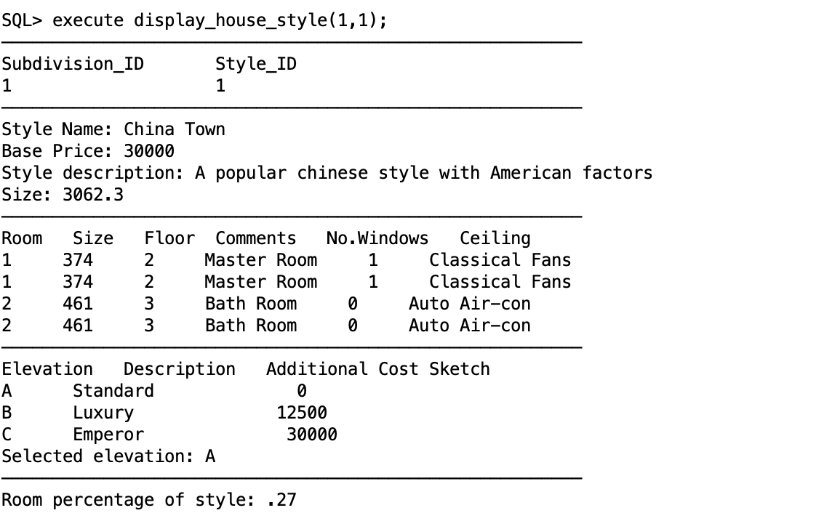

**5. Display a construction progress**

The procedure construction_progress(progress_id) is already compiled in ***G2_eggshell.sql***so only by typing execute construction_progress(2) to check the construction progress of the construction progress with ID = 2. You can check {1, 2, 3, 4, 5, 6} as we only insert limited sample data.

A sample output:

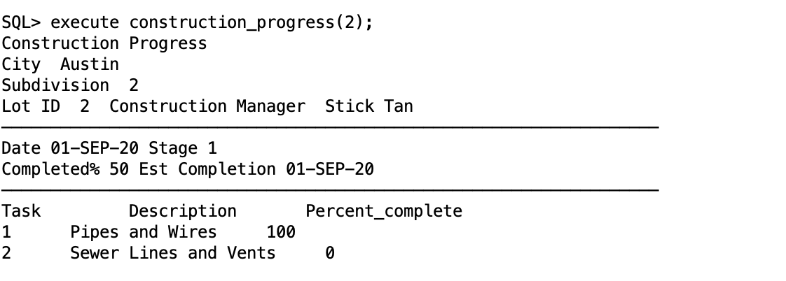

**6. To determine whether a buyer can cancel the contract or not**

According to Eggshell’s business rules, a buyer can cancel his or her sale contract if the house hasn’t been completed within one year after signing the contract. The procedure check_cancel(sale_id) is already compiled in ***G2_eggshell.sql*** so only by typing execute check_cancel(1)can help check the canceling status and sales details of the sale record with ID = 1.

A sample output:

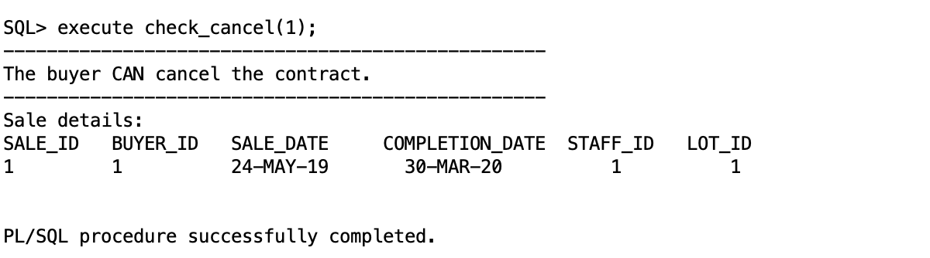

**7. Display the information of a sale record**

The procedure sale_contract(sale_id) is already compiled in ***G2_eggshell.sql*** so only by typing execute sale_contract(1)to check the sales details of the sale record with ID = 1. You can check {1~10} as we only insert limited sample data.

A sample output:

