**Write express js script to perform tasks as asked below.**

1. **Create one HTML file which contains two number type input fields, one dropdown which contains options like (select, addition, subtraction, multiplication, division) and one submit button.**
2. **The input fields must contain the value greater than 0 else it will give a message “Please enter the valid message”. Also, user must select any of the formula from the dropdown else give a message “You have not selected any formula”. (Message will be displayed on “/calc” page.)**
3. **If one formula is selected and numbers are entered then respective calculations will be performed on the page “/calc”.**
4. **Use get method to request data.**

**/Backend/calc.js**

var expr = require("express");

var app = expr();

var p = require("path");

//css file in folder css

var css = p.join(__dirname,"../css");

app.use(expr.static(css));

// Html file in folder frontend

const staticp = p.join(__dirname,"../frontend");

app.use(expr.static(staticp,{index:'calc.html'}));

app.get("/calc",(req,res,next)=>{

    res.set("content-type","text/html");

    var n1 = parseInt(req.query.n1);

    var n2 = parseInt(req.query.n2);

    if ((n1>0) && (n2>0)) {

        if(req.query.formula == "addition"){

            a = n1+n2;

            res.write("<h1>Addition is : " + a + "</h1>");

        }

        else if(req.query.formula == "subtraction"){

            s = n1-n2;

            res.write("<h1>Subtraction is : " + s + "</h1>");

        }

        else if(req.query.formula == "multi"){

            m = n1*n2;

            res.write("<h1>Multiplication is : " + m + "</h1>");

        }

        else if(req.query.formula == "div"){

            d = n1/n2;

            res.write("<h1>Division is : " + d + "</h1>");

        }

        else{

            res.write("<h1>You have not selected any formula.</h1>");

        }

    }else{

        res.write("<h1>Please enter the valid number/s.</h1>");

    }

    res.send()

})

app.listen(6012);

**/css/t1.css**

.lj_form{

    background-color: rgb(158, 158, 219);

}

**/frontend/calc.html**

<html>

<head>

    <link rel="stylesheet" href="/t1.css">

</head>

<body>

    <form action="/calc" method="get" class="lj_form">

    <fieldset>

        <legend>Calculator:</legend>

            <label for="n1">Enter Number1:</label>

            <input type="number" name="n1"><br><br>

            <label for="n2">Enter Number2:</label>

            <input type="number" name="n2"><br><br>

            <label for="formula">Formula: </label>

            <select name="formula" id="formula">

                <option value="">Select formula</option>

                <option value="addition">Addition</option>

                <option value="subtraction">Subtraction</option>

                <option value="multi">Multiplication</option>

                <option value="div">Division</option>

            </select><br><br>

            <input type="submit" value="Submit">

    </fieldset>

    </form>

</body>

</html>

Output:

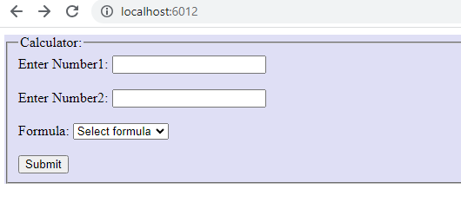

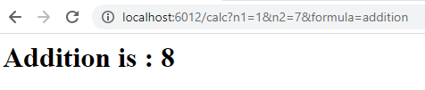

**Example 2**

/backend/t1.js

var expr = require("express");

var app = expr();

var p = require("path");

const staticp = p.join(__dirname,"../frontend");

app.use(expr.static(staticp,{index:'t1.html'}));

app.get("/login",(req,res,next)=>{

    console.log(req.query);

    res.set("content-type","text/html");

    res.write("<center><h1>Welcome " + req.query.name + "</h1>");

    res.write("<center><h2>Your email id is " + req.query.email + "</h2>");

    next();

})

app.get("/login",(req,res,next)=>{

    if(req.query.newsletter && req.query.newsletter == "on"){

        res.write("<h3>Thank you for your subcsription</h3><a href='/'>Logout</a>");

    }else{

        res.write("<h3>You can subcribe to get daily updates</h3><a href='/subscribe'>Subscribe</a></center>");

    }

   next();

});

app.get("/subscribe",(req,res)=>{

    res.set("content-type","text/html");

    res.write("<h3>Thank you for your subcsription</h3></center><a href='/'>Logout</a>");

    res.send();

});

app.listen(5001);

/frontend/t1.html

<form action="/login" method="get">

    <label for="name">Name:</label>

    <input type="text" name="name" required><br><br>

    <label for="email">Email:</label>

    <input type="email" name="email" required><br><br>

    <label for="message">Message:</label><br>

    <textarea name="message" id="message" cols="30" rows="4"></textarea><br><br>

    <input type="checkbox" name="newsletter" id="newsletter">

    <label for="newsletter">Subscribe?</label><br><br>

    <input type="submit" value="Submit">

</form>