Game Design Document

Fill up the Following document

1. Write the title of your project.

Toffee Catcher

1. What is the goal of the game?

The goal of the game is to catch as many toffees as possible.

1. Write a brief story of your game?

Children love toffees and ask god to make a fall of chocolates and sweets. God makes the fall of toffees and gives each child 3 chances to catch them. Along with toffees, God makes the fall of some bombs from which the children need to escape. After child catches a good number of toffees, God makes a fall of some larger chocolate bars. Children catch the toffees in basket.

1. Which are the playing characters of this game?

* Playing characters are the ones which respond to the user based on the input from the user
* Cars, monkeys, dinos, wizards etc, are the playing characters in the game.

|  |  |  |
| --- | --- | --- |
| Number | Character Name | What can this character do? |
| 1 | Basket | Catches toffees, donuts bombs and chocolate bars. |
| 2 |  |  |
| 3 |  |  |
| 4 |  |  |
| 5 |  |  |
| 6 |  |  |
| 7 |  |  |
| 8 |  |  |

1. Which are the Non Playing Characters of this game?

* Non Playing characters are the ones which don't have an action or a behaviour when the user interacts with the game.
* Hurdles, stones, bananas, coins, etc are non playing characters in the game.

|  |  |  |
| --- | --- | --- |
| Number | Character Name | What can this character do? |
| 1 | Toffees | Fall from sky. |
| 2 | Chocolate Bars | Fall from sky. |
| 3 | Donuts | Fall from sky. |
| 4 | Bombs | Fall from sky. |
| 5 | Score | Increases when toffees, chocolate bars and donuts are catched. |
| 6 | Lifelines | Decreases when bombs are catched. |
| 7 |  |  |
| 8 |  |  |

Draw your imagination of this game. What does this game look like?

* Draw the game either on your computer or on paper,
* Add images of scenes of the game to show each of the playing and non-playing characters at least once.

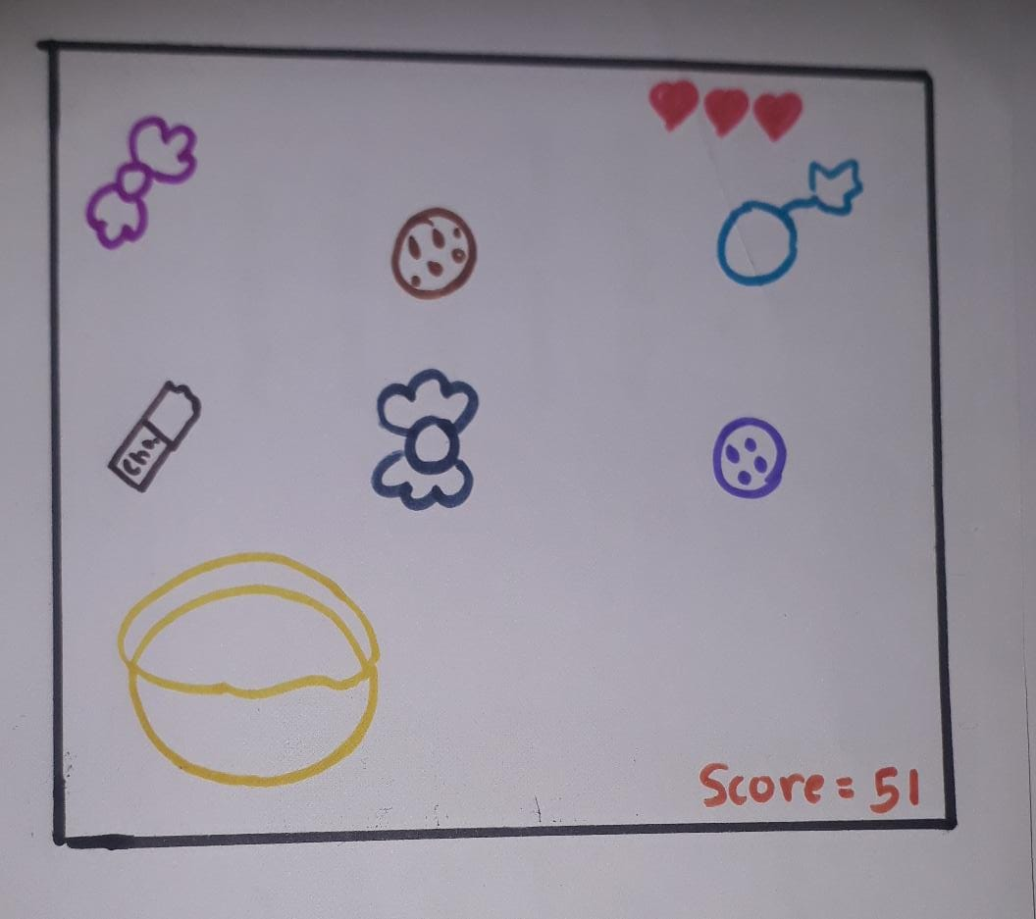

How do you plan to make your game engaging?

Player needs to concentrate on toffees and bombs continuously and needs to decide whether to catch or leave it fastly. This makes the game engaging.