TABLES:

Given create and insert queries.

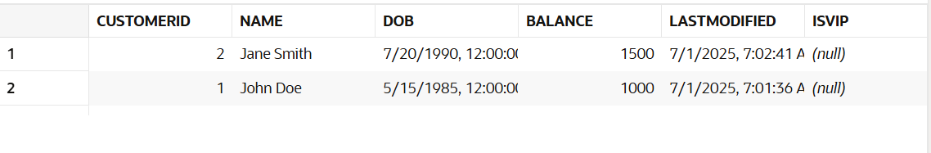

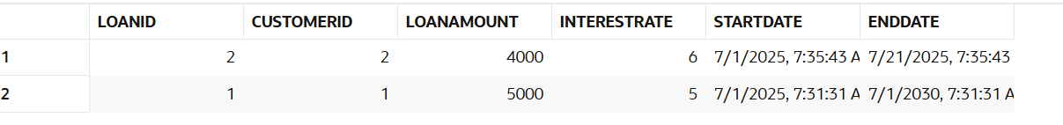

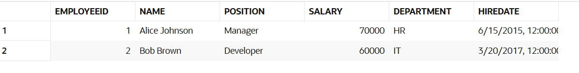

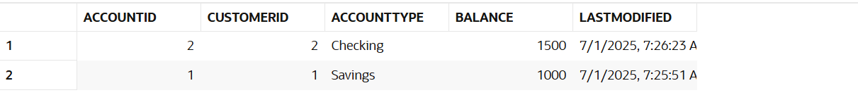

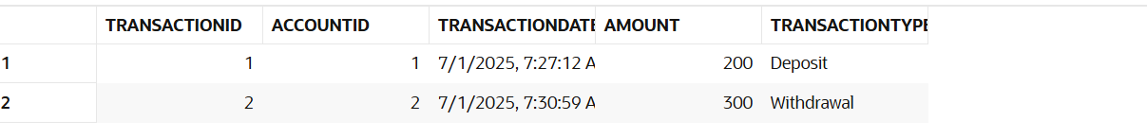

**Exercise 1: Control Structures**

**Scenario 1:** The bank wants to apply a discount to loan interest rates for customers above 60 years old.

* + **Question:** Write a PL/SQL block that loops through all customers, checks their age, and if they are above 60, apply a 1% discount to their current loan interest rates

BEGIN

FOR cust_rec IN (

SELECT CustomerID, DOB

FROM Customers

)

LOOP

DECLARE

v_age NUMBER;

BEGIN

v_age := TRUNC(MONTHS_BETWEEN(SYSDATE, cust_rec.DOB) / 12);

IF v_age > 60 THEN

UPDATE Loans

SET InterestRate = InterestRate - 1

WHERE CustomerID = cust_rec.CustomerID;

END IF;

END;

END LOOP;

COMMIT;

END;

/

OUTPUT:

SELECT LoanID, CustomerID, InterestRate FROM Loans;

/

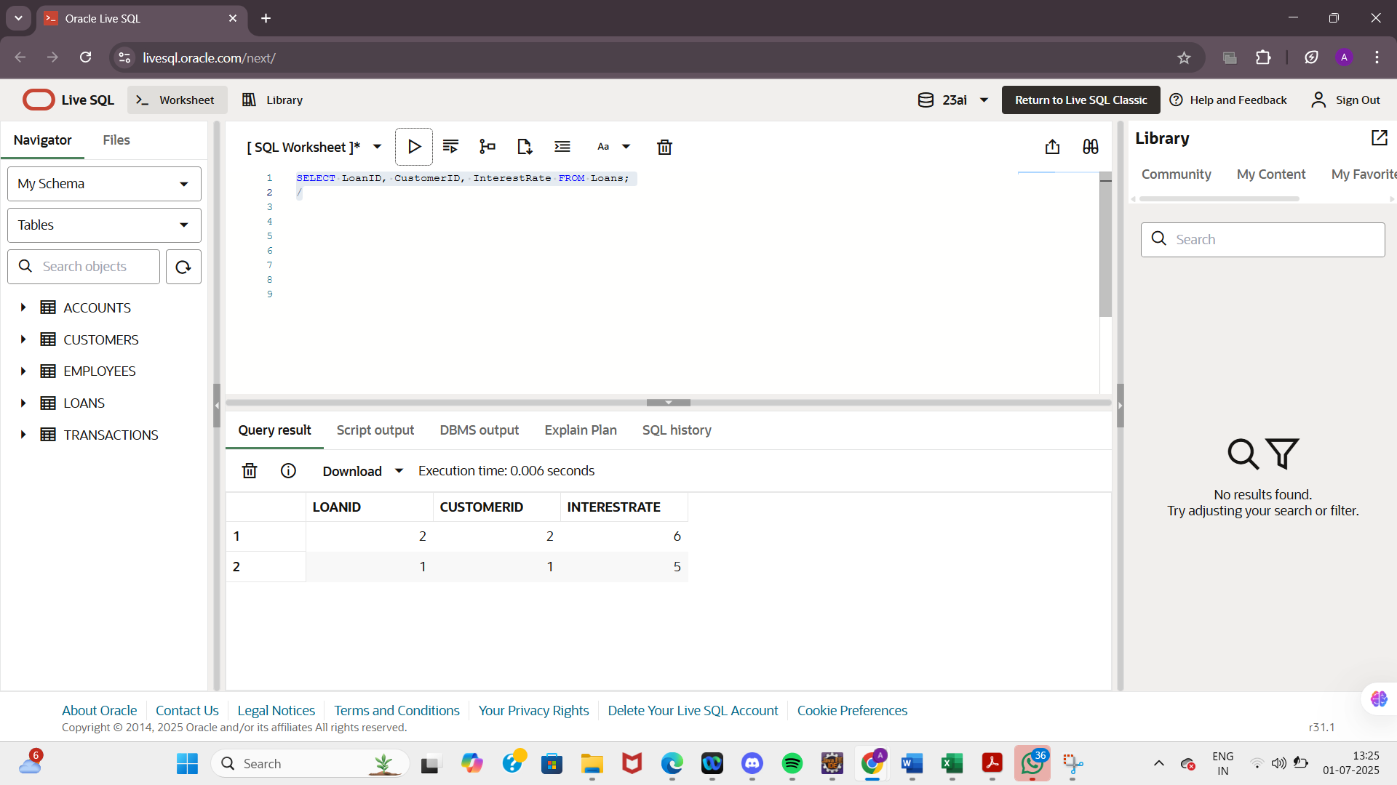

**Scenario 2:** A customer can be promoted to VIP status based on their balance.

* + **Question:** Write a PL/SQL block that iterates through all customers and sets a flag IsVIP to TRUE for those with a balance over $10,000.

BEGIN

FOR cust IN (

SELECT CustomerID, Balance

FROM Customers

)

LOOP

IF cust.Balance > 10000 THEN

UPDATE Customers

SET IsVIP = 'Y'

WHERE CustomerID = cust.CustomerID;

END IF;

END LOOP;

COMMIT;

END;

/

OUTPUT:

SELECT CustomerID, Name, Balance, IsVIP FROM Customers;

/

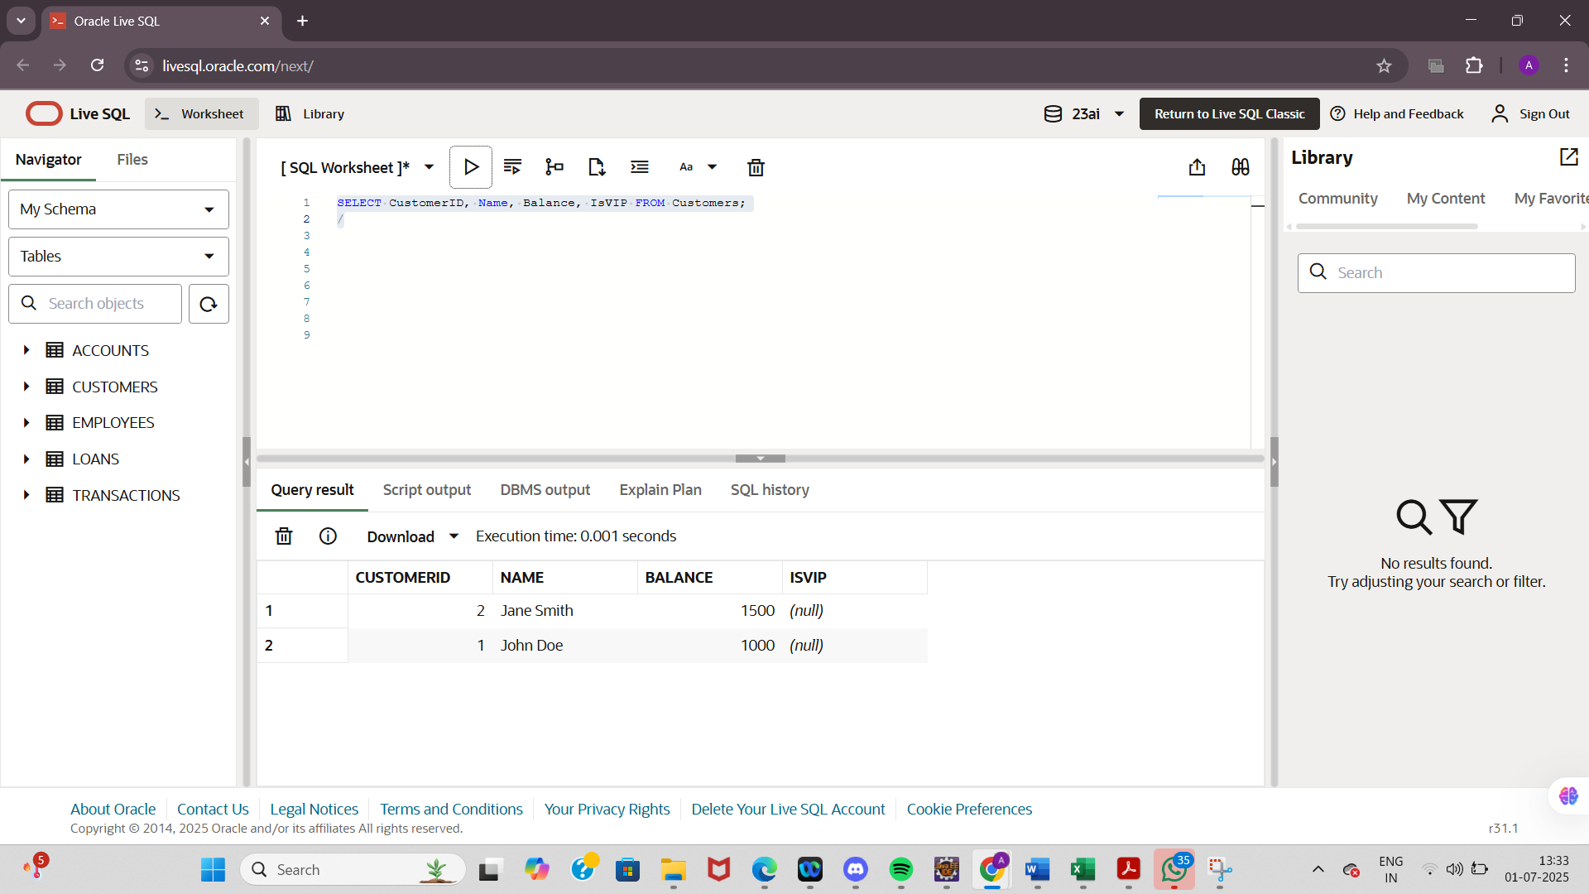

**Scenario 3:** The bank wants to send reminders to customers whose loans are due within the next 30 days.

**Question:** Write a PL/SQL block that fetches all loans due in the next 30 days and prints a reminder message for each customer

BEGIN

FOR loan_rec IN (

SELECT l.LoanID, l.CustomerID, c.Name, l.EndDate

FROM Loans l

JOIN Customers c ON l.CustomerID = c.CustomerID

WHERE l.EndDate BETWEEN SYSDATE AND SYSDATE + 30

)

LOOP

DBMS_OUTPUT.PUT_LINE('Reminder: Loan ID ' || loan_rec.LoanID ||

' for customer ' || loan_rec.Name ||

' is due on ' || TO_CHAR(loan_rec.EndDate, 'DD-MON-YYYY'));

END LOOP;

END;

/

OUTPUT:

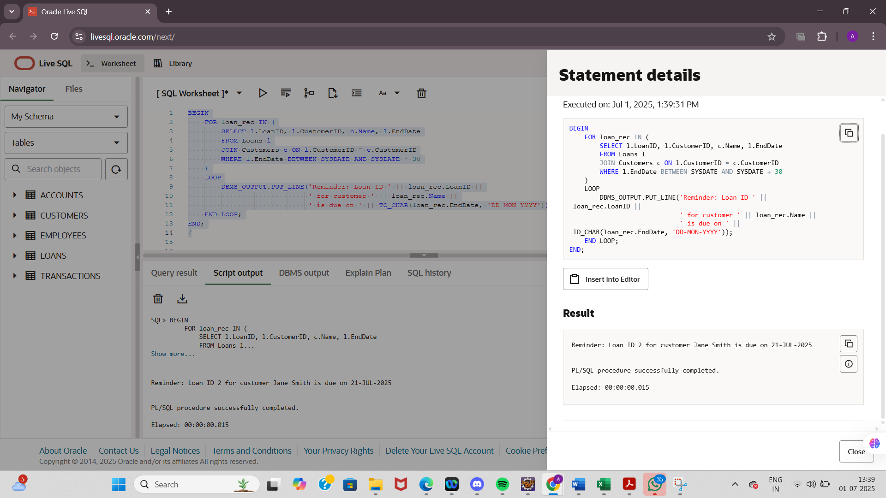

**Exercise 3: Stored Procedures**

**TABLES:**

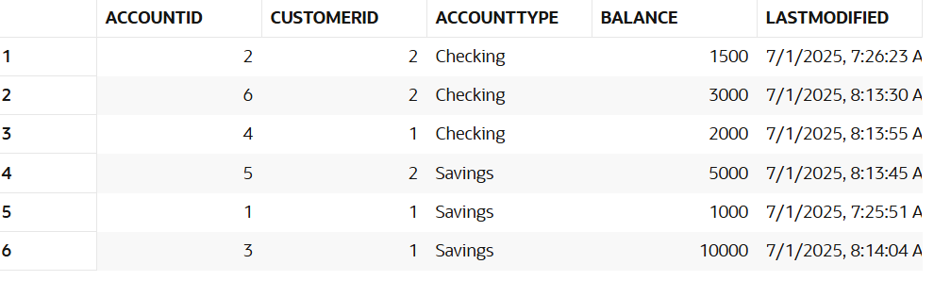

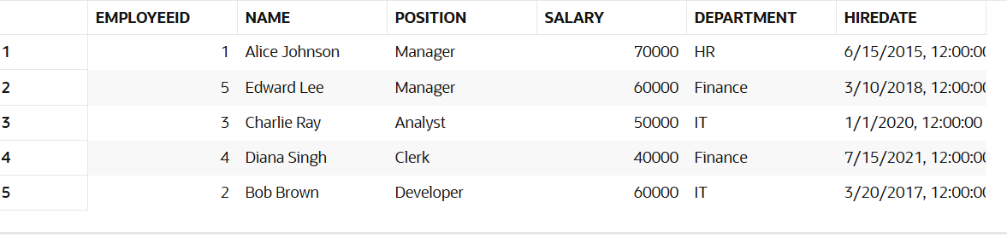

**Scenario 1:** The bank needs to process monthly interest for all savings accounts.

* + **Question:** Write a stored procedure **ProcessMonthlyInterest** that calculates and updates the balance of all savings accounts by applying an interest rate of 1% to the current balance.

CREATE OR REPLACE PROCEDURE ProcessMonthlyInterest IS

BEGIN

UPDATE Accounts

SET Balance = Balance + (Balance * 0.01)

WHERE AccountType = 'Savings';

COMMIT;

END;

/

BEGIN

ProcessMonthlyInterest;

END;

/

OUTPUT:

SELECT AccountID, AccountType, Balance FROM Accounts;

/

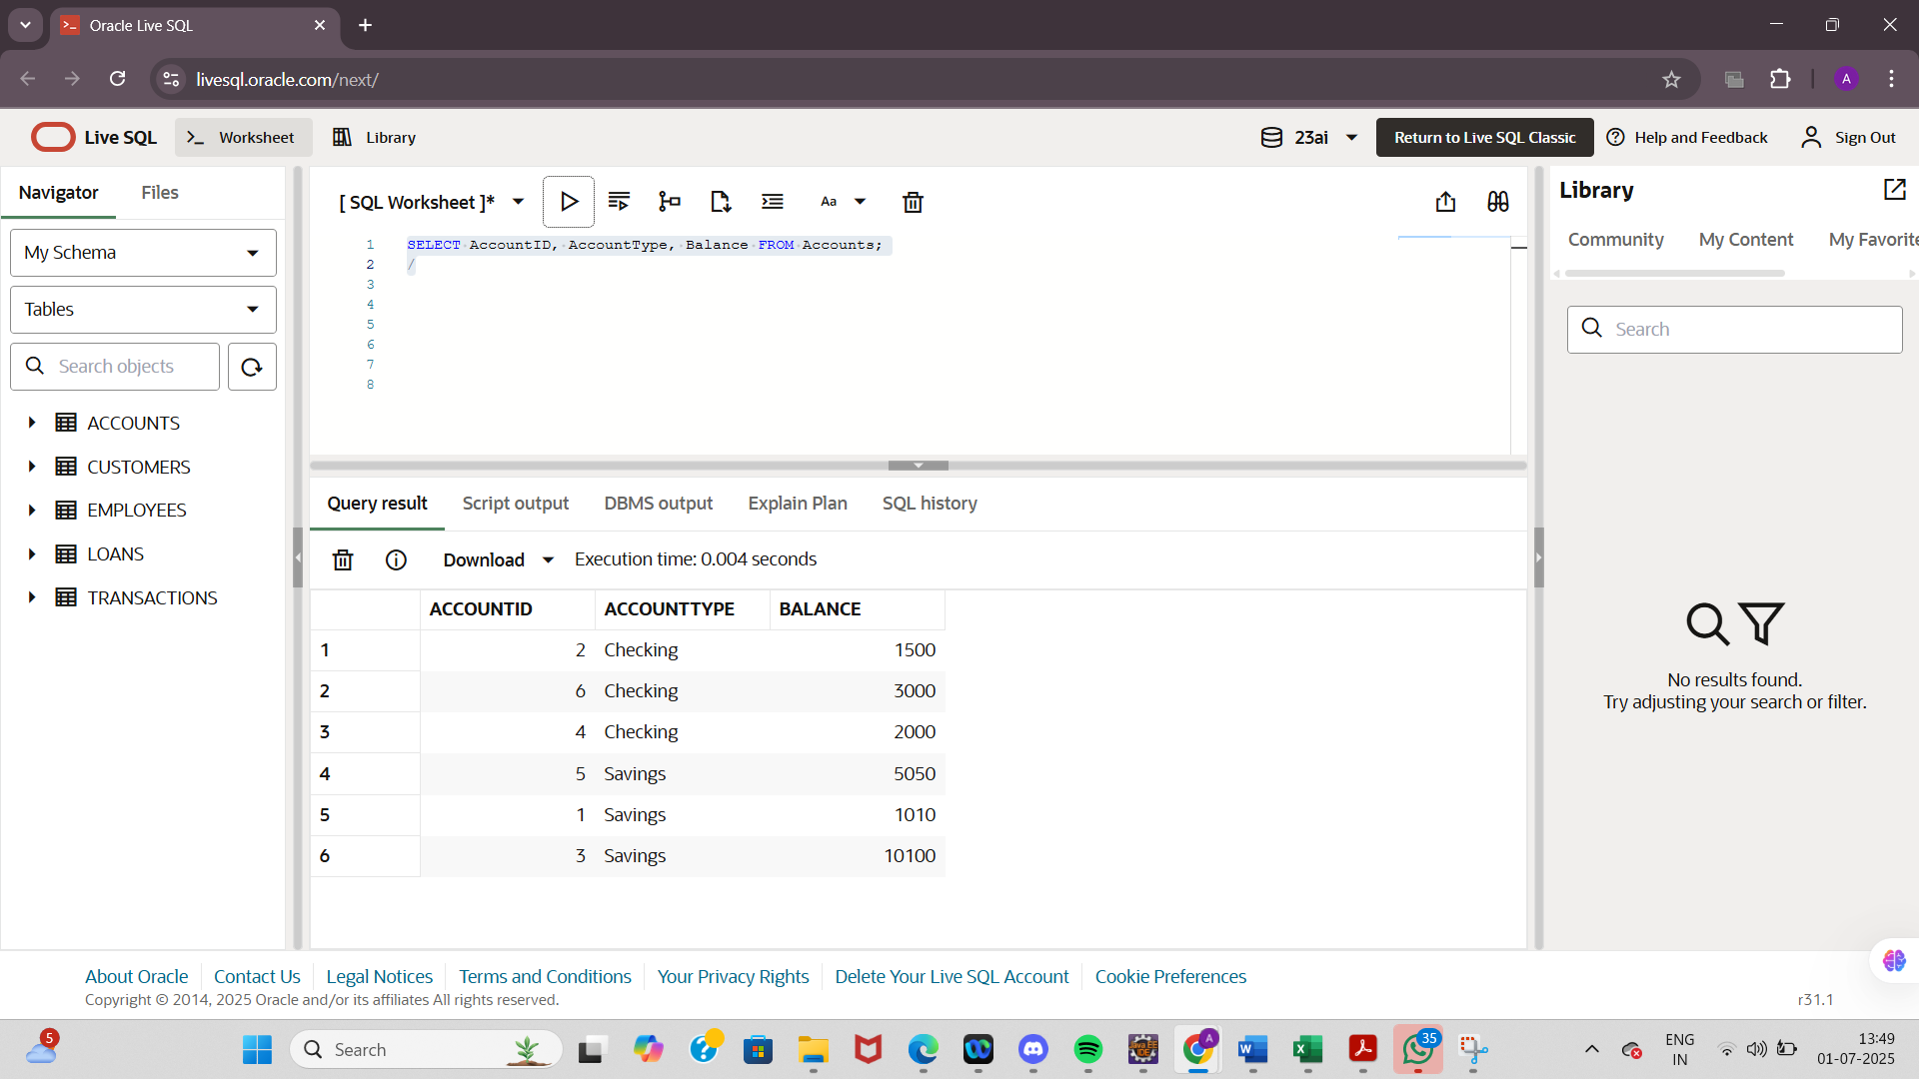

**Scenario 2:** The bank wants to implement a bonus scheme for employees based on their performance.

* + **Question:** Write a stored procedure **UpdateEmployeeBonus** that updates the salary of employees in a given department by adding a bonus percentage passed as a parameter.

CREATE OR REPLACE PROCEDURE UpdateEmployeeBonus (

p_department IN VARCHAR2,

p_bonus_percent IN NUMBER

) IS

BEGIN

UPDATE Employees

SET Salary = Salary + (Salary * p_bonus_percent / 100)

WHERE Department = p_department;

COMMIT;

END;

/

BEGIN

UpdateEmployeeBonus('Finance', 10);

END;

/

OUTPUT:

SELECT EmployeeID, Name, Department, Salary FROM Employees;

/

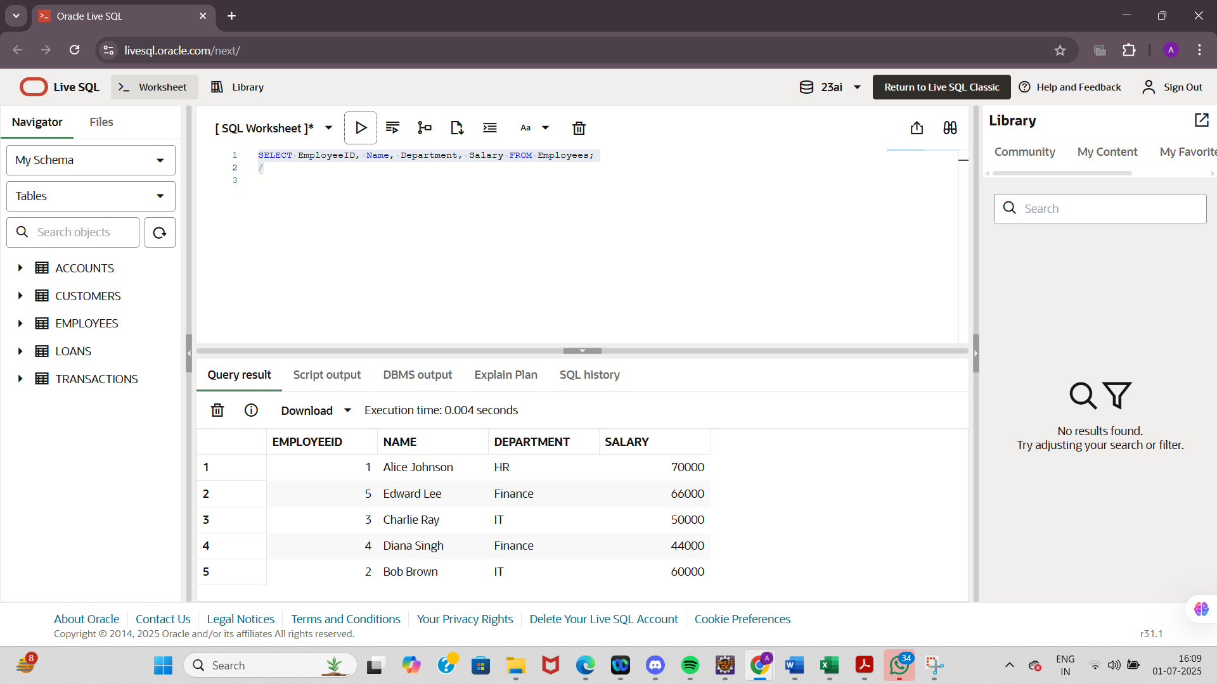

**Scenario 3:** Customers should be able to transfer funds between their accounts.

* + **Question:** Write a stored procedure **TransferFunds** that transfers a specified amount from one account to another, checking that the source account has sufficient balance before making the transfer.

DECLARE

v_from_account_id NUMBER := 4; -- source account (Checking for Customer 1)

v_to_account_id NUMBER := 3; -- destination account (Savings for Customer 1)

v_amount NUMBER := 500;

v_from_balance NUMBER;

BEGIN

-- Get current balance of source account

SELECT Balance INTO v_from_balance

FROM Accounts

WHERE AccountID = v_from_account_id;

IF v_from_balance >= v_amount THEN

-- Deduct from source

UPDATE Accounts

SET Balance = Balance - v_amount

WHERE AccountID = v_from_account_id;

-- Add to destination

UPDATE Accounts

SET Balance = Balance + v_amount

WHERE AccountID = v_to_account_id;

COMMIT;

DBMS_OUTPUT.PUT_LINE('Transfer successful!');

ELSE

DBMS_OUTPUT.PUT_LINE('Transfer failed: Insufficient balance.');

END IF;

END;

/

OUTPUT:

SELECT AccountID, AccountType, Balance FROM Accounts

WHERE AccountID IN (3, 4);

/

