1. Title of the Invention
Title:
AI-Based Voice Coding Assistant for Differently-Abled People

2. Field of the Invention
The present invention relates to artificial intelligence–enabled software development tools, particularly voice-based programming assistance and accessibility-focused integrated development environments.

3. Background of the Invention
Existing software development environments rely predominantly on keyboard and mouse interaction for writing, editing, and navigating source code. While such systems are effective for conventional users, they pose significant accessibility challenges for individuals with physical or motor impairments, repetitive strain injuries, or temporary disabilities. Conventional speech-to-text systems allow dictation but lack understanding of programming context, syntax, and structural code relationships. Advanced AI coding assistants exist; however, they are primarily designed for text-based interaction and are not optimized for voice-driven workflows. Additionally, uncontrolled generative systems may introduce unsafe or unintended code modifications. Hence, there is a need for a voice-driven coding system that combines artificial intelligence with controlled, context-aware code manipulation, ensuring accessibility, safety, and predictable behavior within professional development environments.

4. Objectives of the Invention
- To enable hands-free software development using natural voice commands
- To provide context-aware code generation and modification within an IDE
- To improve programming accessibility for developers with disabilities
- To ensure controlled, safe, and predictable code manipulation using AI

5. Summary of the Invention
The present invention proposes an AI-based voice-driven coding assistant integrated into an integrated development environment, which overcomes the limitations of existing systems by enabling safe and context-aware programming through voice interaction. Spoken commands are converted into text and analyzed using artificial intelligence to identify user intent. The system applies predefined intelligent code transformation patterns rather than unrestricted generation, ensuring reliability and stability. Editor context such as programming language, cursor position, and selection state is utilized to perform accurate code insertion or modification. The invention enhances accessibility, usability, and productivity while maintaining deterministic behaviour suitable for real-world software development.

6. Brief Description of Drawings
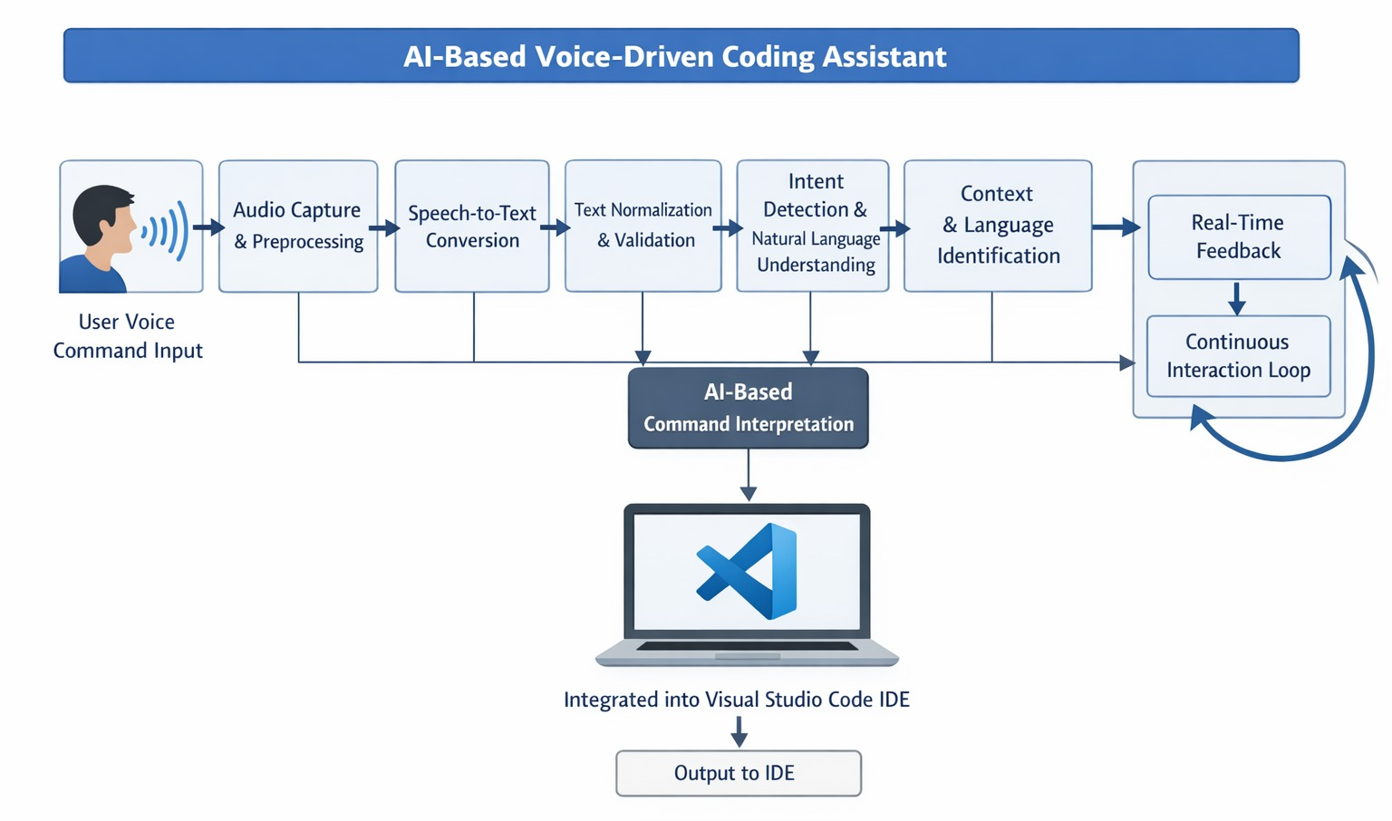
The figure illustrates the architecture of the AI-Based Voice-Driven Coding Assistant integrated with the Visual Studio Code IDE. User voice commands are first captured through an audio input interface and processed by the audio capture and preprocessing module. The speech-to-text conversion component transforms spoken input into textual form, which is then normalized and validated. The processed text is analyzed by the intent detection and natural language understanding module to identify the user’s programming intent. Context and programming language information from the IDE are incorporated to ensure accurate interpretation. The AI-based command interpretation module maps the identified intent to controlled programming actions. Real-time feedback and a continuous interaction loop enable responsive user interaction. The final output is securely transmitted and applied within the Visual Studio Code IDE.

7. Detailed Description of the Invention
The present invention comprises an AI-based voice-driven coding assistant designed to operate as an extension within an integrated development environment. The system includes a voice input module, a speech-to-text processing unit, an artificial intelligence–based intent interpretation module, a context-analysis component, and a controlled code generation engine. These components interact in a modular manner to ensure reliable and accessible software development.
Initially, the user issues a spoken command using a microphone interface. The voice input module captures the audio signal and forwards it to the speech-to-text processing unit. The speech-to-text unit converts the audio signal into a textual representation while handling pauses, silence, and environmental noise. The generated text represents the natural language command provided by the user.
Subsequently, the textual command is processed by the intent interpretation module. This module employs artificial intelligence techniques to analyze the semantic meaning of the command and classify it into predefined intent categories such as code generation, code modification, navigation, or execution. Unlike unrestricted generative systems, the intent interpretation module produces structured outputs that conform to a defined schema, ensuring predictable behavior.
The system further includes a context-analysis component that retrieves information from the integrated development environment, including the active programming language, cursor position, and selection status. This context information is transmitted securely to the backend system and combined with the interpreted intent to determine the appropriate action. Context awareness prevents incorrect code insertion and ensures that programming actions align with the current development state.
Following intent classification and context evaluation, the controlled code generation engine generates code using predefined templates or transformation rules. For example, when a function creation intent is detected, a syntactically valid function template is generated. When a wrapping or insertion intent is detected, the system applies deterministic transformations to existing code segments. This approach prevents unsafe or unintended modifications while providing Copilot-like behavior through constrained intelligence.
Finally, the generated code or message is transmitted back to the integrated development environment and inserted at the appropriate location. The system provides user feedback through status indicators or messages, confirming successful execution or informing the user of limitations. The invention ensures stability by implementing timeout handling, error validation, and graceful degradation in case of backend or input failures.

8. Claims
An AI-based voice-driven coding assistant system comprising a voice input module, a speech-to-text processing unit, an intent interpretation module, a context-analysis component, and a controlled code generation engine integrated within an integrated development environment.
- The system as claimed in claim 1, wherein the speech-to-text processing unit converts spoken commands into textual representations for further analysis.
- The system as claimed in claim 1, wherein the intent interpretation module classifies textual commands into predefined intent categories.
- The system as claimed in claim 1, wherein the context-analysis component retrieves programming language and cursor information from the integrated development environment.
- The system as claimed in claim 1, wherein the controlled code generation engine produces deterministic code templates based on identified intent.
- The system as claimed in claim 1, wherein unrestricted generative code output is prevented to ensure safety and predictability.
- The system as claimed in claim 1, wherein code insertion is performed only after validation of intent and editor context.
- The system as claimed in claim 1, wherein the system provides feedback messages indicating successful or failed command execution.
- The system as claimed in claim 1, wherein the system supports accessibility-focused software development.

- Abstract
The present invention relates to an AI-based voice-driven coding assistant designed to improve accessibility and usability in software development environments. The invention addresses the problem of limited accessibility in traditional integrated development environments that rely heavily on keyboard and mouse interaction. Spoken commands are captured through a microphone and converted into text using speech-to-text processing. The proposed system includes an artificial intelligence–based intent interpretation mechanism that identifies programming actions from natural language commands. Context information from the development environment, such as programming language and cursor position, is utilized to ensure accurate and safe code insertion. Rather than relying on unrestricted generative models, the system employs controlled code transformation templates to prevent unintended modifications. The invention enables hands-free, context-aware programming while maintaining stability, predictability, and professional development workflows. The system is suitable for developers with disabilities and supports inclusive software engineering practices.

- Industrial Applicability
The invention can be applied in software development industries, educational institutions, assistive technology solutions, and professional programming environments. It is particularly useful for accessibility-focused development tools, inclusive coding platforms, and voice-enabled integrated development environments.

