Voice-Enabled AI Coding Assistant for Accessible Programming
Rajalakshmi M, Esther Nowroji S, Sharanya T, Santhosh S, Aashif Shadin K N
Department of Artificial Intelligence and Data Science, Dr. Mahalingam College of Engineering and Technology, Coimbatore, India
Abstract - This work aims to improve accessibility in software development using artificial intelligence and voice-based interaction for developers with disabilities. An AI-based, voice-driven coding assistant integrated into an Integrated Development Environment is proposed. Spoken commands are converted into text and interpreted to perform relevant programming actions such as code generation, modification, and navigation. By combining natural language understanding with IDE-level functionality, the system reduces dependence on traditional input devices and supports inclusive coding workflows. The proposed framework serves as a foundation for future voice-controlled coding systems.
Keywords - Voice-Based Coding Assistant, Artificial Intelligence, Accessibility, Speech-to-Text, Natural Language Processing, Integrated Development Environment, Inclusive Computing, Visual Studio Code
I. INTRODUCTION
Programming environments have traditionally been designed around intensive keyboard and mouse interaction, which poses significant accessibility challenges for developers with physical, motor, or visual disabilities. Writing, editing, and navigating source code often require precise and continuous manual input, making conventional Integrated Development Environments (IDEs) difficult to use for individuals who are unable to rely on standard input devices. As a result, many capable individuals face barriers to participating fully in software development.
Recent advancements in artificial intelligence and speech recognition technologies have enabled more natural and intuitive human–computer interaction. Voice-based interfaces, in particular, offer a promising alternative by allowing users to interact with computing systems through spoken commands. However, existing voice tools are primarily designed for general-purpose tasks and lack deep integration with programming environments. They often fail to understand programming-specific syntax, context, and workflows, limiting their effectiveness for coding tasks.
AI-powered coding assistants have emerged as valuable tools for improving developer productivity by providing code suggestions, automation, and error detection. Despite these advancements, most such assistants assume traditional input methods and are not optimized for accessibility. Moreover, limited attention has been given to enabling hands-free coding through natural language voice commands that can directly manipulate code within an IDE.
To address these challenges, this paper proposes an AI-based, voice-driven coding assistant integrated as a Visual Studio Code extension. The proposed system aims to interpret natural language voice commands and translate them into programming actions such as code generation, modification, and navigation across multiple programming languages. By focusing on accessibility and seamless IDE integration, the proposed approach seeks to reduce barriers to coding and promote inclusive software development practices for developers with disabilities.
II. RELATED WORKS
Recent research in human–computer interaction has highlighted the potential of voice-based systems in improving accessibility for users with disabilities. Speech recognition technologies have been widely explored for enabling hands-free interaction with computing systems, particularly for text dictation and basic command execution. While these systems demonstrate high accuracy in converting speech to text, they are generally not designed to handle programming-specific syntax or contextual code understanding.
AI-powered coding assistants have gained popularity for supporting developers through features such as code completion, error detection, and automated suggestions. These tools leverage machine learning and large language models to improve coding efficiency and reduce development time. However, most existing coding assistants assume the availability of traditional input devices and are not specifically tailored to support developers with disabilities. Their interaction mechanisms remain largely keyboard-centric, limiting their accessibility.
Several studies have explored accessibility-focused software tools aimed at assisting users with motor or visual impairments. These tools often provide alternative input methods such as screen readers, switch-based controls, or limited voice commands. Although they improve accessibility to some extent, they lack deep integration with modern Integrated Development Environments (IDEs) and do not support complex programming workflows across multiple languages.
More recent works have investigated the use of natural language processing and artificial intelligence for interpreting user intent in software development tasks. These approaches show promise in translating natural language descriptions into executable code. However, existing solutions typically operate as standalone systems or web-based tools, rather than being seamlessly integrated into IDEs as real-time, voice-driven assistants.
In summary, existing research demonstrates the effectiveness of voice interaction, AI-based code assistance, and accessibility tools independently. Nevertheless, there remains a notable gap in combining these technologies into a unified, IDE-integrated solution that enables accessible, voice-driven coding. This paper aims to address this gap by proposing an AI-based voice-controlled coding assistant designed specifically to support developers with disabilities within a modern programming environment.
III. PROBLEM DESCRIPTION
Software development environments are predominantly designed for users who can efficiently operate keyboards and pointing devices. This design paradigm creates significant barriers for developers with physical, motor, or visual disabilities, who may find it difficult or impossible to perform continuous typing, cursor navigation, and precise code editing. As a result, accessibility in programming remains limited despite advancements in development tools.
Although voice recognition technologies have improved considerably in recent years, their application in programming environments remains inadequate. Most existing voice-based tools are designed for general-purpose tasks such as text dictation or basic system commands and lack an understanding of programming syntax, structure, and context. Consequently, these tools are unable to support complex coding activities such as function creation, code modification, debugging, and navigation within an Integrated Development Environment (IDE).
AI-based coding assistants have demonstrated strong potential in assisting developers through automated code suggestions and error detection. However, these systems are primarily optimized for traditional input methods and offer limited accessibility support. The lack of voice-driven, context-aware interaction within IDEs restricts their usability for developers with disabilities and reduces their effectiveness as inclusive development tools.
Therefore, there is a critical need for an intelligent, voice-driven coding system that can interpret natural language commands, understand programming context, and seamlessly integrate with modern IDEs. Addressing this challenge is essential to enable accessible programming workflows and promote inclusive participation in software development.
IV. OBJECTIVE OF THE PROJECT
The primary objective of this project is to design an AI-based, voice-driven coding assistant that enhances accessibility for developers with disabilities. The proposed system aims to enable hands-free interaction with a programming environment by allowing users to issue natural language voice commands for coding tasks.
The project seeks to develop a system capable of interpreting spoken commands and translating them into meaningful programming actions such as code generation, modification, navigation, and execution within an Integrated Development Environment. By integrating artificial intelligence techniques, the system is intended to support multiple programming languages while maintaining contextual awareness of the code being edited.
Additionally, the project aims to provide a seamless integration with Visual Studio Code through an extension-based architecture, ensuring usability without disrupting existing development workflows. By improving accessibility and reducing reliance on traditional input devices, the proposed approach aspires to promote inclusive software development and enable wider participation in programming activities.
V. METHODOLOGY
The proposed system employs an artificial intelligence–based approach to interpret voice commands and convert them into programming actions. The methodology focuses on understanding natural language input and mapping it to code-related operations within an Integrated Development Environment.
A) AI-Based Voice Command Processing
- Voice-Driven Interaction: The system allows users to interact with the programming environment using spoken commands, eliminating the need for continuous keyboard and mouse usage.
- Speech-to-Text Conversion: Voice input is converted into textual form using speech-to-text techniques, ensuring that spoken instructions are accurately captured for further processing.
- Natural Language Understanding: The converted text is analysed using natural language processing to determine the intent of the command, such as code creation, modification, or navigation.
- Context Awareness: The system considers the active programming language and editor context to ensure that commands are interpreted correctly.
- Scalability: The modular design enables support for multiple programming languages and future enhancements without major architectural changes.
B) Artificial Intelligence for Command Interpretation
Artificial intelligence techniques are employed to bridge the gap between natural language commands and programming-specific actions.
- Intent Detection: The AI module identifies the purpose of the spoken command, distinguishing between actions such as inserting code, editing existing content, or navigating files.
- Command Mapping: Identified intents are mapped to predefined programming actions or code templates suitable for the selected language.
- Language-Agnostic Design: The system is designed to operate across different programming languages by adapting command interpretation based on the development context.
- Error Handling: In cases of ambiguous or incomplete commands, the system can request clarification or safely ignore the command to prevent unintended actions.
C) Code Generation and IDE Integration
This stage focuses on executing the interpreted commands within the programming environment.
- Code Generation: The system generates syntactically correct code snippets based on the interpreted voice commands.
- Code Modification: Existing code can be edited or extended through voice instructions, such as adding functions or modifying variables.
- IDE Interaction: The generated actions are executed through a Visual Studio Code extension, enabling direct interaction with the editor.
- Real-Time Feedback: Visual feedback is provided within the editor to confirm successful execution of commands and improve user confidence.
D) Accessibility-Oriented Design
The proposed methodology emphasizes accessibility to support developers with disabilities.
- Hands-Free Operation: All core coding tasks can be performed using voice commands, reducing reliance on traditional input devices.
- User-Friendly Feedback: The system provides clear feedback for executed actions, ensuring users remain aware of system responses.
- Extensibility: The architecture supports future improvements, including enhanced speech recognition accuracy and additional accessibility features.
VI. PROPOSED SYSTEM
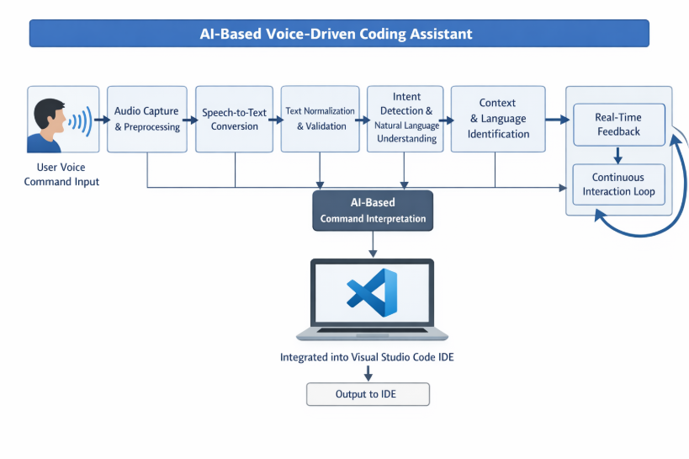
Fig 1. Flow Chart: Voice-Enabled AI Coding Assistant
The proposed system is an AI-based, voice-driven coding assistant designed as an extension for the Visual Studio Code Integrated Development Environment. The system architecture follows a sequential workflow that enables developers with disabilities to interact with the coding environment using natural language voice commands.
The process begins with the user issuing a spoken command through a microphone interface. The captured audio input is then forwarded to the speech-to-text module, where the spoken command is converted into textual form. This textual representation serves as the primary input for further analysis.
Once the speech is transcribed, the AI-based interpretation module processes the text to determine the user’s intent. Natural language processing techniques are employed to identify whether the command corresponds to code generation, code modification, navigation within files, or execution of development-related actions. The system considers the active programming language and the current coding context to ensure relevant and accurate interpretation.
After intent identification, the system maps the interpreted command to a corresponding programming action. This may involve generating syntactically correct code snippets, inserting or modifying existing code, or performing editor-level operations such as cursor movement or file access. The generated output is structured to align with the conventions of the selected programming language.
Finally, the Visual Studio Code extension executes the generated actions within the editor in real time. This seamless integration ensures that users can perform coding tasks efficiently without relying on traditional input devices. The modular design of the proposed system allows for future enhancements, including expanded language support, improved command interpretation, and advanced accessibility features.
VII. CONCLUSION
This paper presented a conceptual framework for an AI-based, voice-driven coding assistant aimed at improving accessibility in software development environments. By integrating voice interaction, artificial intelligence, and seamless IDE support, the proposed system addresses key challenges faced by developers with disabilities who encounter barriers when using traditional input devices.
The proposed approach emphasizes natural language interaction and contextual understanding of programming tasks, enabling hands-free code generation, modification, and navigation within an Integrated Development Environment. By designing the system as a Visual Studio Code extension, the framework ensures compatibility with existing development workflows while promoting inclusive participation in coding activities.
Future work will focus on the complete implementation of the proposed system, followed by performance evaluation and user studies involving developers with diverse accessibility needs. Additional enhancements may include improved speech recognition accuracy, expanded programming language support, and offline functionality. Overall, the proposed framework lays a foundation for accessible and inclusive software development through voice-driven AI assistance.
References
[1] Alan Dix, Janet Finlay, Gregory Abowd, and Russell Beale: “Human–Computer Interaction” (2019)
[2] James Lester, Khashayar Rohanimanesh, and Patrick Wilson: “Voice-Based Interfaces for accessible Computing Systems” (2020)
[3] Markel Vigo and Simon Harper: “Accessible Software Development Tools for Developers with Disabilities” Published in IEEE (2021) Computer Science, Human–Computer Interaction
[4] Y. Liu, J. Huang, and Z. Wang: “Speech Recognition Techniques for Natural Language Programming Interfaces” (2022)
[5] S. Amershi, D. Weld, and M. Vorvoreanu: “Guidelines for Human–AI Interaction” Published in ACM (2019)
[6] Christopher Power, Shaun Kane, and Meredith Ringel Morris: “Making Programming More Accessible Through Voice Interaction” (2020)
[7] R. Patel, A. Singh, and P. Mehta: “AI-Based Code Generation Using Natural Language Processing” Published in IEEE International Conference (2021)
[8] S. K. Das, A. Mukherjee, and R. Banerjee: “Voice-Controlled Interfaces for Integrated Development Environments” (2022)
[9] T. Miller: “Explanation in Artificial Intelligence: Insights from the Social Sciences” Published in Artificial Intelligence Journal (2019)
[10] M. Storey, A. Zagalsky, and F. F. Filho: “How Developers Use and Trust AI-Based Programming Assistants” (2022)
[11] P. Madhusudanan and V. Thiagarajan: “Natural Language Understanding for Programming Task Automation” (2023)
[12] Microsoft Research: “Accessibility in Developer Tools: Challenges and Opportunities” (2021)
[13] J. Shneiderman: “Human-Centered Artificial Intelligence for Inclusive Computing” (2020)
[14] K. Wobbrock, J. Kane, and S. Gajos: “Ability-Based Design: Concept, Principles, and Examples” Published in ACM (2018)
[15] A. Kapoor, E. Horvitz, and R. Basu: “Voice-Driven Intelligent Systems for Inclusive Human–Computer Interaction” (2022)

