FORM - 2
THE PATENTS ACT, 1970

(39 OF1970)
&
THE PATENTS RULES, 2003
COMPLETE SPECIFICATION
(See Section 10 & rule 13)
- TITLE OF THE INVENTION:

VOICE TO CODE ASSISTANT: AN OFFLINE, HANDS-FREE PROGRAMMING SYSTEM FOR INTEGRATED DEVELOPMENT ENVIRONMENTS

2. APPLICANTS:

NAME: Dr. Mahalingam College of Engineering and Technology
NATIONALITY: Indian Educational Institute
ADDRESS: Makkinaickenpatti Post, Udumalai Road,
Pollachi,Coimbatore, Tamil Nadu – 642 003
3. PREAMBLE TO THE DESCRIPTION:
The following specification particularly describes the invention and the manner in which it is to be performed.

VOICE TO CODE ASSISTANT: AN OFFLINE, HANDS-FREE PROGRAMMING SYSTEM FOR INTEGRATED DEVELOPMENT ENVIRONMENTS FIELD OF INVENTION
The present invention relates to artificial intelligence–enabled software development tools, particularly voice-based programming assistance and accessibility-focused integrated development environments.
BACKGROUND ART
The utilization of keyboard and mouse inputs, along with traditional Graphical User Interfaces (GUIs), is conventionally required and steadily rising in almost all software development and civil programming applications owing to their historical dominance. These manual input methods find extensive use in integrated development environments (IDEs), cloud computing architectures, and terminal environments due to their established legacy. Input methods such as mechanical keyboards, ergonomic mice, and trackpads are cost-effective, universally available, and reliable, either completely or partially.
They offer the potential to develop complex, high-performance software applications. The physical properties of these devices, including tactile feedback, keystroke accuracy, and durability, are satisfactory, rendering them more appealing over the decades compared to other human-computer interaction methods. The ready availability and familiarity of manual input peripherals present them as the primary standard for software developers. This patent literature explores the utilization of alternative input methods in coding applications, highlighting the constraints of traditional methods and the potential for innovation in human-computer interaction engineering.
Voice-driven computing systems have emerged as promising candidates, boasting several advantageous properties such as hands-free operability, reduced localized physical strain, and rapid text generation, thereby garnering increasing interest for various accessibility and accessibility-first applications. In recent decades, there has been a concerted effort among researchers to explore voice-activated materials and speech-to-text engines as alternatives to synthetic manual typing and their associated physical strains (such as repetitive strain injury or RSI). However, the specific properties of these voice-coding materials are contingent upon factors such as the network dependency of the speech models, latency, and the integration techniques used with modern IDEs.
This study presents a comprehensive technical review focusing on speech-to-code environments manufactured through cloud-based APIs. It delves into technical aspects concerning the cloud processing of natural language-reinforced composites, elucidating the types of internet dependencies used and the latency processes involved prior to execution in the IDE. The review encompasses a diverse array of cloud-based voice assistants utilized by developers for code manufacturing purposes. The increasing adoption of voice-assisted systems is notable across various industries, particularly in smart home and mobile applications. These systems offer numerous advantages such as hands-free convenience, accessibility, and multitasking.
However, existing voice-to-code software primarily employs cloud-based, internet-dependent artificial intelligence engines, raising severe concerns regarding proprietary source code privacy, data security, execution latency, and offline sustainability. The present invention addresses these concerns by incorporating decoupled, entirely offline acoustic processing models integrated directly with the IDE's local API extensions, offering a secure, zero-latency, and privacy-centric programming solution.

Non-Patent Literature references:

Subhash S., P. N. Srivatsa, S. Siddesh, A. Ullas, and B. Santhosh, AI-Based Voice Assistant for Accessibility, 2020 Fourth World Conference on Smart Trends in Systems, Security and Sustainability (WorldS4), pp. 593–596, 2020.

Felix S. M., S. Kumar, and A. Veeramuthu, A Smart Personal AI Assistant for Visually Impaired People, 2018 2nd International Conference on Trends in Electronics and Informatics (ICOEI), pp. 112–117, 2018.

Chen R., Z. Tian, H. Liu, F. Zhao, and S. Zhang, Construction of a Voice-Driven Life Assistant System for Visually Impaired People, 2018 International Conference on Artificial Intelligence and Big Data (ICAIBD), pp. 87–92, 2018.

Rani P. J., J. Bakthakumar, B. P. Kumaar, U. P. Kumaar, and S. Kumar, Voice Controlled Home Automation Using Natural Language Processing (NLP) and IoT, 2017 Third International Conference on Science Technology Engineering & Management (ICONSTEM), pp. 45–50, 2017.

Iannizzotto G., L. L. Bello, A. Nucita, and G. M. Grasso, A Vision and Speech Enabled Customizable Virtual Assistant for Smart Environments, 2018 11th International Conference on Human System Interaction (HSI), pp. 50–56, 2018.

Objectives Of The Invention

To enable hands-free software development using natural voice commands

To provide context-aware code generation and modification within an IDE

To improve programming accessibility for developers with disabilities

To ensure controlled, safe, and predictable code manipulation using AI

SUMMARY OF INVENTION
This innovation combines the utilization of a lightweight offline speech-to-text framework and a specialized intent classification engine within a decoupled software architecture, falling within the field of software engineering. The assistant functions securely as a plug-in layer to an IDE to provide a more environmentally ergonomic and highly private coding solution.
The invention involves the production of a Voice to Code Assistant using a decoupled client-server architecture composed of a Backend Core and an Execution Layer. The preferred configuration enables offline transcription of audio, intent normalization (e.g., resolving "nine twenty" to "line 20"), and structured conversion of text into commands such as GOTO_LINE, REMOVE_LINE, and GENERATE_CODE. The utilization of this local processing ensures absolute data security and eliminates networking issues.
The invention presents an innovative approach to hands-free programming without exposing proprietary code to external APIs, offering an accessible method for code creation and manipulation compared to traditional keyboard methods or cloud-based software.
BRIEF DESCRIPTION OF THE ACCOMPANYING DRAWINGS

Figure 1 illustrates the Use Case Diagram of the Voice to Code Assistant in accordance with the present system architecture.

Figure 2 illustrates the Flow Diagram of the Voice to Code Assistant depicting the operational sequence and functional workflow of the system.

DETAILED DESCRIPTION
The present invention introduces a novel method for generating and navigating code by utilizing an offline speech-recognition engine and contextual IDE synchronization. Code assistants are essential for improving developer workflows and alleviating physiological strain. In the past, voice assistants were commonly dependent on cloud ecosystems, but they were heavily susceptible to latency and posed a proprietary data hazard. Consequently, manual typing remained the predominant choice for enterprise developers. However, manual typing raises concerns regarding accessibility and repetitive strain injury. By incorporating offline speech models paired directly with IDE APIs, numerous advantages arise, including zero-latency execution, uncompromised privacy, and complex architectural code manipulation.
The initial process involves the Backend Core acting as the cognitive engine. The audio data is captured in real-time securely using direct physical interfaces. A lightweight offline Speech-to-Text engine subsequently processes this audio data, strictly keeping the raw data isolated to the host machine.
Next, the transcribed text undergoes processing within an Intent Classification Engine. This engine employs deterministic rules to detect programming specific syntax, handling ambiguities inherently found in spoken natural language. Through a normalization sequence, verbs and nouns are mapped to definitive editor behaviors. Once mapped, the backend yields structured payloads via a local API Gateway, communicating cleanly over locally hosted ports.
The execution process is orchestrated by the IDE Extension Layer. This layer maintains continuous synchrony with the editor layout, registering the precise physical location of the cursor, tracking selected text ranges, and recognizing the active computing language syntax. When the structured payload arrives from the Backend Core, the payload is interpreted, simulating keystrokes, invoking system clipboards, initiating debug events, or injecting scaffolded functions natively.
The invention involves several steps:
Transcription Phase: The developer inputs verbal instructions which are recorded and interpreted into text arrays completely on offline physical hardware using trained local acoustic models.
Classification Phase: The string is normalized. Commands matching structural paradigms are designated with intents, extracting variable parameters such as line vectors and method nomenclature.
Execution Phase: Driven by an independent frontend extension process, the instructions are executed natively against the source document. Modifications immediately reflect text insertions, cursor jumps, deletions, and loop generation matching the determined coordinates of the IDE.
Thermal stability and mechanical analogues here relate to system stability and computational latency, guaranteeing sub-second response times without external computational dependencies.
Novelty
- First fully offline, privacy-first voice-driven architecture engineered natively for IDE coupling without external server requests based on VOSK or equivalent isolated acoustic engines.
- Ambiguity resolution mapped specifically to programming lexicons and IDE structural grammar.
- Decoupled architecture isolating intensive cognitive speech conversion from main-thread IDE performance limits.
While the present invention has been described with reference to a specific preferred embodiment, it will be apparent that various modifications and changes could be made to this embodiment without departing from the scope of the invention as here in after claimed.
The above-mentioned description is provided to serve the purpose of clarifying the aspects of the invention, and it will be apparent to one skilled in the art that they do not serve to limit the scope of the invention. By way of example, the total arrangement of the different sections is customized. All modifications and improvements have been incorporated herein for reference.

Claims
We Claim:
- A voice-controlled integrated development system configured for hands-free programming comprising of:
• an offline Backend Core comprising a local speech-to-text transcription engine;
• an Intent Classification module configured to process text into programming-specific directives; and
• an Execution Layer functioning within a source code editor parsing local API payloads into native keystrokes and navigation controls.
- The voice-controlled system as claimed in claim 1, wherein the Backend Core processes verbal audio inputs solely on the local hardware to prevent privacy hazards and mitigate latency issues completely.
- The voice-controlled system as claimed in claim 1, wherein the Intent Classification module contains programmed definitions capable of replacing ambiguous phonetic results with structured logical instructions compatible with text-editing constraints.
- The voice-controlled system as claimed in claim 1, wherein the Execution Layer actively preserves an active context state encompassing language formatting identifiers, cursor bounds, and file dimensions prior to rendering modifications.
- The method for fabrication of the logic sequence for the hands-free editor comprises the steps of:
• extracting audio data streams via physical sound peripherals
• processing the streams utilizing algorithmic offline interpretation arrays;
• resolving lexical intents into encoded structural commands;
• deploying programmatic text transformations natively inside the document.
- The method as claimed in claim 5, wherein said logic sequence includes the continuous polling of editor dimensions ensuring out-of-bounds lines are padded automatically upon receiving navigation requests extending past the end of the file.
Dated this 21st day of February 2026

Signature of the Applicant

ABSTRACT

VOICE TO CODE ASSISTANT: AN OFFLINE, HANDS-FREE PROGRAMMING SYSTEM FOR INTEGRATED DEVELOPMENT ENVIRONMENTS

The invention aims at the use of a completely local and decentralized Voice-to-Code architecture in the manufacture of an IDE assisting solution. The use of offline acoustic recognition coupled seamlessly to an isolated execution layer helps to provide the necessary alternative source for developers physically hindered by manual input restraints (RSI).

This decoupled composite meets the required characteristic properties for high-speed, secure, and private software engineering by totally eliminating the usage of invasive cloud processing.

Dr. Mahalingam College of Engineering and Technology Total no. of sheets : 2
Sheet No: 1

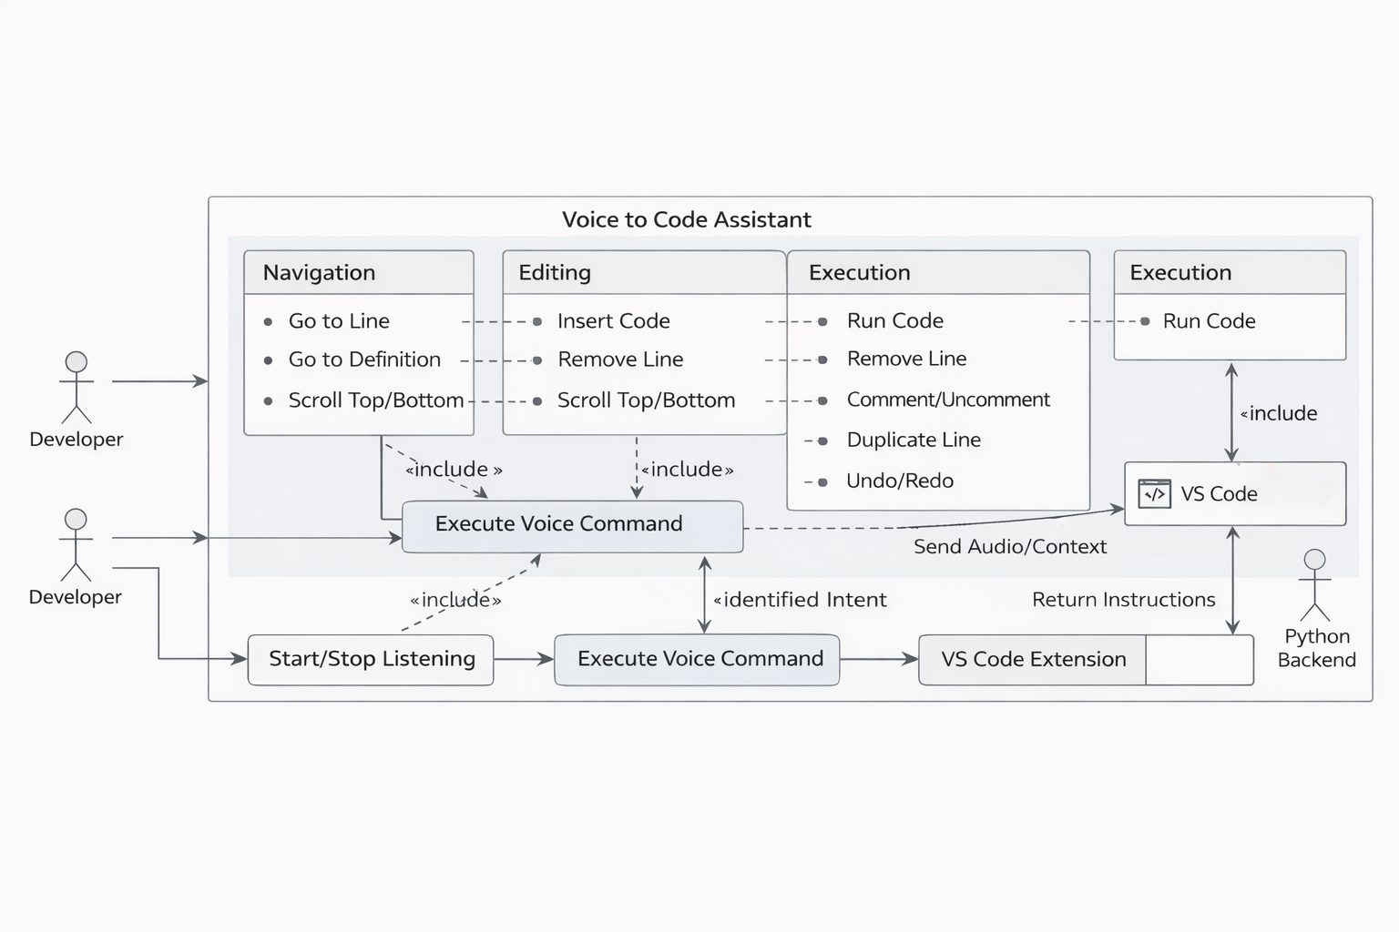

Figure 1: Use Case Diagram of the Voice to Code Assistant

Signature of the Applicant

Dr. Mahalingam College of Engineering and Technology Total no. of sheets : 2
Sheet No: 2

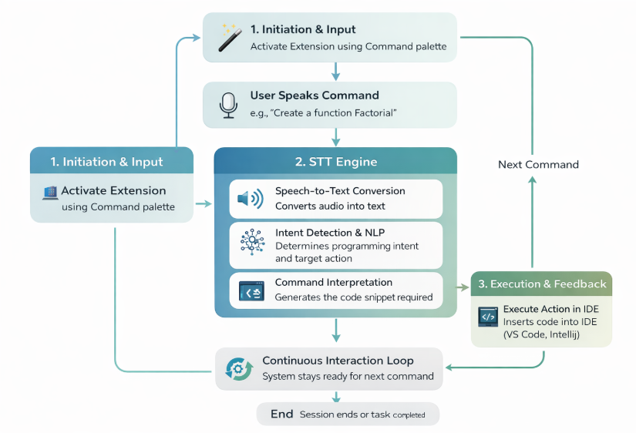

Figure 2: Flow Diagram of the Voice to Code Assistant

Signature of the Applicant

