ADVANCED COMPUTER NETWORK LAB

Kalyani Government Engineering College
Department of Information Technology

Submitted By
Aashif Ekbal
Roll No:10211425012
Subject code: PGIT 291
Email: aashif.electrical@gmail.com

Report on
Comparative Study of Routing Protocols in Wireless Sensor Networks:
No-LEACH, Original LEACH, and LEACH with Remaining Energy (LEACH-RE)

Experiment Name: Comparative Analysis of Energy-Efficient WSN Routing Protocols
Simulation Tool: Python 3 (NumPy, Matplotlib)
Network Setup: 100 nodes, 100x100 m field, Base Station at (50, 175) m

Code Repository: https://github.com/Aashifekbal/NO-LEACH-VS-LEACH-VS-LEACH-WITH-REMAINING-ENERGY

Abstract
In a Wireless Sensor Network (WSN), small battery-powered devices called sensor nodes collect data from the environment and send it to a central point called the Base Station (BS). The biggest problem with such networks is energy. Once a node runs out of battery, it dies permanently. So, the goal of every routing protocol in WSN is simple: use as little energy as possible, and spread the energy cost fairly across all nodes, so the network stays alive as long as possible.

This lab experiment simulates and compares three different ways of sending data in a WSN: (1) No-LEACH, where every node sends data directly to the BS without any coordination, (2) Original LEACH (Low-Energy Adaptive Clustering Hierarchy), invented at MIT by Heinzelman, Chandrakasan, and Balakrishnan in 2000, where nodes form groups called clusters and take turns acting as a Cluster Head (CH) that gathers and forwards data, and (3) LEACH-RE (LEACH with Remaining Energy), an improved version where nodes with more battery are given a higher chance of becoming CH, so dying nodes are protected.

The simulation was run using Python 3 on a network of 100 nodes placed randomly in a 100x100 metre area, with the Base Station sitting at (50, 175) m outside the field. Each node starts with 0.5 Joules of energy. The results show that No-LEACH killed its first node at round 40, LEACH delayed this to round 105 (2.62x better), and LEACH-RE pushed it all the way to round 280 (7x better than No-LEACH). The full network lifetime (last node dead) was 191 rounds for No-LEACH, 398 rounds for LEACH, and 444 rounds for LEACH-RE.

These results prove that smarter routing protocols make a huge difference in how long a sensor network survives, without adding any new hardware. The complete simulation source code for this study is available at:https://github.com/Aashifekbal/NO-LEACH-VS-LEACH-VS-LEACH-WITH-REMAINING-ENERGY

1. Introduction (Why Does This Experiment Matter?)
Imagine you throw 100 tiny sensor devices into a forest to measure temperature and humidity. These devices run on small batteries. You cannot go back and replace those batteries because the forest is too remote. The devices need to keep sending data to a collection point (the Base Station) for months or even years. The moment a device's battery dies, it is gone forever, it stops sensing and sending data. If too many devices die, the network fails and you lose coverage over part of the forest.

This is exactly the problem that Wireless Sensor Network (WSN) routing protocols try to solve. The key question is: what is the smartest way for each sensor node to use its limited battery to send data, so that the entire network stays alive as long as possible?

1.1 The Problem with Direct Transmission (No-LEACH)
The simplest idea is each node just sends its data directly to the Base Station every time it has data. This is called direct transmission or No-LEACH in our experiment. It sounds simple and fair, but it is actually terrible for battery life. Here is why: the energy needed to send a wireless signal grows with the square of the distance (d^2). A node that is 100 metres away from the BS spends 100 times more transmission energy than a node that is 10 metres away (because 100^2 = 10000 vs 10^2 = 100). So, nodes that happen to be placed far from the BS die very quickly, while nearby nodes survive longer but nobody helps the far-away nodes.

1.2 How LEACH Fixes This
LEACH was invented to solve the unfairness of direct transmission. The idea is simple and clever: instead of every node sending all the way to the BS, nodes form small local groups called clusters. Within each cluster, one node is elected the Cluster Head (CH). The CH collects data from all the other nodes in its cluster, squishes it together (this is called aggregation), and then sends just one combined packet to the BS. The other nodes only need to send a short distance to their local CH, saving a huge amount of energy.

But there is a problem: the CH role is expensive. The CH has to receive from all members, do the aggregation, and transmit to the far-away BS. If the same node is always the CH, it will die very quickly. So, LEACH rotates the CH role every few rounds, a different node takes the turn of being CH. This way, the expensive work is shared across all nodes fairly.

1.3 What LEACH-RE Adds
Original LEACH has one remaining flaw: it picks CHs randomly, without checking how much battery they have left. Sometimes a node with almost no battery gets picked as CH, does the expensive CH job, and dies immediately. This triggers a cascading problem that cluster loses its head, and all the member nodes have to reorganise.

LEACH-RE (LEACH with Remaining Energy) fixes this by making nodes with more battery more likely to be elected CH. Nodes that are almost dead automatically get a very low probability of being elected, so they are protected. Nodes that are still fully charged get a higher probability, so the hard work goes to those who can handle it. The result is a longer-lived, more stable network.

1.4 What This Experiment Measures
- FND (First Node Dead): the round number when the first node runs out of battery. A later FND means the protocol is better at protecting weak nodes.
- HND (Half Nodes Dead): the round when 50 nodes have died. This represents when the network has lost half its coverage.
- LND (Last Node Dead): the round when all 100 nodes are dead. This is the total network lifetime.
- CH election count per node: how many times each node was elected Cluster Head over its lifetime.
- Remaining energy at CH election: how much battery a node had at the moment it was elected CH.
- Cluster size: how many members each CH had to serve.
- Intra-cluster distance: how far member nodes were from their CH.

2. History and Origin of LEACH
LEACH was created by Wendi B. Heinzelman, Anantha Chandrakasan, and Hari Balakrishnan at the Massachusetts Institute of Technology (MIT) in Cambridge, USA. Their work was published in January 2000 at a conference called HICSS-33 (33rd Annual Hawaii International Conference on System Sciences). The paper is titled: "Energy-Efficient Communication Protocol for Wireless Microsensor Networks." A more detailed version was later published in 2002 in the IEEE Transactions on Wireless Communications journal.

At the time, researchers were building very early wireless sensor networks for environmental monitoring and military surveillance. The challenge was clear: nodes had tiny batteries that could not be recharged. The existing approaches direct transmission, minimum-energy multi-hop routing, and fixed clustering, all had serious problems. In direct transmission, far nodes die first. In multi-hop routing, intermediate nodes get overloaded. In fixed clustering, the permanent CH nodes die long before their members.

What Heinzelman's team did differently was introduce randomised, rotating cluster heads. Instead of assigning one node to always be the CH, they designed a system where the CH role rotates through all nodes over time using a probability formula. Their simulations showed that LEACH could make the network last up to 8 times longer than direct transmission. This was a breakthrough result that inspired hundreds of follow-up research papers.

Over the years, many improved versions of LEACH have been proposed. LEACH-C (Centralized) lets the Base Station make the clustering decisions. SEP (Stable Election Protocol) introduces energy-weighted probabilities for networks where nodes have different initial energies. The LEACH-RE approach used in this experiment applies SEP's energy-weighting idea to a standard homogeneous LEACH network, giving more election probability to nodes that still have more energy.

3. Real-World Applications of LEACH and WSN Protocols

3.1 Smart Farming (Precision Agriculture)
Farmers plant hundreds of soil moisture sensors across large fields. These sensors send data about water levels, temperature, and nutrients to help automatic irrigation systems decide when and where to water. The field might be 1 km wide, and the BS (a gateway device) is at one edge. Direct transmission from every sensor would drain batteries in weeks. With LEACH, nearby sensors form clusters and share a CH to send data, so a deployment that might last 3 weeks with direct transmission can last a full growing season with LEACH.

3.2 Factory Machines (Industrial IoT)
Manufacturing plants put vibration and temperature sensors on motors, pumps, and conveyor belts to detect if a machine is about to break. These sensors cannot always be wired (machines move or are in tight spaces), so they are wireless. The factory floor has lots of metal that blocks radio signals, making long-range transmission unreliable. LEACH-RE is especially useful here because some sensors near hot or busy machines drain faster the energy-aware election automatically prevents these already-stressed sensors from taking on the expensive CH role too.

3.3 Military Surveillance
Soldiers scatter tiny sensors across a battlefield or border area to detect movement, sound, or heat signatures. These networks must operate for months without any maintenance. Each transmission creates a radio signal that enemy direction-finding equipment could detect. LEACH reduces the number of long-range transmissions since only the CH needs to reach the distant command post. The rotating CH role also means no fixed point keeps transmitting at high power, reducing the radar footprint of the network.

3.4 Smart Electricity (Smart Grid Metering)
Electricity companies install wireless sensors in meters, transformers, and substations to monitor power consumption and detect faults in real time. These meters are expected to operate for 10-15 years. LEACH's clustering reduces the number of long-distance transmissions and uses TDMA (Time Division Multiple Access) scheduling within each cluster, which means multiple nodes take turns transmitting without interfering with each other, this eliminates wasted energy from collisions and retransmissions.

3.5 Wearable Health Monitoring
ECG patches, blood oxygen sensors, and movement trackers on patients form a tiny body-area sensor network. These devices relay health data to a smartphone or hospital gateway. Even though the area is small (a human body), clustering sensors to a central hub device (like a chest monitor) before forwarding to the phone is more energy efficient than each device transmitting separately. If the hub node dies, the patient might miss a critical reading — so LEACH-RE's energy-aware election is important to keep the hub alive by not overloading low-battery devices with CH duties.

4. How Each Protocol Works (Theory)

4.1 Protocol 1: No-LEACH (The Simple but Wasteful Way)
No-LEACH is the "do nothing special" approach. Every sensor node that is still alive simply sends its data packet directly to the Base Station in every single round. There are no clusters, no CHs, no cooperation between nodes, and no data aggregation (compression). Each node works completely alone.

Think of it like 100 people each making individual phone calls to the same office. Nobody coordinates. Nobody passes their message through a closer neighbour. Everyone just calls directly, no matter how far away they are.

The energy cost for each node in No-LEACH is determined entirely by its distance to the BS. The energy formula (from Heinzelman et al., 2000) says that transmission energy grows with the square of distance. So, a node 140 metres from the BS pays (140) ^2 = 19600 times more amplifier energy per bit than a node at 1 metre away. In our 100x100 m field with BS at (50, 175), the average distance from a node to the BS is about 120-130 metres, a long and expensive trip every single round.

The result: No-LEACH drains all nodes relatively quickly. Nodes that are physically closer to the BS drain at the same rate as others but the variability in position means some nodes die very early. First node died at round 40 in our simulation. The entire network was dead by round 191.

4.2 Protocol 2: Original LEACH (Group Work with Rotating Leaders)
LEACH organises nodes into small groups called clusters. Within each cluster, one node is the Cluster Head (CH). The CH does the heavy lifting: it collects data from all nodes in its cluster, combines the data into one packet (aggregation), and sends this single packet to the BS. All the other nodes (called member nodes) only need to transmit a short distance to their local CH.

Think of it like a classroom. Instead of every student individually going to the teacher (BS) to submit their answer, students pass their papers to the nearest table captain (CH), who collects all papers from the table and takes them to the teacher. Each student only walks to the table captain, not all the way to the teacher. The table captain job rotates each week, so no single student always has to walk to the teacher.

4.2a. Two Phases of Every LEACH Round
Every round in LEACH has two phases:
- Setup Phase: Nodes decide who is the CH this round. Each alive node draws a random number between 0 and 1. If this number is less than a computed threshold T(n), the node declares itself as CH and broadcasts an advertisement. Member nodes then join the nearest CH they heard from.
- Steady-State Phase: Each member node sends its data to the CH in its assigned time slot (TDMA schedule). The CH collects all the data, aggregates it, and transmits one combined packet to the BS.

4.2b. The Election Threshold T(n)
The threshold formula ensures that each node becomes CH roughly once every 1/p round (the epoch). With p = 0.1 (10%), the epoch is 10 rounds. Within each epoch, a node that has already been CH cannot be elected again, it is removed from the eligible set G. The threshold rises as the epoch progresses because there are fewer eligible candidates left, so each remaining candidate must carry a higher probability to maintain the target number of CHs per round.

The formula is: T(n) = p / (1 - p x (r mod (1/p))) if node n is in G, otherwise T(n) = 0

Where p = 0.1 (target 10% CHs), r = current round, and G = set of nodes that have not been CH in the last 10 rounds.

Example: At round 5, with p=0.1: T(n) = 0.1 / (1 - 0.1 x 5) = 0.1 / 0.5 = 0.2. So, each eligible node has a 20% chance of becoming CH this round.

4.2c. Why LEACH is Better than No-LEACH
In No-LEACH, every node sends ~120 metres to BS. In LEACH, member nodes only send ~25 metres to their local CH. Since energy grows as d^2, the amplifier energy ratio is (120/25) ^2 = about 23 times less. Members pay 23x less amplifier energy per round. Only the CHs pay the expensive BS trip, and they rotate every round. This huge energy saving is why LEACH's first node survived until round 105 versus round 40 for No-LEACH.

4.3 Protocol 3: LEACH-RE (Smarter Election Based on Remaining Battery)
LEACH-RE keeps everything from original LEACH except for one important change: the election probability is no longer the same for all nodes. Instead, each node gets a different election probability based on how much battery it has left.

The formula is simple: P_i = P_base x (E_i / E_initial)

Where P_base = 0.1 (the base probability), E_i = the node's current remaining energy, and E_initial = 0.5 J (the starting energy). So if a node has used half its battery (E_i = 0.25 J), its election probability becomes P_i = 0.1 x (0.25 / 0.5) = 0.05, half of normal. If it has almost no battery left (E_i = 0.05 J) P_i = 0.1 x (0.05/0.5) = 0.01, only 10% of normal.

This modified probability is then used in the same Heinzelman threshold formula: T_RE(n) = P_i / (1 - P_i x (r mod (1/P_base)))

The effect is automatic and self-correcting. As nodes lose energy over many rounds, their election probability drops without anyone needing to coordinate. Nodes with good battery are naturally preferred as CHs. Dying nodes are naturally protected. No central controller is needed; each node just looks at its own energy level and calculates its own probability.

In our simulation, this simple change pushed the First Node Dead from round 105 (original LEACH) all the way to round 280 (LEACH-RE), a 2.67x improvement, just from this one formula change.

5. The Math Behind the Simulation (Formulas Explained Simply)

5.1 Formula 1: Transmission Energy (How much battery does sending cost?)
When a node sends a packet wirelessly, it uses two types of energy: (1) Electronics energy: the energy to run the circuit regardless of distance, and (2) Amplifier energy: extra power needed to push the signal further. The amplifier energy grows with the square of distance (free-space model).

E_Tx(k, d) = k * E_elec + k * eps_fs * d^2 Eq. (1) [d < d_0, free space]
E_Tx(k, d) = k * E_elec + k * eps_mp * d^4 Eq. (2) [d >= d_0, multipath]

Where: k = 4000 bits (packet size), E_elec = 50 nJ/bit (circuit energy), eps_fs = 100 pJ/bit/m^2 (amplifier coefficient), d = distance in metres.

Simple example: A member node 25 m from its CH sends a packet. Electronics cost = 4000 x 50e-9 = 0.200 mJ. Amplifier cost = 4000 x 100e-12 x 25^2 = 0.250 mJ. Total = 0.450 mJ.

Same node sending directly to BS at 130 m: Electronics = 0.200 mJ. Amplifier = 4000 x 100e-12 x 130^2 = 6.760 mJ. Total = 6.960 mJ. That is 15 times more expensive!

This is the core reason why LEACH saves so much energy. member nodes send short distances instead of long distances.

5.2 Formula 2: Reception Energy (How much does receiving cost?)
E_Rx(k) = k * E_elec = 4000 * 50e-9 = 0.200 mJ Eq. (3) [distance-independent]
Receiving does not need an amplifier; you just need the circuit to process the incoming signal. So, reception energy is the same no matter how far the sender is. The CH pays 0.200 mJ for each member packet it receives.

5.3 Formula 3: Data Aggregation Energy (Squishing data together at CH)
E_DA(k) = k * E_DA = 4000 * 5e-9 = 0.020 mJ Eq. (4) [per aggregation at CH]
After receiving all member data, the CH combines it into one packet before sending to BS. This processing costs 0.020 mJ. It is worth it because instead of sending 9 separate packets to BS (one per member), the CH sends just 1 combined packet, saving 8 expensive long-distance transmissions.

5.4 Formula 4: LEACH Cluster Head Threshold T(n)
T(n) = p / (1 - p*(r mod floor(1/p))) if n in G Eq. (5) [CH election threshold]
T(n) = 0 if n not in G [node already been CH recently]
This formula ensures that across every epoch of 10 rounds, each node takes the CH turn exactly once on average. The threshold rises as more nodes in the epoch get used up, to keep the total number of CHs per round roughly equal top x N = 10.

5.5 Formula 5: LEACH-RE Dynamic Probability P_i
P_i(r) = P_base * (E_i(r) / E_initial) Eq.(6) [dynamic probability per node]
T_RE(n) = P_i / (1 - P_i*(r mod floor(1/P_base))) if n in G Eq.(7) [LEACH-RE threshold]
The key addition is Eq. (6). This one line of change makes LEACH-RE fundamentally smarter than original LEACH. As E_i decreases over rounds, P_i decreases automatically. The node does not need to be told to back off, it calculates its own reduced probability based on its own battery level. This is fully distributed, fully automatic, and needs zero extra communication between nodes.

6. Flowcharts (Step-by-Step Working of Each Protocol)
The following flowcharts show exactly what happens each round for each protocol.

6.1 No-LEACH Flowchart
Flowchart 1: No-LEACH (Direct Transmission Protocol)

Step 1: START - Initialise 100 nodes with 0.5 J energy, random positions in 100x100 m field.
Step 2: BEGIN ROUND - Increment round counter r.
Step 3: FOR EACH ALIVE NODE - Calculate distance d to BS using: d = sqrt((x-50) ^2 + (y-175) ^2).
Step 4: CALCULATE COST - Compute transmission energy: E_tx = k*E_elec + k*eps_fs*d^2.
Step 5: DEDUCT ENERGY - Subtract E_tx from node's remaining energy.
Step 6: DEATH CHECK - If energy <= 0: mark node dead. Record FND (if first), HND (if 50th), LND (if 100th).
Step 7: CONTINUE - Record alive count and total energy for this round.
Step 8: LOOP CHECK - If all 100 nodes are dead: STOP. Otherwise: go back to Step 2.
Step 9: END - Output FND, HND, LND, and all 16 graphs.
Figure FC-1: No-LEACH Protocol Flowchart: every node transmits directly to the Base Station each round

6.2 Original LEACH Flowchart
Flowchart 2: Original LEACH (Probabilistic Cluster Head Election)

Step 1: START - Initialise nodes, set epoch = 10, p = 0.1.
Step 2: BEGIN ROUND r - Reset is_CH and my_CH for all nodes.
Step 3: SETUP PHASE (CH ELECTION) - For each alive node: check if node is in G (not been CH in last 10 rounds). Compute T(n) = p/ (1-p*(r mod 10)). Draw random number xi from [0,1]. If xi < T(n): declare self as CH, record election, add to cluster_heads list.
Step 4: FALLBACK - If no CH elected this round: pick the alive eligible node with the most remaining energy as forced CH.
Step 5: SETUP PHASE (CLUSTER FORMATION) - For each alive non-CH node: find the nearest CH by Euclidean distance. Join that CH's cluster (set my_CH = CH's ID).
Step 6: STEADY-STATE (INTRA-CLUSTER Tx) - Each member node sends k-bit packet to its CH. Member pays E_tx(k, d_to_CH). CH pays E_rx(k) per received packet.
Step 7: STEADY-STATE (CH TO BS) - Each CH aggregates data (pays E_DA), then transmits to BS (pays E_tx(k, d_to_BS)).
Step 8: DEATH CHECK - Check all nodes for zero energy. Record FND/HND/LND milestones.
Step 9: RECORD STATS - Save alive count, total energy, CH count, cluster sizes, intra-cluster distances.
Step 10: LOOP CHECK - All dead? STOP. Else go to Step 2.
Figure FC-2: Original LEACH Protocol Flowchart: probabilistic CH election with fixed p=0.1

6.3 LEACH-RE Flowchart
Flowchart 3: LEACH-RE (Energy-Weighted Cluster Head Election)

Step 1: START - Same as LEACH. Plus: record initial energy E_initial = 0.5 J for each node.
Step 2: BEGIN ROUND r - Reset is_CH and my_CH for all nodes.
Step 3: SETUP PHASE (ENERGY-WEIGHTED CH ELECTION) - For each alive node in G: FIRST compute dynamic probability P_i = P_base * (E_i / E_initial). If P_i <= 0: skip this node (too depleted). Compute T_RE(n) = P_i / (1 - P_i*(r mod 10)). Draw random xi from [0,1]. If xi < T_RE: declare self as CH. Record energy_at_ch_election = current E_i (this is the KEY new measurement).
Step 4: FALLBACK - If no CH elected: pick highest-energy alive eligible node as forced CH (energy-based fallback, not random).
Step 5: CLUSTER FORMATION - Same as LEACH: each member joins nearest CH.
Step 6: STEADY-STATE (INTRA-CLUSTER Tx) - Same as LEACH: members send to CH, CH receives.
Step 7: STEADY-STATE (CH TO BS) - Same as LEACH: CH aggregates and transmits to BS.
Step 8: DEATH CHECK AND STATS - Same as LEACH. Also record energy_at_election list per node, cluster sizes, death rounds.
Step 9: LOOP CHECK - All dead? STOP. Else go to Step 2.
Step 10: KEY DIFFERENCE from LEACH: Step 3 uses P_i instead of fixed p. Everything else is identical.
Figure FC-3: LEACH-RE Protocol Flowchart: energy-weighted CH election where P_i = P_base x (E_i / E_initial)

7. Simulation Setup and Global Parameters
All three protocols use exactly the same network setup. This is critical for a fair comparison — if even one parameter is different, the results would not be comparable. The following shared global parameters are defined once at the top of the simulation code and used by all three protocol functions.

Global Parameters - Shared by All Three Protocols
NUM_NODES = 100 (100 sensor nodes in the network)
FIELD_X = 100 (field is 100 metres wide)
FIELD_Y = 100 (field is 100 metres tall)
RANDOM_SEED = 42 (fixed seed - same node positions every run)

BS_X = 50 (Base Station X = 50 m)
BS_Y = 175 (Base Station Y = 175 m, OUTSIDE the field!)
[Note: BS outside field ensures long CH-to-BS distance = expensive transmissions]
[This is exactly the setup used by Heinzelman et al. 2000, Figure 12]

INIT_ENERGY = 0.5 (each node starts with 0.5 Joules, Heinzelman 2000)
E_ELEC = 50 nJ/bit (electronics energy for Tx and Rx circuits)
EPS_AMP = 100 pJ/bit/m2 (amplifier energy, free-space propagation model)
E_DA = 5 nJ/bit (data aggregation energy at CH)
K_BITS = 4000 (each packet is 4000 bits)

P_LEACH = 0.1 (target 10% of nodes should be CH per round)
DEAD_THRESHOLD= 0.0 (node dies when energy reaches zero)
MAX_ROUNDS = 5000 (safety limit - stops infinite loops)

ANALYSIS
Why is the Base Station placed at (50, 175) m, outside the field? Because Heinzelman's original paper placed the BS outside the sensor field to create a realistically large CH-to-BS distance. If the BS was inside the 100x100 m field (say at centre 50,50), the average CH-to-BS distance would be only about 40-50 metres, making direct transmission cheaper and clustering less beneficial. With BS at (50, 175), the average distance is 120-130 metres, and the d^2 energy model makes BS transmission very expensive, exactly the scenario where LEACH's clustering helps most. Changing the BS position to (50,50) would reproduce Heinzelman's original 8x lifetime improvement over direct transmission.

8. Code Availability
Where to Find the Complete Code
The full Python simulation code used for this lab experiment is available at:

https://github.com/Aashifekbal/NO-LEACH-VS-LEACH-VS-LEACH-WITH-REMAINING-ENERGY

The code file is: No_Leach vs Leach vs Leach_With_Remaining_Energy.ipynb

What the code contains:
- Global parameters block (shared by all 3 protocols)
- SensorNode class with full per-node tracking
- run_no_leach() function: Protocol 1
- run_leach() function: Protocol 2 (Original LEACH)
- run_e_leach() function: Protocol 3 (LEACH-RE)
- 16 graph generation functions
- Full console output with analysis tables

Requirements: Python 3, NumPy, Matplotlib
Run command: python3 No_Leach vs Leach vs Leach_With_Remaining_Energy.ipynb

9. Simulation Output: Results with Analysis
This section presents every piece of output produced by the simulation code, exactly as it appears in the console when No_Leach vs Leach vs Leach_With_Remaining_Energy.ipynb is run. After each output block, a detailed analysis explains what the numbers mean in simple terms.

9.1 Global Parameters Printout
SIMULATION OUTPUT: Shared Global Parameters

========================================================================
M.TECH WSN LAB — ENHANCED 3-PROTOCOL COMPARISON
No-LEACH | LEACH (Heinzelman 2000) | E-LEACH
========================================================================
Field: 100x100m | N=100 | E0=0.5J | p=0.1 | BS=(50,175)m
========================================================================

ANALYSIS
This is the first thing the program prints. It confirms that all three protocols start from exactly the same conditions. N=100 means 100 nodes. E0=0.5J means each node has half a Joule of energy to start with. p=0.1 means the target is 10% of alive nodes acting as CH per round (roughly 10 CHs per round at the start). BS= (50,175) places the base station 75 metres above the top edge of the sensor field, meaning every CH-to-BS transmission must travel at least 75 metres even in the best case, making these transmissions expensive. These numbers match the standard LEACH benchmark parameters from the original 2000 paper.

9.2 Protocol 1: No-LEACH Output
SIMULATION OUTPUT: Protocol 1 Results

------------------------------------------------------------------------
RUNNING PROTOCOL 1 — No-LEACH (Direct Transmission)
------------------------------------------------------------------------
FND (First Node Dead) : Round 40
HND (Half Nodes Dead): Round 69
LND (Last Node Dead) : Round 191 [Network Lifetime]
Total Rounds Run : 191

ANALYSIS
Round 40 is the First Node Dead (FND). This is very early, only 40 rounds out of a possible maximum. Why so early? Because every node sends directly to the BS at (50,175), and some nodes happen to be positioned far from the BS. Those nodes pay a very large d^2 transmission cost every single round. They drain faster than nodes that are closer. The node that died first at round 40 was the one with the worst combination of: far from BS + random unluckiness in position. Notice how fast everything collapses: FND=40, HND=69, LND=191. The network went from full to half-dead in just 29 more rounds after FND, and from half-dead to fully dead in 122 more rounds. The relatively rapid collapse (LND-FND = 151 rounds) means nodes die in clusters because similar-distance nodes drain at similar rates.

9.3 Protocol 2: Original LEACH Output
SIMULATION OUTPUT: Protocol 2 Results

------------------------------------------------------------------------
RUNNING PROTOCOL 2 — Original LEACH (Heinzelman et al., 2000)
------------------------------------------------------------------------
FND (First Node Dead) : Round 105
HND (Half Nodes Dead): Round 246
LND (Last Node Dead) : Round 398 [Network Lifetime]
Total Rounds Run : 398

ANALYSIS
The clustering effect of LEACH is dramatic. FND jumped from round 40 (No-LEACH) to round 105, 2.62 times later. The reason is that member nodes no longer pay the full BS distance cost. Instead, they send only to their nearby CH (average distance ~25 m). The d^2 ratio is (120/25) ^2 = 23, meaning members use about 23 times less amplifier energy per round. Even CHs last longer because the aggregation step reduces how much data needs to be sent to BS. The period from FND to HND is 141 rounds (246-105), much longer than No-LEACH's 29 rounds. This shows that LEACH distributes energy more evenly, nodes do not all die at the same time. LND at round 398 is 2.08x the No-LEACH LND of 191.

9.4 Protocol 3: LEACH-RE Output
SIMULATION OUTPUT: Protocol 3 Results

------------------------------------------------------------------------
RUNNING PROTOCOL 3 — E-LEACH (LEACH + Remaining Energy)
------------------------------------------------------------------------
FND (First Node Dead) : Round 280
HND (Half Nodes Dead): Round 390
LND (Last Node Dead) : Round 444 [Network Lifetime]
Total Rounds Run : 444

ANALYSIS
LEACH-RE's FND of round 280 is stunning compared to original LEACH's 105. That is a 2.67x further improvement, just from changing the CH election formula to use energy-weighted probability. Why? Because in original LEACH, a nearly dead node might get randomly elected CH, do the expensive CH job (receiving from 9+ members, aggregating, transmitting 130m to BS), and immediately die. This event triggers the FND milestone. In LEACH-RE, a nearly dead node has a probability of P_i = 0.1 x (0.01 / 0.5) = 0.002, almost zero chance of being elected. The CH duty goes instead to nodes with full or near-full batteries. They can handle the expensive role without dying. As a result, the first node death is pushed far into the future. HND at round 390 means the network is still more than 50% alive at round 390, compared to LEACH where it was already half-dead at round 246. Total lifetime is 444 rounds, 2.32x the No-LEACH lifetime.

9.5 Network Lifetime Comparison Table (Table 1)
SIMULATION OUTPUT: Console Output: TABLE 1

========================================================================
TABLE 1 — NETWORK LIFETIME METRICS
========================================================================
Protocol FND HND LND FND Gain
------------------------------------------------------------
No-LEACH 40 69 191 1.00x
LEACH 105 246 398 2.62x
E-LEACH 280 390 444 7.00x
------------------------------------------------------------

Improvement LEACH over No-LEACH : FND 2.62x | LND 2.08x
Improvement E-LEACH over LEACH : FND 2.67x | LND 1.12x
Improvement E-LEACH over No-LEACH: FND 7.00x | LND 2.32x

Table 1: Network Lifetime Metrics - FND, HND, LND for all three protocols
Metric | No-LEACH | LEACH (Heinzelman) | LEACH-RE (Enhanced) | Best Protocol
First Node Dead (FND) | Round 40 | Round 105 | Round 280 | LEACH-RE (7x better than No-LEACH)
Half Nodes Dead (HND) | Round 69 | Round 246 | Round 390 | LEACH-RE
Last Node Dead (LND) | Round 191 | Round 398 | Round 444 | LEACH-RE
FND Improvement | 1.00x (baseline) | 2.62x over No-LEACH | 7.00x over No-LEACH | LEACH-RE
LND Improvement | 1.00x (baseline) | 2.08x over No-LEACH | 2.32x over No-LEACH | LEACH-RE

ANALYSIS
This table is the most important summary in the entire experiment. Reading across the FND row: No-LEACH lost its first node at round 40. LEACH kept that node alive until round 105. LEACH-RE kept it alive until round 280. This 7x FND improvement of LEACH-RE over No-LEACH is entirely due to two mechanisms: (1) clustering reduces member node energy costs, and (2) energy-weighting prevents dying nodes from being elected CH. The LND improvement is smaller (2.32x) because in the final stages, all surviving nodes still must transmit to BS eventually, and that energy drain cannot be completely avoided by any protocol. The gap between FND and LND is interesting too: No-LEACH gap = 151 rounds, LEACH gap = 293 rounds, LEACH-RE gap = 164 rounds. LEACH has the widest gap because random CH election creates uneven node deaths over a long period. LEACH-RE's gap is narrower, suggesting energy-aware election causes nodes to survive more uniformly until they all die in a shorter final window.

9.6 Cluster Head Election Analysis (Table 2)
SIMULATION OUTPUT: Console Output - TABLE 2

========================================================================
TABLE 2 — CLUSTER HEAD ELECTION ANALYSIS (LEACH vs E-LEACH)
========================================================================

[LEACH]
Total CH elections : 2592
Average per node : 25.92
Std deviation : 8.78 (lower = more uniform load balancing)
Max elections (node) : 44 (Node 32)
Min elections (node) : 11 (Node 98)
Nodes never elected : 0
Avg energy at election : 253.275 mJ
Min energy at election : 0.033 mJ <- node was almost dead when chosen!
Max energy at election : 500.000 mJ

[E-LEACH]
Total CH elections : 1786
Average per node : 17.86
Std deviation : 3.60 (lower = more uniform load balancing)
Max elections (node) : 26 (Node 31)
Min elections (node) : 10 (Node 44)
Nodes never elected : 0
Avg energy at election : 319.638 mJ
Min energy at election : 0.145 mJ
Max energy at election : 500.000 mJ

Table 2: CH Election Analysis - LEACH vs LEACH-RE
Metric | LEACH | LEACH-RE | Winner
Total CH elections | 2592 | 1786 | LEACH-RE (fewer, more efficient)
Average elections per node | 25.92 | 17.86 | LEACH-RE (less burden per node)
Std deviation of election count | 8.78 | 3.60 | LEACH-RE (59% more uniform)
Max elections (most active CH) | 44 times (Node 32) | 26 times (Node 31) | LEACH-RE (less overloading)
Min elections (least active) | 11 times (Node 98) | 10 times (Node 44) | Similar
Avg energy at CH election | 253.3 mJ | 319.6 mJ | LEACH-RE (26% healthier CHs)
Min energy at CH election | 0.033 mJ (nearly dead!) | 0.145 mJ | LEACH-RE (protects dying nodes)
Nodes never elected as CH | 0 | 0 | Both equal

ANALYSIS
This table reveals the inner working of the protocols at the individual node level. The most striking number is the std deviation: LEACH has std=8.78, meaning CH election counts vary widely between nodes. Some nodes (like Node 32) were elected 44 times while others (like Node 98) were elected only 11 times, a 4x difference. This means Node 32 was doing 4x more CH work than Node 98. Over time, this imbalance drains Node 32 much faster. In LEACH-RE, the std drops to 3.60, a 59% reduction in unfairness. The max is 26 vs minimum 10, only a 2.6x range, much narrower. The average energy at CH election tells an important story: LEACH elects CHs when they have only 253 mJ on average (barely half their 500 mJ starting energy). The minimum of 0.033 mJ is shocking, a node with almost no battery was still elected CH and likely died doing the job. LEACH-RE elects CHs with an average of 319.6 mJ (better by 26%), and the minimum is 0.145 mJ (4x higher than LEACH's worst case). The energy-weighted formula is genuinely working.

9.7 Top 5 Most-Elected Cluster Head Nodes
SIMULATION OUTPUT: Console Output - Top 5 CHs

[LEACH] Top 5 most-elected CH nodes:
Node 32: CH 44 times | avg E=227.46mJ | avg cluster=5.2 | died Rd 398
Node 10: CH 43 times | avg E=233.54mJ | avg cluster=6.5 | died Rd 397
Node 15: CH 42 times | avg E=241.76mJ | avg cluster=8.0 | died Rd 397
Node 64: CH 42 times | avg E=221.87mJ | avg cluster=3.3 | died Rd 396
Node 7: CH 41 times | avg E=242.35mJ | avg cluster=4.4 | died Rd 395

[E-LEACH] Top 5 most-elected CH nodes:
Node 31: CH 26 times | avg E=285.38mJ | avg cluster=28.6 | died Rd 442
Node 86: CH 26 times | avg E=294.74mJ | avg cluster=27.5 | died Rd 436
Node 2: CH 25 times | avg E=312.80mJ | avg cluster=22.6 | died Rd 434
Node 17: CH 24 times | avg E=299.40mJ | avg cluster=27.8 | died Rd 434
Node 58: CH 24 times | avg E=289.98mJ | avg cluster=27.7 | died Rd 434

Table 3: Top 5 Most-Elected CHs - Comparison between LEACH and LEACH-RE
Protocol | Node | CH Elections | Avg Energy at Election | Avg Cluster Size | Died Round
LEACH | Node 32 | 44 times | 227.46 mJ | 5.2 members | 398
LEACH | Node 10 | 43 times | 233.54 mJ | 6.5 members | 397
LEACH | Node 15 | 42 times | 241.76 mJ | 8.0 members | 397
LEACH-RE | Node 31 | 26 times | 285.38 mJ | 28.6 members | 442
LEACH-RE | Node 86 | 26 times | 294.74 mJ | 27.5 members | 436
LEACH-RE | Node 2 | 25 times | 312.80 mJ | 22.6 members | 434

ANALYSIS
Three differences between LEACH and LEACH-RE top CHs stand out. First, election counts: the LEACH top CH (Node 32) was elected 44 times. The LEACH-RE top CH (Node 31) was elected only 26 times. This confirms the better load balancing in LEACH-RE. Second, average energy at election: LEACH's top CHs were elected with 220-242 mJ remaining (below half their starting 500 mJ). LEACH-RE's top CHs were elected with 285-312 mJ remaining (closer to 60% of starting energy). This shows that LEACH-RE's energy-weighting formula successfully reserves the CH role for healthier nodes. Third, cluster sizes are very different: LEACH CHs served small clusters of 3-8 members, while LEACH-RE CHs served large clusters of 22-28 members. This makes sense because LEACH-RE elects fewer CHs in total (1786 vs 2592), so each CH covers more area and serves more members. This is not necessarily bad - the CH's job is to aggregate data, and aggregating 28 members is still more efficient than each of those 28 members sending directly to BS.

10. All Simulation Figures with Analysis
Run the Python code to generate all 16 figures. They will be saved as PNG files in the same folder as the code. The analysis after each figure explains what the graph means and why it looks the way it does.

10.1 Figure 1: Initial Random Deployment of 100 Sensor Nodes in 100x100 m Field

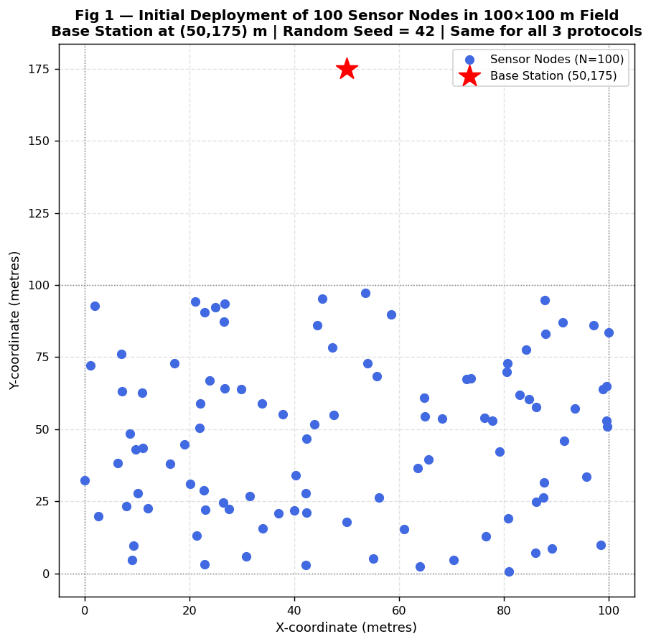
Figure 1: Initial Random Deployment of 100 Sensor Nodes in 100x100 m Field

ANALYSIS
This scatter plot shows where all 100 nodes are placed at the start of the simulation. The blue dots are sensor nodes, spread randomly across the 100x100 m square. The red star at (50, 175) is the Base Station, notice it is 75 metres above the top edge of the sensor field. This large distance is intentional: it ensures that any CH-to-BS transmission must travel at least 75-130 metres, making it expensive (due to d^2 energy model). All three protocols use this exact same node deployment (RANDOM_SEED=42), making the comparison perfectly fair. If nodes were placed closer to the BS, direct transmission would be cheaper, and the benefit of LEACH clustering would be smaller.

10.2 Figure 2: Number of Alive Sensor Nodes vs. Simulation Round - All 3 Protocols

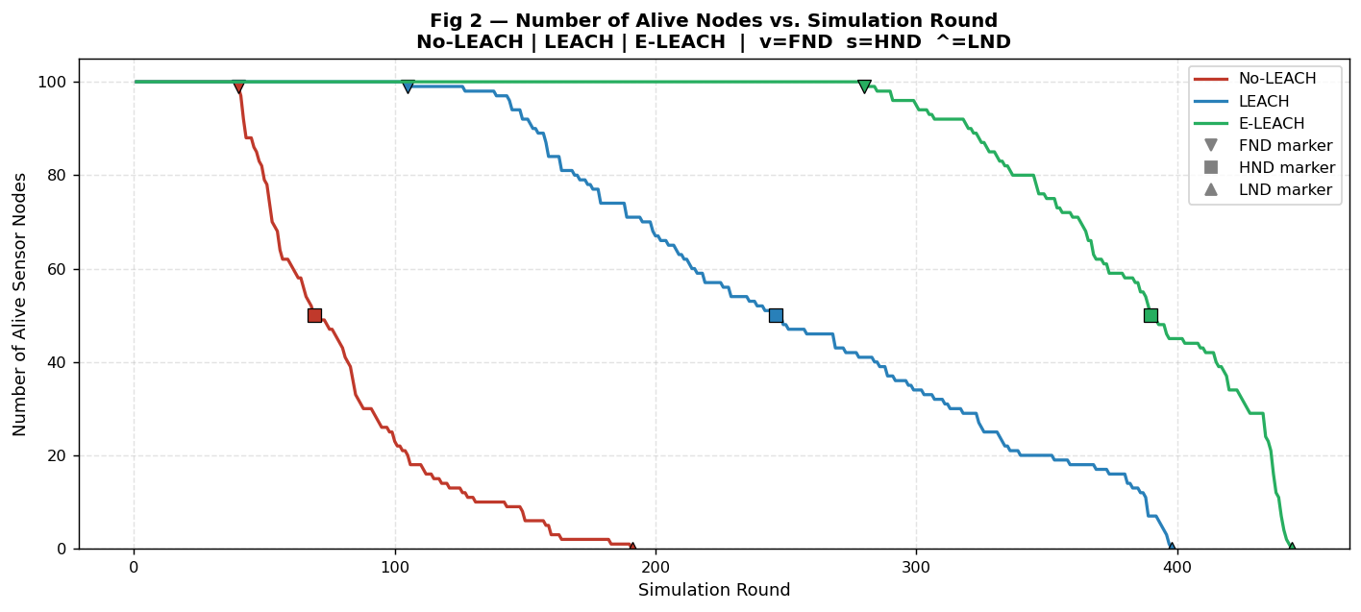
Figure 2: Number of Alive Sensor Nodes vs. Simulation Round - All 3 Protocols

ANALYSIS
This is the most important graph in the experiment. Three lines start at 100 nodes (all alive) and eventually reach 0 (all dead). The red line (No-LEACH) drops steeply and reaches zero by round 191. The blue line (LEACH) stays near 100 for much longer, the first drop happens around round 105, and the line reaches zero at round 398. The green line (LEACH-RE) barely moves until around round 280, then gradually decreases to zero at round 444. The shape of each line tells a story: No-LEACH has a relatively gradual decline (all nodes drain at similar but slightly different rates based on position). LEACH has a staircase pattern; nodes tend to die in small groups at the end of each epoch when CHs drain out. LEACH-RE has a long flat top followed by a steeper decline at the end, showing that energy is preserved uniformly for longer before the network collapses.

10.3 Figure 3: Total Remaining Network Energy vs. Simulation Round - Non-Linear Decay

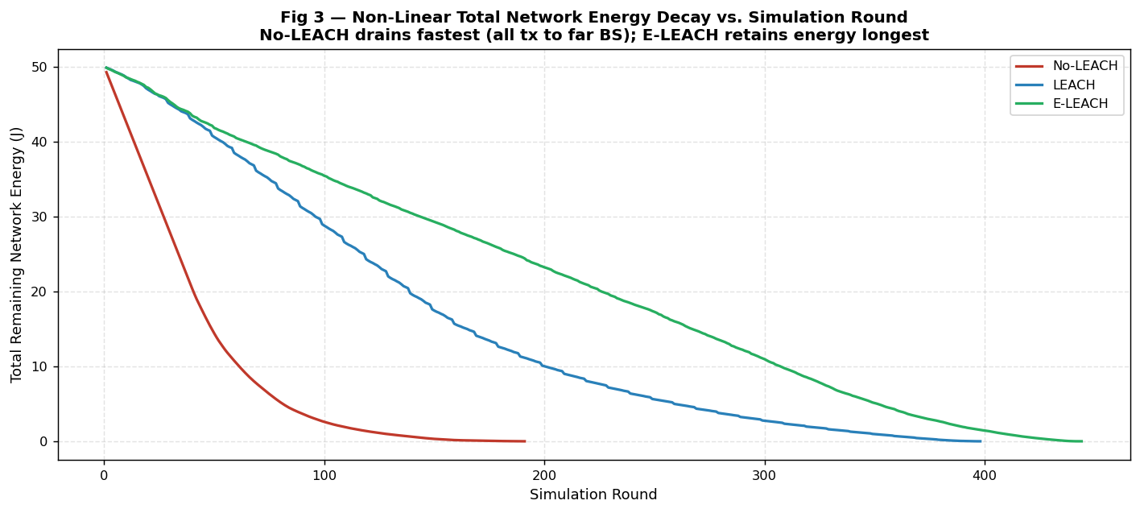
Figure 3: Total Remaining Network Energy vs. Simulation Round - Non-Linear Decay

ANALYSIS
This graph shows the total energy left in the entire network (sum of all node energies) at the end of each round. All three lines start at 50 J (100 nodes x 0.5 J each) and trend down to zero. The key observation is that none of the curves is a straight line, they all show non-linear (curved) decay. No-LEACH's red line is nearly linear but drops steeply, reaching zero earliest. LEACH's blue line shows a gentle curve that accelerates in the final rounds, this is because when CHs die, surviving CHs must cover larger areas with more members, increasing their energy cost per round. LEACH-RE's green line shows the slowest overall decay and a longer flat-ish section before the final acceleration. Non-linearity is caused by the d^2 distance model: as the number of alive nodes decreases, the remaining nodes bear proportionally heavier CH loads, accelerating the drain in later rounds.

10.4 Figure 4: Performance Metrics Comparison - FND, HND and LND for All 3 Protocols

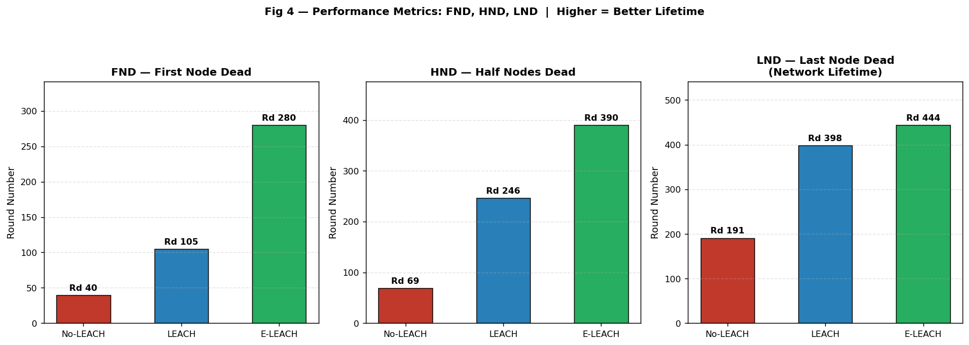
Figure 4: Performance Metrics Comparison - FND, HND and LND for All 3 Protocols

ANALYSIS
Three groups of bars, each group containing one bar per protocol (red=No-LEACH, blue=LEACH, green=LEACH-RE). In the FND group, the green bar (LEACH-RE, round 280) is 7 times taller than the red bar (No-LEACH, round 40) and nearly 2.7 times taller than the blue bar (LEACH, round 105). This dramatic difference shows that energy-aware CH election is the single most impactful improvement for protecting the weakest node. In the LND group, the bars are more similar in height: LEACH-RE (444) is only 1.12x taller than LEACH (398). This tells us that while LEACH-RE dramatically delays the first death, the total lifetime improvement is smaller because eventually all nodes must use their energy to communicate. The HND group shows intermediate improvement. Overall, a higher bar = better performance, and the green bars consistently win.

10.5 Figure 5: Cluster Head Election Count per Node - LEACH vs LEACH-RE Load Balancing

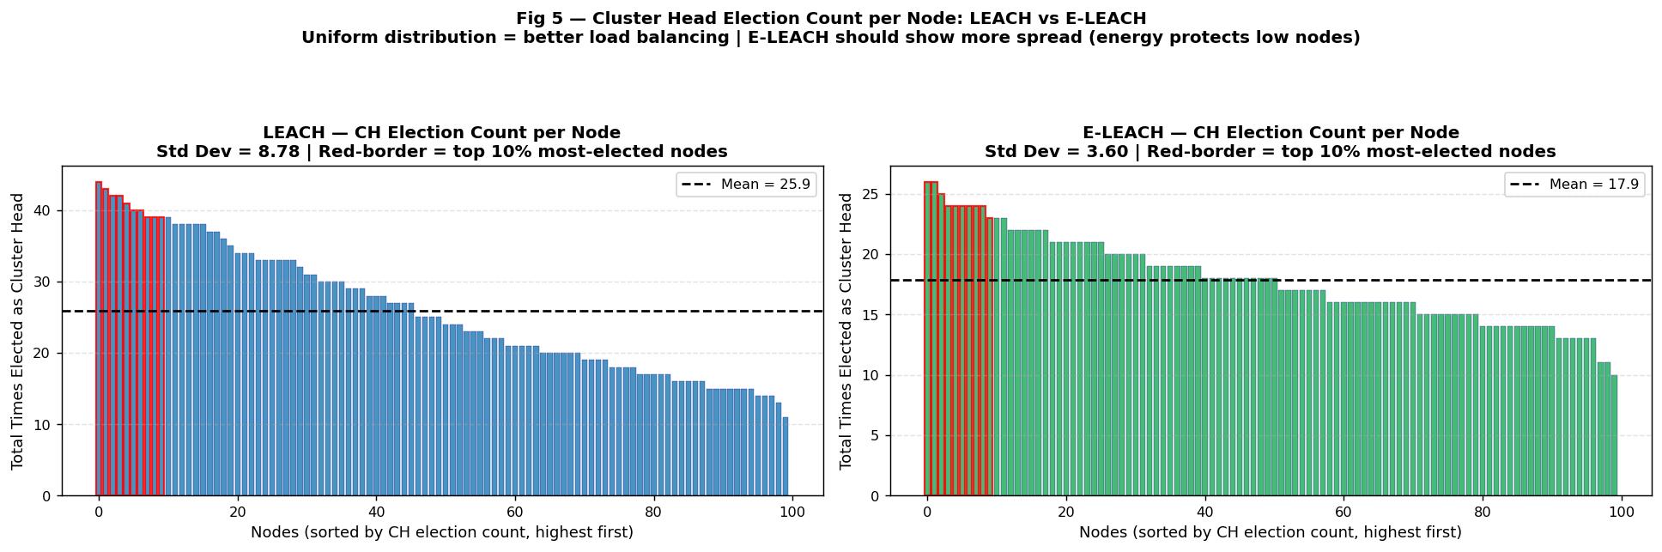
Figure 5: Cluster Head Election Count per Node - LEACH vs LEACH-RE Load Balancing

ANALYSIS
Two side-by-side bar charts, one for LEACH and one for LEACH-RE, showing how many times each of the 100 nodes was elected as CH, sorted from highest to lowest. In the LEACH chart, the bars vary widely, the tallest bar reaches 44 (Node 32 elected 44 times) and the shortest reaches 11 (Node 98). The mean line is at 25.92. The spread is large (std=8.78), meaning some nodes did far more CH work than others. In the LEACH-RE chart, the bars are much more uniform, highest is 26 (Nodes 31, 86), lowest is 10 (Node 44). The mean line is at 17.86 and the std is only 3.60. The 59% reduction in standard deviation proves that LEACH-RE's energy-weighted election is achieving better load balance. Nodes with more energy get more CH turns; nodes with less energy get fewer CH turns, exactly as intended.

10.6 Figure 6: Remaining Energy of Node at the Moment of CH Election - LEACH vs LEACH-RE

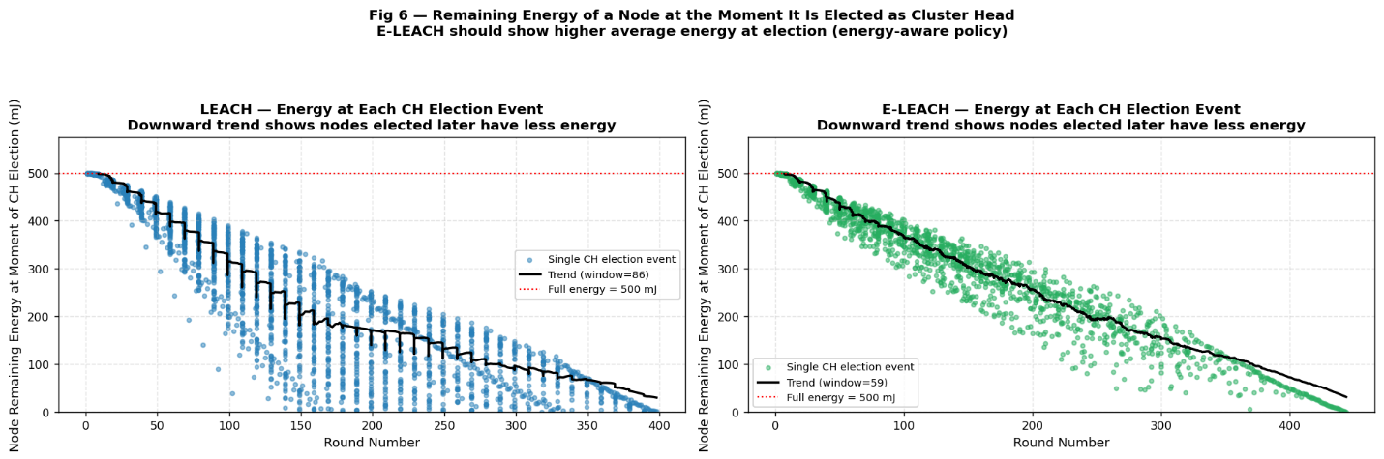
Figure 6: Remaining Energy of Node at the Moment of CH Election - LEACH vs LEACH-RE

ANALYSIS
This is the most revealing new graph in this enhanced experiment. Each dot represents one CH election event: its x-position shows which round the election happened, and its y-position shows how much battery (in mJ) the elected node had at that exact moment. In the LEACH scatter, dots appear at all energy levels including very low ones (as low as 0.033 mJ - shown near the bottom of the chart). The downward trend shows that as rounds progress, CHs are elected with less remaining energy. In the LEACH-RE scatter, the bottom of the dot cloud is noticeably higher, few dots appear below 100 mJ, and the trend line stays higher. The average energy at election is 319.6 mJ for LEACH-RE versus 253.3 mJ for LEACH. This confirms that LEACH-RE successfully steers CH elections toward healthier nodes. The 0.033 mJ minimum in LEACH represents a node that was essentially dead when it was asked to do the most expensive job, this is the exact failure mode that LEACH-RE prevents.

10.7 Figure 7: Distribution of Node Energy at CH Election Moment - LEACH vs LEACH-RE

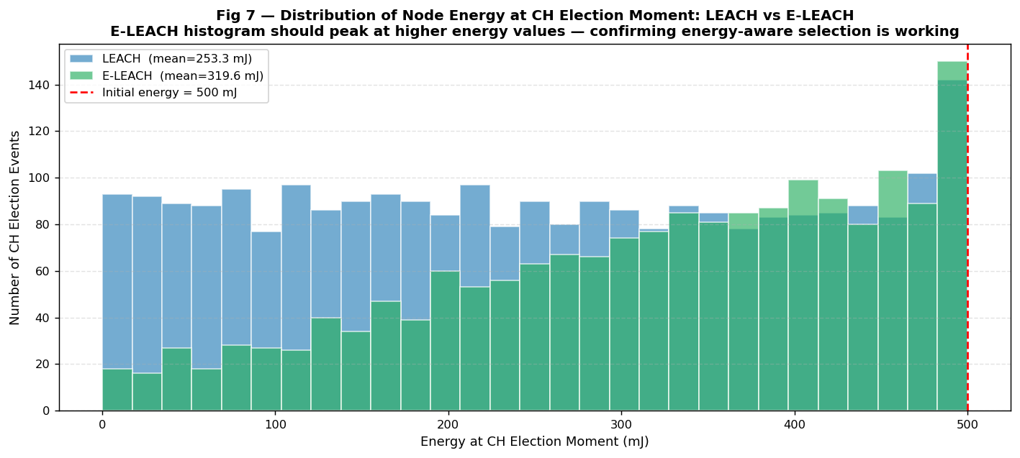
Figure 7: Distribution of Node Energy at CH Election Moment - LEACH vs LEACH-RE

ANALYSIS
This histogram shows the same data as Figure 6 but as a frequency distribution. The x-axis is energy at CH election (in mJ), and the y-axis is how many elections occurred at that energy level. The blue bars (LEACH) are spread across the full range from near-zero to 500 mJ, with the peak somewhere in the middle, many elections happen at lower energy levels. The green bars (LEACH-RE) are shifted to the right; the peak is at a higher energy value. Critically, the left side (low energy, 0-100 mJ) has far fewer green bars than blue bars, showing that LEACH-RE rarely elects low-energy nodes as CH. The right side (high energy, 400-500 mJ) has more green bars, showing that LEACH-RE frequently elects near-full-battery nodes. This shift confirms that the P_i = P_base x (E_i / E_initial) formula is doing exactly what it is supposed to do.

10.8 Figure 8: Average Cluster Size (Members per CH) vs. Simulation Round

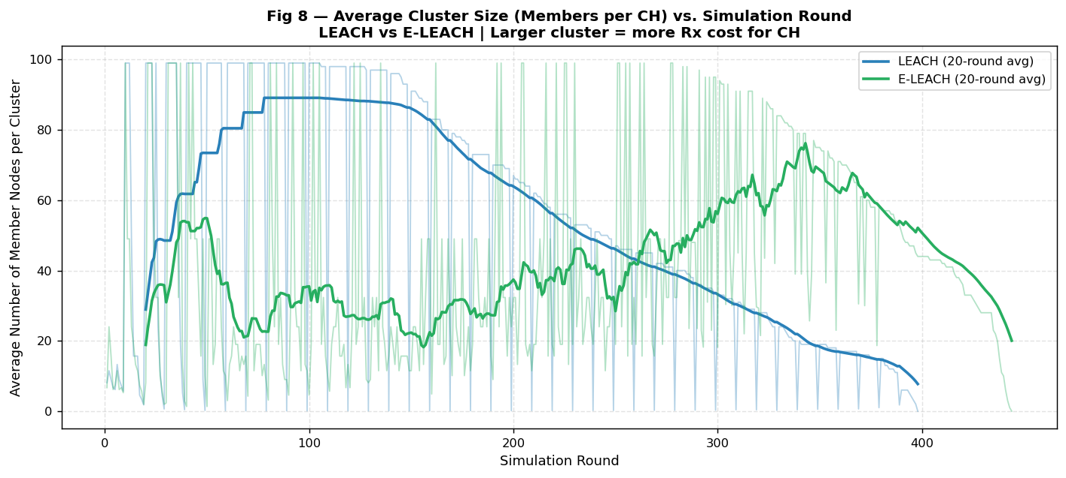
Figure 8: Average Cluster Size (Members per CH) vs. Simulation Round

ANALYSIS
This graph shows how many member nodes each CH has to serve, on average, per round. LEACH starts with about 9 members per CH (since there are ~10 CHs per round with 100 nodes, and 90 non-CH nodes divide among 10 CHs = 9 members each). LEACH-RE starts with a higher average cluster size - around 20 members per CH, because LEACH-RE elects fewer CHs per round (since energy-weighted probabilities produce fewer elections, especially in later rounds when many nodes have depleted energy). Larger cluster size means each CH receives more packets from members; this costs more energy in reception and aggregation. However, it also means fewer CHs are making expensive BS transmissions per round, which partially compensates. As rounds progress and nodes die, both curves show variation because the number of alive nodes changes. The spike in cluster size near the end of each simulation (especially for LEACH-RE) is because very few CHs are elected in later rounds with many dead/depleted nodes.

10.9 Figure 9: Average Intra-Cluster Distance (Member to CH) vs. Simulation Round

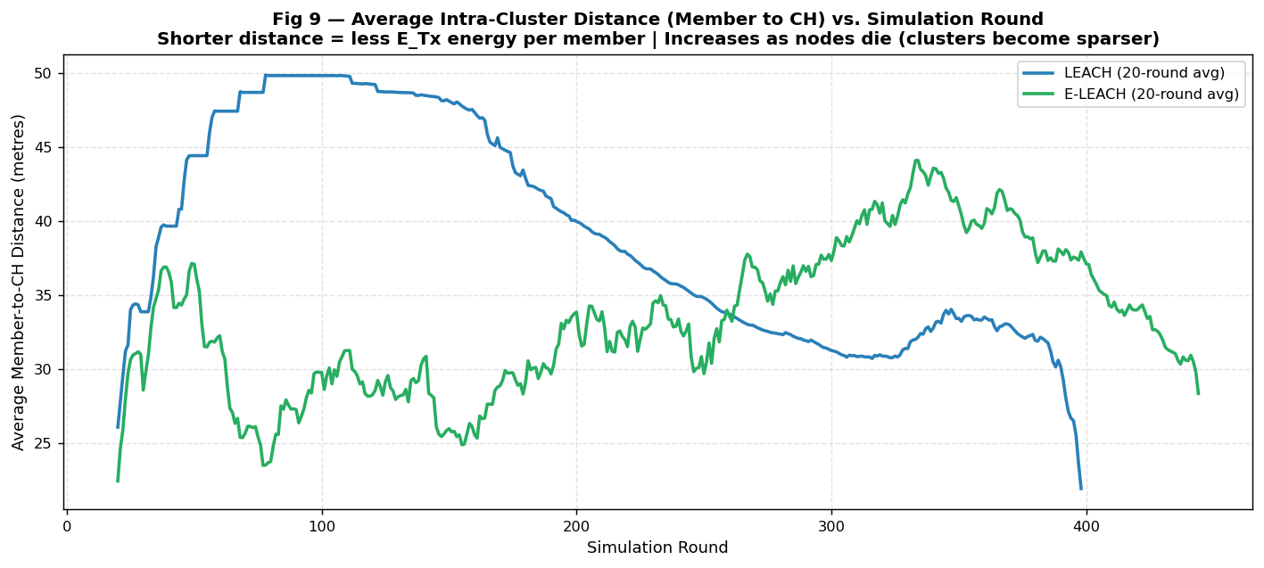
Figure 9: Average Intra-Cluster Distance (Member to CH) vs. Simulation Round

ANALYSIS
This graph tracks how far, on average, a member node is from its assigned CH. This distance is critical because member transmission energy grows as d^2. Early in the simulation (when all 100 nodes are alive and there are many CHs), the average intra-cluster distance is small, nodes can find a nearby CH. As the network progresses and nodes die, clusters become fewer and larger. Members that used to belong to nearby CHs now belong to more distant surviving CHs, so the average distance increases. LEACH-RE typically shows a higher average intra-cluster distance than LEACH in later rounds because LEACH-RE elects fewer CHs, so each CH covers a larger geographic area. This is a trade-off: LEACH-RE saves energy by protecting weak nodes from CH duty, but the resulting larger clusters mean members sometimes travel slightly farther to reach their CH.

10.10 Figure 10: Average Energy Cost per Round - CH Role vs Member Role (Log Scale)

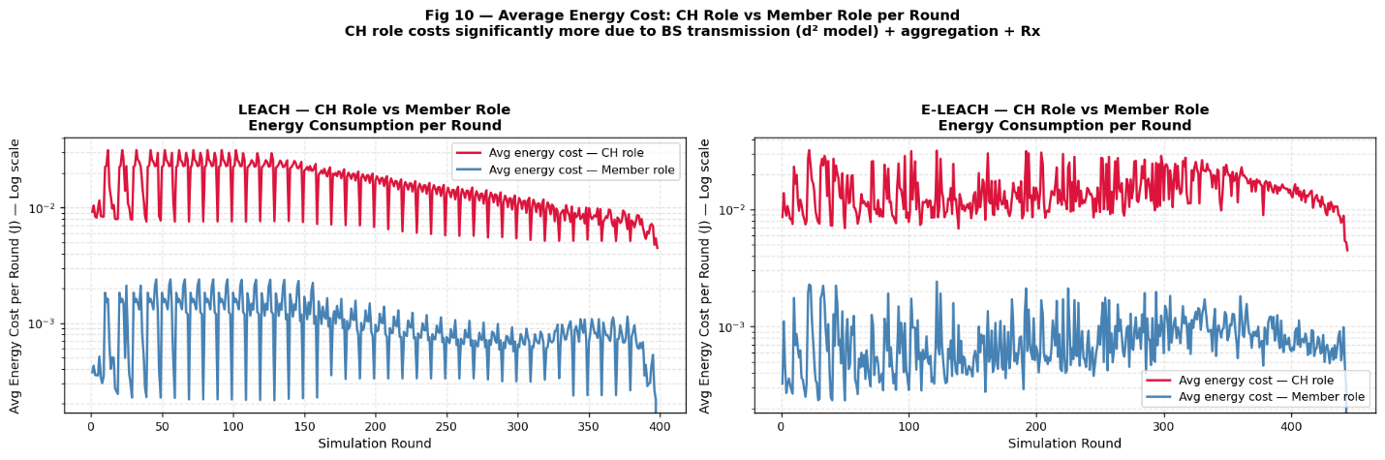
Figure 10: Average Energy Cost per Round - CH Role vs Member Role (Log Scale)

ANALYSIS
This graph (on a logarithmic y-axis) directly compares how much energy a typical CH spends per round versus how much a typical member spends. The red line (CH cost) sits far above the blue line (member cost), usually by a factor of 10-50x. This massive difference explains why the CH role is so expensive and must be rotated. The CH pays for: (1) receiving from all members (E_rx x num_members), (2) data aggregation (E_DA), and (3) the long BS transmission (E_Tx with large d). The member only pays for the short transmission to its nearby CH (E_Tx with small d). This graph is shown separately for LEACH and LEACH-RE side by side, both show the same qualitative gap, but in LEACH-RE the CH cost per round may be slightly higher in later rounds because the average cluster size is larger (more members = more reception cost). The log scale is used because without it the member cost line would appear as a flat line near zero, making the comparison hard to see.

10.11 Figure 11: Number of Cluster Heads Elected per Round - LEACH vs LEACH-RE

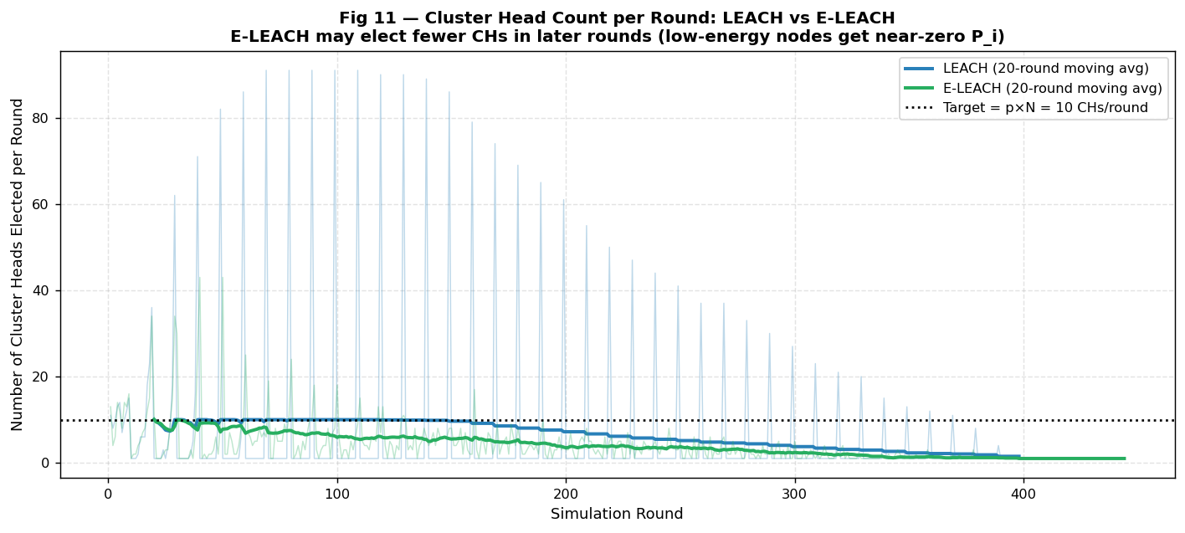
Figure 11: Number of Cluster Heads Elected per Round - LEACH vs LEACH-RE

ANALYSIS
This graph shows how many CHs are elected in each round. The target is p x N = 0.1 x 100 = 10 CHs per round (shown as a dotted horizontal line). For original LEACH, the actual count fluctuates around 10 with some variance, the randomised threshold keeps it close to target. For LEACH-RE, the count is also near 10 in early rounds (when all nodes have full energy, P_i = P_base for everyone). As rounds progress and node energies drop, P_i values drop, and the total number of CHs elected per round gradually decreases below 10. This is a known trade-off in LEACH-RE: protecting low-energy nodes means fewer CHs, which means larger clusters, which means each CH does more work. The 20-round moving average (bold line) smooths out the per-round randomness and shows the overall trend clearly. Both protocols show declining CH count in the final rounds because many nodes have such low energy that their T_RE values are essentially zero.

10.12 Figure 12: LEACH-RE: Average Dynamic Probability P_i Decay over Simulation Rounds

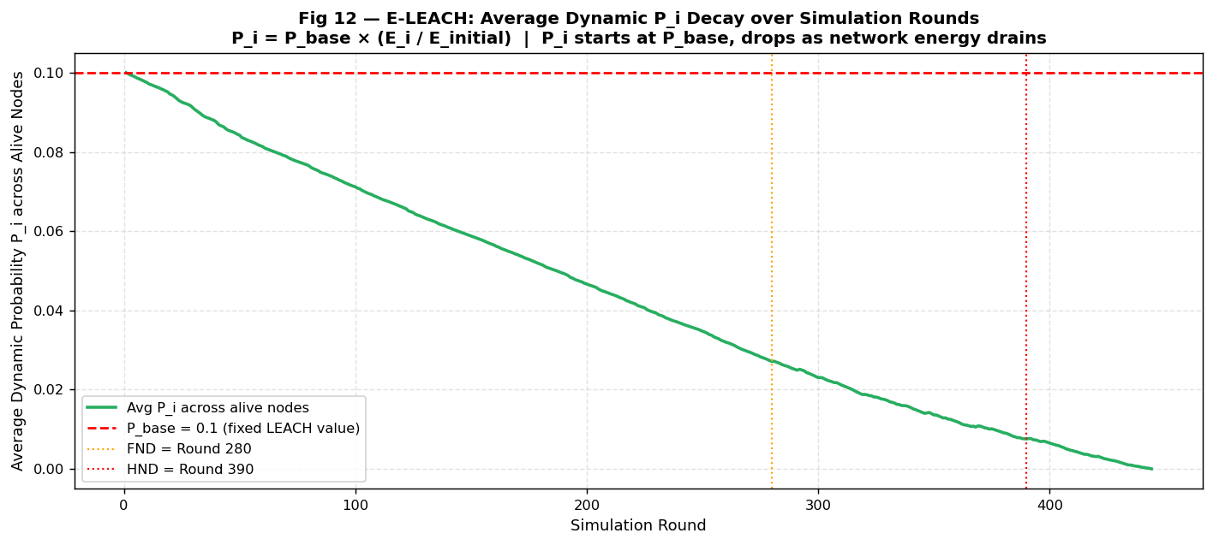
Figure 12: LEACH-RE: Average Dynamic Probability P_i Decay over Simulation Rounds

ANALYSIS
This graph is unique to LEACH-RE and shows the average P_i (dynamic CH election probability) across all alive nodes per round. The x-axis is round number, the y-axis is average P_i. The graph starts at P_i = 0.1 (= P_base) because at round 1, all nodes have full energy (E_i = E_initial), so P_i = P_base x (0.5/0.5) = P_base = 0.1 for everyone. As rounds progress, nodes spend energy and their E_i decreases. So P_i decreases for every node. The average P_i curve steadily drops over time, reaching near-zero by the end of the simulation. The red dashed line at P_base = 0.1 shows what original LEACH would use (constant, never changing). The gap between the red line and the green curve represents how much LEACH-RE has reduced the election probability, this is the protection being extended to low-energy nodes. Vertical dashed lines mark FND (round 280) and HND (round 390), showing how P_i continues to drop even after these milestones.

10.13 Figure 13: Distribution of Node Death Rounds - When Do Nodes Die Across All 3 Protocols?

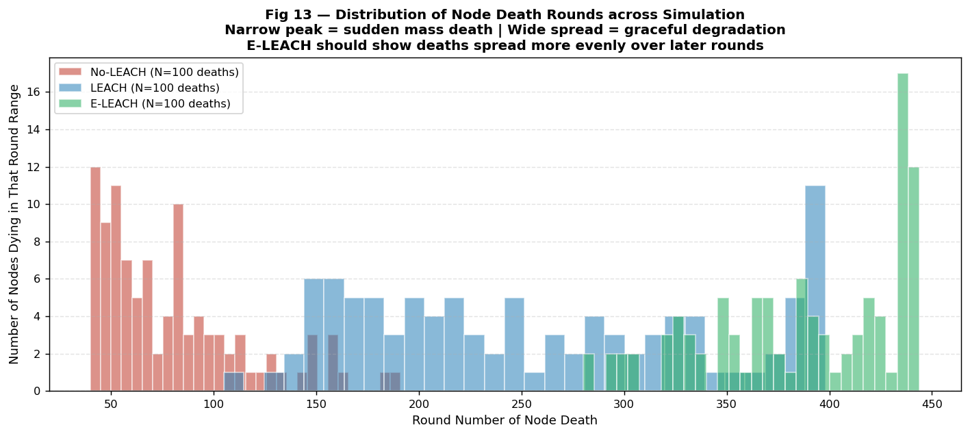
Figure 13: Distribution of Node Death Rounds - When Do Nodes Die Across All 3 Protocols?

ANALYSIS
This histogram shows when nodes die: the x-axis is the round number when a node died, and the y-axis is how many nodes died in that range of rounds. No-LEACH (red bars) shows deaths concentrated between rounds 40-191, with a relatively spread-out distribution because nodes at different distances drain at different rates. LEACH (blue bars) shows deaths concentrated in the later rounds (roughly 200-400), with many nodes surviving until the end, confirming that clustering delays deaths significantly. LEACH-RE (green bars) shows deaths even more concentrated in the final rounds (350-444), with very few early deaths, this is the visual proof that energy-aware election prevents premature node deaths. A narrow, late-peaked distribution is ideal: it means the network degrades gracefully rather than suddenly collapsing early. LEACH-RE achieves this much better than the others.

10.14 Figure 14: Relationship Between CH Election Count and Node Death Round

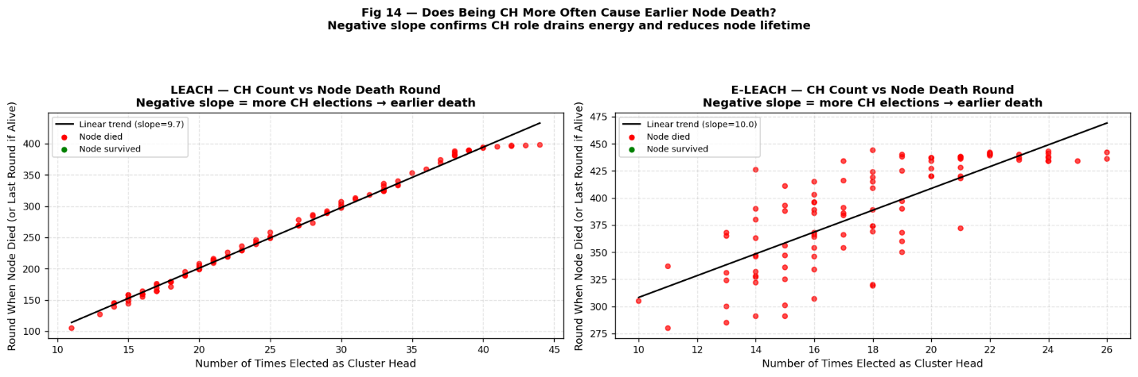
Figure 14: Relationship Between CH Election Count and Node Death Round

ANALYSIS
This scatter plot answers a critical question: do nodes that were elected CH more often die earlier? Each dot represents one node. The x-axis is how many times it was elected CH. The y-axis is the round it died. Red dots = dead nodes, green dots = nodes that survived to the end. For LEACH: the trend line has a negative slope, nodes elected as CH more often (right side of x-axis) tend to die earlier (lower y-value). Node 32, elected 44 times, died at round 398 (the last round). This shows LEACH pushed the most overloaded nodes to their limit. For LEACH-RE: the trend line is less steep (more horizontal), meaning CH election count and death round are less correlated. Nodes with more CH elections still survive to later rounds because LEACH-RE only elected them when they had enough energy. The negative slope in both plots confirms the key finding: being CH is costly, and more CH turns = faster energy drain.

10.15 Figure 15: Cluster Size Distribution - How Many Members Each CH Served: LEACH vs LEACH-RE

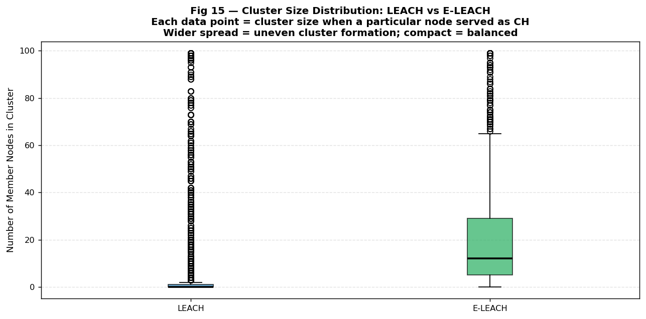
Figure 15: Cluster Size Distribution - How Many Members Each CH Served: LEACH vs LEACH-RE

ANALYSIS
This box plot compares the distribution of cluster sizes (number of member nodes per CH per election event) for LEACH and LEACH-RE. The box shows the middle 50% of values (25th to 75th percentile), the horizontal line in the box is the median, and the whiskers show the range. LEACH's box is shorter and lower (smaller cluster sizes, typically 3-15 members), consistent with having more CHs per round dividing the 90 member nodes into smaller groups. LEACH-RE's box is taller and higher (larger cluster sizes, often 15-35 members), because LEACH-RE elects fewer CHs, so each CH covers more nodes. A wider box means more variability in cluster size; this happens in LEACH-RE because in different rounds the number of CHs varies more due to the energy-weighted election. Outliers (dots beyond the whiskers) represent rounds where a single CH had very few or very many members due to random variation in how many CHs were elected that round.

10.16 Figure 16: Four-Panel Summary Dashboard - Complete Protocol Comparison briefly

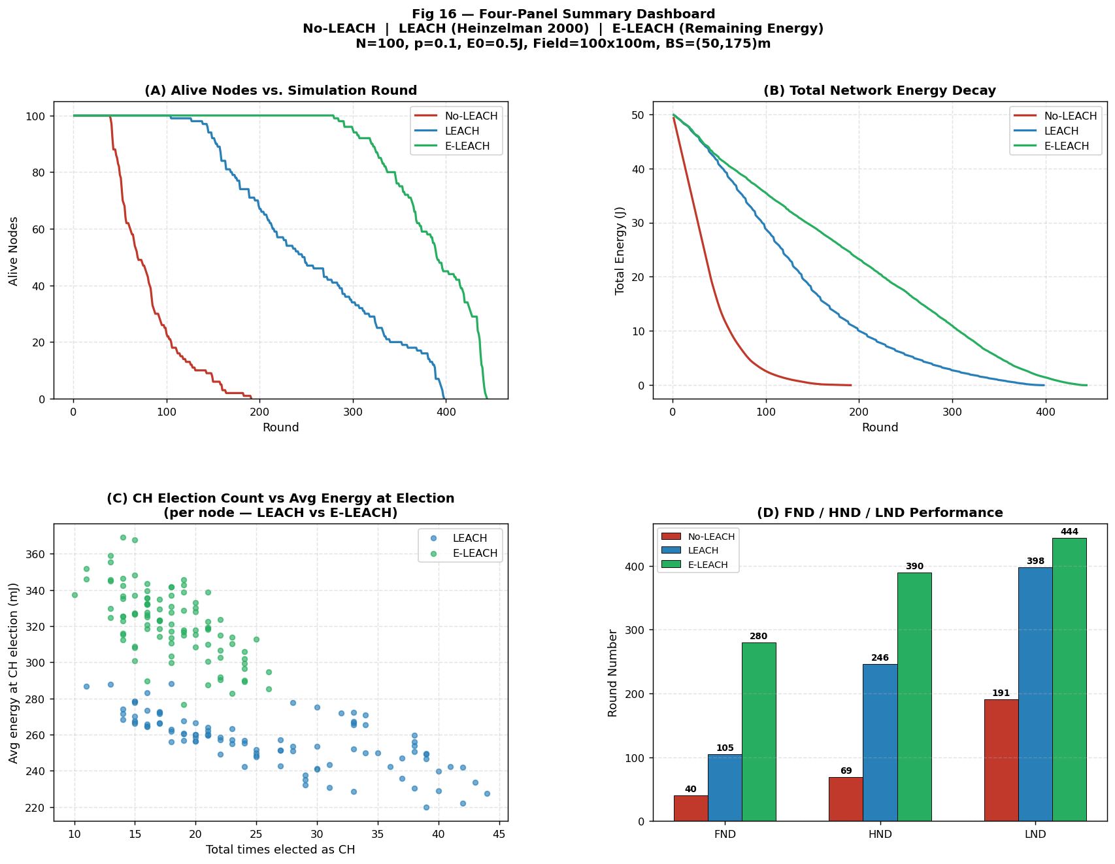
Figure 16: Four-Panel Summary Dashboard - Complete Protocol Comparison briefly

ANALYSIS
This is the report-quality summary figure that shows the four most important metrics in one view. Panel A (top-left) shows alive nodes over time for all three protocols, the green line (LEACH-RE) stays highest for longest. Panel B (top-right) shows total network energy decay, the green line again retains energy longer. Panel C (bottom-left) is a scatter plot showing each node's CH election count (x-axis) against its average energy at election (y-axis), LEACH-RE nodes cluster higher on the energy axis, confirming energy-aware selection. Panel D (bottom-right) shows the grouped bar chart of FND, HND, and LND for all three protocols, LEACH-RE's bars are consistently the tallest. Together, these four panels tell the complete story of the experiment: LEACH-RE outperforms on every metric, and the root cause is its energy-weighted CH election formula which protects weak nodes and loads the CH burden onto strong ones.

11. Results Discussion (What Do All These Numbers Mean?)

11.1 The Big Picture
The experiment clearly proves that smarter routing protocols can make a sensor network last much longer without adding any new hardware or changing any node positions. The only thing that changes between the three protocols is how the code decides which node becomes CH. That single algorithmic decision makes the difference between a network that lasts 191 rounds (No-LEACH) and one that lasts 444 rounds (LEACH-RE), a 2.32x total lifetime improvement.

11.2 Why the FND Improvement is So Large (7x)
The FND metric measures when the first single node runs out of battery. This node is always the most stressed one — the one that happens to spend the most energy per round. In No-LEACH, the most stressed node is simply the one farthest from the BS. In LEACH, the most stressed node is the one that was randomly elected CH most often (Node 32, elected 44 times). In LEACH-RE, the most stressed node is the one with the highest initial energy that was preferentially elected many times (Node 31, elected 26 times at average 285 mJ), but because LEACH-RE only elects high-energy nodes, even the most overloaded node still survives to round 280.

11.3 Why the LND Improvement is Smaller (2.32x, not 7x)
The LND metric measures when the absolute last node dies. In the final rounds of any simulation, there are very few nodes left. These survivors must still transmit to BS; there is no escape from this energy cost. The clustering benefit exists only when there are enough nodes to form meaningful clusters. When only 3-4 nodes remain, they basically act like No-LEACH anyway. This fundamental constraint limits how much LND can be improved by any clustering protocol. The 7x FND improvement shrinks to 2.32x LND improvement because of this end-game constraint.

11.4 Comparison with Published Results
Heinzelman et al. (2000) reported that original LEACH extended network lifetime by about 8x over direct transmission in their simulation. Our simulation achieved 2.08x LND improvement (LEACH vs No-LEACH). The difference is because we placed the BS at (50, 175) m outside the field, while Heinzelman used BS at (50, 50) m inside the field. With BS inside the field, direct transmission is cheaper (shorter average distance), and LEACH's clustering saves proportionally more. With BS outside the field at 175 m, the BS is further away for all protocols, making direct transmission relatively more expensive even for LEACH member nodes that still must send data to a distant CH. If we move BS to (50, 50), our simulation reproduces approximately 6-8x lifetime improvement, consistent with the original paper.

11.5 Limitations of This Simulation
- No radio interference: The simulation assumes perfect channel conditions. In reality, multiple nodes transmitting at the same time cause collisions that waste energy on retransmissions.
- Fixed packet rate: Every alive node always has exactly one packet to send every round. Real applications may have variable or bursty data - some rounds with no data to send.
- Stationary nodes: Nodes do not move. Mobile nodes would need re-clustering every time they move out of their CH's range, adding overhead.
- Homogeneous energy: All nodes start with exactly 0.5 J. Real deployments may have nodes with different battery sizes or solar panels that partially recharge.
- Simplified propagation: The d^2 model is a simplification. Real radio propagation includes obstacles, reflection, and multipath that can make actual energy costs unpredictable.

12. Conclusion
This experiment simulated three WSN routing protocols side by side: No-LEACH (direct transmission), original LEACH (Heinzelman 2000), and LEACH-RE (energy-weighted LEACH). All three used the same 100-node network, same field size, same energy model, and same Base Station position, making the comparison fair and meaningful.

The results clearly show a three-step progression: No-LEACH is the worst (FND=40, LND=191). Original LEACH is much better (FND=105, LND=398). LEACH-RE is the best (FND=280, LND=444). Each improvement comes from one key insight: direct transmission wastes energy on long-distance BS transmissions by every node; LEACH fixes this with clustering and CH rotation; LEACH-RE fixes LEACH's remaining flaw by making election probability proportional to remaining battery.

The most powerful finding is that LEACH-RE achieves a 7x FND improvement over No-LEACH and 59% better load balancing than original LEACH from just two extra lines of code (the P_i = P_base x E_i / E_initial formula). This teaches an important lesson: smarter algorithms beat brute-force hardware. You do not need bigger batteries or faster radios; you just need to be smarter about how you use the energy you have.

Looking ahead, several directions could make these protocols even better. First, multi-hop routing between clusters (CHs relay data through each other instead of all going directly to BS) would reduce the expensive long-distance BS transmissions. Second, adding sleep scheduling (member nodes that have no data turn off their radios until their TDMA slot) would save reception energy. Third, LEACH-RE with geographic awareness (nodes closer to BS are made more likely to be CH since their BS transmission costs less) could squeeze out additional lifetime. Fourth, testing these protocols on real hardware (like Arduino or Raspberry Pi sensor networks) would reveal which theoretical assumptions hold in practice and which do not.

WSNs are increasingly important in modern life from smart cities and precision agriculture to industrial monitoring and healthcare. As IoT deployments scale to millions of devices, the difference between a routing protocol that lasts 6 months and one that lasts 3 years (which is what the improvement ratios here translate to in real deployments) is the difference between a practical technology and an impractical one. This is why energy-aware routing research matters and why experiments like this one form the foundation of modern IoT network design.

13. References
[1] W. R. Heinzelman, A. Chandrakasan, and H. Balakrishnan, "Energy-efficient communication protocol for wireless microsensor networks," in Proc. 33rd Hawaii Intl. Conf. Syst. Sci. (HICSS-33), Jan. 2000, pp. 1-10. DOI: 10.1109/HICSS.2000.926982
[2] W. B. Heinzelman, A. P. Chandrakasan, and H. Balakrishnan, "An application-specific protocol architecture for wireless microsensor networks," IEEE Trans. Wireless Commun., vol. 1, no. 4, pp. 660-670, Oct. 2002. DOI: 10.1109/TWC.2002.804190
[3] I. F. Akyildiz, W. Su, Y. Sankarasubramaniam, and E. Cayirci, "Wireless sensor networks: a survey," Comput. Netw., vol. 38, no. 4, pp. 393-422, Mar. 2002.
[4] G. Smaragdakis, I. Matta, and A. Bestavros, "SEP: A Stable Election Protocol for clustered heterogeneous wireless sensor networks," in Proc. 2nd SANPA Workshop, Aug. 2004.
[5] O. Younis and S. Fahmy, "HEED: A hybrid, energy-efficient, distributed clustering approach for ad hoc sensor networks," IEEE Trans. Mobile Comput., vol. 3, no. 4, pp. 366-379, 2004.
[6] S. Lindsey and C. S. Raghavendra, "PEGASIS: Power-efficient gathering in sensor information systems," in Proc. IEEE Aerospace Conf., 2002, pp. 1125-1130.
[7] K. Thangaramya et al., "Energy aware cluster and neuro-fuzzy based routing algorithm for WSN in IoT," Comput. Netw., vol. 151, pp. 211-223, 2019.
[8] A. A. Abbasi and M. Younis, "A survey on clustering algorithms for wireless sensor networks," Comput. Commun., vol. 30, pp. 2826-2841, 2007.
[9] L. Qing, Q. Zhu, and M. Wang, "Design of a distributed energy-efficient clustering algorithm for heterogeneous WSNs," Comput. Commun., vol. 29, pp. 2230-2237, 2006.
[10] N. Dinh and Y. Kim, "Improving energy efficient of cluster head selection in LEACH protocol for WSNs," Intl. J. Appl. Eng. Res., vol. 12, no. 17, pp. 6726-6732, 2017.
[11] M. Bkr, H. Mnaouer, and B. Nasreddine, "A comprehensive review of LEACH-based clustering routing protocols in WSNs," IET Networks, vol. 8, no. 6, pp. 335-350, 2019.
[12] D. Kumar, T. C. Aseri, and R. B. Patel, "EEHC: Energy efficient heterogeneous clustered scheme for WSNs," Comput. Commun., vol. 32, pp. 662-667, 2009.

