TITLE: CHATBOX

**Report on CHATBOX Development**

**Abstract:**

This report outlines the development of a Chatbox utilizing Python, a data dump, and AIML (Artificial Intelligence Markup Language) files. The aim is to create an intelligent conversational agent that can simulate natural language interactions.

The utilization of AIML facilitates the understanding and response generation processes, making the chatbox more responsive and user-friendly. The report discusses the challenges in existing systems, proposes a novel approach, and highlights the system's advancements.

**Literature Survey:**

The literature survey reveals the evolution of chatbots from rule-based systems to more sophisticated approaches, such as natural language processing (NLP) and machine learning. AIML has gained popularity for creating chatbots due to its simplicity and flexibility. Previous studies have demonstrated the effectiveness of AIML in enhancing conversational agents' capabilities, making them more adaptive to user inputs.

**Introduction:**

Chatbots have become an integral part of modern applications, providing users with a natural and efficient way to interact with systems. This project focuses on the development of a Chatbox using Python as the programming language and leveraging DUMP and AIML files for dialogue management and natural language understanding.

The Chatbox project is a conversational agent designed to engage in natural language conversations with users. Developed using Python, DUMP (Dialog Understanding Markup Language), and AIML (Artificial Intelligence Markup Language) files, the Chatbox demonstrates the integration of various technologies to create a robust and interactive chatbot.

**Architecture**:

**User Input Processing**: Raw user input is received and preprocessed to extract relevant information. Python handles the input processing, tokenization, and basic language understanding.

**Dialog Management (DUMP)**: DUMP files define the structure of the conversation, including possible user inputs and corresponding system responses. These files guide the flow of the conversation, ensuring coherent and contextually relevant interactions.

**Natural Language Understanding (AIML)**: AIML files contain patterns and responses that enable the chatbot to understand user queries. The AIML engine processes user input and selects the most appropriate response based on predefined patterns.

**Problem Statement:**

While chatbots have seen significant advancements, issues persist in creating truly natural and context-aware conversations. Existing systems often struggle with understanding nuanced language, handling ambiguous queries, and adapting to user preferences. The challenge lies in developing a system that not only comprehends the user's intent accurately but also responds with relevance and coherence.

**Challenges:**

**Limited Context Understanding**: Many chatbots lack the ability to retain and use context across multiple turns in a conversation, leading to responses that may seem disjointed.

**Ambiguity Handling**: Natural language is inherently ambiguous, and existing systems often struggle to interpret ambiguous queries, resulting in inaccurate or irrelevant responses.

**Dynamic User Preferences**: Adapting to the user's preferences and evolving conversation topics remains a challenge for many chatbots, hindering the development of truly personalized interactions.

**Contextual Understanding**: Existing systems often face challenges in maintaining context throughout a conversation. Understanding and remembering the context of previous interactions is crucial for providing coherent and relevant responses.

**Limited Customization**: Many chatbots have limited customization options, making it challenging to tailor them to specific use cases or industries. This lack of adaptability hinders the deployment of chatbots in diverse environments with unique requirements.

**Objectives:**

**Create a Conversational Interface**: The primary objective of the Chatbox project is to develop a conversational agent capable of engaging in natural language conversations with users.

**Utilize Python for Flexibility**: Employ Python as the core programming language to harness its flexibility, extensive libraries, and community support for building a robust and adaptable chatbot.

**Implement DUMP for Dialog Managemen**t: Integrate DUMP (Dialog Understanding Markup Language) to structure and manage the flow of conversations. DUMP provides a systematic approach to handling dialog, ensuring coherence and context retention.

**Incorporate AIML for Natural Language Understanding**: Leverage AIML (Artificial Intelligence Markup Language) to enhance the chatbot's natural language understanding. AIML files contain patterns and responses that enable the chatbot to interpret user queries effectively.

**Maintain Contextual Conversations**: Implement features to maintain context throughout conversations, enhancing the user experience by providing coherent and contextually relevant responses.

**Modular Architecture for Extensibility**: Design a modular architecture to facilitate easy integration of additional features and the future expansion of the chatbot's capabilities. This ensures adaptability to evolving user needs and technological advancements.

**Novelty:**

**Integration of DUMP for Dialog Management**: The use of DUMP provides a structured and organized approach to dialog management, setting the Chatbox apart from conventional chatbots by ensuring coherent and contextually rich conversations.

**AIML for Natural Language Understanding**: The incorporation of AIML files distinguishes the Chatbox by enabling a more humanlike natural language understanding. This approach enhances the chatbot's ability to recognize user intent and generate appropriate responses.

**Modular Architecture for Flexibility**: The modular architecture of the Chatbox allows for easy extensibility, making it a versatile platform that can be adapted to incorporate new features and technologies as they emerge.

**Emphasis on Contextual Conversations**: The focus on maintaining context throughout conversations adds a layer of sophistication to the Chatbox, ensuring that user interactions are not treated in isolation but as part of an ongoing, coherent dialogue.

**Open Source and Community Engagement**: Consider making the Chatbox an open-source project, encouraging collaboration and contributions from the developer community. This fosters innovation and allows the chatbot to evolve rapidly with the collective expertise of a diverse group of developers.

**Conclusion:**

The development of the Chatbox using Python, DUMP, and AIML files showcases the successful implementation of a conversational agent. The modular architecture, natural language understanding capabilities, and context management contribute to a seamless and interactive user experience. Continuous improvement and integration of cutting-edge technologies will further enhance the chatbot's performance and utility in real-world applications.

***Some Insight of our Project:***

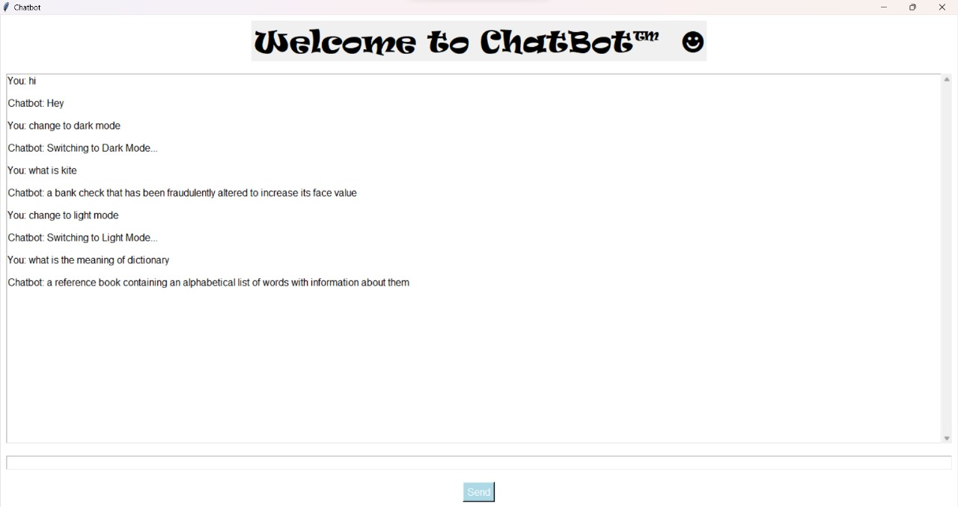



CODES:

