Manual smoke test
- Select the seeded patient row.
2. Enter `Ordering provider` and `Clinical reason`.
3. Click `Place order`.
4. In the report panel, enter findings.
5. Click `Finalize report`.
6. Add an amendment note and click `Amend report`.
7. Add a cancel reason and click `Cancel report`.
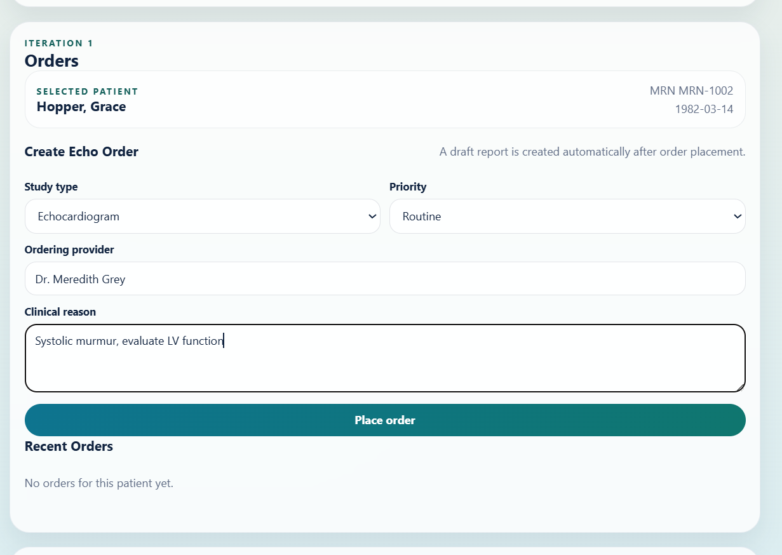
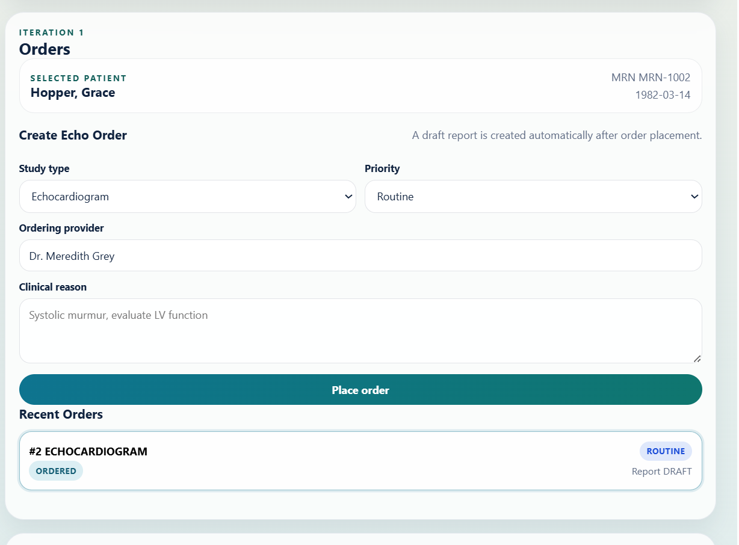
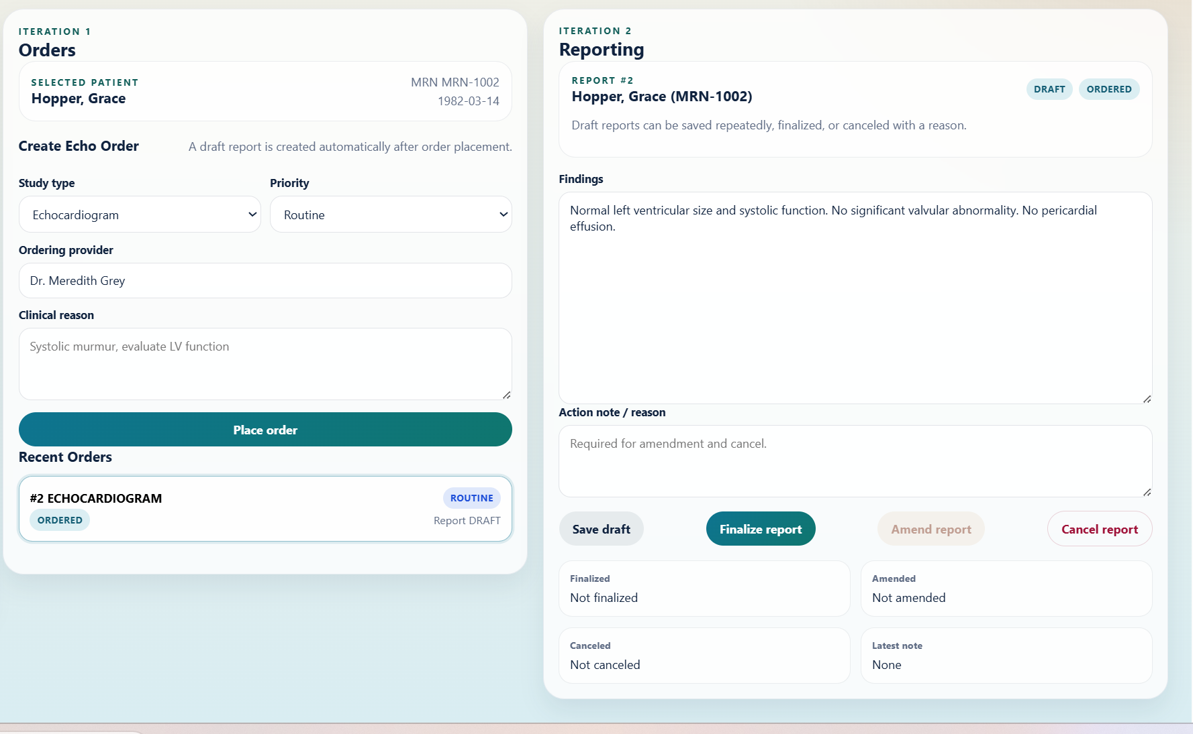
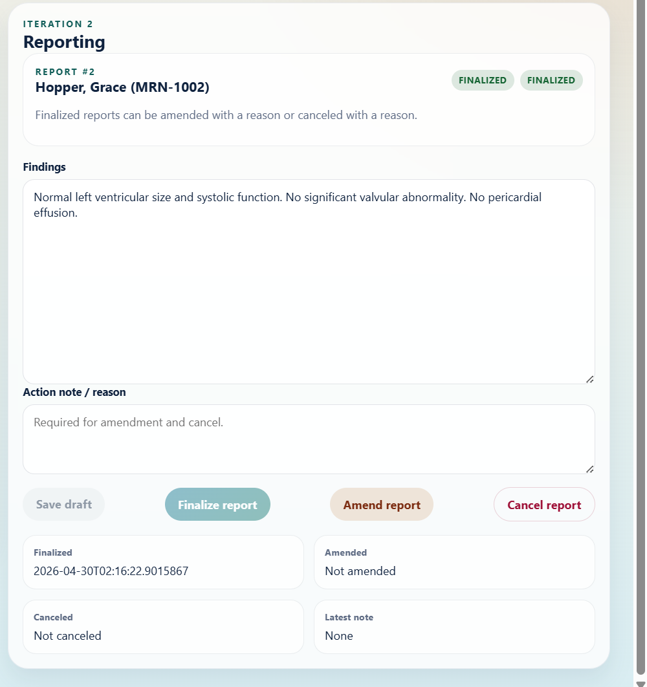
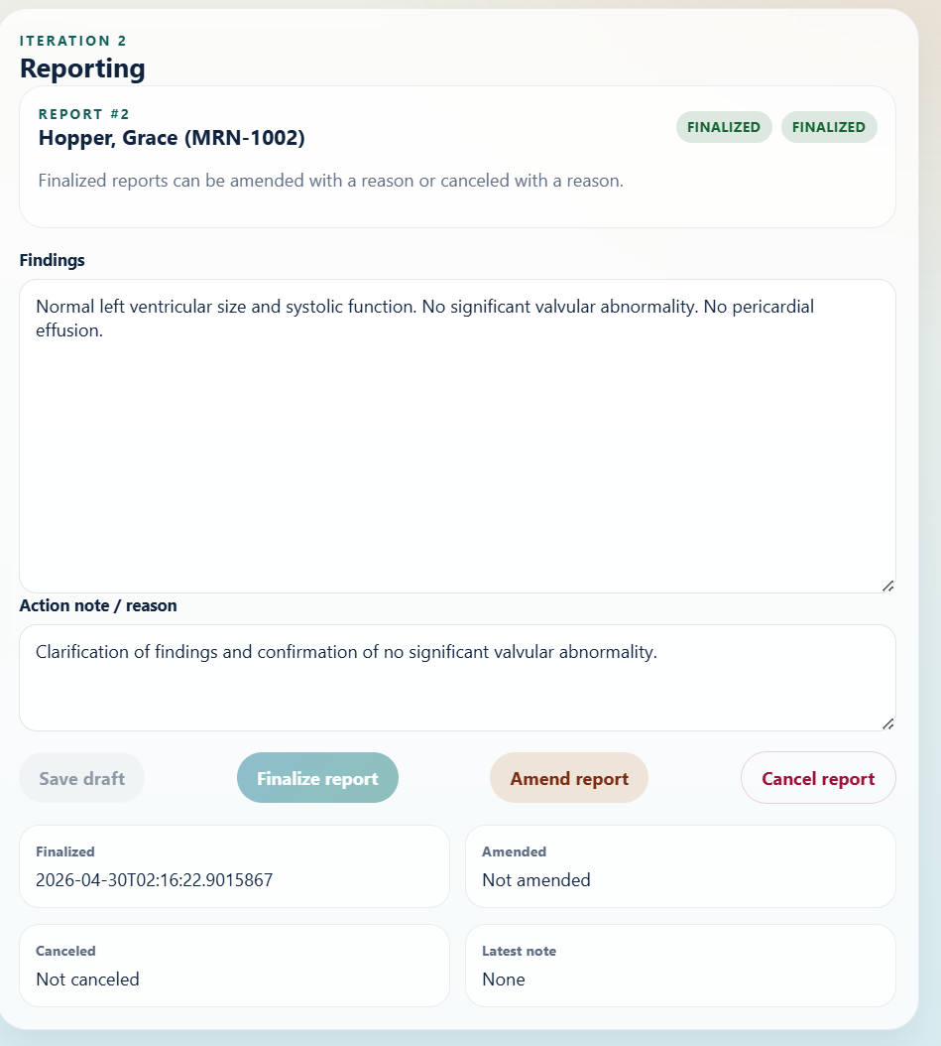
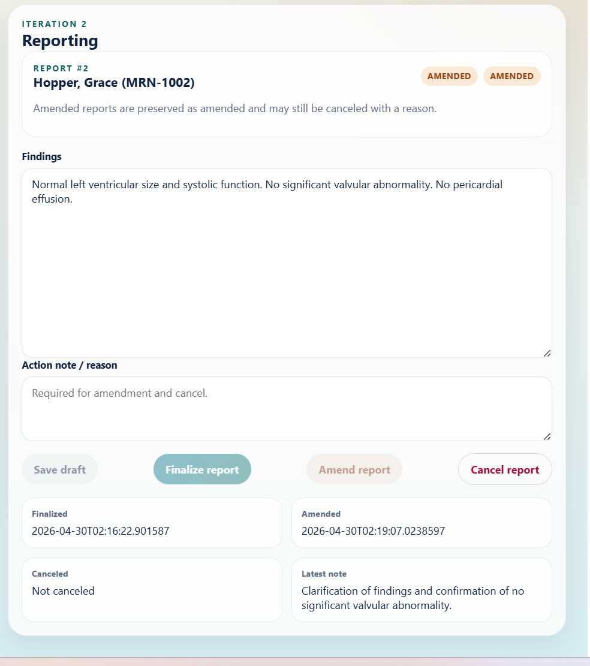
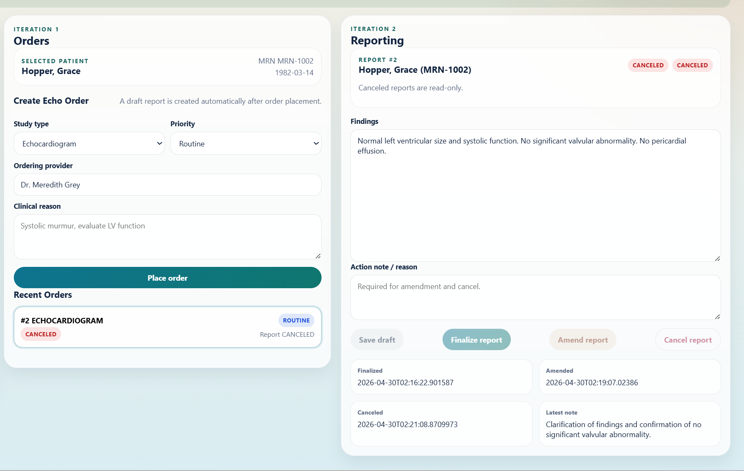

If that flow works, the app is basically wired correctly.
**6. Backend automated tests**
From a new PowerShell window:
```powershell
cd C:\work\clinical-ordering\backend
mvn test
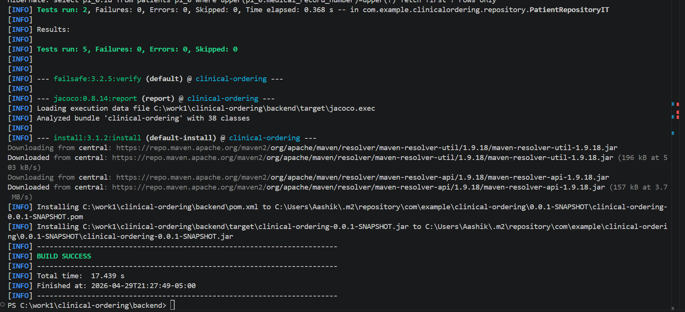
mvn verify
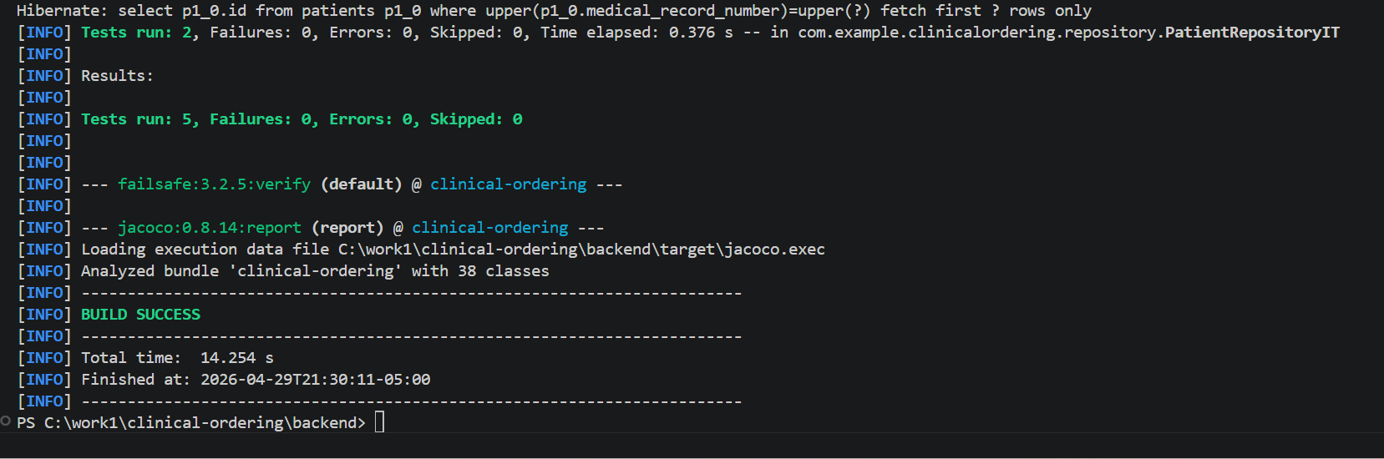
```
What they do:
- `mvn test`: backend unit tests
- `mvn verify`: backend integration tests + JaCoCo coverage
Open coverage report:
```powershell
start .\target\site\jacoco\index.html
```
**7. Frontend automated tests**
From the frontend folder:
```powershell
cd C:\work\clinical-ordering\frontend
npm run test:unit
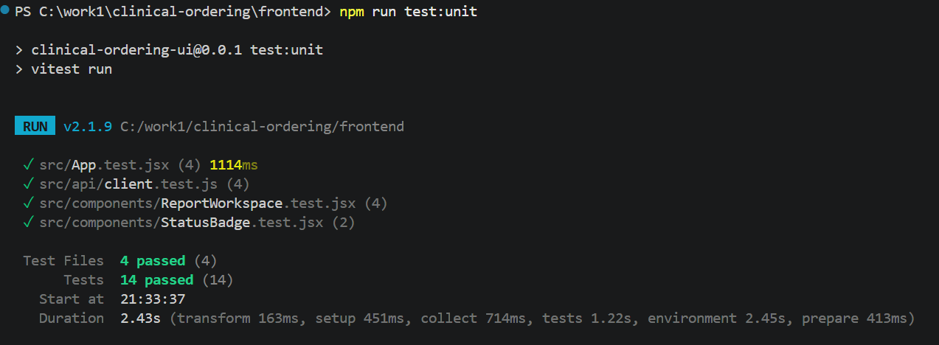
```
That runs the Vitest component/app tests.
**8. Cypress E2E**
Still in `frontend`:
```powershell
npm run test:e2e:cypress
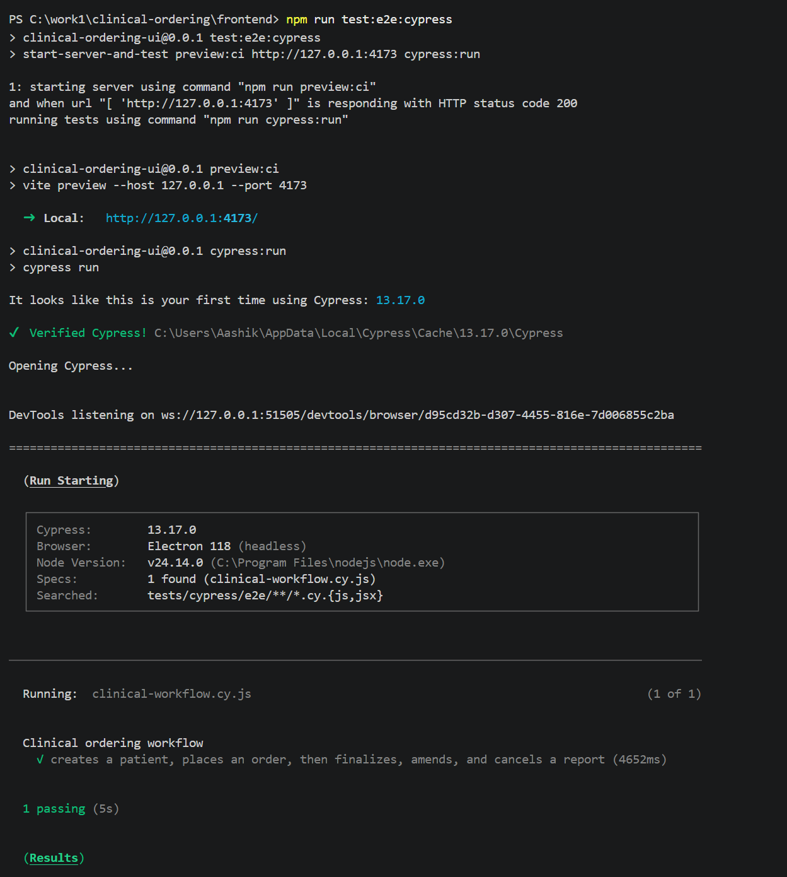
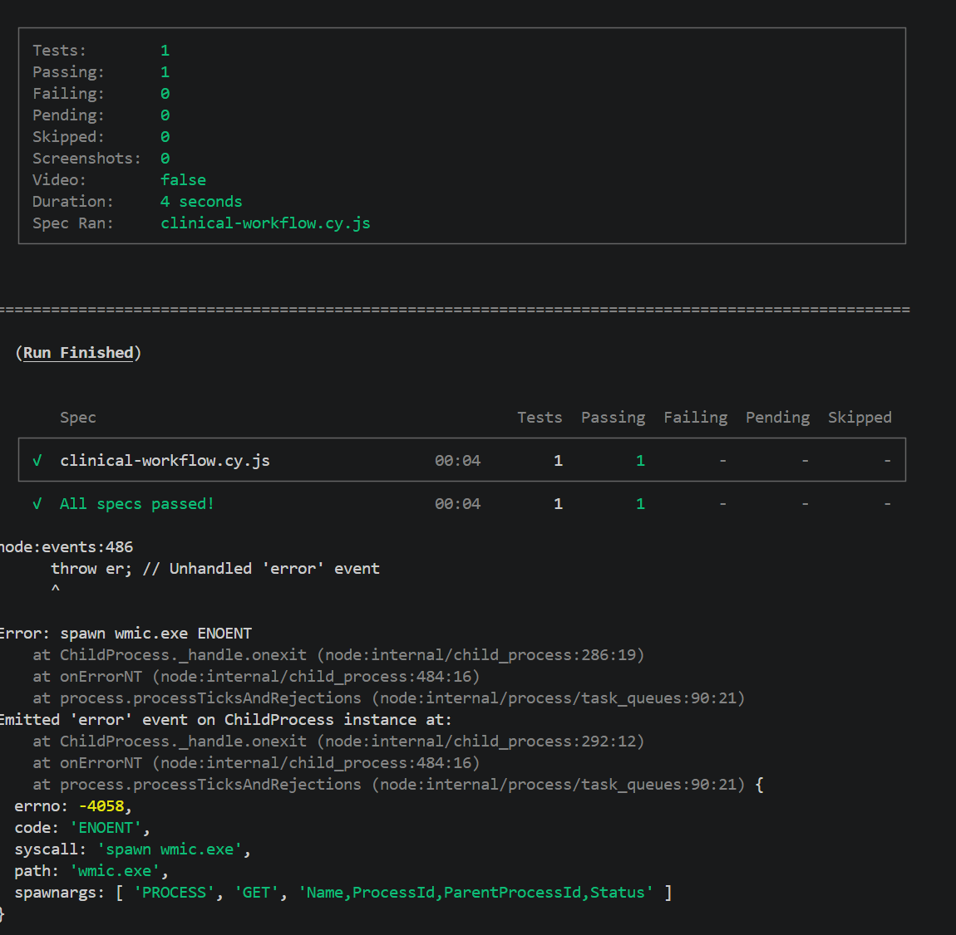
```
This does not need the backend. Cypress mocks the API.
**9. Selenium smoke test**
This one needs the live app running:
- backend on `8080`
- frontend dev server on `5173`
Then run:
```powershell
cd C:\work\clinical-ordering\frontend
npm run test:e2e:selenium
```
If Chrome is not available, try Edge:
```powershell
$env:SELENIUM_BROWSER="MicrosoftEdge"
npm run test:e2e:selenium
```
**10. Frontend performance audit**
From `frontend`:
```powershell
npm run build
npm run test:perf:lighthouse
```
Lighthouse output goes under:
```text
frontend\reports\lighthouseci
```
**11. API performance test**
Keep the backend running, then from the project root:
```powershell
cd C:\work\clinical-ordering
k6 run .\tests\performance\api-workflow.js
```
**12. Optional Postgres instead of H2**
From the project root:
```powershell
docker compose up -d postgres
cd backend
mvn spring-boot:run "-Dspring-boot.run.profiles=postgres,demo"
```
**13. Optional Keycloak mode**
From the project root:
```powershell
docker compose --profile auth up -d
cd backend
mvn spring-boot:run "-Dspring-boot.run.profiles=postgres,keycloak"
```
**Recommended order**
1. `backend` with `demo`
2. `frontend` with `npm install` and `npm run dev`
3. Manual smoke test
4. `mvn test`
5. `mvn verify`
6. `npm run test:unit`
7. `npm run test:e2e:cypress`
8. `npm run test:e2e:selenium`
9. `npm run test:perf:lighthouse`
10. `k6 run .\tests\performance\api-workflow.js`
**If something fails**
Common causes:
- `java` or `mvn` not on `PATH`
- `npm install` not run in `frontend`
- backend not running for Selenium/k6/manual testing
- Docker Desktop not started for Postgres/Keycloak
- Chrome/Edge missing for Selenium
If you want, I can turn this into a Windows-specific `RUN_TESTS_WINDOWS.md` or a `run-tests.ps1` script next.

