ECE 310 – WIRELESS COMMUNICATIONS
MILESTONE 2 PROJECT REPORT
Quantifying the Sum-Rate Cost of Reciprocity in
Beyond-Diagonal RIS-Aided MU-MISO Systems
A Manifold-Optimization Comparison Across Single-, Group-9, and Fully-Connected Architectures

Team Members
Member | Name | Primary M2 Responsibility
Member 1 | Samridhi | Report integration, literature/SOTA positioning and project coordination
Member 2 | Aashi | Reciprocal BD-RIS optimizer, manifold optimization and feasibility validation
Member 3 | Kahaan | General/non-reciprocal-capable BD-RIS baseline and convergence validation
Member 4 | Prakshal | Common simulation framework, channel generation, beamformer, matched comparison and shared metrics
Monsoon Semester 2026

Abstract
This milestone establishes the computational model that is necessary to assess the total cost of the application of reciprocity in the design of Beyond-Diagonal Reconfigurable Intelligent Surfaces (BD-RIS). This work compares the performance of the universal unitary scattering-matrix design to that of the reciprocal one, where the scattering-matrix is also subjected to symmetry constraints. To establish fair conditions for the comparison at M2, both the universal and reciprocal techniques apply the same realization of the channel, parameters of the system, architecture, fixed MMSE beamformer and SINR/sum-rate evaluator. The implementation incorporates single-connected (CWSC), group-connected (CWGC) and fully-connected (CWFC) designs. For M=32, N=K=2 and Pmax=20 dBm under Rayleigh fading, 50 generated Monte-Carlo cases produce mean sum-rates for the fixed beamformer of 8.517, 9.909 and 10.310 bps/Hz for the reciprocal SC, GC and FC cases correspondingly. The general unitary results are 8.517, 10.012 and 10.331 bps/Hz in turn. Therefore, the obtained mean reciprocity gaps are equal to 0 for the SC case, 0.103 (0.881%) bps/Hz for the GC and 0.0209 (0.168%) bps/Hz for the FC format respectively.These results are an initial M2 matched comparison rather than the final project-wide characterization; systematic sweeps over power, RIS size, group size/count, fading and complexity are reserved for later milestones.

1. Introduction and Problem Statement
Conventional RIS models use a diagonal scattering matrix, meaning that each RIS element acts independently. BD-RIS generalizes this model by allowing a non-diagonal scattering matrix, so signals entering one port can be coupled to other ports. This creates additional degrees of freedom for sum-rate maximization. The project studies what is lost when the BD-RIS is required to be physically reciprocal. Reciprocity imposes the symmetry condition Θ=Θᵀ, while a lossless passive scattering matrix must satisfy ΘᴴΘ=I.
The central question of the project is therefore: under otherwise identical conditions, how much sum-rate is lost when the feasible set is changed from general unitary BD-RIS matrices to reciprocal symmetric-unitary matrices? The proposal identifies this difference as the 'price of reciprocity'.
The M1 literature review was refined during M2. In particular, the team found that the literature already contains qualitative evidence that reciprocal and non-reciprocal curves can nearly coincide in at least one setting. Therefore, the project's claim is not that no comparison exists; instead, M2 focuses on a controlled numeric comparison using matched channels and a fixed beamformer, with absolute and percentage gaps.

2. Objectives of M2
- Build a common simulation environment used by both algorithmic pipelines.
- Develop and validate the reciprocal BD-RIS optimization process which is based on the Stiefel/unitary manifold, conjugate-gradient ascent, and Armijo line search.
- Create and validate the baseline of the general unitary/non-reciprocal-capable.
- Utilize the same channels, system characteristics, and fixed MMSE beamformer in order to compare results.
- Confirm the numerical values of the unitarity, symmetry, architectural form, and analytical gradients.
- Achieve initial convergence and matched Monte-Carlo results in order to obtain a reproducible M2 baseline.
- Define the restrictions and do the identification of systematic sweeps and complexity analysis that should be done in the next milestones.

3. System Model
The system is a downlink MU-MISO wireless system with a base station, a BD-RIS and K single-antenna users. The direct BS-user path is blocked in the implemented project model, matching the simulation scope documented in the M2 formulation.
The received signal is modeled as:
rₖ = hₖᵀ Θ H_TX V s + nₖ
where H_TX is the BS-to-RIS channel, H_RX contains the RIS-to-user channels, Θ is the M×M scattering matrix, V is the N×K transmit beamformer and nₖ is receiver noise.
The equivalent channel is E = H_RX Θ H_TX. For stream i at user k, cₖᵢ = eₖvᵢ and:
γₖ = |cₖₖ|² / (Σᵢ≠ₖ |cₖᵢ|² + N₀), R = Σₖ log₂(1 + γₖ)
The reported sum-rate is in bit/s/Hz and is the common metric used by both implementations.

4. BD-RIS Architectures and Reciprocity
Architecture | Structure of Θ | M=32 configuration | Reciprocity effect
CWSC | Diagonal unit-modulus | 32 blocks of size 1 | No additional restriction; exact zero-gap control
CWGC | Block diagonal | 8 groups, block size 4 | Symmetry restricts each 4×4 block
CWFC | Full unitary matrix | One 32×32 block | Symmetry restricts the full matrix
An important M2 convention is that G denotes the number of groups in the implementation. Thus, for M=32, the GC experiment uses G=8 and block size M/G=4. The project documentation distinguishes this group-count convention from papers that sometimes label GC by group size.
For the general design, Θ is unitary: ΘᴴΘ=I. For the reciprocal design, Θ is required to be both unitary and symmetric: ΘᴴΘ=I and Θ=Θᵀ. CWSC is a special control case because a diagonal unitary matrix is already symmetric, so reciprocity cannot reduce its feasible set. Therefore, a non-zero SC gap would indicate an implementation or optimization inconsistency.

5. Optimization Methodology

5.1 Common fractional-programming structure
The project uses the fractional-programming formulation described in the source work. The logarithmic sum-rate is transformed using the Lagrangian dual transform (LDT) and quadratic transform (QT). Auxiliary variables are updated from the current SINRs and effective channels, after which the scattering matrix is optimized. The M2 documentation explicitly corrects an earlier terminology issue: the reciprocal paper uses LDT+QT rather than Dinkelbach's method.

5.2 Reciprocal optimizer – Member 2 (Aashi)
The reciprocal implementation optimizes Θ on the unitary/Stiefel manifold while adding a symmetry penalty -ν||Θ-Θᵀ||² to the FP surrogate. The implemented penalty weight is ν=1.0. The Euclidean gradient includes the sum-rate terms and the symmetry-penalty derivative. It is projected onto the tangent space of the unitary manifold, followed by Polak–Ribière conjugate-gradient ascent and Armijo backtracking.
- Initial Θ is feasible with respect to unitarity and symmetry.
- Riemannian gradients are obtained by tangent-space projection.
- Armijo line search controls the ascent step in the non-convex landscape.
- QR retraction returns the iterate to the unitary manifold; a phase convention is used to make the retraction well-defined.
- At termination, exact symmetry is enforced by symmetrization followed by the unitary polar factor obtained through SVD.
- Final rates are evaluated after the exact projection, not before it.

5.3 General unitary baseline – Member 3 (Kahaan)
The general baseline removes the reciprocity constraint and optimizes over the corresponding block-unitary architecture. Two modes are implemented: a paper-faithful joint Li et al. baseline that updates the precoder and scattering matrix, and a matched fixed-V version used for the controlled reciprocity comparison. The fixed-V version is essential because the reciprocal pipeline freezes V during its Θ optimization; comparing it directly with a solver that continually changes V would mix the reciprocity effect with a beamformer-update effect.

5.4 Common simulation framework – Member 4 (Prakshal)
The common framework supplies channel generation, path loss, MMSE beamformer initialization, SINR, sum-rate, configuration handling, matched experiment execution and result storage. Both solvers receive the same channel matrices and the same fixed beamformer for a matched trial.

6. M2 Configuration
Parameter | M2 value
BS antennas, N | 2
Users, K | 2
RIS elements, M | 32
GC group count, G | 8
GC block size, M/G | 4
Transmit power, Pmax | 20 dBm = 0.1 W
Noise power, N0 | −80 dBm = 10⁻¹¹ W
BS–RIS distance | 50 m
RIS–user distance | 2.5 m
Path-loss reference | C0 = −30 dB at d0 = 1 m
Path-loss exponent | 2.2
Fading for matched M2 result | Rayleigh
Reciprocal penalty, ν | 1.0
Reciprocal stopping tolerance | 10⁻⁸ absolute surrogate-objective change
Matched Monte-Carlo draws | 50
The proposal defines a broader target range of N=K from 2–6, M from 8–64, several group configurations and Pmax from 0–20 dBm. Those broader sweeps are not treated as completed M2 results.

7. Validation and Numerical Checks
M2 includes dedicated tests for the common framework, reciprocal solver and general baseline. The following checks are supported by the saved code/results.
Validation | M2 evidence/result
Gradient finite difference | Analytical reciprocal gradient agrees with central finite differences with relative error ≈ 4.5×10⁻⁹ for tested block sizes 1, 4 and 32.
Unitary manifold/retraction | Unitarity and tangent/retraction errors are maintained at approximately 10⁻¹⁵ in reported tests.
Reciprocal FC final feasibility | For a single FC R=32 draw, final symmetry error ≈1.9×10⁻¹⁴ and unitarity error ≈6.1×10⁻¹⁵.
General baseline feasibility | Saved validation tests check unitary structure, monotone ascent behaviour, power constraint and architecture block structure.
CWSC control | Matched SC runs produce exactly zero measured gap in the saved results.
Reproducibility | Experiments store configuration, per-draw CSV files and MAT results.

8. M2 Results

8.1 Matched 50-draw Rayleigh experiment
The strongest M2 result is the 50-draw matched Monte-Carlo experiment at N=K=2, M=32 and Pmax=20 dBm. For every draw, the general and reciprocal fixed-V pipelines use the same channel realization, initialization protocol and beamformer. The table below reports the saved mean values.
Architecture | Reciprocal R (bps/Hz) | General R (bps/Hz) | Δabs (bps/Hz) | Δrel
SC | 8.5166 | 8.5166 | 0.0000 | 0.000%
GC | 9.9089 | 10.0119 | 0.1030 | 0.881%
FC | 10.3105 | 10.3313 | 0.0209 | 0.168%
The CWSC result is exactly zero-gap, as expected from the fact that a diagonal unitary matrix is already symmetric. For CWGC, the mean fixed-V gap is 0.10297 bps/Hz, corresponding to 0.88097%. For CWFC, the mean gap is 0.02088 bps/Hz, corresponding to 0.16793%. The saved standard errors are 0.02592 bps/Hz (GC) and 0.01160 bps/Hz (FC) for the absolute gap.
Because the optimization problems are non-convex and the solvers are not guaranteed to reach global optima, a small negative per-draw gap can occur even though the reciprocal feasible set is theoretically a subset of the general unitary set. The saved results therefore retain negative values rather than clipping them.
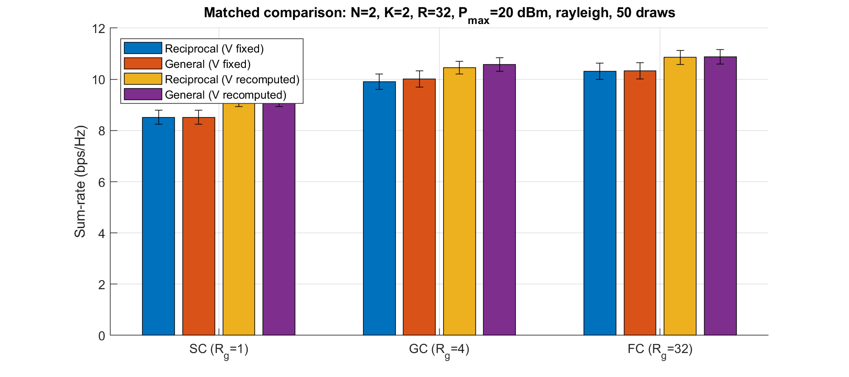
Figure 1. Matched 50-draw Rayleigh sum-rate results for SC, GC and FC architectures.
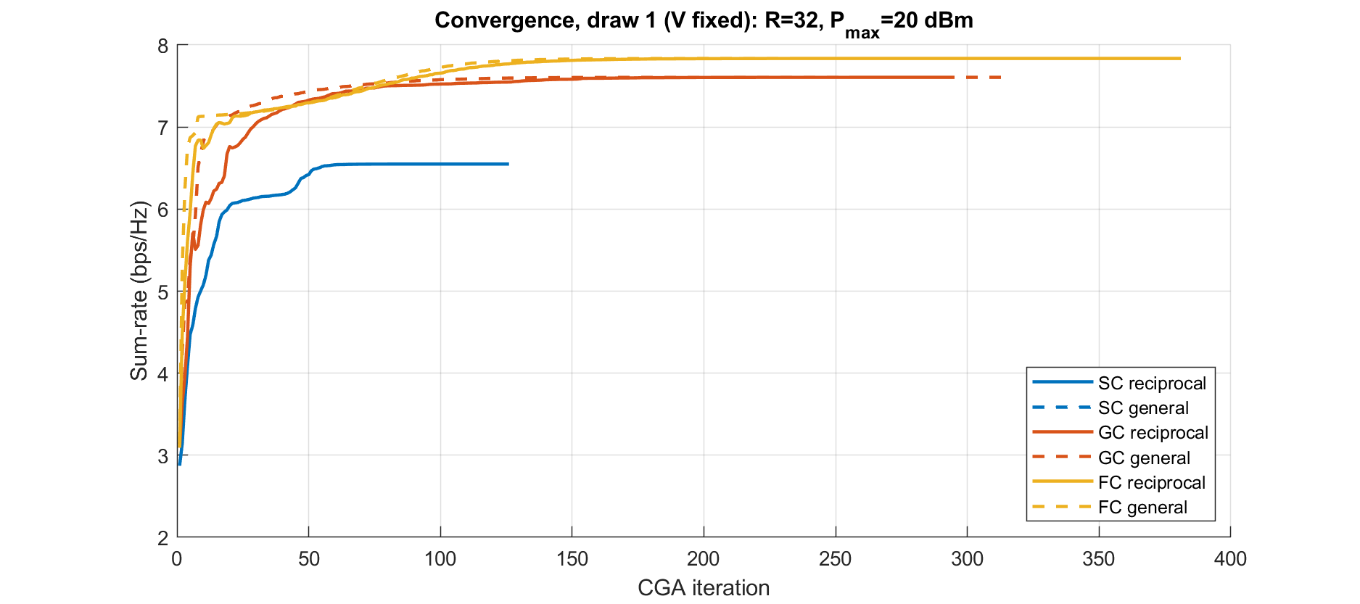
Figure 2. Matched convergence behaviour across the three architectures.

8.2 Reciprocal convergence and projection behaviour
The reciprocal implementation reports an average of approximately 594 iterations for the FC R=32, 50-draw experiment, with a standard deviation of approximately 789 and a range of 59–4395 iterations. The maximum iteration limit was not reached in the reported 50-draw tests. The final exact symmetry/unitarity projection has a reported mean sum-rate cost of approximately 1.1×10⁻³ bps/Hz, indicating that the penalty weight ν=1 was sufficient to keep the final projection correction small in the tested setting.
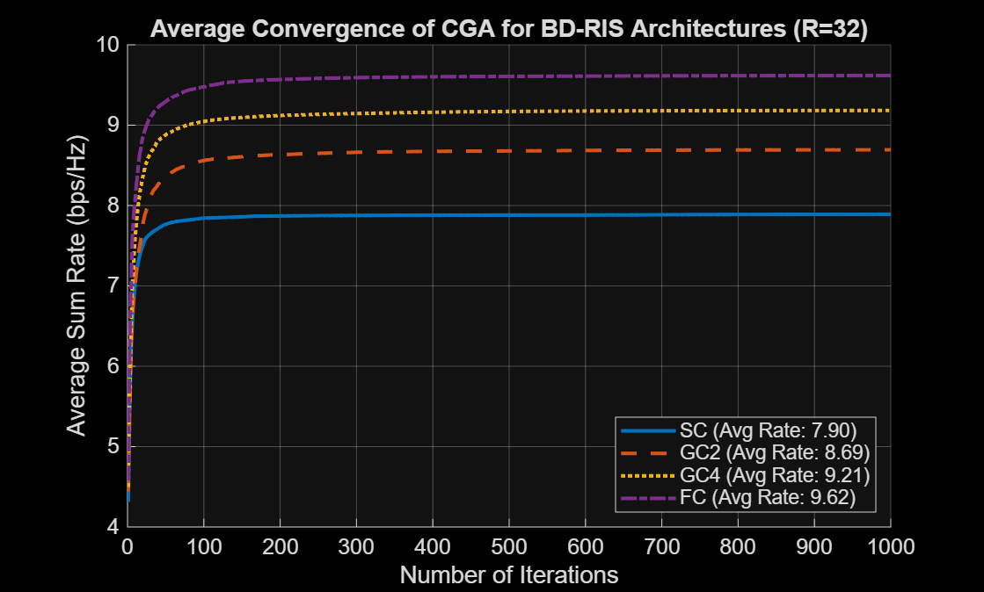
Figure 3. Reciprocal convergence overlay saved by the reciprocal optimization pipeline.

8.3 Paper-faithful joint baseline versus matched fixed-V comparison
Architecture | Reciprocal fixed-V | General fixed-V | General joint V+Θ
SC | 8.517 | 8.517 | 11.290
GC | 9.909 | 10.012 | 13.100
FC | 10.310 | 10.331 | 13.711
The joint baseline is substantially higher than the fixed-V results (e.g., 13.711 bps/Hz for FC versus 10.331 bps/Hz for the general fixed-V baseline). This is not interpreted as a reciprocity gap because the joint baseline changes V while the matched comparison freezes V. Instead, it demonstrates why the fixed-V protocol is necessary for isolating the effect of the scattering-matrix constraint in M2.

9. Interpretation of Results
- Architecture effect: the fixed-V mean rate increases from SC to GC to FC for both reciprocal and general designs, showing that additional BD-RIS connectivity provides more optimization freedom in the tested setting.
- Reciprocity effect: the measured cost is very small in the current R=32 Rayleigh experiment. It is exactly zero for SC and remains below 1% in the tested GC and FC cases.
- Fairness: the general and reciprocal fixed-V results are evaluated using the same matched channel realization and common rate evaluator, so the comparison is more controlled than comparing independently generated channel sets.
- Algorithmic limitation: the small measured gap should not yet be interpreted as a universal conclusion. Local optimization, initialization, fixed-beamformer scope and the limited M2 parameter point can all influence the observed difference.
- Reproduction limitation: the reciprocal FC result is below the approximately 14 bps/Hz reference level discussed in the code documentation. The team deliberately does not tune parameters simply to close this difference. One identified cause is that V is fixed during the M2 reciprocal optimization whereas the source paper may jointly optimize V and Θ; recomputing V at termination improves the reported FC rate.

10. Literature / State-of-the-Art Positioning
Li, Shen and Clerckx provide the general BD-RIS framework and optimize the transmit precoder and scattering matrix using fractional programming, block-coordinate descent and manifold-based optimization. Fidanovski et al. study reciprocal BD-RIS design using a symmetry penalty and manifold optimization. The M2 literature review also identified later work showing that reciprocal and non-reciprocal performance can nearly coincide in a particular setup. Consequently, the project is positioned around a quantitative, matched evaluation rather than a claim that reciprocity comparisons are entirely absent from the literature.
Aspect | Existing general/reciprocal work | This project
Reciprocity | Typically studied separately or under different baselines | Both designs run side-by-side
Beamformer in M2 comparison | Can differ across source setups | Same fixed MMSE V for both
Channel realization | Not necessarily paired | Exactly matched per draw
Architectures | SC/GC/FC studied in source literature | SC/GC/FC compared under one protocol
Output | Sum-rate/convergence curves | Absolute gap, percentage gap and matched raw data
Next-stage scope | Varies by paper | M, G, Pmax, N=K, fading and complexity sweeps

11. Individual Contributions
Member | Name | Contribution in M2
1 | Samridhi | Integrated the milestone report and literature/SOTA positioning; documented the refined research gap, interpretation and limitations.
2 | Aashi | Implemented and validated the reciprocal optimizer: FP auxiliary variables, symmetry penalty, tangent projection, conjugate-gradient ascent, Armijo line search, retraction and exact symmetry/unitarity enforcement.
3 | Kahaan | Implemented and validated the general unitary/non-reciprocal-capable baseline, including matched fixed-V mode and paper-faithful joint baseline.
4 | Prakshal | Implemented the common simulation environment, configuration, channel/rate utilities, matched experiment runner, result storage and comparison plots.

12. Limitations of M2
- The current matched statistical result is limited to Rayleigh fading, N=K=2, M=32 and Pmax=20 dBm.
- Rician fading and systematic power/RIS-size/group sweeps are not yet presented as completed M2 evidence.
- The matched comparison uses a fixed MMSE beamformer, which is an intentional controlled simplification and should not be described as a full joint reproduction.
- The non-convex optimizers may converge to different local stationary points; a measured negative per-draw gap is therefore possible.
- Runtime and asymptotic hardware/optimization complexity have not yet been combined into the final Pareto analysis.
- The source-paper reproduction discrepancy for the FC rate remains an open implementation/modeling issue and is documented rather than hidden.

13. Planned Work for M3
- Extend the matched comparison to multiple RIS sizes M and GC configurations/group sizes.
- Sweep transmit power Pmax over the project range.
- Add Rician fading and compare its behaviour with Rayleigh fading.
- Increase Monte-Carlo sample sizes where required and report confidence intervals for paired gaps.
- Investigate restart strategies and convergence quality so that small gaps are not dominated by local-optimizer variability.
- Measure runtime and combine rate loss with circuit/optimization complexity for a Pareto-style performance–complexity characterization.
- Continue source-paper reproduction checks and resolve the remaining FC-rate discrepancy without parameter tuning aimed only at matching a target curve.

14. Conclusion
M2 establishes a replicable computer foundation for the project inquiry: how much reciprocity costs in the terms of sum-rate in BD-RIS. The next thing is that the team has the same simulation environment, reciprocal and general unitary optimization pipelines, numerical feasibility tests, and matched Rayleigh comparison with 50 draws. It has turned out that reciprocity imposes no further restrictions for SC and only causes minor rate loss in GC and FC tested configurations. This finding is interpreted as supporting evidence for M2 rather than a general conclusion. The immediate task is to find out whether the gap is near zero and low for various RIS sizes and connectivity, the strength of transmission, the users/antennas dimensions, and fades.

References
- [1] H. Li, S. Shen, and B. Clerckx, “Beyond Diagonal Reconfigurable Intelligent Surfaces: From Transmitting and Reflecting Modes to Single-, Group-, and Fully-Connected Architectures,” IEEE Transactions on Wireless Communications, vol. 22, no. 4, pp. 2311–2324, Apr. 2023.
- [2] M. Fidanovski, I. A. Morales Sandoval, H. S. Rou, G. T. F. de Abreu, and E. Björnson, “Reciprocal Beyond-Diagonal Reconfigurable Intelligent Surface (BD-RIS): Scattering Matrix Design via Manifold Optimization,” IEEE Transactions on Wireless Communications, vol. 25, pp. 20463–20477, 2026 (as listed in the project proposal; publication metadata should be rechecked before final submission).
- [3] S. Shen, B. Clerckx, and R. Murch, “Modeling and Architecture Design of Reconfigurable Intelligent Surfaces Using Scattering Parameter Network Analysis,” IEEE Transactions on Wireless Communications, vol. 21, no. 2, pp. 1229–1243, Feb. 2022.
- [4] H. Yahya, H. Li, M. Nerini, B. Clerckx, and M. Debbah, “Beyond Diagonal RIS: Passive Maximum Ratio Transmission and Interference Nulling Enabler,” IEEE Open Journal of the Communications Society, vol. 5, pp. 7613–7627, 2024.
- [5] Z. Wu and B. Clerckx, “Optimization of Beyond Diagonal RIS: A Universal Framework Applicable to Arbitrary Architectures,” arXiv:2412.15965, 2024.
- [6] M. Nerini and B. Clerckx, “Pareto Frontier for the Performance-Complexity Trade-Off in Beyond Diagonal Reconfigurable Intelligent Surfaces,” IEEE Communications Letters, vol. 27, no. 10, pp. 2842–2846, Oct. 2023.
- [7] K. Shen and W. Yu, “Fractional Programming for Communication Systems—Part I: Power Control and Beamforming,” IEEE Transactions on Signal Processing, vol. 66, no. 10, pp. 2616–2630, May 2018.
- [8] N. Boumal, An Introduction to Optimization on Smooth Manifolds, Cambridge University Press, 2023.

Appendix A – Key Saved Result Files
- Results/matched_rayleigh_R32_50draws/summary.csv – 50-draw aggregate metrics.
- Results/matched_rayleigh_R32_50draws/per_draw.csv – per-realization paired results.
- Results/matched_rayleigh_R32_50draws/matched_sumrate.png – matched sum-rate figure.
- Results/matched_rayleigh_R32_50draws/matched_convergence.png – matched convergence figure.
- Code/reciprocal/README.md – reciprocal algorithm details and validation evidence.
- Code/nonreciprocal/README.md – general baseline details and validation status.
- Document/mathematical_formulation.md – system model and optimization formulation.
- Document/sota_comparision.md – refined literature gap and positioning.
- Document/implementation_plan.md – M2 scope, validation plan and fair-comparison protocol.

