# **Dijkstra vs Floyd Warshall Algorithm for all pairs**

**Instructions on how to run the code(equivalent to makefile):**

The input files taken for reading the graph were generated using random graph generator as provided on one of the piazza posts [https://piazza.com/class/hke5ry7c2w24bn?cid=689]. The input file for graph for this project is used as it is as generated by random graph generator. Hence, the graph input file should be similar to below snapshot:

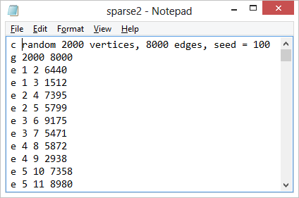

**There are two methods for running the code:**

**Method - 1 (Using native Java compiler and Command prompt):**

**Step 1:** Go to the location **Dijkstra_vs_FloydWarshall -> Dijkstra_vs_FloydWarshall_ sourceCode** in the command prompt. Form, there there are two folder, one for **Dijkstra** and another for **FloydWarshall**. Go to the respective folder for running the corresponding algorithm. Once inside the respective folder, change the directory to **src** which contains the source file for the algorithm.

**Step 2:**  Prerequisite: Make sure the Java Development environment is installed and both the PATH and CLASSPATH environment variables are set.

**Step 3:** Next, compile the file Dijkstra.java or FloydWarshall.java and execute the respective file by typing in Command Prompt:

Example:

**javac Dijkstra.java**

**java Dijkstra**

**or**

**javac FloydWarshall.java**

**java FloydWarshall**

Note: For running the program for very dense graphs, we need to change the JVM heap size. The program now needs to be run as

**java -Xmx2048m Dijkstra**

(The value 2048 in above command can be changed to a greater value if the program shows Java heap space memory Error.)

**Step 4**: You will be prompted with a message : “**Please enter input path file where graph is stored**:”

Where you have to enter the whole path of the graphs created using random graph generator or you can choose graph files provided in the zip file and press enter.

# **Method 2: Run Project through Executable Files (JAR Files) in Command Prompt**

***Prerequisite: JDK 1.7 is required.***

**Step 1**: Copy the executable jars ***(from the zip file)*** FloydWarshall.jar and Dijkstra.jar into a preferred location ***(Path to find JAR files: \..\Dijkstra_vs_FloydWarshall \Dijkstra_vs_FloydWarshall _jarFiles)***

**Step 2**: For very dense graphs, heap size of JVM will have to be increased, so type in the command prompt :

***C:\Users\Aashima>java -Xmx10000m Dijkstra.java***

***C:\Users\Aashima>java -Xmx10000m FloydWarshall.java***

**Step 3**: Now in the command prompt navigate to the directory where the JAR files were stored:

***Example: C:\Users\Aashima\Downloads\Dijkstra_vs_FloydWarshall \Dijkstra_vs_FloydWarshall _jarFiles>***

**Step 4**: Type in the command : ***C:\Users\Aashima\Downloads\Dijkstra_vs_FloydWarshall \Dijkstra_vs_FloydWarshall _jarFiles>java -jar FloydWarshall.jar***

**Step 5**: You will be prompted with a message : “***Please enter input path file where graph is stored:***”

Where you have to enter the whole path of the graphs created using random graph generator or you can choose graph files provided in the zip file and press enter.

***Example : C:\Users\Aashima\Documents\Graphs\sparse_graph1.txt***

**Step 6**: Please repeat steps 4-5 for **Dijkstra.java**