- Introduction --
  - Motivation
  - Scope ---
  - Objectives --
  - Proposed Model --
  - Organization of report --
- Literature review --
- System Analysis and design --
4. Modeling and Implementation--
5. Testing,Results and Discussion--
6. Conclusion and Future Work--

Introduction
The first page provides several links. The Home page contains several information about the site like campus, management, facilities, admission etc. Student login module helps the user to login to the result page. For that he must type the username and password correctly. The login provision in this page helps the already registered user to directly access the site and there is a link for registration to a user who is new to this site. Student Registration module helps the new user to register into the site. The information entered by the users is added into the table registration. The fee payment date announce also done through this.
1.1 Motivation
We attended a seminar in which the speaker laid emphasis upon coming up with ideas to solve the problem of communicating announcement to students. We first made a note of all the students who are having problems. We chose creating college blog which was very useful for student. In order to gather any information regarding exams, sports and extracurricular activities students usually see notice board or college group. Otherwise, a person needs to enquire about it in the department. In order to make this even easier, we decided to make a college blog app, where all the information can be found at one site.
The College Blog Portal is the Web based portal and it acts as a bridge of communication amongst students and lectures and college authorities as well. It acts as a system that provides information about important issues ongoing in college.
1.2 Scope
- Authentication: This app provides a perfect authentication as well as authorization to use this app.
- College announcements: Through this service, one can view information about college events, placements, exams and projects.
- Events: It gives information about different events (including assignments and projects) as well as festivals that will be conducted by college. Information about these events will be updated by user.
- Exam Notification: User can post a timetable of upcoming exams.
- Placements: Information about the companies that visits our college for placement and also the requirements and description for that interview can be given.
- Project: Important or the distinct project can be posted in the blog app.
- Proctor can view the fee payment information for their assigned students and only admin can update the fee info of all the students.
1.3 Objectives
This is a web oriented application that allows us to access the whole information about the college, staffs, students, facilities etc. This application provides a virtual tour of Campus. This generic application is designed for assisting the students of an institute regarding information on the courses, subjects, classes, assignments and timetable. It also provides support that a faculty can also check about his daily schedule, can upload assignments, and notices to the students. Here administrator will manage the accounts of the student and faculties, makes the timetable, and upload the latest information about the campus.

1.4 Proposed Model
In order to make the site permanent, this site is connected to a database. Hence proctors of their respective students can keep themselves updated about the student fee payments. Proctor can register their students and view whether their students has paid the fees.

1.5 Organisation of report

In order to explain the developed system, the following sections are covered:

● Literature Review describes the study of the existing systems and techniques taken into account prior to the development of the proposed system.
● System Analysis and Design provides a detailed walkthrough of the languages adopted to implement the project, an overview of the system and the modules incorporated into the system
● Modelling and Implementation provides a deeper insight into the working of the model. The various modules and their interactions are depicted using relevant descriptive diagrams.
● Testing the model to ensure bug/error free model along with the webpage obtained. The discussion then provides a detailed analysis on quality assurance measures.
● Conclusion about the Results obtained after successfully running the model and Future Scope of the project is highlighted.
2.0 LITERATURE SURVEY
We are having a college website where it can provide information about campus, courses available(curriculum), admission and fee payment. We are also having another web site which is call contineo , with our USN and DOB we can login into it, it provides information about student de tails such as attendance, internals and assignment marks, we can also view the exam history, proctor can make a note about us ,and a time table of academic classes and list of event. And some stuedents also developed a SIS app where it gives the information same as the website .

3.0 SYSTEM DESIGN

System design is the solution to the creation of a new system. This phase is composed of several systems. This phase focuses on the detailed implementation of the feasible system. It emphasis on translating design specifications to performance specification. System design has two phases of development logical and physical design.

During logical design phase the analyst describes inputs (sources), out puts (destinations), databases (data sores) and procedures (data flows) all in a format that meats the uses requirements. The analyst also specifies the user needs and at a level that virtually determines the information flow into and out of the system and the data resources. Here the logical design is done through data flow diagrams and database design.
The physical design is followed by physical design or coding. Physical design produces the working system by defining the design specifications, which tell the programmers exactly what the candidate system must do. The programmers write the necessary programs that accept input from the user, perform necessary processing on accepted data through call and produce the required report on a hard copy or display it on the screen.

TABLES
Field |  | Constraints
id | int
name | varchar
email | varchar
branch | varchar
usernm | varchar
passw | varchar
attend | int | null
mark | int | null
photo | blob

Database – Student Table - studl

DATA FLOW

USER
VIEW

STUDENT
LOGIN

TEACHER
UPDATE
TEACHER

CLASS REPRESENTATIVE LOGIN

UPDATE
AND
VIEW
STUDENT(CR)
LOGIN
STUDENT(CR)

LANGUAGE DESCRIPTION

- HTML
Hypertext Markup Language (HTML) is the main markup language for web pages. HTML elements are the basic building-blocks of WebPages.
HTML is written in the form of HTML elements consisting of tags enclosed in angle brackets (like <html>), within the web page content. HTML tags most commonly come in pairs like <h1>and </h1>, although some tags, known as empty elements, are unpaired, for example <img>. The first tag in a pair is the start tag, the second tag is the end tag (they are also called opening tags and closing tags). In between these tags, web designers can add text, tags, comments and other types of text-based content.
The purpose of a web browser is to read HTML documents and compose them into visible or audible web pages. The browser does not display the HTML tags, but uses the tags to interpret the content of the page.
HTML elements form the building blocks of all websites. HTML allows images and objects to be embedded and can be used to create interactive forms. It provides a means to create structured documents by denoting structural semantics for text such as headings, paragraphs, lists, links, quotes and other items. It can embed scripts in languages such as JavaScript which affect the behavior of HTML webpages.
Web browsers can also refer to Cascading Style Sheets (CSS) to define the appearance and layout of text and other material. The W3C, maintainer of both the HTML and the CSS standards, encourages the use of CSS over explicitly presentational HTML markup.
Elements
HTML documents are composed entirely of HTML elements that, in their most general form have three components: a pair of tags, a "start tag" and "end tag"; some attributes within the start tag; and finally, any textual and graphical content between the start and end tags, perhaps including other nested elements. The HTML element is everything between and including the start and end tags. Each tag is enclosed in angle brackets.
Attributes
Most of the attributes of an element are name-value pairs, separated by "=" and written within the start tag of an element after the element's name. The value may be enclosed in single or double quotes, although values consisting of certain characters can be left unquoted in HTML (but not XHTML). Leaving attribute values unquoted is considered unsafe. In contrast with name-value pair attributes, there are some attributes that affect the element simply by their presence in the start tag of the element.

- CSS
Cascading Style Sheets (CSS) is a style sheet language used to describe the presentation semantics (the look and formatting) of a document written in a markup language. Its most common application is to style web pages written in HTML and XHTML, but the language can also be applied to any kind of XML document, including plain XML, SVG and XUL.
CSS is designed primarily to enable the separation of document content (written in HTML or a similar markup language) from document presentation, including elements such as the layout, colors, and fonts. This separation can improve content accessibility, provide more flexibility and control in the specification of presentation characteristics, enable multiple pages to share formatting, and reduce complexity and repetition in the structural content (such as by allowing for tableless web design). CSS can also allow the same markup page to be presented in different styles for different rendering methods, such as on-screen, in print, by voice (when read out by a speech-based browser or screen reader) and on Braille-based, tactile devices. It can also be used to allow the web page to display differently depending on the screen size or device on which it is being viewed. While the author of a document typically links that document to a CSS style sheet, readers can use a different style sheet, perhaps one on their own computer, to override the one the author has specified.
CSS specifies a priority scheme to determine which style rules apply if more than one rule matches against a particular element. In this so-called cascade, priorities or weights are
TESTING

SYSTEM TESTING

Testing is a set activity that can be planned and conducted systematically. Testing begins at the module level and work towards the integration of entire computers based system. Nothing is complete without testing, as it is vital success of the system.

• Testing Objectives:
There are several rules that can serve as testing objectives, they are
- Testing is a process of executing a program with the intent of finding an error
- A good test case is one that has high probability of finding an undiscovered error.
- A successful test is one that uncovers an undiscovered error.

If testing is conducted successfully according to the objectives as stated above, it would uncover errors in the software. Also testing demonstrates that software functions appear to the working according to the specification, that performance requirements appear to have been met.
There are three ways to test a program
- For Correctness
- For Implementation efficiency
- For Computational Complexity.

Tests for correctness are supposed to verify that a program does exactly what it was designed to do. This is much more difficult than it may at first appear, especially for large programs.

Tests for implementation efficiency attempts to find ways to make a correct program faster or use less storage. It is a code-refining process, which reexamines the implementation phase of algorithm development.
Tests for computational complexity amount to an experimental analysis of the complexity of an algorithm or an experimental comparison of two or more algorithms, which solve the same problem.

• Testing Correctness

The following ideas should be a part of any testing plan:
- Preventive Measures
- Spot checks
- Testing all parts of the program
- Test Data
- Looking for trouble
- Time for testing
- Re Testing

The data is entered in all forms separately and whenever an error occurred, it is corrected immediately. A quality team deputed by the management verified all the necessary documents and tested the Software while entering the data at all levels. The entire testing process can be divided into 3 phases
- Unit Testing
- Integrated Testing
- Final/ System testing

UNIT TESTING

As this system was partially GUI based WINDOWS application, the following were tested in this phase
- Tab Order
- Reverse Tab Order
- Field length
- Front end validations
In our system, Unit testing has been successfully handled. The test data was given to each and every module in all respects and got the desired output. Each module has been tested found working properly.

INTEGRATION TESTING

Test data should be prepared carefully since the data only determines the efficiency and accuracy of the system. Artificial data are prepared solely for testing. Every program validates the input data.

VALIDATION TESTING

In this, all the Code Modules were tested individually one after the other. The following were tested in all the modules
- Loop testing
- Boundary Value analysis
- Equivalence Partitioning Testing

In our case all the modules were combined and given the test data. The combined module works successfully without any side effect on other programs. Everything was found fine working.

OUTPUT TESTING

This is the final step in testing. In this the entire system was tested as a whole with all forms, code, modules and class modules. This form of testing is popularly known as Black Box testing or system tests.

Black Box testing methods focus on the functional requirement of the software. That is, Black Box testing enables the software engineer to derive sets of input conditions that will fully exercise all functional requirements for a program. Black Box testing attempts to find errors in the following categories; incorrect or missing functions, interface errors, errors in data structures or external database access, performance errors and initialization errors and termination errors.

Modeling has two models namely Use case daigram.

ADMIN
Logs in
Can Edit Blogs
Can delete Blogs
Can create Blogs

Logs In
Can create Blogs using
Id and password given
By HOD
Can Edit his/her own Blog
Posting
AUTHOR
Section

END USER
Can only view the Blogs

Admin
Logs In
Can Edit Fee Payment
thing

Fee updation
Section
Proctor
Logs In
Can add new students

Implementation

Pseudo-Code

5.1 Testing,Results and Discussion

Module | Module Description | Expected results
1. Blogs | It contains different types of blogs. | The Information that we give will be stored in the database and also shows a part of it in home page.
a.Common Announcement  blog | It contains the blogs that have common information.,Eg. sudden holiday announcement and other common activites. | The common announcements are shown.
b.Examination Announcement  blog | It contains the blogs that have information about the exam time table,exam postponement and so on. | The exam issues are displayed.
c.Interview Announcement  blog | It contains the blogs that have the information about circulars and activities regarding placement. | The interview that are offered and information about the processes is found.
d.Project Display blog | It conatins the blogs that have the information about the projects that are completed by the college students. | The projects of the students are displayed.
e.Events Announcement blog | It contains the blogs that have announcements of the college events. | All the events that take place in the college are displayed here.
2.Fee Updation Section | It conatins the data of the student under certain proctor. | The due of payment is shown.

Results

The running of each of the module is shown below through the output screenshots.

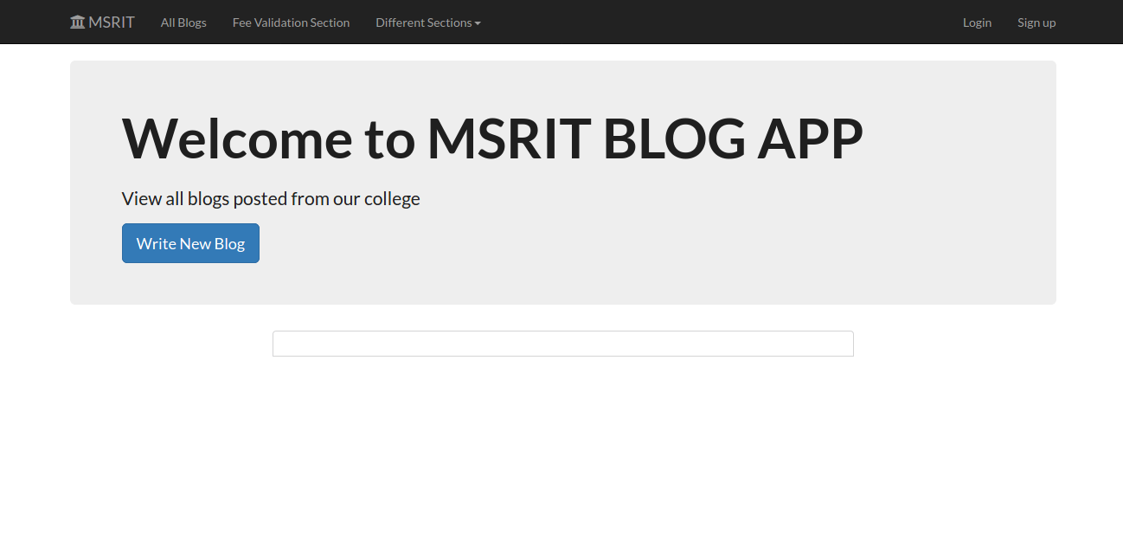
The first page of the College blog App before adding any announcements

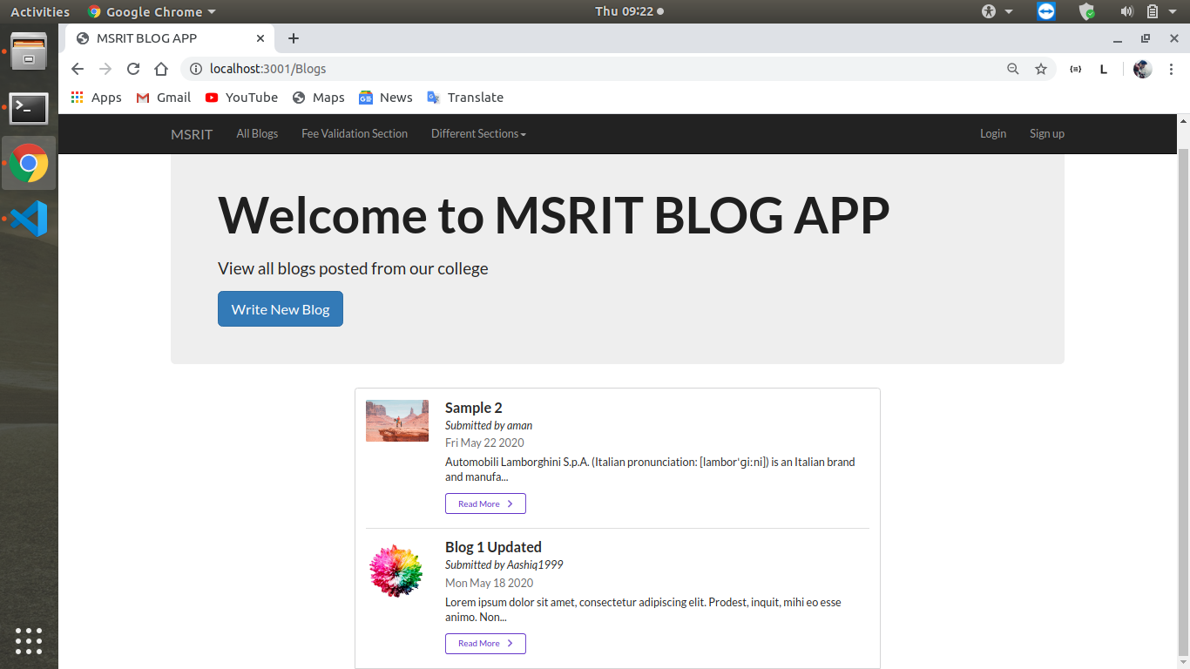

After adding the common announcements.

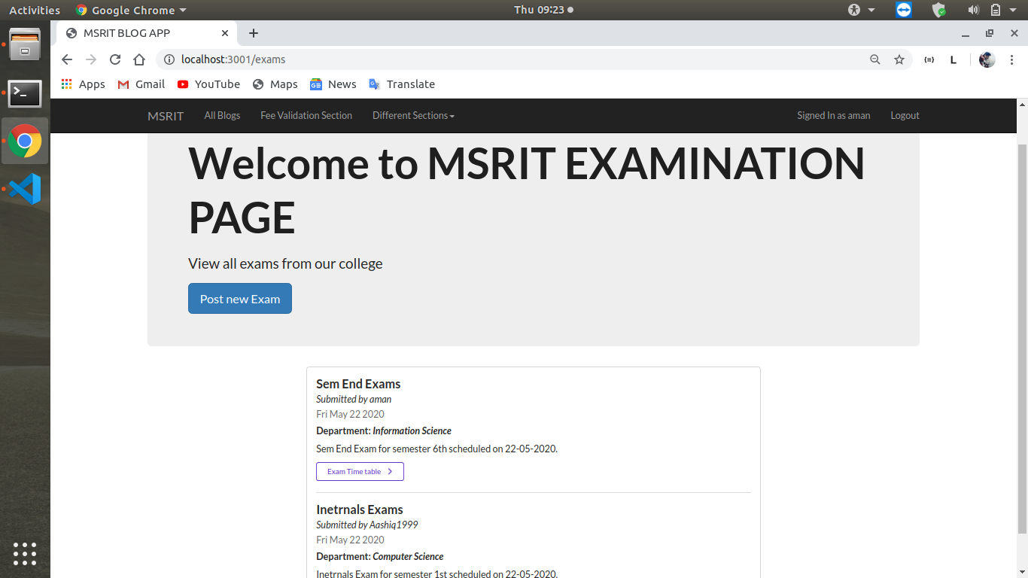

After adding a exam time table in the examination announcement sec.

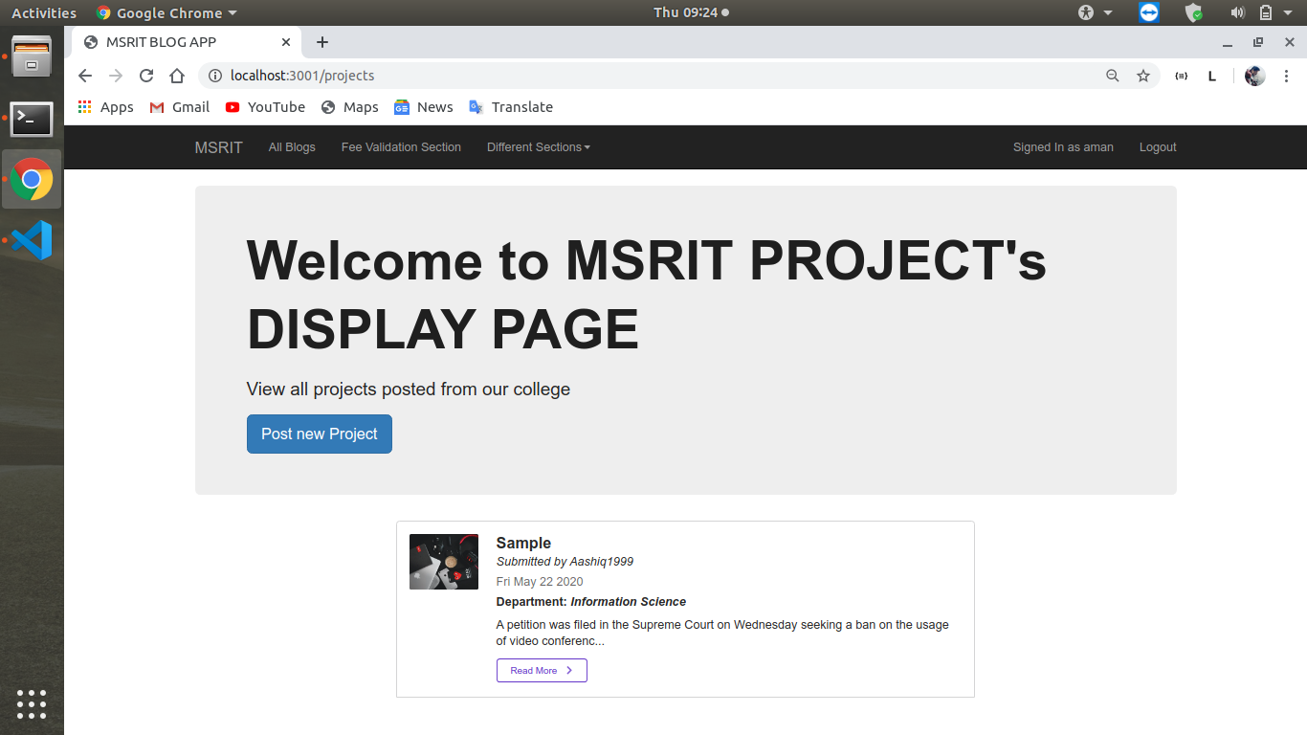

After adding a project in the project display section.

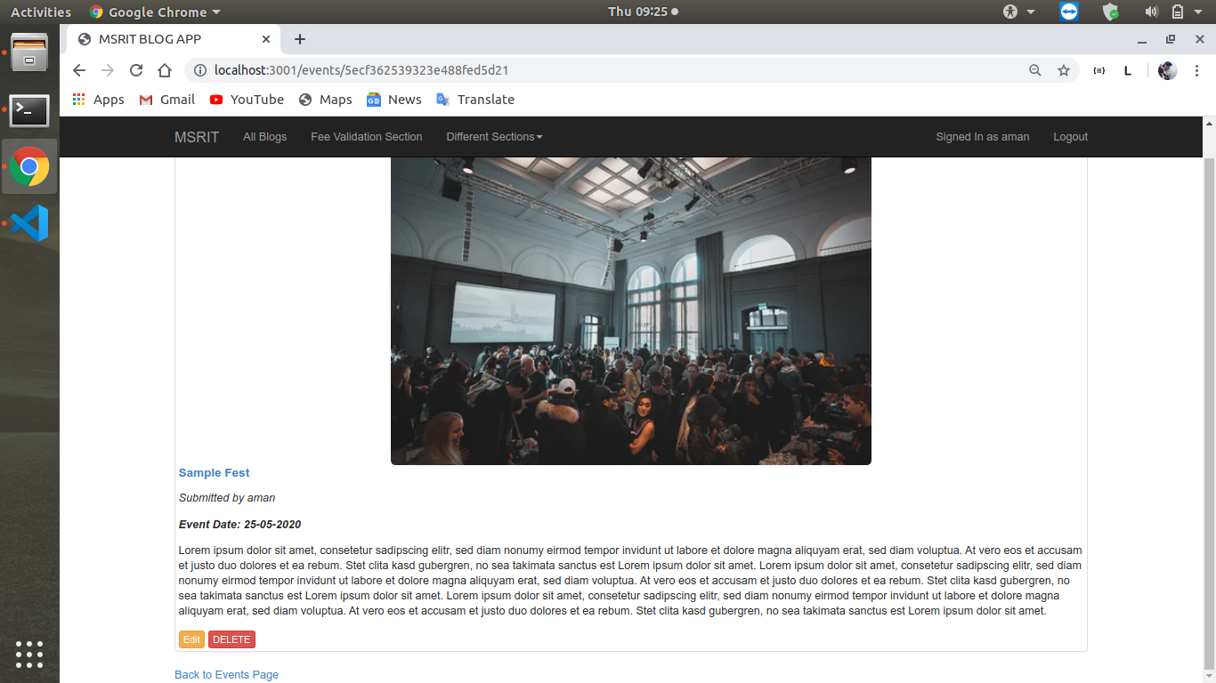
Detailed look of a common announcement .

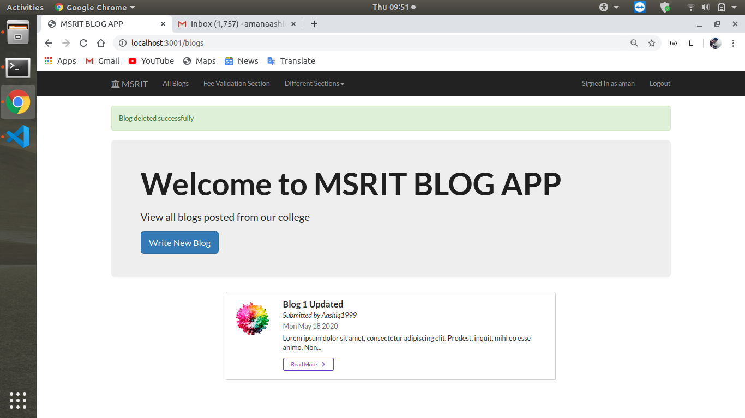

After deleting a post done earlier.

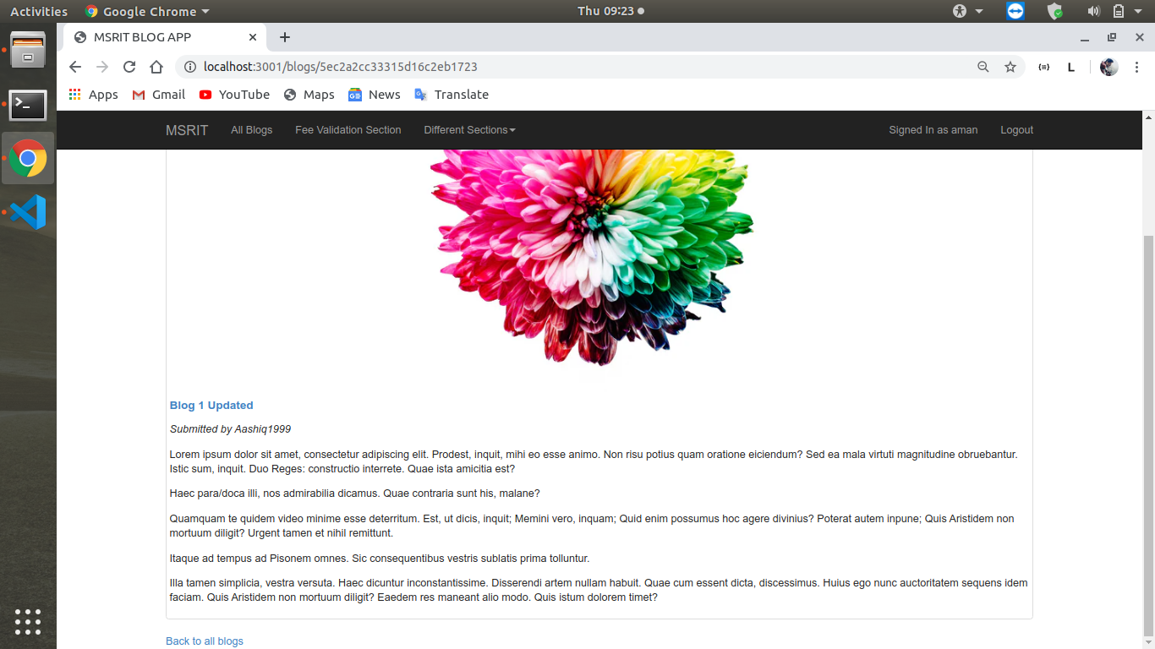

It shows a Common announcement and one user can not delete or edit other users post.

Discussion

Each module has worked successfully and description is discussed here.

1.The Application has basically two modules
a.Posting Section
b.Fee updation Section

2. To use any section you need to login either as Admin or User(Faculty and CRs). Login id is given by the HOD of the department.

3. Posting Section has many other sub sections.
a. Common Announcement Blog: The user can make any announcement that is rather different from the other blog. The user can post the new common announcements. Here, it is shown as the All blogs section in the front page of the site.

b. Examination Annonucement Blog: The user here mainly is exam
section. It can make the announcements. Here the time table and any other exam related announcements are made.

c. Interview Announcement Blog: The user here is the Placement
department. The main feature of the Blog is that has the interview
timings and the companies that came for placement selections.

d. Project Display Blog: Here the user is a student who wants to
display his/her project in the blog with the permission of the
HOD.

e. Event Announcement Blog: Here the user is member of the extra
extracurricular activity. They can post the announcements of the
events that takes place in the college and of the other colleges as well.

4. Fee-updation Section: The main feature of this is the proctor getting information about the fee payment status of teh student.Here
the proctor can only add the new students to his/her list. The updation of the Fee dues is made by the Admin. Here the end users are both students and the proctor.

5. Editing and Deleting of any announcement is in the control of the
Admin. The author can edit or delete only his/her blog.

6.We are maintaining a database for running each section and any updation is reflected in the blog after it is updated in the database.

Conclusion and Future Work

The College Blog Application is very useful rather than posting the announcements in locally in a single application will make it do easier. Good projects will get more noticed. The proctor will know about the fee dues of his/her list of students.

The application has good future we can extend it to whole global colleges and can make each college events,projects,Interviews known for any student and it makes prospective students of any college to look more deeper into the college and can choose the best one.

The users and Admin of the blog cannot delete their id themselves. In future we want to give that access to themselves once their term is finished in the college.

