**Software Requirements Specification**

**Project: Kreator Konnect  
Subject: Software Engineering  
Group Members:**

* **22i-0950 Azfar Bilal**
* **22i-0920 Aashir Hameed  
  Deliverable Number: Sprint 1 Documentation  
  Date of Submission: 23rd March 22, 2025**

**Table of Contents**

1. **Introduction**
   * **1.1 Purpose**
   * **1.2 Document Conventions**
   * **1.3 Intended Audience and Reading Suggestions**
   * **1.4 Product Scope**
   * **1.5 References**
2. **Overall Description**
   * **2.1 Product Perspective**
   * **2.2 Product Functions**
   * **2.3 User Classes and Characteristics**
   * **2.4 Operating Environment**
   * **2.5 Design and Implementation Constraints**
   * **2.6 User Documentation**
   * **2.7 Assumptions and Dependencies**
3. **External Interface Requirements**
   * **3.1 User Interfaces**
   * **3.2 Hardware Interfaces**
   * **3.3 Software Interfaces**
   * **3.4 Communications Interfaces**
4. **System Features (User Stories)**
5. **Other Non-functional Requirements**
6. **Design**
   * **6.1 Use Case Diagram**
   * **6.2 Activity Diagram**
   * **6.3 Sequence Diagram**
   * **6.4 Class Diagram**
7. **Sprint Backlog**
8. **GitHub Repository & Trello Snapshots**
9. **Product Burn-down Chart**

**1. Introduction**

**1.1 Purpose**

**This document provides a detailed specification for Kreator Konnect, a subscription-based content platform for creators and their audiences.**

**1.2 Document Conventions**

**This document follows the IEEE Software Requirements Specification (SRS) format.**

**1.3 Intended Audience and Reading Suggestions**

**The primary audience for this document includes:**

* **Software developers**
* **Project managers**
* **Testers**
* **Stakeholders**

**It is structured for reading from general project details to specific system features.**

**1.4 Product Scope**

**Kreator Konnect is designed to allow content creators to monetize their work through a membership-based model. The platform enables:**

* **Secure payments**
* **Exclusive content access**
* **Community engagement**
* **Analytics for creators**

**1.5 References**

1. **SRS Template Document**
2. **Group#6_sectionA Document**
3. **[Applied software engineering series]** **Auerbach Series on Applied Software Engineering**
4. **Requirements Engineering Fundamentals. Foundation Level**

**2. Overall Description**

**2.1 Product Perspective**

**Kreator Konnect is a standalone platform designed to help content creators monetize their work through subscriptions and exclusive content access. It integrates with payment gateways and notification services.**

**2.2 Product Functions**

**The key functions of the platform include:  
• Secure user authentication  
• Subscription management  
• Exclusive content access  
• Payment processing  
• Community engagement features  
• Creator analytics dashboard**

**2.3 User Classes and Characteristics**

**• General Users – Subscribe, view content  
• Creators – Upload content, set memberships  
• Administrators – Manage users, enforce policies**

**2.4 Operating Environment**

**The system will be a web-based application with a responsive design, compatible with modern browsers and mobile devices.**

**2.5 Design and Implementation Constraints**

**• Integration with third-party payment providers  
• Compliance with security standards (AES-256 encryption, 2FA)**

**2.6 User Documentation**

**User guides and FAQs will be available in the Help Center.**

**2.7 Assumptions and Dependencies**

**The platform depends on:  
• Third-party payment services (Stripe, PayPal)  
• Email/SMS notification services**

**3. External Interface Requirements**

**3.1 User Interfaces**

* **The platform will have a responsive web UI for users to sign up, browse content, and manage subscriptions.**

**3.2 Hardware Interfaces**

* **The system does not have direct hardware dependencies, apart from hosting servers.**

**3.3 Software Interfaces**

* **Integrations with payment gateways (Stripe/PayPal), email services, and cloud storage APIs.**

**3.4 Communications Interfaces**

* **RESTful API endpoints for:**
  + **User authentication**
  + **Subscription handling**
  + **Notifications**

**4. System Features (User Stories)**

**User Authentication**

Users can securely sign up, log in, and manage their credentials.

**Exclusive Content Access**

Creators can mark content as exclusive, and only paying members can access it.

**Profile Management**

Users can update their profile details, including bio and images.

**Subscription Management**

Users can subscribe, cancel, or upgrade their membership plans.

**Two-Factor Authentication**

Users can enable 2FA for additional account security.

**5. Non-functional Requirements**

* **Performance: The system must handle up to 10,000 concurrent users.**
* **Security: Data must be encrypted using AES-256.**
* **Availability: 99.9% uptime guarantee.**
* **Usability: The UI should be intuitive and responsive.**

**6. Design (Diagrams)**

**6.1 Use Case Diagram**

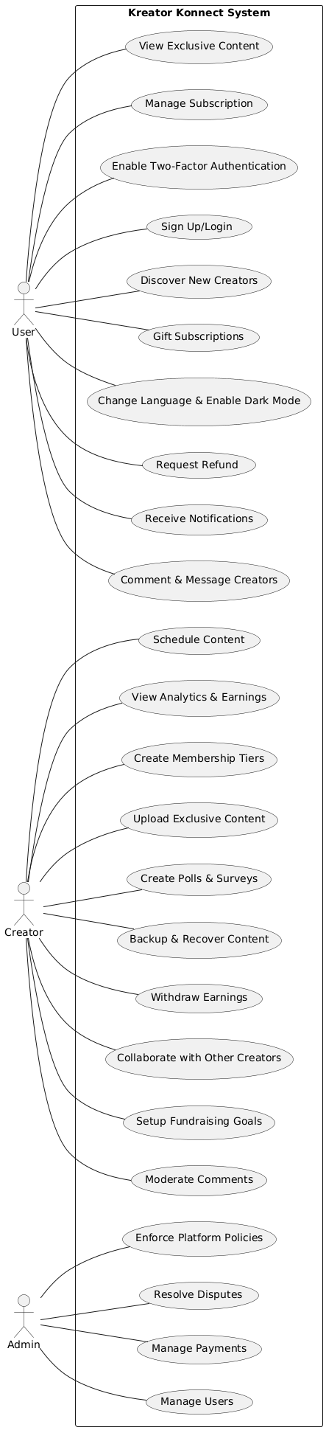

**6.2 Activity Diagram (User Authentication, Content Access, Subscription Management)**

**User Authentication**

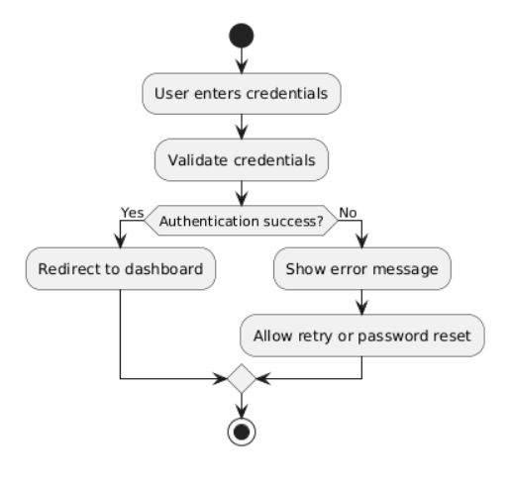

**Content Access**

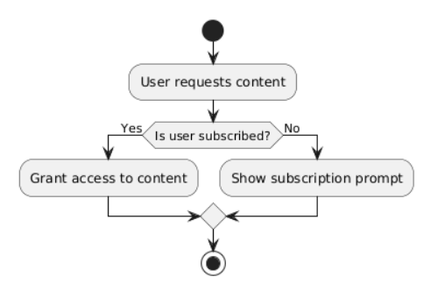

**Subscription Management**

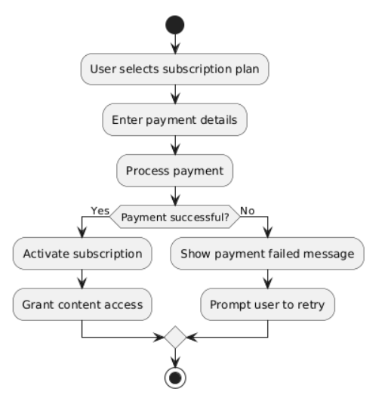

**6.3 Sequence Diagrams**

**User Authentication**

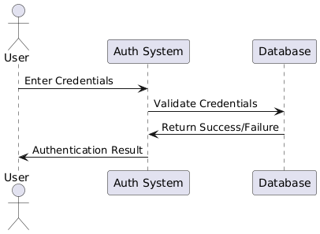

**Content Access**

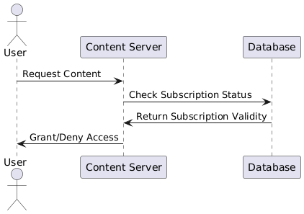

**Subscription Management**

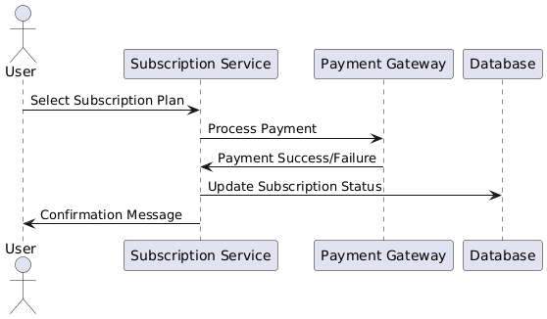

**6.4 Class Diagram**

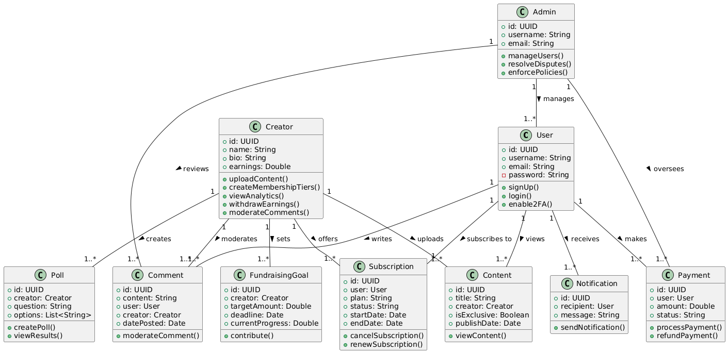

**7. Sprint Backlog**

**The following user stories are planned for Sprint 1:**

* **User Authentication**
* **Exclusive Content Access**
* **Profile Management**
* **Subscription Management**
* **Two-Factor Authentication**

**Trello Board Snapshots**

**[Snapshot 1: Initial Board Setup (Product & Sprint Backlog) - Insert Screenshot]  
[Snapshot 2: Mid-Sprint Progress - Insert Screenshot]  
[Snapshot 3: End of Sprint (Completed & Leftover Tasks) - Insert Screenshot]  
[Snapshot 4: Scrum Master’s Activities - Insert Screenshot]**

**8. GitHub Repository**

* **Repository Link: https://github.com/Aashir0920/SE_Project**
* **[Insert Screenshot of Repository]**

**9. Product Burn-down Chart**

**[Placeholder for Burn-down Chart]**