

KUTABKHANA - LIBRARY MANAGEMENT SYSTEM

SOFTWARE REQUIREMENTS SPECIFICATION



May 17, 2022

11063 Muhammad Aashir khan

11456 MUHAMMAD HAMMAD

Table of Contents

INTRODUCTION

* 1. Purpose
  2. Scope

1. GENERAL DESCRIPTION 
   1. Product Perspective
   2. Product Functions
   3. User Characteristics
   4. General Constraints
   5. Assumptions and Dependencies
2. SPECIFIC REQUIREMENTS 
   1. External Interface Requirements 
      1. User Interfaces

3.1.3 Software Interfaces

* 1. Functional Requirements

3.3 Analysis Class Diagram ...............................................................................................

3.3.1 Use Case.................................................................................................................

3.3.2 Activity Diagram ...................................................................................................

3.4 Review Class Diagram .................................................................................................

3.4.1 Sequence ................................................................................................................

3.4.2 Collaboration.......................................................................................................

3.5 Final Class Diagram .....................................................................................................

3.4.1 State Chart .............................................................................................................

3.6 Class Diagram ..............................................................................................................

3.7 Non-Functional Requirements....................................................................................

3.8 Performance Requirements ........................................................................................

3.9 Interface Requirements ...............................................................................................

SOFTWARE REQUIREMENT SPECIFICATION

1. Introduction

Our Library Management System will be an indoor website. All categories of books would be available here. Such as story books, academic books and history books etc. The system would allow viewing various books available only to registered users to borrow a desired book. Our project provides an easy access to Administrators and Managers to view issued books and all the details about borrowed books. In order to develop management systems there are many Technologies are studied and understood. These includes ASP.NET, programming language (such as C#) and databases etc.

## Purpose

The purpose of this project is to develop a simple library management system where books can be borrowed through a short process. And to specify all verifications are correct. To create a user friendly management system where users can view books and also find whatever they want to read.

## Scope

Our library management system is a way of issue and return borrowed books easily through a short process. Online libraries have also gone through so many changes that have changed its face completely. People around the world have prefer read books online, whether it be horror stories, history, magazines, academic books, programming books, even for cooking recipes magazines. The scope of online book reading and borrowing a book is just getting wider and wider.

* Search and Sort to easily find categories, Manage Categories
* Search and sort to easily find books by book title and author’s name
* Member Login, Manage members accounts
* Add and update book details
* Issue and return book
* Calculate easily fines on late returned books

1. General Description

## Product Perspective

Our library management system is an easy-to-use system that is maintaining the records of all the new users as well as for all the books with proper details of author and editions.

* 1. Product Function

This system allows the registered members to read books/borrow books online across the premises. Improve search functionality. Our book details will be well organized. Admin can create new members accounts for registration.

## User Characteristics

* + 1. Administrator

Administrators are the ones who adds or update the books, members details. Able to see all the books record and could maintains all the data.

* + 1. End User/Customer

The end user will be the one who logins with provided details by admin and can read books online also can borrow a book, and can be charged with fine of returning book after due date.

## General Constraints

The software needs to be designed in a user-friendly manner to ensure that the user can easily borrow a book or able to return a book with fine paid. The design allows for simple prototyping in MVC, C#.

* 1. Assumption and Dependencies

The coding should be error free. The database should have more capacity and provide fast access to database. User must have their correct username and passwords (provided by Admin). User could borrow any book. User should see what books he/she is borrowing. Fine charged if book returned late as per policy. The information of the user must be stored in a database. The admin should have all knowledge of the project.

1. Specific Requirements

## External Interface Requirements

* + 1. User Interface:

Our website should produce a user-friendly interface and should be easy to navigate for user towards borrowing books.

* + 1. Software Interface:

It would work on multiple systems in library or many web browsers so easily assessed by the user. And for maintaining back end records databases will be used.

## Functional Requirements

Functional Requirements of Our Project are as follow:

1. User Login
2. Manage Members (Add, Update)
3. Manage Books (Add, Update, Delete)
4. Fine Calculation (after due date)
5. Issue Book
6. Return Borrowed Book

## Analysis Class Diagram:

* + 1. Use Cases

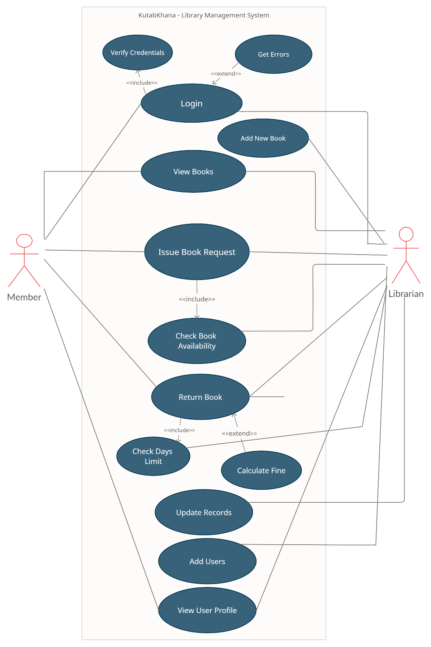

* + 1. Activity Diagram
       1. AS-IS

3.3.2.1.1 Issue Book

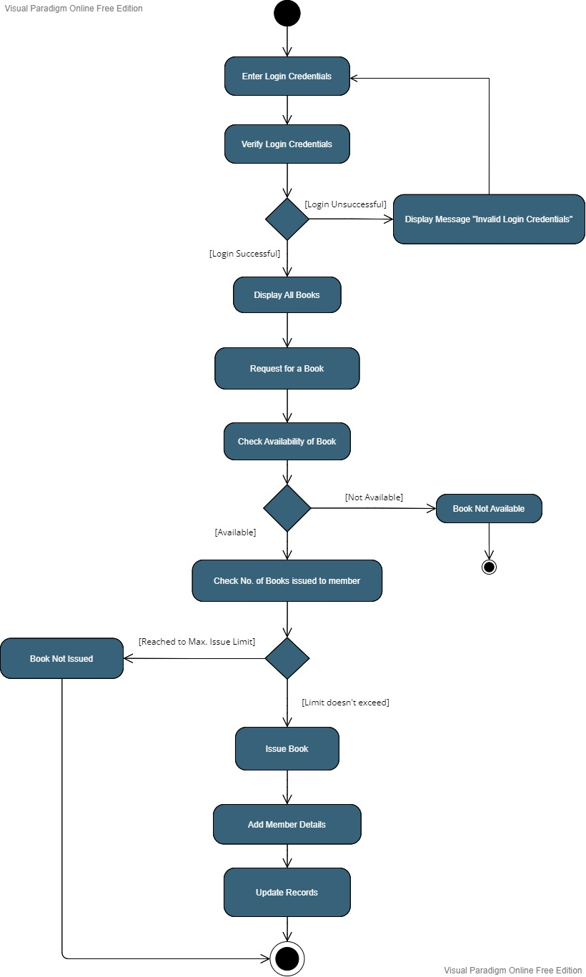

3.3.2.1.2 Return Book

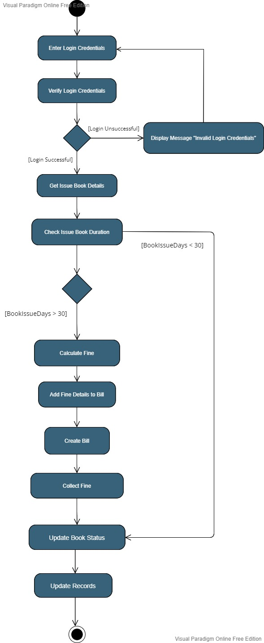

* 1. Review Class Dagram:
     1. Sequence

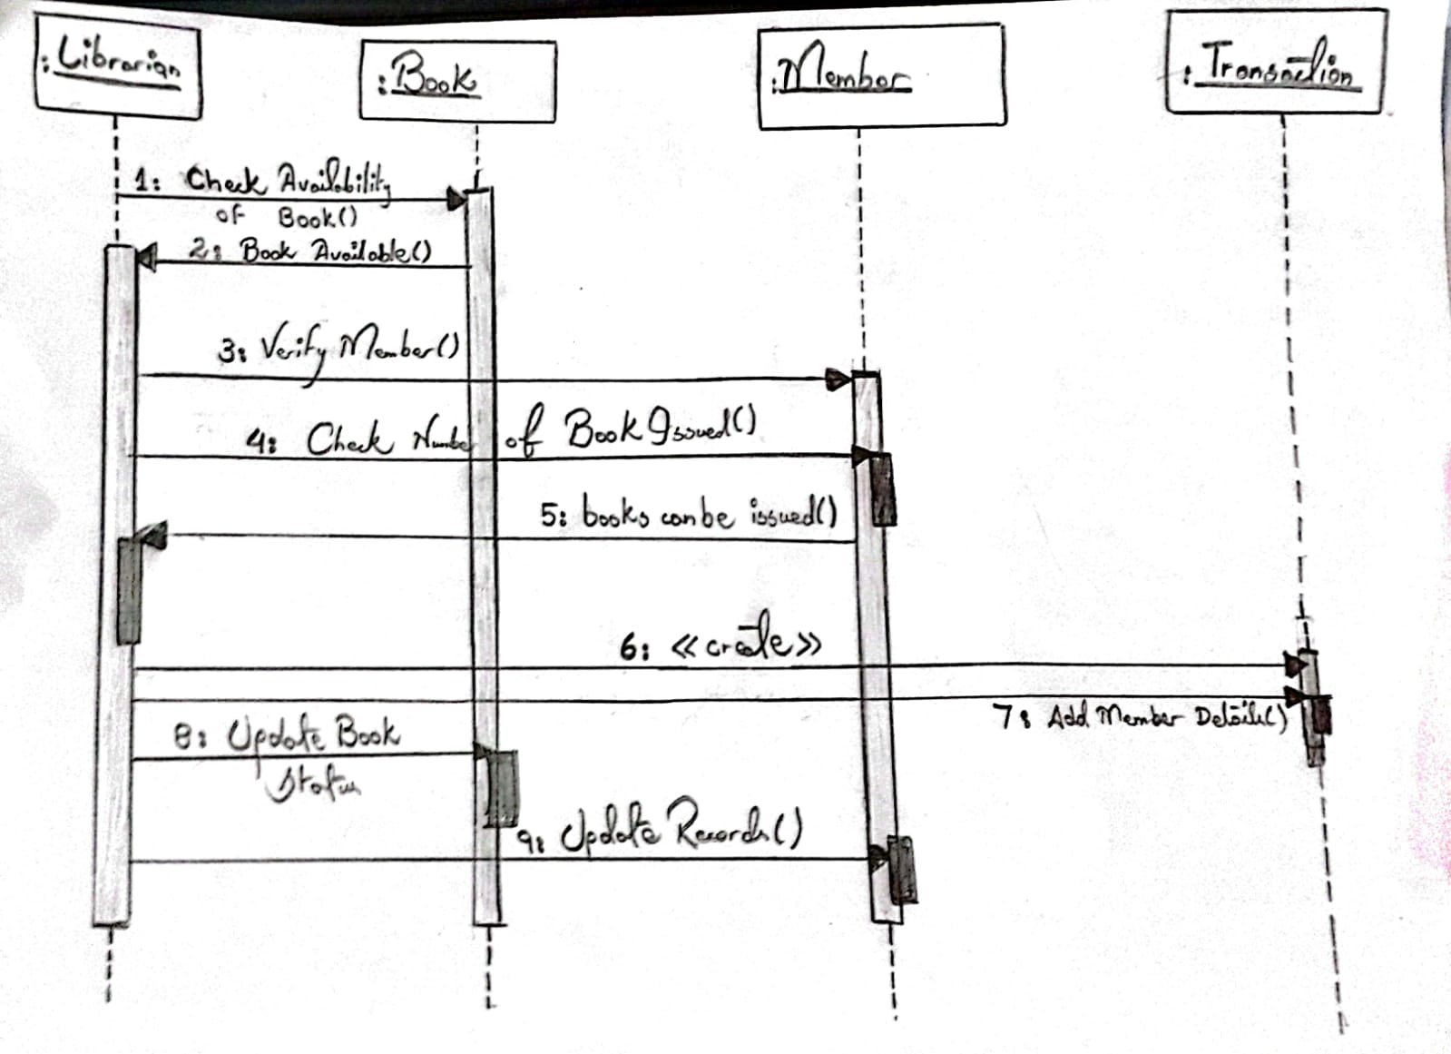

* + 1. Collaboration

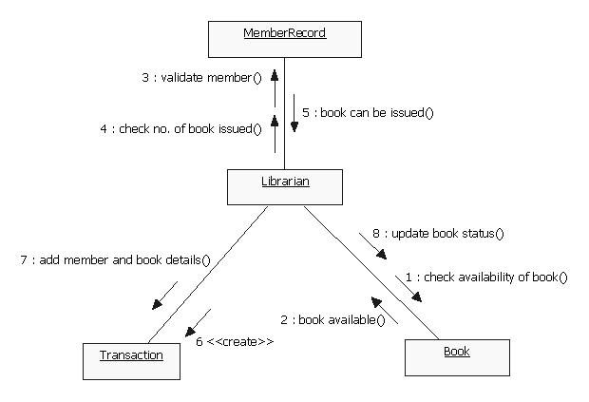

For Issue Book Collaboration

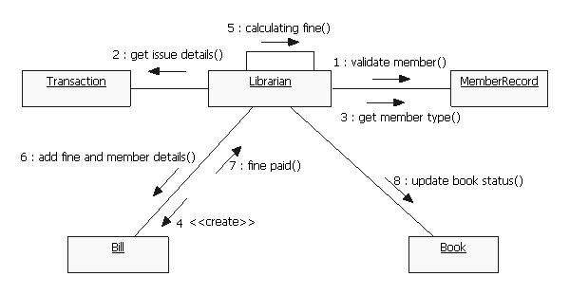

For Return Book Collaboration

* 1. Final Class Diagram:
     1. State Chart

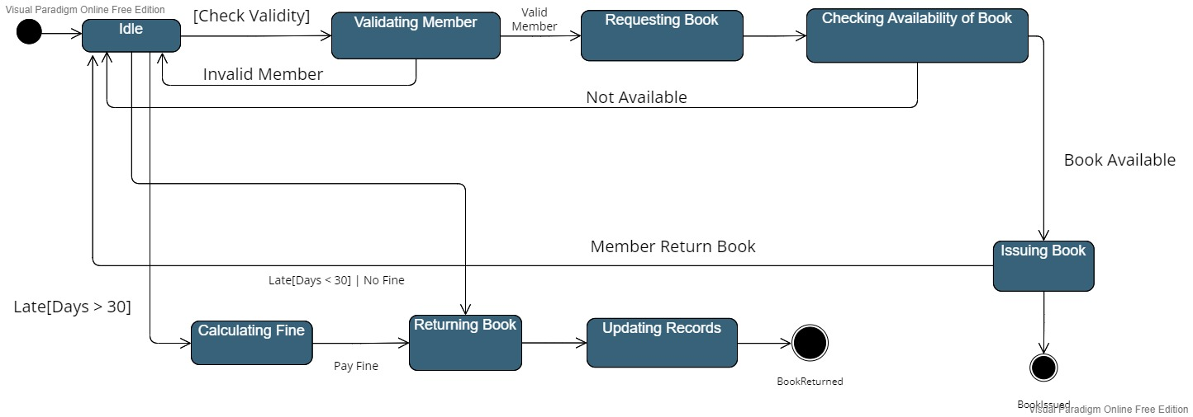

* 1. Class Diagram

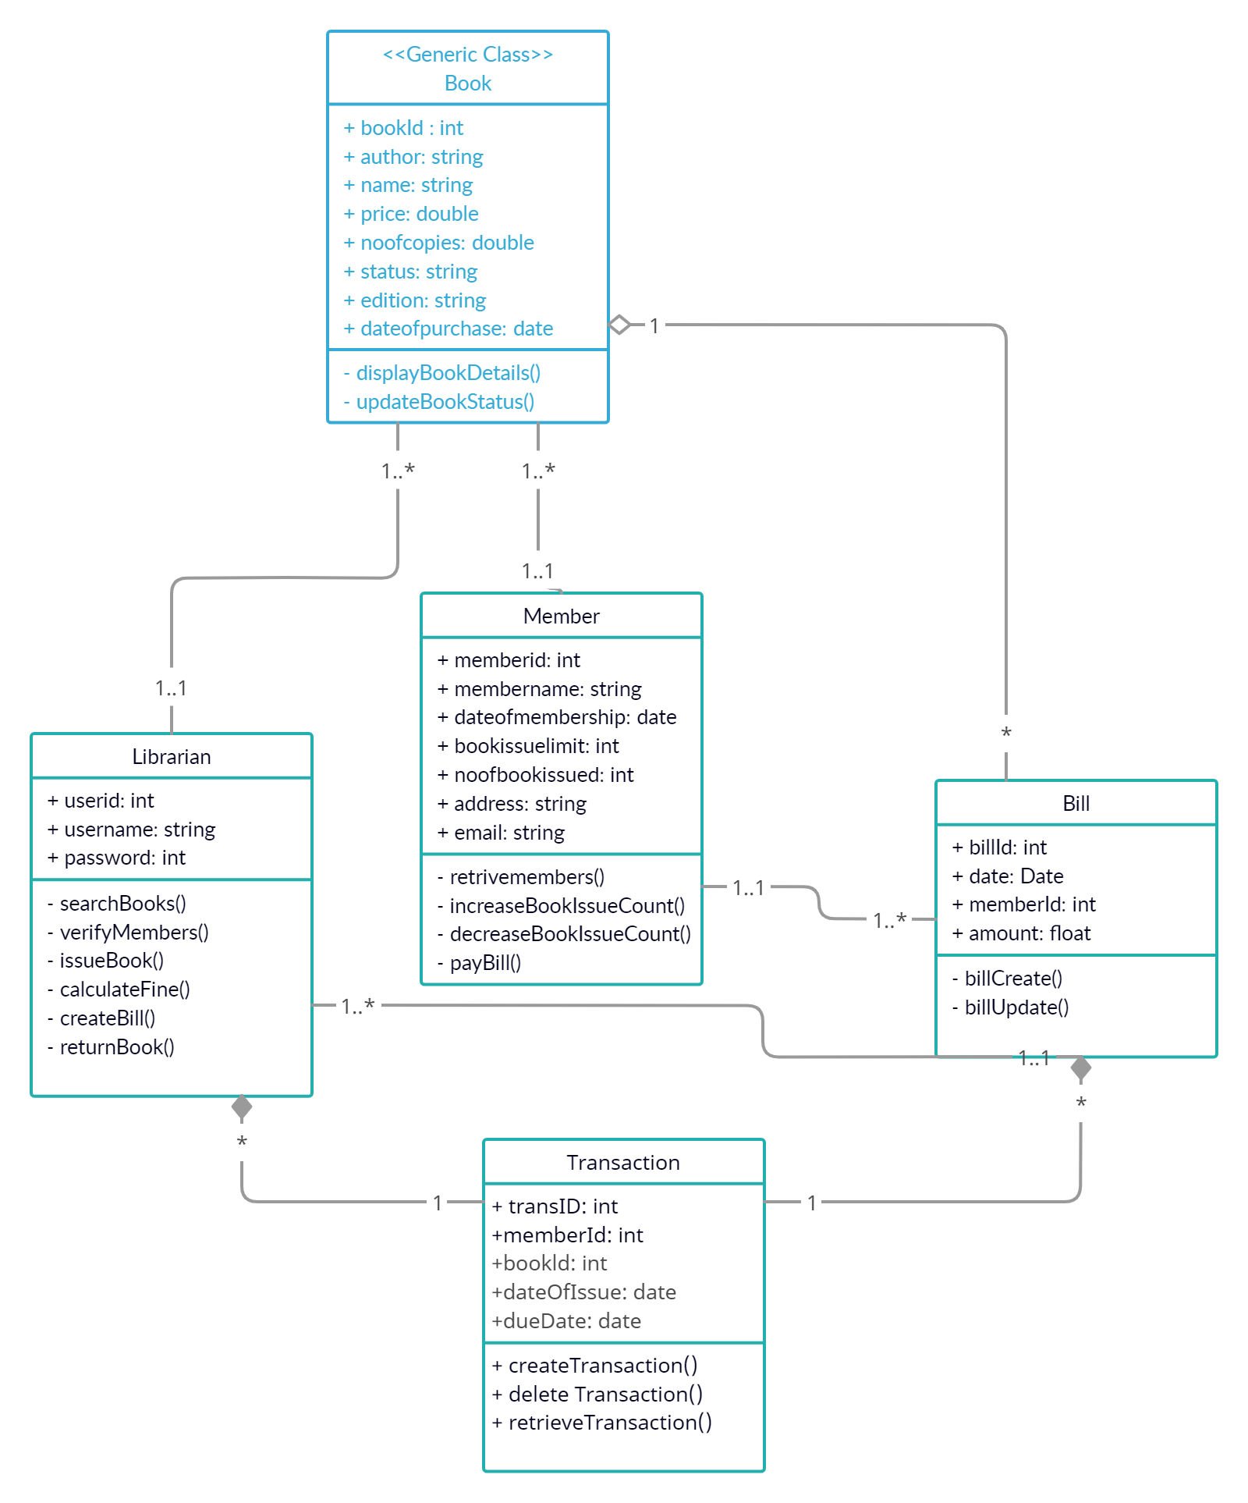

* 1. Non-Functional Requirements

Non-Functional Requirements of Our Project are as follow:

1. Security
2. Reliability’
3. Maintainability
4. Portability
5. Extensibility
6. Reusability
7. Compatibility
8. Resource Utilization
   1. Interface Requirement

Various interfaces for the product could be

1. Login Page
2. There will be a screen displaying information about books that the library having.
3. If the customers select the borrow button, then another popup of due date and other details will be opened.
4. After borrowing the book, the system will sent one copy of the issuing slip to the members email address
   1. Some UI Screenshots

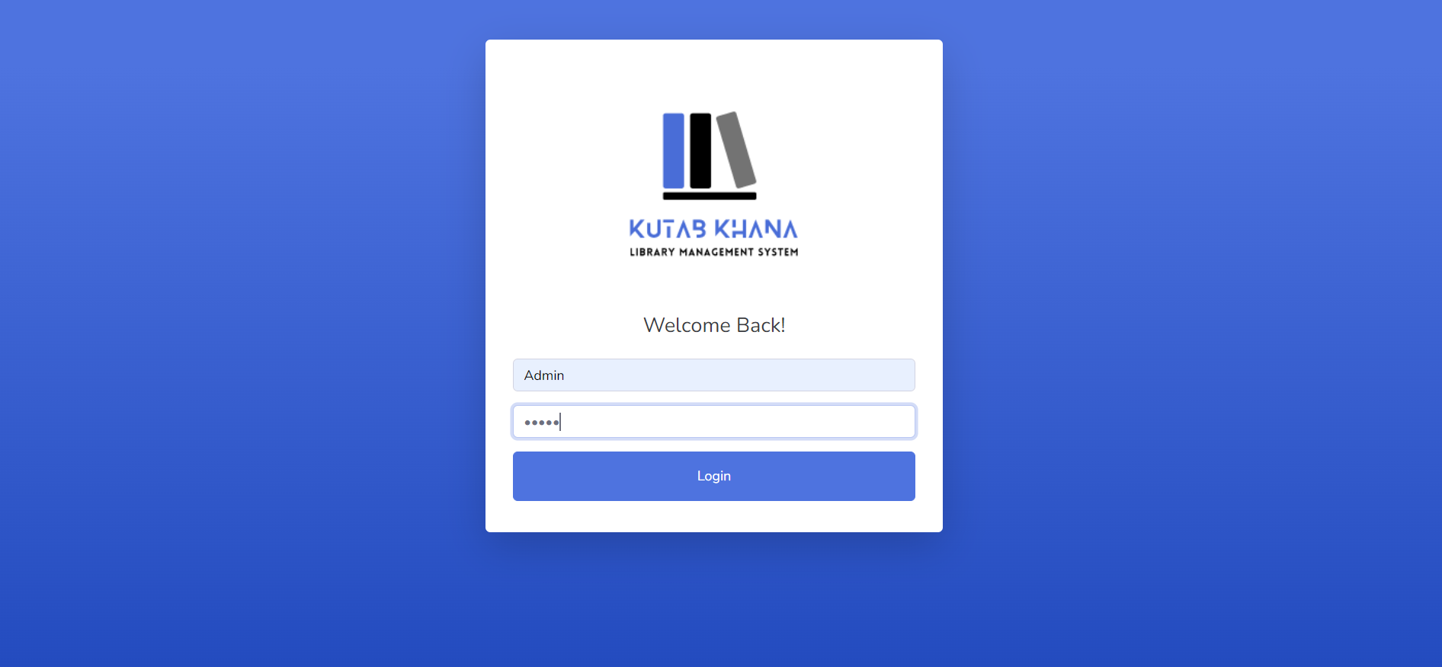

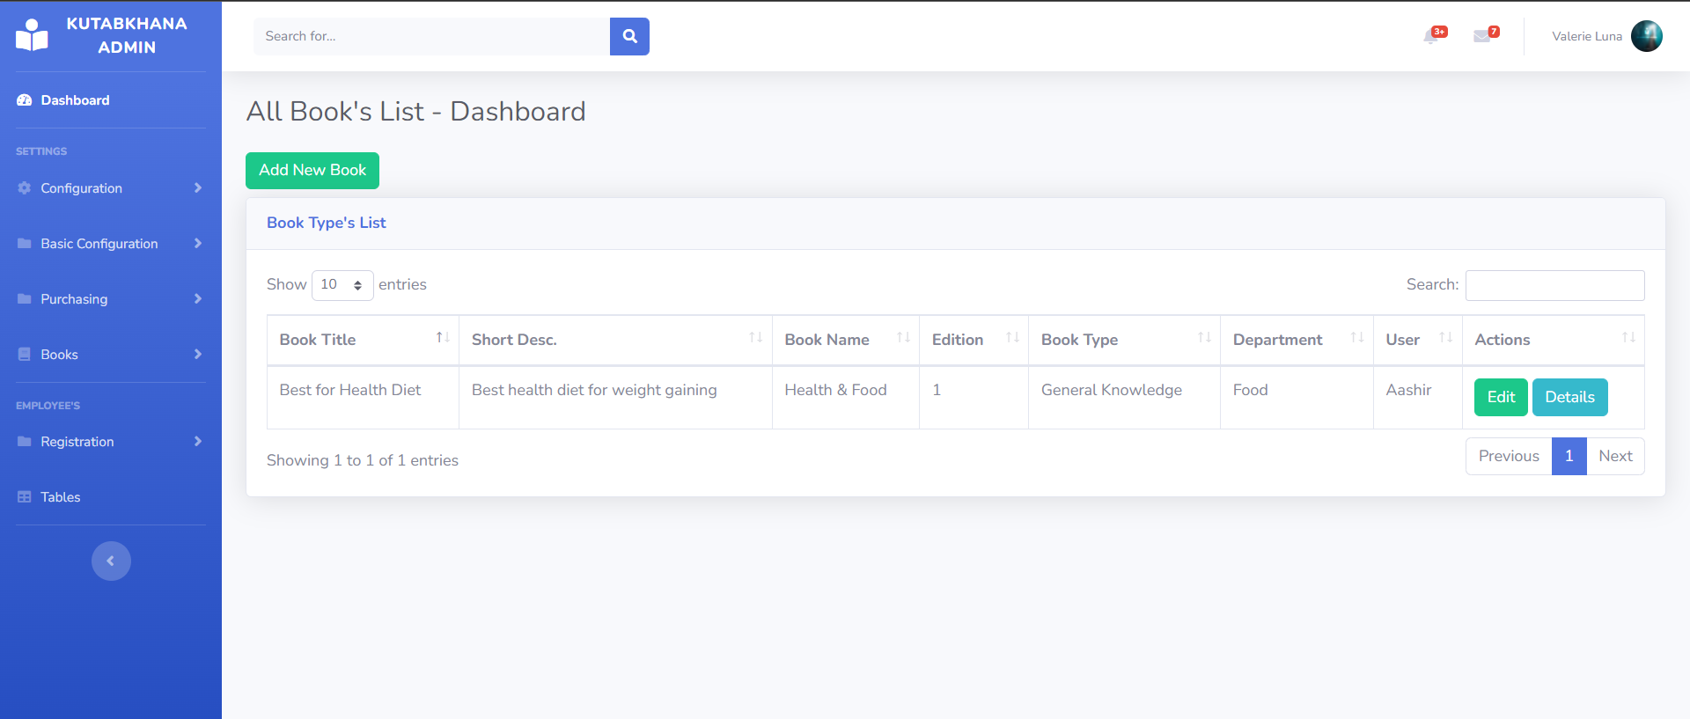

* 1. References
* <https://github.com/AashirKhan21/OOAD-Project/>
* kutabkhana.somee.com